Testing Branch based rules :-

Since it’s a small project with 5 developers a suitable branching strategy will be 3 branches (main, develop, hotfix). The main branch should be protected and no merges will be allowed without PR and Code Review.
For new features or development there is the develop branch. Developers should always pull the required changes from main branch before committing to the development branch. This branch also will have the necessary branch protection rules.
For any emergency changes the hotfix branch has been created. For any fix the first step is to fetch the latest changes from the main branch and then make the necessary changes and raise a PR approval to merge the changes back to main.

Here is the implementation of the above . Here we switched to the hotfix branch and pulled the latest changes from main and then raised a PR approval for merging the changes back to main.

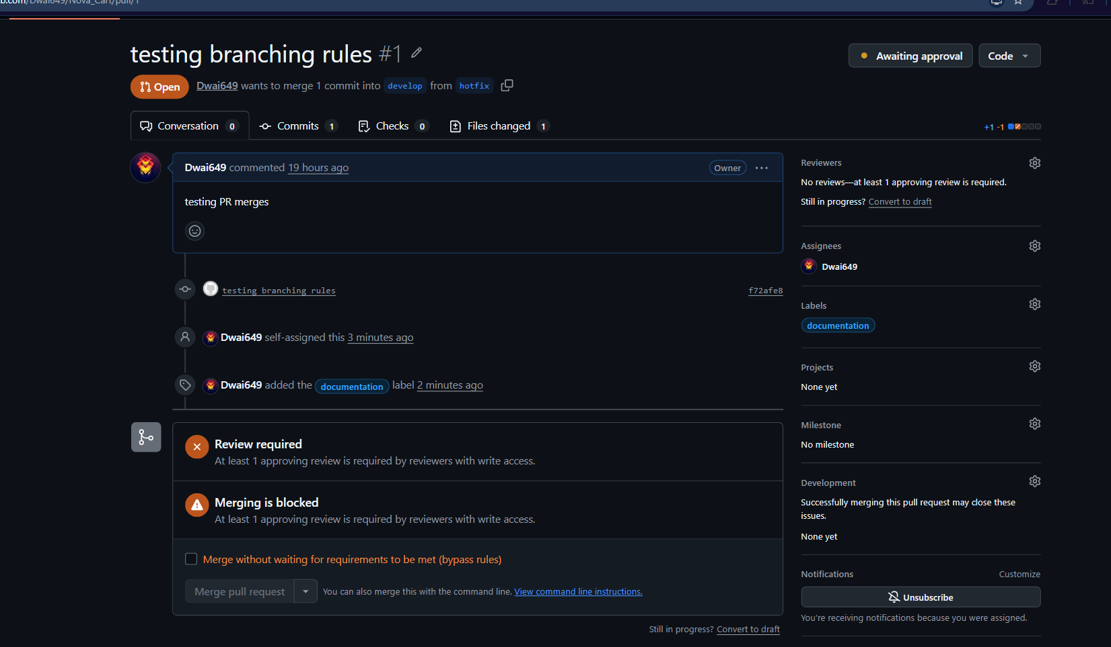

Here we haven’t yet added a reviewer, but the rules work.

