

Requirement & Design Specification
SPWPOS / PLANORA — SMART PERSONAL WORKLOAD PLANNING AND OPTIMIZATION SYSTEM
Version: 6.0 – reviewed working draft

– Danang, October 2026 –

Record of Changes
Version | Date | A*  M, D | In charge | Change Description
V1.0 | 21/9/2026 | A | SPWPOS Team | Initial SPWPOS RDS draft.
V3.0 | 30/9/2026 | M | SPWPOS Team | Code-aligned working requirements and design draft.
V4.0 | 5/10/2026 | M | SPWPOS Team | Corrected UC flows, mapping, data and traceability.
V5.0 | 12/10/2026 | M | SPWPOS Team | Aligned document presentation with the official FPT University RDS format.
V6.0 | 18/10/2026 | M | SPWPOS Team | Rebuilt actor/workspace screen flows incl. return paths; aligned descriptions; added package and verified partial-FK diagrams; corrected figure numbering and explicit gaps.
*A - Added M - Modified D - Deleted

Contents

Record of Changes 2
Contents 3
I. Overview 10
1. User Requirements 10
1.1 Actors 10
1.2 Use Cases 10
2. Overall Functionalities 20
2.1 Screens Flow 20
2.2 Screen Descriptions 24
2.3 Screen Authorization 26
2.4 Non-UI Functions 27
3. System High Level Design 28
3.1 Database Design 28
3.1.1 Detailed Physical Database Schema 29
17.1. Accounts and Security 29
17.2. Time and Preferences 31
17.3. Tasks and Categories 31
17.4. Planning and Execution 32
17.5. Intelligence and Workload Analytics 33
17.6. Notifications and Operations 35
17.7. Notes and AI Assistant 36
3.2 Code Packages 39
II. Requirement Specifications 39
1. Account & Profile 39
1.1 UC01 — Register Account 39
1.2 UC02 — Login 40
1.3 UC03 — Logout 40
1.4 UC04 — Request Password Reset 41
1.5 UC05 — Reset Password 41
1.6 UC06 — Change Password 42
1.7 UC07 — View Profile 42
1.8 UC08 — Update Profile 43
1.9 UC73 — Resend Email Verification OTP [PROVISIONAL] 43
1.10 UC74 — Sign Out All Sessions [PROVISIONAL] 44
1.11 UC75 — View Login Methods [PROVISIONAL] 44
1.12 UC76 — Set Initial Password [PROVISIONAL] 45
2. Task Management 46
2.1 UC09 — Create Task 46
2.2 UC10 — View Task List 46
2.3 UC11 — View Task Details 47
2.4 UC12 — Update Task 47
2.5 UC13 — Delete Task 48
2.6 UC14 — Search Tasks 48
2.7 UC15 — Filter Tasks 49
2.8 UC16 — Change Task Status 49
2.9 UC17 — Create Task Category 50
2.10 UC18 — Update Task Category 50
2.11 UC19 — Delete Task Category 51
2.12 UC20 — Create Subtask 51
2.13 UC21 — Update Subtask 52
2.14 UC22 — Delete Subtask 52
2.15 UC23 — Add Task Dependency 53
2.16 UC24 — Remove Task Dependency 53
2.17 UC25 — Capture Task Using Natural Language 54
2.18 UC26 — Break Down Complex Task 54
3. Time Management 55
3.1 UC27 — Set Weekly Availability 55
3.2 UC28 — Add Availability Exception 55
3.3 UC29 — Update Availability Exception 56
3.4 UC30 — Remove Availability Exception 56
3.5 UC31 — Create Fixed Event 57
3.6 UC32 — Update Fixed Event 57
3.7 UC33 — Delete Fixed Event 58
3.8 UC34 — View Personal Calendar 58
3.9 UC35 — Set Work Preferences 59
4. Planning & Scheduling 59
4.1 UC36 — Generate Work Plan 59
4.2 UC37 — Review Proposed Plan 60
4.3 UC38 — Apply Proposed Plan 60
4.4 UC39 — Move Work Session 61
4.5 UC40 — Change Work Session Duration 61
4.6 UC41 — Lock Work Session 62
4.7 UC42 — Unlock Work Session 62
4.8 UC43 — Split Work Session 63
4.9 UC44 — Detect Scheduling Conflict 63
4.10 UC45 — Generate Reschedule Proposal 64
4.11 UC46 — Review Reschedule Proposal 64
4.12 UC47 — Apply Reschedule Proposal 65
4.13 UC48 — Explain Scheduling Decision 65
4.14 UC49 — Run What-if Scenario 66
5. Execution & Feedback 67
5.1 UC50 — Start Work Session 67
5.2 UC51 — Pause Work Session 67
5.3 UC52 — Resume Work Session 68
5.4 UC53 — Complete Work Session 68
5.5 UC54 — Skip Work Session 69
5.6 UC55 — Update Task Progress 69
5.7 UC56 — Record Actual Work Duration 70
5.8 UC57 — Review Planned vs Actual Performance 70
6. Intelligence & Personalization 71
6.1 UC58 — Get Personalized Duration Estimate 71
6.2 UC59 — Review Estimation Bias 71
6.3 UC60 — Review Effective Capacity 72
6.4 UC61 — View Workload Analysis 72
6.5 UC62 — View Overload Risk 73
6.6 UC63 — View Task Completion Risk 73
6.7 UC64 — View Personal Productivity Insights 74
7. Notifications 74
7.1 UC65 — Receive Deadline Notification 74
7.2 UC66 — Receive Upcoming Work Session Reminder 75
7.3 UC67 — Receive Workload Warning 75
7.4 UC68 — Receive Schedule Change Notification 76
7.5 UC99 — Configure Notification Preferences [PROVISIONAL] 76
7.6 UC100 — Mark Notification as Read [PROVISIONAL] 77
8. Administration 78
8.1 UC69 — Search User Accounts 78
8.2 UC70 — Lock User Account 78
8.3 UC71 — Unlock User Account 79
8.4 UC72 — View System Status 79
8.5 UC101 — View Account Status Logs [PROVISIONAL] 80
8.6 UC102 — View Background Job History [PROVISIONAL] 80
9. AI Agent & NORA 81
9.1 UC77 — View AI Capabilities and Usage [PROVISIONAL] 81
9.2 UC78 — Interact with NORA Agent [PROVISIONAL] 81
9.3 UC79 — Browse and Search NORA Conversations [PROVISIONAL] 82
9.4 UC80 — Edit NORA Conversation [PROVISIONAL] 82
9.5 UC81 — Delete NORA Conversation [PROVISIONAL] 83
9.6 UC82 — Export NORA Conversation [PROVISIONAL] 83
9.7 UC83 — Apply NORA Proposed Action [PROVISIONAL] 84
9.8 UC84 — Undo NORA Applied Action [PROVISIONAL] 84
9.9 UC85 — Use Voice Input with NORA [PROVISIONAL] 85
10. Notes & AI Note Processing 85
10.1 UC86 — View Notes [PROVISIONAL] 85
10.2 UC87 — Create Note [PROVISIONAL] 86
10.3 UC88 — Update Note [PROVISIONAL] 86
10.4 UC89 — Delete Note [PROVISIONAL] 87
10.5 UC90 — Analyze Note with AI [PROVISIONAL] 87
10.6 UC91 — Convert Note into Tasks [PROVISIONAL] 88
10.7 UC92 — Generate Schedule from Note [PROVISIONAL] 88
11. Schedule Recovery 89
11.1 UC93 — Configure Recovery Settings [PROVISIONAL] 89
11.2 UC94 — View Recovery Proposals [PROVISIONAL] 90
11.3 UC95 — Scan for Recovery Opportunities [PROVISIONAL] 90
11.4 UC96 — Rebuild Recovery Proposal [PROVISIONAL] 91
11.5 UC97 — Apply Recovery Proposal [PROVISIONAL] 91
11.6 UC98 — Dismiss Recovery Proposal [PROVISIONAL] 92
12. Common Functions 92
13. Main User Features 93
Account & Profile 93
Task Management 93
Time Management 93
Planning & Scheduling 93
Execution & Feedback 93
Intelligence & Personalization 93
Notifications 93
Administration 93
AI Agent & NORA 93
Notes & AI Note Processing 93
Schedule Recovery 94
14. Common Business Rules 94
III. Design Specifications 94
1. Authentication & Account 94
1.1 Screen / Function 94
2. Task Management 95
2.1 Screen / Function 95
3. Notes & NORA 96
3.1 Screen / Function 96
4. Time & Calendar 96
4.1 Screen / Function 96
5. Planning & Recovery 97
5.1 Screen / Function 97
6. Execution & Insights 98
6.1 Screen / Function 98
7. Notifications 99
7.1 Screen / Function 99
8. Administration 99
8.1 Screen / Function 99
IV. Appendix 100
1. Assumptions & Dependencies 100
2. Limitations & Exclusions 100
3. Business Rules 101
4. Traceability to Repository 101
5. Final Acceptance Checklist (team action) 102
6. Document Status 102
7. Open Issues and Required Evidence (not yet verified) 102

I. Overview

1. User Requirements

1.1 Actors
# | Actor | Description
1 | Guest / unauthenticated visitor | Registers, verifies an email, signs in, requests recovery; only public authorization endpoints.
2 | User | Authenticated owner of tasks, notes, availability, plans, sessions, insights, messages and personal preferences.
3 | Administrator | Authenticated Admin role; account search, lock/unlock, system status, job/status history.
4 | Email / SMTP service | External delivery for OTP and optional deadline/session email reminders; Mailpit is a development sink.
5 | Firebase Authentication | Optional third-party verification of Google sign-in ID tokens, when configured.
6 | Configured AI provider | Optional service for NORA/notes/natural-language processing; provider and credentials vary by environment.
7 | Background worker | Internal trigger for scanning reminders, risks and operational job records (not a human user).
Actor modeling note: the database and planner are system components, not external actors. Background processing appears as a supporting automated actor only to explain time-triggered use cases. A login screen being hidden is not an authorization control.

1.2 Use Cases

a. Diagram(s)
The original UML v2 baseline contains UC01–UC72. The diagram below is a legible functional overview. The numbered case catalog and detailed specifications are the source of truth for exact case names; the newer provisional surfaces are not silently inserted into the approved 72-case UML.
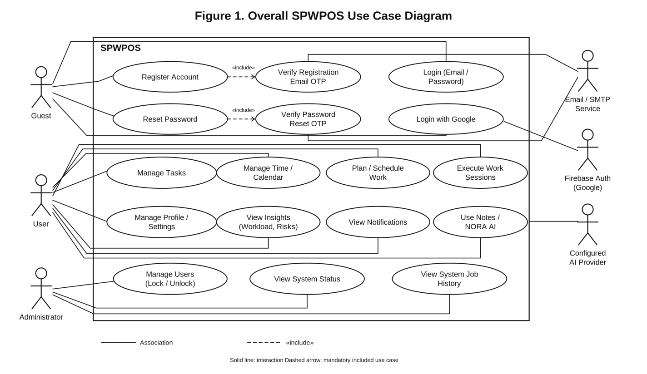
Figure 1 — Overall SPWPOS Use Case Diagram.
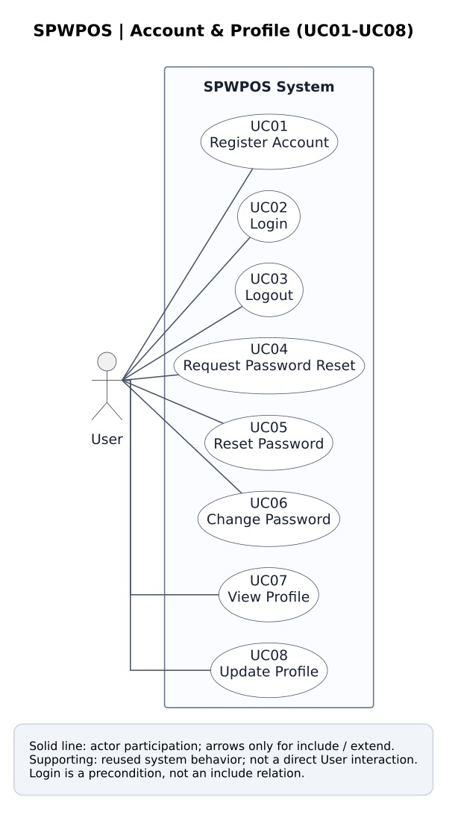
Figure 2. Account & Profile use case diagram
Original baseline UC group diagram (from SPWPOS_RDS2.docx / UML-v2; later provisional cases not shown).
UC | Use-case oval / intended user goal | Status
UC01 | Register Account | Baseline
UC02 | Login | Baseline
UC03 | Logout | Baseline
UC04 | Request Password Reset | Baseline
UC05 | Reset Password | Baseline
UC06 | Change Password | Baseline
UC07 | View Profile | Baseline
UC08 | Update Profile | Baseline
UC73 | Resend Email Verification OTP | Provisional
UC74 | Sign Out All Sessions | Provisional
UC75 | View Login Methods | Provisional
UC76 | Set Initial Password | Provisional
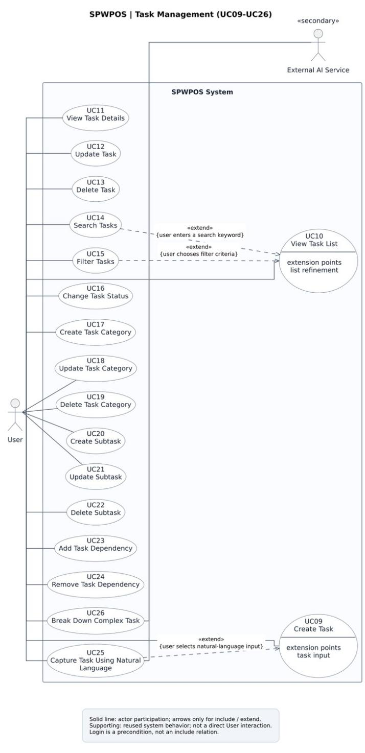
Figure 3. Task Management use case diagram
Original baseline UC group diagram (from SPWPOS_RDS2.docx / UML-v2; later provisional cases not shown).
UC | Use-case oval / intended user goal | Status
UC09 | Create Task | Baseline
UC10 | View Task List | Baseline
UC11 | View Task Details | Baseline
UC12 | Update Task | Baseline
UC13 | Delete Task | Baseline
UC14 | Search Tasks | Baseline
UC15 | Filter Tasks | Baseline
UC16 | Change Task Status | Baseline
UC17 | Create Task Category | Baseline
UC18 | Update Task Category | Baseline
UC19 | Delete Task Category | Baseline
UC20 | Create Subtask | Baseline
UC21 | Update Subtask | Baseline
UC22 | Delete Subtask | Baseline
UC23 | Add Task Dependency | Baseline
UC24 | Remove Task Dependency | Baseline
UC25 | Capture Task Using Natural Language | Baseline
UC26 | Break Down Complex Task | Baseline
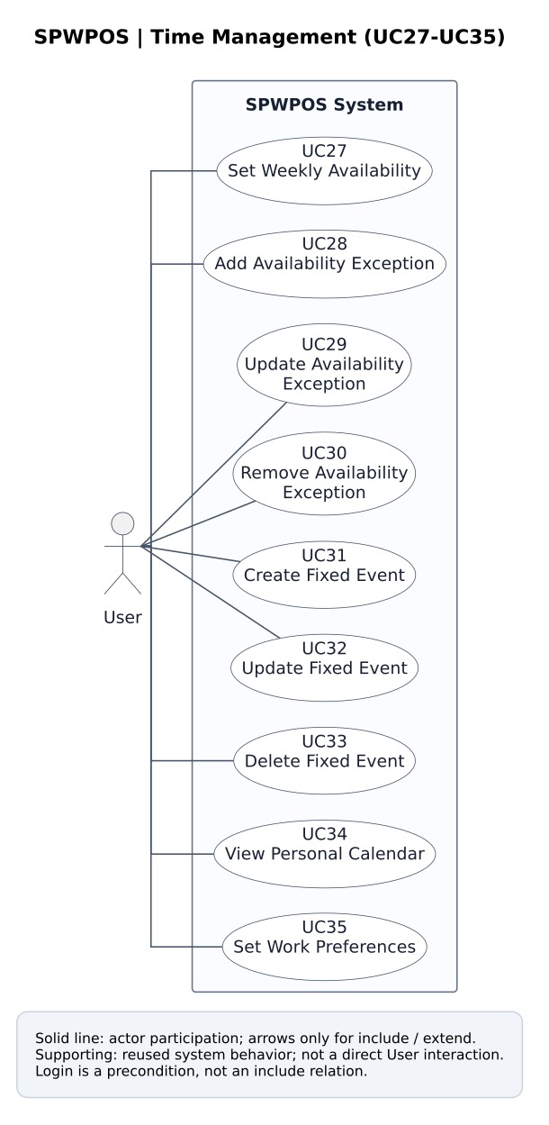
Figure 4. Time Management use case diagram
Original baseline UC group diagram (from SPWPOS_RDS2.docx / UML-v2; later provisional cases not shown).
UC | Use-case oval / intended user goal | Status
UC27 | Set Weekly Availability | Baseline
UC28 | Add Availability Exception | Baseline
UC29 | Update Availability Exception | Baseline
UC30 | Remove Availability Exception | Baseline
UC31 | Create Fixed Event | Baseline
UC32 | Update Fixed Event | Baseline
UC33 | Delete Fixed Event | Baseline
UC34 | View Personal Calendar | Baseline
UC35 | Set Work Preferences | Baseline
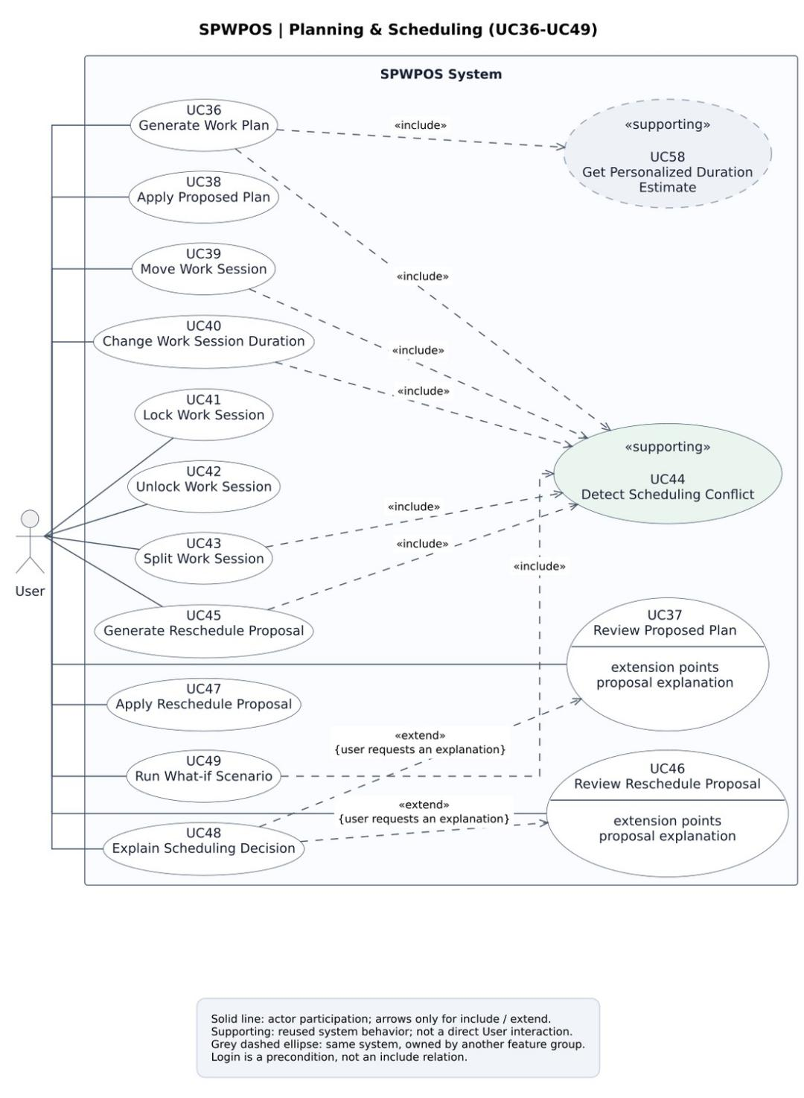
Figure 5. Planning & Scheduling use case diagram
Original baseline UC group diagram (from SPWPOS_RDS2.docx / UML-v2; later provisional cases not shown).
UC | Use-case oval / intended user goal | Status
UC36 | Generate Work Plan | Baseline
UC37 | Review Proposed Plan | Baseline
UC38 | Apply Proposed Plan | Baseline
UC39 | Move Work Session | Baseline
UC40 | Change Work Session Duration | Baseline
UC41 | Lock Work Session | Baseline
UC42 | Unlock Work Session | Baseline
UC43 | Split Work Session | Baseline
UC44 | Detect Scheduling Conflict | Baseline
UC45 | Generate Reschedule Proposal | Baseline
UC46 | Review Reschedule Proposal | Baseline
UC47 | Apply Reschedule Proposal | Baseline
UC48 | Explain Scheduling Decision | Baseline
UC49 | Run What-if Scenario | Baseline
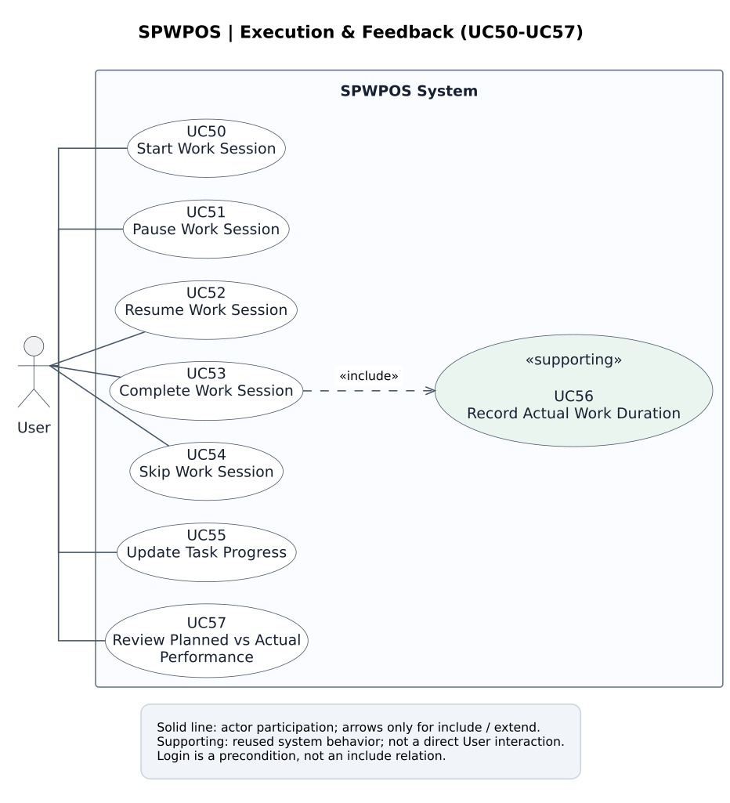
Figure 6. Execution & Feedback use case diagram
Original baseline UC group diagram (from SPWPOS_RDS2.docx / UML-v2; later provisional cases not shown).
UC | Use-case oval / intended user goal | Status
UC50 | Start Work Session | Baseline
UC51 | Pause Work Session | Baseline
UC52 | Resume Work Session | Baseline
UC53 | Complete Work Session | Baseline
UC54 | Skip Work Session | Baseline
UC55 | Update Task Progress | Baseline
UC56 | Record Actual Work Duration | Baseline
UC57 | Review Planned vs Actual Performance | Baseline
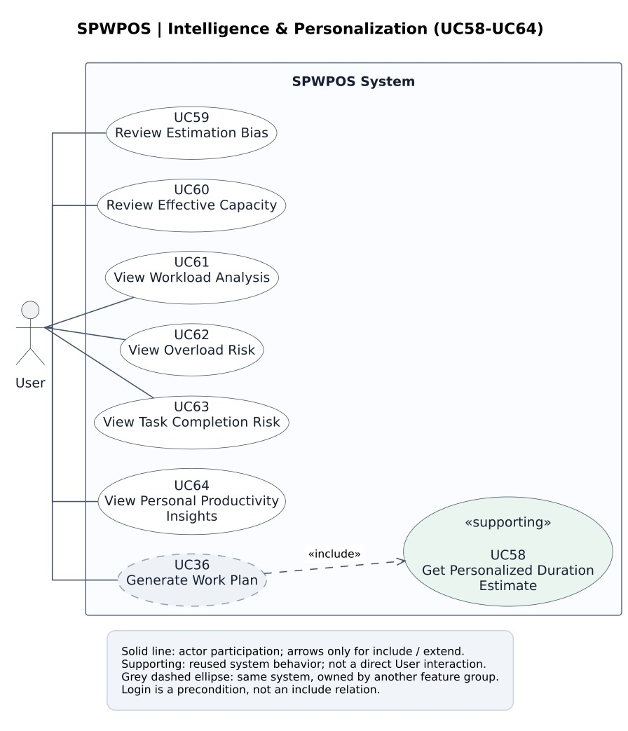
Figure 7. Intelligence & Personalization use case diagram
Original baseline UC group diagram (from SPWPOS_RDS2.docx / UML-v2; later provisional cases not shown).
UC | Use-case oval / intended user goal | Status
UC58 | Get Personalized Duration Estimate | Baseline
UC59 | Review Estimation Bias | Baseline
UC60 | Review Effective Capacity | Baseline
UC61 | View Workload Analysis | Baseline
UC62 | View Overload Risk | Baseline
UC63 | View Task Completion Risk | Baseline
UC64 | View Personal Productivity Insights | Baseline
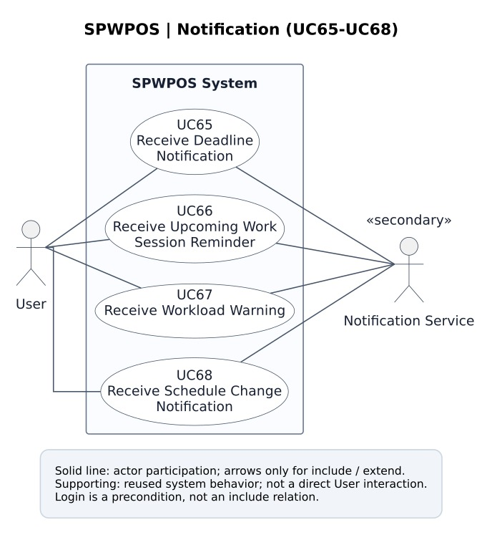
Figure 8. Notifications use case diagram
Original baseline UC group diagram (from SPWPOS_RDS2.docx / UML-v2; later provisional cases not shown).
UC | Use-case oval / intended user goal | Status
UC65 | Receive Deadline Notification | Baseline
UC66 | Receive Upcoming Work Session Reminder | Baseline
UC67 | Receive Workload Warning | Baseline
UC68 | Receive Schedule Change Notification | Baseline
UC99 | Configure Notification Preferences | Provisional
UC100 | Mark Notification as Read | Provisional
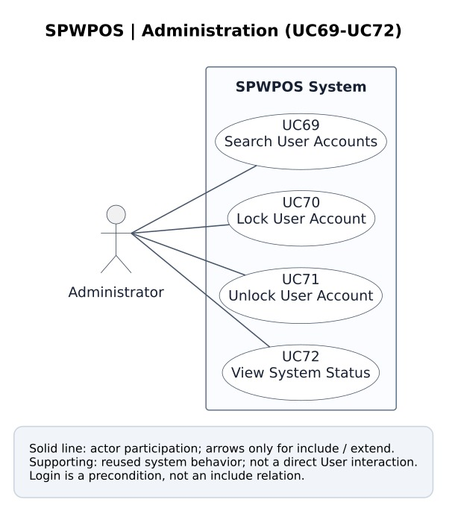
Figure 9. Administration use case diagram
Original baseline UC group diagram (from SPWPOS_RDS2.docx / UML-v2; later provisional cases not shown).
UC | Use-case oval / intended user goal | Status
UC69 | Search User Accounts | Baseline
UC70 | Lock User Account | Baseline
UC71 | Unlock User Account | Baseline
UC72 | View System Status | Baseline
UC101 | View Account Status Logs | Provisional
UC102 | View Background Job History | Provisional

b. Descriptions
Feature | Approved baseline | Candidate additions | Reference
Account & Profile | 8 | 4 | UC01, UC02, UC03, UC04…
Task Management | 18 | 0 | UC09, UC10, UC11, UC12…
Time Management | 9 | 0 | UC27, UC28, UC29, UC30…
Planning & Scheduling | 14 | 0 | UC36, UC37, UC38, UC39…
Execution & Feedback | 8 | 0 | UC50, UC51, UC52, UC53…
Intelligence & Personalization | 7 | 0 | UC58, UC59, UC60, UC61…
Notifications | 4 | 2 | UC65, UC66, UC67, UC68…
Administration | 4 | 2 | UC69, UC70, UC71, UC72…
AI Agent & NORA | 0 | 9 | UC77, UC78, UC79, UC80…
Notes & AI Note Processing | 0 | 7 | UC86, UC87, UC88, UC89…
Schedule Recovery | 0 | 6 | UC93, UC94, UC95, UC96…
The official pre-existing baseline is 72 use cases. Thirty additional independent-or-subflow candidates are documented for review; the team must approve the final classification before submitting a new official total.

2. Overall Functionalities

2.1 Screens Flow
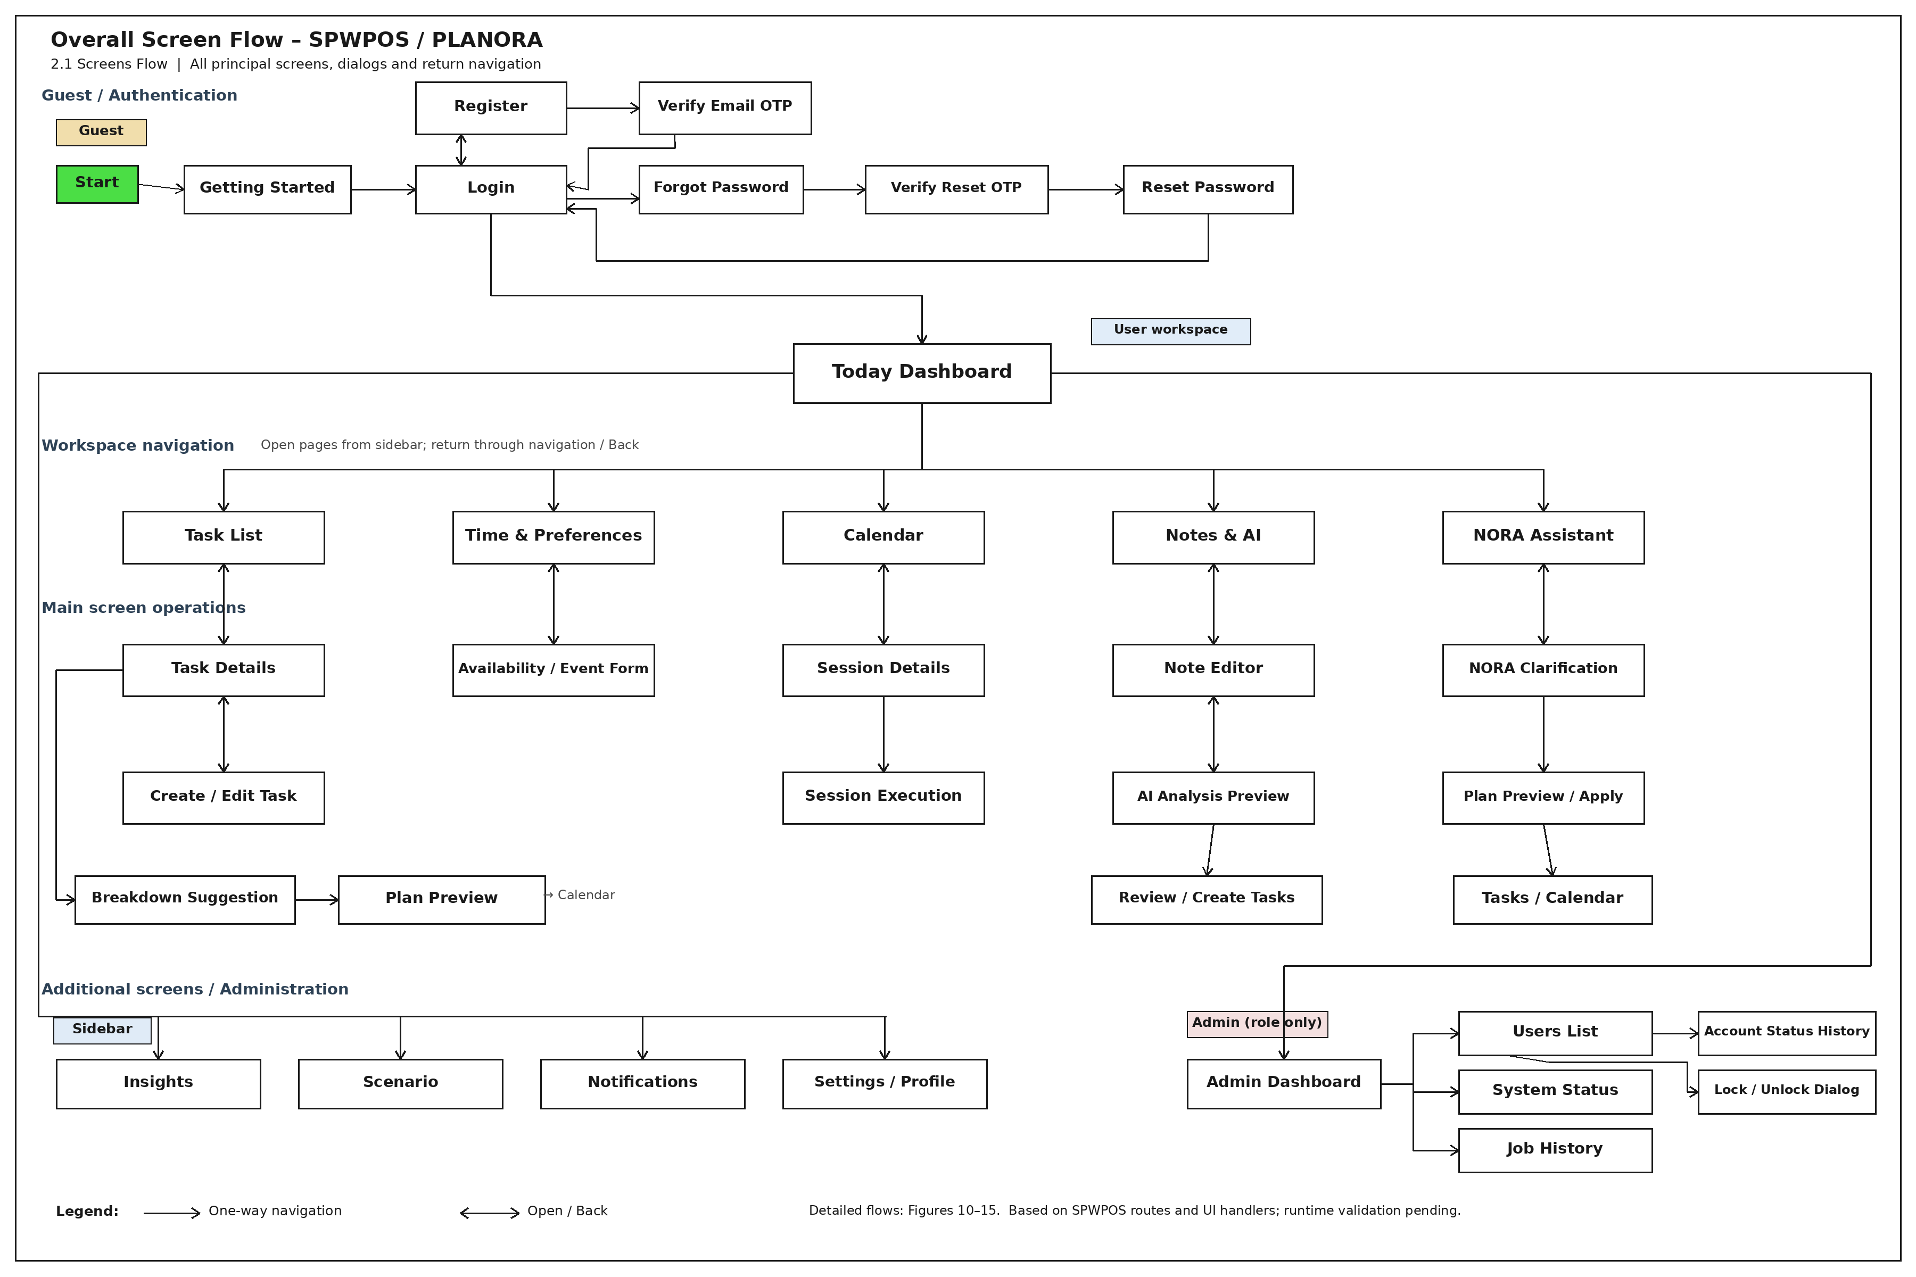
Overall Screen Flow Diagram of SPWPOS.
The screen-flow diagrams below were redrawn in the same spirit as the course template and the JobTrans sample: square/rectangular screen boxes, orthogonal bent connectors, and explicit return paths where users can navigate back by Back, Close, Cancel, or the persistent workspace navigation. The purpose is to present a human-made, easy-to-read interaction flow rather than a generic AI-style diagram.

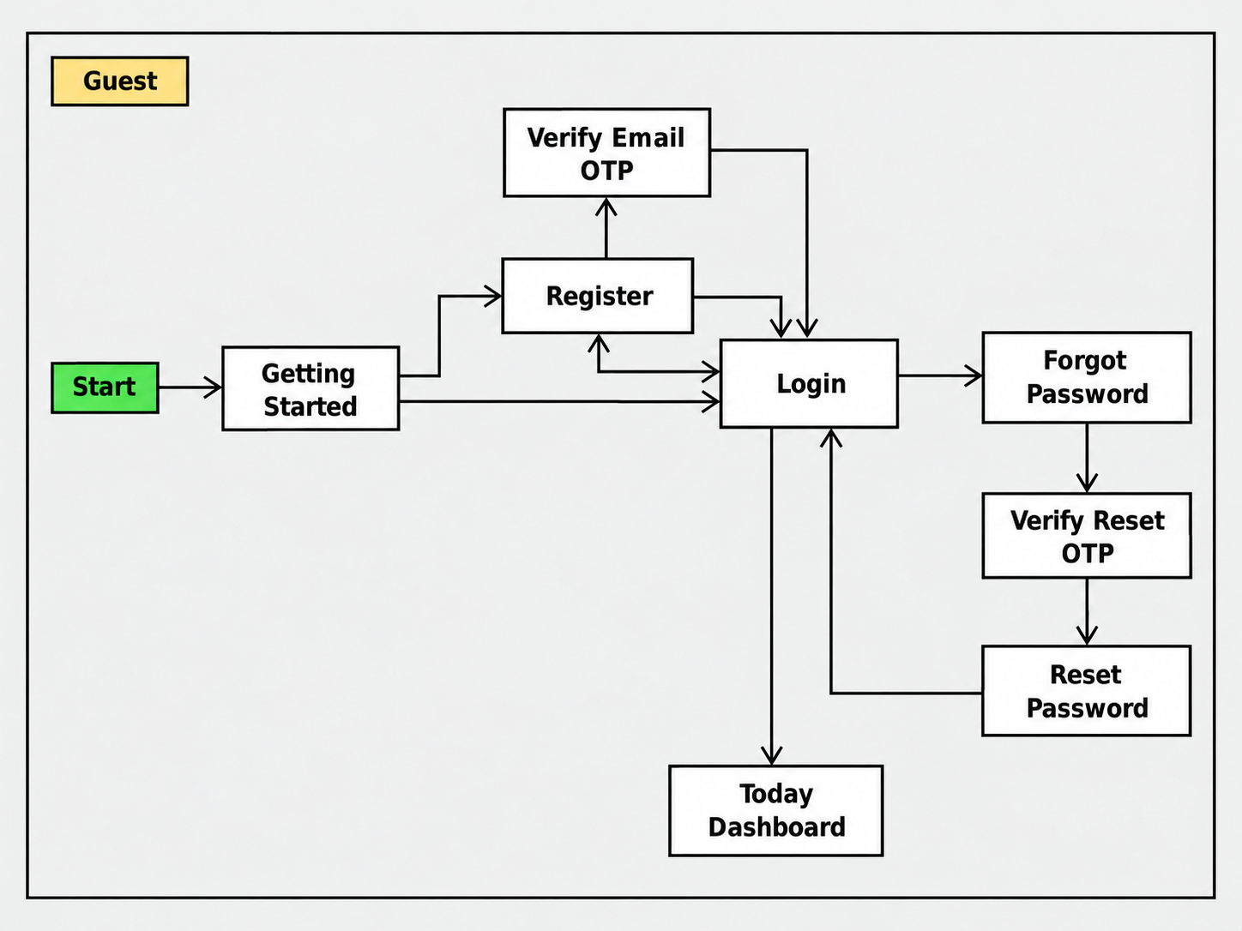
Figure 10. Screen Flow Diagram – Guest and Authentication.

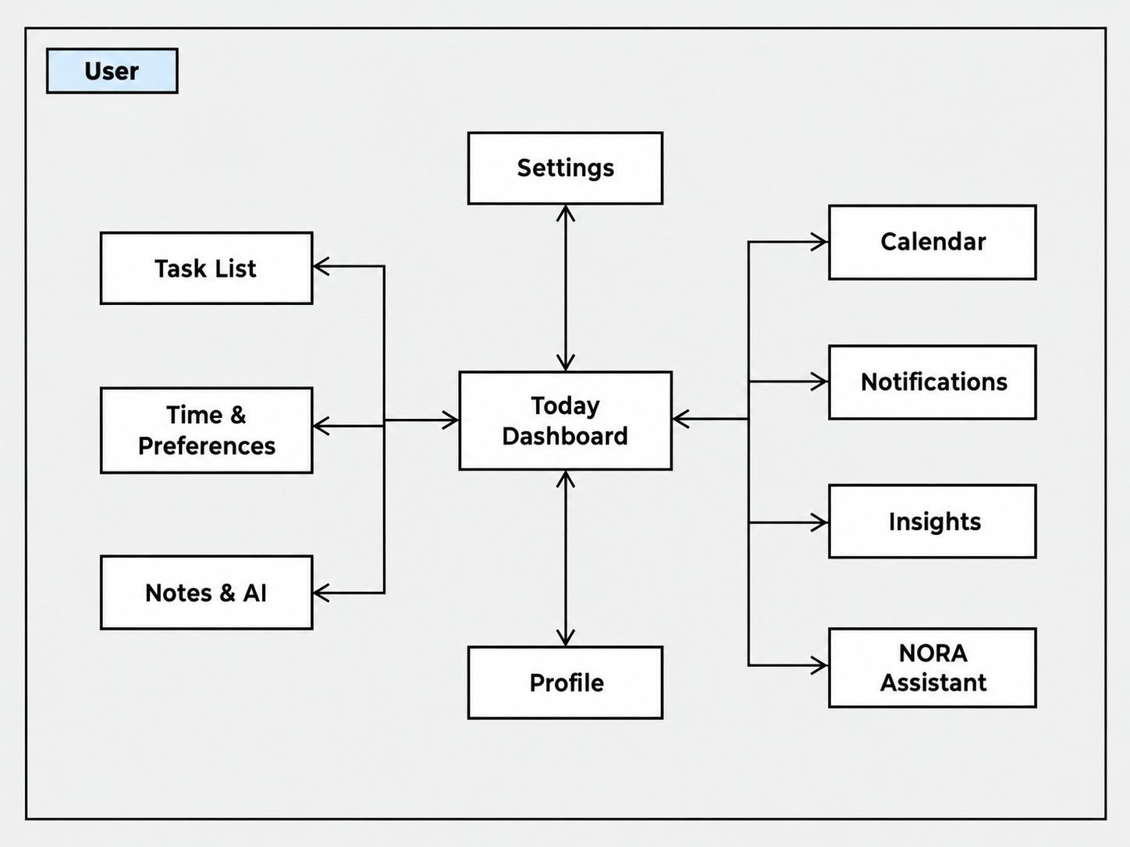
Figure 11. Screen Flow Diagram – Main Workspace Navigation.
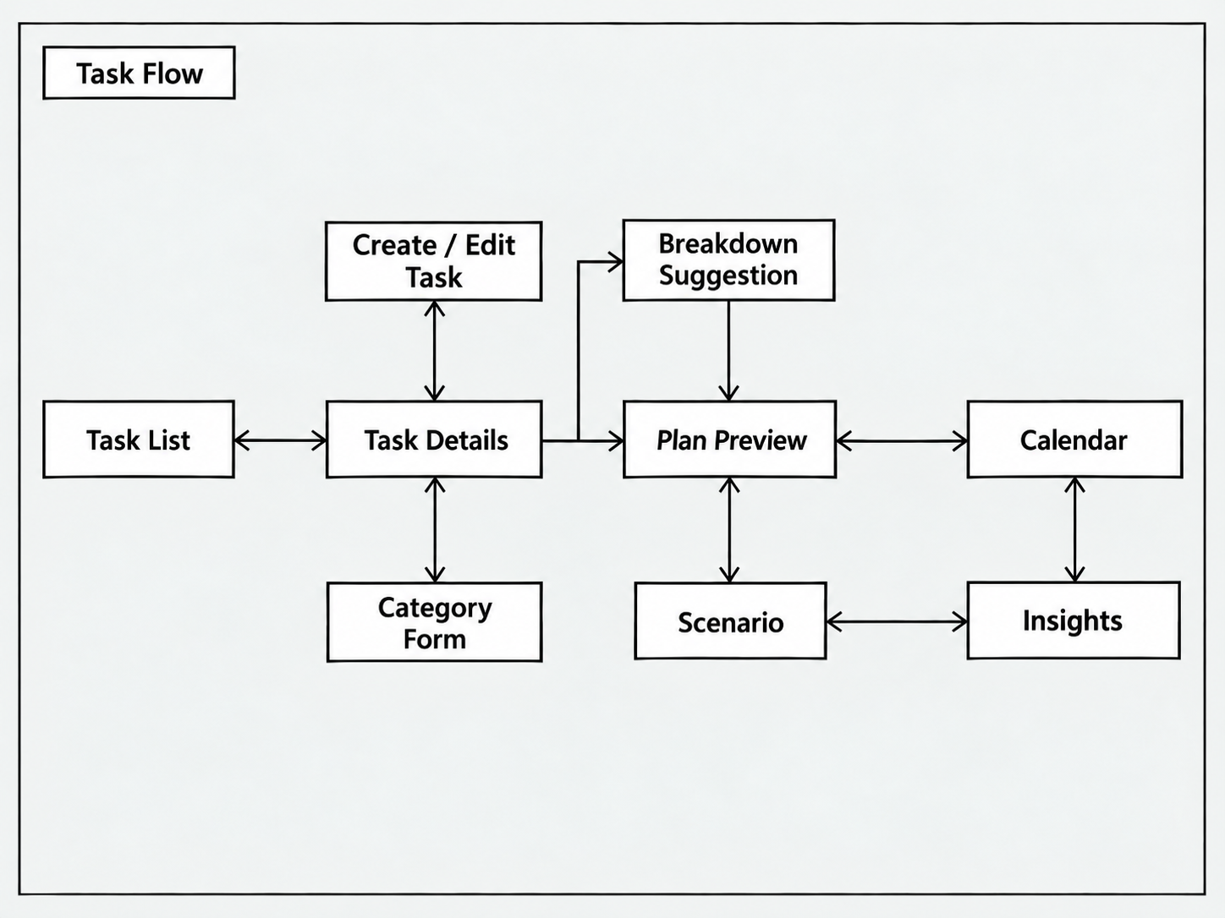
Figure 12. Screen Flow Diagram – Task Management and Planning.
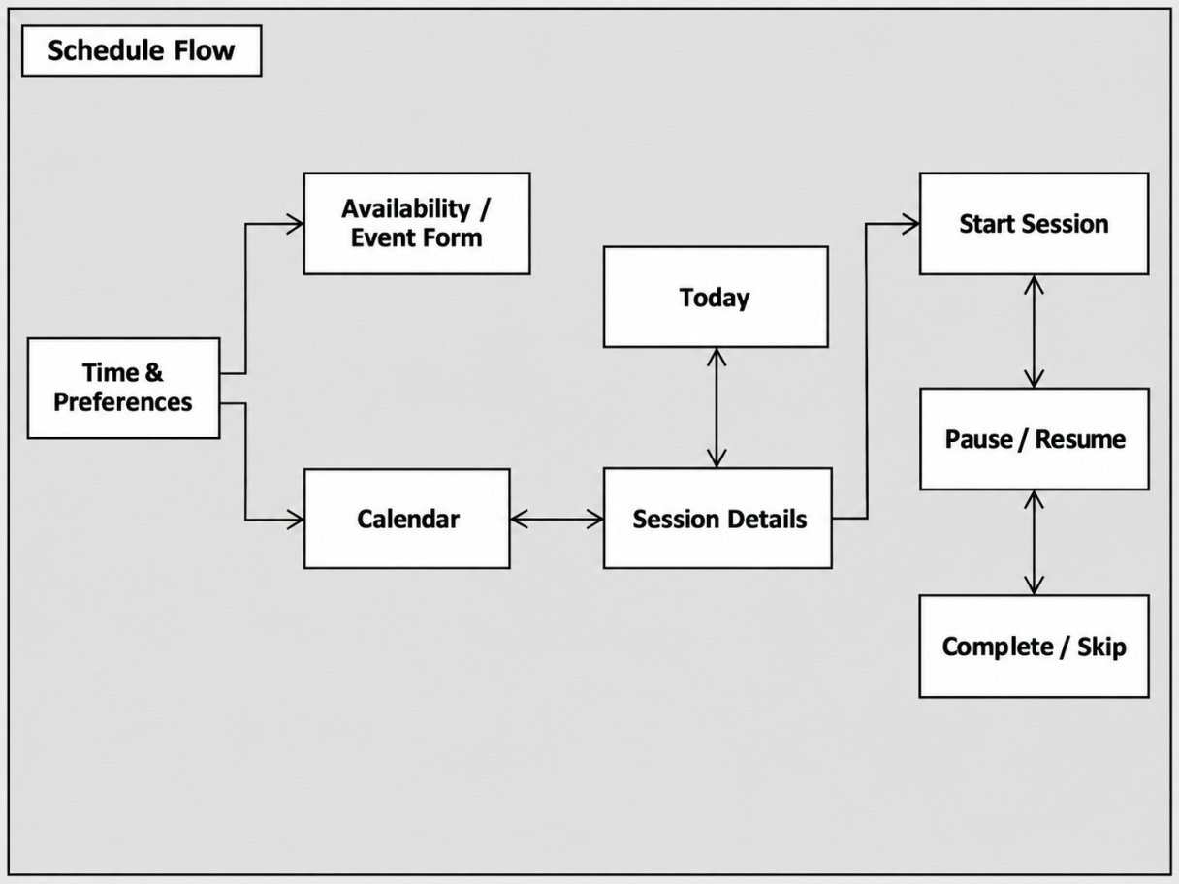
Figure 13. Screen Flow Diagram – Time, Calendar and Session Execution.
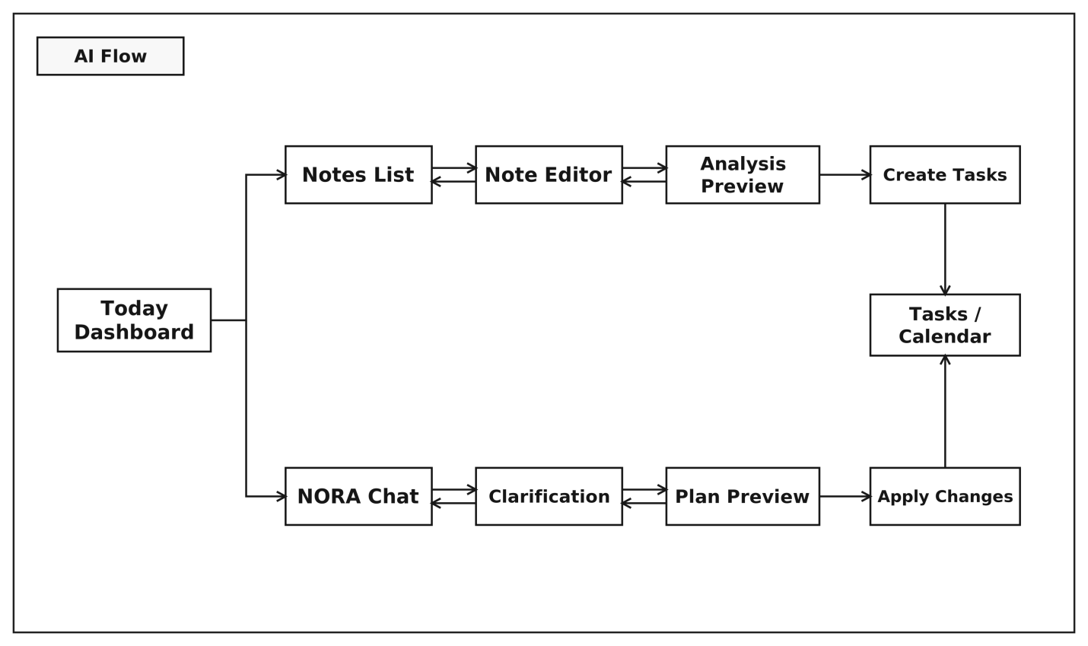
Figure 14. Screen Flow Diagram – Notes and NORA.
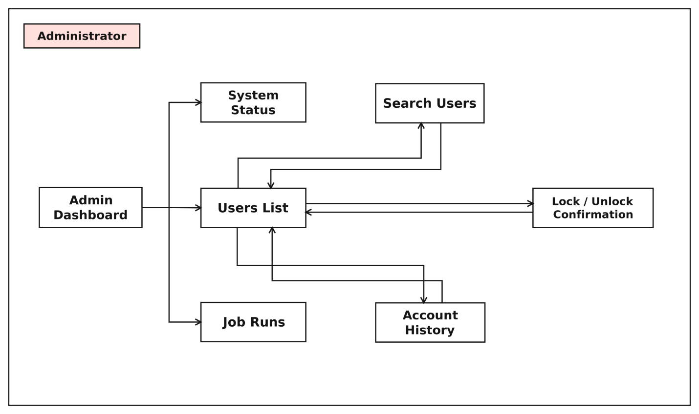
Figure 15. Screen Flow Diagram – Administration.

2.2 Screen Descriptions
The following table summarizes the main screens shown in the screen-flow figures. Screen IDs S01–S17 are used only for traceability across this section and the later design/requirement sections.
ID | Screen Name | Main Responsibility | Main Navigation / Result
S01 | Homepage | Public landing page for guests and first-time visitors. | Provides navigation to Register, Login, Contact, and public task browsing.
S02 | Register | Collects information required to create a new account. | Submits registration data and proceeds to Verify OTP.
S03 | Verify OTP | Validates the OTP sent by email after registration. | A successful verification leads to Login.
S04 | Login | Authenticates an existing account. | A successful login opens Today Dashboard; a user may also navigate to Forgot Password.
S05 | Forgot Password | Requests password-reset initiation. | Continues to Reset Password after the reset-verification steps.
S06 | Reset Password | Allows the user to set a new password. | Returns the user to Login after completion.
S07 | Today Dashboard | Main workspace hub after authentication. | Navigates to Task List, Calendar, Time & Preferences, Notes & AI, NORA, Insights, Notifications, Settings, and Profile.
S08 | Task List | Shows user tasks, categories, and task-management operations. | Opens Task Details, Create / Edit Task, Category Form, or Plan Preview.
S09 | Calendar | Shows planned sessions and the user schedule. | Opens Session Details and receives applied results from Plan Preview, Notes, or NORA.
S10 | Time & Preferences | Maintains availability, preferred periods, and personal scheduling preferences. | Opens Availability / Event Form and returns to the dashboard.
S11 | Insights | Shows productivity, workload, and performance analysis. | Can be reached from the dashboard or from planning/execution flows.
S12 | Scenario | Simulates what-if planning situations. | Works together with Plan Preview and Insights.
S13 | Notifications | Shows in-app notifications. | Opens from the dashboard and can return to the dashboard.
S14 | Settings / Profile | Maintains personal profile and account settings. | Opens from the dashboard and returns to the dashboard.
S15 | Notes & AI | Captures free-form notes and uses AI to derive work items. | Opens Notes List, Note Editor, Analysis Preview, and task-creation actions linked to the Calendar.
S16 | NORA Assistant | Conversational AI assistant for planning and scheduling support. | Allows clarification, preview, and apply operations that affect Calendar, Tasks, or Time.
S17 | Admin Dashboard | Administrative workspace for system-management functions. | Navigates to Users List, User Details, System Status, and Job Runs.

Subordinate Dialogs / Panels
The following items are not standalone routes. They are dialogs, forms, or in-page panels opened from the main screens and are included to make the screen flow explicit.
ID | Subordinate View | Entry / Return Behavior
D01 | Create / Edit Task | Opened from Task List or Task Details; after save or cancel it returns to the list or detail screen.
D02 | Task Details | Opened from Task List; returns to Task List or continues to Breakdown / Plan Preview.
D03 | Category Form | Opened inside Task Management to create or update a category.
D04 | Breakdown Suggestion | Opened from Task Details to suggest subtask decomposition; then returns or continues to Plan Preview.
D05 | Plan Preview | Shows a generated scheduling proposal from tasks, notes, or NORA; the user may apply or discard it.
D06 | Availability / Event Form | Opened from Time & Preferences to add or update availability or fixed events.
D07 | Session Details | Opened from Calendar to inspect a work session.
D08 | Start Session | Represents the session-start step and leads to Pause / Resume.
D09 | Pause / Resume | Controls an executing work session.
D10 | Analysis Preview | Opened from Notes & AI to review AI analysis before creating tasks.
D11 | Clarification / Preview Apply | Opened in NORA to clarify input or confirm changes before applying them.
D12 | Admin Status Dialog | Opened from User Details to lock/unlock an account or update administrative status.

2.3 Screen Authorization
Screen-access authorization is summarized below.
Area / Screen Group | Guest | User | Admin | Notes
Homepage, Register, Verify OTP, Login, Forgot Password, Reset Password, Contact | ✓ | — | — | Public screens, no authentication required.
Today Dashboard | — | ✓ | ✓ | Requires a valid authenticated session.
Task List, Calendar, Time & Preferences | — | ✓ | ✓ | Part of the user workspace; admins may also access them in user context.
Insights, Scenario, Notifications | — | ✓ | ✓ | Authenticated access required.
Settings / Profile | — | ✓ | ✓ | Users manage their own personal settings.
Notes & AI, NORA Assistant | — | ✓ | ✓ | Authenticated access required; some actions depend on AI-provider configuration.
Admin Dashboard, Users List, User Details, System Status, Job Runs | — | — | ✓ | Restricted to Admin role only.
Dialogs / Panels | Inherited | Inherited | Inherited | Dialogs inherit the authorization of their parent screen.

2.4 Non-UI Functions
In addition to the visible screens, SPWPOS also includes the following background or service-level functions:
Function | Responsibility / Evidence
OTP / Email verification | Sends and validates OTP values for registration, password-reset, and selected security actions.
Token refresh / session management | Maintains the authenticated session and supports refresh/logout flows.
Planning engine | Analyzes tasks, generates plan proposals, detects conflicts, and produces warnings.
Session execution tracking | Stores the state transitions of a work session: start, pause, resume, complete, or skip.
Notification delivery | Creates, stores, and delivers in-app notifications and, when enabled, email notifications.
Recovery scan and rebuild | Records and handles recovery-related situations for planning/execution problems.
AI note analysis / NORA processing | Processes note-analysis requests and NORA conversational requests when an AI provider is configured.
Administration logging | Stores administrative actions, job-run records, and operational status information.

3. System High Level Design

3.1 Database Design

a. Database Schema
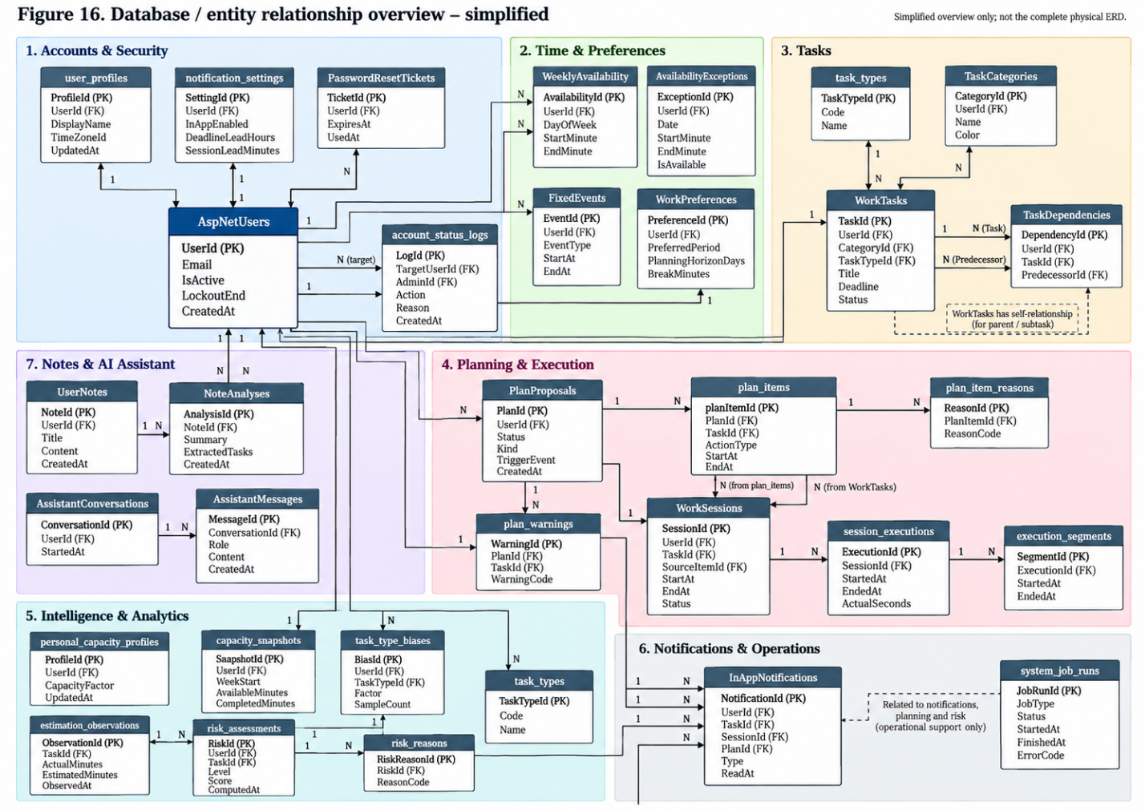
Figure 16. Database/entity relationship overview – simplified; NOT the complete physical ERD.
Figure 16 presents a simplified overview of the main database entities and their relationships in SPWPOS. The complete physical database schema, including all tables, columns, primary keys, and foreign keys, is available in the project's GitHub database documentation.
Canonical EF entity set: src/SPWPOS.Infrastructure/Persistence/ApplicationDbContext.cs, with mapping in Configurations/WorkspaceModel.cs and WorkloadHistoryModel.cs. The legacy ERD in docs/reference/UML-v2 remains a historical specification; new Notes/NORA/Recovery entities and email fields must be included in any final exported full ERD.
The following diagram adds selected relationships corroborated by EF Core configuration and docs/schema.sql (foreign keys including UserId, CategoryId, TaskId, PlanId, SessionId). It is a readable subset, not a substitute for a complete SQL Server ERD with every table, column and cardinality.

3.1.1. Detailed Physical Database Schema
The SPWPOS database schema is organized into seven functional groups to improve readability and maintainability. The diagrams in this appendix are based on the SQL Server, containing 45 tables, 356 columns, and 69 declared foreign keys.
Each diagram presents the tables, columns, and outgoing foreign-key relationships within its functional group. Referenced tables outside the group may be displayed with primary-key information for context. The complete database schema and cross-group relationships are available in the project's GitHub database documentation.

17.1. Accounts and Security
Figure 17.1. SPWPOS Accounts and Security Database Schema
The Accounts and Security database schema contains 15 tables responsible for user identity, authentication, authorization, and account security. Key tables include AspNetUsers, AspNetRoles, user_profiles, EmailOtps, RefreshTokens, PasswordResetTickets, and SecurityAuditLogs.
These tables support user registration, email verification, login sessions, password recovery, role-based authorization, and security auditing. Their relationships help maintain account ownership, authentication records, and security-related activities.
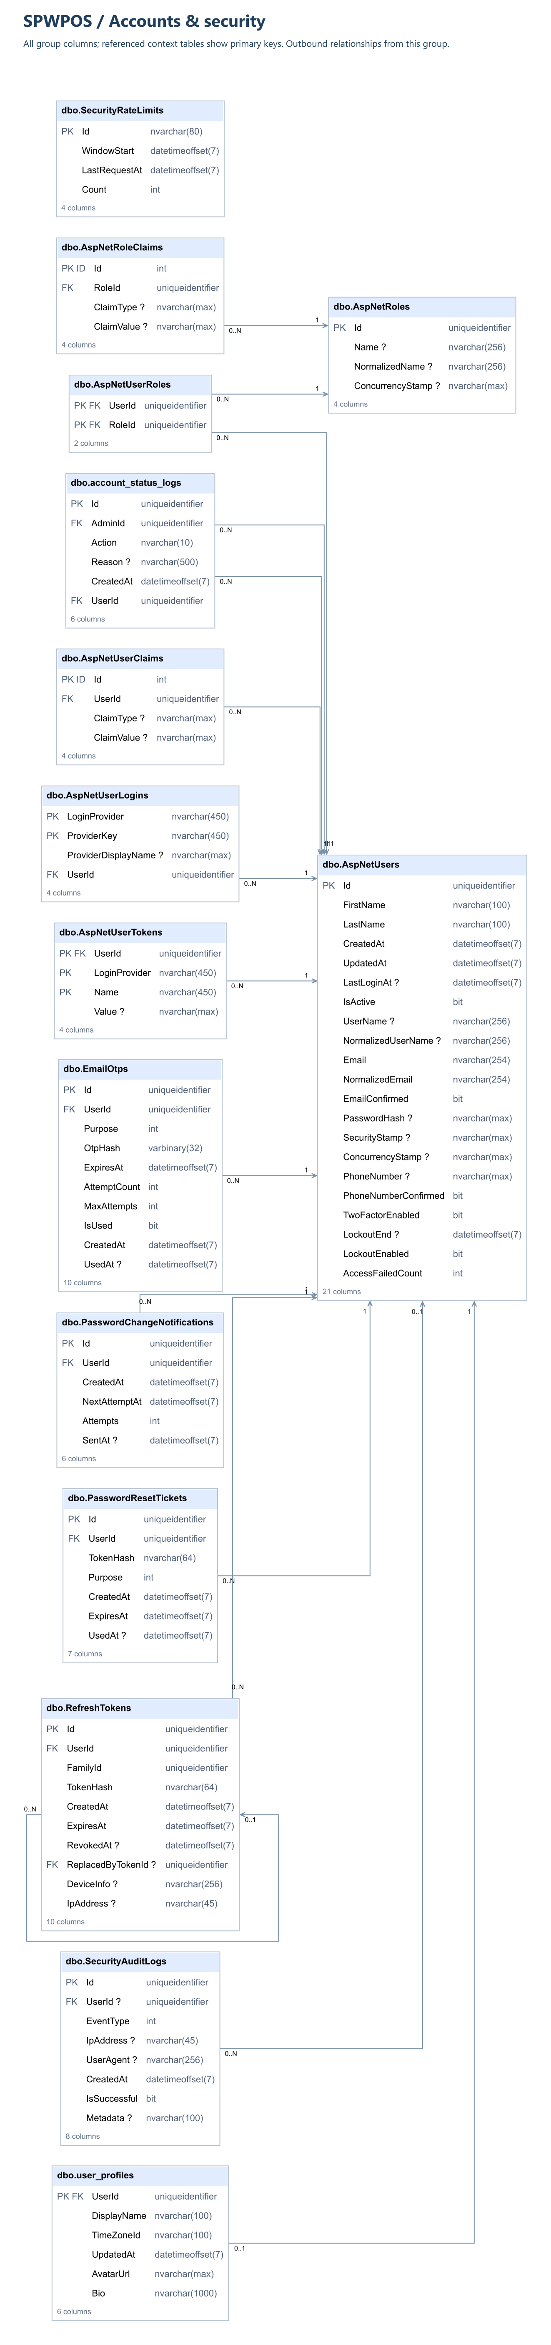

17.2. Time and Preferences
Figure 17.2. SPWPOS Time and Preferences Database Schema
The Time and Preferences database schema contains four main tables: WeeklyAvailability, AvailabilityExceptions, FixedEvents, and WorkPreferences.
These tables store users' recurring availability, exceptional time adjustments, fixed calendar events, and personal scheduling preferences. They provide scheduling constraints and preferences used by the planning functionality of SPWPOS.

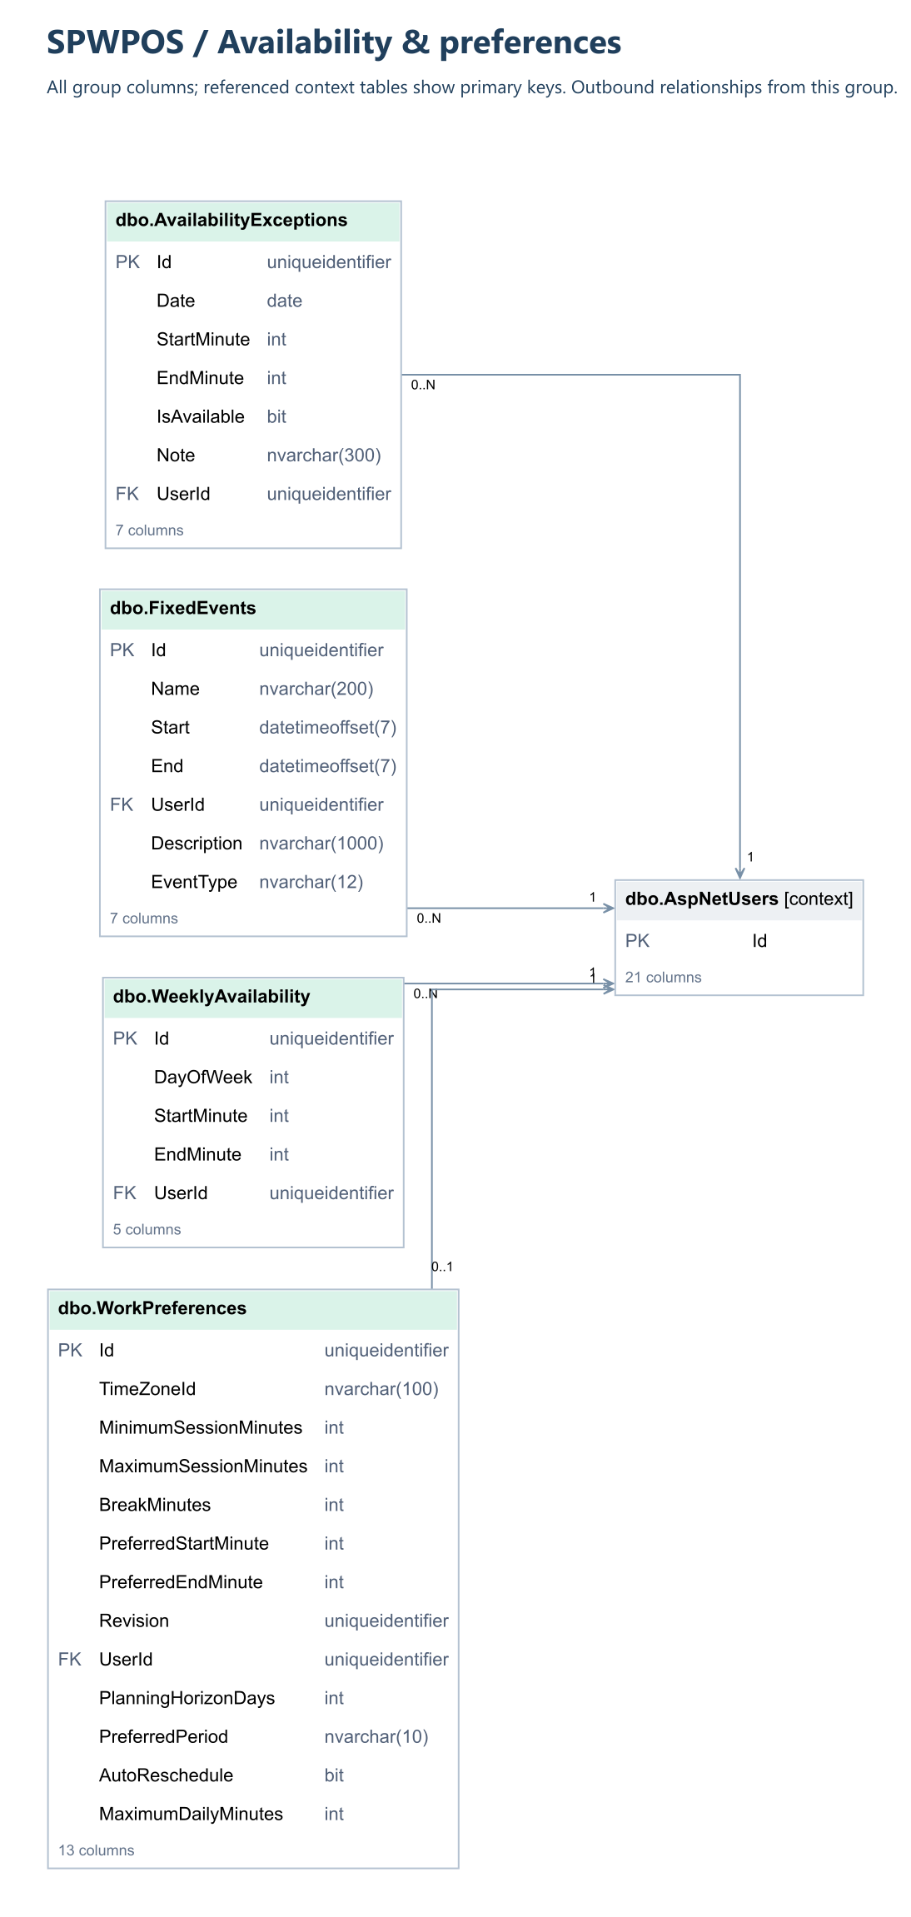
17.3. Tasks and Categories
Figure 17.3. SPWPOS Task Management Database Schema
The Task Management database schema contains four main tables: WorkTasks, TaskCategories, task_types, and TaskDependencies.
These tables manage task information, categories, task types, and dependencies between tasks. Their relationships support task organization, dependency management, and the preparation of tasks for workload planning and scheduling.
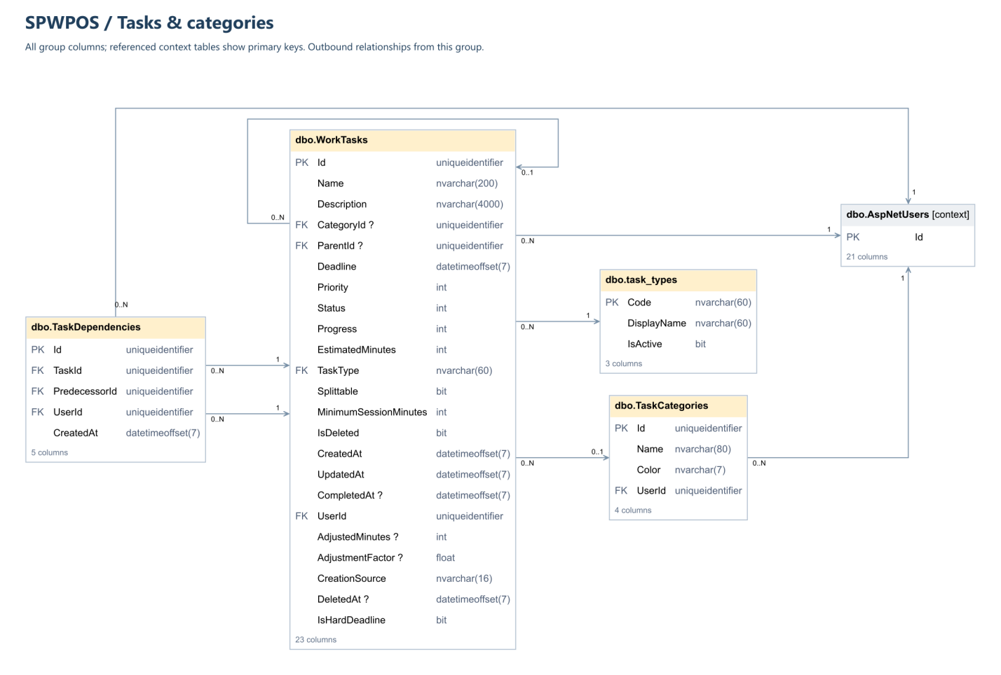

17.4. Planning and Execution
Figure 17.4. SPWPOS Planning and Execution Database Schema
The Planning and Execution database schema contains nine tables, including PlanProposals, plan_items, plan_item_reasons, plan_warnings, WorkSessions, session_executions, execution_segments, RecoveryCases, and RecoverySettings.
These tables support work-plan proposals, scheduling decisions, warnings, work-session execution, and recovery-related operations. Their relationships enable the system to associate planning results with tasks and work sessions while retaining execution records and supporting information.
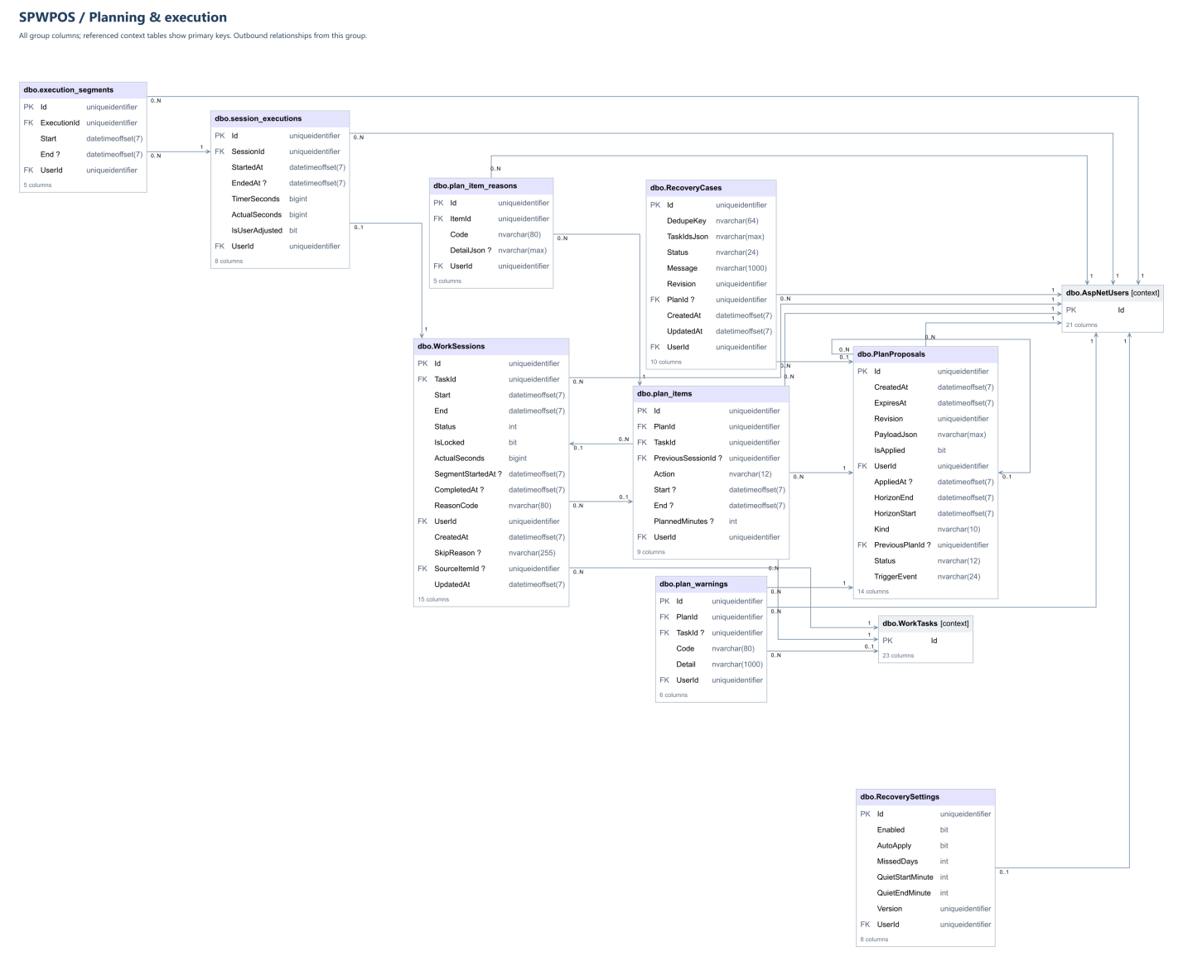

17.5. Intelligence and Workload Analytics
Figure 17.5. SPWPOS Intelligence and Workload Analytics Database Schema
The Intelligence and Workload Analytics database schema contains six tables: estimation_observations, personal_capacity_profiles, task_type_biases, capacity_snapshots, risk_assessments, and risk_reasons.
These tables store historical estimation observations, capacity-related information, task-type estimation adjustments, and workload-risk assessments. The recorded data supports personalized workload analysis, estimation adjustments, and explanations of identified risks.
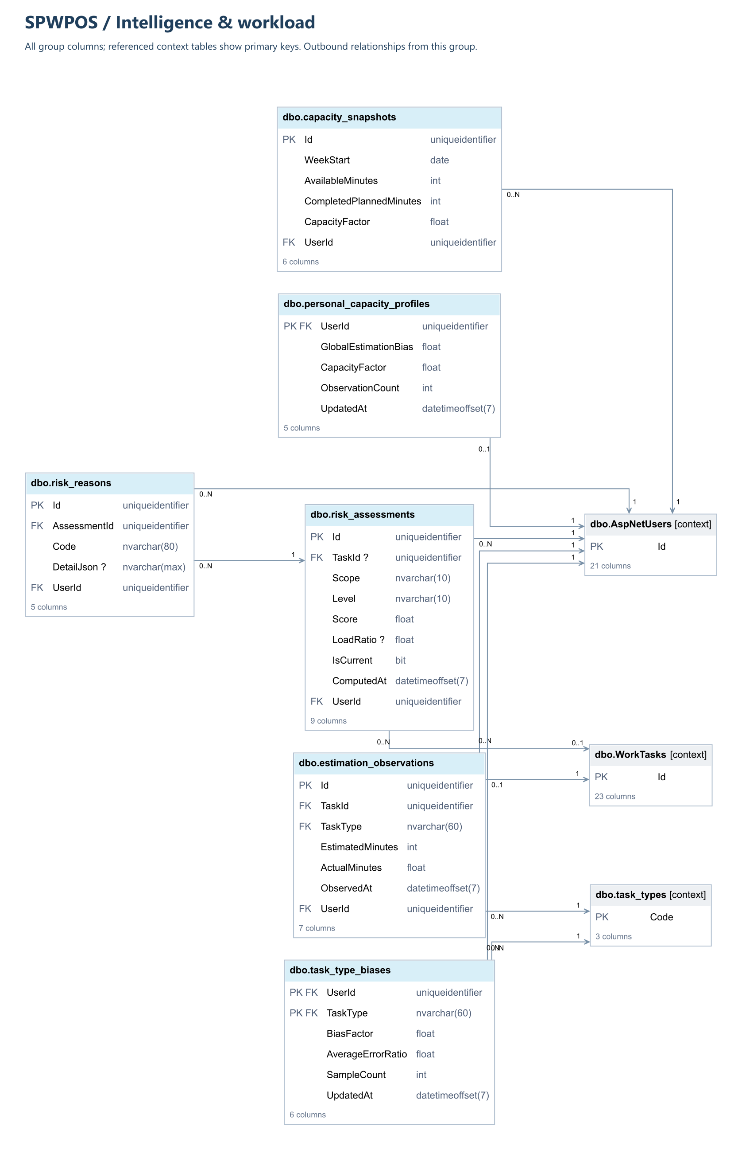

17.6. Notifications and Operations
Figure 17.6. SPWPOS Notifications and Operations Database Schema
The Notifications and Operations database schema contains three tables: InAppNotifications, notification_settings, and system_job_runs.
These tables maintain in-application notifications, user notification preferences, and operational job execution records. They support notification management and provide information about background processing activities and their execution status.
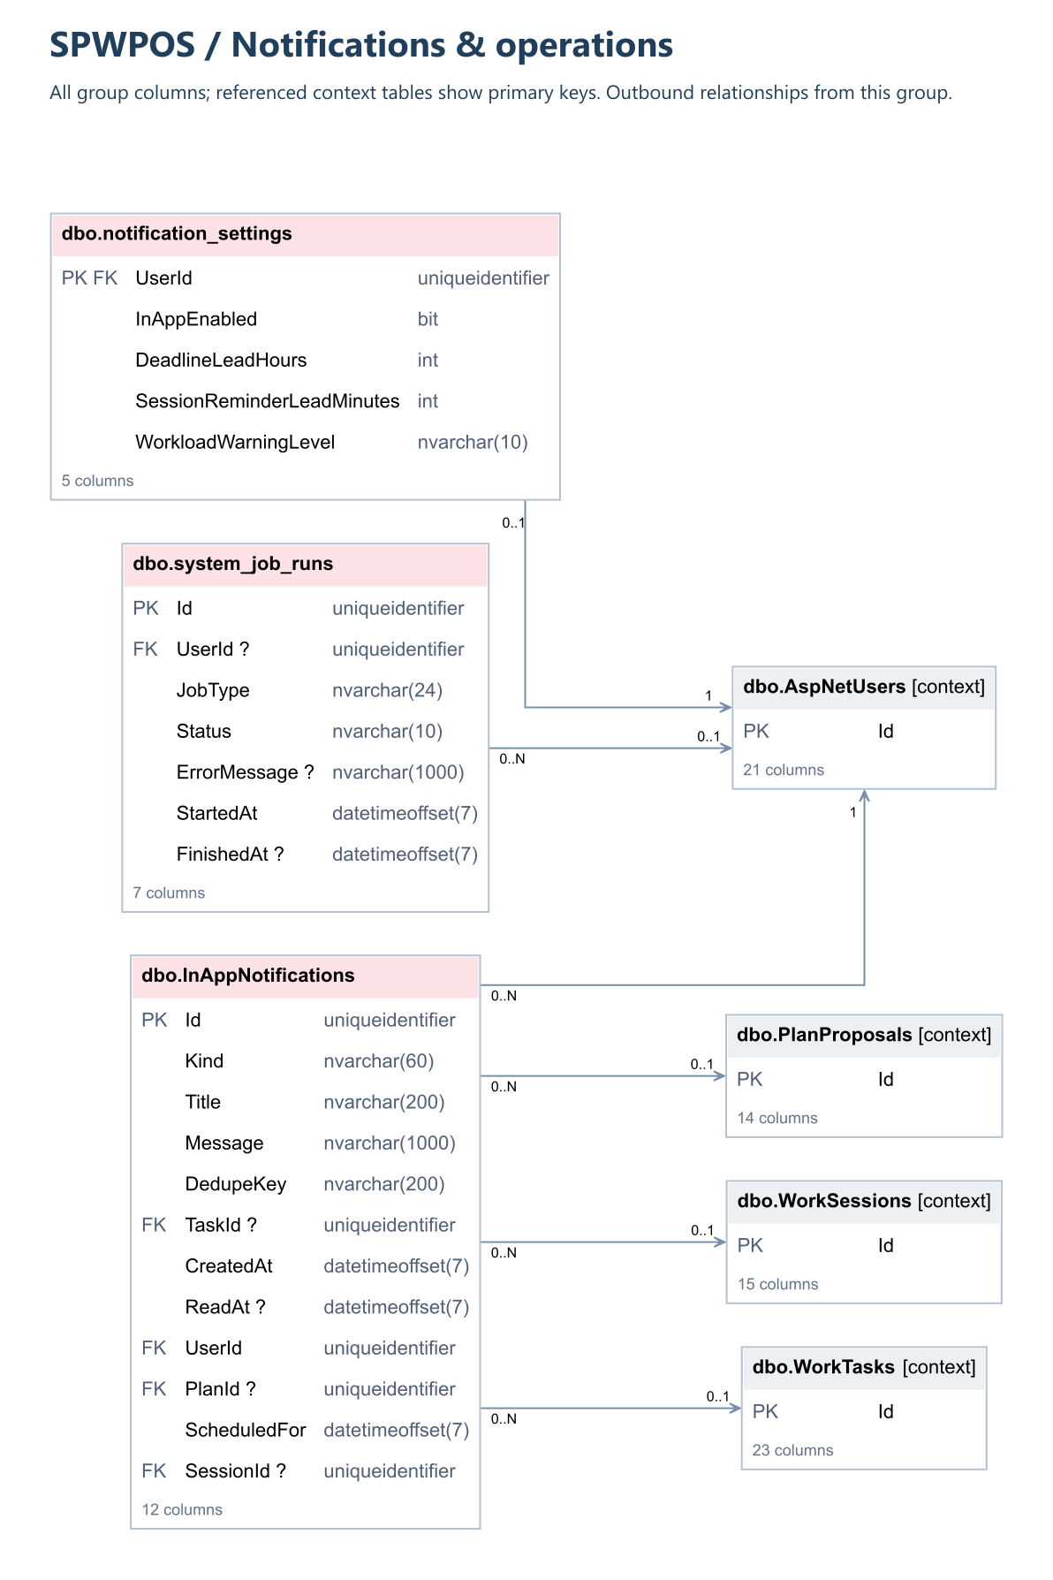

17.7. Notes and AI Assistant
Figure 17.7. SPWPOS Notes and AI Assistant Database Schema
The Notes and AI Assistant database schema contains four tables: PlanningNotes, AgentConversations, AgentTurns, and AiUsageRecords.
These tables support the storage of planning notes, AI assistant conversations, individual conversation turns, and AI usage records. They provide persistence for note-related features and interactions with NORA, the AI planning assistant integrated into SPWPOS.
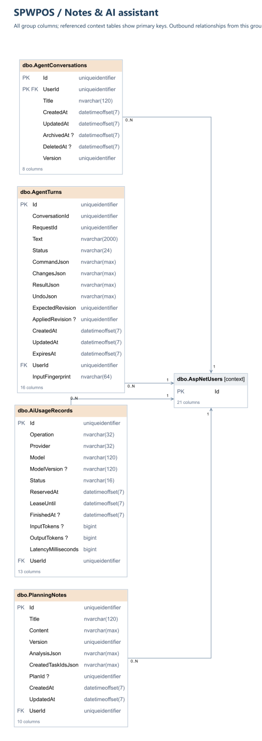
b. Table Descriptions
Entity / table group | Purpose | Module
AspNetUsers | ASP.NET Core Identity users and lock/login metadata | Identity
AspNetRoles | Identity roles | Identity
AspNetUserRoles | Account-role memberships | Identity
AspNetUserClaims / AspNetUserLogins / AspNetUserTokens / AspNetRoleClaims | Other Identity support tables | Identity
EmailOtps | Purpose-bound verification / reset / change OTP | Auth
RefreshTokens | Rotatable access-session refresh credentials | Auth
PasswordResetTickets | Single-use password recovery tickets | Auth
SecurityAuditLogs | Authentication and security auditing | Auth
SecurityRateLimits | Rate-limiting state | Auth
PasswordChangeNotifications | Password change message/outbox metadata | Auth
UserProfiles | Profile, display and timezone information | Account
AccountStatusLogs | Admin account-state transitions and rationale | Admin
TaskCategories | Per-account task categories | Tasks
WorkTasks | Tasks/subtasks, estimates, deadlines, progress, soft deletion | Tasks
TaskDependencies | Task predecessor edges | Tasks
WeeklyAvailability | Recurring available minutes by weekday | Time
AvailabilityExceptions | Specific-day busy/free intervals | Time
FixedEvents | Non-work calendar commitments | Time
WorkPreferences | Timezone, session durations, daily limit, revision | Time
PlanProposals | Draft/applied/discarded proposal lifecycle | Planning
PlanItems | Stored plan actions and session items | Planning
PlanItemReasons | Structured explanations for plan actions | Planning
PlanWarnings | Plan feasibility / deadline warnings | Planning
WorkSessions | Applied scheduled and executed sessions | Execution
SessionExecutions | Aggregate actual timer/execution state | Execution
ExecutionSegments | Start/resume-to-pause/complete timer segments | Execution
EstimationObservations | Actual-versus-estimated learning samples | Insights
PersonalCapacityProfiles | Learned user capacity estimate | Insights
TaskTypeBiases | Bias by task type | Insights
CapacitySnapshots | Time-based capacity history | Insights
RiskAssessments | Risk level/score snapshots | Insights
RiskReasons | Risk explanation details | Insights
InAppNotifications | In-app notification, email-delivery state and deduplication | Notifications
NotificationSettings | Per-user warning/reminder/email preferences | Notifications
TaskTypes | Task type lookup definitions | Lookup
SystemJobRuns | Worker/AI background job execution summaries | Operations
PlanningNotes | User notes and analysis results | Notes
AgentConversations | Conversation metadata and lifecycle | Agent
AgentTurns | Agent request/response/proposal history | Agent
AiUsageRecords | AI usage and reservations | Agent
RecoverySettings | Per-user recovery behavior | Recovery
RecoveryCases | Schedule recovery cases and proposals | Recovery
IMPORTANT: Entity/DbSet names are listed rather than asserting that every SQL Server physical table identifier is identical. The final full physical ERD must be generated from the current migration snapshot and compared with the deployed database.

3.2 Code Packages
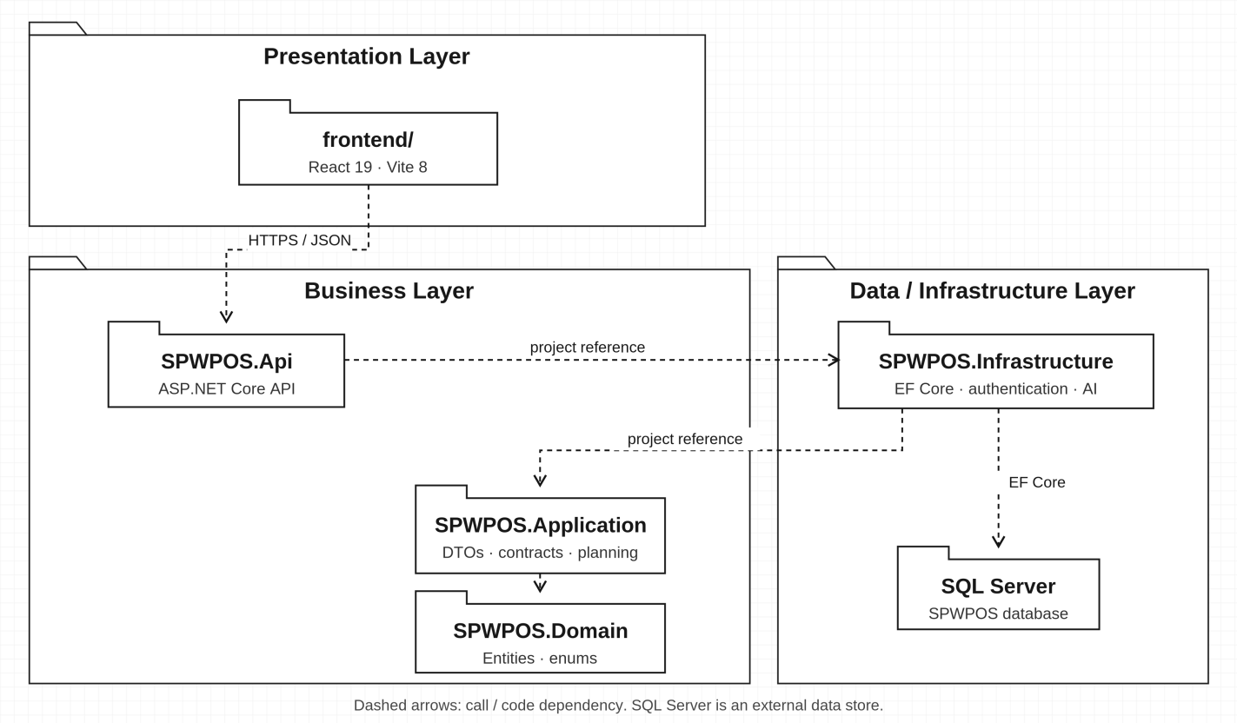
Figure 18. Code package/layer diagram – SPWPOS (source structure and dependencies).
Package | Responsibility
frontend/ | React 19, Vite 8, Tailwind 4; UI route modules, controller and API client.
src/SPWPOS.Api | HTTP controllers, auth/role checks, middleware, DI, static frontend hosting.
src/SPWPOS.Application | Contracts, DTOs and planning/business orchestration interfaces.
src/SPWPOS.Domain | Domain entities and core task/session types.
src/SPWPOS.Infrastructure | EF persistence, authentication, worker, planner, agent adapters and analytics.
tests/SPWPOS.UnitTests | Business/utility and application-level unit tests.
tests/SPWPOS.IntegrationTests | HTTP, migration, concurrency and multi-module integration tests.
docs/ and scripts/ | Project guides, UML artifacts, schema and startup/verification automation.
Technology stack confirmed in README.md: .NET 8 LTS, ASP.NET Core Web API, Entity Framework Core, SQL Server, React 19, Vite 8, Tailwind CSS 4; optional Firebase and AI configuration. Do not replace the core heuristic scheduler with a claim of guaranteed global optimization.

II. Requirement Specifications
Each use case follows the template fields: ID and name, author/date, actors, trigger, description, preconditions, postconditions, normal flow, alternative flows, exceptions, priority, frequency, business rules, other information, and assumptions. The draft’s previously reused generic account workflow has been replaced by action-specific steps. Frequencies are non-measured estimates, not usage telemetry.

1. Account & Profile
Use cases UC01, UC02, UC03, UC04, UC05, UC06, UC07, UC08, UC73, UC74, UC75, UC76. Cases over UC72 are documented independently to preserve code traceability but remain provisional in scope.

1.1 UC01 — Register Account

a. Functional Description
UC ID and Name: | UC01 — Register Account
Created By: | SPWPOS Team | Date Created: | 18/10/2026
Primary Actor: | Guest / account owner | Secondary Actors: | External service (if applicable)
Trigger: | Enter email, name and password; submit registration.
Description: | Creates an account and starts the email-verification process.
Preconditions: | PRE-1. No existing signed-in session required; email must be eligible for registration.
Postconditions: | POST-1. Create pending account and request verification OTP; no authenticated session yet. POST-2. Unrelated accounts and protected history are unchanged.
Normal Flow: | 1. Enter email, name and password; submit registration.  2. Submit public account request via POST /api/auth/register.  3. Validate identity data/password policy and account constraints.  4. Create pending account and request verification OTP; no authenticated session yet.
Alternative Flows: | A1. If user cancels before save/apply, keep existing persisted state.
Exceptions: | E1. Invalid/expired OTP, password, ticket or account state: reject without disclosing secrets. E2. Rate-limit or email service problem: return safe error/neutral confirmation according to endpoint contract.
Priority: | High (specification estimate)
Frequency of Use: | Occasional / event-driven (not production measurements)
Business Rules: | BR-01, BR-02, BR-03
Other Information: | Source-present endpoint: POST /api/auth/register. Evidence: src/SPWPOS.Api/Controllers/AuthController.cs; BrowserSessionController.cs; FirebaseSessionController.cs. Case status: S1 — 72-UC baseline.
Assumptions: | Exact visible labels may change; real provider delivery and end-to-end behavior require environment-specific QA.

1.2 UC02 — Login

a. Functional Description
UC ID and Name: | UC02 — Login
Created By: | SPWPOS Team | Date Created: | 18/10/2026
Primary Actor: | Guest / account owner | Secondary Actors: | External service (if applicable)
Trigger: | Enter username or verified email with password.
Description: | Sign in using a username or verified email address and password.
Preconditions: | PRE-1. Public sign-in view; account must exist and be eligible for authentication.
Postconditions: | POST-1. Issue the supported login/session credentials and load the workspace. POST-2. Unrelated accounts and protected history are unchanged.
Normal Flow: | 1. Enter username or verified email with password.  2. Submit public account request via POST /api/browser-session/login; POST /api/auth/login.  3. Validate password, confirmed email, account active state and rate limits.  4. Issue the supported login/session credentials and load the workspace.
Alternative Flows: | A1. If user cancels before save/apply, keep existing persisted state.
Exceptions: | E1. Invalid/expired OTP, password, ticket or account state: reject without disclosing secrets. E2. Rate-limit or email service problem: return safe error/neutral confirmation according to endpoint contract.
Priority: | High (specification estimate)
Frequency of Use: | Occasional / event-driven (not production measurements)
Business Rules: | BR-01, BR-02, BR-03
Other Information: | Source-present endpoint: POST /api/browser-session/login; POST /api/auth/login. Evidence: src/SPWPOS.Api/Controllers/AuthController.cs; BrowserSessionController.cs; FirebaseSessionController.cs. Case status: S1 — 72-UC baseline.
Assumptions: | Exact visible labels may change; real provider delivery and end-to-end behavior require environment-specific QA.

1.3 UC03 — Logout

a. Functional Description
UC ID and Name: | UC03 — Logout
Created By: | SPWPOS Team | Date Created: | 18/10/2026
Primary Actor: | User | Secondary Actors: | External service (if applicable)
Trigger: | Select sign-out for the current session.
Description: | End the current sign-in session.
Preconditions: | PRE-1. The current authenticated session can be identified.
Postconditions: | POST-1. Revoke current session and return to the sign-in view. POST-2. Unrelated accounts and protected history are unchanged.
Normal Flow: | 1. Select sign-out for the current session.  2. Submit authorized operation via POST /api/browser-session/logout; POST /api/auth/logout.  3. Identify current authenticated session and any protected cookie/token.  4. Revoke current session and return to the sign-in view.
Alternative Flows: | A1. If user cancels before save/apply, keep existing persisted state.
Exceptions: | E1. Invalid input or business-rule conflict: safe validation error; do not falsely report success. E2. Unauthorized, stale version, missing object or provider outage: reject or return explicit failure.
Priority: | High (specification estimate)
Frequency of Use: | Occasional / event-driven (not production measurements)
Business Rules: | BR-01, BR-02, BR-03
Other Information: | Source-present endpoint: POST /api/browser-session/logout; POST /api/auth/logout. Evidence: src/SPWPOS.Api/Controllers/AuthController.cs; BrowserSessionController.cs; FirebaseSessionController.cs. Case status: S1 — 72-UC baseline.
Assumptions: | Exact visible labels may change; real provider delivery and end-to-end behavior require environment-specific QA.

1.4 UC04 — Request Password Reset

a. Functional Description
UC ID and Name: | UC04 — Request Password Reset
Created By: | SPWPOS Team | Date Created: | 18/10/2026
Primary Actor: | Guest / account owner | Secondary Actors: | External service (if applicable)
Trigger: | Enter the account email for password recovery.
Description: | Request an OTP to recover a password.
Preconditions: | PRE-1. Public endpoint; input and rate limits apply; applicable OTP/ticket must be available.
Postconditions: | POST-1. Request a purpose-bound recovery OTP and display neutral confirmation. POST-2. Unrelated accounts and protected history are unchanged.
Normal Flow: | 1. Enter the account email for password recovery.  2. Submit public account request via POST /api/auth/forgot-password.  3. Apply rate limits while avoiding disclosure of account existence.  4. Request a purpose-bound recovery OTP and display neutral confirmation.
Alternative Flows: | A1. If user cancels before save/apply, keep existing persisted state.
Exceptions: | E1. Invalid/expired OTP, password, ticket or account state: reject without disclosing secrets. E2. Rate-limit or email service problem: return safe error/neutral confirmation according to endpoint contract.
Priority: | High (specification estimate)
Frequency of Use: | Occasional / event-driven (not production measurements)
Business Rules: | BR-01, BR-02, BR-03
Other Information: | Source-present endpoint: POST /api/auth/forgot-password. Evidence: src/SPWPOS.Api/Controllers/AuthController.cs; BrowserSessionController.cs; FirebaseSessionController.cs. Case status: S1 — 72-UC baseline.
Assumptions: | Exact visible labels may change; real provider delivery and end-to-end behavior require environment-specific QA.

1.5 UC05 — Reset Password

a. Functional Description
UC ID and Name: | UC05 — Reset Password
Created By: | SPWPOS Team | Date Created: | 18/10/2026
Primary Actor: | Guest / account owner | Secondary Actors: | External service (if applicable)
Trigger: | Submit recovery OTP and subsequently a new password with reset ticket.
Description: | Verify the OTP and set a new password using a single-use reset ticket.
Preconditions: | PRE-1. Public endpoint; input and rate limits apply; applicable OTP/ticket must be available.
Postconditions: | POST-1. Update password, consume ticket and revoke earlier sessions. POST-2. Unrelated accounts and protected history are unchanged.
Normal Flow: | 1. Submit recovery OTP and subsequently a new password with reset ticket.  2. Submit public account request via POST /api/auth/verify-forgot-password-otp; POST /api/auth/reset-password.  3. Check OTP/ticket expiration, one-time use and password policy.  4. Update password, consume ticket and revoke earlier sessions.
Alternative Flows: | A1. If user cancels before save/apply, keep existing persisted state.
Exceptions: | E1. Invalid/expired OTP, password, ticket or account state: reject without disclosing secrets. E2. Rate-limit or email service problem: return safe error/neutral confirmation according to endpoint contract.
Priority: | High (specification estimate)
Frequency of Use: | Occasional / event-driven (not production measurements)
Business Rules: | BR-01, BR-02, BR-03
Other Information: | Source-present endpoint: POST /api/auth/verify-forgot-password-otp; POST /api/auth/reset-password. Evidence: src/SPWPOS.Api/Controllers/AuthController.cs; BrowserSessionController.cs; FirebaseSessionController.cs. Case status: S1 — 72-UC baseline.
Assumptions: | Exact visible labels may change; real provider delivery and end-to-end behavior require environment-specific QA.

1.6 UC06 — Change Password

a. Functional Description
UC ID and Name: | UC06 — Change Password
Created By: | SPWPOS Team | Date Created: | 18/10/2026
Primary Actor: | User | Secondary Actors: | External service (if applicable)
Trigger: | Request password-change OTP and provide current password, OTP and new password.
Description: | Change the password after verification in accordance with the security policy.
Preconditions: | PRE-1. Authenticated account with valid session; referenced data must belong to that account.
Postconditions: | POST-1. Change password and revoke existing sessions. POST-2. Unrelated accounts and protected history are unchanged.
Normal Flow: | 1. Request password-change OTP and provide current password, OTP and new password.  2. Submit authorized operation via POST /api/auth/change-password/request-otp; POST /api/auth/change-password.  3. Verify current password, OTP and password policy.  4. Change password and revoke existing sessions.
Alternative Flows: | A1. If user cancels before save/apply, keep existing persisted state.
Exceptions: | E1. Invalid/expired OTP, password, ticket or account state: reject without disclosing secrets. E2. Rate-limit or email service problem: return safe error/neutral confirmation according to endpoint contract.
Priority: | High (specification estimate)
Frequency of Use: | Occasional / event-driven (not production measurements)
Business Rules: | BR-01, BR-02, BR-03
Other Information: | Source-present endpoint: POST /api/auth/change-password/request-otp; POST /api/auth/change-password. Evidence: src/SPWPOS.Api/Controllers/AuthController.cs; BrowserSessionController.cs; FirebaseSessionController.cs. Case status: S1 — 72-UC baseline.
Assumptions: | Exact visible labels may change; real provider delivery and end-to-end behavior require environment-specific QA.

1.7 UC07 — View Profile

a. Functional Description
UC ID and Name: | UC07 — View Profile
Created By: | SPWPOS Team | Date Created: | 18/10/2026
Primary Actor: | User | Secondary Actors: | External service (if applicable)
Trigger: | Open Account / Profile.
Description: | View the current account profile.
Preconditions: | PRE-1. Authenticated account with valid session; referenced data must belong to that account.
Postconditions: | POST-1. Display permitted profile fields, excluding secret material. POST-2. Unrelated accounts and protected history are unchanged.
Normal Flow: | 1. Open Account / Profile.  2. Submit authorized operation via GET /api/auth/me.  3. Validate the session and resolve authenticated account.  4. Display permitted profile fields, excluding secret material.
Alternative Flows: | A1. If user cancels before save/apply, keep existing persisted state.
Exceptions: | E1. Invalid input or business-rule conflict: safe validation error; do not falsely report success. E2. Unauthorized, stale version, missing object or provider outage: reject or return explicit failure.
Priority: | High (specification estimate)
Frequency of Use: | Occasional / event-driven (not production measurements)
Business Rules: | BR-01, BR-02, BR-03
Other Information: | Source-present endpoint: GET /api/auth/me. Evidence: src/SPWPOS.Api/Controllers/AuthController.cs; BrowserSessionController.cs; FirebaseSessionController.cs. Case status: S1 — 72-UC baseline.
Assumptions: | Exact visible labels may change; real provider delivery and end-to-end behavior require environment-specific QA.

1.8 UC08 — Update Profile

a. Functional Description
UC ID and Name: | UC08 — Update Profile
Created By: | SPWPOS Team | Date Created: | 18/10/2026
Primary Actor: | User | Secondary Actors: | External service (if applicable)
Trigger: | Edit own name, display name, bio or avatar in settings.
Description: | Update personal profile information.
Preconditions: | PRE-1. Authenticated account with valid session; referenced data must belong to that account.
Postconditions: | POST-1. Persist changes and refresh the profile view. POST-2. Unrelated accounts and protected history are unchanged.
Normal Flow: | 1. Edit own name, display name, bio or avatar in settings.  2. Submit authorized operation via PUT /api/workspace/profile.  3. Validate length/format and account ownership.  4. Persist changes and refresh the profile view.
Alternative Flows: | A1. If user cancels before save/apply, keep existing persisted state.
Exceptions: | E1. Invalid input or business-rule conflict: safe validation error; do not falsely report success. E2. Unauthorized, stale version, missing object or provider outage: reject or return explicit failure.
Priority: | High (specification estimate)
Frequency of Use: | Occasional / event-driven (not production measurements)
Business Rules: | BR-01, BR-02, BR-03
Other Information: | Source-present endpoint: PUT /api/workspace/profile. Evidence: src/SPWPOS.Api/Controllers/AuthController.cs; BrowserSessionController.cs; FirebaseSessionController.cs. Case status: S1 — 72-UC baseline.
Assumptions: | Exact visible labels may change; real provider delivery and end-to-end behavior require environment-specific QA.

1.9 UC73 — Resend Email Verification OTP [PROVISIONAL]

a. Functional Description
UC ID and Name: | UC73 — Resend Email Verification OTP [PROVISIONAL CLASSIFICATION]
Created By: | SPWPOS Team | Date Created: | 18/10/2026
Primary Actor: | Guest / account owner | Secondary Actors: | External service (if applicable)
Trigger: | User requests replacement email-verification code.
Description: | Request a replacement email-verification OTP when the previous code has expired or been lost.
Preconditions: | PRE-1. Public endpoint; input and rate limits apply; applicable OTP/ticket must be available. Identity email verification is required.
Postconditions: | POST-1. Send or queue a fresh purpose-bound verification OTP. POST-2. Unrelated accounts and protected history are unchanged.
Normal Flow: | 1. User requests replacement email-verification code.  2. Submit public account request via POST /api/auth/resend-verification-otp.  3. Apply OTP rate limits and invalidate previous code.  4. Send or queue a fresh purpose-bound verification OTP.
Alternative Flows: | A1. If user cancels before save/apply, keep existing persisted state.
Exceptions: | E1. Invalid/expired OTP, password, ticket or account state: reject without disclosing secrets. E2. Rate-limit or email service problem: return safe error/neutral confirmation according to endpoint contract.
Priority: | Medium (specification estimate)
Frequency of Use: | Occasional / event-driven (not production measurements)
Business Rules: | BR-01, BR-02, BR-03
Other Information: | Source-present endpoint: POST /api/auth/resend-verification-otp. Evidence: src/SPWPOS.Api/Controllers/AuthController.cs; BrowserSessionController.cs; FirebaseSessionController.cs. Case status: P — candidate, requires scope approval.
Assumptions: | Exact visible labels may change; real provider delivery and end-to-end behavior require environment-specific QA.

1.10 UC74 — Sign Out All Sessions [PROVISIONAL]

a. Functional Description
UC ID and Name: | UC74 — Sign Out All Sessions [PROVISIONAL CLASSIFICATION]
Created By: | SPWPOS Team | Date Created: | 18/10/2026
Primary Actor: | User | Secondary Actors: | External service (if applicable)
Trigger: | User selects Sign out all devices.
Description: | Revoke all account sessions across devices.
Preconditions: | PRE-1. Authenticated account with valid session; referenced data must belong to that account.
Postconditions: | POST-1. Revoke all active sessions. POST-2. Unrelated accounts and protected history are unchanged.
Normal Flow: | 1. User selects Sign out all devices.  2. Submit authorized operation via POST /api/auth/logout-all.  3. Check authenticated user and session ownership.  4. Revoke all active sessions.
Alternative Flows: | A1. If user cancels before save/apply, keep existing persisted state.
Exceptions: | E1. Invalid input or business-rule conflict: safe validation error; do not falsely report success. E2. Unauthorized, stale version, missing object or provider outage: reject or return explicit failure.
Priority: | Medium (specification estimate)
Frequency of Use: | Occasional / event-driven (not production measurements)
Business Rules: | BR-01, BR-02, BR-03
Other Information: | Source-present endpoint: POST /api/auth/logout-all. Evidence: src/SPWPOS.Api/Controllers/AuthController.cs; BrowserSessionController.cs; FirebaseSessionController.cs. Case status: P — candidate, requires scope approval.
Assumptions: | Exact visible labels may change; real provider delivery and end-to-end behavior require environment-specific QA.

1.11 UC75 — View Login Methods [PROVISIONAL]

a. Functional Description
UC ID and Name: | UC75 — View Login Methods [PROVISIONAL CLASSIFICATION]
Created By: | SPWPOS Team | Date Created: | 18/10/2026
Primary Actor: | User | Secondary Actors: | External service (if applicable)
Trigger: | User opens linked login methods.
Description: | View sign-in methods linked to the account.
Preconditions: | PRE-1. Authenticated account with valid session; referenced data must belong to that account.
Postconditions: | POST-1. Return password/Google-method availability. POST-2. Unrelated accounts and protected history are unchanged.
Normal Flow: | 1. User opens linked login methods.  2. Submit authorized operation via GET /api/auth/login-methods.  3. Load own authentication methods only.  4. Return password/Google-method availability.
Alternative Flows: | A1. If user cancels before save/apply, keep existing persisted state.
Exceptions: | E1. Invalid input or business-rule conflict: safe validation error; do not falsely report success. E2. Unauthorized, stale version, missing object or provider outage: reject or return explicit failure.
Priority: | Medium (specification estimate)
Frequency of Use: | Occasional / event-driven (not production measurements)
Business Rules: | BR-01, BR-02, BR-03
Other Information: | Source-present endpoint: GET /api/auth/login-methods. Evidence: src/SPWPOS.Api/Controllers/AuthController.cs; BrowserSessionController.cs; FirebaseSessionController.cs. Case status: P — candidate, requires scope approval.
Assumptions: | Exact visible labels may change; real provider delivery and end-to-end behavior require environment-specific QA.

1.12 UC76 — Set Initial Password [PROVISIONAL]

a. Functional Description
UC ID and Name: | UC76 — Set Initial Password [PROVISIONAL CLASSIFICATION]
Created By: | SPWPOS Team | Date Created: | 18/10/2026
Primary Actor: | User | Secondary Actors: | External service (if applicable)
Trigger: | User with external sign-in requests first password.
Description: | Set an initial password for an account signed in through another method, after verification.
Preconditions: | PRE-1. Authenticated account with valid session; referenced data must belong to that account. Identity email verification is required.
Postconditions: | POST-1. Set password and revoke prior sessions. POST-2. Unrelated accounts and protected history are unchanged.
Normal Flow: | 1. User with external sign-in requests first password.  2. Submit authorized operation via POST /api/auth/set-password.  3. Verify email OTP and enforce password policy.  4. Set password and revoke prior sessions.
Alternative Flows: | A1. If user cancels before save/apply, keep existing persisted state.
Exceptions: | E1. Invalid/expired OTP, password, ticket or account state: reject without disclosing secrets. E2. Rate-limit or email service problem: return safe error/neutral confirmation according to endpoint contract.
Priority: | Medium (specification estimate)
Frequency of Use: | Occasional / event-driven (not production measurements)
Business Rules: | BR-01, BR-02, BR-03
Other Information: | Source-present endpoint: POST /api/auth/set-password. Evidence: src/SPWPOS.Api/Controllers/AuthController.cs; BrowserSessionController.cs; FirebaseSessionController.cs. Case status: P — candidate, requires scope approval.
Assumptions: | Exact visible labels may change; real provider delivery and end-to-end behavior require environment-specific QA.

b. Business Rules
ID | Business Rule | Business Rule Description
BR-01 | Identity / OTP | Email verification and recovery OTP are purpose-bound, short-lived and one-time; credentials must never be exposed.
BR-02 | Session security | Refresh token rotation/revocation; password reset/change invalidates existing sessions; access authorization is enforced on API.
BR-03 | Ownership / roles | Workspace data is scoped to the current user; administrative APIs require the Admin role.

2. Task Management
Use cases UC09, UC10, UC11, UC12, UC13, UC14, UC15, UC16, UC17, UC18, UC19, UC20, UC21, UC22, UC23, UC24, UC25, UC26. Cases over UC72 are documented independently to preserve code traceability but remain provisional in scope.

2.1 UC09 — Create Task

a. Functional Description
UC ID and Name: | UC09 — Create Task
Created By: | SPWPOS Team | Date Created: | 18/10/2026
Primary Actor: | User | Secondary Actors: | External service (if applicable)
Trigger: | Enter task title, deadline, estimate, priority and optional category/parent.
Description: | Create a task with a name, deadline, estimate, priority, and optional category/dependency details. When saved availability exists, the user can leave the “auto-schedule after creation” option enabled to request placement into available time.
Preconditions: | PRE-1. Authenticated account with valid session; referenced data must belong to that account.
Postconditions: | POST-1. Create task; optional scheduling is a separate safeguarded proposal/apply flow. POST-2. Unrelated accounts and protected history are unchanged.
Normal Flow: | 1. Enter task title, deadline, estimate, priority and optional category/parent.  2. Submit authorized operation via POST /api/tasks.  3. Validate fields, parent/deadline constraints and task ownership.  4. Create task; optional scheduling is a separate safeguarded proposal/apply flow.
Alternative Flows: | A1. User can create the task without applying a plan; scheduling warnings require proposal review.
Exceptions: | E1. Invalid input or business-rule conflict: safe validation error; do not falsely report success. E2. Unauthorized, stale version, missing object or provider outage: reject or return explicit failure.
Priority: | High (specification estimate)
Frequency of Use: | Frequent (daily/weekly expected) (not production measurements)
Business Rules: | BR-03, BR-04, BR-13
Other Information: | Source-present endpoint: POST /api/tasks. Evidence: src/SPWPOS.Api/Controllers/WorkspaceControllers.cs (TasksController/CategoriesController); src/SPWPOS.Infrastructure/Workspace/TaskService.cs. Case status: S1 — 72-UC baseline.
Assumptions: | Exact visible labels may change; real provider delivery and end-to-end behavior require environment-specific QA.

2.2 UC10 — View Task List

a. Functional Description
UC ID and Name: | UC10 — View Task List
Created By: | SPWPOS Team | Date Created: | 18/10/2026
Primary Actor: | User | Secondary Actors: | External service (if applicable)
Trigger: | Open task list and optionally choose a page.
Description: | View tasks in a paginated list of 12 items per page, with search and filters. Long task names are truncated to two lines in the list; the full name is available in task details.
Preconditions: | PRE-1. Authenticated account with valid session; referenced data must belong to that account.
Postconditions: | POST-1. Show paginated list; client displays 12 items/page and resets pagination when filters change. POST-2. Unrelated accounts and protected history are unchanged.
Normal Flow: | 1. Open task list and optionally choose a page.  2. Submit authorized operation via GET /api/tasks; GET /api/workspace.  3. Read only non-deleted tasks of current user.  4. Show paginated list; client displays 12 items/page and resets pagination when filters change.
Alternative Flows: | A1. If user cancels before save/apply, keep existing persisted state.
Exceptions: | E1. Invalid input or business-rule conflict: safe validation error; do not falsely report success. E2. Unauthorized, stale version, missing object or provider outage: reject or return explicit failure.
Priority: | High (specification estimate)
Frequency of Use: | Frequent (daily/weekly expected) (not production measurements)
Business Rules: | BR-03, BR-04, BR-13
Other Information: | Source-present endpoint: GET /api/tasks; GET /api/workspace. Evidence: src/SPWPOS.Api/Controllers/WorkspaceControllers.cs (TasksController/CategoriesController); src/SPWPOS.Infrastructure/Workspace/TaskService.cs. Case status: S1 — 72-UC baseline.
Assumptions: | Exact visible labels may change; real provider delivery and end-to-end behavior require environment-specific QA.

2.3 UC11 — View Task Details

a. Functional Description
UC ID and Name: | UC11 — View Task Details
Created By: | SPWPOS Team | Date Created: | 18/10/2026
Primary Actor: | User | Secondary Actors: | External service (if applicable)
Trigger: | Select a task from list/calendar.
Description: | View task details.
Preconditions: | PRE-1. Authenticated account with valid session; referenced data must belong to that account.
Postconditions: | POST-1. Show details, status, subtasks/dependencies and available actions. POST-2. Unrelated accounts and protected history are unchanged.
Normal Flow: | 1. Select a task from list/calendar.  2. Submit authorized operation via GET /api/tasks/{id}.  3. Resolve task ID within current user and exclude soft-deleted records.  4. Show details, status, subtasks/dependencies and available actions.
Alternative Flows: | A1. If user cancels before save/apply, keep existing persisted state.
Exceptions: | E1. Invalid input or business-rule conflict: safe validation error; do not falsely report success. E2. Unauthorized, stale version, missing object or provider outage: reject or return explicit failure.
Priority: | High (specification estimate)
Frequency of Use: | Frequent (daily/weekly expected) (not production measurements)
Business Rules: | BR-03, BR-04, BR-13
Other Information: | Source-present endpoint: GET /api/tasks/{id}. Evidence: src/SPWPOS.Api/Controllers/WorkspaceControllers.cs (TasksController/CategoriesController); src/SPWPOS.Infrastructure/Workspace/TaskService.cs. Case status: S1 — 72-UC baseline.
Assumptions: | Exact visible labels may change; real provider delivery and end-to-end behavior require environment-specific QA.

2.4 UC12 — Update Task

a. Functional Description
UC ID and Name: | UC12 — Update Task
Created By: | SPWPOS Team | Date Created: | 18/10/2026
Primary Actor: | User | Secondary Actors: | External service (if applicable)
Trigger: | Modify task data and submit changes.
Description: | Edit an existing task.
Preconditions: | PRE-1. Authenticated account with valid session; referenced data must belong to that account.
Postconditions: | POST-1. Update task and refresh planning/risk context as required. POST-2. Unrelated accounts and protected history are unchanged.
Normal Flow: | 1. Modify task data and submit changes.  2. Submit authorized operation via PUT /api/tasks/{id}.  3. Enforce parent/subtask/dependency/deadline rules and ownership.  4. Update task and refresh planning/risk context as required.
Alternative Flows: | A1. If user cancels before save/apply, keep existing persisted state.
Exceptions: | E1. Invalid input or business-rule conflict: safe validation error; do not falsely report success. E2. Unauthorized, stale version, missing object or provider outage: reject or return explicit failure.
Priority: | High (specification estimate)
Frequency of Use: | Frequent (daily/weekly expected) (not production measurements)
Business Rules: | BR-03, BR-04, BR-13
Other Information: | Source-present endpoint: PUT /api/tasks/{id}. Evidence: src/SPWPOS.Api/Controllers/WorkspaceControllers.cs (TasksController/CategoriesController); src/SPWPOS.Infrastructure/Workspace/TaskService.cs. Case status: S1 — 72-UC baseline.
Assumptions: | Exact visible labels may change; real provider delivery and end-to-end behavior require environment-specific QA.

2.5 UC13 — Delete Task

a. Functional Description
UC ID and Name: | UC13 — Delete Task
Created By: | SPWPOS Team | Date Created: | 18/10/2026
Primary Actor: | User | Secondary Actors: | External service (if applicable)
Trigger: | Request task deletion and confirm.
Description: | Soft-deletes a task while preserving required history.
Preconditions: | PRE-1. Authenticated account with valid session; referenced data must belong to that account.
Postconditions: | POST-1. Soft-delete task; cancel eligible future scheduled sessions. POST-2. Unrelated accounts and protected history are unchanged.
Normal Flow: | 1. Request task deletion and confirm.  2. Submit authorized operation via DELETE /api/tasks/{id}.  3. Reject deletion of tasks with active timers; preserve historical records.  4. Soft-delete task; cancel eligible future scheduled sessions.
Alternative Flows: | A1. If user cancels before save/apply, keep existing persisted state.
Exceptions: | E1. Invalid input or business-rule conflict: safe validation error; do not falsely report success. E2. Unauthorized, stale version, missing object or provider outage: reject or return explicit failure.
Priority: | High (specification estimate)
Frequency of Use: | Frequent (daily/weekly expected) (not production measurements)
Business Rules: | BR-03, BR-04, BR-13
Other Information: | Source-present endpoint: DELETE /api/tasks/{id}. Evidence: src/SPWPOS.Api/Controllers/WorkspaceControllers.cs (TasksController/CategoriesController); src/SPWPOS.Infrastructure/Workspace/TaskService.cs. Case status: S1 — 72-UC baseline.
Assumptions: | Exact visible labels may change; real provider delivery and end-to-end behavior require environment-specific QA.

2.6 UC14 — Search Tasks

a. Functional Description
UC ID and Name: | UC14 — Search Tasks
Created By: | SPWPOS Team | Date Created: | 18/10/2026
Primary Actor: | User | Secondary Actors: | External service (if applicable)
Trigger: | Enter search text in Tasks.
Description: | Searches tasks using the available filters.
Preconditions: | PRE-1. Authenticated account with valid session; referenced data must belong to that account.
Postconditions: | POST-1. Return matching task list without cross-account leakage. POST-2. Unrelated accounts and protected history are unchanged.
Normal Flow: | 1. Enter search text in Tasks.  2. Submit authorized operation via GET /api/tasks?search=....  3. Apply case-insensitive name/description search within own tasks.  4. Return matching task list without cross-account leakage.
Alternative Flows: | A1. If user cancels before save/apply, keep existing persisted state.
Exceptions: | E1. Invalid input or business-rule conflict: safe validation error; do not falsely report success. E2. Unauthorized, stale version, missing object or provider outage: reject or return explicit failure.
Priority: | High (specification estimate)
Frequency of Use: | Frequent (daily/weekly expected) (not production measurements)
Business Rules: | BR-03, BR-04, BR-13
Other Information: | Source-present endpoint: GET /api/tasks?search=.... Evidence: src/SPWPOS.Api/Controllers/WorkspaceControllers.cs (TasksController/CategoriesController); src/SPWPOS.Infrastructure/Workspace/TaskService.cs. Case status: S1 — 72-UC baseline.
Assumptions: | Exact visible labels may change; real provider delivery and end-to-end behavior require environment-specific QA.

2.7 UC15 — Filter Tasks

a. Functional Description
UC ID and Name: | UC15 — Filter Tasks
Created By: | SPWPOS Team | Date Created: | 18/10/2026
Primary Actor: | User | Secondary Actors: | External service (if applicable)
Trigger: | Choose status, category, priority or deadline range.
Description: | Filter tasks by status, category, priority, or deadline.
Preconditions: | PRE-1. Authenticated account with valid session; referenced data must belong to that account.
Postconditions: | POST-1. Return matching tasks and reset client pagination. POST-2. Unrelated accounts and protected history are unchanged.
Normal Flow: | 1. Choose status, category, priority or deadline range.  2. Submit authorized operation via GET /api/tasks?status=...&categoryId=...&priority=...&from=...&to=....  3. Validate filters; combine conditions with current-account scope.  4. Return matching tasks and reset client pagination.
Alternative Flows: | A1. If user cancels before save/apply, keep existing persisted state.
Exceptions: | E1. Invalid input or business-rule conflict: safe validation error; do not falsely report success. E2. Unauthorized, stale version, missing object or provider outage: reject or return explicit failure.
Priority: | High (specification estimate)
Frequency of Use: | Frequent (daily/weekly expected) (not production measurements)
Business Rules: | BR-03, BR-04, BR-13
Other Information: | Source-present endpoint: GET /api/tasks?status=...&categoryId=...&priority=...&from=...&to=.... Evidence: src/SPWPOS.Api/Controllers/WorkspaceControllers.cs (TasksController/CategoriesController); src/SPWPOS.Infrastructure/Workspace/TaskService.cs. Case status: S1 — 72-UC baseline.
Assumptions: | Exact visible labels may change; real provider delivery and end-to-end behavior require environment-specific QA.

2.8 UC16 — Change Task Status

a. Functional Description
UC ID and Name: | UC16 — Change Task Status
Created By: | SPWPOS Team | Date Created: | 18/10/2026
Primary Actor: | User | Secondary Actors: | External service (if applicable)
Trigger: | Choose a new task status.
Description: | Change a task status.
Preconditions: | PRE-1. Authenticated account with valid session; referenced data must belong to that account.
Postconditions: | POST-1. Persist status; update completion time where applicable. POST-2. Unrelated accounts and protected history are unchanged.
Normal Flow: | 1. Choose a new task status.  2. Submit authorized operation via PATCH /api/tasks/{id}/status.  3. Validate permitted status/progress transition and ownership.  4. Persist status; update completion time where applicable.
Alternative Flows: | A1. If user cancels before save/apply, keep existing persisted state.
Exceptions: | E1. Invalid input or business-rule conflict: safe validation error; do not falsely report success. E2. Unauthorized, stale version, missing object or provider outage: reject or return explicit failure.
Priority: | High (specification estimate)
Frequency of Use: | Frequent (daily/weekly expected) (not production measurements)
Business Rules: | BR-03, BR-04, BR-13
Other Information: | Source-present endpoint: PATCH /api/tasks/{id}/status. Evidence: src/SPWPOS.Api/Controllers/WorkspaceControllers.cs (TasksController/CategoriesController); src/SPWPOS.Infrastructure/Workspace/TaskService.cs. Case status: S1 — 72-UC baseline.
Assumptions: | Exact visible labels may change; real provider delivery and end-to-end behavior require environment-specific QA.

2.9 UC17 — Create Task Category

a. Functional Description
UC ID and Name: | UC17 — Create Task Category
Created By: | SPWPOS Team | Date Created: | 18/10/2026
Primary Actor: | User | Secondary Actors: | External service (if applicable)
Trigger: | Enter category name and optional color.
Description: | Create a personal task category.
Preconditions: | PRE-1. Authenticated account with valid session; referenced data must belong to that account.
Postconditions: | POST-1. Create personal task category. POST-2. Unrelated accounts and protected history are unchanged.
Normal Flow: | 1. Enter category name and optional color.  2. Submit authorized operation via POST /api/categories.  3. Validate uniqueness within the account and name format.  4. Create personal task category.
Alternative Flows: | A1. If user cancels before save/apply, keep existing persisted state.
Exceptions: | E1. Invalid input or business-rule conflict: safe validation error; do not falsely report success. E2. Unauthorized, stale version, missing object or provider outage: reject or return explicit failure.
Priority: | Medium (specification estimate)
Frequency of Use: | Occasional / event-driven (not production measurements)
Business Rules: | BR-03, BR-04, BR-13
Other Information: | Source-present endpoint: POST /api/categories. Evidence: src/SPWPOS.Api/Controllers/WorkspaceControllers.cs (TasksController/CategoriesController); src/SPWPOS.Infrastructure/Workspace/TaskService.cs. Case status: S1 — 72-UC baseline.
Assumptions: | Exact visible labels may change; real provider delivery and end-to-end behavior require environment-specific QA.

2.10 UC18 — Update Task Category

a. Functional Description
UC ID and Name: | UC18 — Update Task Category
Created By: | SPWPOS Team | Date Created: | 18/10/2026
Primary Actor: | User | Secondary Actors: | External service (if applicable)
Trigger: | Choose existing category and modify name/color.
Description: | Edit a task category.
Preconditions: | PRE-1. Authenticated account with valid session; referenced data must belong to that account.
Postconditions: | POST-1. Update category used by task grouping. POST-2. Unrelated accounts and protected history are unchanged.
Normal Flow: | 1. Choose existing category and modify name/color.  2. Submit authorized operation via PUT /api/categories/{id}.  3. Validate own-category scope and uniqueness.  4. Update category used by task grouping.
Alternative Flows: | A1. If user cancels before save/apply, keep existing persisted state.
Exceptions: | E1. Invalid input or business-rule conflict: safe validation error; do not falsely report success. E2. Unauthorized, stale version, missing object or provider outage: reject or return explicit failure.
Priority: | Medium (specification estimate)
Frequency of Use: | Occasional / event-driven (not production measurements)
Business Rules: | BR-03, BR-04, BR-13
Other Information: | Source-present endpoint: PUT /api/categories/{id}. Evidence: src/SPWPOS.Api/Controllers/WorkspaceControllers.cs (TasksController/CategoriesController); src/SPWPOS.Infrastructure/Workspace/TaskService.cs. Case status: S1 — 72-UC baseline.
Assumptions: | Exact visible labels may change; real provider delivery and end-to-end behavior require environment-specific QA.

2.11 UC19 — Delete Task Category

a. Functional Description
UC ID and Name: | UC19 — Delete Task Category
Created By: | SPWPOS Team | Date Created: | 18/10/2026
Primary Actor: | User | Secondary Actors: | External service (if applicable)
Trigger: | Request category removal.
Description: | Delete a task category according to data-integrity rules.
Preconditions: | PRE-1. Authenticated account with valid session; referenced data must belong to that account.
Postconditions: | POST-1. Delete/detach category according to implemented integrity rules. POST-2. Unrelated accounts and protected history are unchanged.
Normal Flow: | 1. Request category removal.  2. Submit authorized operation via DELETE /api/categories/{id}.  3. Check ownership and category references.  4. Delete/detach category according to implemented integrity rules.
Alternative Flows: | A1. If user cancels before save/apply, keep existing persisted state.
Exceptions: | E1. Invalid input or business-rule conflict: safe validation error; do not falsely report success. E2. Unauthorized, stale version, missing object or provider outage: reject or return explicit failure.
Priority: | Medium (specification estimate)
Frequency of Use: | Occasional / event-driven (not production measurements)
Business Rules: | BR-03, BR-04, BR-13
Other Information: | Source-present endpoint: DELETE /api/categories/{id}. Evidence: src/SPWPOS.Api/Controllers/WorkspaceControllers.cs (TasksController/CategoriesController); src/SPWPOS.Infrastructure/Workspace/TaskService.cs. Case status: S1 — 72-UC baseline.
Assumptions: | Exact visible labels may change; real provider delivery and end-to-end behavior require environment-specific QA.

2.12 UC20 — Create Subtask

a. Functional Description
UC ID and Name: | UC20 — Create Subtask
Created By: | SPWPOS Team | Date Created: | 18/10/2026
Primary Actor: | User | Secondary Actors: | External service (if applicable)
Trigger: | Add a child task under a parent.
Description: | Creates a subtask under a parent task.
Preconditions: | PRE-1. Authenticated account with valid session; referenced data must belong to that account.
Postconditions: | POST-1. Create subtask linked by ParentId. POST-2. Unrelated accounts and protected history are unchanged.
Normal Flow: | 1. Add a child task under a parent.  2. Submit authorized operation via POST /api/tasks (parentId).  3. Ensure parent belongs to user, depth limited to one level and child deadline <= parent.  4. Create subtask linked by ParentId.
Alternative Flows: | A1. If user cancels before save/apply, keep existing persisted state.
Exceptions: | E1. Invalid input or business-rule conflict: safe validation error; do not falsely report success. E2. Unauthorized, stale version, missing object or provider outage: reject or return explicit failure.
Priority: | Medium (specification estimate)
Frequency of Use: | Occasional / event-driven (not production measurements)
Business Rules: | BR-03, BR-04, BR-13
Other Information: | Source-present endpoint: POST /api/tasks (parentId). Evidence: src/SPWPOS.Api/Controllers/WorkspaceControllers.cs (TasksController/CategoriesController); src/SPWPOS.Infrastructure/Workspace/TaskService.cs. Case status: S1 — 72-UC baseline.
Assumptions: | Exact visible labels may change; real provider delivery and end-to-end behavior require environment-specific QA.

2.13 UC21 — Update Subtask

a. Functional Description
UC ID and Name: | UC21 — Update Subtask
Created By: | SPWPOS Team | Date Created: | 18/10/2026
Primary Actor: | User | Secondary Actors: | External service (if applicable)
Trigger: | Edit a subtask from task detail.
Description: | Updates a subtask.
Preconditions: | PRE-1. Authenticated account with valid session; referenced data must belong to that account.
Postconditions: | POST-1. Save edited child without violating parent deadline. POST-2. Unrelated accounts and protected history are unchanged.
Normal Flow: | 1. Edit a subtask from task detail.  2. Submit authorized operation via PUT /api/tasks/{id}.  3. Validate parent relationship and own-account scope.  4. Save edited child without violating parent deadline.
Alternative Flows: | A1. If user cancels before save/apply, keep existing persisted state.
Exceptions: | E1. Invalid input or business-rule conflict: safe validation error; do not falsely report success. E2. Unauthorized, stale version, missing object or provider outage: reject or return explicit failure.
Priority: | Medium (specification estimate)
Frequency of Use: | Occasional / event-driven (not production measurements)
Business Rules: | BR-03, BR-04, BR-13
Other Information: | Source-present endpoint: PUT /api/tasks/{id}. Evidence: src/SPWPOS.Api/Controllers/WorkspaceControllers.cs (TasksController/CategoriesController); src/SPWPOS.Infrastructure/Workspace/TaskService.cs. Case status: S1 — 72-UC baseline.
Assumptions: | Exact visible labels may change; real provider delivery and end-to-end behavior require environment-specific QA.

2.14 UC22 — Delete Subtask

a. Functional Description
UC ID and Name: | UC22 — Delete Subtask
Created By: | SPWPOS Team | Date Created: | 18/10/2026
Primary Actor: | User | Secondary Actors: | External service (if applicable)
Trigger: | Delete a subtask.
Description: | Soft-deletes a subtask.
Preconditions: | PRE-1. Authenticated account with valid session; referenced data must belong to that account.
Postconditions: | POST-1. Soft-delete child and handle eligible scheduled sessions. POST-2. Unrelated accounts and protected history are unchanged.
Normal Flow: | 1. Delete a subtask.  2. Submit authorized operation via DELETE /api/tasks/{id}.  3. Reject active-timer deletion; respect retention rules.  4. Soft-delete child and handle eligible scheduled sessions.
Alternative Flows: | A1. If user cancels before save/apply, keep existing persisted state.
Exceptions: | E1. Invalid input or business-rule conflict: safe validation error; do not falsely report success. E2. Unauthorized, stale version, missing object or provider outage: reject or return explicit failure.
Priority: | Medium (specification estimate)
Frequency of Use: | Occasional / event-driven (not production measurements)
Business Rules: | BR-03, BR-04, BR-13
Other Information: | Source-present endpoint: DELETE /api/tasks/{id}. Evidence: src/SPWPOS.Api/Controllers/WorkspaceControllers.cs (TasksController/CategoriesController); src/SPWPOS.Infrastructure/Workspace/TaskService.cs. Case status: S1 — 72-UC baseline.
Assumptions: | Exact visible labels may change; real provider delivery and end-to-end behavior require environment-specific QA.

2.15 UC23 — Add Task Dependency

a. Functional Description
UC ID and Name: | UC23 — Add Task Dependency
Created By: | SPWPOS Team | Date Created: | 18/10/2026
Primary Actor: | User | Secondary Actors: | External service (if applicable)
Trigger: | Select prerequisite task for a task.
Description: | Creates a dependency relationship between tasks.
Preconditions: | PRE-1. Authenticated account with valid session; referenced data must belong to that account.
Postconditions: | POST-1. Create dependency relation. POST-2. Unrelated accounts and protected history are unchanged.
Normal Flow: | 1. Select prerequisite task for a task.  2. Submit authorized operation via POST /api/tasks/{id}/dependencies/{predecessor}.  3. Check both tasks belong to same user; reject self-loop and cycles.  4. Create dependency relation.
Alternative Flows: | A1. If user cancels before save/apply, keep existing persisted state.
Exceptions: | E1. Invalid input or business-rule conflict: safe validation error; do not falsely report success. E2. Unauthorized, stale version, missing object or provider outage: reject or return explicit failure.
Priority: | Medium (specification estimate)
Frequency of Use: | Occasional / event-driven (not production measurements)
Business Rules: | BR-03, BR-04, BR-13
Other Information: | Source-present endpoint: POST /api/tasks/{id}/dependencies/{predecessor}. Evidence: src/SPWPOS.Api/Controllers/WorkspaceControllers.cs (TasksController/CategoriesController); src/SPWPOS.Infrastructure/Workspace/TaskService.cs. Case status: S1 — 72-UC baseline.
Assumptions: | Exact visible labels may change; real provider delivery and end-to-end behavior require environment-specific QA.

2.16 UC24 — Remove Task Dependency

a. Functional Description
UC ID and Name: | UC24 — Remove Task Dependency
Created By: | SPWPOS Team | Date Created: | 18/10/2026
Primary Actor: | User | Secondary Actors: | External service (if applicable)
Trigger: | Remove a listed prerequisite.
Description: | Removes a dependency relationship between tasks.
Preconditions: | PRE-1. Authenticated account with valid session; referenced data must belong to that account.
Postconditions: | POST-1. Delete dependency edge. POST-2. Unrelated accounts and protected history are unchanged.
Normal Flow: | 1. Remove a listed prerequisite.  2. Submit authorized operation via DELETE /api/tasks/{id}/dependencies/{predecessor}.  3. Check relation ownership and existence.  4. Delete dependency edge.
Alternative Flows: | A1. If user cancels before save/apply, keep existing persisted state.
Exceptions: | E1. Invalid input or business-rule conflict: safe validation error; do not falsely report success. E2. Unauthorized, stale version, missing object or provider outage: reject or return explicit failure.
Priority: | Medium (specification estimate)
Frequency of Use: | Occasional / event-driven (not production measurements)
Business Rules: | BR-03, BR-04, BR-13
Other Information: | Source-present endpoint: DELETE /api/tasks/{id}/dependencies/{predecessor}. Evidence: src/SPWPOS.Api/Controllers/WorkspaceControllers.cs (TasksController/CategoriesController); src/SPWPOS.Infrastructure/Workspace/TaskService.cs. Case status: S1 — 72-UC baseline.
Assumptions: | Exact visible labels may change; real provider delivery and end-to-end behavior require environment-specific QA.

2.17 UC25 — Capture Task Using Natural Language

a. Functional Description
UC ID and Name: | UC25 — Capture Task Using Natural Language
Created By: | SPWPOS Team | Date Created: | 18/10/2026
Primary Actor: | User | Secondary Actors: | External service (if applicable)
Trigger: | Enter free-text task instruction and request parsing.
Description: | Describe a task in natural language so the system can parse it into a task draft.
Preconditions: | PRE-1. Authenticated account with valid session; referenced data must belong to that account.
Postconditions: | POST-1. Return a structured task suggestion for user review; do not auto-save. POST-2. Unrelated accounts and protected history are unchanged.
Normal Flow: | 1. Enter free-text task instruction and request parsing.  2. Submit authorized operation via POST /api/tasks/capture.  3. Try rule-based interpretation; optional AI only with configured provider and consent.  4. Return a structured task suggestion for user review; do not auto-save.
Alternative Flows: | A1. If opted-in AI is unavailable, return rule-based suggestion where supported; let user edit/decline.
Exceptions: | E1. Invalid input or business-rule conflict: safe validation error; do not falsely report success. E2. Unauthorized, stale version, missing object or provider outage: reject or return explicit failure.
Priority: | Medium (specification estimate)
Frequency of Use: | Occasional / event-driven (not production measurements)
Business Rules: | BR-03, BR-04, BR-13
Other Information: | Source-present endpoint: POST /api/tasks/capture. Evidence: src/SPWPOS.Api/Controllers/WorkspaceControllers.cs (TasksController/CategoriesController); src/SPWPOS.Infrastructure/Workspace/TaskService.cs. Case status: S1 — 72-UC baseline.
Assumptions: | Exact visible labels may change; real provider delivery and end-to-end behavior require environment-specific QA.

2.18 UC26 — Break Down Complex Task

a. Functional Description
UC ID and Name: | UC26 — Break Down Complex Task
Created By: | SPWPOS Team | Date Created: | 18/10/2026
Primary Actor: | User | Secondary Actors: | External service (if applicable)
Trigger: | Request breakdown of a complex task.
Description: | Suggest breaking a complex task into subtasks.
Preconditions: | PRE-1. Authenticated account with valid session; referenced data must belong to that account.
Postconditions: | POST-1. Return editable suggested subtasks; save only when user confirms. POST-2. Unrelated accounts and protected history are unchanged.
Normal Flow: | 1. Request breakdown of a complex task.  2. Submit authorized operation via POST /api/tasks/{id}/breakdown.  3. Validate ownership and optional AI consent/provider.  4. Return editable suggested subtasks; save only when user confirms.
Alternative Flows: | A1. If opted-in AI is unavailable, return rule-based suggestion where supported; let user edit/decline.
Exceptions: | E1. Invalid input or business-rule conflict: safe validation error; do not falsely report success. E2. Unauthorized, stale version, missing object or provider outage: reject or return explicit failure.
Priority: | Medium (specification estimate)
Frequency of Use: | Occasional / event-driven (not production measurements)
Business Rules: | BR-03, BR-04, BR-13
Other Information: | Source-present endpoint: POST /api/tasks/{id}/breakdown. Evidence: src/SPWPOS.Api/Controllers/WorkspaceControllers.cs (TasksController/CategoriesController); src/SPWPOS.Infrastructure/Workspace/TaskService.cs. Case status: S1 — 72-UC baseline.
Assumptions: | Exact visible labels may change; real provider delivery and end-to-end behavior require environment-specific QA.

b. Business Rules
ID | Business Rule | Business Rule Description
BR-03 | Ownership / roles | Workspace data is scoped to the current user; administrative APIs require the Admin role.
BR-04 | Task hierarchy | Task dependencies cannot cycle; nested child tasks limited to one level; child deadline cannot exceed parent; soft deletion preserves history.
BR-13 | Data retention | Soft-deleted tasks preserve required historical execution and analytics records; security logs do not expose secrets.

3. Time Management
Use cases UC27, UC28, UC29, UC30, UC31, UC32, UC33, UC34, UC35. Cases over UC72 are documented independently to preserve code traceability but remain provisional in scope.

3.1 UC27 — Set Weekly Availability

a. Functional Description
UC ID and Name: | UC27 — Set Weekly Availability
Created By: | SPWPOS Team | Date Created: | 18/10/2026
Primary Actor: | User | Secondary Actors: | External service (if applicable)
Trigger: | Edit weekday free-time intervals; allow multiple windows on a day.
Description: | Configure recurring free-time windows for each weekday. A weekday may contain multiple separate windows, such as 07:00–09:00 and 15:00–17:00, interpreted in the user’s configured time zone.
Preconditions: | PRE-1. Authenticated account with valid session; referenced data must belong to that account.
Postconditions: | POST-1. Replace/save recurring weekly availability. POST-2. Unrelated accounts and protected history are unchanged.
Normal Flow: | 1. Edit weekday free-time intervals; allow multiple windows on a day.  2. Submit authorized operation via PUT /api/time/availability.  3. Validate minute ranges/non-overlap and supported slot count.  4. Replace/save recurring weekly availability.
Alternative Flows: | A1. If user cancels before save/apply, keep existing persisted state.
Exceptions: | E1. Invalid input or business-rule conflict: safe validation error; do not falsely report success. E2. Unauthorized, stale version, missing object or provider outage: reject or return explicit failure.
Priority: | High (specification estimate)
Frequency of Use: | Occasional / event-driven (not production measurements)
Business Rules: | BR-03, BR-05
Other Information: | Source-present endpoint: PUT /api/time/availability. Evidence: src/SPWPOS.Api/Controllers/WorkspaceControllers.cs (TimeController); src/SPWPOS.Infrastructure/Workspace/TimeService.cs. Case status: S1 — 72-UC baseline.
Assumptions: | Exact visible labels may change; real provider delivery and end-to-end behavior require environment-specific QA.

3.2 UC28 — Add Availability Exception

a. Functional Description
UC ID and Name: | UC28 — Add Availability Exception
Created By: | SPWPOS Team | Date Created: | 18/10/2026
Primary Actor: | User | Secondary Actors: | External service (if applicable)
Trigger: | Enter exceptional busy/free interval for a date.
Description: | Add an availability exception for a specific date.
Preconditions: | PRE-1. Authenticated account with valid session; referenced data must belong to that account.
Postconditions: | POST-1. Create a dated availability exception. POST-2. Unrelated accounts and protected history are unchanged.
Normal Flow: | 1. Enter exceptional busy/free interval for a date.  2. Submit authorized operation via POST /api/time/exceptions.  3. Validate date, minute bounds and overlaps.  4. Create a dated availability exception.
Alternative Flows: | A1. If user cancels before save/apply, keep existing persisted state.
Exceptions: | E1. Invalid input or business-rule conflict: safe validation error; do not falsely report success. E2. Unauthorized, stale version, missing object or provider outage: reject or return explicit failure.
Priority: | High (specification estimate)
Frequency of Use: | Occasional / event-driven (not production measurements)
Business Rules: | BR-03, BR-05
Other Information: | Source-present endpoint: POST /api/time/exceptions. Evidence: src/SPWPOS.Api/Controllers/WorkspaceControllers.cs (TimeController); src/SPWPOS.Infrastructure/Workspace/TimeService.cs. Case status: S1 — 72-UC baseline.
Assumptions: | Exact visible labels may change; real provider delivery and end-to-end behavior require environment-specific QA.

3.3 UC29 — Update Availability Exception

a. Functional Description
UC ID and Name: | UC29 — Update Availability Exception
Created By: | SPWPOS Team | Date Created: | 18/10/2026
Primary Actor: | User | Secondary Actors: | External service (if applicable)
Trigger: | Edit exception interval or note.
Description: | Updates an availability exception.
Preconditions: | PRE-1. Authenticated account with valid session; referenced data must belong to that account.
Postconditions: | POST-1. Update dated exception. POST-2. Unrelated accounts and protected history are unchanged.
Normal Flow: | 1. Edit exception interval or note.  2. Submit authorized operation via PUT /api/time/exceptions/{id}.  3. Validate ownership and time bounds.  4. Update dated exception.
Alternative Flows: | A1. If user cancels before save/apply, keep existing persisted state.
Exceptions: | E1. Invalid input or business-rule conflict: safe validation error; do not falsely report success. E2. Unauthorized, stale version, missing object or provider outage: reject or return explicit failure.
Priority: | High (specification estimate)
Frequency of Use: | Occasional / event-driven (not production measurements)
Business Rules: | BR-03, BR-05
Other Information: | Source-present endpoint: PUT /api/time/exceptions/{id}. Evidence: src/SPWPOS.Api/Controllers/WorkspaceControllers.cs (TimeController); src/SPWPOS.Infrastructure/Workspace/TimeService.cs. Case status: S1 — 72-UC baseline.
Assumptions: | Exact visible labels may change; real provider delivery and end-to-end behavior require environment-specific QA.

3.4 UC30 — Remove Availability Exception

a. Functional Description
UC ID and Name: | UC30 — Remove Availability Exception
Created By: | SPWPOS Team | Date Created: | 18/10/2026
Primary Actor: | User | Secondary Actors: | External service (if applicable)
Trigger: | Delete chosen exception.
Description: | Removes an availability exception.
Preconditions: | PRE-1. Authenticated account with valid session; referenced data must belong to that account.
Postconditions: | POST-1. Remove exception; surface resulting schedule conflicts where relevant. POST-2. Unrelated accounts and protected history are unchanged.
Normal Flow: | 1. Delete chosen exception.  2. Submit authorized operation via DELETE /api/time/exceptions/{id}.  3. Check ownership and any affected future schedule.  4. Remove exception; surface resulting schedule conflicts where relevant.
Alternative Flows: | A1. If user cancels before save/apply, keep existing persisted state.
Exceptions: | E1. Invalid input or business-rule conflict: safe validation error; do not falsely report success. E2. Unauthorized, stale version, missing object or provider outage: reject or return explicit failure.
Priority: | High (specification estimate)
Frequency of Use: | Occasional / event-driven (not production measurements)
Business Rules: | BR-03, BR-05
Other Information: | Source-present endpoint: DELETE /api/time/exceptions/{id}. Evidence: src/SPWPOS.Api/Controllers/WorkspaceControllers.cs (TimeController); src/SPWPOS.Infrastructure/Workspace/TimeService.cs. Case status: S1 — 72-UC baseline.
Assumptions: | Exact visible labels may change; real provider delivery and end-to-end behavior require environment-specific QA.

3.5 UC31 — Create Fixed Event

a. Functional Description
UC ID and Name: | UC31 — Create Fixed Event
Created By: | SPWPOS Team | Date Created: | 18/10/2026
Primary Actor: | User | Secondary Actors: | External service (if applicable)
Trigger: | Enter event name, start/end and type.
Description: | Create a fixed event such as a class, meeting, or appointment.
Preconditions: | PRE-1. Authenticated account with valid session; referenced data must belong to that account.
Postconditions: | POST-1. Save a fixed event visible in calendar and planning constraints. POST-2. Unrelated accounts and protected history are unchanged.
Normal Flow: | 1. Enter event name, start/end and type.  2. Submit authorized operation via POST /api/time/events.  3. Validate time interval and owned-account scope.  4. Save a fixed event visible in calendar and planning constraints.
Alternative Flows: | A1. If user cancels before save/apply, keep existing persisted state.
Exceptions: | E1. Invalid input or business-rule conflict: safe validation error; do not falsely report success. E2. Unauthorized, stale version, missing object or provider outage: reject or return explicit failure.
Priority: | High (specification estimate)
Frequency of Use: | Occasional / event-driven (not production measurements)
Business Rules: | BR-03, BR-05
Other Information: | Source-present endpoint: POST /api/time/events. Evidence: src/SPWPOS.Api/Controllers/WorkspaceControllers.cs (TimeController); src/SPWPOS.Infrastructure/Workspace/TimeService.cs. Case status: S1 — 72-UC baseline.
Assumptions: | Exact visible labels may change; real provider delivery and end-to-end behavior require environment-specific QA.

3.6 UC32 — Update Fixed Event

a. Functional Description
UC ID and Name: | UC32 — Update Fixed Event
Created By: | SPWPOS Team | Date Created: | 18/10/2026
Primary Actor: | User | Secondary Actors: | External service (if applicable)
Trigger: | Edit event properties or dates.
Description: | Edit a fixed event.
Preconditions: | PRE-1. Authenticated account with valid session; referenced data must belong to that account.
Postconditions: | POST-1. Update event; identify potential schedule consequences. POST-2. Unrelated accounts and protected history are unchanged.
Normal Flow: | 1. Edit event properties or dates.  2. Submit authorized operation via PUT /api/time/events/{id}.  3. Validate changed interval and ownership.  4. Update event; identify potential schedule consequences.
Alternative Flows: | A1. If user cancels before save/apply, keep existing persisted state.
Exceptions: | E1. Invalid input or business-rule conflict: safe validation error; do not falsely report success. E2. Unauthorized, stale version, missing object or provider outage: reject or return explicit failure.
Priority: | High (specification estimate)
Frequency of Use: | Occasional / event-driven (not production measurements)
Business Rules: | BR-03, BR-05
Other Information: | Source-present endpoint: PUT /api/time/events/{id}. Evidence: src/SPWPOS.Api/Controllers/WorkspaceControllers.cs (TimeController); src/SPWPOS.Infrastructure/Workspace/TimeService.cs. Case status: S1 — 72-UC baseline.
Assumptions: | Exact visible labels may change; real provider delivery and end-to-end behavior require environment-specific QA.

3.7 UC33 — Delete Fixed Event

a. Functional Description
UC ID and Name: | UC33 — Delete Fixed Event
Created By: | SPWPOS Team | Date Created: | 18/10/2026
Primary Actor: | User | Secondary Actors: | External service (if applicable)
Trigger: | Delete own fixed event.
Description: | Delete a fixed event.
Preconditions: | PRE-1. Authenticated account with valid session; referenced data must belong to that account.
Postconditions: | POST-1. Remove fixed event from availability calculation. POST-2. Unrelated accounts and protected history are unchanged.
Normal Flow: | 1. Delete own fixed event.  2. Submit authorized operation via DELETE /api/time/events/{id}.  3. Validate event identity/ownership.  4. Remove fixed event from availability calculation.
Alternative Flows: | A1. If user cancels before save/apply, keep existing persisted state.
Exceptions: | E1. Invalid input or business-rule conflict: safe validation error; do not falsely report success. E2. Unauthorized, stale version, missing object or provider outage: reject or return explicit failure.
Priority: | High (specification estimate)
Frequency of Use: | Occasional / event-driven (not production measurements)
Business Rules: | BR-03, BR-05
Other Information: | Source-present endpoint: DELETE /api/time/events/{id}. Evidence: src/SPWPOS.Api/Controllers/WorkspaceControllers.cs (TimeController); src/SPWPOS.Infrastructure/Workspace/TimeService.cs. Case status: S1 — 72-UC baseline.
Assumptions: | Exact visible labels may change; real provider delivery and end-to-end behavior require environment-specific QA.

3.8 UC34 — View Personal Calendar

a. Functional Description
UC ID and Name: | UC34 — View Personal Calendar
Created By: | SPWPOS Team | Date Created: | 18/10/2026
Primary Actor: | User | Secondary Actors: | External service (if applicable)
Trigger: | Navigate to a calendar week.
Description: | View the personal calendar, including work sessions and events.
Preconditions: | PRE-1. Authenticated account with valid session; referenced data must belong to that account.
Postconditions: | POST-1. Display calendar with interactive session/event detail. POST-2. Unrelated accounts and protected history are unchanged.
Normal Flow: | 1. Navigate to a calendar week.  2. Submit authorized operation via GET /api/time/calendar.  3. Load own fixed events and applied sessions.  4. Display calendar with interactive session/event detail.
Alternative Flows: | A1. If user cancels before save/apply, keep existing persisted state.
Exceptions: | E1. Invalid input or business-rule conflict: safe validation error; do not falsely report success. E2. Unauthorized, stale version, missing object or provider outage: reject or return explicit failure.
Priority: | High (specification estimate)
Frequency of Use: | Frequent (daily/weekly expected) (not production measurements)
Business Rules: | BR-03, BR-05
Other Information: | Source-present endpoint: GET /api/time/calendar. Evidence: src/SPWPOS.Api/Controllers/WorkspaceControllers.cs (TimeController); src/SPWPOS.Infrastructure/Workspace/TimeService.cs. Case status: S1 — 72-UC baseline.
Assumptions: | Exact visible labels may change; real provider delivery and end-to-end behavior require environment-specific QA.

3.9 UC35 — Set Work Preferences

a. Functional Description
UC ID and Name: | UC35 — Set Work Preferences
Created By: | SPWPOS Team | Date Created: | 18/10/2026
Primary Actor: | User | Secondary Actors: | External service (if applicable)
Trigger: | Edit timezone, session bounds, daily cap, breaks and horizon.
Description: | Configures work preferences and planning-horizon settings.
Preconditions: | PRE-1. Authenticated account with valid session; referenced data must belong to that account.
Postconditions: | POST-1. Save preferences and increment planning revision as applicable. POST-2. Unrelated accounts and protected history are unchanged.
Normal Flow: | 1. Edit timezone, session bounds, daily cap, breaks and horizon.  2. Submit authorized operation via PUT /api/time/preferences.  3. Validate ranges and preferences.  4. Save preferences and increment planning revision as applicable.
Alternative Flows: | A1. If user cancels before save/apply, keep existing persisted state.
Exceptions: | E1. Invalid input or business-rule conflict: safe validation error; do not falsely report success. E2. Unauthorized, stale version, missing object or provider outage: reject or return explicit failure.
Priority: | High (specification estimate)
Frequency of Use: | Frequent (daily/weekly expected) (not production measurements)
Business Rules: | BR-03, BR-05
Other Information: | Source-present endpoint: PUT /api/time/preferences. Evidence: src/SPWPOS.Api/Controllers/WorkspaceControllers.cs (TimeController); src/SPWPOS.Infrastructure/Workspace/TimeService.cs. Case status: S1 — 72-UC baseline.
Assumptions: | Exact visible labels may change; real provider delivery and end-to-end behavior require environment-specific QA.

b. Business Rules
ID | Business Rule | Business Rule Description
BR-03 | Ownership / roles | Workspace data is scoped to the current user; administrative APIs require the Admin role.
BR-05 | Availability | Plans respect one or more weekly intervals per weekday, dated exceptions, fixed events, timezone and preferences.

4. Planning & Scheduling
Use cases UC36, UC37, UC38, UC39, UC40, UC41, UC42, UC43, UC44, UC45, UC46, UC47, UC48, UC49. Cases over UC72 are documented independently to preserve code traceability but remain provisional in scope.

4.1 UC36 — Generate Work Plan

a. Functional Description
UC ID and Name: | UC36 — Generate Work Plan
Created By: | SPWPOS Team | Date Created: | 18/10/2026
Primary Actor: | User | Secondary Actors: | External service (if applicable)
Trigger: | Select date range/horizon and request proposal.
Description: | Generate a work-plan proposal from the user’s tasks and scheduling constraints. Generation does not itself create calendar sessions.
Preconditions: | PRE-1. Authenticated account with valid session; referenced data must belong to that account. Scheduling uses current user availability and planning revision.
Postconditions: | POST-1. Return a proposed plan and warnings without immediately writing new calendar sessions. POST-2. Unrelated accounts and protected history are unchanged.
Normal Flow: | 1. Select date range/horizon and request proposal.  2. Submit authorized operation via POST /api/plans.  3. Combine availability, exceptions, events, task deadlines, dependencies and session constraints.  4. Return a proposed plan and warnings without immediately writing new calendar sessions.
Alternative Flows: | A1. If warning or ambiguity is returned, offer review/clarification; do not silently apply an unsafe plan.
Exceptions: | E1. Invalid input or business-rule conflict: safe validation error; do not falsely report success. E2. Unauthorized, stale version, missing object or provider outage: reject or return explicit failure.
Priority: | High (specification estimate)
Frequency of Use: | Frequent (daily/weekly expected) (not production measurements)
Business Rules: | BR-05, BR-06, BR-07, BR-09
Other Information: | Source-present endpoint: POST /api/plans. Evidence: src/SPWPOS.Api/Controllers/WorkspaceControllers.cs (PlansController); src/SPWPOS.Infrastructure/Workspace/PlanService.cs. Case status: S1 — 72-UC baseline.
Assumptions: | Exact visible labels may change; real provider delivery and end-to-end behavior require environment-specific QA.

4.2 UC37 — Review Proposed Plan

a. Functional Description
UC ID and Name: | UC37 — Review Proposed Plan
Created By: | SPWPOS Team | Date Created: | 18/10/2026
Primary Actor: | User | Secondary Actors: | External service (if applicable)
Trigger: | Open proposal preview and its items/reason codes.
Description: | Review the proposed schedule, including changes, warnings, reasons, and tasks that could not be scheduled.
Preconditions: | PRE-1. Authenticated account with valid session; referenced data must belong to that account. Scheduling uses current user availability and planning revision.
Postconditions: | POST-1. Show preserved/moved/new sessions and unscheduled tasks; allow decision. POST-2. Unrelated accounts and protected history are unchanged.
Normal Flow: | 1. Open proposal preview and its items/reason codes.  2. Submit authorized operation via GET /api/plans/{id}; GET /api/plans/{id}/items.  3. Read own unexpired proposal and structured warnings.  4. Show preserved/moved/new sessions and unscheduled tasks; allow decision.
Alternative Flows: | A1. If warning or ambiguity is returned, offer review/clarification; do not silently apply an unsafe plan.
Exceptions: | E1. Invalid input or business-rule conflict: safe validation error; do not falsely report success. E2. Unauthorized, stale version, missing object or provider outage: reject or return explicit failure.
Priority: | High (specification estimate)
Frequency of Use: | Frequent (daily/weekly expected) (not production measurements)
Business Rules: | BR-05, BR-06, BR-07, BR-09
Other Information: | Source-present endpoint: GET /api/plans/{id}; GET /api/plans/{id}/items. Evidence: src/SPWPOS.Api/Controllers/WorkspaceControllers.cs (PlansController); src/SPWPOS.Infrastructure/Workspace/PlanService.cs. Case status: S1 — 72-UC baseline.
Assumptions: | Exact visible labels may change; real provider delivery and end-to-end behavior require environment-specific QA.

4.3 UC38 — Apply Proposed Plan

a. Functional Description
UC ID and Name: | UC38 — Apply Proposed Plan
Created By: | SPWPOS Team | Date Created: | 18/10/2026
Primary Actor: | User | Secondary Actors: | External service (if applicable)
Trigger: | Confirm apply of a reviewed proposal.
Description: | Apply a valid proposal to the calendar after review. A no-warning proposal may be applied automatically by the supported task-creation workflow; proposals with warnings or insufficient time require review.
Preconditions: | PRE-1. Authenticated account with valid session; referenced data must belong to that account. Scheduling uses current user availability and planning revision.
Postconditions: | POST-1. Commit valid session changes transactionally and mark proposal applied. POST-2. Unrelated accounts and protected history are unchanged.
Normal Flow: | 1. Confirm apply of a reviewed proposal.  2. Submit authorized operation via POST /api/plans/{id}/apply.  3. Revalidate expiry, revision, conflicts and locked/current sessions.  4. Commit valid session changes transactionally and mark proposal applied.
Alternative Flows: | A1. If warning or ambiguity is returned, offer review/clarification; do not silently apply an unsafe plan.
Exceptions: | E1. Invalid input or business-rule conflict: safe validation error; do not falsely report success. E2. Unauthorized, stale version, missing object or provider outage: reject or return explicit failure.
Priority: | High (specification estimate)
Frequency of Use: | Frequent (daily/weekly expected) (not production measurements)
Business Rules: | BR-05, BR-06, BR-07, BR-09
Other Information: | Source-present endpoint: POST /api/plans/{id}/apply. Evidence: src/SPWPOS.Api/Controllers/WorkspaceControllers.cs (PlansController); src/SPWPOS.Infrastructure/Workspace/PlanService.cs. Case status: S1 — 72-UC baseline.
Assumptions: | Exact visible labels may change; real provider delivery and end-to-end behavior require environment-specific QA.

4.4 UC39 — Move Work Session

a. Functional Description
UC ID and Name: | UC39 — Move Work Session
Created By: | SPWPOS Team | Date Created: | 18/10/2026
Primary Actor: | User | Secondary Actors: | External service (if applicable)
Trigger: | Drag/edit session to another interval.
Description: | Move a work session to another time.
Preconditions: | PRE-1. Authenticated account with valid session; referenced data must belong to that account.
Postconditions: | POST-1. Move session or report conflict. POST-2. Unrelated accounts and protected history are unchanged.
Normal Flow: | 1. Drag/edit session to another interval.  2. Submit authorized operation via PUT /api/sessions/{id}.  3. Validate account scope, overlap, availability and protected sessions.  4. Move session or report conflict.
Alternative Flows: | A1. If user cancels before save/apply, keep existing persisted state.
Exceptions: | E1. Invalid input or business-rule conflict: safe validation error; do not falsely report success. E2. Unauthorized, stale version, missing object or provider outage: reject or return explicit failure.
Priority: | High (specification estimate)
Frequency of Use: | Frequent (daily/weekly expected) (not production measurements)
Business Rules: | BR-05, BR-06, BR-07, BR-09
Other Information: | Source-present endpoint: PUT /api/sessions/{id}. Evidence: src/SPWPOS.Api/Controllers/WorkspaceControllers.cs (PlansController); src/SPWPOS.Infrastructure/Workspace/PlanService.cs. Case status: S1 — 72-UC baseline.
Assumptions: | Exact visible labels may change; real provider delivery and end-to-end behavior require environment-specific QA.

4.5 UC40 — Change Work Session Duration

a. Functional Description
UC ID and Name: | UC40 — Change Work Session Duration
Created By: | SPWPOS Team | Date Created: | 18/10/2026
Primary Actor: | User | Secondary Actors: | External service (if applicable)
Trigger: | Enter new start/end to adjust duration.
Description: | Change the duration of a work session.
Preconditions: | PRE-1. Authenticated account with valid session; referenced data must belong to that account.
Postconditions: | POST-1. Save changed session duration if feasible. POST-2. Unrelated accounts and protected history are unchanged.
Normal Flow: | 1. Enter new start/end to adjust duration.  2. Submit authorized operation via PUT /api/sessions/{id}.  3. Validate duration, breaks, max daily minutes and overlap.  4. Save changed session duration if feasible.
Alternative Flows: | A1. If user cancels before save/apply, keep existing persisted state.
Exceptions: | E1. Invalid input or business-rule conflict: safe validation error; do not falsely report success. E2. Unauthorized, stale version, missing object or provider outage: reject or return explicit failure.
Priority: | High (specification estimate)
Frequency of Use: | Occasional / event-driven (not production measurements)
Business Rules: | BR-05, BR-06, BR-07, BR-09
Other Information: | Source-present endpoint: PUT /api/sessions/{id}. Evidence: src/SPWPOS.Api/Controllers/WorkspaceControllers.cs (PlansController); src/SPWPOS.Infrastructure/Workspace/PlanService.cs. Case status: S1 — 72-UC baseline.
Assumptions: | Exact visible labels may change; real provider delivery and end-to-end behavior require environment-specific QA.

4.6 UC41 — Lock Work Session

a. Functional Description
UC ID and Name: | UC41 — Lock Work Session
Created By: | SPWPOS Team | Date Created: | 18/10/2026
Primary Actor: | User | Secondary Actors: | External service (if applicable)
Trigger: | Choose Lock on eligible future session.
Description: | Lock a session so the planner preserves its selected time.
Preconditions: | PRE-1. Authenticated account with valid session; referenced data must belong to that account.
Postconditions: | POST-1. Mark session locked so replanning preserves it. POST-2. Unrelated accounts and protected history are unchanged.
Normal Flow: | 1. Choose Lock on eligible future session.  2. Submit authorized operation via POST /api/sessions/{id}/lock.  3. Validate session ownership and allowed status.  4. Mark session locked so replanning preserves it.
Alternative Flows: | A1. If user cancels before save/apply, keep existing persisted state.
Exceptions: | E1. Invalid input or business-rule conflict: safe validation error; do not falsely report success. E2. Unauthorized, stale version, missing object or provider outage: reject or return explicit failure.
Priority: | High (specification estimate)
Frequency of Use: | Occasional / event-driven (not production measurements)
Business Rules: | BR-05, BR-06, BR-07, BR-09
Other Information: | Source-present endpoint: POST /api/sessions/{id}/lock. Evidence: src/SPWPOS.Api/Controllers/WorkspaceControllers.cs (PlansController); src/SPWPOS.Infrastructure/Workspace/PlanService.cs. Case status: S1 — 72-UC baseline.
Assumptions: | Exact visible labels may change; real provider delivery and end-to-end behavior require environment-specific QA.

4.7 UC42 — Unlock Work Session

a. Functional Description
UC ID and Name: | UC42 — Unlock Work Session
Created By: | SPWPOS Team | Date Created: | 18/10/2026
Primary Actor: | User | Secondary Actors: | External service (if applicable)
Trigger: | Choose Unlock on locked session.
Description: | Unlock a session to allow adjustments.
Preconditions: | PRE-1. Authenticated account with valid session; referenced data must belong to that account.
Postconditions: | POST-1. Clear lock to allow later rescheduling. POST-2. Unrelated accounts and protected history are unchanged.
Normal Flow: | 1. Choose Unlock on locked session.  2. Submit authorized operation via POST /api/sessions/{id}/unlock.  3. Check ownership and current session status.  4. Clear lock to allow later rescheduling.
Alternative Flows: | A1. If user cancels before save/apply, keep existing persisted state.
Exceptions: | E1. Invalid input or business-rule conflict: safe validation error; do not falsely report success. E2. Unauthorized, stale version, missing object or provider outage: reject or return explicit failure.
Priority: | High (specification estimate)
Frequency of Use: | Occasional / event-driven (not production measurements)
Business Rules: | BR-05, BR-06, BR-07, BR-09
Other Information: | Source-present endpoint: POST /api/sessions/{id}/unlock. Evidence: src/SPWPOS.Api/Controllers/WorkspaceControllers.cs (PlansController); src/SPWPOS.Infrastructure/Workspace/PlanService.cs. Case status: S1 — 72-UC baseline.
Assumptions: | Exact visible labels may change; real provider delivery and end-to-end behavior require environment-specific QA.

4.8 UC43 — Split Work Session

a. Functional Description
UC ID and Name: | UC43 — Split Work Session
Created By: | SPWPOS Team | Date Created: | 18/10/2026
Primary Actor: | User | Secondary Actors: | External service (if applicable)
Trigger: | Select split point for one work session.
Description: | Split a session into smaller valid sessions.
Preconditions: | PRE-1. Authenticated account with valid session; referenced data must belong to that account.
Postconditions: | POST-1. Create valid resulting sessions without overlap. POST-2. Unrelated accounts and protected history are unchanged.
Normal Flow: | 1. Select split point for one work session.  2. Submit authorized operation via POST /api/sessions/{id}/split.  3. Validate minimum lengths, available time and active/locked state.  4. Create valid resulting sessions without overlap.
Alternative Flows: | A1. If user cancels before save/apply, keep existing persisted state.
Exceptions: | E1. Invalid input or business-rule conflict: safe validation error; do not falsely report success. E2. Unauthorized, stale version, missing object or provider outage: reject or return explicit failure.
Priority: | Medium (specification estimate)
Frequency of Use: | Occasional / event-driven (not production measurements)
Business Rules: | BR-05, BR-06, BR-07, BR-09
Other Information: | Source-present endpoint: POST /api/sessions/{id}/split. Evidence: src/SPWPOS.Api/Controllers/WorkspaceControllers.cs (PlansController); src/SPWPOS.Infrastructure/Workspace/PlanService.cs. Case status: S1 — 72-UC baseline.
Assumptions: | Exact visible labels may change; real provider delivery and end-to-end behavior require environment-specific QA.

4.9 UC44 — Detect Scheduling Conflict

a. Functional Description
UC ID and Name: | UC44 — Detect Scheduling Conflict
Created By: | SPWPOS Team | Date Created: | 18/10/2026
Primary Actor: | User | Secondary Actors: | External service (if applicable)
Trigger: | Request conflict check for planning input.
Description: | Check for conflicts among the schedule, events, and constraints.
Preconditions: | PRE-1. Authenticated account with valid session; referenced data must belong to that account. Scheduling uses current user availability and planning revision.
Postconditions: | POST-1. Return conflict/warning set without committing a plan. POST-2. Unrelated accounts and protected history are unchanged.
Normal Flow: | 1. Request conflict check for planning input.  2. Submit authorized operation via POST /api/plans/conflicts.  3. Evaluate constraints in memory including events, dependencies and available capacity.  4. Return conflict/warning set without committing a plan.
Alternative Flows: | A1. If user cancels before save/apply, keep existing persisted state.
Exceptions: | E1. Invalid input or business-rule conflict: safe validation error; do not falsely report success. E2. Unauthorized, stale version, missing object or provider outage: reject or return explicit failure.
Priority: | Medium (specification estimate)
Frequency of Use: | Occasional / event-driven (not production measurements)
Business Rules: | BR-05, BR-06, BR-07, BR-09
Other Information: | Source-present endpoint: POST /api/plans/conflicts. Evidence: src/SPWPOS.Api/Controllers/WorkspaceControllers.cs (PlansController); src/SPWPOS.Infrastructure/Workspace/PlanService.cs. Case status: S1 — 72-UC baseline.
Assumptions: | Exact visible labels may change; real provider delivery and end-to-end behavior require environment-specific QA.

4.10 UC45 — Generate Reschedule Proposal

a. Functional Description
UC ID and Name: | UC45 — Generate Reschedule Proposal
Created By: | SPWPOS Team | Date Created: | 18/10/2026
Primary Actor: | User | Secondary Actors: | External service (if applicable)
Trigger: | Request reschedule for impacted work.
Description: | Generate a rescheduling proposal for the affected part of the schedule.
Preconditions: | PRE-1. Authenticated account with valid session; referenced data must belong to that account. Scheduling uses current user availability and planning revision.
Postconditions: | POST-1. Create a targeted reschedule proposal. POST-2. Unrelated accounts and protected history are unchanged.
Normal Flow: | 1. Request reschedule for impacted work.  2. Submit authorized operation via POST /api/plans/reschedule.  3. Identify affected sessions; protect locked/running/completed and unrelated sessions.  4. Create a targeted reschedule proposal.
Alternative Flows: | A1. If warning or ambiguity is returned, offer review/clarification; do not silently apply an unsafe plan.
Exceptions: | E1. Invalid input or business-rule conflict: safe validation error; do not falsely report success. E2. Unauthorized, stale version, missing object or provider outage: reject or return explicit failure.
Priority: | Medium (specification estimate)
Frequency of Use: | Occasional / event-driven (not production measurements)
Business Rules: | BR-05, BR-06, BR-07, BR-09
Other Information: | Source-present endpoint: POST /api/plans/reschedule. Evidence: src/SPWPOS.Api/Controllers/WorkspaceControllers.cs (PlansController); src/SPWPOS.Infrastructure/Workspace/PlanService.cs. Case status: S1 — 72-UC baseline.
Assumptions: | Exact visible labels may change; real provider delivery and end-to-end behavior require environment-specific QA.

4.11 UC46 — Review Reschedule Proposal

a. Functional Description
UC ID and Name: | UC46 — Review Reschedule Proposal
Created By: | SPWPOS Team | Date Created: | 18/10/2026
Primary Actor: | User | Secondary Actors: | External service (if applicable)
Trigger: | Open affected-schedule proposal preview.
Description: | Review and evaluate a rescheduling proposal.
Preconditions: | PRE-1. Authenticated account with valid session; referenced data must belong to that account. Scheduling uses current user availability and planning revision.
Postconditions: | POST-1. Present retained vs changed sessions and needed review. POST-2. Unrelated accounts and protected history are unchanged.
Normal Flow: | 1. Open affected-schedule proposal preview.  2. Submit authorized operation via GET /api/plans/{id}; GET /api/plans/{id}/items.  3. Check current revision and any warnings.  4. Present retained vs changed sessions and needed review.
Alternative Flows: | A1. If warning or ambiguity is returned, offer review/clarification; do not silently apply an unsafe plan.
Exceptions: | E1. Invalid input or business-rule conflict: safe validation error; do not falsely report success. E2. Unauthorized, stale version, missing object or provider outage: reject or return explicit failure.
Priority: | Medium (specification estimate)
Frequency of Use: | Occasional / event-driven (not production measurements)
Business Rules: | BR-05, BR-06, BR-07, BR-09
Other Information: | Source-present endpoint: GET /api/plans/{id}; GET /api/plans/{id}/items. Evidence: src/SPWPOS.Api/Controllers/WorkspaceControllers.cs (PlansController); src/SPWPOS.Infrastructure/Workspace/PlanService.cs. Case status: S1 — 72-UC baseline.
Assumptions: | Exact visible labels may change; real provider delivery and end-to-end behavior require environment-specific QA.

4.12 UC47 — Apply Reschedule Proposal

a. Functional Description
UC ID and Name: | UC47 — Apply Reschedule Proposal
Created By: | SPWPOS Team | Date Created: | 18/10/2026
Primary Actor: | User | Secondary Actors: | External service (if applicable)
Trigger: | Confirm reschedule after review.
Description: | Apply an accepted rescheduling proposal.
Preconditions: | PRE-1. Authenticated account with valid session; referenced data must belong to that account. Scheduling uses current user availability and planning revision.
Postconditions: | POST-1. Apply selected reschedule transactionally. POST-2. Unrelated accounts and protected history are unchanged.
Normal Flow: | 1. Confirm reschedule after review.  2. Submit authorized operation via POST /api/plans/{id}/apply.  3. Recheck plan revision, protection and conflicts.  4. Apply selected reschedule transactionally.
Alternative Flows: | A1. If warning or ambiguity is returned, offer review/clarification; do not silently apply an unsafe plan.
Exceptions: | E1. Invalid input or business-rule conflict: safe validation error; do not falsely report success. E2. Unauthorized, stale version, missing object or provider outage: reject or return explicit failure.
Priority: | Medium (specification estimate)
Frequency of Use: | Occasional / event-driven (not production measurements)
Business Rules: | BR-05, BR-06, BR-07, BR-09
Other Information: | Source-present endpoint: POST /api/plans/{id}/apply. Evidence: src/SPWPOS.Api/Controllers/WorkspaceControllers.cs (PlansController); src/SPWPOS.Infrastructure/Workspace/PlanService.cs. Case status: S1 — 72-UC baseline.
Assumptions: | Exact visible labels may change; real provider delivery and end-to-end behavior require environment-specific QA.

4.13 UC48 — Explain Scheduling Decision

a. Functional Description
UC ID and Name: | UC48 — Explain Scheduling Decision
Created By: | SPWPOS Team | Date Created: | 18/10/2026
Primary Actor: | User | Secondary Actors: | External service (if applicable)
Trigger: | Expand proposed-session rationale.
Description: | View the rationale behind a scheduling decision.
Preconditions: | PRE-1. Authenticated account with valid session; referenced data must belong to that account.
Postconditions: | POST-1. Show why a scheduling decision was made; no mutation. POST-2. Unrelated accounts and protected history are unchanged.
Normal Flow: | 1. Expand proposed-session rationale.  2. Submit authorized operation via GET /api/plans/{id}/items (reason codes).  3. Read associated plan items and reason codes.  4. Show why a scheduling decision was made; no mutation.
Alternative Flows: | A1. If user cancels before save/apply, keep existing persisted state.
Exceptions: | E1. Invalid input or business-rule conflict: safe validation error; do not falsely report success. E2. Unauthorized, stale version, missing object or provider outage: reject or return explicit failure.
Priority: | Medium (specification estimate)
Frequency of Use: | Occasional / event-driven (not production measurements)
Business Rules: | BR-05, BR-06, BR-07, BR-09
Other Information: | Source-present endpoint: GET /api/plans/{id}/items (reason codes). Evidence: src/SPWPOS.Api/Controllers/WorkspaceControllers.cs (PlansController); src/SPWPOS.Infrastructure/Workspace/PlanService.cs. Case status: S1 — 72-UC baseline.
Assumptions: | Exact visible labels may change; real provider delivery and end-to-end behavior require environment-specific QA.

4.14 UC49 — Run What-if Scenario

a. Functional Description
UC ID and Name: | UC49 — Run What-if Scenario
Created By: | SPWPOS Team | Date Created: | 18/10/2026
Primary Actor: | User | Secondary Actors: | External service (if applicable)
Trigger: | Enter hypothetical task and ask what-if.
Description: | Simulate a what-if scenario without changing the actual schedule.
Preconditions: | PRE-1. Authenticated account with valid session; referenced data must belong to that account. Scheduling uses current user availability and planning revision.
Postconditions: | POST-1. Show before/after capacity and proposed schedule; write no task/plan/session. POST-2. Unrelated accounts and protected history are unchanged.
Normal Flow: | 1. Enter hypothetical task and ask what-if.  2. Submit authorized operation via POST /api/plans/scenario.  3. Run planner on an isolated copy of user workspace.  4. Show before/after capacity and proposed schedule; write no task/plan/session.
Alternative Flows: | A1. If warning or ambiguity is returned, offer review/clarification; do not silently apply an unsafe plan.
Exceptions: | E1. Invalid input or business-rule conflict: safe validation error; do not falsely report success. E2. Unauthorized, stale version, missing object or provider outage: reject or return explicit failure.
Priority: | Medium (specification estimate)
Frequency of Use: | Occasional / event-driven (not production measurements)
Business Rules: | BR-05, BR-06, BR-07, BR-09
Other Information: | Source-present endpoint: POST /api/plans/scenario. Evidence: src/SPWPOS.Api/Controllers/WorkspaceControllers.cs (PlansController); src/SPWPOS.Infrastructure/Workspace/PlanService.cs. Case status: S1 — 72-UC baseline.
Assumptions: | Exact visible labels may change; real provider delivery and end-to-end behavior require environment-specific QA.

b. Business Rules
ID | Business Rule | Business Rule Description
BR-05 | Availability | Plans respect one or more weekly intervals per weekday, dated exceptions, fixed events, timezone and preferences.
BR-06 | Plan lifecycle | Generation creates a proposal; application revalidates conflict/revision/expiration then commits in a transaction.
BR-07 | Session safety | Locked/active/executed sessions are protected; user cannot have multiple simultaneous running/paused sessions.
BR-09 | Non-mutating simulation | What-if and conflict detection operate without writing live tasks, plans, sessions or risks.

5. Execution & Feedback
Use cases UC50, UC51, UC52, UC53, UC54, UC55, UC56, UC57. Cases over UC72 are documented independently to preserve code traceability but remain provisional in scope.

5.1 UC50 — Start Work Session

a. Functional Description
UC ID and Name: | UC50 — Start Work Session
Created By: | SPWPOS Team | Date Created: | 18/10/2026
Primary Actor: | User | Secondary Actors: | External service (if applicable)
Trigger: | Press Start on upcoming/eligible session.
Description: | Start a work session.
Preconditions: | PRE-1. Authenticated account with valid session; referenced data must belong to that account.
Postconditions: | POST-1. Start timer and execution segment. POST-2. Unrelated accounts and protected history are unchanged.
Normal Flow: | 1. Press Start on upcoming/eligible session.  2. Submit authorized operation via POST /api/sessions/{id}/start.  3. Validate one-active-timer invariant and start-window rule.  4. Start timer and execution segment.
Alternative Flows: | A1. If user cancels before save/apply, keep existing persisted state.
Exceptions: | E1. Invalid input or business-rule conflict: safe validation error; do not falsely report success. E2. Unauthorized, stale version, missing object or provider outage: reject or return explicit failure.
Priority: | High (specification estimate)
Frequency of Use: | Frequent (daily/weekly expected) (not production measurements)
Business Rules: | BR-07, BR-08
Other Information: | Source-present endpoint: POST /api/sessions/{id}/start. Evidence: src/SPWPOS.Api/Controllers/WorkspaceControllers.cs (SessionsController); src/SPWPOS.Infrastructure/Workspace/ExecutionService.cs. Case status: S1 — 72-UC baseline.
Assumptions: | Exact visible labels may change; real provider delivery and end-to-end behavior require environment-specific QA.

5.2 UC51 — Pause Work Session

a. Functional Description
UC ID and Name: | UC51 — Pause Work Session
Created By: | SPWPOS Team | Date Created: | 18/10/2026
Primary Actor: | User | Secondary Actors: | External service (if applicable)
Trigger: | Press Pause on running session.
Description: | Pause the running session.
Preconditions: | PRE-1. Authenticated account with valid session; referenced data must belong to that account.
Postconditions: | POST-1. Close running segment, persist paused state. POST-2. Unrelated accounts and protected history are unchanged.
Normal Flow: | 1. Press Pause on running session.  2. Submit authorized operation via POST /api/sessions/{id}/pause.  3. Require running session owned by account.  4. Close running segment, persist paused state.
Alternative Flows: | A1. If user cancels before save/apply, keep existing persisted state.
Exceptions: | E1. Invalid input or business-rule conflict: safe validation error; do not falsely report success. E2. Unauthorized, stale version, missing object or provider outage: reject or return explicit failure.
Priority: | High (specification estimate)
Frequency of Use: | Frequent (daily/weekly expected) (not production measurements)
Business Rules: | BR-07, BR-08
Other Information: | Source-present endpoint: POST /api/sessions/{id}/pause. Evidence: src/SPWPOS.Api/Controllers/WorkspaceControllers.cs (SessionsController); src/SPWPOS.Infrastructure/Workspace/ExecutionService.cs. Case status: S1 — 72-UC baseline.
Assumptions: | Exact visible labels may change; real provider delivery and end-to-end behavior require environment-specific QA.

5.3 UC52 — Resume Work Session

a. Functional Description
UC ID and Name: | UC52 — Resume Work Session
Created By: | SPWPOS Team | Date Created: | 18/10/2026
Primary Actor: | User | Secondary Actors: | External service (if applicable)
Trigger: | Press Resume on paused session.
Description: | Resume a paused session.
Preconditions: | PRE-1. Authenticated account with valid session; referenced data must belong to that account.
Postconditions: | POST-1. Open new execution segment and restore running state. POST-2. Unrelated accounts and protected history are unchanged.
Normal Flow: | 1. Press Resume on paused session.  2. Submit authorized operation via POST /api/sessions/{id}/resume.  3. Require paused session and absence of another active timer.  4. Open new execution segment and restore running state.
Alternative Flows: | A1. If user cancels before save/apply, keep existing persisted state.
Exceptions: | E1. Invalid input or business-rule conflict: safe validation error; do not falsely report success. E2. Unauthorized, stale version, missing object or provider outage: reject or return explicit failure.
Priority: | High (specification estimate)
Frequency of Use: | Frequent (daily/weekly expected) (not production measurements)
Business Rules: | BR-07, BR-08
Other Information: | Source-present endpoint: POST /api/sessions/{id}/resume. Evidence: src/SPWPOS.Api/Controllers/WorkspaceControllers.cs (SessionsController); src/SPWPOS.Infrastructure/Workspace/ExecutionService.cs. Case status: S1 — 72-UC baseline.
Assumptions: | Exact visible labels may change; real provider delivery and end-to-end behavior require environment-specific QA.

5.4 UC53 — Complete Work Session

a. Functional Description
UC ID and Name: | UC53 — Complete Work Session
Created By: | SPWPOS Team | Date Created: | 18/10/2026
Primary Actor: | User | Secondary Actors: | External service (if applicable)
Trigger: | Press Complete on active/paused work session.
Description: | Complete a session and save actual-work data.
Preconditions: | PRE-1. Authenticated account with valid session; referenced data must belong to that account.
Postconditions: | POST-1. Close timer and save actual work; task completion remains distinct. POST-2. Unrelated accounts and protected history are unchanged.
Normal Flow: | 1. Press Complete on active/paused work session.  2. Submit authorized operation via POST /api/sessions/{id}/complete.  3. Validate state and update elapsed execution data.  4. Close timer and save actual work; task completion remains distinct.
Alternative Flows: | A1. If user cancels before save/apply, keep existing persisted state.
Exceptions: | E1. Invalid input or business-rule conflict: safe validation error; do not falsely report success. E2. Unauthorized, stale version, missing object or provider outage: reject or return explicit failure.
Priority: | High (specification estimate)
Frequency of Use: | Frequent (daily/weekly expected) (not production measurements)
Business Rules: | BR-07, BR-08
Other Information: | Source-present endpoint: POST /api/sessions/{id}/complete. Evidence: src/SPWPOS.Api/Controllers/WorkspaceControllers.cs (SessionsController); src/SPWPOS.Infrastructure/Workspace/ExecutionService.cs. Case status: S1 — 72-UC baseline.
Assumptions: | Exact visible labels may change; real provider delivery and end-to-end behavior require environment-specific QA.

5.5 UC54 — Skip Work Session

a. Functional Description
UC ID and Name: | UC54 — Skip Work Session
Created By: | SPWPOS Team | Date Created: | 18/10/2026
Primary Actor: | User | Secondary Actors: | External service (if applicable)
Trigger: | Choose Skip on work session.
Description: | Skip a session and update its execution status.
Preconditions: | PRE-1. Authenticated account with valid session; referenced data must belong to that account.
Postconditions: | POST-1. Mark skipped and retain execution/history. POST-2. Unrelated accounts and protected history are unchanged.
Normal Flow: | 1. Choose Skip on work session.  2. Submit authorized operation via POST /api/sessions/{id}/skip.  3. Validate session status and owned-account scope.  4. Mark skipped and retain execution/history.
Alternative Flows: | A1. If user cancels before save/apply, keep existing persisted state.
Exceptions: | E1. Invalid input or business-rule conflict: safe validation error; do not falsely report success. E2. Unauthorized, stale version, missing object or provider outage: reject or return explicit failure.
Priority: | High (specification estimate)
Frequency of Use: | Frequent (daily/weekly expected) (not production measurements)
Business Rules: | BR-07, BR-08
Other Information: | Source-present endpoint: POST /api/sessions/{id}/skip. Evidence: src/SPWPOS.Api/Controllers/WorkspaceControllers.cs (SessionsController); src/SPWPOS.Infrastructure/Workspace/ExecutionService.cs. Case status: S1 — 72-UC baseline.
Assumptions: | Exact visible labels may change; real provider delivery and end-to-end behavior require environment-specific QA.

5.6 UC55 — Update Task Progress

a. Functional Description
UC ID and Name: | UC55 — Update Task Progress
Created By: | SPWPOS Team | Date Created: | 18/10/2026
Primary Actor: | User | Secondary Actors: | External service (if applicable)
Trigger: | Edit task progress percentage.
Description: | Update task progress.
Preconditions: | PRE-1. Authenticated account with valid session; referenced data must belong to that account.
Postconditions: | POST-1. Save progress, including Completed when 100%. POST-2. Unrelated accounts and protected history are unchanged.
Normal Flow: | 1. Edit task progress percentage.  2. Submit authorized operation via PATCH /api/tasks/{id}/progress.  3. Validate integer 0–100 and status transition.  4. Save progress, including Completed when 100%.
Alternative Flows: | A1. If user cancels before save/apply, keep existing persisted state.
Exceptions: | E1. Invalid input or business-rule conflict: safe validation error; do not falsely report success. E2. Unauthorized, stale version, missing object or provider outage: reject or return explicit failure.
Priority: | High (specification estimate)
Frequency of Use: | Frequent (daily/weekly expected) (not production measurements)
Business Rules: | BR-07, BR-08
Other Information: | Source-present endpoint: PATCH /api/tasks/{id}/progress. Evidence: src/SPWPOS.Api/Controllers/WorkspaceControllers.cs (SessionsController); src/SPWPOS.Infrastructure/Workspace/ExecutionService.cs. Case status: S1 — 72-UC baseline.
Assumptions: | Exact visible labels may change; real provider delivery and end-to-end behavior require environment-specific QA.

5.7 UC56 — Record Actual Work Duration

a. Functional Description
UC ID and Name: | UC56 — Record Actual Work Duration
Created By: | SPWPOS Team | Date Created: | 18/10/2026
Primary Actor: | User | Secondary Actors: | External service (if applicable)
Trigger: | Correct actual minutes for completed session.
Description: | Record or edit actual work duration.
Preconditions: | PRE-1. Authenticated account with valid session; referenced data must belong to that account.
Postconditions: | POST-1. Persist adjusted actual time and learning observation without inventing timer segments. POST-2. Unrelated accounts and protected history are unchanged.
Normal Flow: | 1. Correct actual minutes for completed session.  2. Submit authorized operation via PUT /api/sessions/{id}/actual-duration.  3. Validate duration 0–10080 and eligible status.  4. Persist adjusted actual time and learning observation without inventing timer segments.
Alternative Flows: | A1. If user cancels before save/apply, keep existing persisted state.
Exceptions: | E1. Invalid input or business-rule conflict: safe validation error; do not falsely report success. E2. Unauthorized, stale version, missing object or provider outage: reject or return explicit failure.
Priority: | Medium (specification estimate)
Frequency of Use: | Frequent (daily/weekly expected) (not production measurements)
Business Rules: | BR-07, BR-08
Other Information: | Source-present endpoint: PUT /api/sessions/{id}/actual-duration. Evidence: src/SPWPOS.Api/Controllers/WorkspaceControllers.cs (SessionsController); src/SPWPOS.Infrastructure/Workspace/ExecutionService.cs. Case status: S1 — 72-UC baseline.
Assumptions: | Exact visible labels may change; real provider delivery and end-to-end behavior require environment-specific QA.

5.8 UC57 — Review Planned vs Actual Performance

a. Functional Description
UC ID and Name: | UC57 — Review Planned vs Actual Performance
Created By: | SPWPOS Team | Date Created: | 18/10/2026
Primary Actor: | User | Secondary Actors: | External service (if applicable)
Trigger: | Open analytics for selected date range.
Description: | Compare planned duration with actual duration.
Preconditions: | PRE-1. Authenticated account with valid session; referenced data must belong to that account.
Postconditions: | POST-1. Compare planned/actual minutes in authorized history. POST-2. Unrelated accounts and protected history are unchanged.
Normal Flow: | 1. Open analytics for selected date range.  2. Submit authorized operation via GET /api/intelligence/history; GET /api/intelligence/tasks.  3. Aggregate own scheduled and completed work.  4. Compare planned/actual minutes in authorized history.
Alternative Flows: | A1. If user cancels before save/apply, keep existing persisted state.
Exceptions: | E1. Invalid input or business-rule conflict: safe validation error; do not falsely report success. E2. Unauthorized, stale version, missing object or provider outage: reject or return explicit failure.
Priority: | Medium (specification estimate)
Frequency of Use: | Frequent (daily/weekly expected) (not production measurements)
Business Rules: | BR-07, BR-08
Other Information: | Source-present endpoint: GET /api/intelligence/history; GET /api/intelligence/tasks. Evidence: src/SPWPOS.Api/Controllers/WorkspaceControllers.cs (SessionsController); src/SPWPOS.Infrastructure/Workspace/ExecutionService.cs. Case status: S1 — 72-UC baseline.
Assumptions: | Exact visible labels may change; real provider delivery and end-to-end behavior require environment-specific QA.

b. Business Rules
ID | Business Rule | Business Rule Description
BR-07 | Session safety | Locked/active/executed sessions are protected; user cannot have multiple simultaneous running/paused sessions.
BR-08 | Estimation and capacity | Learning uses actual work history and cold-start rules; zero actual time does not become a learning observation.

6. Intelligence & Personalization
Use cases UC58, UC59, UC60, UC61, UC62, UC63, UC64. Cases over UC72 are documented independently to preserve code traceability but remain provisional in scope.

6.1 UC58 — Get Personalized Duration Estimate

a. Functional Description
UC ID and Name: | UC58 — Get Personalized Duration Estimate
Created By: | SPWPOS Team | Date Created: | 18/10/2026
Primary Actor: | User | Secondary Actors: | External service (if applicable)
Trigger: | Review task/planner duration estimate.
Description: | Get a duration estimate adjusted using personal data.
Preconditions: | PRE-1. Authenticated account with valid session; referenced data must belong to that account.
Postconditions: | POST-1. Show adjusted duration and cold-start behavior where sample is insufficient. POST-2. Unrelated accounts and protected history are unchanged.
Normal Flow: | 1. Review task/planner duration estimate.  2. Submit authorized operation via POST /api/intelligence (estimate component).  3. Use stored estimate and available personal observations.  4. Show adjusted duration and cold-start behavior where sample is insufficient.
Alternative Flows: | A1. If user cancels before save/apply, keep existing persisted state.
Exceptions: | E1. Invalid input or business-rule conflict: safe validation error; do not falsely report success. E2. Unauthorized, stale version, missing object or provider outage: reject or return explicit failure.
Priority: | Medium (specification estimate)
Frequency of Use: | Occasional / event-driven (not production measurements)
Business Rules: | BR-08, BR-09
Other Information: | Source-present endpoint: POST /api/intelligence (estimate component). Evidence: src/SPWPOS.Api/Controllers/WorkspaceControllers.cs (InsightsController); src/SPWPOS.Infrastructure/Workspace/AnalyticsService.cs. Case status: S1 — 72-UC baseline.
Assumptions: | Exact visible labels may change; real provider delivery and end-to-end behavior require environment-specific QA.

6.2 UC59 — Review Estimation Bias

a. Functional Description
UC ID and Name: | UC59 — Review Estimation Bias
Created By: | SPWPOS Team | Date Created: | 18/10/2026
Primary Actor: | User | Secondary Actors: | External service (if applicable)
Trigger: | Open bias insights.
Description: | Review time-estimation bias based on recorded sessions.
Preconditions: | PRE-1. Authenticated account with valid session; referenced data must belong to that account.
Postconditions: | POST-1. Show factor/sample count and estimation error. POST-2. Unrelated accounts and protected history are unchanged.
Normal Flow: | 1. Open bias insights.  2. Submit authorized operation via POST /api/intelligence; GET /api/intelligence/history.  3. Compute from applicable nonzero actual observations.  4. Show factor/sample count and estimation error.
Alternative Flows: | A1. If user cancels before save/apply, keep existing persisted state.
Exceptions: | E1. Invalid input or business-rule conflict: safe validation error; do not falsely report success. E2. Unauthorized, stale version, missing object or provider outage: reject or return explicit failure.
Priority: | Medium (specification estimate)
Frequency of Use: | Occasional / event-driven (not production measurements)
Business Rules: | BR-08, BR-09
Other Information: | Source-present endpoint: POST /api/intelligence; GET /api/intelligence/history. Evidence: src/SPWPOS.Api/Controllers/WorkspaceControllers.cs (InsightsController); src/SPWPOS.Infrastructure/Workspace/AnalyticsService.cs. Case status: S1 — 72-UC baseline.
Assumptions: | Exact visible labels may change; real provider delivery and end-to-end behavior require environment-specific QA.

6.3 UC60 — Review Effective Capacity

a. Functional Description
UC ID and Name: | UC60 — Review Effective Capacity
Created By: | SPWPOS Team | Date Created: | 18/10/2026
Primary Actor: | User | Secondary Actors: | External service (if applicable)
Trigger: | Open effective-capacity insights.
Description: | View effective capacity estimated from execution history.
Preconditions: | PRE-1. Authenticated account with valid session; referenced data must belong to that account.
Postconditions: | POST-1. Show capacity factor with cold-start guard. POST-2. Unrelated accounts and protected history are unchanged.
Normal Flow: | 1. Open effective-capacity insights.  2. Submit authorized operation via POST /api/intelligence; GET /api/intelligence/history.  3. Aggregate elapsed relevant execution records.  4. Show capacity factor with cold-start guard.
Alternative Flows: | A1. If user cancels before save/apply, keep existing persisted state.
Exceptions: | E1. Invalid input or business-rule conflict: safe validation error; do not falsely report success. E2. Unauthorized, stale version, missing object or provider outage: reject or return explicit failure.
Priority: | Medium (specification estimate)
Frequency of Use: | Occasional / event-driven (not production measurements)
Business Rules: | BR-08, BR-09
Other Information: | Source-present endpoint: POST /api/intelligence; GET /api/intelligence/history. Evidence: src/SPWPOS.Api/Controllers/WorkspaceControllers.cs (InsightsController); src/SPWPOS.Infrastructure/Workspace/AnalyticsService.cs. Case status: S1 — 72-UC baseline.
Assumptions: | Exact visible labels may change; real provider delivery and end-to-end behavior require environment-specific QA.

6.4 UC61 — View Workload Analysis

a. Functional Description
UC ID and Name: | UC61 — View Workload Analysis
Created By: | SPWPOS Team | Date Created: | 18/10/2026
Primary Actor: | User | Secondary Actors: | External service (if applicable)
Trigger: | Request workload analysis.
Description: | View workload analysis.
Preconditions: | PRE-1. Authenticated account with valid session; referenced data must belong to that account.
Postconditions: | POST-1. Display workload metrics and explanation. POST-2. Unrelated accounts and protected history are unchanged.
Normal Flow: | 1. Request workload analysis.  2. Submit authorized operation via POST /api/intelligence.  3. Compare remaining work, free time and effective capacity.  4. Display workload metrics and explanation.
Alternative Flows: | A1. If user cancels before save/apply, keep existing persisted state.
Exceptions: | E1. Invalid input or business-rule conflict: safe validation error; do not falsely report success. E2. Unauthorized, stale version, missing object or provider outage: reject or return explicit failure.
Priority: | Medium (specification estimate)
Frequency of Use: | Occasional / event-driven (not production measurements)
Business Rules: | BR-08, BR-09
Other Information: | Source-present endpoint: POST /api/intelligence. Evidence: src/SPWPOS.Api/Controllers/WorkspaceControllers.cs (InsightsController); src/SPWPOS.Infrastructure/Workspace/AnalyticsService.cs. Case status: S1 — 72-UC baseline.
Assumptions: | Exact visible labels may change; real provider delivery and end-to-end behavior require environment-specific QA.

6.5 UC62 — View Overload Risk

a. Functional Description
UC ID and Name: | UC62 — View Overload Risk
Created By: | SPWPOS Team | Date Created: | 18/10/2026
Primary Actor: | User | Secondary Actors: | External service (if applicable)
Trigger: | Open overload-risk view.
Description: | View overload risk and its rationale.
Preconditions: | PRE-1. Authenticated account with valid session; referenced data must belong to that account.
Postconditions: | POST-1. Show level/score/reasons and in-app alert conditions. POST-2. Unrelated accounts and protected history are unchanged.
Normal Flow: | 1. Open overload-risk view.  2. Submit authorized operation via POST /api/intelligence.  3. Calculate workload to capacity balance and reasons.  4. Show level/score/reasons and in-app alert conditions.
Alternative Flows: | A1. If user cancels before save/apply, keep existing persisted state.
Exceptions: | E1. Invalid input or business-rule conflict: safe validation error; do not falsely report success. E2. Unauthorized, stale version, missing object or provider outage: reject or return explicit failure.
Priority: | Medium (specification estimate)
Frequency of Use: | Occasional / event-driven (not production measurements)
Business Rules: | BR-08, BR-09
Other Information: | Source-present endpoint: POST /api/intelligence. Evidence: src/SPWPOS.Api/Controllers/WorkspaceControllers.cs (InsightsController); src/SPWPOS.Infrastructure/Workspace/AnalyticsService.cs. Case status: S1 — 72-UC baseline.
Assumptions: | Exact visible labels may change; real provider delivery and end-to-end behavior require environment-specific QA.

6.6 UC63 — View Task Completion Risk

a. Functional Description
UC ID and Name: | UC63 — View Task Completion Risk
Created By: | SPWPOS Team | Date Created: | 18/10/2026
Primary Actor: | User | Secondary Actors: | External service (if applicable)
Trigger: | Inspect task-level deadline risks.
Description: | View the risk of missing task deadlines.
Preconditions: | PRE-1. Authenticated account with valid session; referenced data must belong to that account.
Postconditions: | POST-1. Show risk ranking and reasons. POST-2. Unrelated accounts and protected history are unchanged.
Normal Flow: | 1. Inspect task-level deadline risks.  2. Submit authorized operation via POST /api/intelligence.  3. Compute per-task remaining effort and feasibility.  4. Show risk ranking and reasons.
Alternative Flows: | A1. If user cancels before save/apply, keep existing persisted state.
Exceptions: | E1. Invalid input or business-rule conflict: safe validation error; do not falsely report success. E2. Unauthorized, stale version, missing object or provider outage: reject or return explicit failure.
Priority: | Medium (specification estimate)
Frequency of Use: | Occasional / event-driven (not production measurements)
Business Rules: | BR-08, BR-09
Other Information: | Source-present endpoint: POST /api/intelligence. Evidence: src/SPWPOS.Api/Controllers/WorkspaceControllers.cs (InsightsController); src/SPWPOS.Infrastructure/Workspace/AnalyticsService.cs. Case status: S1 — 72-UC baseline.
Assumptions: | Exact visible labels may change; real provider delivery and end-to-end behavior require environment-specific QA.

6.7 UC64 — View Personal Productivity Insights

a. Functional Description
UC ID and Name: | UC64 — View Personal Productivity Insights
Created By: | SPWPOS Team | Date Created: | 18/10/2026
Primary Actor: | User | Secondary Actors: | External service (if applicable)
Trigger: | View personal productivity insights.
Description: | View personal productivity insights.
Preconditions: | PRE-1. Authenticated account with valid session; referenced data must belong to that account.
Postconditions: | POST-1. Render available measures; avoid unsupported causal claims. POST-2. Unrelated accounts and protected history are unchanged.
Normal Flow: | 1. View personal productivity insights.  2. Submit authorized operation via GET /api/intelligence/history; POST /api/intelligence.  3. Aggregate execution history, bias, progress and capacity.  4. Render available measures; avoid unsupported causal claims.
Alternative Flows: | A1. If user cancels before save/apply, keep existing persisted state.
Exceptions: | E1. Invalid input or business-rule conflict: safe validation error; do not falsely report success. E2. Unauthorized, stale version, missing object or provider outage: reject or return explicit failure.
Priority: | Medium (specification estimate)
Frequency of Use: | Occasional / event-driven (not production measurements)
Business Rules: | BR-08, BR-09
Other Information: | Source-present endpoint: GET /api/intelligence/history; POST /api/intelligence. Evidence: src/SPWPOS.Api/Controllers/WorkspaceControllers.cs (InsightsController); src/SPWPOS.Infrastructure/Workspace/AnalyticsService.cs. Case status: S1 — 72-UC baseline.
Assumptions: | Exact visible labels may change; real provider delivery and end-to-end behavior require environment-specific QA.

b. Business Rules
ID | Business Rule | Business Rule Description
BR-08 | Estimation and capacity | Learning uses actual work history and cold-start rules; zero actual time does not become a learning observation.
BR-09 | Non-mutating simulation | What-if and conflict detection operate without writing live tasks, plans, sessions or risks.

7. Notifications
Use cases UC65, UC66, UC67, UC68, UC99, UC100. Cases over UC72 are documented independently to preserve code traceability but remain provisional in scope.

7.1 UC65 — Receive Deadline Notification

a. Functional Description
UC ID and Name: | UC65 — Receive Deadline Notification
Created By: | SPWPOS Team | Date Created: | 18/10/2026
Primary Actor: | User | Secondary Actors: | External service (if applicable)
Trigger: | Approach task deadline within configured lead time.
Description: | The system creates a deadline notification. It appears in-app; an email reminder is also queued when email reminders are enabled and the account/task remain eligible.
Preconditions: | PRE-1. Configured worker or eligible system event, account-level notification settings, and a valid owned target.
Postconditions: | POST-1. Create eligible in-app reminder and optional email delivery state. POST-2. Unrelated accounts and protected history are unchanged.
Normal Flow: | 1. Approach task deadline within configured lead time.  2. The background worker or triggering event processes notifications; retrieval: GET /api/notifications (worker-produced).  3. Background notification scan checks settings, owner and dedupe key.  4. Create eligible in-app reminder and optional email delivery state.
Alternative Flows: | A1. If disabled or duplicate, suppress notification; email is optional and requires explicit opt-in.
Exceptions: | E1. Duplicate/ineligible reminder suppressed. E2. SMTP failure retains retry/error state; do not mark unsent email as delivered.
Priority: | High (specification estimate)
Frequency of Use: | Occasional / event-driven (not production measurements)
Business Rules: | BR-03, BR-11
Other Information: | Source-present endpoint: GET /api/notifications (worker-produced). Evidence: src/SPWPOS.Api/Controllers/WorkspaceControllers.cs (NotificationsController); src/SPWPOS.Infrastructure/Email/ReminderNotificationService.cs. Case status: S1 — 72-UC baseline.
Assumptions: | Exact visible labels may change; real provider delivery and end-to-end behavior require environment-specific QA.

7.2 UC66 — Receive Upcoming Work Session Reminder

a. Functional Description
UC ID and Name: | UC66 — Receive Upcoming Work Session Reminder
Created By: | SPWPOS Team | Date Created: | 18/10/2026
Primary Actor: | User | Secondary Actors: | External service (if applicable)
Trigger: | Approach upcoming scheduled work session.
Description: | The system creates a reminder before a scheduled work session. It appears in-app and may also be delivered by email when the user has enabled email reminders and the session is still upcoming and scheduled.
Preconditions: | PRE-1. Configured worker or eligible system event, account-level notification settings, and a valid owned target.
Postconditions: | POST-1. Create in-app reminder; queue eligible SMTP email only when opted in. POST-2. Unrelated accounts and protected history are unchanged.
Normal Flow: | 1. Approach upcoming scheduled work session.  2. The background worker or triggering event processes notifications; retrieval: GET /api/notifications (worker-produced).  3. Worker checks lead time, notification preference and deduplication.  4. Create in-app reminder; queue eligible SMTP email only when opted in.
Alternative Flows: | A1. If disabled or duplicate, suppress notification; email is optional and requires explicit opt-in.
Exceptions: | E1. Duplicate/ineligible reminder suppressed. E2. SMTP failure retains retry/error state; do not mark unsent email as delivered.
Priority: | High (specification estimate)
Frequency of Use: | Occasional / event-driven (not production measurements)
Business Rules: | BR-03, BR-11
Other Information: | Source-present endpoint: GET /api/notifications (worker-produced). Evidence: src/SPWPOS.Api/Controllers/WorkspaceControllers.cs (NotificationsController); src/SPWPOS.Infrastructure/Email/ReminderNotificationService.cs. Case status: S1 — 72-UC baseline.
Assumptions: | Exact visible labels may change; real provider delivery and end-to-end behavior require environment-specific QA.

7.3 UC67 — Receive Workload Warning

a. Functional Description
UC ID and Name: | UC67 — Receive Workload Warning
Created By: | SPWPOS Team | Date Created: | 18/10/2026
Primary Actor: | User | Secondary Actors: | External service (if applicable)
Trigger: | Workload exceeds configured warning threshold.
Description: | Receive workload warnings when thresholds are exceeded.
Preconditions: | PRE-1. Configured worker or eligible system event, account-level notification settings, and a valid owned target.
Postconditions: | POST-1. Display workload warning once per dedupe key/day. POST-2. Unrelated accounts and protected history are unchanged.
Normal Flow: | 1. Workload exceeds configured warning threshold.  2. The background worker or triggering event processes notifications; retrieval: GET /api/notifications (worker-produced).  3. Calculate level/reason and honor in-app settings.  4. Display workload warning once per dedupe key/day.
Alternative Flows: | A1. If disabled or duplicate, suppress notification; email is optional and requires explicit opt-in.
Exceptions: | E1. Invalid input or business-rule conflict: safe validation error; do not falsely report success. E2. Unauthorized, stale version, missing object or provider outage: reject or return explicit failure.
Priority: | Medium (specification estimate)
Frequency of Use: | Occasional / event-driven (not production measurements)
Business Rules: | BR-03, BR-11
Other Information: | Source-present endpoint: GET /api/notifications (worker-produced). Evidence: src/SPWPOS.Api/Controllers/WorkspaceControllers.cs (NotificationsController); src/SPWPOS.Infrastructure/Email/ReminderNotificationService.cs. Case status: S1 — 72-UC baseline.
Assumptions: | Exact visible labels may change; real provider delivery and end-to-end behavior require environment-specific QA.

7.4 UC68 — Receive Schedule Change Notification

a. Functional Description
UC ID and Name: | UC68 — Receive Schedule Change Notification
Created By: | SPWPOS Team | Date Created: | 18/10/2026
Primary Actor: | User | Secondary Actors: | External service (if applicable)
Trigger: | Planning action changes actual calendar.
Description: | Receive notifications when the schedule changes.
Preconditions: | PRE-1. Configured worker or eligible system event, account-level notification settings, and a valid owned target.
Postconditions: | POST-1. Create schedule-change notification for account. POST-2. Unrelated accounts and protected history are unchanged.
Normal Flow: | 1. Planning action changes actual calendar.  2. The background worker or triggering event processes notifications; retrieval: GET /api/notifications (worker-produced).  3. Check notification preference and changed sessions.  4. Create schedule-change notification for account.
Alternative Flows: | A1. If disabled or duplicate, suppress notification; email is optional and requires explicit opt-in.
Exceptions: | E1. Invalid input or business-rule conflict: safe validation error; do not falsely report success. E2. Unauthorized, stale version, missing object or provider outage: reject or return explicit failure.
Priority: | Medium (specification estimate)
Frequency of Use: | Occasional / event-driven (not production measurements)
Business Rules: | BR-03, BR-11
Other Information: | Source-present endpoint: GET /api/notifications (worker-produced). Evidence: src/SPWPOS.Api/Controllers/WorkspaceControllers.cs (NotificationsController); src/SPWPOS.Infrastructure/Email/ReminderNotificationService.cs. Case status: S1 — 72-UC baseline.
Assumptions: | Exact visible labels may change; real provider delivery and end-to-end behavior require environment-specific QA.

7.5 UC99 — Configure Notification Preferences [PROVISIONAL]

a. Functional Description
UC ID and Name: | UC99 — Configure Notification Preferences [PROVISIONAL CLASSIFICATION]
Created By: | SPWPOS Team | Date Created: | 18/10/2026
Primary Actor: | User | Secondary Actors: | External service (if applicable)
Trigger: | User edits notification toggles/lead times and optional email flag.
Description: | Configure in-app notifications, deadline/session reminder lead times, workload-warning threshold, and optional email delivery for deadline and upcoming-session reminders.
Preconditions: | PRE-1. Authenticated account with valid session; referenced data must belong to that account.
Postconditions: | POST-1. Save settings used by later scans and deliveries. POST-2. Unrelated accounts and protected history are unchanged.
Normal Flow: | 1. User edits notification toggles/lead times and optional email flag.  2. Submit authorized operation via PUT /api/notifications/settings.  3. Validate ranges and own-account scope.  4. Save settings used by later scans and deliveries.
Alternative Flows: | A1. If user cancels before save/apply, keep existing persisted state.
Exceptions: | E1. Invalid input or business-rule conflict: safe validation error; do not falsely report success. E2. Unauthorized, stale version, missing object or provider outage: reject or return explicit failure.
Priority: | Medium (specification estimate)
Frequency of Use: | Occasional / event-driven (not production measurements)
Business Rules: | BR-03, BR-11
Other Information: | Source-present endpoint: PUT /api/notifications/settings. Evidence: src/SPWPOS.Api/Controllers/WorkspaceControllers.cs (NotificationsController); src/SPWPOS.Infrastructure/Email/ReminderNotificationService.cs. Case status: P — candidate, requires scope approval.
Assumptions: | Exact visible labels may change; real provider delivery and end-to-end behavior require environment-specific QA.

7.6 UC100 — Mark Notification as Read [PROVISIONAL]

a. Functional Description
UC ID and Name: | UC100 — Mark Notification as Read [PROVISIONAL CLASSIFICATION]
Created By: | SPWPOS Team | Date Created: | 18/10/2026
Primary Actor: | User | Secondary Actors: | External service (if applicable)
Trigger: | User opens a notification and marks read.
Description: | Mark a notification as read.
Preconditions: | PRE-1. Authenticated account with valid session; referenced data must belong to that account.
Postconditions: | POST-1. Set read timestamp and refresh unread count. POST-2. Unrelated accounts and protected history are unchanged.
Normal Flow: | 1. User opens a notification and marks read.  2. Submit authorized operation via POST /api/notifications/{id}/read.  3. Validate notification belongs to user.  4. Set read timestamp and refresh unread count.
Alternative Flows: | A1. If user cancels before save/apply, keep existing persisted state.
Exceptions: | E1. Invalid input or business-rule conflict: safe validation error; do not falsely report success. E2. Unauthorized, stale version, missing object or provider outage: reject or return explicit failure.
Priority: | Medium (specification estimate)
Frequency of Use: | Occasional / event-driven (not production measurements)
Business Rules: | BR-03, BR-11
Other Information: | Source-present endpoint: POST /api/notifications/{id}/read. Evidence: src/SPWPOS.Api/Controllers/WorkspaceControllers.cs (NotificationsController); src/SPWPOS.Infrastructure/Email/ReminderNotificationService.cs. Case status: P — candidate, requires scope approval.
Assumptions: | Exact visible labels may change; real provider delivery and end-to-end behavior require environment-specific QA.

b. Business Rules
ID | Business Rule | Business Rule Description
BR-03 | Ownership / roles | Workspace data is scoped to the current user; administrative APIs require the Admin role.
BR-11 | Notifications | Notification preferences and per-account deduplication are respected; email reminders require opt-in and valid SMTP.

8. Administration
Use cases UC69, UC70, UC71, UC72, UC101, UC102. Cases over UC72 are documented independently to preserve code traceability but remain provisional in scope.

8.1 UC69 — Search User Accounts

a. Functional Description
UC ID and Name: | UC69 — Search User Accounts
Created By: | SPWPOS Team | Date Created: | 18/10/2026
Primary Actor: | Administrator | Secondary Actors: | External service (if applicable)
Trigger: | Admin enters account search text.
Description: | Administrators search accounts by email, first/last name, or username and inspect account metadata including creation time, last login, active login sessions, and completed versus total non-deleted tasks.
Preconditions: | PRE-1. Admin role and valid session; target must exist as applicable.
Postconditions: | POST-1. Return filtered user metadata without exposing secrets. POST-2. Unrelated accounts and protected history are unchanged.
Normal Flow: | 1. Admin enters account search text.  2. Submit authorized operation via GET /api/admin/users?search=....  3. API enforces Admin role and searches supported account fields.  4. Return filtered user metadata without exposing secrets.
Alternative Flows: | A1. If user cancels before save/apply, keep existing persisted state.
Exceptions: | E1. Invalid input or business-rule conflict: safe validation error; do not falsely report success. E2. Unauthorized, stale version, missing object or provider outage: reject or return explicit failure.
Priority: | High (specification estimate)
Frequency of Use: | Occasional / event-driven (not production measurements)
Business Rules: | BR-03, BR-14
Other Information: | Source-present endpoint: GET /api/admin/users?search=.... Evidence: src/SPWPOS.Api/Controllers/WorkspaceControllers.cs (AdministrationController). Case status: S1 — 72-UC baseline.
Assumptions: | Exact visible labels may change; real provider delivery and end-to-end behavior require environment-specific QA.

8.2 UC70 — Lock User Account

a. Functional Description
UC ID and Name: | UC70 — Lock User Account
Created By: | SPWPOS Team | Date Created: | 18/10/2026
Primary Actor: | Administrator | Secondary Actors: | External service (if applicable)
Trigger: | Admin chooses target and reason, then Lock.
Description: | Lock a user account (Admin).
Preconditions: | PRE-1. Admin role and valid session; target must exist as applicable.
Postconditions: | POST-1. Mark account inactive/revoke sessions as implemented and append audit record. POST-2. Unrelated accounts and protected history are unchanged.
Normal Flow: | 1. Admin chooses target and reason, then Lock.  2. Submit authorized operation via POST /api/admin/users/{id}/lock.  3. Verify admin role, target validity and protected-admin constraints.  4. Mark account inactive/revoke sessions as implemented and append audit record.
Alternative Flows: | A1. If user cancels before save/apply, keep existing persisted state.
Exceptions: | E1. Invalid input or business-rule conflict: safe validation error; do not falsely report success. E2. Unauthorized, stale version, missing object or provider outage: reject or return explicit failure.
Priority: | High (specification estimate)
Frequency of Use: | Occasional / event-driven (not production measurements)
Business Rules: | BR-03, BR-14
Other Information: | Source-present endpoint: POST /api/admin/users/{id}/lock. Evidence: src/SPWPOS.Api/Controllers/WorkspaceControllers.cs (AdministrationController). Case status: S1 — 72-UC baseline.
Assumptions: | Exact visible labels may change; real provider delivery and end-to-end behavior require environment-specific QA.

8.3 UC71 — Unlock User Account

a. Functional Description
UC ID and Name: | UC71 — Unlock User Account
Created By: | SPWPOS Team | Date Created: | 18/10/2026
Primary Actor: | Administrator | Secondary Actors: | External service (if applicable)
Trigger: | Admin chooses previously locked account and Unlock.
Description: | Unlock a user account (Admin).
Preconditions: | PRE-1. Admin role and valid session; target must exist as applicable.
Postconditions: | POST-1. Reactivate account and record status transition. POST-2. Unrelated accounts and protected history are unchanged.
Normal Flow: | 1. Admin chooses previously locked account and Unlock.  2. Submit authorized operation via POST /api/admin/users/{id}/unlock.  3. Verify Admin role and target account eligibility.  4. Reactivate account and record status transition.
Alternative Flows: | A1. If user cancels before save/apply, keep existing persisted state.
Exceptions: | E1. Invalid input or business-rule conflict: safe validation error; do not falsely report success. E2. Unauthorized, stale version, missing object or provider outage: reject or return explicit failure.
Priority: | High (specification estimate)
Frequency of Use: | Occasional / event-driven (not production measurements)
Business Rules: | BR-03, BR-14
Other Information: | Source-present endpoint: POST /api/admin/users/{id}/unlock. Evidence: src/SPWPOS.Api/Controllers/WorkspaceControllers.cs (AdministrationController). Case status: S1 — 72-UC baseline.
Assumptions: | Exact visible labels may change; real provider delivery and end-to-end behavior require environment-specific QA.

8.4 UC72 — View System Status

a. Functional Description
UC ID and Name: | UC72 — View System Status
Created By: | SPWPOS Team | Date Created: | 18/10/2026
Primary Actor: | Administrator | Secondary Actors: | External service (if applicable)
Trigger: | Admin opens System Status.
Description: | View database health, system counters and background-job indicators as an authorized administrator.
Preconditions: | PRE-1. Admin role and valid session; target must exist as applicable.
Postconditions: | POST-1. Return health/aggregate counts/background-job indicators. POST-2. Unrelated accounts and protected history are unchanged.
Normal Flow: | 1. Admin opens System Status.  2. Submit authorized operation via GET /api/admin/status.  3. Restrict endpoint to Admin role.  4. Return health/aggregate counts/background-job indicators.
Alternative Flows: | A1. If user cancels before save/apply, keep existing persisted state.
Exceptions: | E1. Invalid input or business-rule conflict: safe validation error; do not falsely report success. E2. Unauthorized, stale version, missing object or provider outage: reject or return explicit failure.
Priority: | Medium (specification estimate)
Frequency of Use: | Occasional / event-driven (not production measurements)
Business Rules: | BR-03, BR-14
Other Information: | Source-present endpoint: GET /api/admin/status. Evidence: src/SPWPOS.Api/Controllers/WorkspaceControllers.cs (AdministrationController). Case status: S1 — 72-UC baseline.
Assumptions: | Exact visible labels may change; real provider delivery and end-to-end behavior require environment-specific QA.

8.5 UC101 — View Account Status Logs [PROVISIONAL]

a. Functional Description
UC ID and Name: | UC101 — View Account Status Logs [PROVISIONAL CLASSIFICATION]
Created By: | SPWPOS Team | Date Created: | 18/10/2026
Primary Actor: | Administrator | Secondary Actors: | External service (if applicable)
Trigger: | Admin opens status history for chosen account.
Description: | View account lock/unlock history, acting administrator, dates and recorded reasons.
Preconditions: | PRE-1. Admin role and valid session; target must exist as applicable.
Postconditions: | POST-1. Return recorded lock/unlock history and reasons. POST-2. Unrelated accounts and protected history are unchanged.
Normal Flow: | 1. Admin opens status history for chosen account.  2. Submit authorized operation via GET /api/admin/users/{id}/status-logs.  3. Authorize Admin role and target ID.  4. Return recorded lock/unlock history and reasons.
Alternative Flows: | A1. If user cancels before save/apply, keep existing persisted state.
Exceptions: | E1. Invalid input or business-rule conflict: safe validation error; do not falsely report success. E2. Unauthorized, stale version, missing object or provider outage: reject or return explicit failure.
Priority: | Medium (specification estimate)
Frequency of Use: | Occasional / event-driven (not production measurements)
Business Rules: | BR-03, BR-14
Other Information: | Source-present endpoint: GET /api/admin/users/{id}/status-logs. Evidence: src/SPWPOS.Api/Controllers/WorkspaceControllers.cs (AdministrationController). Case status: P — candidate, requires scope approval.
Assumptions: | Exact visible labels may change; real provider delivery and end-to-end behavior require environment-specific QA.

8.6 UC102 — View Background Job History [PROVISIONAL]

a. Functional Description
UC ID and Name: | UC102 — View Background Job History [PROVISIONAL CLASSIFICATION]
Created By: | SPWPOS Team | Date Created: | 18/10/2026
Primary Actor: | Administrator | Secondary Actors: | External service (if applicable)
Trigger: | Admin opens background-job history.
Description: | View background-job execution history and success/failure status.
Preconditions: | PRE-1. Admin role and valid session; target must exist as applicable.
Postconditions: | POST-1. Return statuses/error codes/timestamps without credential disclosure. POST-2. Unrelated accounts and protected history are unchanged.
Normal Flow: | 1. Admin opens background-job history.  2. Submit authorized operation via GET /api/admin/jobs.  3. Authorize Admin role and bound result scope.  4. Return statuses/error codes/timestamps without credential disclosure.
Alternative Flows: | A1. If user cancels before save/apply, keep existing persisted state.
Exceptions: | E1. Invalid input or business-rule conflict: safe validation error; do not falsely report success. E2. Unauthorized, stale version, missing object or provider outage: reject or return explicit failure.
Priority: | Medium (specification estimate)
Frequency of Use: | Occasional / event-driven (not production measurements)
Business Rules: | BR-03, BR-14
Other Information: | Source-present endpoint: GET /api/admin/jobs. Evidence: src/SPWPOS.Api/Controllers/WorkspaceControllers.cs (AdministrationController). Case status: P — candidate, requires scope approval.
Assumptions: | Exact visible labels may change; real provider delivery and end-to-end behavior require environment-specific QA.

b. Business Rules
ID | Business Rule | Business Rule Description
BR-03 | Ownership / roles | Workspace data is scoped to the current user; administrative APIs require the Admin role.
BR-14 | Admin audit | Account lock/unlock decisions are authorized and recorded with history.

9. AI Agent & NORA
Use cases UC77, UC78, UC79, UC80, UC81, UC82, UC83, UC84, UC85. Cases over UC72 are documented independently to preserve code traceability but remain provisional in scope.

9.1 UC77 — View AI Capabilities and Usage [PROVISIONAL]

a. Functional Description
UC ID and Name: | UC77 — View AI Capabilities and Usage [PROVISIONAL CLASSIFICATION]
Created By: | SPWPOS Team | Date Created: | 18/10/2026
Primary Actor: | User | Secondary Actors: | External service (if applicable)
Trigger: | User opens AI capabilities/usage panel.
Description: | Views agent availability/capabilities and an overview of AI usage.
Preconditions: | PRE-1. Authenticated account with valid session; referenced data must belong to that account.
Postconditions: | POST-1. Show capability and usage response; does not guarantee live provider access. POST-2. Unrelated accounts and protected history are unchanged.
Normal Flow: | 1. User opens AI capabilities/usage panel.  2. Submit authorized operation via GET /api/agent/capabilities; GET /api/agent/usage.  3. Resolve configured provider availability and own usage.  4. Show capability and usage response; does not guarantee live provider access.
Alternative Flows: | A1. If user cancels before save/apply, keep existing persisted state.
Exceptions: | E1. Invalid input or business-rule conflict: safe validation error; do not falsely report success. E2. Unauthorized, stale version, missing object or provider outage: reject or return explicit failure.
Priority: | Medium (specification estimate)
Frequency of Use: | Occasional / event-driven (not production measurements)
Business Rules: | BR-10, BR-12
Other Information: | Source-present endpoint: GET /api/agent/capabilities; GET /api/agent/usage. Evidence: src/SPWPOS.Api/Controllers/AgentController.cs; AgentVoiceController.cs; docs/PLANNING_AGENT_GUIDE.md. Case status: P — candidate, requires scope approval.
Assumptions: | Exact visible labels may change; real provider delivery and end-to-end behavior require environment-specific QA.

9.2 UC78 — Interact with NORA Agent [PROVISIONAL]

a. Functional Description
UC ID and Name: | UC78 — Interact with NORA Agent [PROVISIONAL CLASSIFICATION]
Created By: | SPWPOS Team | Date Created: | 18/10/2026
Primary Actor: | User | Secondary Actors: | External service (if applicable)
Trigger: | User submits a Vietnamese natural-language request.
Description: | Submit a natural-language request and receive an agent response or proposed action.
Preconditions: | PRE-1. Authenticated account with valid session; referenced data must belong to that account. Configured AI capability is needed for provider-dependent operations.
Postconditions: | POST-1. Return explanation/proposal; apply only through authorized auto-apply or reviewed action. POST-2. Unrelated accounts and protected history are unchanged.
Normal Flow: | 1. User submits a Vietnamese natural-language request.  2. Submit authorized operation via POST /api/agent/turns; POST /api/agent/turns/stream.  3. Validate configured provider, quota, intent, timestamps and any needed clarification.  4. Return explanation/proposal; apply only through authorized auto-apply or reviewed action.
Alternative Flows: | A1. Ask a clarifying question for ambiguous time/intent or present a preview when auto-apply is unsafe.
Exceptions: | E1. Invalid input or business-rule conflict: safe validation error; do not falsely report success. E2. Unauthorized, stale version, missing object or provider outage: reject or return explicit failure.
Priority: | Medium (specification estimate)
Frequency of Use: | Frequent (daily/weekly expected) (not production measurements)
Business Rules: | BR-10, BR-12
Other Information: | Source-present endpoint: POST /api/agent/turns; POST /api/agent/turns/stream. Evidence: src/SPWPOS.Api/Controllers/AgentController.cs; AgentVoiceController.cs; docs/PLANNING_AGENT_GUIDE.md. Case status: P — candidate, requires scope approval.
Assumptions: | Exact visible labels may change; real provider delivery and end-to-end behavior require environment-specific QA.

9.3 UC79 — Browse and Search NORA Conversations [PROVISIONAL]

a. Functional Description
UC ID and Name: | UC79 — Browse and Search NORA Conversations [PROVISIONAL CLASSIFICATION]
Created By: | SPWPOS Team | Date Created: | 18/10/2026
Primary Actor: | User | Secondary Actors: | External service (if applicable)
Trigger: | User opens/searches conversation list.
Description: | Browse, search, and open conversation history, including archived conversations where supported.
Preconditions: | PRE-1. Authenticated account with valid session; referenced data must belong to that account.
Postconditions: | POST-1. Display selected history/turns. POST-2. Unrelated accounts and protected history are unchanged.
Normal Flow: | 1. User opens/searches conversation list.  2. Submit authorized operation via GET /api/agent/conversations; GET /api/agent/conversations/{id}/turns.  3. Filter own conversations and pagination/archived state.  4. Display selected history/turns.
Alternative Flows: | A1. If user cancels before save/apply, keep existing persisted state.
Exceptions: | E1. Invalid input or business-rule conflict: safe validation error; do not falsely report success. E2. Unauthorized, stale version, missing object or provider outage: reject or return explicit failure.
Priority: | Medium (specification estimate)
Frequency of Use: | Occasional / event-driven (not production measurements)
Business Rules: | BR-10, BR-12
Other Information: | Source-present endpoint: GET /api/agent/conversations; GET /api/agent/conversations/{id}/turns. Evidence: src/SPWPOS.Api/Controllers/AgentController.cs; AgentVoiceController.cs; docs/PLANNING_AGENT_GUIDE.md. Case status: P — candidate, requires scope approval.
Assumptions: | Exact visible labels may change; real provider delivery and end-to-end behavior require environment-specific QA.

9.4 UC80 — Edit NORA Conversation [PROVISIONAL]

a. Functional Description
UC ID and Name: | UC80 — Edit NORA Conversation [PROVISIONAL CLASSIFICATION]
Created By: | SPWPOS Team | Date Created: | 18/10/2026
Primary Actor: | User | Secondary Actors: | External service (if applicable)
Trigger: | User changes conversation title/archive state.
Description: | Edit supported conversation properties, such as the title or archive status.
Preconditions: | PRE-1. Authenticated account with valid session; referenced data must belong to that account.
Postconditions: | POST-1. Persist permitted metadata edits. POST-2. Unrelated accounts and protected history are unchanged.
Normal Flow: | 1. User changes conversation title/archive state.  2. Submit authorized operation via PUT /api/agent/conversations/{id}.  3. Check version and ownership.  4. Persist permitted metadata edits.
Alternative Flows: | A1. If user cancels before save/apply, keep existing persisted state.
Exceptions: | E1. Invalid input or business-rule conflict: safe validation error; do not falsely report success. E2. Unauthorized, stale version, missing object or provider outage: reject or return explicit failure.
Priority: | Medium (specification estimate)
Frequency of Use: | Occasional / event-driven (not production measurements)
Business Rules: | BR-10, BR-12
Other Information: | Source-present endpoint: PUT /api/agent/conversations/{id}. Evidence: src/SPWPOS.Api/Controllers/AgentController.cs; AgentVoiceController.cs; docs/PLANNING_AGENT_GUIDE.md. Case status: P — candidate, requires scope approval.
Assumptions: | Exact visible labels may change; real provider delivery and end-to-end behavior require environment-specific QA.

9.5 UC81 — Delete NORA Conversation [PROVISIONAL]

a. Functional Description
UC ID and Name: | UC81 — Delete NORA Conversation [PROVISIONAL CLASSIFICATION]
Created By: | SPWPOS Team | Date Created: | 18/10/2026
Primary Actor: | User | Secondary Actors: | External service (if applicable)
Trigger: | User requests deletion of conversation.
Description: | Delete the current user’s conversation with a version check.
Preconditions: | PRE-1. Authenticated account with valid session; referenced data must belong to that account.
Postconditions: | POST-1. Delete conversation through supported endpoint. POST-2. Unrelated accounts and protected history are unchanged.
Normal Flow: | 1. User requests deletion of conversation.  2. Submit authorized operation via DELETE /api/agent/conversations/{id}.  3. Check ownership and version token.  4. Delete conversation through supported endpoint.
Alternative Flows: | A1. If user cancels before save/apply, keep existing persisted state.
Exceptions: | E1. Invalid input or business-rule conflict: safe validation error; do not falsely report success. E2. Unauthorized, stale version, missing object or provider outage: reject or return explicit failure.
Priority: | Medium (specification estimate)
Frequency of Use: | Occasional / event-driven (not production measurements)
Business Rules: | BR-10, BR-12
Other Information: | Source-present endpoint: DELETE /api/agent/conversations/{id}. Evidence: src/SPWPOS.Api/Controllers/AgentController.cs; AgentVoiceController.cs; docs/PLANNING_AGENT_GUIDE.md. Case status: P — candidate, requires scope approval.
Assumptions: | Exact visible labels may change; real provider delivery and end-to-end behavior require environment-specific QA.

9.6 UC82 — Export NORA Conversation [PROVISIONAL]

a. Functional Description
UC ID and Name: | UC82 — Export NORA Conversation [PROVISIONAL CLASSIFICATION]
Created By: | SPWPOS Team | Date Created: | 18/10/2026
Primary Actor: | User | Secondary Actors: | External service (if applicable)
Trigger: | User chooses export on own conversation.
Description: | Export conversation content for saving or viewing outside the system.
Preconditions: | PRE-1. Authenticated account with valid session; referenced data must belong to that account.
Postconditions: | POST-1. Download textual conversation representation. POST-2. Unrelated accounts and protected history are unchanged.
Normal Flow: | 1. User chooses export on own conversation.  2. Submit authorized operation via GET /api/agent/conversations/{id}/export.  3. Authorize ownership and resolve stored turns.  4. Download textual conversation representation.
Alternative Flows: | A1. If user cancels before save/apply, keep existing persisted state.
Exceptions: | E1. Invalid input or business-rule conflict: safe validation error; do not falsely report success. E2. Unauthorized, stale version, missing object or provider outage: reject or return explicit failure.
Priority: | Medium (specification estimate)
Frequency of Use: | Occasional / event-driven (not production measurements)
Business Rules: | BR-10, BR-12
Other Information: | Source-present endpoint: GET /api/agent/conversations/{id}/export. Evidence: src/SPWPOS.Api/Controllers/AgentController.cs; AgentVoiceController.cs; docs/PLANNING_AGENT_GUIDE.md. Case status: P — candidate, requires scope approval.
Assumptions: | Exact visible labels may change; real provider delivery and end-to-end behavior require environment-specific QA.

9.7 UC83 — Apply NORA Proposed Action [PROVISIONAL]

a. Functional Description
UC ID and Name: | UC83 — Apply NORA Proposed Action [PROVISIONAL CLASSIFICATION]
Created By: | SPWPOS Team | Date Created: | 18/10/2026
Primary Actor: | User | Secondary Actors: | External service (if applicable)
Trigger: | User reviews and accepts a proposed agent action.
Description: | Accept and apply a NORA-proposed action after validation.
Preconditions: | PRE-1. Authenticated account with valid session; referenced data must belong to that account. Agent action requires an eligible stored proposal and current revision.
Postconditions: | POST-1. Apply authorized changes transactionally. POST-2. Unrelated accounts and protected history are unchanged.
Normal Flow: | 1. User reviews and accepts a proposed agent action.  2. Submit authorized operation via POST /api/agent/turns/{id}/apply.  3. Recheck revision and proposed action validity.  4. Apply authorized changes transactionally.
Alternative Flows: | A1. If warning or ambiguity is returned, offer review/clarification; do not silently apply an unsafe plan.
Exceptions: | E1. Invalid input or business-rule conflict: safe validation error; do not falsely report success. E2. Unauthorized, stale version, missing object or provider outage: reject or return explicit failure.
Priority: | Medium (specification estimate)
Frequency of Use: | Occasional / event-driven (not production measurements)
Business Rules: | BR-10, BR-12
Other Information: | Source-present endpoint: POST /api/agent/turns/{id}/apply. Evidence: src/SPWPOS.Api/Controllers/AgentController.cs; AgentVoiceController.cs; docs/PLANNING_AGENT_GUIDE.md. Case status: P — candidate, requires scope approval.
Assumptions: | Exact visible labels may change; real provider delivery and end-to-end behavior require environment-specific QA.

9.8 UC84 — Undo NORA Applied Action [PROVISIONAL]

a. Functional Description
UC ID and Name: | UC84 — Undo NORA Applied Action [PROVISIONAL CLASSIFICATION]
Created By: | SPWPOS Team | Date Created: | 18/10/2026
Primary Actor: | User | Secondary Actors: | External service (if applicable)
Trigger: | User clicks Undo of latest applicable NORA action.
Description: | Undo an action applied by NORA when the current state allows it.
Preconditions: | PRE-1. Authenticated account with valid session; referenced data must belong to that account. Agent action requires an eligible stored proposal and current revision.
Postconditions: | POST-1. Restore eligible prior state; reject unsafe undo. POST-2. Unrelated accounts and protected history are unchanged.
Normal Flow: | 1. User clicks Undo of latest applicable NORA action.  2. Submit authorized operation via POST /api/agent/turns/{id}/undo.  3. Confirm preconditions and no subsequent unsafe state change.  4. Restore eligible prior state; reject unsafe undo.
Alternative Flows: | A1. If user cancels before save/apply, keep existing persisted state.
Exceptions: | E1. Invalid input or business-rule conflict: safe validation error; do not falsely report success. E2. Unauthorized, stale version, missing object or provider outage: reject or return explicit failure.
Priority: | Medium (specification estimate)
Frequency of Use: | Occasional / event-driven (not production measurements)
Business Rules: | BR-10, BR-12
Other Information: | Source-present endpoint: POST /api/agent/turns/{id}/undo. Evidence: src/SPWPOS.Api/Controllers/AgentController.cs; AgentVoiceController.cs; docs/PLANNING_AGENT_GUIDE.md. Case status: P — candidate, requires scope approval.
Assumptions: | Exact visible labels may change; real provider delivery and end-to-end behavior require environment-specific QA.

9.9 UC85 — Use Voice Input with NORA [PROVISIONAL]

a. Functional Description
UC ID and Name: | UC85 — Use Voice Input with NORA [PROVISIONAL CLASSIFICATION]
Created By: | SPWPOS Team | Date Created: | 18/10/2026
Primary Actor: | User | Secondary Actors: | External service (if applicable)
Trigger: | User records a short audio command and submits.
Description: | Submit audio for transcription as input to a NORA interaction.
Preconditions: | PRE-1. Authenticated account with valid session; referenced data must belong to that account. Configured AI capability is needed for provider-dependent operations.
Postconditions: | POST-1. Return transcription for review/input; do not silently commit schedule. POST-2. Unrelated accounts and protected history are unchanged.
Normal Flow: | 1. User records a short audio command and submits.  2. Submit authorized operation via POST /api/agent/voice/transcribe.  3. Validate supported MIME, bytes and configured transcriber/quota.  4. Return transcription for review/input; do not silently commit schedule.
Alternative Flows: | A1. If user cancels before save/apply, keep existing persisted state.
Exceptions: | E1. Invalid input or business-rule conflict: safe validation error; do not falsely report success. E2. Unauthorized, stale version, missing object or provider outage: reject or return explicit failure.
Priority: | Medium (specification estimate)
Frequency of Use: | Occasional / event-driven (not production measurements)
Business Rules: | BR-10, BR-12
Other Information: | Source-present endpoint: POST /api/agent/voice/transcribe. Evidence: src/SPWPOS.Api/Controllers/AgentController.cs; AgentVoiceController.cs; docs/PLANNING_AGENT_GUIDE.md. Case status: P — candidate, requires scope approval.
Assumptions: | Exact visible labels may change; real provider delivery and end-to-end behavior require environment-specific QA.

b. Business Rules
ID | Business Rule | Business Rule Description
BR-10 | Review AI actions | AI parsing/proposals are validated by backend; uncertain or warned changes require review; an unavailable provider must not claim success.
BR-12 | Recovery / concurrency | Recovery and agent action application checks state/revision, with safety constraints; retries must not duplicate user data.

10. Notes & AI Note Processing
Use cases UC86, UC87, UC88, UC89, UC90, UC91, UC92. Cases over UC72 are documented independently to preserve code traceability but remain provisional in scope.

10.1 UC86 — View Notes [PROVISIONAL]

a. Functional Description
UC ID and Name: | UC86 — View Notes [PROVISIONAL CLASSIFICATION]
Created By: | SPWPOS Team | Date Created: | 18/10/2026
Primary Actor: | User | Secondary Actors: | External service (if applicable)
Trigger: | User opens note collection.
Description: | Read notes belonging to the current authenticated account.
Preconditions: | PRE-1. Authenticated account with valid session; referenced data must belong to that account.
Postconditions: | POST-1. Return stored notes and their processing state. POST-2. Unrelated accounts and protected history are unchanged.
Normal Flow: | 1. User opens note collection.  2. Submit authorized operation via GET /api/notes.  3. Filter notes by authenticated owner.  4. Return stored notes and their processing state.
Alternative Flows: | A1. If user cancels before save/apply, keep existing persisted state.
Exceptions: | E1. Invalid input or business-rule conflict: safe validation error; do not falsely report success. E2. Unauthorized, stale version, missing object or provider outage: reject or return explicit failure.
Priority: | Medium (specification estimate)
Frequency of Use: | Frequent (daily/weekly expected) (not production measurements)
Business Rules: | BR-10, BR-15
Other Information: | Source-present endpoint: GET /api/notes. Evidence: src/SPWPOS.Api/Controllers/NotesController.cs; docs/NOTES_AGENT_GUIDE.md. Case status: P — candidate, requires scope approval.
Assumptions: | Exact visible labels may change; real provider delivery and end-to-end behavior require environment-specific QA.

10.2 UC87 — Create Note [PROVISIONAL]

a. Functional Description
UC ID and Name: | UC87 — Create Note [PROVISIONAL CLASSIFICATION]
Created By: | SPWPOS Team | Date Created: | 18/10/2026
Primary Actor: | User | Secondary Actors: | External service (if applicable)
Trigger: | User writes title/content and saves draft.
Description: | Create a note to store ideas or work-related content.
Preconditions: | PRE-1. Authenticated account with valid session; referenced data must belong to that account.
Postconditions: | POST-1. Persist note without invoking AI on draft-only save. POST-2. Unrelated accounts and protected history are unchanged.
Normal Flow: | 1. User writes title/content and saves draft.  2. Submit authorized operation via POST /api/notes.  3. Validate note size/count and account ownership.  4. Persist note without invoking AI on draft-only save.
Alternative Flows: | A1. If user cancels before save/apply, keep existing persisted state.
Exceptions: | E1. Invalid input or business-rule conflict: safe validation error; do not falsely report success. E2. Unauthorized, stale version, missing object or provider outage: reject or return explicit failure.
Priority: | Medium (specification estimate)
Frequency of Use: | Frequent (daily/weekly expected) (not production measurements)
Business Rules: | BR-10, BR-15
Other Information: | Source-present endpoint: POST /api/notes. Evidence: src/SPWPOS.Api/Controllers/NotesController.cs; docs/NOTES_AGENT_GUIDE.md. Case status: P — candidate, requires scope approval.
Assumptions: | Exact visible labels may change; real provider delivery and end-to-end behavior require environment-specific QA.

10.3 UC88 — Update Note [PROVISIONAL]

a. Functional Description
UC ID and Name: | UC88 — Update Note [PROVISIONAL CLASSIFICATION]
Created By: | SPWPOS Team | Date Created: | 18/10/2026
Primary Actor: | User | Secondary Actors: | External service (if applicable)
Trigger: | User edits an existing note.
Description: | Updates the current note content.
Preconditions: | PRE-1. Authenticated account with valid session; referenced data must belong to that account.
Postconditions: | POST-1. Save revised note and display current version. POST-2. Unrelated accounts and protected history are unchanged.
Normal Flow: | 1. User edits an existing note.  2. Submit authorized operation via PUT /api/notes/{id}.  3. Validate version and limits; invalidate stale analysis as appropriate.  4. Save revised note and display current version.
Alternative Flows: | A1. If user cancels before save/apply, keep existing persisted state.
Exceptions: | E1. Invalid input or business-rule conflict: safe validation error; do not falsely report success. E2. Unauthorized, stale version, missing object or provider outage: reject or return explicit failure.
Priority: | Medium (specification estimate)
Frequency of Use: | Occasional / event-driven (not production measurements)
Business Rules: | BR-10, BR-15
Other Information: | Source-present endpoint: PUT /api/notes/{id}. Evidence: src/SPWPOS.Api/Controllers/NotesController.cs; docs/NOTES_AGENT_GUIDE.md. Case status: P — candidate, requires scope approval.
Assumptions: | Exact visible labels may change; real provider delivery and end-to-end behavior require environment-specific QA.

10.4 UC89 — Delete Note [PROVISIONAL]

a. Functional Description
UC ID and Name: | UC89 — Delete Note [PROVISIONAL CLASSIFICATION]
Created By: | SPWPOS Team | Date Created: | 18/10/2026
Primary Actor: | User | Secondary Actors: | External service (if applicable)
Trigger: | User requests note deletion with version.
Description: | Delete a note belonging to the current account after a version check.
Preconditions: | PRE-1. Authenticated account with valid session; referenced data must belong to that account.
Postconditions: | POST-1. Delete note with safe conflict response. POST-2. Unrelated accounts and protected history are unchanged.
Normal Flow: | 1. User requests note deletion with version.  2. Submit authorized operation via DELETE /api/notes/{id}.  3. Check ownership and optimistic-concurrency version.  4. Delete note with safe conflict response.
Alternative Flows: | A1. If user cancels before save/apply, keep existing persisted state.
Exceptions: | E1. Invalid input or business-rule conflict: safe validation error; do not falsely report success. E2. Unauthorized, stale version, missing object or provider outage: reject or return explicit failure.
Priority: | Medium (specification estimate)
Frequency of Use: | Occasional / event-driven (not production measurements)
Business Rules: | BR-10, BR-15
Other Information: | Source-present endpoint: DELETE /api/notes/{id}. Evidence: src/SPWPOS.Api/Controllers/NotesController.cs; docs/NOTES_AGENT_GUIDE.md. Case status: P — candidate, requires scope approval.
Assumptions: | Exact visible labels may change; real provider delivery and end-to-end behavior require environment-specific QA.

10.5 UC90 — Analyze Note with AI [PROVISIONAL]

a. Functional Description
UC ID and Name: | UC90 — Analyze Note with AI [PROVISIONAL CLASSIFICATION]
Created By: | SPWPOS Team | Date Created: | 18/10/2026
Primary Actor: | User | Secondary Actors: | External service (if applicable)
Trigger: | User requests analyze note.
Description: | Analyze note content to identify tasks and related information.
Preconditions: | PRE-1. Authenticated account with valid session; referenced data must belong to that account. Configured AI capability is needed for provider-dependent operations.
Postconditions: | POST-1. Return structured candidate tasks or explicit provider error; no rule-based silent fallback. POST-2. Unrelated accounts and protected history are unchanged.
Normal Flow: | 1. User requests analyze note.  2. Submit authorized operation via POST /api/notes/{id}/analyze.  3. Require configured AI provider; send selected note content and timezone.  4. Return structured candidate tasks or explicit provider error; no rule-based silent fallback.
Alternative Flows: | A1. On AI error/unconfigured provider, retain draft note and show actionable error; NO rule-based replacement.
Exceptions: | E1. Missing API configuration -> NOTE_AI_NOT_CONFIGURED. E2. Quota/provider/schema failure -> explicit AI error; note unchanged.
Priority: | Medium (specification estimate)
Frequency of Use: | Occasional / event-driven (not production measurements)
Business Rules: | BR-10, BR-15
Other Information: | Source-present endpoint: POST /api/notes/{id}/analyze. Evidence: src/SPWPOS.Api/Controllers/NotesController.cs; docs/NOTES_AGENT_GUIDE.md. Case status: P — candidate, requires scope approval.
Assumptions: | Exact visible labels may change; real provider delivery and end-to-end behavior require environment-specific QA.

10.6 UC91 — Convert Note into Tasks [PROVISIONAL]

a. Functional Description
UC ID and Name: | UC91 — Convert Note into Tasks [PROVISIONAL CLASSIFICATION]
Created By: | SPWPOS Team | Date Created: | 18/10/2026
Primary Actor: | User | Secondary Actors: | External service (if applicable)
Trigger: | User reviews extracted tasks and selects Save.
Description: | Select or enter note content and convert it into structured tasks.
Preconditions: | PRE-1. Authenticated account with valid session; referenced data must belong to that account. Configured AI capability is needed for provider-dependent operations.
Postconditions: | POST-1. Create selected tasks transactionally with retry safety. POST-2. Unrelated accounts and protected history are unchanged.
Normal Flow: | 1. User reviews extracted tasks and selects Save.  2. Submit authorized operation via POST /api/notes/{id}/tasks.  3. Check analysis version, edited task fields, duplicates and user ownership.  4. Create selected tasks transactionally with retry safety.
Alternative Flows: | A1. If user cancels before save/apply, keep existing persisted state.
Exceptions: | E1. Invalid input or business-rule conflict: safe validation error; do not falsely report success. E2. Unauthorized, stale version, missing object or provider outage: reject or return explicit failure.
Priority: | Medium (specification estimate)
Frequency of Use: | Occasional / event-driven (not production measurements)
Business Rules: | BR-10, BR-15
Other Information: | Source-present endpoint: POST /api/notes/{id}/tasks. Evidence: src/SPWPOS.Api/Controllers/NotesController.cs; docs/NOTES_AGENT_GUIDE.md. Case status: P — candidate, requires scope approval.
Assumptions: | Exact visible labels may change; real provider delivery and end-to-end behavior require environment-specific QA.

10.7 UC92 — Generate Schedule from Note [PROVISIONAL]

a. Functional Description
UC ID and Name: | UC92 — Generate Schedule from Note [PROVISIONAL CLASSIFICATION]
Created By: | SPWPOS Team | Date Created: | 18/10/2026
Primary Actor: | User | Secondary Actors: | External service (if applicable)
Trigger: | User requests schedule from analyzed note.
Description: | Generate a schedule proposal from note content and identified tasks.
Preconditions: | PRE-1. Authenticated account with valid session; referenced data must belong to that account. Configured AI capability is needed for provider-dependent operations. Scheduling uses current user availability and planning revision.
Postconditions: | POST-1. Create/apply when safe; otherwise require review; retry does not duplicate. POST-2. Unrelated accounts and protected history are unchanged.
Normal Flow: | 1. User requests schedule from analyzed note.  2. Submit authorized operation via POST /api/notes/{id}/schedule.  3. Check AI analysis, availability, task fields and proposal warnings.  4. Create/apply when safe; otherwise require review; retry does not duplicate.
Alternative Flows: | A1. If warning or ambiguity is returned, offer review/clarification; do not silently apply an unsafe plan.
Exceptions: | E1. Invalid input or business-rule conflict: safe validation error; do not falsely report success. E2. Unauthorized, stale version, missing object or provider outage: reject or return explicit failure.
Priority: | Medium (specification estimate)
Frequency of Use: | Occasional / event-driven (not production measurements)
Business Rules: | BR-10, BR-15
Other Information: | Source-present endpoint: POST /api/notes/{id}/schedule. Evidence: src/SPWPOS.Api/Controllers/NotesController.cs; docs/NOTES_AGENT_GUIDE.md. Case status: P — candidate, requires scope approval.
Assumptions: | Exact visible labels may change; real provider delivery and end-to-end behavior require environment-specific QA.

b. Business Rules
ID | Business Rule | Business Rule Description
BR-10 | Review AI actions | AI parsing/proposals are validated by backend; uncertain or warned changes require review; an unavailable provider must not claim success.
BR-15 | Note processing | Note AI extraction requires configured provider; drafts remain usable without AI and errors do not silently create tasks.

11. Schedule Recovery
Use cases UC93, UC94, UC95, UC96, UC97, UC98. Cases over UC72 are documented independently to preserve code traceability but remain provisional in scope.

11.1 UC93 — Configure Recovery Settings [PROVISIONAL]

a. Functional Description
UC ID and Name: | UC93 — Configure Recovery Settings [PROVISIONAL CLASSIFICATION]
Created By: | SPWPOS Team | Date Created: | 18/10/2026
Primary Actor: | User | Secondary Actors: | External service (if applicable)
Trigger: | User opens and edits recovery settings.
Description: | Configure how the system handles affected sessions or schedules that require recovery.
Preconditions: | PRE-1. Authenticated account with valid session; referenced data must belong to that account.
Postconditions: | POST-1. Persist recovery mode/preferences. POST-2. Unrelated accounts and protected history are unchanged.
Normal Flow: | 1. User opens and edits recovery settings.  2. Submit authorized operation via PUT /api/recovery/settings.  3. Validate own-account scope and input constraints.  4. Persist recovery mode/preferences.
Alternative Flows: | A1. If user cancels before save/apply, keep existing persisted state.
Exceptions: | E1. Invalid input or business-rule conflict: safe validation error; do not falsely report success. E2. Unauthorized, stale version, missing object or provider outage: reject or return explicit failure.
Priority: | Medium (specification estimate)
Frequency of Use: | Occasional / event-driven (not production measurements)
Business Rules: | BR-06, BR-07, BR-12
Other Information: | Source-present endpoint: PUT /api/recovery/settings. Evidence: src/SPWPOS.Api/Controllers/RecoveryController.cs; src/SPWPOS.Infrastructure/Workspace/RecoveryService.cs. Case status: P — candidate, requires scope approval.
Assumptions: | Exact visible labels may change; real provider delivery and end-to-end behavior require environment-specific QA.

11.2 UC94 — View Recovery Proposals [PROVISIONAL]

a. Functional Description
UC ID and Name: | UC94 — View Recovery Proposals [PROVISIONAL CLASSIFICATION]
Created By: | SPWPOS Team | Date Created: | 18/10/2026
Primary Actor: | User | Secondary Actors: | External service (if applicable)
Trigger: | User opens recovery proposals list.
Description: | View the user’s schedule-recovery proposals.
Preconditions: | PRE-1. Authenticated account with valid session; referenced data must belong to that account.
Postconditions: | POST-1. Show current cases/statuses and allowed actions. POST-2. Unrelated accounts and protected history are unchanged.
Normal Flow: | 1. User opens recovery proposals list.  2. Submit authorized operation via GET /api/recovery.  3. Load own recovery cases and page.  4. Show current cases/statuses and allowed actions.
Alternative Flows: | A1. If user cancels before save/apply, keep existing persisted state.
Exceptions: | E1. Invalid input or business-rule conflict: safe validation error; do not falsely report success. E2. Unauthorized, stale version, missing object or provider outage: reject or return explicit failure.
Priority: | Medium (specification estimate)
Frequency of Use: | Occasional / event-driven (not production measurements)
Business Rules: | BR-06, BR-07, BR-12
Other Information: | Source-present endpoint: GET /api/recovery. Evidence: src/SPWPOS.Api/Controllers/RecoveryController.cs; src/SPWPOS.Infrastructure/Workspace/RecoveryService.cs. Case status: P — candidate, requires scope approval.
Assumptions: | Exact visible labels may change; real provider delivery and end-to-end behavior require environment-specific QA.

11.3 UC95 — Scan for Recovery Opportunities [PROVISIONAL]

a. Functional Description
UC ID and Name: | UC95 — Scan for Recovery Opportunities [PROVISIONAL CLASSIFICATION]
Created By: | SPWPOS Team | Date Created: | 18/10/2026
Primary Actor: | User | Secondary Actors: | External service (if applicable)
Trigger: | User requests scan of scheduling problems.
Description: | Request a schedule scan to identify situations that may require recovery proposals.
Preconditions: | PRE-1. Authenticated account with valid session; referenced data must belong to that account. Scheduling uses current user availability and planning revision.
Postconditions: | POST-1. Create/update eligible recovery proposals. POST-2. Unrelated accounts and protected history are unchanged.
Normal Flow: | 1. User requests scan of scheduling problems.  2. Submit authorized operation via POST /api/recovery/scan.  3. Inspect affected upcoming sessions under constraints.  4. Create/update eligible recovery proposals.
Alternative Flows: | A1. If user cancels before save/apply, keep existing persisted state.
Exceptions: | E1. Invalid input or business-rule conflict: safe validation error; do not falsely report success. E2. Unauthorized, stale version, missing object or provider outage: reject or return explicit failure.
Priority: | Medium (specification estimate)
Frequency of Use: | Occasional / event-driven (not production measurements)
Business Rules: | BR-06, BR-07, BR-12
Other Information: | Source-present endpoint: POST /api/recovery/scan. Evidence: src/SPWPOS.Api/Controllers/RecoveryController.cs; src/SPWPOS.Infrastructure/Workspace/RecoveryService.cs. Case status: P — candidate, requires scope approval.
Assumptions: | Exact visible labels may change; real provider delivery and end-to-end behavior require environment-specific QA.

11.4 UC96 — Rebuild Recovery Proposal [PROVISIONAL]

a. Functional Description
UC ID and Name: | UC96 — Rebuild Recovery Proposal [PROVISIONAL CLASSIFICATION]
Created By: | SPWPOS Team | Date Created: | 18/10/2026
Primary Actor: | User | Secondary Actors: | External service (if applicable)
Trigger: | User chooses Rebuild for a recovery case.
Description: | Rebuild a recovery proposal for an identified case.
Preconditions: | PRE-1. Authenticated account with valid session; referenced data must belong to that account. Scheduling uses current user availability and planning revision.
Postconditions: | POST-1. Compute replacement proposal and warnings. POST-2. Unrelated accounts and protected history are unchanged.
Normal Flow: | 1. User chooses Rebuild for a recovery case.  2. Submit authorized operation via POST /api/recovery/{id}/rebuild.  3. Validate case status and current planning revision.  4. Compute replacement proposal and warnings.
Alternative Flows: | A1. If user cancels before save/apply, keep existing persisted state.
Exceptions: | E1. Invalid input or business-rule conflict: safe validation error; do not falsely report success. E2. Unauthorized, stale version, missing object or provider outage: reject or return explicit failure.
Priority: | Medium (specification estimate)
Frequency of Use: | Occasional / event-driven (not production measurements)
Business Rules: | BR-06, BR-07, BR-12
Other Information: | Source-present endpoint: POST /api/recovery/{id}/rebuild. Evidence: src/SPWPOS.Api/Controllers/RecoveryController.cs; src/SPWPOS.Infrastructure/Workspace/RecoveryService.cs. Case status: P — candidate, requires scope approval.
Assumptions: | Exact visible labels may change; real provider delivery and end-to-end behavior require environment-specific QA.

11.5 UC97 — Apply Recovery Proposal [PROVISIONAL]

a. Functional Description
UC ID and Name: | UC97 — Apply Recovery Proposal [PROVISIONAL CLASSIFICATION]
Created By: | SPWPOS Team | Date Created: | 18/10/2026
Primary Actor: | User | Secondary Actors: | External service (if applicable)
Trigger: | User reviews and confirms Apply recovery.
Description: | Apply a reviewed recovery proposal that remains valid.
Preconditions: | PRE-1. Authenticated account with valid session; referenced data must belong to that account. Scheduling uses current user availability and planning revision.
Postconditions: | POST-1. Apply eligible recovery proposal transactionally. POST-2. Unrelated accounts and protected history are unchanged.
Normal Flow: | 1. User reviews and confirms Apply recovery.  2. Submit authorized operation via POST /api/recovery/{id}/apply.  3. Recheck revision, expiry, account ownership and protected sessions.  4. Apply eligible recovery proposal transactionally.
Alternative Flows: | A1. If warning or ambiguity is returned, offer review/clarification; do not silently apply an unsafe plan.
Exceptions: | E1. Invalid input or business-rule conflict: safe validation error; do not falsely report success. E2. Unauthorized, stale version, missing object or provider outage: reject or return explicit failure.
Priority: | Medium (specification estimate)
Frequency of Use: | Occasional / event-driven (not production measurements)
Business Rules: | BR-06, BR-07, BR-12
Other Information: | Source-present endpoint: POST /api/recovery/{id}/apply. Evidence: src/SPWPOS.Api/Controllers/RecoveryController.cs; src/SPWPOS.Infrastructure/Workspace/RecoveryService.cs. Case status: P — candidate, requires scope approval.
Assumptions: | Exact visible labels may change; real provider delivery and end-to-end behavior require environment-specific QA.

11.6 UC98 — Dismiss Recovery Proposal [PROVISIONAL]

a. Functional Description
UC ID and Name: | UC98 — Dismiss Recovery Proposal [PROVISIONAL CLASSIFICATION]
Created By: | SPWPOS Team | Date Created: | 18/10/2026
Primary Actor: | User | Secondary Actors: | External service (if applicable)
Trigger: | User chooses Dismiss recovery case.
Description: | Dismiss a recovery proposal the user does not want to apply.
Preconditions: | PRE-1. Authenticated account with valid session; referenced data must belong to that account.
Postconditions: | POST-1. Mark case dismissed without changing real calendar. POST-2. Unrelated accounts and protected history are unchanged.
Normal Flow: | 1. User chooses Dismiss recovery case.  2. Submit authorized operation via POST /api/recovery/{id}/dismiss.  3. Validate owner and case status.  4. Mark case dismissed without changing real calendar.
Alternative Flows: | A1. If user cancels before save/apply, keep existing persisted state.
Exceptions: | E1. Invalid input or business-rule conflict: safe validation error; do not falsely report success. E2. Unauthorized, stale version, missing object or provider outage: reject or return explicit failure.
Priority: | Medium (specification estimate)
Frequency of Use: | Occasional / event-driven (not production measurements)
Business Rules: | BR-06, BR-07, BR-12
Other Information: | Source-present endpoint: POST /api/recovery/{id}/dismiss. Evidence: src/SPWPOS.Api/Controllers/RecoveryController.cs; src/SPWPOS.Infrastructure/Workspace/RecoveryService.cs. Case status: P — candidate, requires scope approval.
Assumptions: | Exact visible labels may change; real provider delivery and end-to-end behavior require environment-specific QA.

b. Business Rules
ID | Business Rule | Business Rule Description
BR-06 | Plan lifecycle | Generation creates a proposal; application revalidates conflict/revision/expiration then commits in a transaction.
BR-07 | Session safety | Locked/active/executed sessions are protected; user cannot have multiple simultaneous running/paused sessions.
BR-12 | Recovery / concurrency | Recovery and agent action application checks state/revision, with safety constraints; retries must not duplicate user data.

12. Common Functions
Common function | Requirement and source
Authentication and security | OTP issuance/verify, token rotation, session revocation, password policy, audit; AuthController and Authentication services.
Centralized authorization | UserId scope and Admin role at API; WorkspaceController/AdministrationController.
Input validation / consistent errors | DTO validation attributes, AuthException and GlobalExceptionHandler.
Idempotent scheduling and transaction safety | Plan/recovery/agent revision and apply transaction; see PlanningEngine/PlanService.
Logging and background notifications | SystemJobRuns, notification scans and optional email delivery retry state.
AI provider adapter | Provider selection and runtime availability are conditional; Note AI specifically requires a configured provider.

13. Main User Features

Account & Profile
The user goal of this feature is to register account, login, logout, request password reset, reset password and related flows. Implementation references: src/SPWPOS.Api/Controllers/AuthController.cs; BrowserSessionController.cs; FirebaseSessionController.cs.

Task Management
The user goal of this feature is to create task, view task list, view task details, update task, delete task and related flows. Implementation references: src/SPWPOS.Api/Controllers/WorkspaceControllers.cs (TasksController/CategoriesController); src/SPWPOS.Infrastructure/Workspace/TaskService.cs.

Time Management
The user goal of this feature is to set weekly availability, add availability exception, update availability exception, remove availability exception, create fixed event and related flows. Implementation references: src/SPWPOS.Api/Controllers/WorkspaceControllers.cs (TimeController); src/SPWPOS.Infrastructure/Workspace/TimeService.cs.

Planning & Scheduling
The user goal of this feature is to generate work plan, review proposed plan, apply proposed plan, move work session, change work session duration and related flows. Implementation references: src/SPWPOS.Api/Controllers/WorkspaceControllers.cs (PlansController); src/SPWPOS.Infrastructure/Workspace/PlanService.cs.

Execution & Feedback
The user goal of this feature is to start work session, pause work session, resume work session, complete work session, skip work session and related flows. Implementation references: src/SPWPOS.Api/Controllers/WorkspaceControllers.cs (SessionsController); src/SPWPOS.Infrastructure/Workspace/ExecutionService.cs.

Intelligence & Personalization
The user goal of this feature is to get personalized duration estimate, review estimation bias, review effective capacity, view workload analysis, view overload risk and related flows. Implementation references: src/SPWPOS.Api/Controllers/WorkspaceControllers.cs (InsightsController); src/SPWPOS.Infrastructure/Workspace/AnalyticsService.cs.

Notifications
The user goal of this feature is to receive deadline notification, receive upcoming work session reminder, receive workload warning, receive schedule change notification, configure notification preferences and related flows. Implementation references: src/SPWPOS.Api/Controllers/WorkspaceControllers.cs (NotificationsController); src/SPWPOS.Infrastructure/Email/ReminderNotificationService.cs.

Administration
The user goal of this feature is to search user accounts, lock user account, unlock user account, view system status, view account status logs and related flows. Implementation references: src/SPWPOS.Api/Controllers/WorkspaceControllers.cs (AdministrationController).

AI Agent & NORA
The user goal of this feature is to view ai capabilities and usage, interact with nora agent, browse and search nora conversations, edit nora conversation, delete nora conversation and related flows. Implementation references: src/SPWPOS.Api/Controllers/AgentController.cs; AgentVoiceController.cs; docs/PLANNING_AGENT_GUIDE.md.

Notes & AI Note Processing
The user goal of this feature is to view notes, create note, update note, delete note, analyze note with ai and related flows. Implementation references: src/SPWPOS.Api/Controllers/NotesController.cs; docs/NOTES_AGENT_GUIDE.md.

Schedule Recovery
The user goal of this feature is to configure recovery settings, view recovery proposals, scan for recovery opportunities, rebuild recovery proposal, apply recovery proposal and related flows. Implementation references: src/SPWPOS.Api/Controllers/RecoveryController.cs; src/SPWPOS.Infrastructure/Workspace/RecoveryService.cs.

14. Common Business Rules
ID | Rule | Requirement
BR-01 | Identity / OTP | Email verification and recovery OTP are purpose-bound, short-lived and one-time; credentials must never be exposed.
BR-02 | Session security | Refresh token rotation/revocation; password reset/change invalidates existing sessions; access authorization is enforced on API.
BR-03 | Ownership / roles | Workspace data is scoped to the current user; administrative APIs require the Admin role.
BR-04 | Task hierarchy | Task dependencies cannot cycle; nested child tasks limited to one level; child deadline cannot exceed parent; soft deletion preserves history.
BR-05 | Availability | Plans respect one or more weekly intervals per weekday, dated exceptions, fixed events, timezone and preferences.
BR-06 | Plan lifecycle | Generation creates a proposal; application revalidates conflict/revision/expiration then commits in a transaction.
BR-07 | Session safety | Locked/active/executed sessions are protected; user cannot have multiple simultaneous running/paused sessions.
BR-08 | Estimation and capacity | Learning uses actual work history and cold-start rules; zero actual time does not become a learning observation.
BR-09 | Non-mutating simulation | What-if and conflict detection operate without writing live tasks, plans, sessions or risks.
BR-10 | Review AI actions | AI parsing/proposals are validated by backend; uncertain or warned changes require review; an unavailable provider must not claim success.
BR-11 | Notifications | Notification preferences and per-account deduplication are respected; email reminders require opt-in and valid SMTP.
BR-12 | Recovery / concurrency | Recovery and agent action application checks state/revision, with safety constraints; retries must not duplicate user data.
BR-13 | Data retention | Soft-deleted tasks preserve required historical execution and analytics records; security logs do not expose secrets.
BR-14 | Admin audit | Account lock/unlock decisions are authorized and recorded with history.
BR-15 | Note processing | Note AI extraction requires configured provider; drafts remain usable without AI and errors do not silently create tasks.

III. Design Specifications
This section follows the teacher template’s Screen/Function → UI Design → Database Access / CRUD and SQL commands. UI sections describe source-grounded fields and navigation; actual screenshots remain team-acceptance evidence. SQL below is illustrative parameterized design SQL, not a claim of literal handcrafted SQL executed by EF Core.

Supplementary Screenshot 1. Public Landing Page.
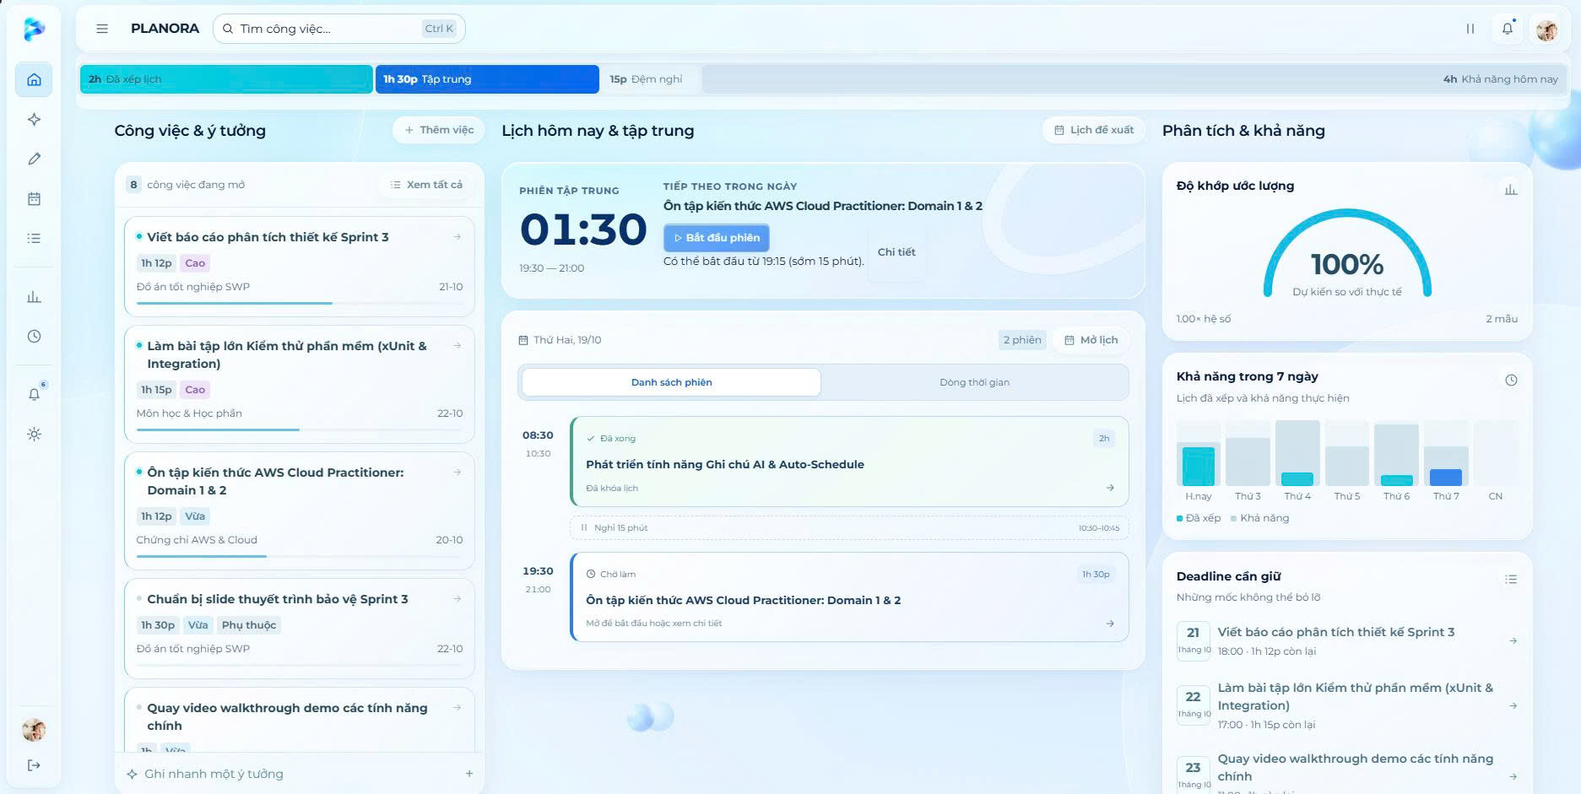
Supplementary Screenshot 2. Today Dashboard.

1. Authentication & Account

1.1 Screen / Function
Frontend source: frontend/src/auth-view.jsx, auth.jsx, page-settings.jsx. API: AuthController / DashboardController.

UI Design
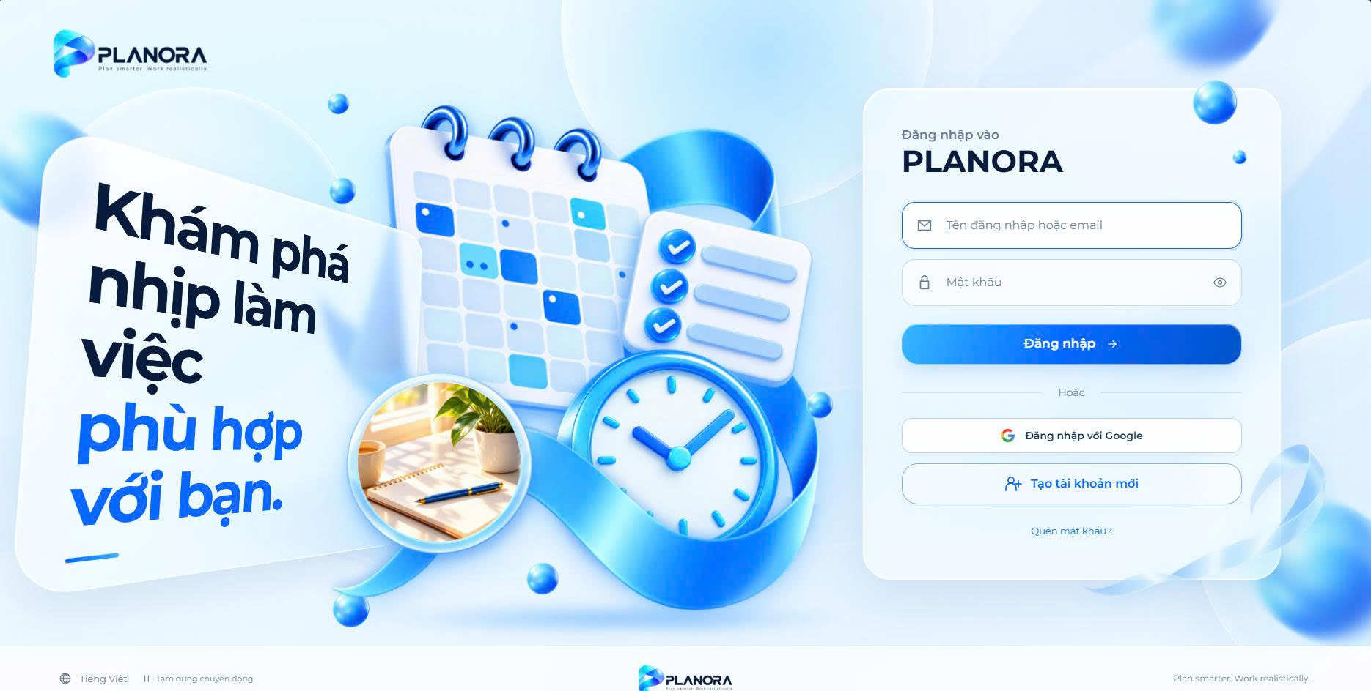
Figure 19. Login Screen
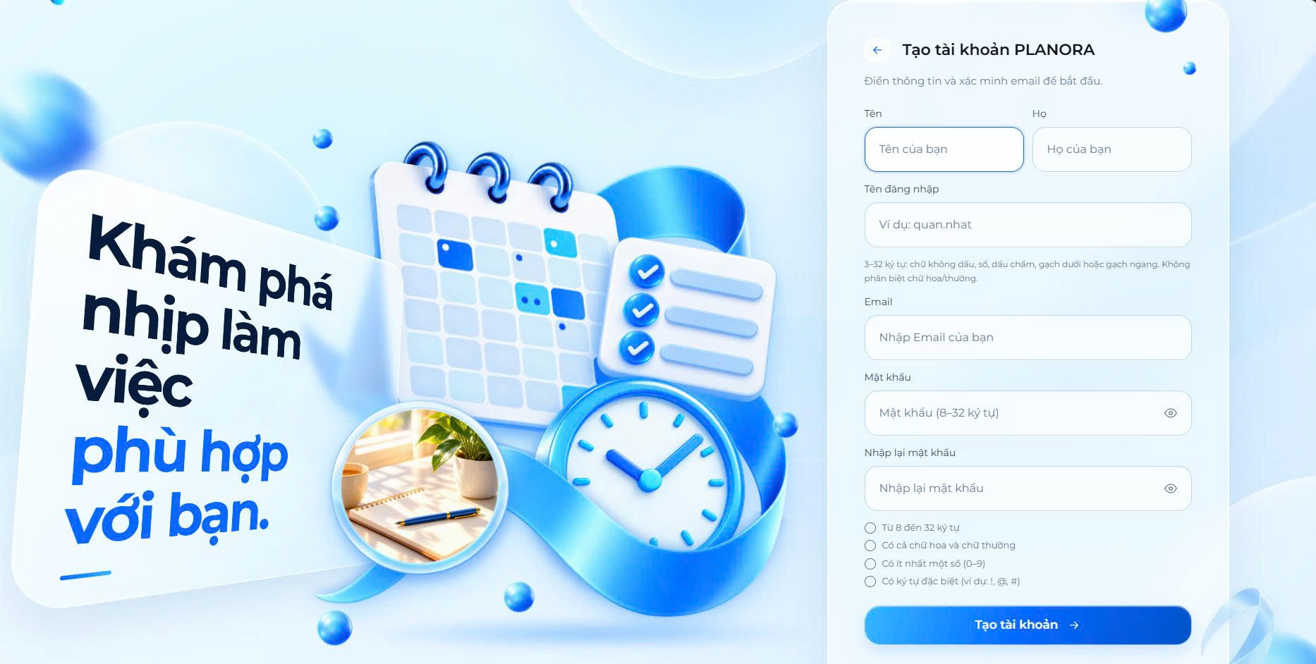
Figure 20. Registration Screen

Screen / section | Fields, controls and intended behavior
Sign-in | Username or verified email; password; sign-in button; Google option only if configured
Registration | First name, last name, email, password; verification OTP
Recovery | Email; OTP; one-time reset ticket; new password
Profile settings | Name, display name, bio/avatar; change password and active sessions
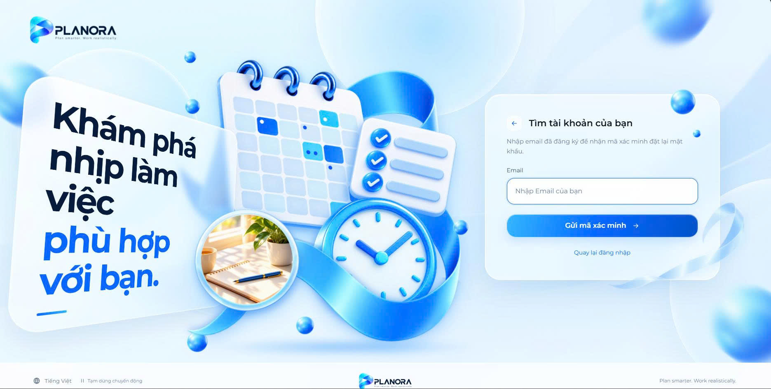
Supplementary Screenshot 3. Forgot Password Screen.
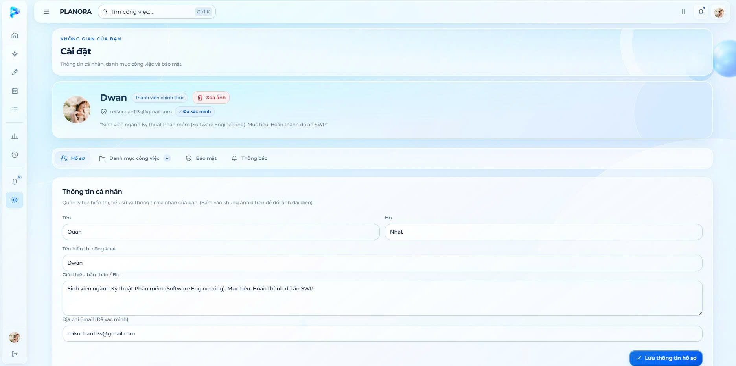
Supplementary Screenshot 4. Profile Settings Screen.

UI Field Specification
Field Name | Field Type | Description / validation
Login identifier | Text | Username or verified email
Password | Password | Credential is masked
Email OTP | One-time code | Verification/recovery requirement
First/last name | Text | Identity profile fields

Database Access
Entity / table | CRUD | Purpose
AspNetUsers | R/U | Account fields/password hash and status
EmailOtps | C/R/U | Purpose-bound OTP lifecycle
RefreshTokens | C/R/U | Session rotation/revocation
UserProfiles | R/U | Public profile fields
D* denotes soft deletion/retention, not necessarily a physical DELETE statement.

SQL Commands (illustrative design)
-- Parameterized conceptual equivalent (actual application primarily uses EF Core):
SELECT Id, Email, UserName, EmailConfirmed FROM AspNetUsers WHERE Id = @UserId;

2. Task Management

2.1 Screen / Function
Frontend source: frontend/src/page-tasks.jsx, task details/modal in controller.jsx. API: TasksController / CategoriesController.

UI Design
ChenAnhODayNhe!
Figure 21. Task Management Screen
ChenAnhODayNhe!
Figure 22. Task Creation and Editing Screen
Screen / section | Fields, controls and intended behavior
Task list | Search text, status/category/priority/deadline filters; 12-item client pages
Task editor | Name, description, deadline, estimate, priority, type, category, parent, hard/soft deadline
Detail & breakdown | Progress, subtask, prerequisite, breakdown suggestion and optional schedule controls

UI Field Specification
Field Name | Field Type | Description / validation
Name | Text | Required task title
Description | Multiline | Optional details
Deadline | Datetime | Hard or soft deadline
EstimatedMinutes | Number | Estimated duration
Priority | Choice | Task priority
CategoryId/ParentId | Select | Owned category or valid parent
Search/filters | Text/choice | Status, category, priority and deadlines

Database Access
Entity / table | CRUD | Purpose
WorkTasks | C/R/U/D* | Tasks, soft-delete flag, estimates and parent
TaskDependencies | C/R/D | Predecessor edges
TaskCategories | C/R/U/D | Per-account labels
D* denotes soft deletion/retention, not necessarily a physical DELETE statement.

SQL Commands (illustrative design)
-- Parameterized conceptual equivalent (actual application primarily uses EF Core):
SELECT Id, Name, Deadline, EstimatedMinutes, Status FROM WorkTasks WHERE UserId = @UserId AND IsDeleted = 0;

3. Notes & NORA

3.1 Screen / Function
Frontend source: frontend/src/notes.jsx, note-studio.jsx, agent.jsx. API: NotesController / AgentController / AgentVoiceController.

UI Design
ChenAnhODayNhe!
Figure 23. Notes Management Screen
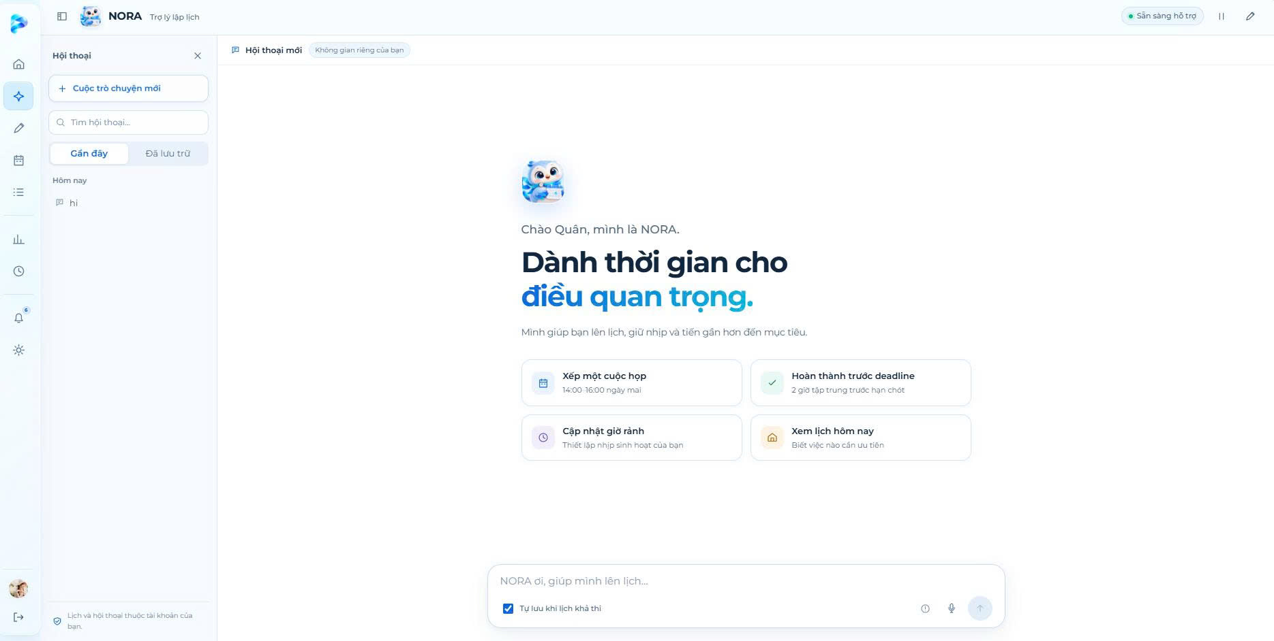
Figure 24. NORA AI Assistant Screen
Screen / section | Fields, controls and intended behavior
Notes | Title, multiline body, save draft, analyze, preview extracted tasks, import/schedule
NORA chat | Conversation list, input, clarification, preview/apply/undo and history
Voice | Optional record/transcribe; review transcription before any action

UI Field Specification
Field Name | Field Type | Description / validation
Note title | Text | Subject to note length limit
Note content | Multiline | Draft save independent of AI
AI analyze | Button | Requires configured provider
NORA instruction | Multiline | Clarification/preview supported
Conversation list | List/search | Own history and export
Voice clip | Audio | Configured provider and MIME checks

Database Access
Entity / table | CRUD | Purpose
PlanningNotes | C/R/U/D | User notes, analysis and state
AgentConversations | C/R/U/D | Conversation metadata
AgentTurns | C/R/U | Agent requests, suggestions and action state
AiUsageRecords | C/R/U | Usage/quota records
D* denotes soft deletion/retention, not necessarily a physical DELETE statement.

SQL Commands (illustrative design)
-- Parameterized conceptual equivalent (actual application primarily uses EF Core):
SELECT Id, Title FROM PlanningNotes WHERE UserId = @UserId;

4. Time & Calendar

4.1 Screen / Function
Frontend source: frontend/src/page-time.jsx, calendar.jsx, schedule.jsx. API: TimeController / SessionsController.

UI Design
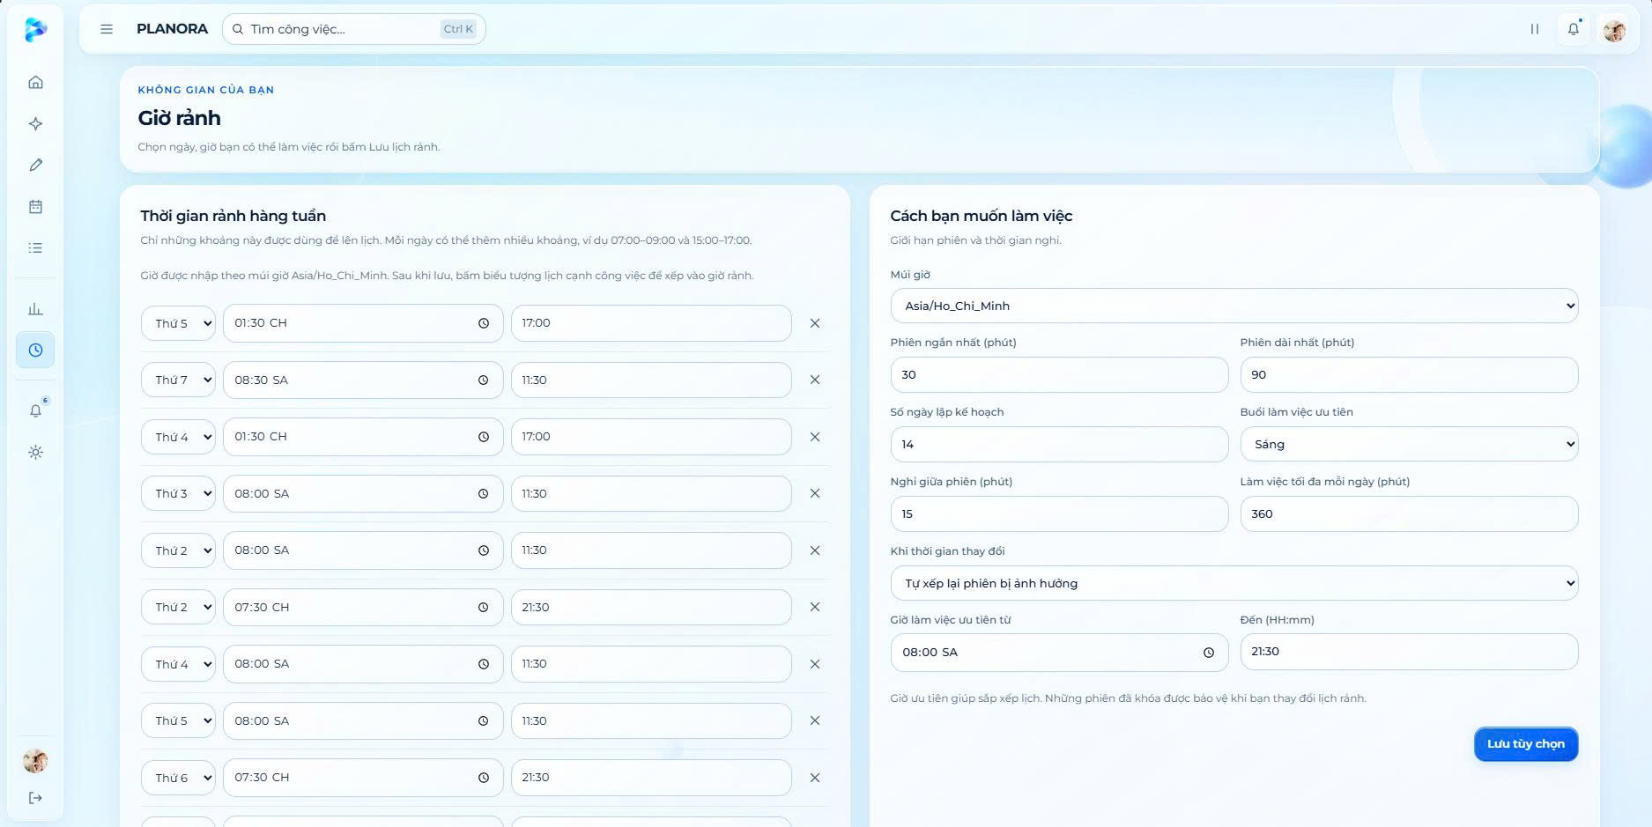
Figure 25. Weekly Availability Screen
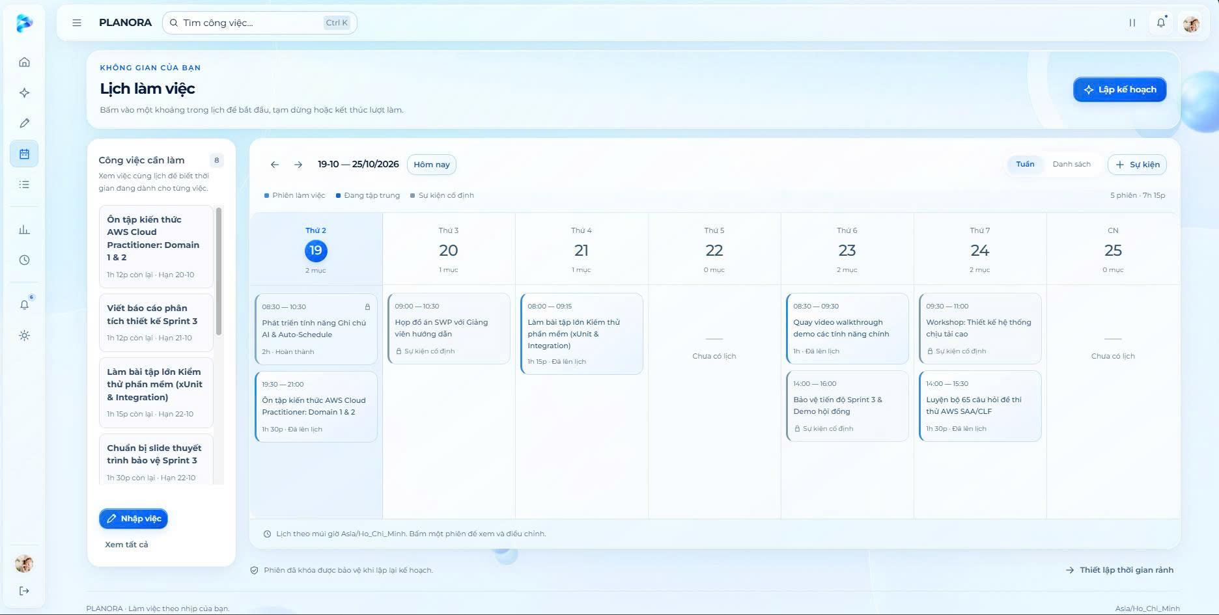
Figure 26. Work Calendar Screen
Screen / section | Fields, controls and intended behavior
Weekly slots | Weekday, one or more start/end intervals
Exception/event | Date, start/end, available/busy; event name, type, description
Calendar | Week navigation, sessions/events; edit, lock, split, execution actions

UI Field Specification
Field Name | Field Type | Description / validation
DayOfWeek | Weekday | API 0 Sunday through 6 Saturday
StartMinute / EndMinute | Time | Minutes 0 to 1440; multiple windows/day
Exception date | Date | Date-specific availability
IsAvailable | Boolean | Busy or free exception
Event Start/End | Datetime | Fixed-event span
TimeZoneId | Choice | Local time zone
Planning limits | Numbers | Daily cap, session min/max and breaks

Database Access
Entity / table | CRUD | Purpose
WeeklyAvailability | C/R/U/D | Recurring available slots
AvailabilityExceptions | C/R/U/D | Dated intervals
FixedEvents | C/R/U/D | Calendar commitments
WorkPreferences | R/U | Limits, timezone and revision
WorkSessions | R/U | Applied sessions
D* denotes soft deletion/retention, not necessarily a physical DELETE statement.

SQL Commands (illustrative design)
-- Parameterized conceptual equivalent (actual application primarily uses EF Core):
SELECT DayOfWeek, StartMinute, EndMinute FROM WeeklyAvailability WHERE UserId = @UserId;

5. Planning & Recovery

5.1 Screen / Function
Frontend source: frontend/src/schedule.jsx, recovery.jsx. API: PlansController / RecoveryController.

UI Design
ChenAnhODayNhe!
Figure 27. Work Plan Preview Screen
ChenAnhODayNhe!
Figure 28. Schedule Recovery Screen
Screen / section | Fields, controls and intended behavior
Generate plan | Start date, horizon 1–30 days, requested planning mode
Preview & apply | Proposed changes, warnings, unscheduled minutes, reason codes, apply/discard
Recovery | Recovery preference, case list, scan, rebuild, apply/dismiss

UI Field Specification
Field Name | Field Type | Description / validation
Plan start | Datetime | Horizon starting point
HorizonDays | Number | 1 to 30 days
Proposal warnings | Read-only list | Reasons and unscheduled work
Proposal actions | Buttons | Apply or discard reviewed proposal
Recovery case | List | Rebuild, apply or dismiss

Database Access
Entity / table | CRUD | Purpose
PlanProposals | C/R/U | Lifecycle, revision, expiration
PlanItems | C/R | Proposed change records
PlanWarnings | C/R | Feasibility warnings
RecoveryCases | C/R/U | Recovery case state
WorkSessions | C/R/U | Applied schedule
D* denotes soft deletion/retention, not necessarily a physical DELETE statement.

SQL Commands (illustrative design)
-- Parameterized conceptual equivalent (actual application primarily uses EF Core):
SELECT Id, Status, ExpiresAt, Revision FROM PlanProposals WHERE UserId = @UserId AND Id = @PlanId;

6. Execution & Insights

6.1 Screen / Function
Frontend source: frontend/src/schedule.jsx, page-insights.jsx, analytics.jsx. API: SessionsController / InsightsController.

UI Design
ChenAnhODayNhe!
Figure 29. Work Session Execution Screen
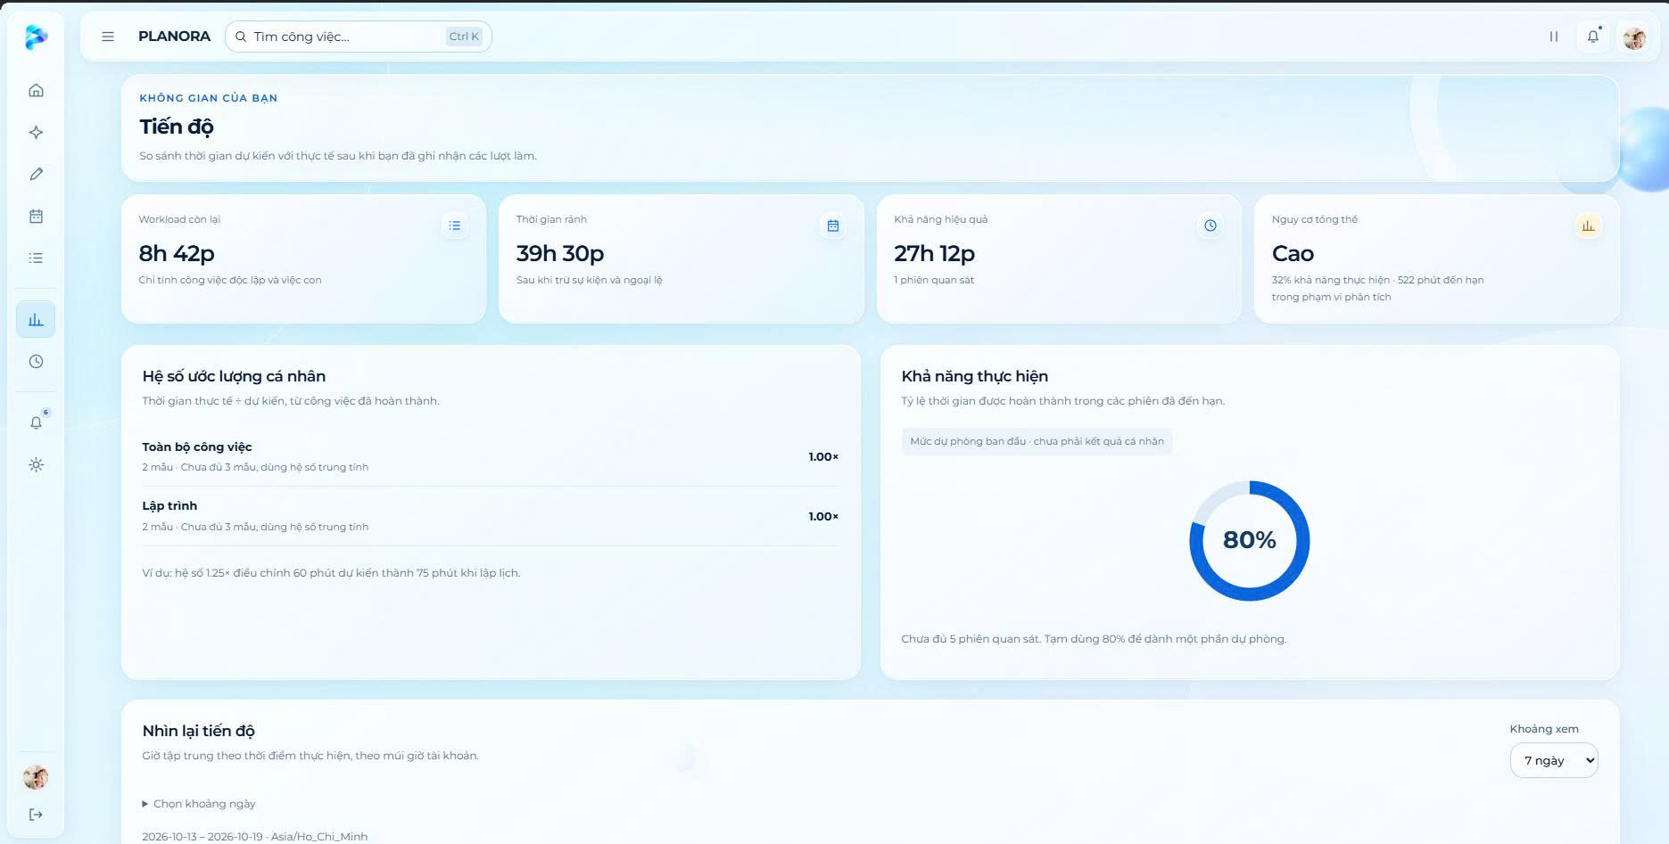
Figure 30. Productivity Insights Screen
Screen / section | Fields, controls and intended behavior
Session execution | Start, pause, resume, complete, skip and actual-duration correction
Analytics | Planned/actual, bias, effective capacity, overload/task risks
Scenario | Hypothetical task and before/after capacity, with no writes

UI Field Specification
Field Name | Field Type | Description / validation
Timer controls | Buttons | Start, pause, resume and complete
ActualMinutes | Number | Correction for eligible execution
Period selector | Date range | Analytics timeframe
Risk details | Read-only | Level, score and reasons
Scenario input | Form | Hypothetical task with no saved changes

Database Access
Entity / table | CRUD | Purpose
WorkSessions | R/U | Session status and planned span
SessionExecutions | C/R/U | Actual timer aggregates
ExecutionSegments | C/R/U | Timer segments
EstimationObservations | C/R/U | Learning samples
RiskAssessments | C/R/U | Risk outputs
D* denotes soft deletion/retention, not necessarily a physical DELETE statement.

SQL Commands (illustrative design)
-- Parameterized conceptual equivalent (actual application primarily uses EF Core):
SELECT Id, TaskId, Start, [End], ActualSeconds FROM WorkSessions WHERE UserId = @UserId;

7. Notifications

7.1 Screen / Function
Frontend source: frontend/src/notifications.jsx, page-settings.jsx. API: NotificationsController / notification worker.

UI Design
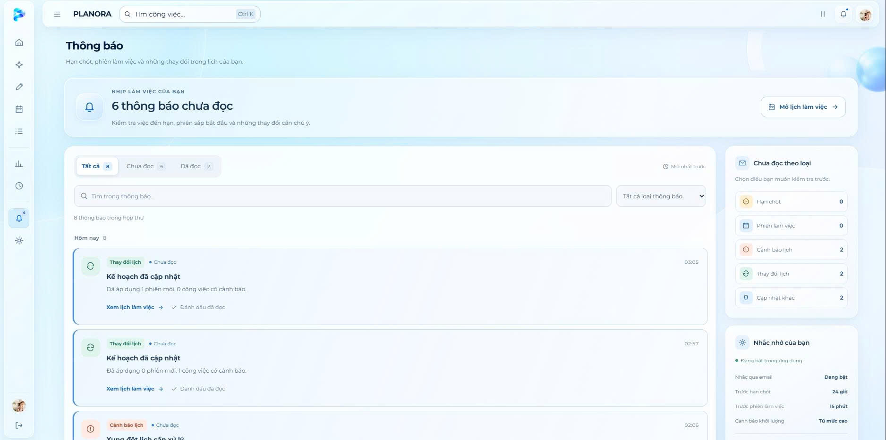
Figure 31. Notifications Screen
ChenAnhODayNhe!
Figure 32. Notification Preferences Screen
Screen / section | Fields, controls and intended behavior
List | Title, message, kind, date, read/unread state
Preferences | In-app, lead times, warning level, opt-in email reminder toggle

UI Field Specification
Field Name | Field Type | Description / validation
Notification list | Read-only list | Title, content and read status
DeadlineLeadHours | Number | 1–168 hours
SessionReminderLeadMinutes | Number | 1–120 minutes
WorkloadWarningLevel | Choice | MODERATE, HIGH or OVERLOAD
EmailEnabled | Toggle | Explicit optional opt-in

Database Access
Entity / table | CRUD | Purpose
InAppNotifications | C/R/U | Notification/read state, email retry metadata
NotificationSettings | C/R/U | Owned preferences
D* denotes soft deletion/retention, not necessarily a physical DELETE statement.

SQL Commands (illustrative design)
-- Parameterized conceptual equivalent (actual application primarily uses EF Core):
SELECT Id, Kind, Title, ReadAt FROM InAppNotifications WHERE UserId = @UserId ORDER BY CreatedAt DESC;

8. Administration

8.1 Screen / Function
Frontend source: frontend/src/page-admin.jsx. API: AdministrationController.

UI Design
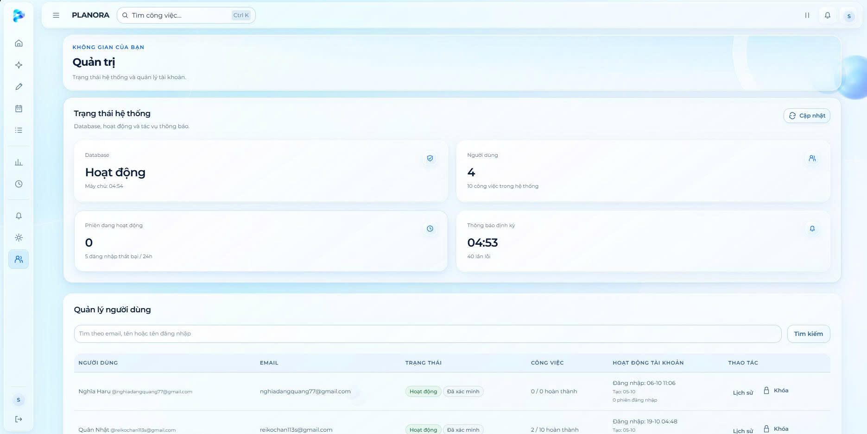
Figure 33. User Administration Screen
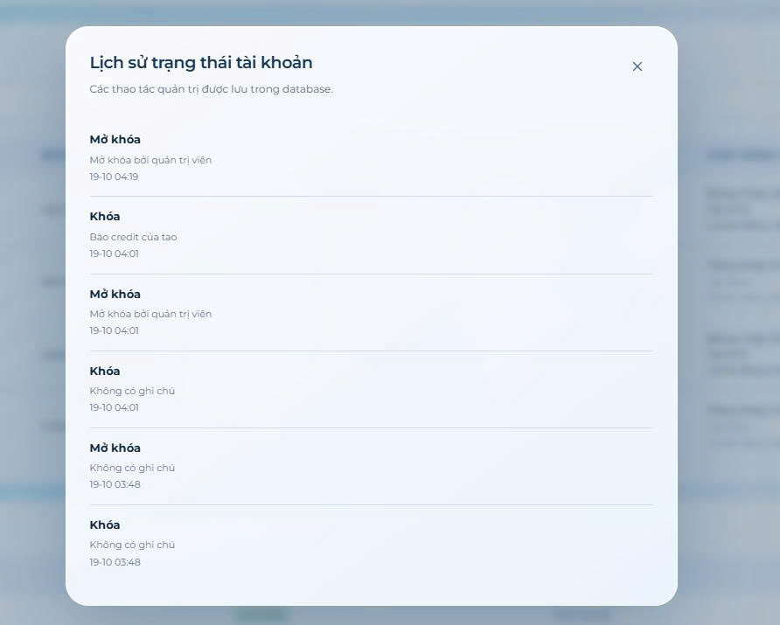
Supplementary Screenshot 5. Account Status History Screen.
Figure 34. System Monitoring Screen
Screen / section | Fields, controls and intended behavior
Account search | Username/email/name, active state, created/last login, task statistics
Lock/unlock | Target account, reason and confirm action
Operations | System health, job runs, status-history views

UI Field Specification
Field Name | Field Type | Description / validation
Search | Text | Name, email or username
Account status | Read-only | Active and verified status
Action reason | Text | Lock/unlock audit reason
Lock / Unlock | Buttons | Admin authorized only
System status | Metrics | Health, counters, job history

Database Access
Entity / table | CRUD | Purpose
AspNetUsers | R/U | Account state, counters as derived values
AccountStatusLogs | C/R | Admin actions and reasons
SystemJobRuns | R | Background job status
D* denotes soft deletion/retention, not necessarily a physical DELETE statement.

SQL Commands (illustrative design)
-- Parameterized conceptual equivalent (actual application primarily uses EF Core):
SELECT Id, UserName, Email FROM AspNetUsers WHERE Email LIKE @SearchPattern OR UserName LIKE @SearchPattern;

IV. Appendix

1. Assumptions & Dependencies
ID | Assumption / dependency
AS-01 | Frontend and API are deployed on a supported browser/HTTPS origin; secrets are server-side.
AS-02 | User provides realistic availability, timezone, deadline and estimated duration.
AS-03 | AI provider is optional for core scheduling; Notes AI extraction requires configured provider and usable quota.
AS-04 | Email OTP and opted-in email reminders require working SMTP; Mailpit delivery is for development only.
AS-05 | Google login requires Firebase client/admin configuration.
AS-06 | Database migrations in repository are applied to the target database before using newer module paths.
AS-07 | UC73–UC102 are not approved as independent official cases unless the team decides so.

2. Limitations & Exclusions
• No claim of mathematically globally optimal schedule; the planner is constraint-aware heuristic.
• Do not assume push notifications or external Google Calendar synchronization; these are not demonstrated by the reviewed surface.
• Do not claim the SMTP, AI or Firebase integration works with live credentials without environment-specific evidence.
• Legacy UML-v2 diagram may omit newer Notes/NORA/Recovery and reminder-email fields. Export a refreshed full physical ERD.
• Actual screenshots are intentionally not fabricated; teams must insert approved captures from the current deployed frontend.
• Code/source-present does not imply each use case has its own independent automatic test.
• Version 6.0 is a review draft; author/date/team roster and acceptance remain for the group to confirm.

3. Business Rules
ID | Category | Rule Definition
BR-01 | Identity / OTP | Email verification and recovery OTP are purpose-bound, short-lived and one-time; credentials must never be exposed.
BR-02 | Session security | Refresh token rotation/revocation; password reset/change invalidates existing sessions; access authorization is enforced on API.
BR-03 | Ownership / roles | Workspace data is scoped to the current user; administrative APIs require the Admin role.
BR-04 | Task hierarchy | Task dependencies cannot cycle; nested child tasks limited to one level; child deadline cannot exceed parent; soft deletion preserves history.
BR-05 | Availability | Plans respect one or more weekly intervals per weekday, dated exceptions, fixed events, timezone and preferences.
BR-06 | Plan lifecycle | Generation creates a proposal; application revalidates conflict/revision/expiration then commits in a transaction.
BR-07 | Session safety | Locked/active/executed sessions are protected; user cannot have multiple simultaneous running/paused sessions.
BR-08 | Estimation and capacity | Learning uses actual work history and cold-start rules; zero actual time does not become a learning observation.
BR-09 | Non-mutating simulation | What-if and conflict detection operate without writing live tasks, plans, sessions or risks.
BR-10 | Review AI actions | AI parsing/proposals are validated by backend; uncertain or warned changes require review; an unavailable provider must not claim success.
BR-11 | Notifications | Notification preferences and per-account deduplication are respected; email reminders require opt-in and valid SMTP.
BR-12 | Recovery / concurrency | Recovery and agent action application checks state/revision, with safety constraints; retries must not duplicate user data.
BR-13 | Data retention | Soft-deleted tasks preserve required historical execution and analytics records; security logs do not expose secrets.
BR-14 | Admin audit | Account lock/unlock decisions are authorized and recorded with history.
BR-15 | Note processing | Note AI extraction requires configured provider; drafts remain usable without AI and errors do not silently create tasks.

4. Traceability to Repository
Scope | Source of evidence
Baseline use-case map | docs/USE_CASE_COVERAGE.md (UC01–UC72)
Current architecture | README.md; frontend/src/route-pages.jsx; src/SPWPOS.Infrastructure/Persistence/ApplicationDbContext.cs
Current HTTP endpoints | src/SPWPOS.Api/Controllers/*.cs (specific path recorded with each use case)
Data model and ERD history | docs/UML_ALIGNMENT.md; docs/reference/UML-v2/; Configurations/WorkspaceModel.cs and WorkloadHistoryModel.cs
Note / agent behavior | docs/NOTES_AGENT_GUIDE.md; docs/PLANNING_AGENT_GUIDE.md
Latest task/reminder enhancement | docs/PLANORA_TASK_AND_REMINDER_UPDATE.md; migration 20261018130002_AddReminderEmailDelivery.cs
Course specification template | SWP391_Template2_RDS_Document.docx
Repository location: https://github.com/Dwan123s/SPWPOS ; reviewed main tree SHA 5f1870227b59cfc4a8582ab73f0732d977dd4a43.

5. Final Acceptance Checklist (team action)
[ ] Confirm actual group/member names, supervisor, date and authorship.
[ ] Confirm official UC01–UC72 scope and classification of UC73–UC102 (new UC vs subflow).
[ ] Generate one complete ERD from current EF migration/database; verify all physical table names and FK cardinalities.
[ ] Attach approved screenshots for 8 UI module sections and visually compare controls with this source-grounded field listing.
[ ] Execute end-to-end flows of register/OTP/login/logout and recent automatic planning behavior in target environment.
[ ] Test SMTP/Mailpit/Gmail separately; delivery confirmation is not an inbox-arrival guarantee.
[ ] Test provider-configured Notes/NORA and agent/voice features, recording actual successes/failures and quotas.
[ ] Run project tests and record pass counts with test date and environment; do not reuse historical counts as current.
[ ] Refine 83 reused generic Alternative Flows and 92 reused generic Exceptions descriptions with source-specific branches; distinguish true alternatives from cancellation and failures.
[ ] Confirm any instructor-specific extra depth for screen mockups, full physical ERD, and SQL CRUD details; Screen Flow is already required by the provided template and now included.

6. Document Status
Working draft revised against Template2_RDS Document.docx and the JobTrans sample: six navigable Screen Flow diagrams with explicit return paths, cross-referenced Screen Descriptions, a package diagram, and source-verified partial foreign-key view. This is not an approval or production-test certificate; open acceptance and evidence items remain in Appendix section 7. A separate audit identified repeated generic Alternative Flows and Exceptions in the UC catalog; see OPEN-11.

7. Open Issues and Required Evidence (not yet verified)
ID | Item | Missing / verification required | Owner | State
OPEN-01 | Physical database ERD | Current diagram is simplified/selected FK relationships. Export full up-to-date DB schema with table names, PK/FK, data types, cardinalities; compare against migrations and running SQL Server. | Team / DB owner | Open
OPEN-02 | UI design evidence | Eight Section III UI modules still lack approved real screenshots/wireframes and field-level pixel/design evidence. Use actual running app screenshots; do not fabricate. | UI owner | Open
OPEN-03 | UC scope approval | 72 baseline UCs are mapped; UC73–UC102 are candidate UCs/subflows pending group/lecturer decision. Update overview and diagrams after approval. | Team lead | Open
OPEN-04 | Live integration verification | No current test record in this document proves actual Firebase/SMTP/Gemini/OpenAI/voice behavior in target deployment; source presence is not live availability. | Integration owner | Open
OPEN-05 | Current automated test evidence | Attach dated test command, environment, pass/fail counts and log; historical README reports are not execution evidence for this revision. | QA owner | Open
OPEN-06 | Screen-flow UI validation | Six diagrams are derived from frontend routes/controllers and known navigation patterns; verify real Back/Close behavior on each device and add real screenshots, especially D01–D12. | Frontend owner | Open
OPEN-07 | Diagram traceability | Baseline UML-v2 use-case figures do not cover the proposed new 30 UCs. Add approved diagrams after classifying new UCs/subflows. | Requirements owner | Open
OPEN-08 | Detailed SQL / database access | Section III SQL is illustrative, EF Core generates most commands; validate actual transaction/queries and data contracts instead of calling examples production SQL. | Backend owner | Open
OPEN-09 | Team and submission metadata | Replace placeholder SPWPOS Team; confirm names, reviewers, final date, version, approval and teacher-specific requirements. | Team lead | Open
OPEN-10 | Source revision / deployment | Repository main tree SHA is documented, but deployment commit and database migration state must be compared with the tested environment. | DevOps owner | Open
OPEN-11 | Use-case alternative/exception specificity | 83/102 UC use the same generic cancellation Alternative Flow; 92/102 UC use a generic Exceptions pattern. Rewrite case-specific alternatives and exception triggers against services/tests before formal sign-off. | Requirements / Dev owners | Open

