HOTEL RESERVATION SYSTEM
1. Project Title
Hotel Reservation System using Java

2. Objective
The objective of this project is to develop a hotel reservation system that allows users to:
- View available rooms
- Book rooms
- Cancel bookings
- View booking details
- Store booking information in a file

3. Software Requirements
- Java JDK 8 or above
- Visual Studio Code
- Windows Operating System

4. Features
- Room Management
- Room Booking
- Booking Cancellation
- Customer Information Storage
- Booking ID Generation
- File Handling using bookings.txt

5. Technologies Used
- Java
- OOP Concepts
- Arrays
- Methods
- File Handling
- Scanner Class

6. Project Structure
HotelReservationSystem
│
├── Room.java
├── HotelReservationSystem.java
├── bookings.txt
└── Screenshots

7. Output Screenshots
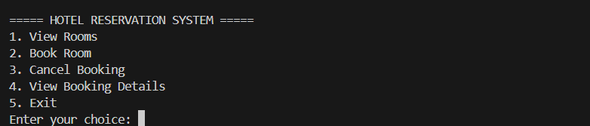
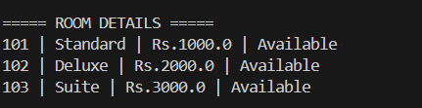



8. Conclusion
The Hotel Reservation System was successfully developed using Java. The project demonstrates Object-Oriented Programming, File Handling, Arrays, and User Interaction through a console-based application.

