**SportyShoes**

Sporty Shoes is a company that manufactures and sells sports shoes. They have a walk-in store, and now, they wish to launch their e-commerce portal sportyshoes.com.

You’re asked to develop a prototype of the application. It will be then presented to the relevant stakeholders for budget approval. Your manager has set up a meeting where you’re asked to do the following:

● Presenting the specification document which has the product’s capabilities, appearance, and user interactions  
● Setting up Git and GitHub account to store and track your enhancements of the prototype   
● Explaining the Java concepts used in the project   
● Discussing the generic features of the product:  
● There will be an admin to manage the website. An administrator login will be required to access the admin page.

The admin should be able to change his password if he wants, he should be able to:

● Manage the products in the store including categorizing them  
● Browse the list of users who have signed up and be able to search users  
● See purchase reports filtered by date and category

**View project locally**

To try out the project in your local machine:

* clone this repository using git clone
* Open the folder from Eclipse/IntelliJ
* Open index.html and Run

## **Sprints planning and Task completion**

The project is planned to be completed in 1 sprint.

## **Core concepts used in project**

Object oriented programing ,Classes, Methods, Array list, MySql, Hibernate , Servlet, Springboot, HTML

Technologies used

Java

Git Hub

## **Steps:**

## Creating a new project in Eclipse

* Open Eclipse
* Go to File -> Import->Existing projects into workspace -> Select root directory -> Browse “SportyShoes” and click on “Finish.”
* Select your project and go to src->main->Java
* Find model,dao and controller programs
* Go to Web app-
* Create required html/jsp pages of project
* Also configure application.properties in src/main/java resources

**Run Project :**

To run project

* First open src/main/java
* Open com.mjava.SportyShoesOnline ->SportyShoesOnlineApplication.java
* Select RunAs -> Spring Boot App
* open browser and type localhost:8090/home

The Project folder structure is as follows :

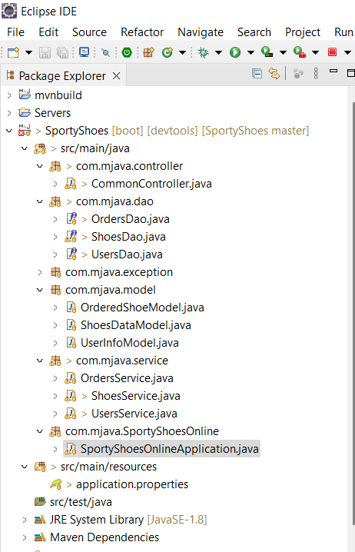

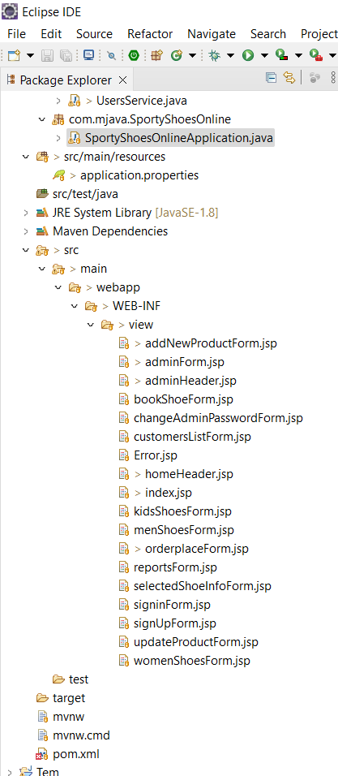

**Project output :**

**Open localhost:8090/home in Web browser**

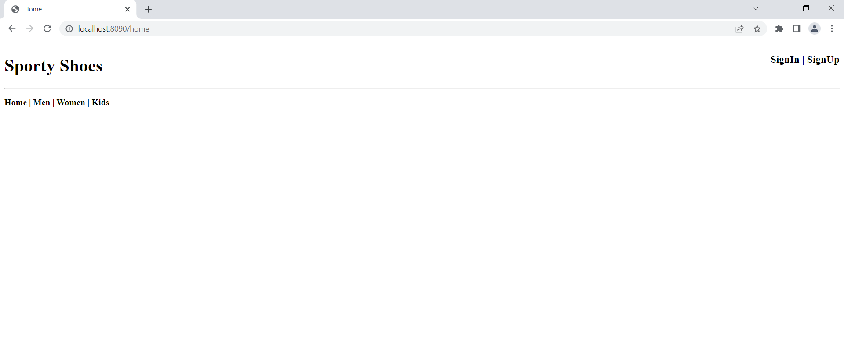

**Click signup**

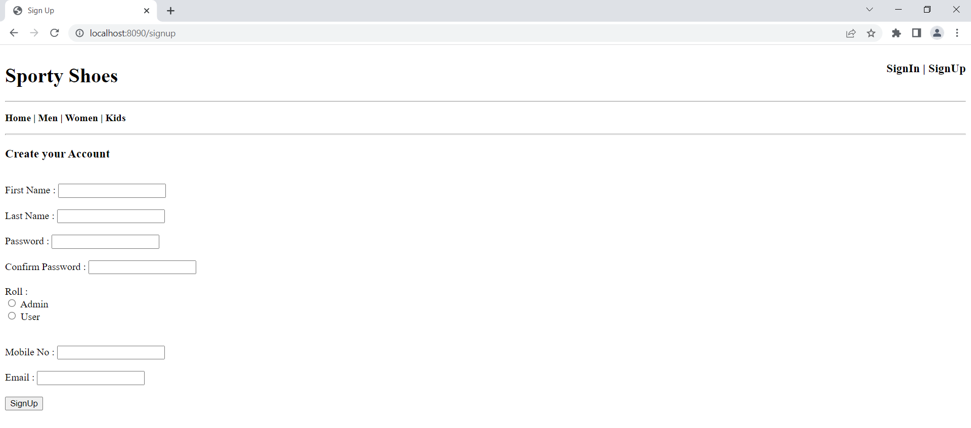

**Enter details of form**

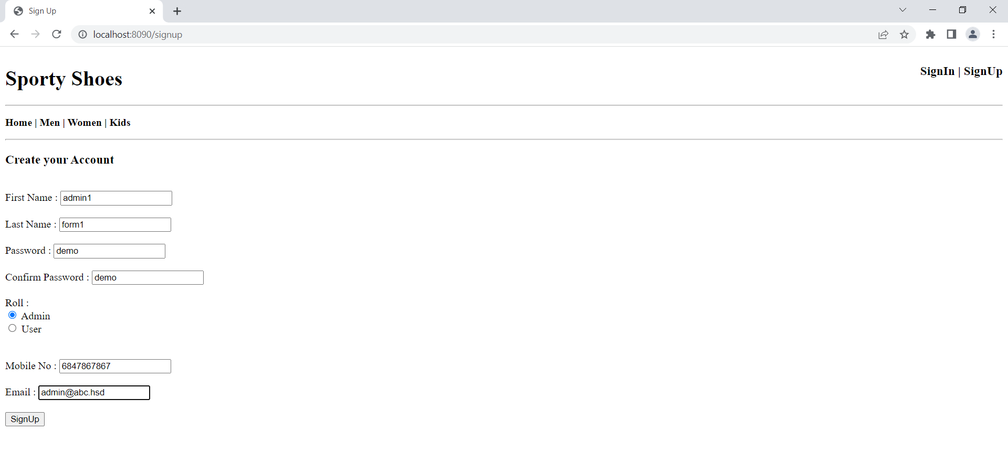

**Sign-in from admin and perform operations from the list**

