**V.S.B. COLLEGE OF ENGINEERING TECHNICAL CAMPUS**

**Department of Computer Science and Engineering**

**COIMBATORE**



**A Multi Media Project Report**

**On**

**Topic: “PASSION FOR GLORY”**

**Submitted by, Guided by,**

DWARAKESHWARAN B M (723715104006) Mrs. M.S. VINU

IV-CSE (AP/CSE)

**Signature of the guide**

**Introduction:**

**Passion** is a feeling of intense enthusiasm towards or compelling desire for someone or something. Passion can range from eager interest in or admiration for an idea, proposal, or cause; to enthusiastic enjoyment of an interest or activity; to strong attraction, excitement, or emotion towards a person. Passion can drive people to do the best things in life, or it can drive   people to do the most terrible things possible in life. Passion is an important factor in every single soul on earth. Passion drives me, and many others to achieve goals in life. Have passion in my life to do the best I can in all I do and make the best out of every experience.

**Do What You Love To Do:**

***"Work is***[***love***](http://1000ventures.com/business_guide/crosscuttings/love.html)***made visible. And if you cannot***[***work with love***](http://inhalelove.com/coach/love_wudo.html)***but only with distaste,   
it is better that you should leave your work and sit at the gate of the temple and take alms of those who work with joy." -***[***Khalil Gibran***](http://feed4soul.com/coach/authors_gibran_khalil.html)

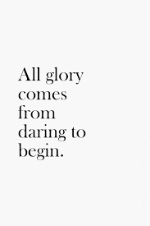Happiness is the freedom to pursue your [**→**](http://1000ventures.com/business_guide/crosscuttings/passion.html)[**true passion**](http://1000ventures.com/info/passion_brief.html).

We were born to do not what we are [forced to do](http://1000ventures.com/fun/fun_pictures_dio.html), but what we [love to do](http://1000ventures.com/business_guide/innovation_love.html). If you love what you do, you release your [**→**](http://kotelnikov.biz/coach/creativity_3levels.html)[**divine creativity**](http://1000ventures.com/info/creativity_3levels.html). Continuous [creative activity](http://1000ventures.com/business_guide/crosscuttings/creativity_main.html) and the joy of achievement is a great source of happiness.

Happiness is not about life-business [**→**](http://1000ventures.com/business_guide/crosscuttings/balance.html)[**balance**](http://1000ventures.com/info/balance_brief.html), it's about life-business [**→**](http://1000ventures.com/business_guide/crosscuttings/synergy.html)[**synergy**](http://1000ventures.com/info/synergy_brief.html).

If you find your true passion and [devote yourself to it](http://1000ventures.com/business_guide/crosscuttings/life-business_synergy.html), you’ll find harmony and [happiness](http://1000ventures.com/business_guide/crosscuttings/happiness.html) in [**→**](http://1000ventures.com/business_guide/crosscuttings/vision_main.html)[**your life**](http://1000ventures.com/info/vision_personal_brief.html). You’ll be [**→**](http://kotelnikov.biz/coach/achievement_coca.html)[**achieving**](http://1000ventures.com/info/achievement_COCA_brief.html) great results continually and effortlessly.

[Successful people](http://1000ventures.com/business_guide/crosscuttings/success_wheel.html) win because they love what they do. You can't tell the dancer from the dance. Actually, your noble [passion](http://1000ventures.com/business_guide/crosscuttings/passion.html) is your mission. Begin to do more of what you love now and let that fill [your life](http://kotelnikov.biz/vk_quotes_life_symphony.html). Passion is the single fastest way to spur you to massive success. It is something you [love](http://1000ventures.com/business_guide/crosscuttings/love.html). Something you're excited about. Something you get up early to work on or to stay up late.

***"Finding happiness is like finding yourself. You don't find happiness, you make happiness. You choose happiness. Self-actualization is a process of discovering who you are, who you want to be and paving the way to happiness by doing what brings you the most meaning and contentment to your life over the long run." -David Leonhardt.***

**A Journey to Self Discovery:**

***“Passion is energy. Feel the power that comes from focusing on what excites you.”***

***- Oprah Winfrey***

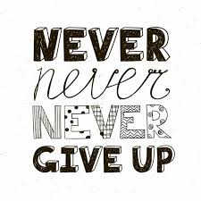Passion is our inner flame of wanting, craving, and deep yearning. It is an energy of action that lights us up from the inside — our hearts trying to gain our attention. It needs to be heard and heeded. When we dull the surge of that call, we move further away from what our soul desires. We do not need to explain what we are magnetically drawn to, not to ourselves or others — we should not attempt to dissect and deflate desire. Instead, we trust the rush of that energy to lead our way forward. The journey to our true calling is the journey of our self-discovery — to our authenticity, [innate creativity](https://www.goalcast.com/2017/09/15/find-your-purpose-through-creativity/), and natural talents. When we tap into our inner dynamism and truly master the art of following our heart we begin to view life through a different lens. We disengage with mind clutter, foreboding and fears, and we enter a liberating space where our inner voice speaks to us through coherent and crystal-clear speech.

## The call of passion

***“I am here for a purpose and that purpose is to grow into a mountain, not to shrink to a grain of sand. Henceforth will I apply all my efforts to become the highest mountain of all and I will strain my potential until it cries for mercy.”***

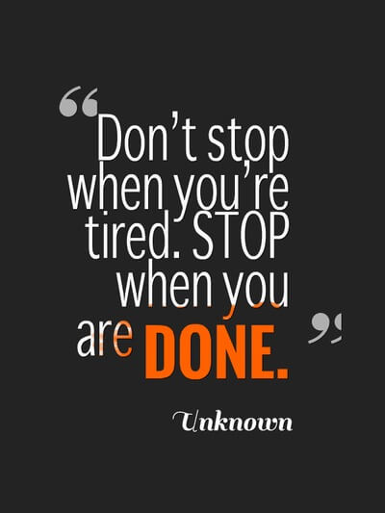 ***- Og Mandino***

When we are guided by love, curiosity, and enthusiasm we carve a path forward toward the picture of what may be; these are the architects of our dreams. We unlock our potential by pushing back the limits that we set for ourselves. Our purpose may not be something that inspires great and super-quick monetary gain; it is [not a dream or vision we sculpt for selfish or egoistic reasons](https://www.goalcast.com/2017/06/09/letting-ego-guide-your-goals/). It is our magnanimous offering to ourselves and the universe; it is embracing our gifts [so we can share them with others](https://www.goalcast.com/2017/10/17/the-world-needs-more-you-how-to-be-successful-at-being-yourself/). When we’re focused on what we can give rather than receive, we find a new path that aligns with a more wholesome and altruistic way of existing. It is the call of our passion that drives us to climb the highest mountains and reach the tallest heights. It is the call of our passion to meet our supreme cause and to take the risks in order to reap the commendable rewards.

**“Good, better, best. Never let it rest. Till your good is better and your better is best.”**

**- St. Jerome**

## Where your passion meets your talents

***“The starting point of discovering, who you are, your gifts, your talents, your dreams, is being comfortable with yourself. Spend time alone. Write in a journal. Take long walks in the woods.”***

***- Robin S. Sharma***

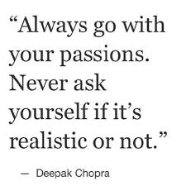Our deepest purpose is often found where our flares of passion meet our talents. Together they embolden us and stir us into action. When we perplex and bewilder ourselves by trying to find our purpose, we generate more mental disharmony and emotional turmoil. people and wonder how they are living their dream when we are yet to realize ours. In simplicity there is a subtle strength: we can refine rather than pollute our minds with tangled thinking. Very often we can fall into our purpose by accident. The push that steers us toward one dream might indirectly lead us to something more meaningful. Or we may find our passion meets our talents in the form of something that we loved to do as a child but as an adult had long since forgotten. Perhaps we accept a job opportunity that at first does not look like it will amount to anything fulfilling, only to find that it is the perfect fit. The possibilities are endless as long as we keep living for them rather than the guarantees**.**As Rumi said, what we are seeking is often seeking us too.

**Exploring our full potential**

***“Life is full of beauty. Notice it. Notice the bumble bee, the small child, and the smiling faces. Smell the rain, and feel the wind. Live your life to the fullest potential, and fight for your dreams.”***

***- Ashley Smith***

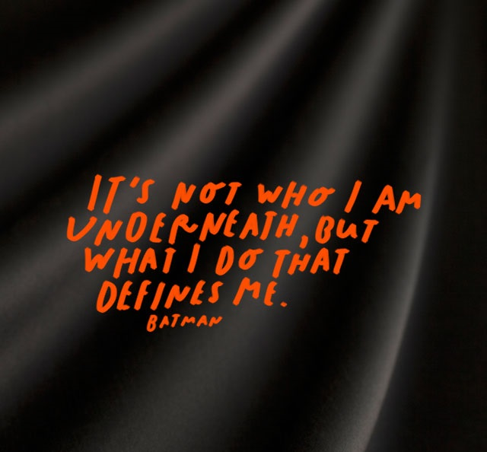We never miss out on anything when we focus on experiencing the full promise and escapades of life. It is an exploration of truth, beauty, pain and sorrow, and all the ephemeral joys that create enduring memories. The gifts we have are open for our discovery when we look within for each spark of passion, and each prospect of chance that finds its way to us.  We are strengthened by all we feel makes us weak, and fused together by everything we fear may tear us apart. Our potential is unlimited, boundless, and immense, and only we can accept all it holds.

## Keeping our hearts wide open

***“Put your heart, mind, and soul into even your smallest acts. This is the secret of success.”***

***- Swami Sivananda***

We can find our bliss when we follow our passion and wire ourselves to create. This is how we learn to settle into our skin. We fuel ourselves with the wonder of our full potential and what pumps a wakeful beat to our. The journey to our purpose is an adventure through mysterious lands: we may walk toward it with our eyes closed, but always with our hearts wide open.