**UMKC**

**Name: Dwarkamoye Mohanty**

**ID: 16281824**

**5110 0001 Network Architecture - 1**

**Assignment 3**

1.

(a)

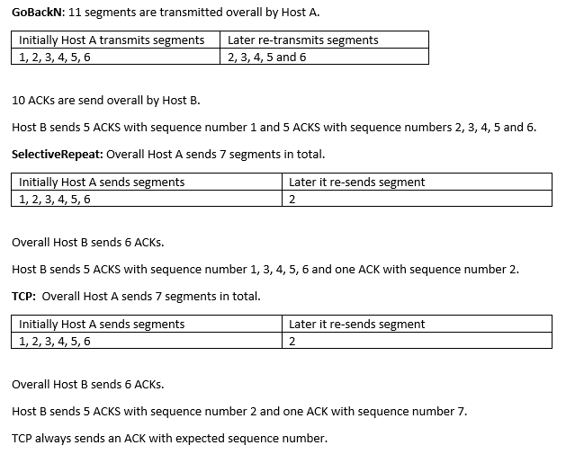

(b) TCP does not wait until timeout it uses retransmit, so TCP.

2.(a)

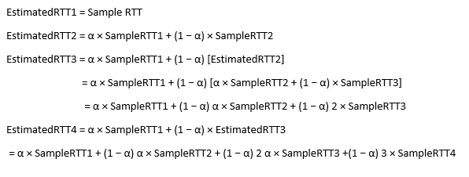

(b)

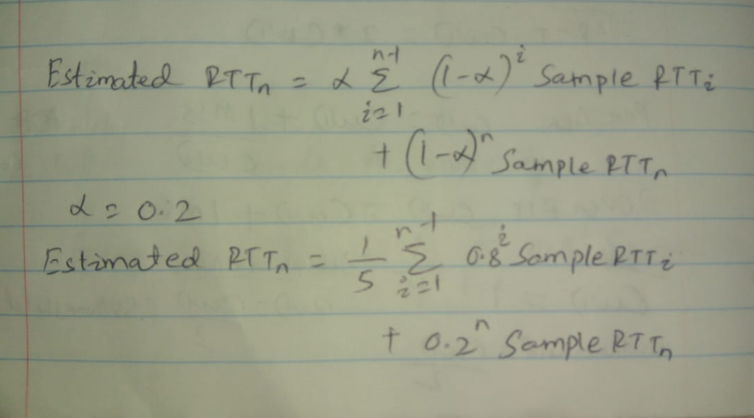

(c)

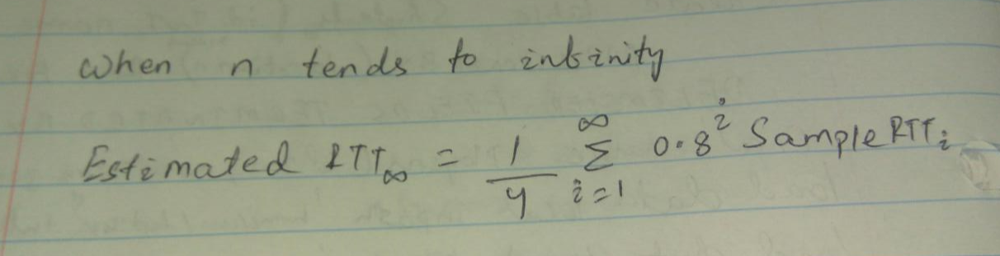

The method is termed as an exponential moving average as coefficient 0.8𝑖 exponentially deceases with proceeding time.

3.

(a)

Number of RTTs taken to increase CWND size is mentioned below:

|  |  |
| --- | --- |
| RTT | CWND size FROM TO (in terms of MSS) |
| 1 | 5-6 |
| 2 | 6-7 |
| 3 | 7-8 |
| 4 | 8-9 |
| 5 | 9-10 |
| 6 | 10-11 |

(b)

For 1RTT = 5MSS, 2RTT=6MSS, 3RTT= 7MSS, 4RTT=8MSS, 5RTT=9MSS, 6RTT=10MSS

Total = (5+6+7+8+9+10) = 45MSS

Through time = 6RTT

Throughput = 45/6 = 7.5 MSS/RTT

**Lab**

**Part-1:**

1.

UDP connections are **73**, TCP connections are **59**.

TCP session - IP address: 127.0.0.1 and port number: 65000

There are many TCP connections and UDP connections listing few:

UDP session IP address: 192.168.150.1 and port number: 59902.

TCP session IP address: 192.168.1.216 and port number: 139.

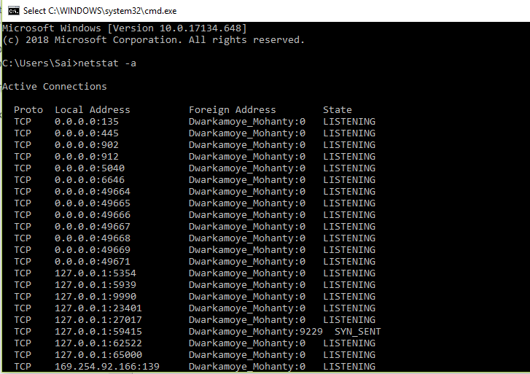

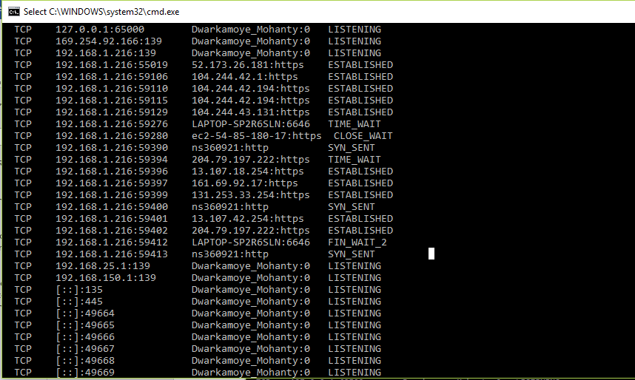

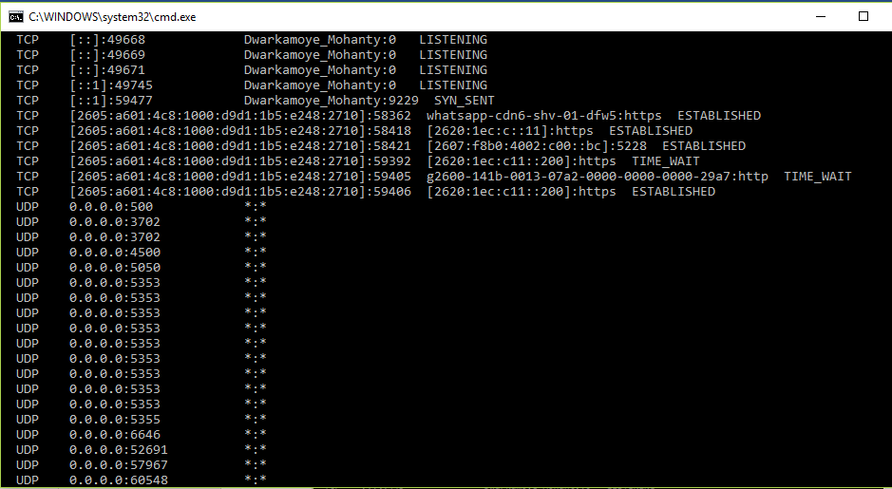

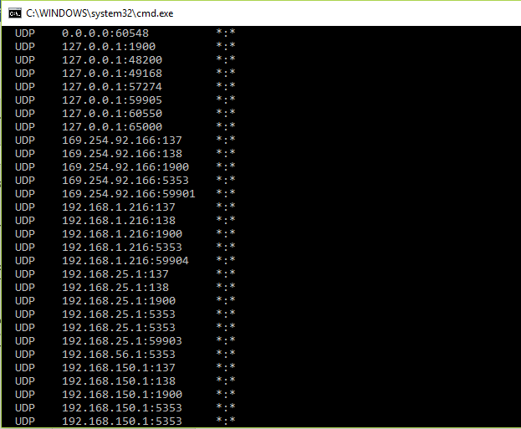

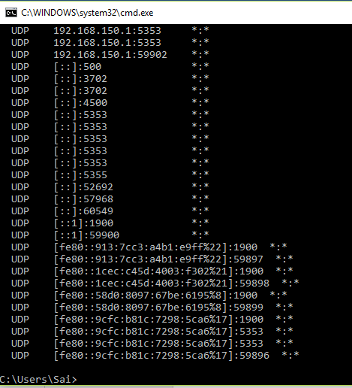

2.

IPv4 statistics:

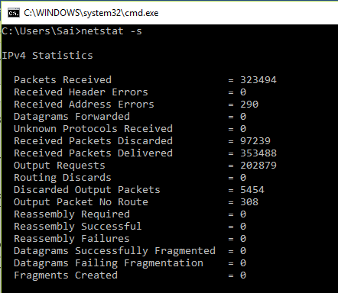

IPv6 statistics:

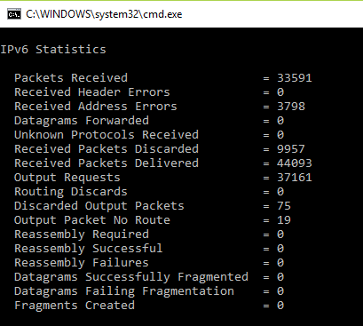

ICMPv4 Statistics:

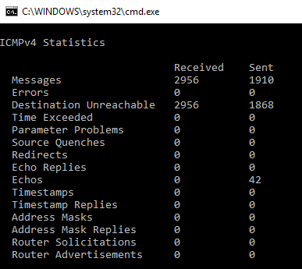

ICMPv6 Statistics:

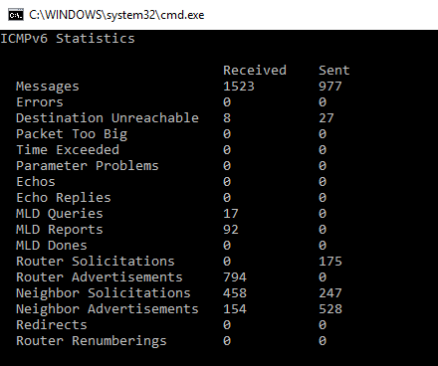

TCP stats for IPv4, IPv6:

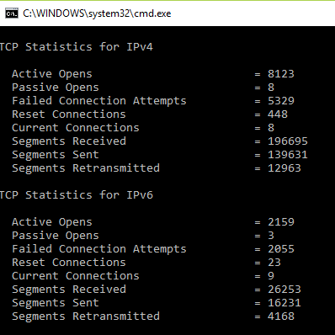

UDP stats for IPv4, IPv6:

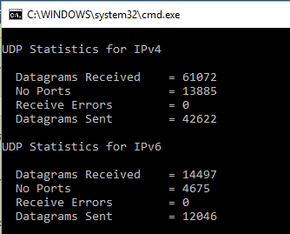

After executing ping command

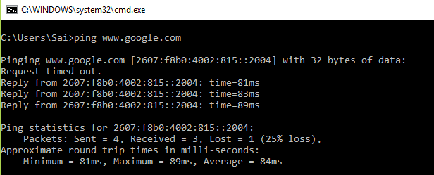

IPv4 statistics:

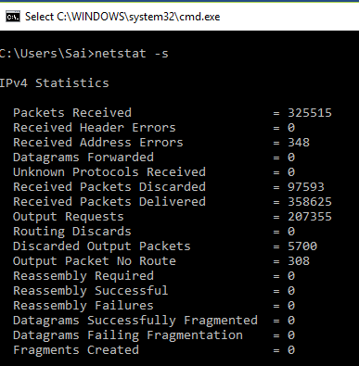

IPv6 statistics:

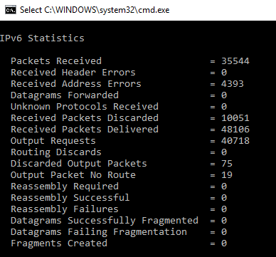

ICMPv4 Statistics:

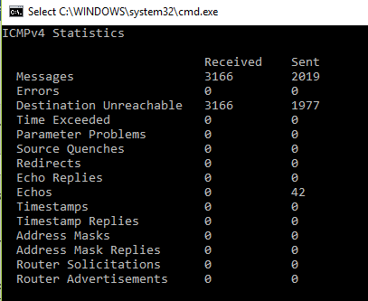

ICMPv6 stats:

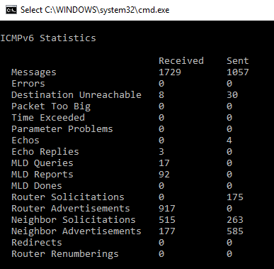

TCP stats for IPv4, IPv6

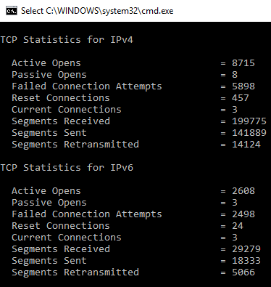

UDP stats for IPv4, IPv6

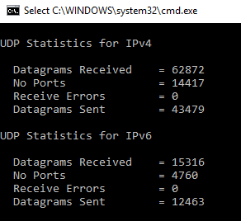

Findings:

The bundles tally got expanded somewhat. For instance: Packets got tally, got bundles conveyance tally, got parcels disposed of tally got expanded by doing the ping.

Every one of the bundles tallies got expanded, for instance: for messages check (sent/got), goal inaccessible parcels tally got expanded by doing ping to the google.com.

Practically every one of the insights means TCP and UDP got expanded.

From above investigation we saw that, in the wake of pinging to www.google.com,all the insights (IP, ICMP, TCP and UDP) got expanded.

Part 2:

1.

IP Address of source: 192.168.1.216, Port number of source: 64086

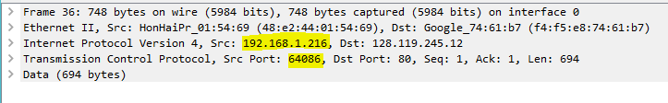

2.

IP Address: 128.119.245.12, Port Number: 80

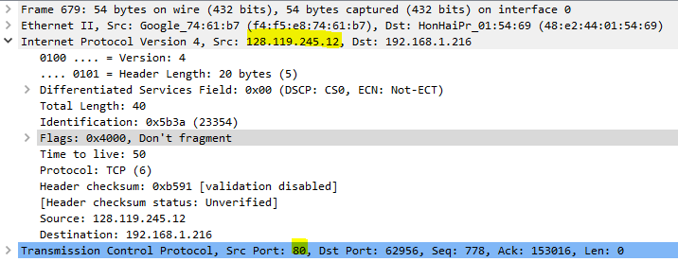

3.

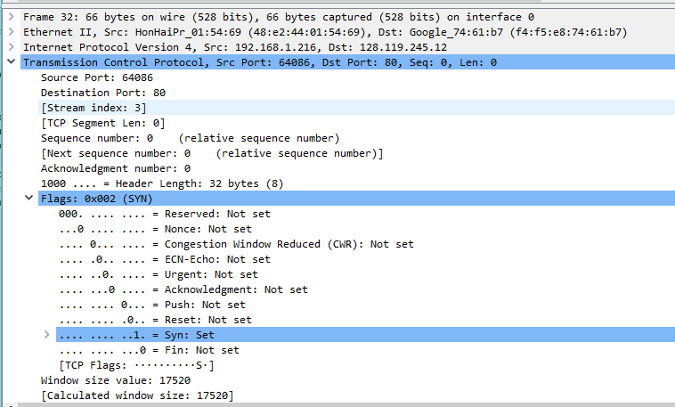

Under Transmission Control Protocol the SYN flag is set to 1 in the Flags section, which indicates that this segment is a SYN segment.

Sequence number is 0 .

4.

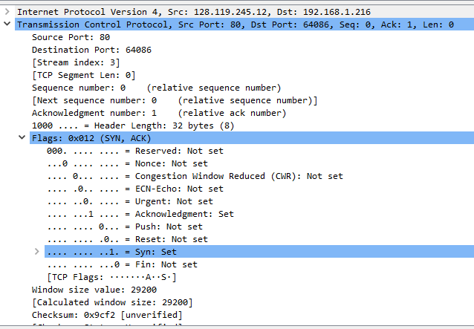

Value of acknowledgment is 1, SYN and Acknowledgment is set to 1 determines it’s a SYNACK segment.

5. Sequence number is 1.

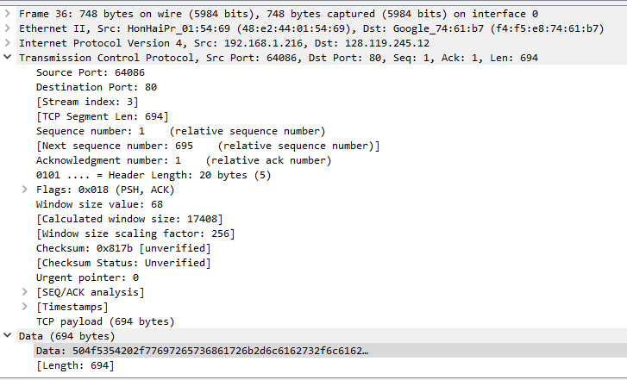

6.

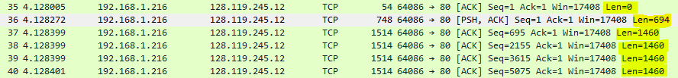

7.

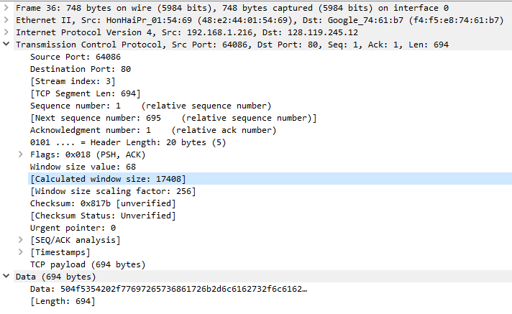

Minimum amount of buffer size available = 17408

Lacking receiver buffer size is never the reason of the sender getting throttled,

the recipient window develops until it achieves the most extreme beneficiary support size of 62780 bytes.

8.

There is no re-transmission because sequence number never decreases. It is rising throughout.

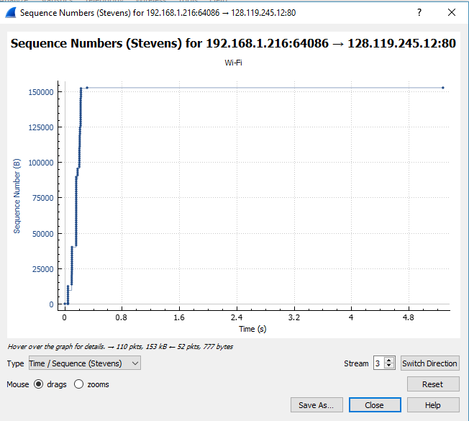

9.

The ACK numbers seems to increase as highlighted e.g. 21135, 22595, 24055 and rest follows.

The receiver acknowledges 1460 bytes which is indicated by the ACK numbers.

Each time the increase in ACK numbers is 1460.

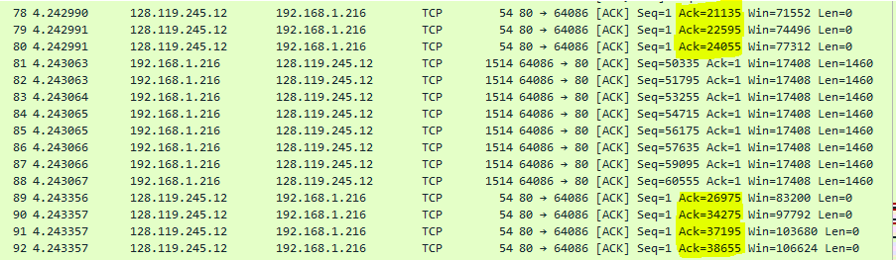

10.

Time = 9.671206-4.21210 =5.459seconds

Data transferred amount = 153016

Through put = 153016/5.459 =28030.04bytes/sec



