**UMKC**

**Name: Dwarkamoye Mohanty**

**ID: 16281824**

**5110 0001 Network Architecture - 1**

**Assignment 4**

1.

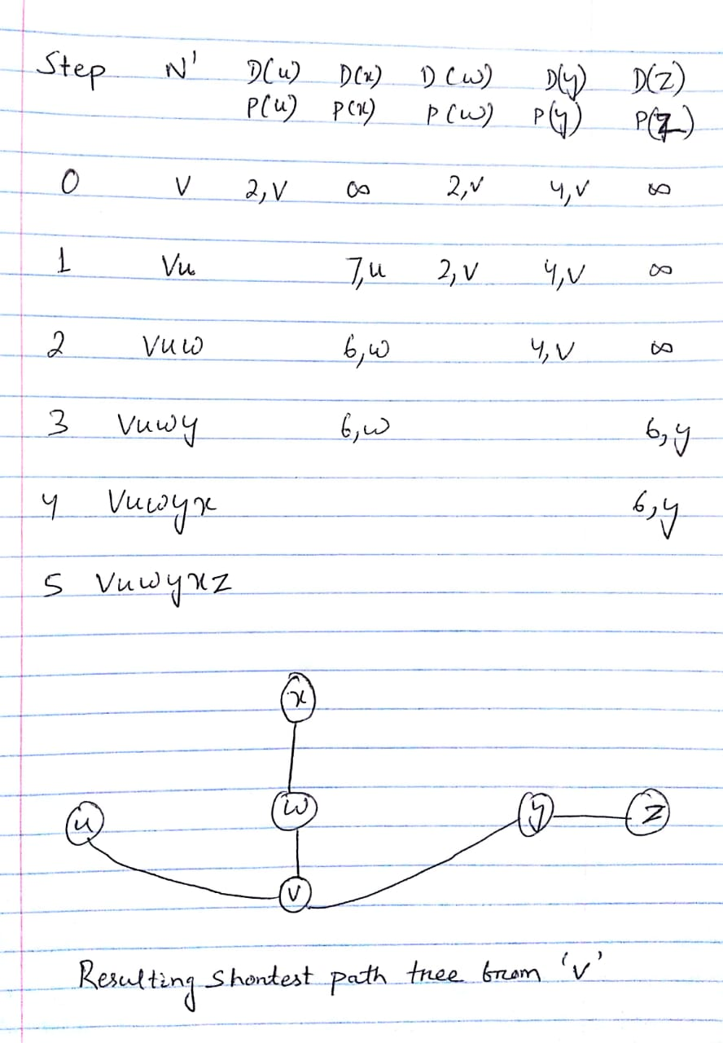

Resulting forward table at node ‘v’:

|  |  |
| --- | --- |
| **Destination** | **Link** |
| u | (v, u) |
| w | (v, w) |
| y | (v, y) |
| x | (v, w) |
| z | (v, y) |

2.

(a)

An IP address is deciphered as made from two sections: a system recognizing prefix pursued by a host identifier inside that organize. In the past classful system engineering, IP address portions depended on the bit limits of the four octets of an IP address. A location was viewed as the blend of a 8, 16, or 24-bit arrange prefix alongside a 24, 16, or 8-bit have identifier individually. In this manner, the littlest assignment and steering square contained just 256 locations—unreasonably little for most enterprises, and the following bigger square contained 65536 locations—too vast to possibly be utilized productively even by substantial associations. This prompted wasteful aspects in location use just as wasteful aspects in the directing claiming it required countless class-C systems with individual course declarations

CIDR objective was to slow the growth of routing tables on routers across the Internet and to help slow the rapid exhaustion of IPv4 addresses.

CIDR includes a few ideas. It depends on the variable-length subnet masking (VLSM) system, which permits the determination of arbitrary length prefixes. CIDR presented another technique for portrayal for IP addresses, presently normally known as CIDR documentation, in which a location or directing prefix is composed with an additional showing the number of bits of the prefix such as 192.0.1.0/24 for IPv4, and 2001:db8::/32 for IPv6.

(b)

Subnet mask:

* 32-bit number.
* Partitions IP address into host address & system address.
* Two host addresses within a network are held and can’t be assigned to hosts.
* The "0" address is relegated a network address and "255" is appointed to a broadcast address, and they can't be assigned to hosts.

(c )

|  |  |  |  |  |
| --- | --- | --- | --- | --- |
|  | CIDR Address  Specification | Range of address Allocated | Total Number of bits allocated | Total Number of bits reqd. |
| Organization 1 | 200.193.0.0/23 | 200.193.0.0 – 200.193.1.255 | 512 | 300 |
| Organization 2 | 200.193.2.0/20 | 200.193.2.0 – 200.193.9.255 | 2048 | 1500 |
| Organization 3 | 200.193.10.0/20 | 200.193.10.0 – 200.193.11.255 | 512 | 400 |
| Organization 4 | 200.193.12.0/18 | 200.193.12.0 – 200.193.43.255 | 8192 | 5000 |

|  |  |  |
| --- | --- | --- |
|  | Number address not allocated | Range of address not allocated |
| Gap 1 | 212 | 200.193.1.44 – 200.193.1.255 |
| Gap 2 | 548 | 200.193.7.219 – 200.193.9.255 |
| Gap 3 | 112 | 200.193.11.111 – 200.193.11.255 |
| Gap 4 | 3192 | 200.193.31.135 – 200.193.43.255 |

3.

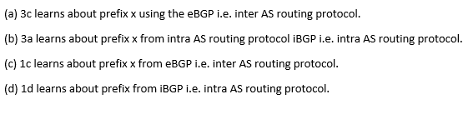

Lab Homework

Part 1:

1. IP Address: Whenever a device gets connected to computer network that communicates using Internet Protocol then a numerical address/label is assigned to it, termed as Internet Protocol Address or IP address. Primary functions of IP address are network interface identification & location addressing.

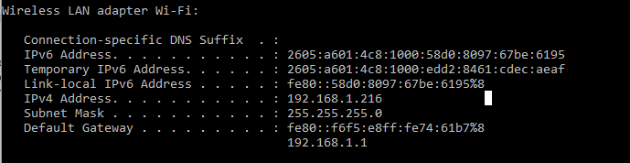

Physical Address: Physical Address or MAC address i.e. media access control address of a device or system is a unique label assigned to NIC i.e. network interface controller. It is six group of two-digit hexadecimal number, which is separated by colons, hyphens, or no separator. It is dependent on number of network adapter i.e. Ethernet or WIFI adapter, different address for different adapter.

Below is the address when connected over Wi-Fi:

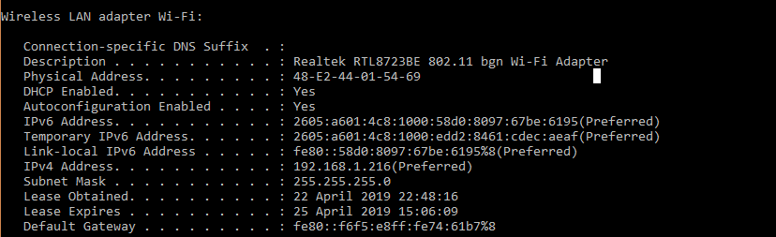

2.

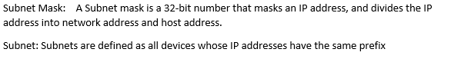

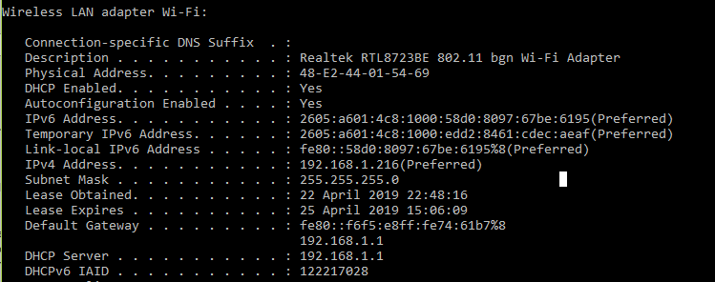

255.255.255.0 is the default subnet mask.

Subnet is**:** 192.168.1.216/21

Part 2:

3.

(a) ARP table of interface of host:

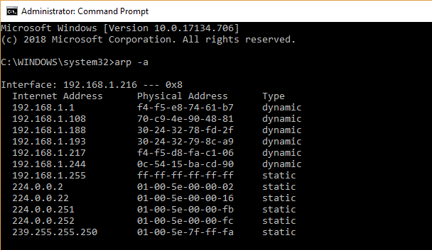

(b) Deleting entries of ARP table

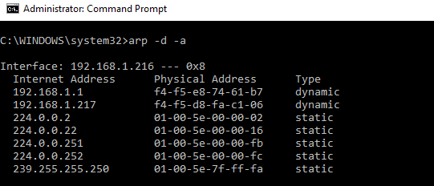

(c ) ARP table after some web browsing.

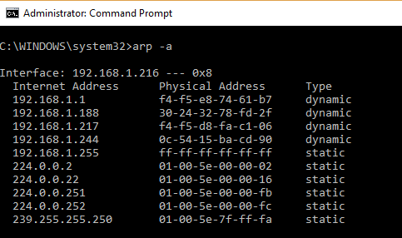

(d) ARP table after inactivity after some minutes:

The previous interface was Wi-Fi, when disconnected it is not found in ARP.

