**UMKC**

**Name: Dwarkamoye Mohanty**

**ID: 16281824**

**5110 0001 Network Architecture - 1**

**Assignment 5**

1.

The protocols can be used are TCP, DHCP, DNS, IP, eBGP, iBGP, OSPF, IGRP, RIP.

2.

Probability that a node will choose k=10 after the fifth collision in CSMA/CD is:

2^5 = 32

P = 1/32 = 0.03125 = 3.125%

K =10

Delay = k*512 = 10*512 = 5120-bit times

5120/10 Mbps = 512 microseconds

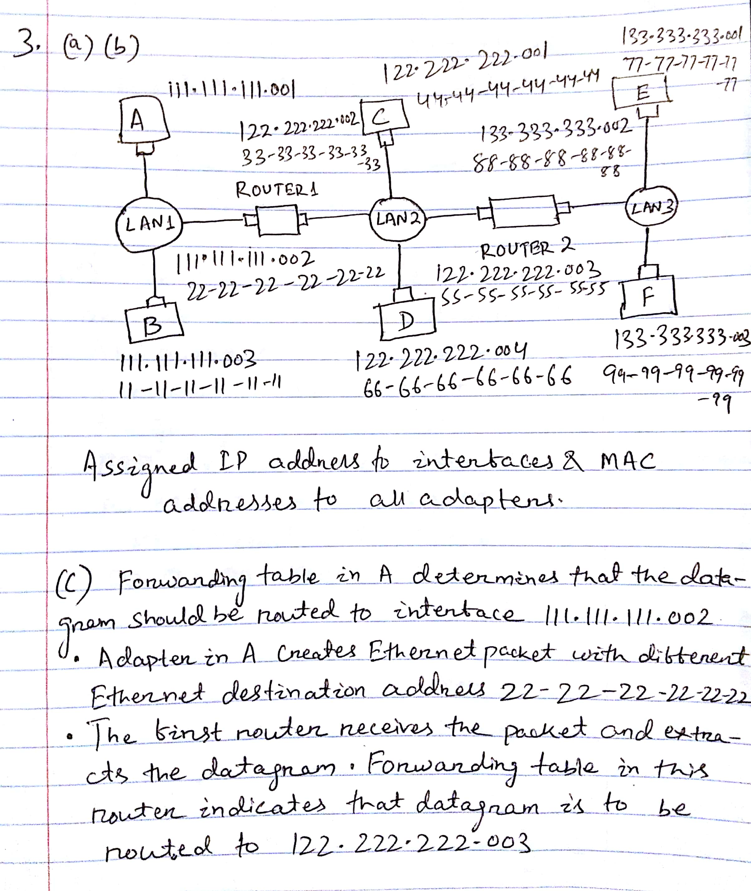

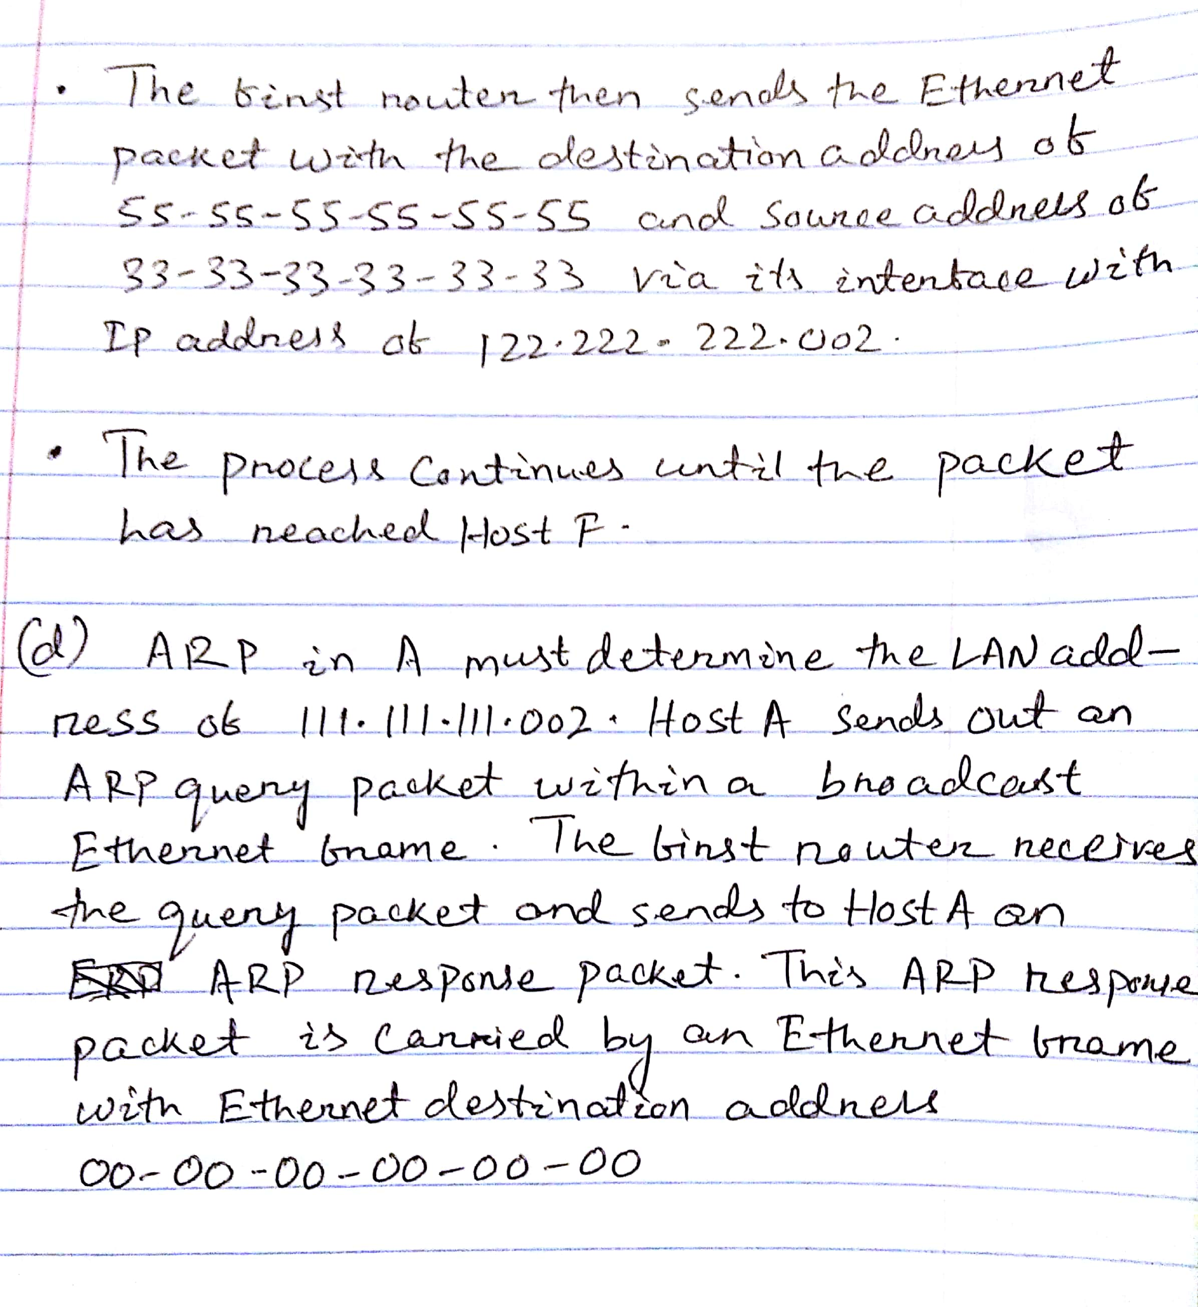

4.

(a)

a. End to End Propagation delay = 1km/ (2*10^5) km/sec = 5 microsec

b. Worst case collision detection time = 2*5 microsec = 10 microsec

c. Minimum frame size = 2*r*t = 2*100Mbps*5 microsec = 1000bits

(b)

When bandwidth takes a rise to 1Gbps, the affected one will be frame size.

If we calculate the Minimum frame size which is 2*r*t:

R = 1Gbps, t=5 microsec

* 100000bits

The transmission time is supposedly to be same or greater than total time taken for first bit to propagate to receiver and in case of collision takes place, sender should receive the jam signal from receiver.

f = 2*r*t =10000 bits = 1250 bytes.