Network Architecture – 1

P SAI SREE NIKITHA

16274538

1.

(a) Router 3c learns about prefix x from which routing protocol: OSPF, RIP, eBGP or iBGP?

Sol: 3c learns about prefix x using the eBGP i.e inter AS routing protocol.

(b) Router 3a learns about prefix x from which routing protocol?

Sol: 3a learns about prefix x from intra AS routing protocol iBGP.

(c) Router 1c learns about prefix x from which routing protocol?

Sol: Router learns about prefix x from eBGP, inter AS routing protocol.

(d) Router 1d learns about prefix x from which routing protocol?

Sol: 1d learns about prefix from iBGP, intra AS routing protocol.

2.

The probability that a node will choose k=10 after the fifth collision in CSMA/CD is:

{0,1,2, …, 2m-1}. M = 5

So, probability p = 1/32

= 0.03125

The result of k = 10 corresponds to the delay of:

Delay = K * 512-bit times and k = 10

= 10 * 512 = 5120bit times

5120bit times / 10 Mbps = 0.000512 sec

Delay = 0.000512 sec

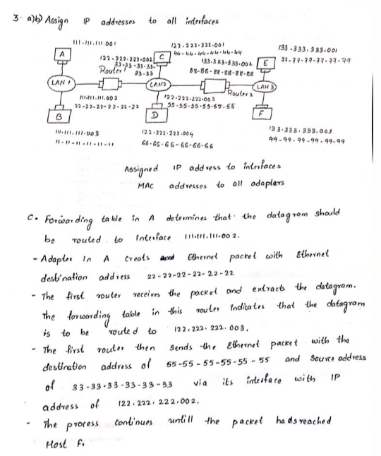

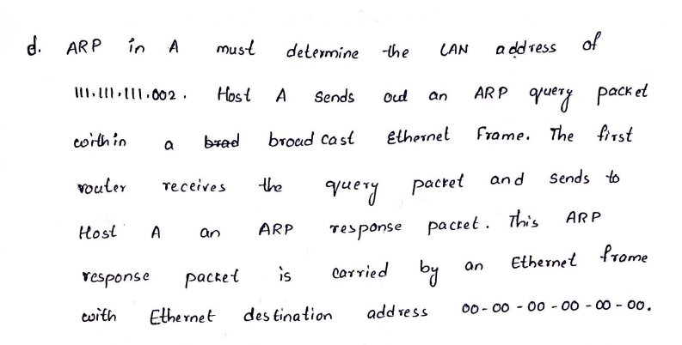

4.

a. end to end propagation delay = d/s = 1km/200000km/sec = 5microsec

b. Worst-case (i.e., the longest) collision detection time = 2 t

i.e for the signal to travel back if collision occurs = 2*5micro sec = 10 micro sec

c. Minimum frame size = f= 2*r*t = 2*10Mbps*5 micro sec

= 100bits

ii. suppose the bandwidth is increased to 1Gbps only the frame size will be affected.

Minimum frame size = 2*1Gbps*5 microsec = 100000bits

The frame size should be long enough such that if there is a collision at the receiver's side, the sender can still hear it DURING the transmission. This way, the sender wouldn't mistakenly thought that the frame has been transmitted successfully. That is, the transmission time should be equal to or larger than the summation of time it takes for the first bit to propagate to the receiver and if collision occurs, for the jam signal to travel all the way back to the sender. Suppose the frame size is f, transmission rate is r, and propagation delay is t. Then f/r >= 2*t ==> f >= r * 2 * t = 1Gbps * 2 * (1km / 200000km/s) ==> f >= 10,000 bits = 1,250 bytes.

**Laboratory Homework**

Part 1

1. Physical Address: The physical address is the MAC address of the host machine. The MAC address is a 6-digit hexadecimal number

Example of a MAC address: BE: FF: 00: A1: 2B: CC If host has more than one network adapter (for example, an ethernet adapter and a wireless adapter), it will have a different MAC address for each adapter.

IP Address: The IP address of the host machine when it is connected to any network (ethernet/wi-fi). The following screenshot shows the physical address and IPv4 address of the host machine when it is connected to the Wi-Fi.

Command: ipconfig /all Physical Address:

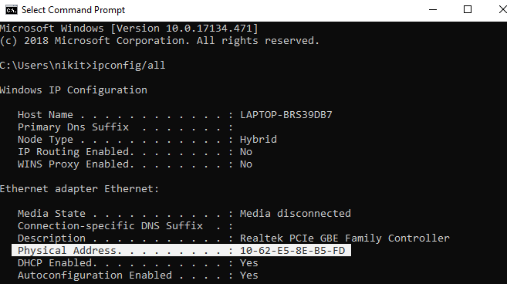

Physical address – 10-62-E5-8E-B5-FD

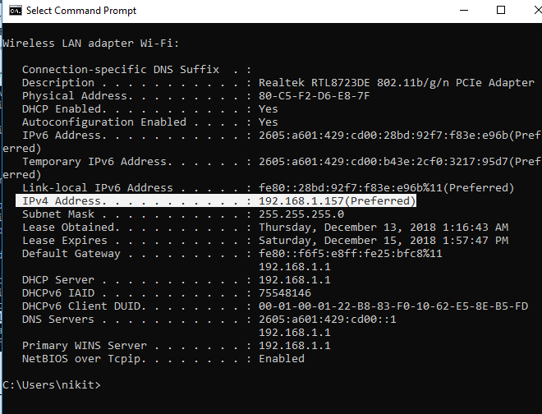

IP Address – 192.168.1.157

**2.**

Subnet Mask: A Subnet mask is a 32-bit number that masks an IP address, and divides the IP address into network address and host address.

Subnet: Subnets are defined as all devices whose IP addresses have the same prefix

The subnet mask and Subnet of the host machine:

Command: ipconfig /all

**Subnet mask: 255.255.255.0**

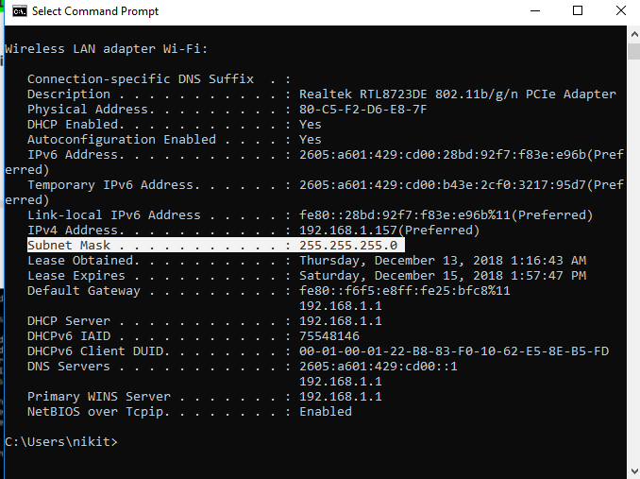

**Subnet is:** 192.168.1.157/21

**Part 2:**

1.ARP table of an interface:

Command arp -a

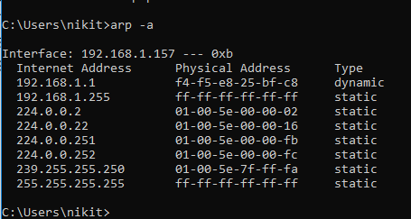

2.

To delete the entries of current ARP Table

Command arp -d

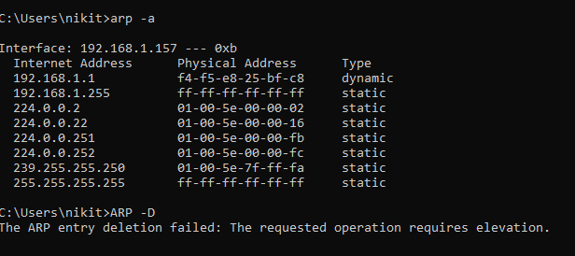

3. after web browsing



4. After no network activity

