**UMKC**

Dwarkamoye Mohanty

16281824

Individual Project-1

**Network Architecture 1**

Connect to University of Missouri System from GENI portal:



Login to University of Missouri System:

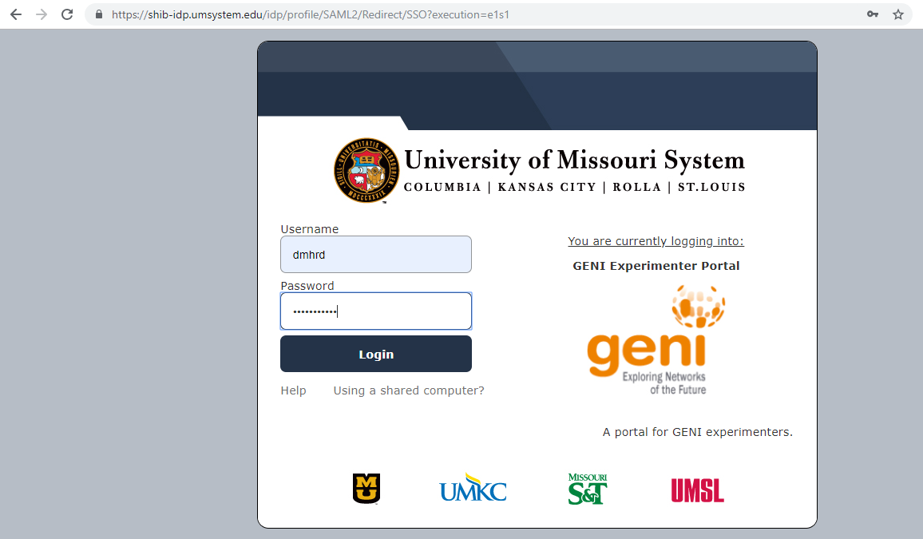

Joined Project Spring2019-NA1:

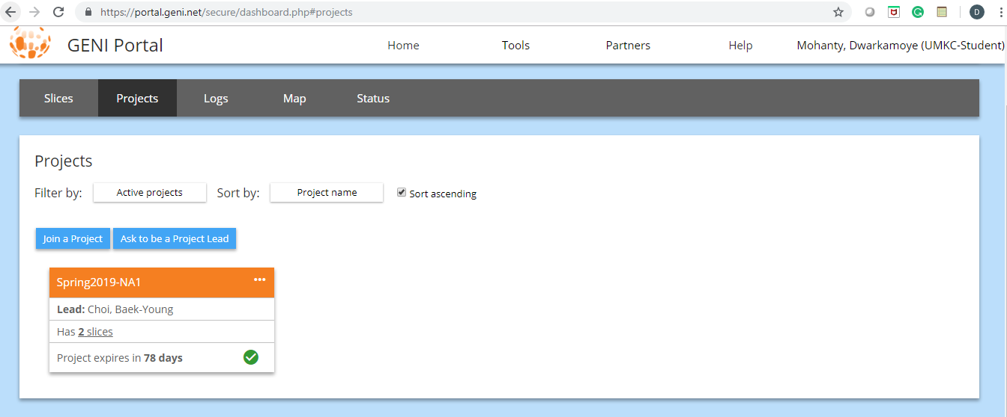

List of slices created:

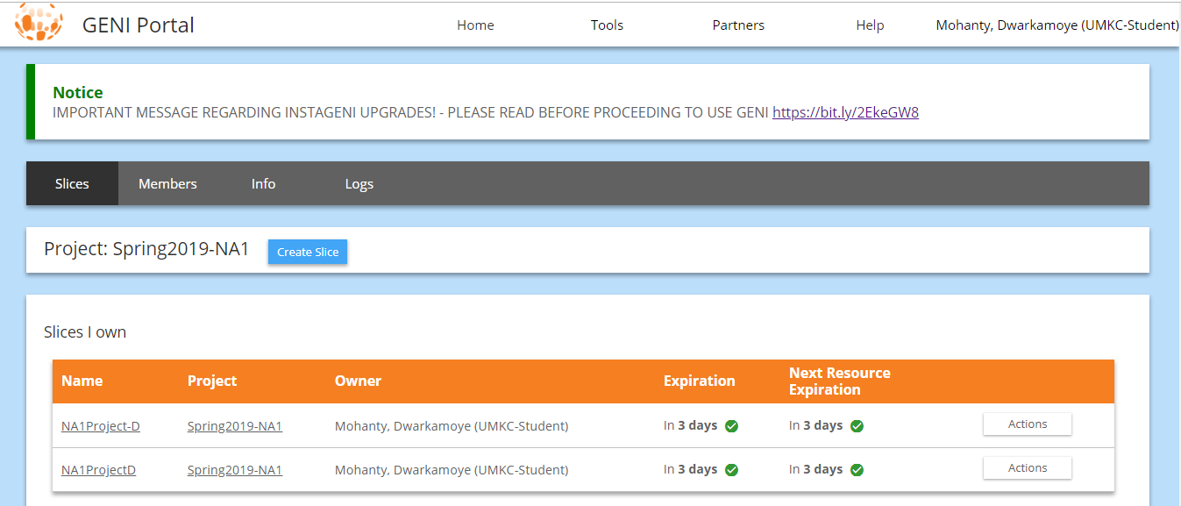

Selected Slice NA1Project-D and assigned resources:

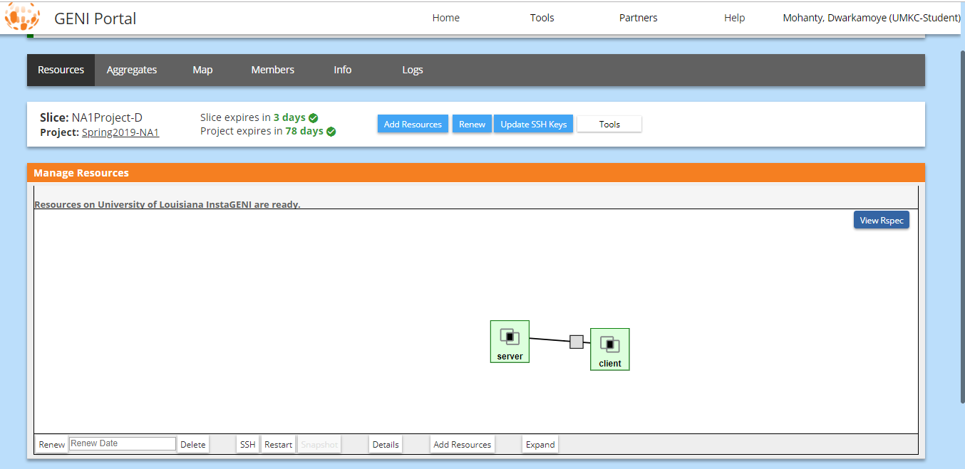

IP Details of the Server created:

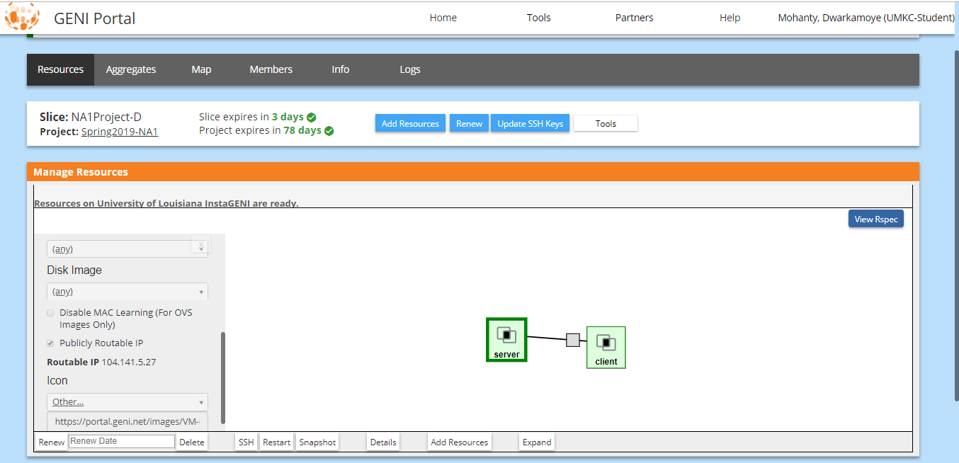

IP details of Client created:

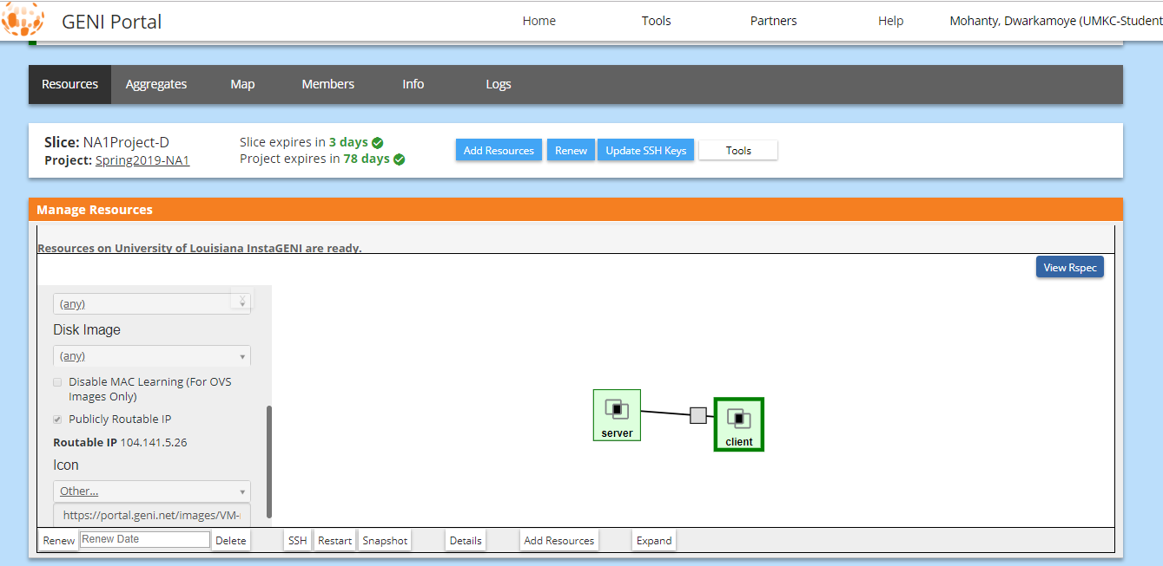

Link connecting two systems:

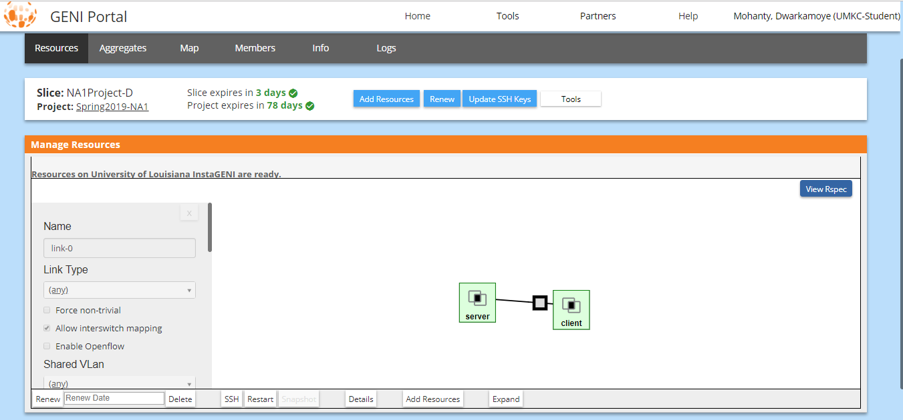

List of Machines created under University of Louisiana InstaGENI:

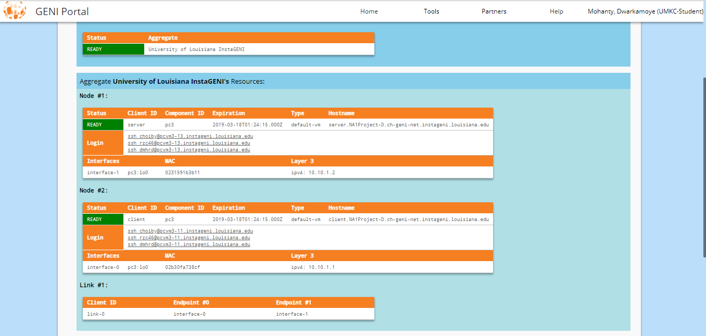

Generated SSH Keys:

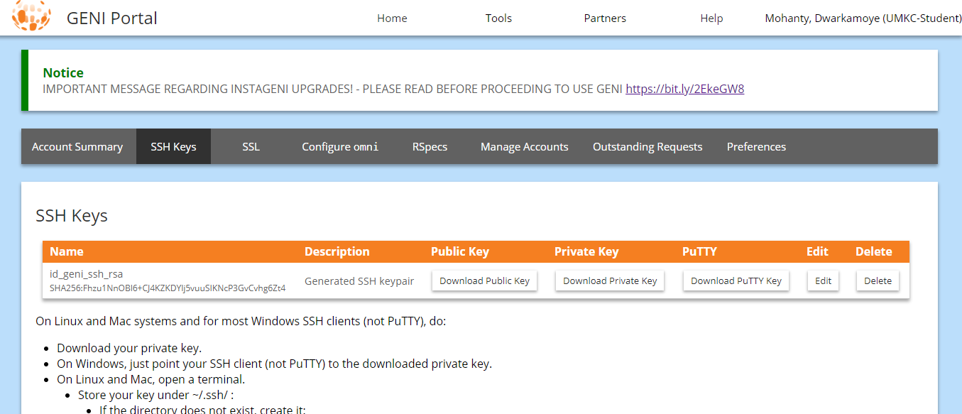

Downloaded PuTTY key:

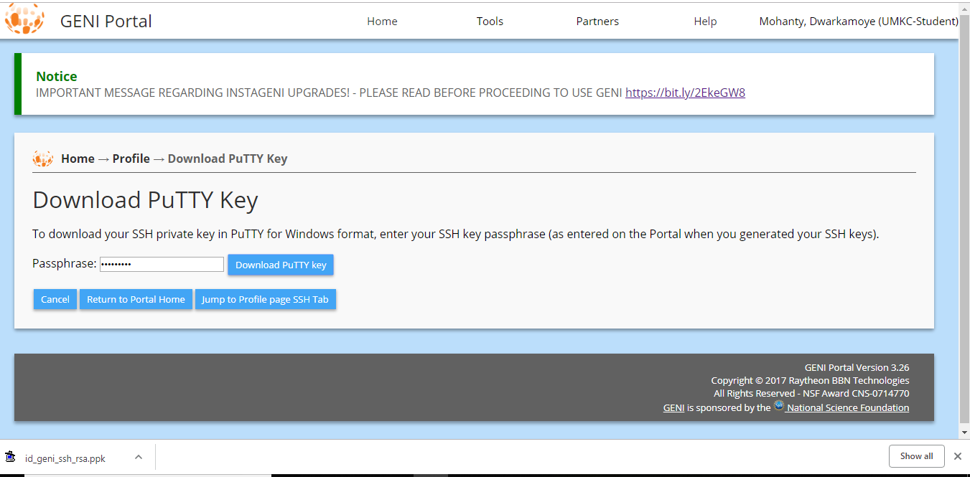

Connecting to server using PuTTY:

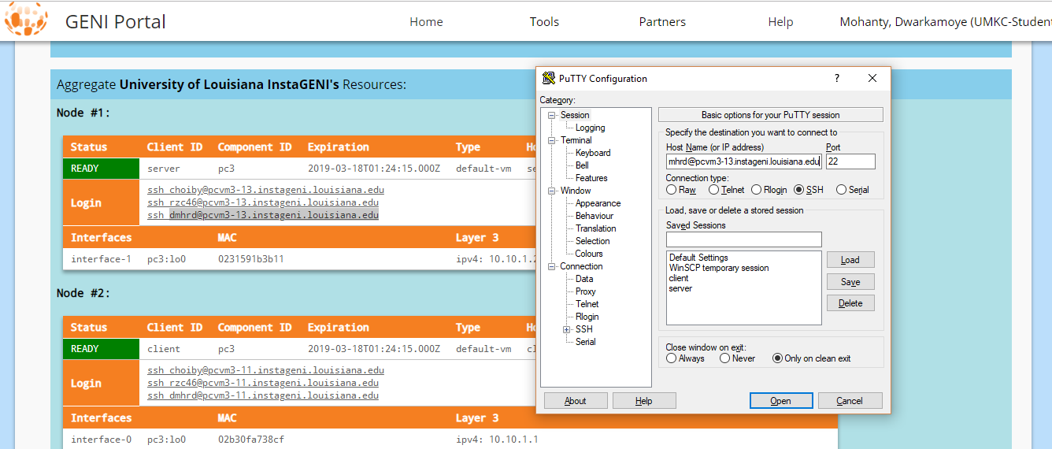

Adding PuTTY key for authentication:

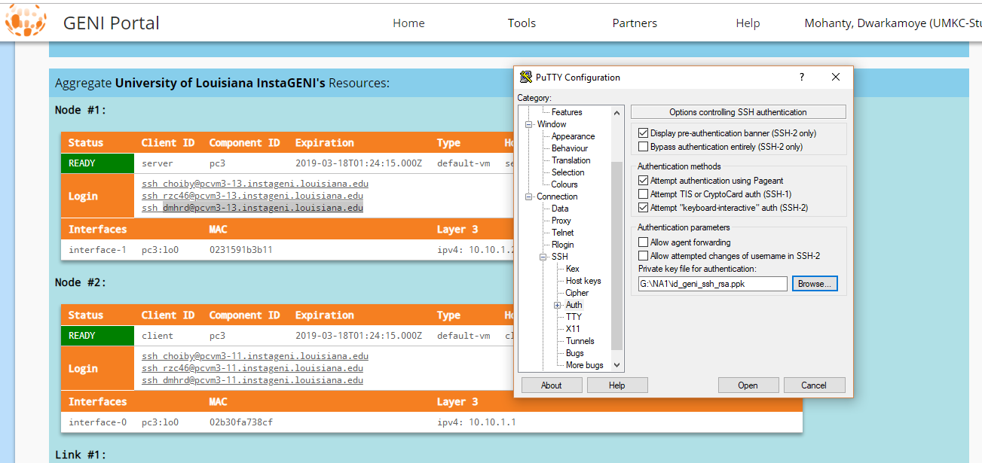

Connected to Server:

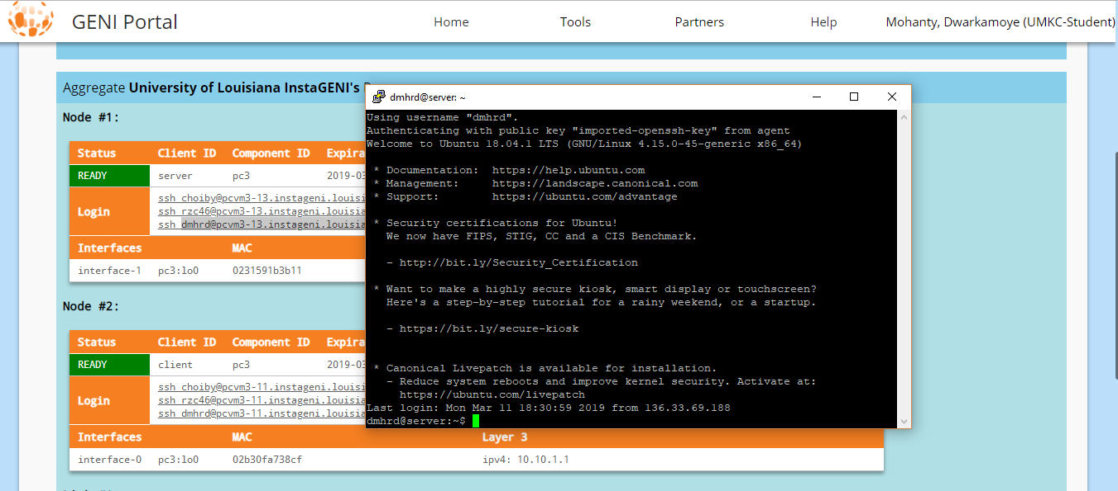

Connecting to client using PuTTY:

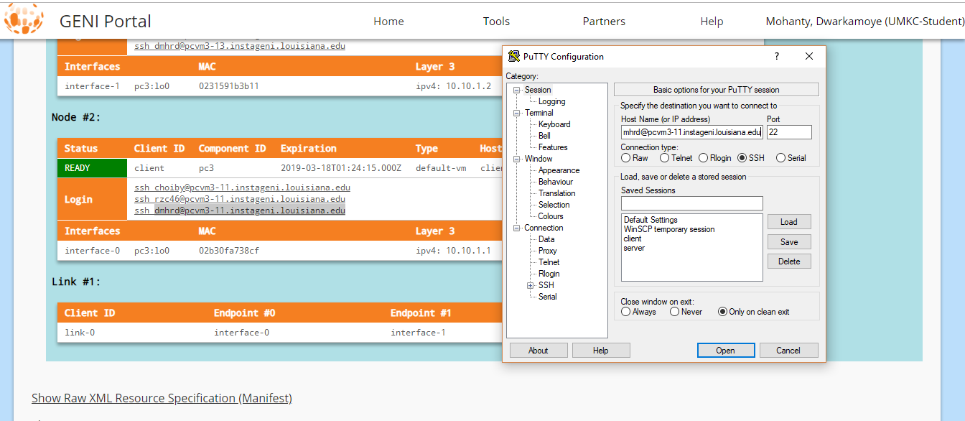

Adding PuTTY key for authentication:

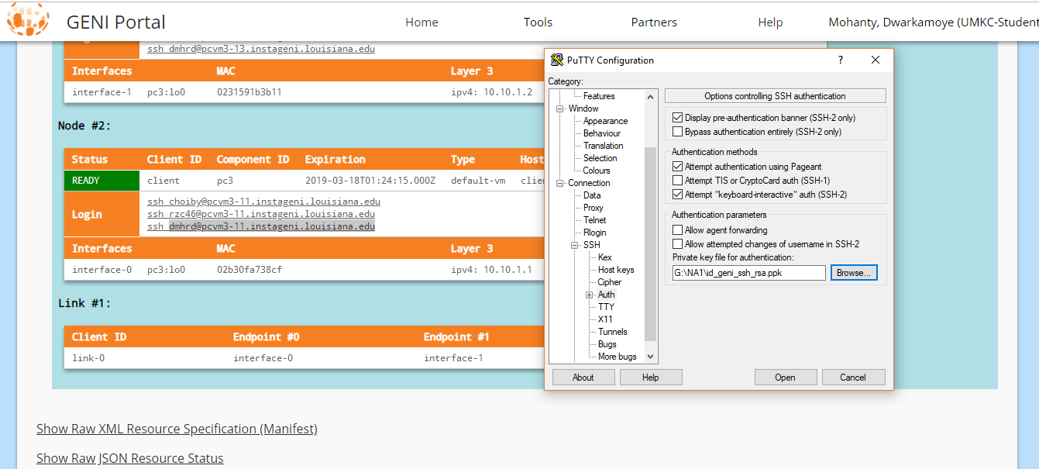

Connected to client:

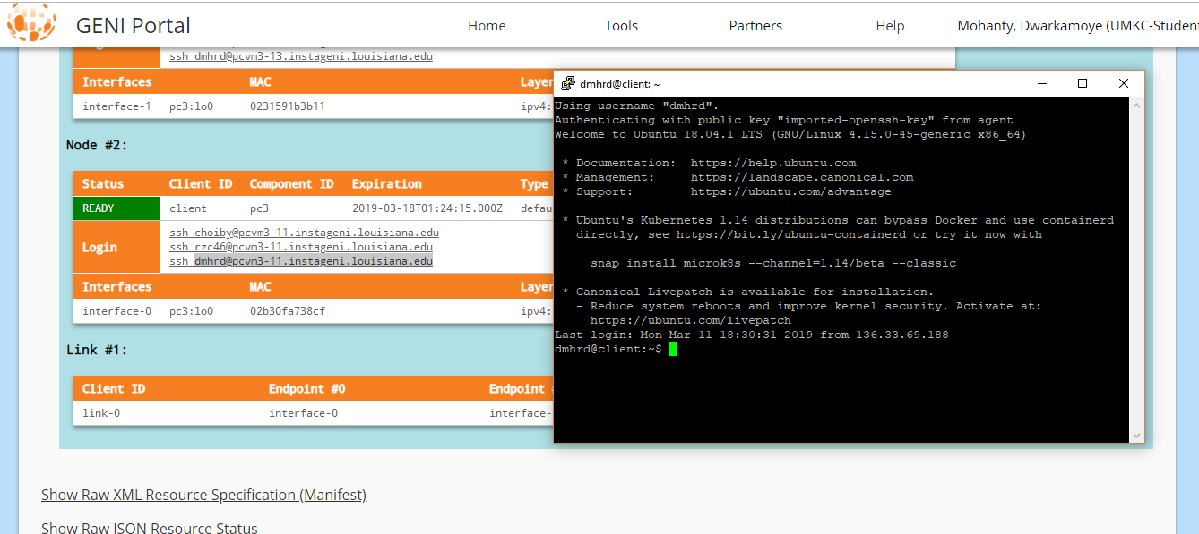

Updating the packages:

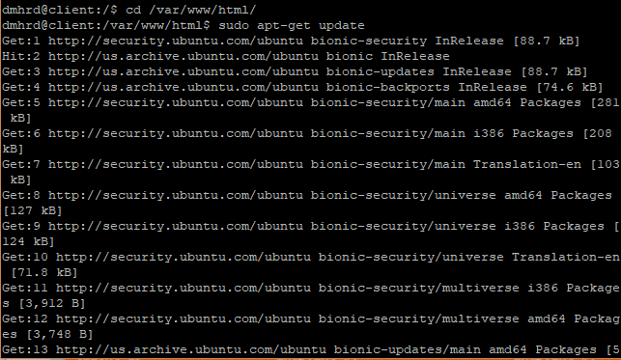

Installing apache2:

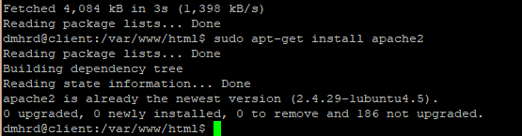

Updating index.html

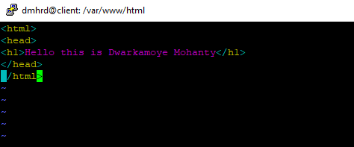

Checked for IP:



Output:



(a)

Server file to initiate Socket connection:

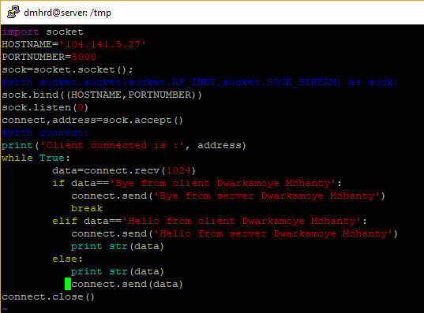

**Server code for client server communication**:

import socket  
HOSTNAME='104.141.5.27'  
PORTNUMBER=5000  
sock=socket.socket();  
#with socket.socket(socket.AF_INET,socket.SOCK_STREAM) as sock:  
sock.bind((HOSTNAME,PORTNUMBER))  
sock.listen(0)  
connect,address=sock.accept()  
#with connect:  
print('Client connected is :', address)  
while True:  
 data=connect.recv(1024)  
 if data=='Bye from client Dwarkamoye Mohanty':  
 connect.send('Bye from server Dwarkamoye Mohanty')  
 break  
 elif data=='Hello from client Dwarkamoye Mohanty':  
 connect.send('Hello from server Dwarkamoye Mohanty')  
 print str(data)  
 else:  
 print str(data)  
 connect.send(data)  
connect.close()

Here socket is opened/bind at the mentioned hostname and port number which is waiting to receive messages. Once message is received as per conditional statement it sends back the adequate message back to client. And if the message is not same as per conditions it gets echoed.

Client file to send messages over socket:

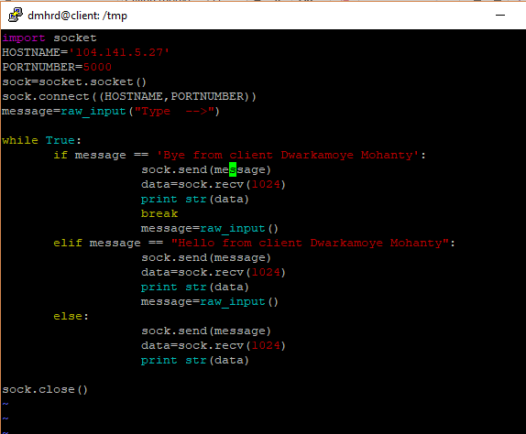

**Client code for client server communication:**

import socket  
HOSTNAME='104.141.5.27'  
PORTNUMBER=5000  
sock=socket.socket()  
sock.connect((HOSTNAME,PORTNUMBER))  
message=raw_input("Type -->")  
  
while True:  
 if message == 'Bye from client Dwarkamoye Mohanty':  
 sock.send(message)  
 data=sock.recv(1024)  
 print str(data)  
 break  
 message=raw_input()  
 elif message == "Hello from client Dwarkamoye Mohanty":  
 sock.send(message)  
 data=sock.recv(1024)  
 print str(data)  
 message=raw_input()  
 else:  
 sock.send(message)  
 data=sock.recv(1024)  
 print str(data)  
  
sock.close()

Here socket is connecting to server socket hostname and port number, once a message is typed it checks for conditional statement and process as per wise. Messages from server are printed. On “Bye from client Dwarkamoye Mohanty” server closes the connection and client follows the same.

Started Server:

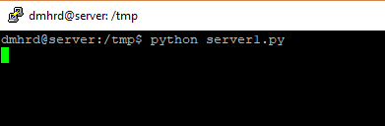

Started Client:

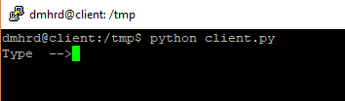

Client connected to server using socket:

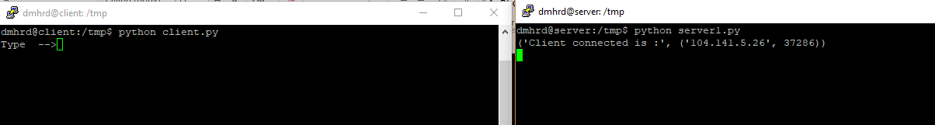

Typed message “Hello from client Dwarkamoye Mohanty” server replied with “Hello from server Dwarkamoye Mohanty”:



Typed message “Bye from client Dwarkamoye Mohanty” server replied with “Bye from server Dwarkamoye Mohanty” and closed the connection/server:

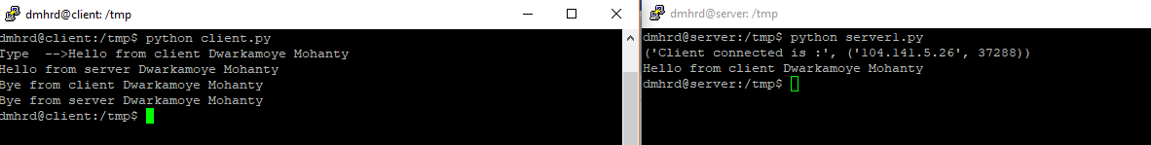

(b)

File to be transferred from client to server is >10K:

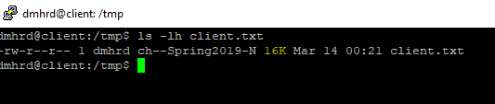

Before transferring client text file:

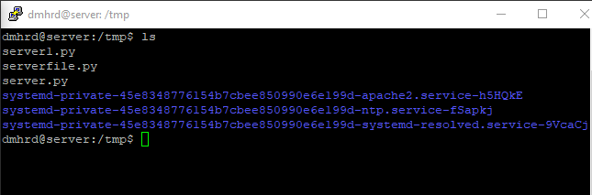

Press enter to send the text file from client to server:



Server received the file:

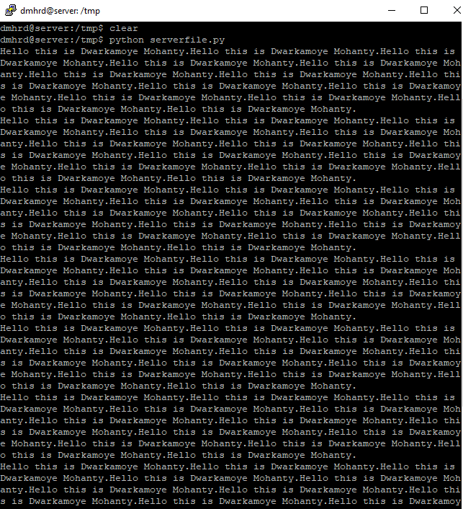

Client received the file back with a new line from server:

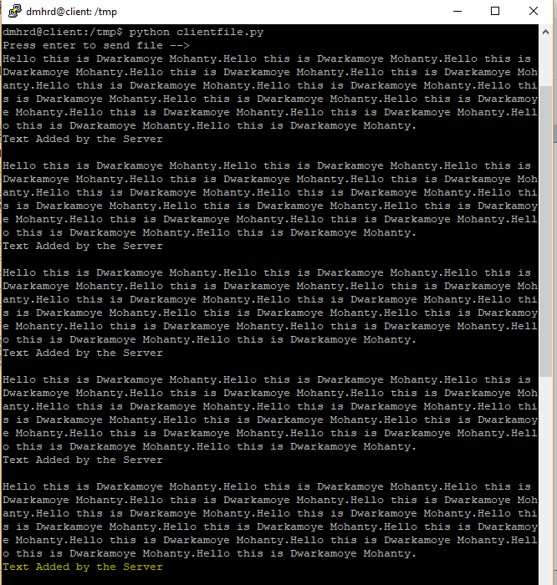

Client file for text file communication:

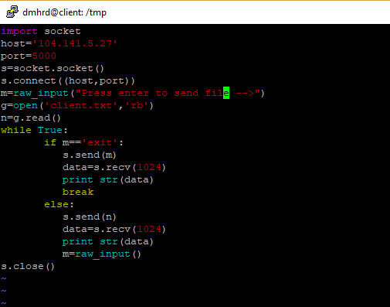

Client code for text file send and receive:

import socket  
host='104.141.5.27'  
port=5000  
s=socket.socket()  
s.connect((host,port))  
m=raw_input("Press enter to send file -->")  
g=open('client.txt','rb')  
n=g.read()  
while True:  
 if m=='exit':  
 s.send(m)  
 data=s.recv(1024)  
 print str(data)  
 break  
 else:  
 s.send(n)  
 data=s.recv(1024)  
 print str(data)  
 m=raw_input()  
s.close()

Server file for text file communication:

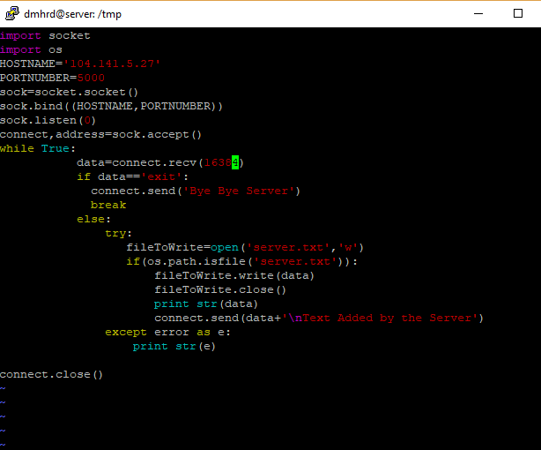

Server code for text file receive and send:

import socket  
import os  
HOSTNAME='104.141.5.27'  
PORTNUMBER=5000  
sock=socket.socket()  
sock.bind((HOSTNAME,PORTNUMBER))  
sock.listen(0)  
connect,address=sock.accept()  
while True:  
 data=connect.recv(16384)  
 if data=='exit':  
 connect.send('Bye Bye Server')  
 break  
 else:  
 try:  
 fileToWrite=open('server.txt','w')  
 if(os.path.isfile('server.txt')):  
 fileToWrite.write(data)  
 fileToWrite.close()  
 print str(data)  
 connect.send(data+'\nText Added by the Server')  
 except error as e:  
 print str(e)  
  
connect.close()

Server saves the file:

