**CS5590 APS**

**-**

**Python and Deep Learning Programming**

**LAB1**

**Team Members:**

**Dwarkamoye Mohanty (25)**

**Kruthika Basvankote Channappa (4)**

**Bhavaz Akula (2)**

**Introduction: -**

The assignment is targeted to cover python fundamentals and trying hands on machine learning models with different dataset. Python is a deciphered, abnormal state, universally useful programming language. Made by Guido van Rossum and first discharged in 1991, Python's plan reasoning stresses code intelligibility with its outstanding utilization of critical whitespace. Supervised learning is the place you have input factors (x) and a yield variable (Y) and you utilize a calculation to take in the mapping capacity from the contribution to the yield. Unsupervised learning is the place you just have input information (X) and no relating yield factors.

**Objectives: -**

* Creating list, tuple, dictionaries to do operations.
* Training classifier or model with different dataset and check the accuracy score for each model.
* Creating multiple regression and evaluating the model with R2 and RMSE score.
* Using a clustering algorithm on a dataset to find the distribution of data across clusters i.e. Unsupervised approach.

**Methods: -**

* Created Python file using PyCharm IDE.
* Downloaded the dataset from Kaggle.
* Trained model with that dataset.
* Plotted using matplotlib.

**Workflow: -**



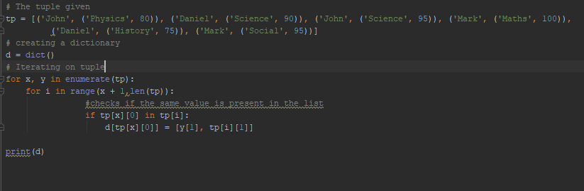



2.

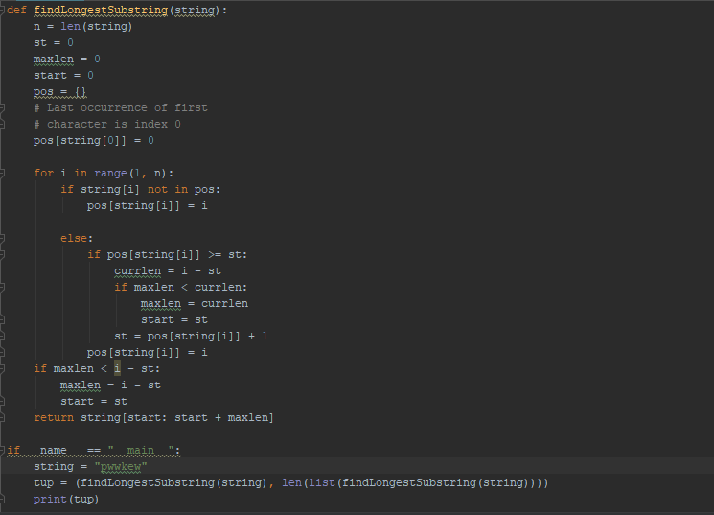

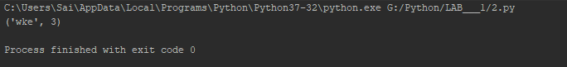

3.

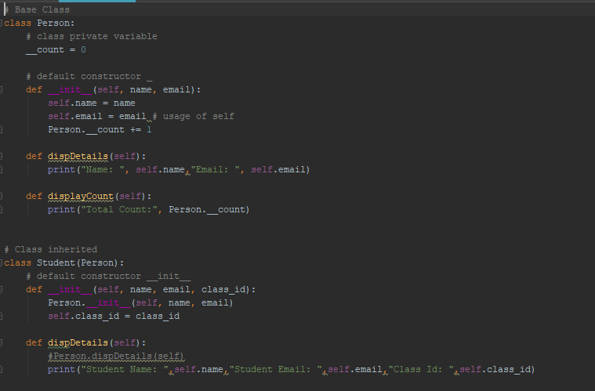

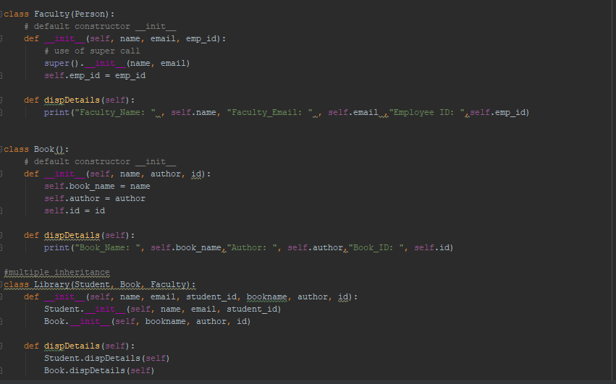

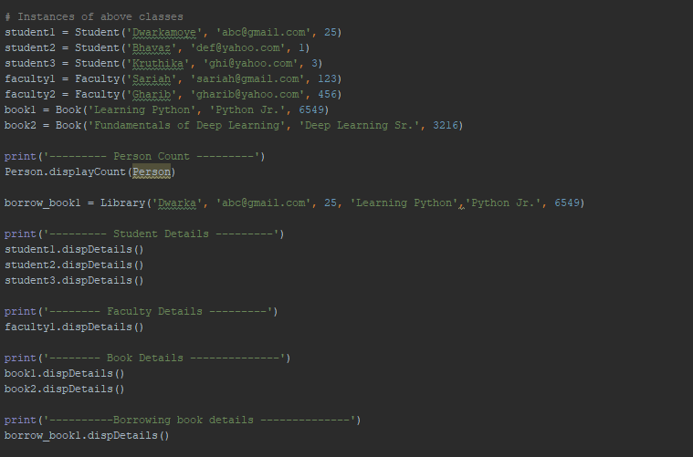

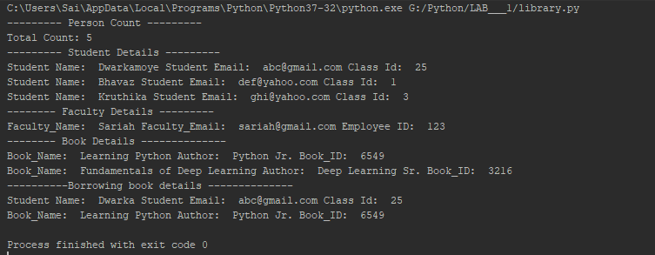

4.

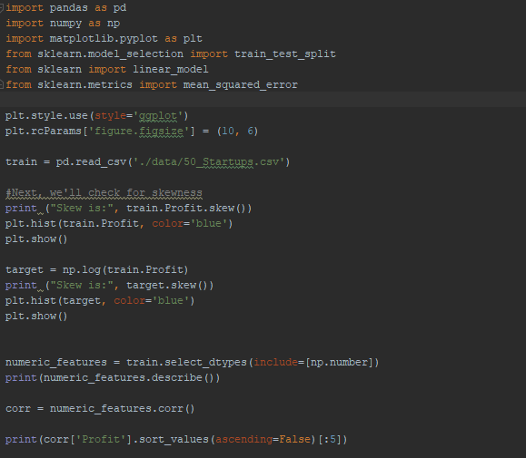

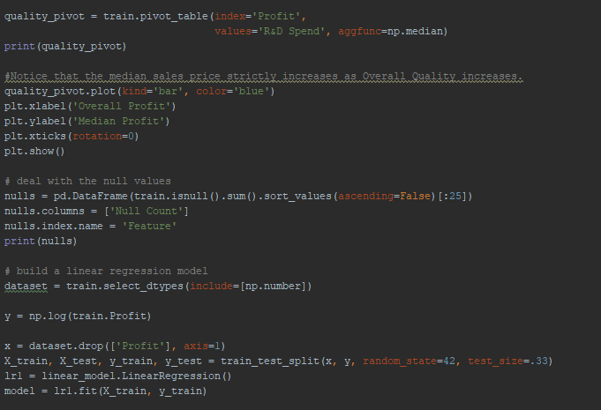

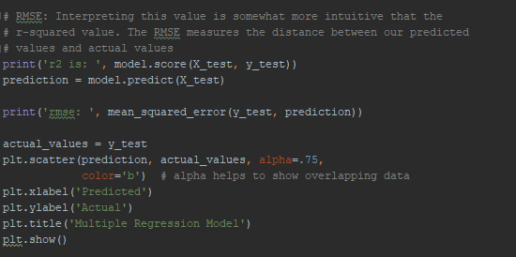

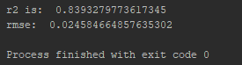

5.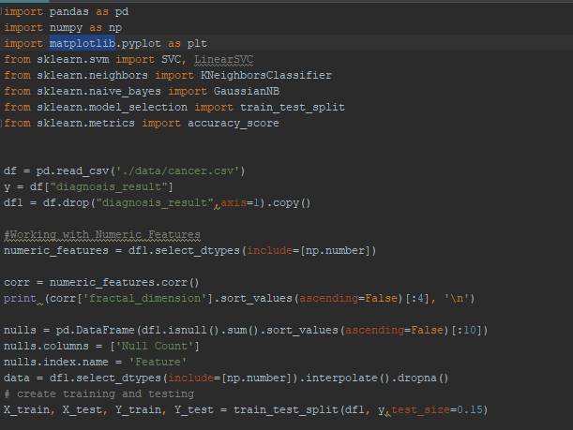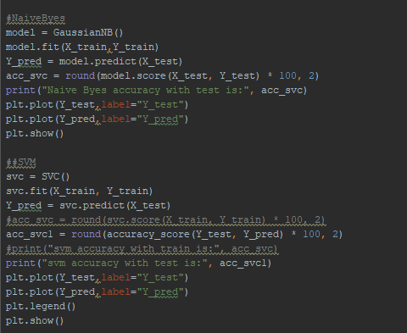

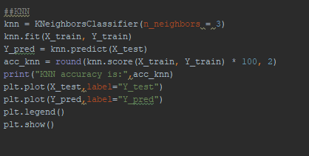

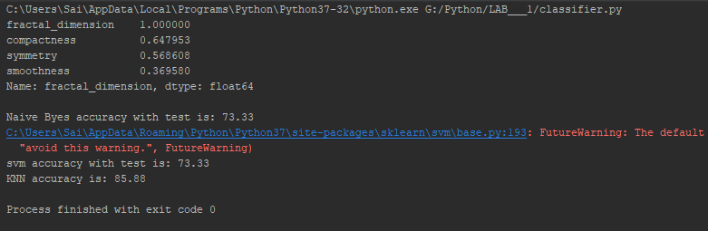

6.

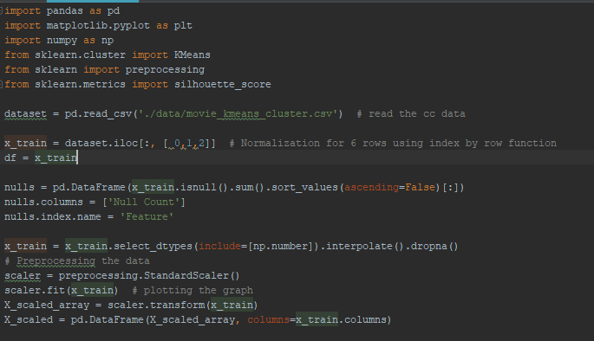

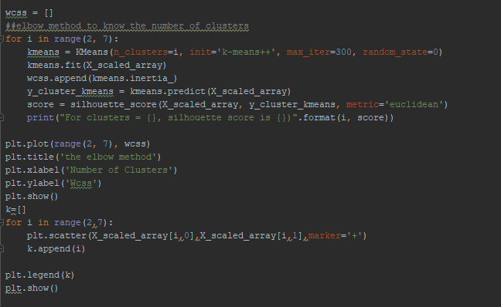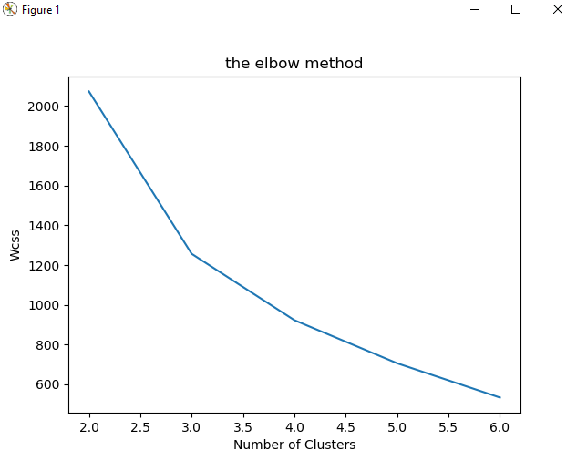

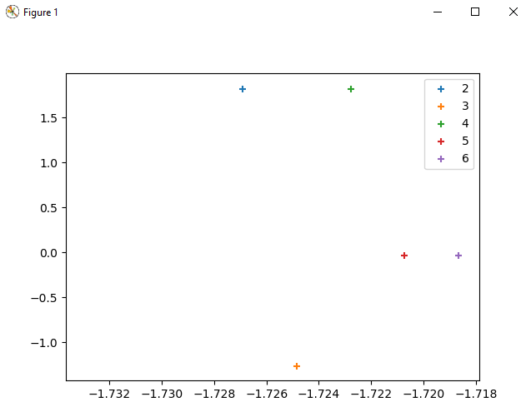

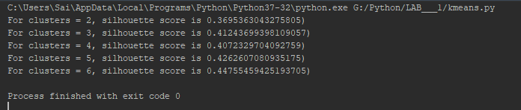

Datasets: -

<https://www.kaggle.com/>

1. We have downloaded 3 datasets,

|  |  |
| --- | --- |
| Dataset | Usage |
| 50 Startups | Multiple Regression |
| Cancer | Classifiers |
| Movie Kmeans Cluster | K Means |

**Evaluation: -**

**Conclusion: -**

We have completed the assignments covering fundamentals of python and have trained classifier with models like SVM, KNN, Naïve Byes. We have also applied Kmeans clustering and plotted the clusters successfully. We have also created Multiple regression and evaluated R2, RMSE scores successfully.

**GITHUB LINK: -**

<https://github.com/Dwarkamoye/Python-CS5590-490-0001/tree/master/Lab-1>