**CS5590 APS**

**-**

**Python and Deep Learning Programming**

**LAB2**

**Team Members:**

**Dwarkamoye Mohanty (25)**

**Kruthika Basvankote Channappa (4)**

**Bhavaz Akula (2)**

**Introduction: -**

The assignment is targeted to cover D/L concepts and trying hands on neural network models with different dataset using KERAS.

**Objectives: -**

* Creating regression and evaluating the model with MAE and Loss score.
* Creating CNN models
* Training text classification & image classification model with different dataset and check the accuracy score for each model.
* Creating LSTM model for text classification.
* Comparing CNN and LSTM model for text classification

**Methods: -**

* Created notebooks in GoogleColab.
* Downloaded the dataset from Kaggle.
* Trained model with that dataset.
* Plotted using tensorboard.

**Workflow: -**

1. 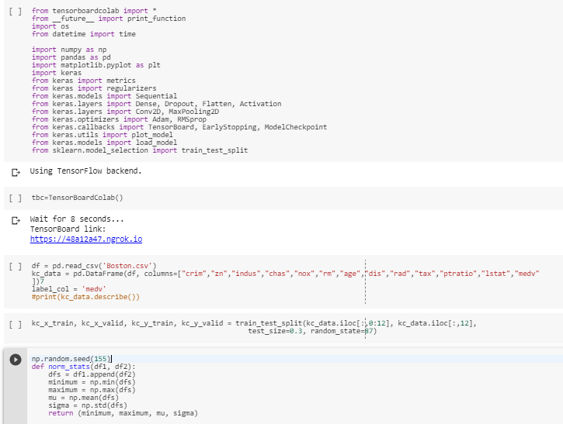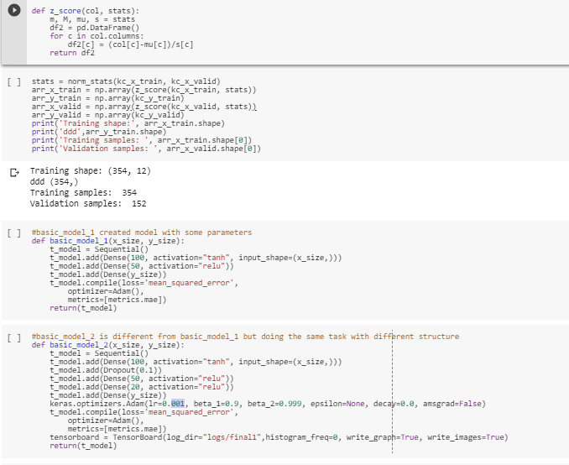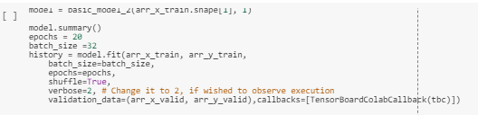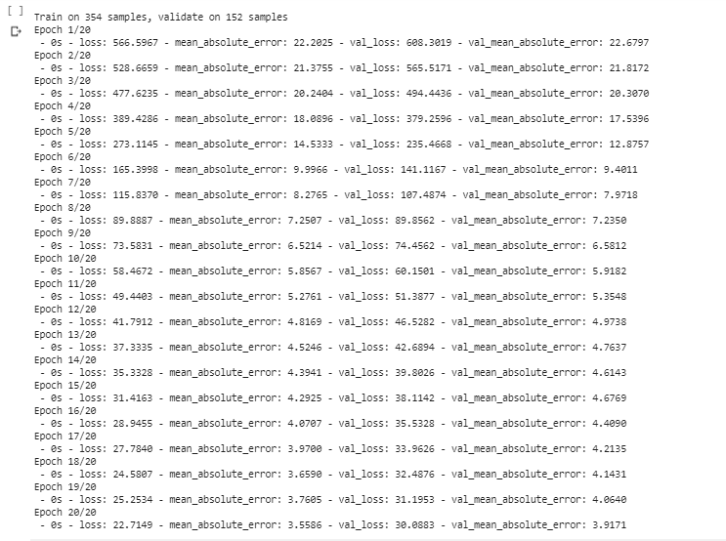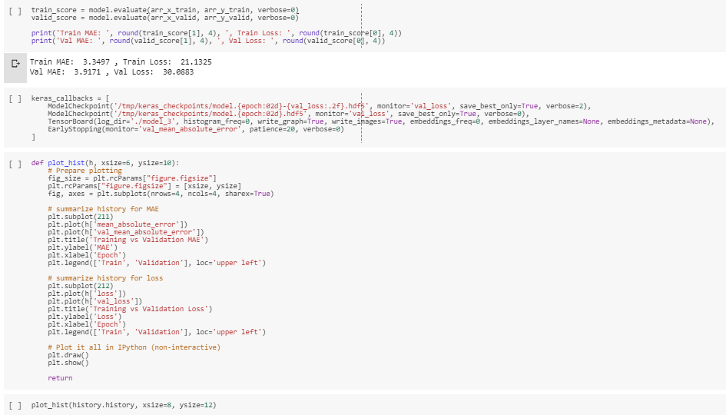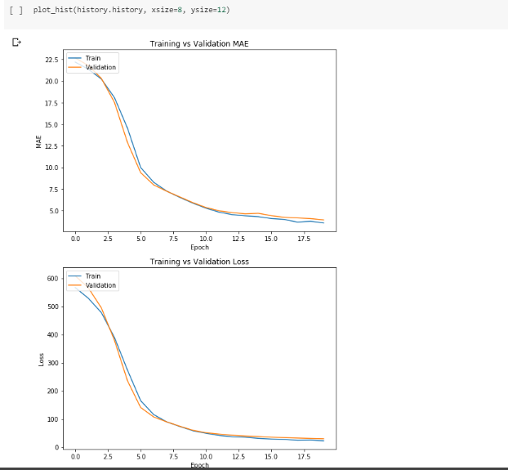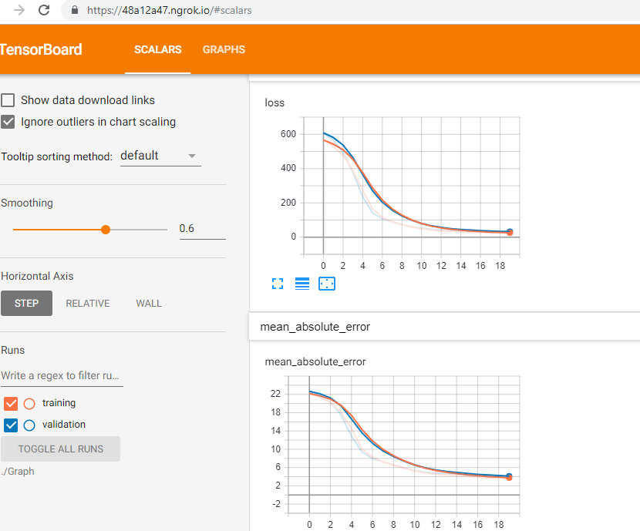

2.

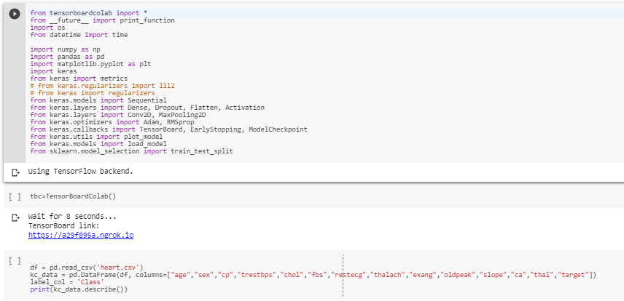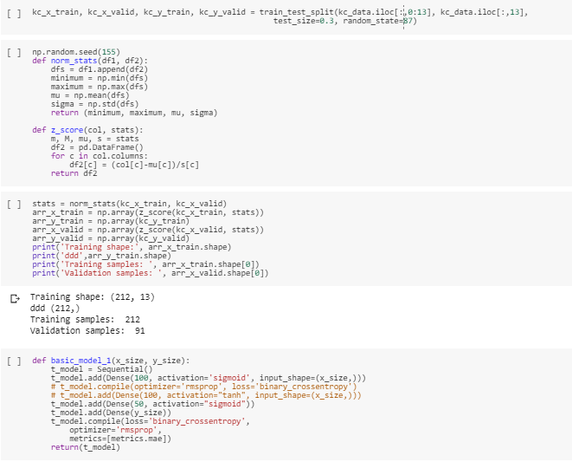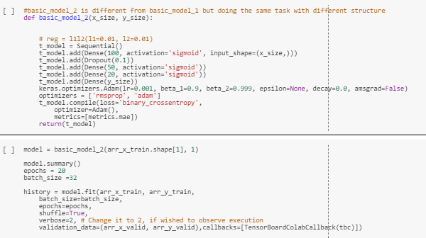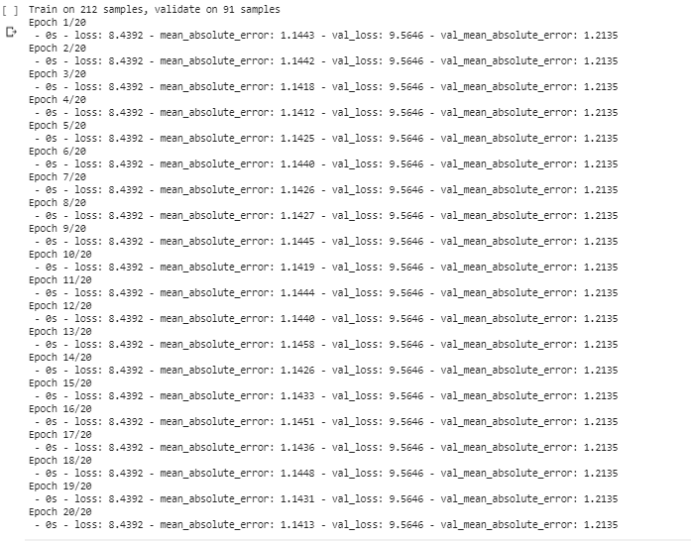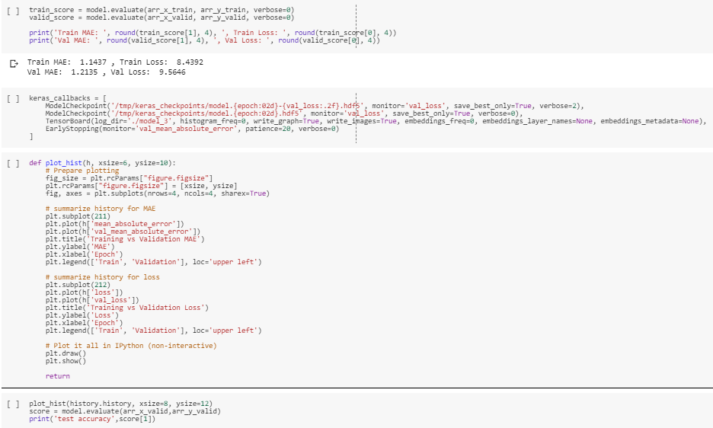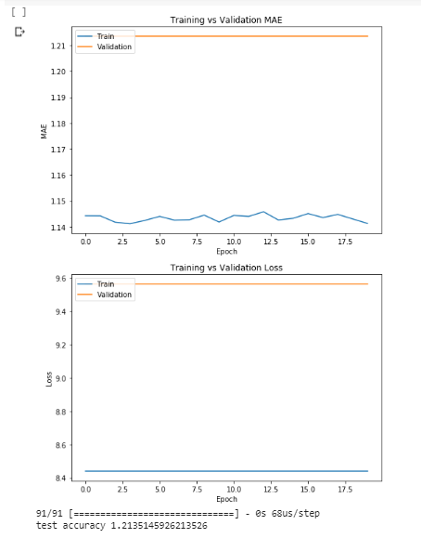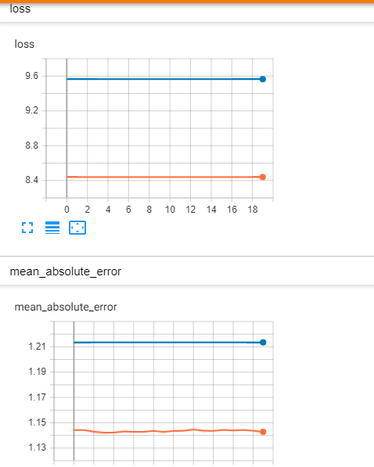

3.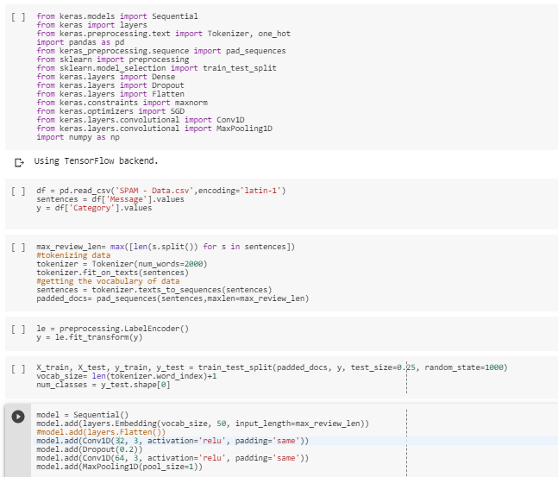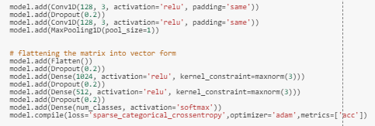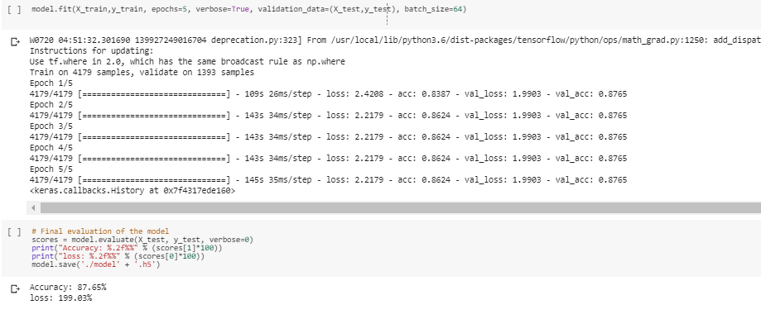4.

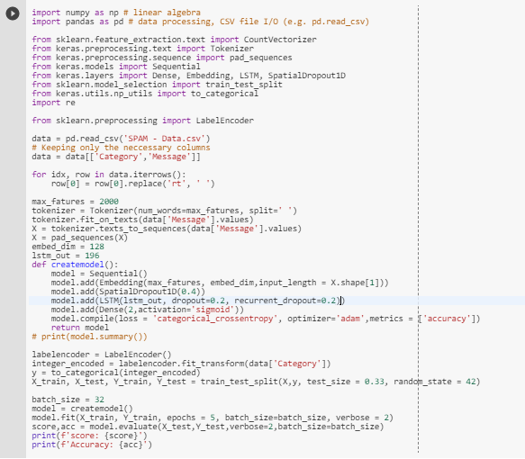

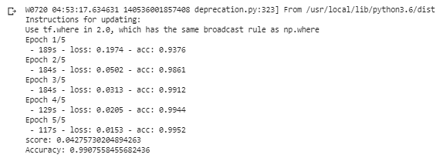

5.

|  |  |
| --- | --- |
| Model | Accuracy |
| CNN | 87.65 |
| LSTM | 99.07 |

The accuracy for LSTM model while text classification is higher than of CNN model, this is because of cell state and recurrent dropout. Dropping low priority feature over random dropping is always essential. So **LSTM** model is **best** for text classification.

6.

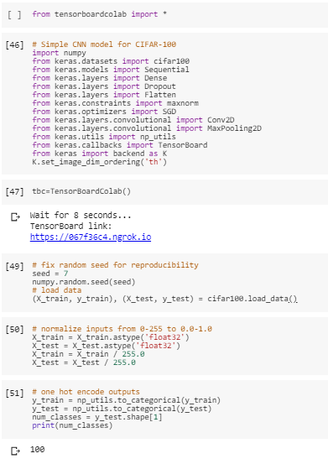

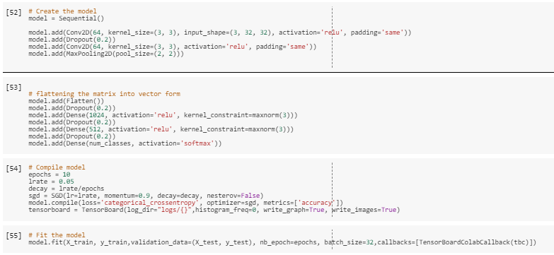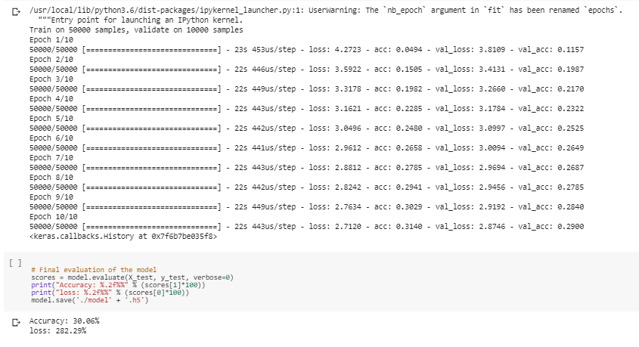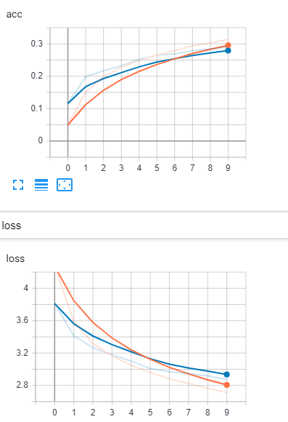

**Datasets: -**

<https://www.kaggle.com/>

<https://keras.io/datasets/>

We have downloaded 4 datasets,

|  |  |
| --- | --- |
| Dataset | Usage |
| SPAM-Data | Text Classification |
| Boston | Linear Regression |
| Heart | Logistic Regression |
| CIFAR-100 | Image Classification |

**Evaluation & Discussion: -**

A machine learning model's exhibition is viewed as great dependent on its expectation and how well it sums up on a free test dataset. Based on the presentation of various models we pick the model which positions most elevated in performance. When we have an input x and we apply a function f on the input x to anticipate an output y. Difference between the genuine yield and anticipated yield is the error. Our objective with ML algo is to produce a model which limits the mistake of the test dataset.

**Conclusion: -**

We have completed the assignments covering Deep Learning and have trained CNN & LSTM models. We have evaluated Linear & Logistic Regression, Image & Text Classification successfully.

**GITHUB LINK: -**

<https://github.com/Dwarkamoye/Python-CS5590-490-0001/tree/master/LAB-2>