PRN Number : 230943120027
Name : Dwarkesh Sanjay Virkhare

Student.cs (class) :

using System;
using System.Collections.Generic;
using System.Linq;
using System.Text;
using System.Threading.Tasks;

namespace StudentConsoleApp
{
public class Student
{
public int Rollname { get; set; }
public string name { get; set; }

public string dateofbirth { get; set; }

public double fees { get; set; }

public string email_id { get; set; }

}
}

studentDal.sc (class)

using System;
using System.Collections.Generic;
using System.Data.SqlClient;
using System.Data;
using System.Linq;
using System.Text;
using System.Threading.Tasks;
using MySql.Data.MySqlClient;
using System.Configuration;
using System.Data;

namespace StudentConsoleApp
{
public class StudentDal
{
public List<Student> GetAllStudents()
{
using (MySqlConnection CN = new MySqlConnection(ConfigurationManager.ConnectionStrings["InfowayPoDbConStr"].ConnectionString))
{
using (MySqlCommand CMD = new MySqlCommand())
{
CN.Open();
CMD.Connection = CN;
CMD.CommandType = CommandType.StoredProcedure;
CMD.CommandText = "GetAllStudent";
MySqlDataReader DR = CMD.ExecuteReader();
List<Student> Students = new List<Student>();
while (DR.Read())
{
Students.Add(new Student()
{
Rollname = Convert.ToInt32(DR["Rollname"]),
name = Convert.ToString(DR["name"]),
dateofbirth = Convert.ToString(DR["dateofbirth"]),
fees = Convert.ToDouble(DR["fees"]),
email_id = Convert.ToString(DR["email_id"]),

});
}

DR.Close();
CN.Close();
return Students;

}

}

}

public int AddStudent(Student student)
{
using (MySqlConnection CN = new MySqlConnection(ConfigurationManager.ConnectionStrings["InfowayPoDbConStr"].ConnectionString))
{
using (MySqlCommand CMD = new MySqlCommand())
{
CN.Open();
CMD.Connection = CN;
CMD.CommandType = CommandType.StoredProcedure;
CMD.CommandText = "AddStudent";
CMD.Parameters.AddWithValue("P_Rollname", student.Rollname);
CMD.Parameters.AddWithValue("P_name", student.name);
CMD.Parameters.AddWithValue("P_dateofbirth", student.dateofbirth);
CMD.Parameters.AddWithValue("P_fees", student.fees);
CMD.Parameters.AddWithValue("P_email_id", student.email_id);

int result = CMD.ExecuteNonQuery();
return result;

}
}
}

public int UpdateCustomer(Student student)
{

using (MySqlConnection CN = new MySqlConnection(ConfigurationManager.ConnectionStrings["InfowayPoDbConStr"].ConnectionString))
{
using (MySqlCommand CMD = new MySqlCommand())
{
CN.Open();
CMD.Connection = CN;
CMD.CommandType = CommandType.StoredProcedure;
CMD.CommandText = "UdateStudent";
CMD.Parameters.AddWithValue("P_Rollname", student.Rollname);
CMD.Parameters.AddWithValue("P_name", student.name);
CMD.Parameters.AddWithValue("P_dateofbirth", student.dateofbirth);
CMD.Parameters.AddWithValue("P_fees", student.fees);
CMD.Parameters.AddWithValue("P_email_id", student.email_id);

int result = CMD.ExecuteNonQuery();
return result;

}
}

}

public int RemoveStudent(Student student)
{
using (MySqlConnection CN = new MySqlConnection(ConfigurationManager.ConnectionStrings["InfowayPoDbConStr"].ConnectionString))
{
using (MySqlCommand CMD = new MySqlCommand())
{
CN.Open();
CMD.Connection = CN;
CMD.CommandType = CommandType.StoredProcedure;
CMD.CommandText = "RemoveStudent";
CMD.Parameters.AddWithValue("P_Rollnumber", student.Rollname);
int result = CMD.ExecuteNonQuery();
return result;

}
}

}

}
}

programe.sc :

using System;
using System.Collections.Generic;

public enum Course
{
DAC,
DMC,
DVLSI,
DESD,
DACA,
DSSD,
DBDA
}

public class Student
{
public int RollNumber { get; set; }
public string Name { get; set; }
public string DateOfBirth { get; set; }
public double Fees { get; set; }
public string EmailId { get; set; }
public Course Course { get; set; }

// Default constructor
public Student()
{
}

// Parameterized constructor
public Student(int rollNo, string name, string dateOfBirth, double fees, string emailId, Course course)
{
RollNumber = rollNo;
Name = name;
DateOfBirth = dateOfBirth;
Fees = fees;
EmailId = emailId;
Course = course;
}

// Search method to print data on console based on student rollNo or name
public void Search(List<Student> studentList, int rollNo = 0, string name = null)
{
if (rollNo != 0)
{
var student = studentList.Find(s => s.RollNumber == rollNo);
if (student != null)
Console.WriteLine($"Roll No: {student.RollNumber}, Name: {student.Name}, Course: {student.Course}, Fees: {student.Fees}");
else
Console.WriteLine("Student not found with the given Roll No.");
}
else if (!string.IsNullOrEmpty(name))
{
var student = studentList.Find(s => s.Name == name);
if (student != null)
Console.WriteLine($"Roll No: {student.RollNumber}, Name: {student.Name}, Course: {student.Course}, Fees: {student.Fees}");
else
Console.WriteLine("Student not found with the given Name.");
}
}
}

public class StudentDatabase
{
private List<Student> students = new List<Student>();

// Event declaration
public event Action StudentListChanged;

// Add student to the in-memory list (simulating a database)
public void AddStudent(Student student)
{
students.Add(student);
OnStudentListChanged();
}

// Update student details in the in-memory list
public void UpdateStudent(Student student)
{
var existingStudent = students.Find(s => s.RollNumber == student.RollNumber);
if (existingStudent != null)
{
existingStudent.Name = student.Name;
existingStudent.DateOfBirth = student.DateOfBirth;
existingStudent.Fees = student.Fees;
existingStudent.EmailId = student.EmailId;
existingStudent.Course = student.Course;
OnStudentListChanged();
}
else
{
Console.WriteLine("Student not found with the given Roll No.");
}
}

// Remove student from the in-memory list
public bool RemoveStudent(int rollNo)
{
var student = students.Find(s => s.RollNumber == rollNo);
if (student != null)
{
students.Remove(student);
OnStudentListChanged();
return true;
}
else
{
Console.WriteLine("Student not found with the given Roll No.");
return false;
}
}

// Event firing method
private void OnStudentListChanged()
{
StudentListChanged?.Invoke();
}

// Get all students in the in-memory list
public List<Student> GetAllStudents()
{
return students;
}
}

class Program
{
static void Main(string[] args)
{
// Example usage of the Student and StudentDatabase classes
StudentDatabase studentDatabase = new StudentDatabase();

// Subscribe to the event
studentDatabase.StudentListChanged += () => Console.WriteLine("Student list changed!");

// Adding a student
Student newStudent1 = new Student(1, "John Doe", "1990-01-01", 5000.0, "john@example.com", Course.DAC);
studentDatabase.AddStudent(newStudent1);

Student newStudent2 = new Student(1, "Jane Smith", "1999-08-20", 6000.0, "jane.smith@example.com", Course.DESD);
studentDatabase.AddStudent(newStudent2);

Student newStudent3 = new Student(3, "Bob Johnson", "2001-02-10", 4500.5, "bob.johnson@example.com", Course.DSSD);
studentDatabase.AddStudent(newStudent3);

Student newStudent4 = new Student(4, "Alice Brown", "2000-11-05", 5500.75, "alice.brown@example.com", Course.DESD);
studentDatabase.AddStudent(newStudent4);

Student newStudent5 = new Student(5, "Charlie Wilson", "1998-07-30", 7000.25, "charlie.wilson@example.com", Course.DMC);
studentDatabase.AddStudent(newStudent5);

// Searching for a student
newStudent1.Search(studentDatabase.GetAllStudents());

// Updating a student
Student updatedStudent = new Student(1, "John Updated", "1990-01-01", 2500.0, "john@example.com", Course.DMC);
studentDatabase.UpdateStudent(updatedStudent);

// Searching for the updated student
updatedStudent.Search(studentDatabase.GetAllStudents());

// Removing a student
studentDatabase.RemoveStudent(1);

// Searching for the removed student
updatedStudent.Search(studentDatabase.GetAllStudents());

Console.ReadLine();
}
}

App.cofigue :
<?xml version="1.0" encoding="utf-8" ?>
<configuration>
<startup>
<supportedRuntime version="v4.0" sku=".NETFramework,Version=v4.8.1" />
</startup>
<connectionStrings>
<add name ="InfowayPoDbConStr" connectionString="Data Source=127.0.0.1;Port=3306;Database=mvc;User Id=root;Password=root" providerName="MySql.Data.MySqlClient"/>
</connectionStrings>
</configuration>

stored Procedures ;

Addstudent ;

CREATE DEFINER=`root`@`localhost` PROCEDURE `AddStudent`(
P_Rollname int ,
P_name varchar(200),
P_dateofbirth date ,
P_fees decimal(10,2),
P_email_id varchar(100)
)
BEGIN
INSERT INTO student(Rollnumber, Name, dateofbirth, fees, email_id)
VALUES (P_Rollname, P_name, P_dateofbirth, P_fees, P_email_id);
END

GetAll Students

CREATE DEFINER=`root`@`localhost` PROCEDURE `GetAllStudent`()
BEGIN
select *from student ;
END

Getstudent

CREATE DEFINER=`root`@`localhost` PROCEDURE `GetStudentDetails`(
P_rollnumber int
)
BEGIN
select *from student where Rollnumber = P_rollnumber ;
END

Search student

table database

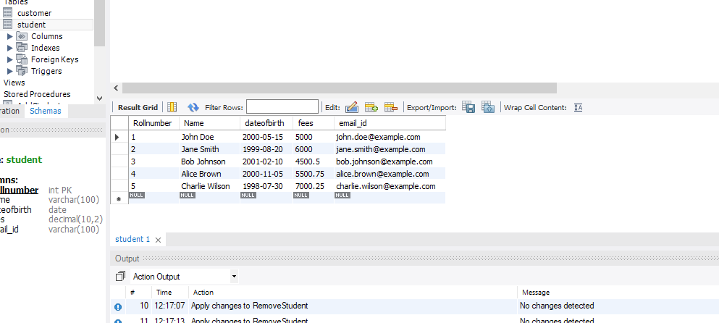

CREATE DEFINER=`root`@`localhost` PROCEDURE `SearchStudent`(
P_rollnumber int ,
P_name varchar(200)
)
BEGIN
select *from student where Rollnumber = P_rollnumber and name = P_name ;
END

Remove student

CREATE DEFINER=`root`@`localhost` PROCEDURE `RemoveStudent`(
P_Rollnumber int
)
BEGIN
DELETE FROM Student WHERE Rollnumber = P_Rollnumber;
END

Update student

CREATE DEFINER=`root`@`localhost` PROCEDURE `UdateStudent`(
P_Rollname int ,
P_name varchar(200),
P_dateofbirth date ,
P_fees decimal(10,2),
P_email_id varchar(100)
)
BEGIN
UPDATE student
SET Name = P_name, dateofbirth = P_dateofbirth, fees = P_fees, email_id = P_email_id, EndDate = p_EndDate, Fees = p_Fees, TotalSeatsFilled = p_TotalSeatsFilled, Logo = p_Logo
WHERE Rollnumber = P_Rollname;
END

console output :

on event call :
