PRN Number : 230943120027
Name : Dwarkesh Sanjay Virkhare

Student class :
using System;
using System.Collections.Generic;
using System.Linq;
using System.Text;
using System.Threading.Tasks;

namespace StudentConsoleApp
{

public enum Course
{
DAC,
DMC,
DVLSI,
DESD,
DACA,
DSSD,
DBDA
}
public class Student
{
public int Rollnumber { get; set; }
public string name { get; set; }

public string dateofbirth { get; set; }

public double fees { get; set; }

public string email_id { get; set; }

public Course course { get; set; }

public Student()
{

}

public Student(int rollnumber, string name, string dateofbirth, double fees, string email_id, Course course)
{
Rollnumber = rollnumber;
this.name = name;
this.dateofbirth = dateofbirth;
this.fees = fees;
this.email_id = email_id;
this.course = course;
}

}

}

StudentDal.cs Class :

using System;
using System.Collections.Generic;
using System.Data.SqlClient;
using System.Data;
using System.Linq;
using System.Text;
using System.Threading.Tasks;
using MySql.Data.MySqlClient;
using System.Configuration;
using System.Data;
using System.Collections.Specialized;

namespace StudentConsoleApp
{
public class StudentDal
{

// Event declaration
public event Action StudentListChanged;
public void SearchStudent()
{
using (MySqlConnection CN = new MySqlConnection(ConfigurationManager.ConnectionStrings["InfowayPoDbConStr"].ConnectionString))
{
using (MySqlCommand CMD = new MySqlCommand("Select * from student where Rollnumber = @P_RollNumber and name = @P_name ", CN))
{
Console.WriteLine("Enter Student RollNumber :");
int P_Rollnumber = int.Parse(Console.ReadLine());
Console.WriteLine("Enter Student Name :");
string P_name = Console.ReadLine();
CMD.Parameters.AddWithValue("@P_RollNumber", P_Rollnumber);
CMD.Parameters.AddWithValue("@P_name", P_name);
CN.Open();
//CMD.Connection = CN;
// CMD.CommandType = CommandType.StoredProcedure;
// CMD.CommandText = "GetAllStudent";
MySqlDataReader DR = CMD.ExecuteReader();
// List<Student> Students = new List<Student>();
Student student = new Student();
while (DR.Read())
{

{
student.Rollnumber = Convert.ToInt32(DR["Rollnumber"]);
student.name = Convert.ToString(DR["name"]);
student.dateofbirth = Convert.ToString(DR["dateofbirth"]);
student.fees = Convert.ToDouble(DR["fees"]);
student.email_id = Convert.ToString(DR["email_id"]);

};
}

DR.Close();
CN.Close();

Console.WriteLine($"Student name : {student.name}");
Console.WriteLine($"Student DOB : {student.dateofbirth}");
Console.WriteLine($"Student course Fees : {student.fees}");
Console.WriteLine($"Student Email_ID : {student.email_id}");

}

}

}

public void AddStudent(Student student)
{
using (MySqlConnection CN = new MySqlConnection(ConfigurationManager.ConnectionStrings["InfowayPoDbConStr"].ConnectionString))
{
using (MySqlCommand CMD = new MySqlCommand("INSERT INTO student(Rollnumber, name, dateofbirth, fees, email_id ,course) VALUES (@P_Rollnumber, @P_name, @P_dateofbirth, @P_fees, @P_email_id, @P_course);", CN))
{
CN.Open();

Console.WriteLine("Enter Student RollNumber :");
int P_Rollnumber = int.Parse(Console.ReadLine());
Console.WriteLine("Enter Student Name :");
string P_name = Console.ReadLine();
Console.WriteLine("Enter Student DOB :");
string P_dateofbirth = Console.ReadLine();
Console.WriteLine( "Enter Student Course Fees :");
Double P_fees = Double.Parse(Console.ReadLine());
Console.WriteLine("Enter Student Email_ID :");
string P_email_id = Console.ReadLine();
Console.WriteLine("1.DAC , 2.DMC , 3.DVSLI , 4.DESD ,5.DACA , 6.DSSD , 7.DBDA");
Console.WriteLine("Enter Choice for Course :");
String P_course = Console.ReadLine();

CMD.Parameters.AddWithValue("@P_Rollnumber", P_Rollnumber);
CMD.Parameters.AddWithValue("@P_name", P_name);
CMD.Parameters.AddWithValue("@P_dateofbirth", P_dateofbirth);
CMD.Parameters.AddWithValue("@P_fees", P_fees);
CMD.Parameters.AddWithValue("@P_email_id", P_email_id);
CMD.Parameters.AddWithValue("@P_course", P_course);

int result = CMD.ExecuteNonQuery();

OnStudentListChanged();
CN.Close();
// return result;

// Event firing method

}
}

}

public void UpdateCustomer(Student student)
{

using (MySqlConnection CN = new MySqlConnection(ConfigurationManager.ConnectionStrings["InfowayPoDbConStr"].ConnectionString))
{
using (MySqlCommand CMD = new MySqlCommand("UPDATE student SET Name = @P_name, dateofbirth = @P_dateofbirth, fees = @P_fees, fees = @P_Fees, email_id = @P_email_id WHERE Rollnumber = @P_Rollnumber ;", CN ))
{
CN.Open();

StudentDal studentDal = new StudentDal();
studentDal.SearchStudent();

Console.WriteLine("Enter Student updated RollNumber :");
int P_Rollnumber = int.Parse(Console.ReadLine());
Console.WriteLine("Enter Student udated Name :");
string P_name = Console.ReadLine();
Console.WriteLine("Enter Student updated DOB :");
string P_dateofbirth = Console.ReadLine();
Console.WriteLine("Enter Student updated Course Fees :");
Double P_fees = Double.Parse(Console.ReadLine());
Console.WriteLine("Enter Student updated Email_ID :");
string P_email_id = Console.ReadLine();

CMD.Parameters.AddWithValue("@P_Rollnumber", P_Rollnumber);
CMD.Parameters.AddWithValue("@P_name", P_name);
CMD.Parameters.AddWithValue("@P_dateofbirth", P_dateofbirth);
CMD.Parameters.AddWithValue("@P_fees", P_fees);
CMD.Parameters.AddWithValue("@P_email_id", P_email_id);

Console.WriteLine("Student Data Updated Successfully into DataBase!!");

int result = CMD.ExecuteNonQuery();

CN.Close();
}
}

}

public bool RemoveStudent(Student student)
{
using (MySqlConnection CN = new MySqlConnection(ConfigurationManager.ConnectionStrings["InfowayPoDbConStr"].ConnectionString))
{
using (MySqlCommand CMD = new MySqlCommand(" DELETE FROM Student WHERE Rollnumber = @P_Rollnumber ;", CN))
{
CN.Open();
Console.WriteLine("Enter The Student RollNumber Which You Want to Delete : ");
int P_RollNumber = int.Parse(Console.ReadLine());
CMD.Parameters.AddWithValue("@P_Rollnumber", P_RollNumber);
int result = CMD.ExecuteNonQuery();
OnStudentListChanged();
CN.Close();
return true;
}
}

}

// Helper method to raise the event
protected virtual void OnStudentListChanged()
{
StudentListChanged?.Invoke();
}

}
}

Programe.cs

using System;
using System.Collections.Generic;
using System.Diagnostics;
using StudentConsoleApp;

class Program
{
static void Main(string[] args)
{
StudentDal studentdal = new StudentDal();
Student student = new Student();

studentdal.StudentListChanged += () => Console.WriteLine("***************Student list is been changed ! ************************");

Console.WriteLine("Enter The RollNumber And Name of student to Search in the DataBase !");

studentdal.SearchStudent();

Console.WriteLine("-------------------------------------------------------");
Console.WriteLine("Enter Details of Student to Add into Database : ");

studentdal.AddStudent(student);
Console.WriteLine("Student Data insert into DataBase Successfully !!");
Console.WriteLine("-------------------------------------------------------");
Console.WriteLine("Enter the Student Rollnumber and Student Name for Updatation !");
studentdal.UpdateCustomer(student);
Console.WriteLine("-------------------------------------------------------");
if (studentdal.RemoveStudent(student))
{
Console.WriteLine("Student Data from DataBase Deleted SuccessFully !");
}
else { Console.WriteLine("Please Provide Valid Rollnumber of Student "); }

Console.WriteLine("-----------------------THANK YOU-----------------------------");
Console.ReadKey();
}
}

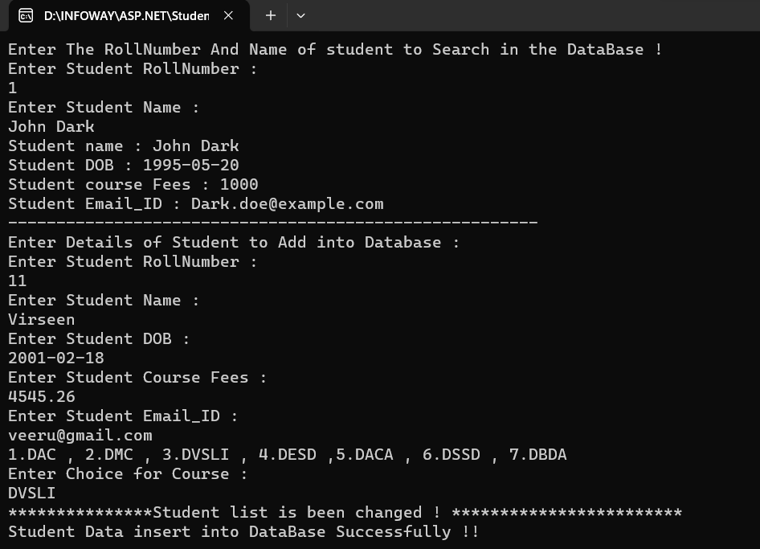
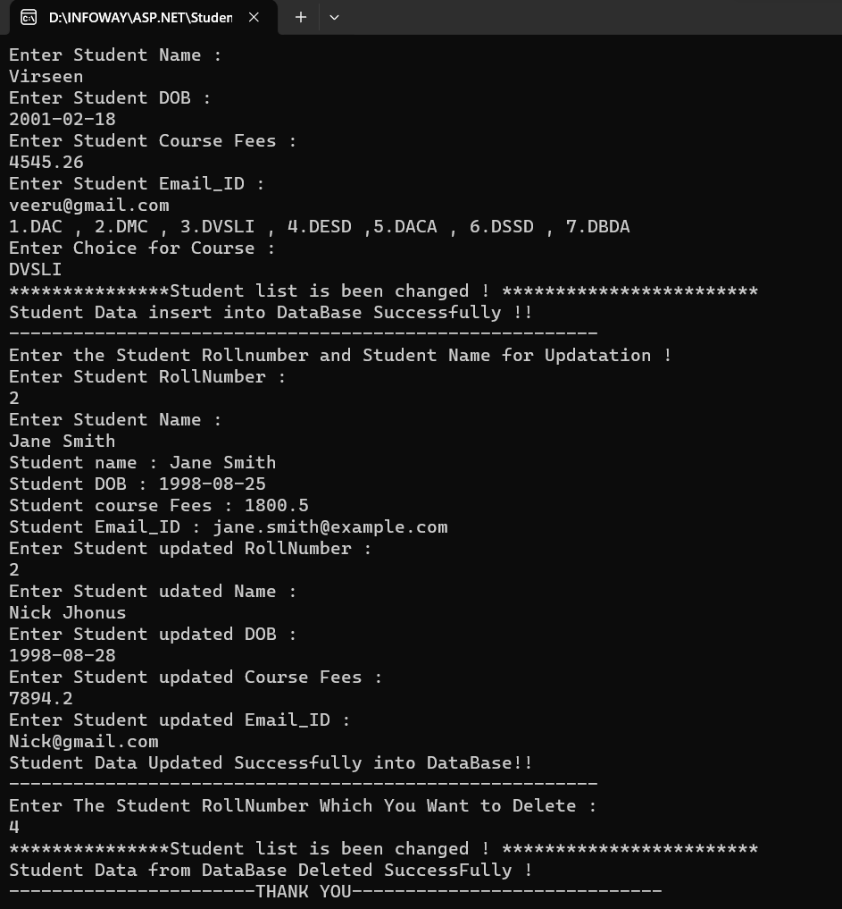

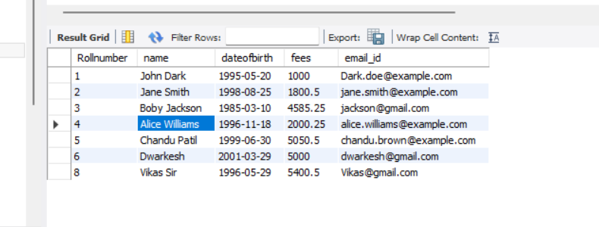
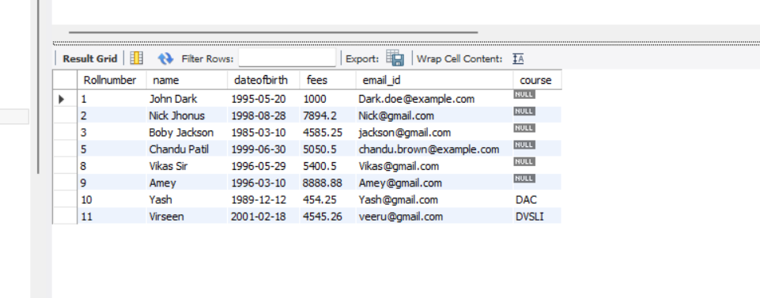
After Update Student Details Of Data And Deletion of Data from Database :
After Addition of Student into Database :

