Praktikum 9: P2P Lending dengan TDD (Java + JUnit)

Identitas Mahasiswa
Nama Lengkap: Muhammad Faqih Shiam
NIM: 251524023
Kelas: 1A
URL Repo GitHub: https://github.com/Dwdun/Praktikum-9-P2P-Lending-dengan-TDD-

Tujuan
- Menerapkan TDD (Red-Green-Refactor)
- Membuat Unit Test dengan JUnit
- Mengimplementasikan business rule pada studi kasus P2P Lending

Pembagian Waktu
1. Setup Environment (30 menit)
2. Loan Creation (60-190 menit)
Pada praktikum ini, mahasiswa diberikan satu contoh test case end-to-end sebagai gambaran alur bisnis P2P Lending.

1. REQUIREMENT
Requirement yang diberikan ini dalam rangka overview case study. Requirement lebih lengkapnya akan di deliver pada dokumen yang diperbarui setelah dokumen versi ini.
1. Kebutuhan Aktor
Borrower
- Mengajukan pinjaman
- Membayar cicilan
Lender
- Mendanai pinjaman
Sistem (Platform)
- Menilai kelayakan (credit scoring)
- Mengelola status loan
- Mengelola transaksi

2. Kebutuhan Fungsional (Functional Requirements)
A. Loan Creation
- Borrower harus terverifikasi (KYC)
- Loan hanya bisa dibuat jika:
  - amount > 0
- Sistem melakukan credit scoring
- Jika credit score ≥ threshold → APPROVED
- Jika credit score < threshold → REJECTED
B. Funding
- Lender dapat mendanai loan
- Lender tidak boleh mendanai jika:
  - saldo tidak cukup
- Loan menjadi:
  - FUNDED jika dana terpenuhi
C. Disbursement
- Loan hanya bisa di-activate jika:
  - status = FUNDED
- Setelah di-activate:
  - status menjadi ACTIVE
D. Repayment
- Borrower dapat membayar loan
- Pembayaran harus: 0
- Outstanding balance berkurang
- Jika outstanding = 0 → status COMPLETED

3. Kebutuhan Non-Fungsional (untuk praktikum)
- Menggunakan Java + Maven
- Menggunakan JUnit untuk testing
- Menggunakan pendekatan Test-Driven Development (TDD)
- Setiap behavior diuji dengan unit test

4. Kebutuhan Domain (Calon Class)
Dari kebutuhan di atas, muncul kandidat:
- Borrower
- Lender
- Loan
- LoanService
- FundingService

2. TAHAPAN SETUP PROJECT
- Create project Maven
  - Buka Text Editor atau IDE, seperti VS Code, tekan Ctrl + Shift + P pilih java: create java project
  - Maven: Create Maven Project pilih maven-archetype-quickstart
  - Isi group ID = com.p2p
  - ArtifactId = p2p-lending
  - Pilih Lokasi project
  - Struktur Project
p2p-lending/
├── pom.xml
├── src/
│ ├── main/java/com/p2p/App.java
│ └── test/java/com/p2p/AppTest.java
- Create PACKAGE
com.p2p.domain
com.p2p.service

- Tambahkan JUnit 5
<dependencies>
<dependency>
<groupId>org.junit.jupiter</groupId>
<artifactId>junit-jupiter</artifactId>
<version>5.10.0</version>
<scope>test</scope>
</dependency>
</dependencies>
- Tambahkan Plugin
<build>
<plugins>
<plugin>
<groupId>org.apache.maven.plugins</groupId>
<artifactId>maven-surefire-plugin</artifactId>
<version>3.1.2</version>
</plugin>
</plugins>
</build>
- Jalankan Test
mvn test

3. TAHAPAN IMPLEMENTASI

3.1 INTRODUCTION TDD
Test-Driven Development (TDD) adalah metode pengembangan perangkat lunak di mana pengembang menulis pengujian (test) terlebih dahulu sebelum membuat kode program. Prosesnya dilakukan secara berulang melalui tiga tahap, yaitu:
  - menulis test yang awalnya gagal (Red),
  - kemudian membuat kode seminimal mungkin agar test tersebut berhasil (Green),
  - merapikan atau memperbaiki struktur kode tanpa mengubah fungsinya (Refactor).
Dengan pendekatan ini, pengembangan dilakukan secara bertahap berdasarkan perilaku kecil yang diharapkan dari sistem, sehingga membantu memastikan kode lebih benar, terstruktur, mudah dipelihara, serta meminimalkan kesalahan sejak awal.

3.2 IDENTIFIKASI TES CASE BERDASARKAN FUNCTIONAL REQUIREMENT

A. LOAN CREATION

TC-01
Nama: shouldRejectLoanWhenBorrowerNotVerified
Skenario:
- Borrower tidak terverifikasi
- Mengajukan loan
Expected:
- Exception/ loan tidak dibuat

Create Test Case TC-01 LoanServiceTest.Java (RED)
import org.junit.jupiter.api.Test;
import static org.junit.jupiter.api.Assertions.*;
import java.math.BigDecimal;
public class LoanServiceTest {
@Test
void shouldRejectLoanWhenBorrowerNotVerified() {

// =====================================================
// SCENARIO:
// Borrower tidak terverifikasi (KYC = false)
// Ketika borrower mengajukan pinjaman
// Maka sistem harus menolak dengan melempar exception
// =====================================================
// =========================
// Arrange (Initial Condition)
// =========================
// Borrower belum lolos proses KYC
Borrower borrower = new Borrower(false, 700);
// Service untuk pengajuan loan
LoanService loanService = new LoanService();
// Jumlah pinjaman valid
BigDecimal amount = BigDecimal.valueOf(1000);
// =========================
// Act (Action)
// =========================
// Borrower mencoba mengajukan loan
loanService.createLoan(borrower, amount);
// =========================
// Assert (Expected Result)
// =========================
assertTrue(true);
}
}

Implementasi TC-01(Green)

Borrower.java
package com.p2p.domain;
public class Borrower {
// Status verifikasi KYC
private boolean verified;
// Nilai credit score borrower
private int creditScore;
// Constructor untuk inisialisasi data borrower
public Borrower(boolean verified, int creditScore) {
this.verified = verified;
this.creditScore = creditScore;
}
// Getter untuk mengecek apakah borrower sudah verified
public boolean isVerified() {
return verified;
}
// Getter untuk mengambil credit score
public int getCreditScore() {
return creditScore;
}
}
// Class ini merepresentasikan pinjaman

Loan.java
package com.p2p.domain;
public class Loan {
// Enum untuk status loan
public enum Status {
PENDING, APPROVED, REJECTED
}

private Status status;

// Saat loan dibuat, status awal adalah PENDING
public Loan() {
this.status = Status.PENDING;
}

// Setter untuk mengubah status loan
public void setStatus(Status status) {
this.status = status;
}

// Getter untuk membaca status loan
public Status getStatus() {
return status;
}
}

LoanService.java
package com.p2p.service;
import com.p2p.domain.*;
import java.math.BigDecimal;
public class LoanService {
public Loan createLoan(Borrower borrower, BigDecimal amount) {
// =========================
// VALIDASI UTAMA (TC-01)
// =========================
// Jika borrower belum terverifikasi,
// maka proses harus dihentikan
if (!borrower.isVerified()) {
throw new IllegalArgumentException("Borrower not verified");
}
// Membuat objek loan baru
Loan loan = new Loan();
// =========================
// LOGIC SEDERHANA (sementara)
// =========================
// Jika credit score tinggi → APPROVED
// Jika tidak → REJECTED
if (borrower.getCreditScore() >= 600) {
loan.setStatus(Loan.Status.APPROVED);
} else {
loan.setStatus(Loan.Status.REJECTED);
}
return loan;
}
}

Run Test
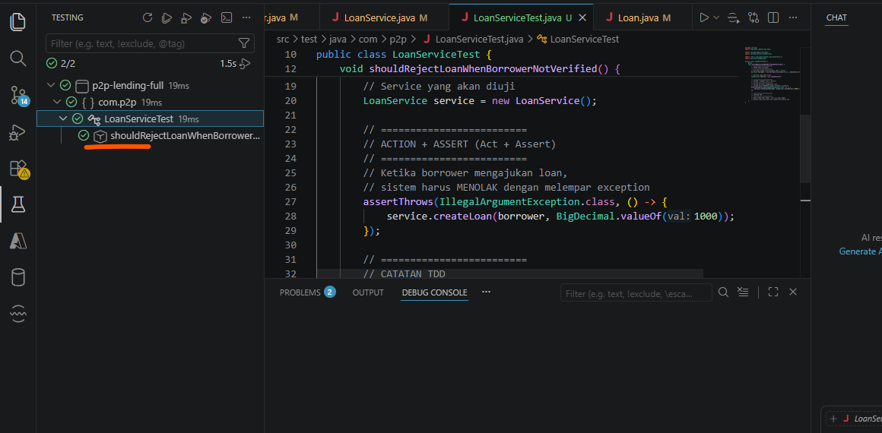

REFACTOR STEP-BY-STEP (FOWLER STYLE)

STEP 1 — Extract Method (validasi borrower)
Fowler: Extract Method
Sebelumnya:
if (!borrower.isVerified()) {
throw new IllegalArgumentException("Borrower not verified");
}
Sesudah:
public Loan createLoan(Borrower borrower, BigDecimal amount) {
validateBorrower(borrower);
Loan loan = new Loan();
loan.setStatus(Loan.Status.APPROVED);
return loan;
}
private void validateBorrower(Borrower borrower) {
if (!borrower.isVerified()) {
throw new IllegalArgumentException("Borrower not verified");
}
}
Tujuan Step 1
- memisahkan validation logic
- membuat createLoan() lebih bersih

STEP 2 — Introduce Meaningful Domain Method (Move Responsibility)
Fowler: Move Method
Sebelumnya:
if (!borrower.isVerified())
Sesudah (dipindahkan ke domain):
private void validateBorrower(Borrower borrower) {
if (!borrower.canApplyLoan()) {
throw new IllegalArgumentException("Borrower not verified");
}
}
Update Borrower (domain improvement)
public boolean canApplyLoan() {
return isVerified;
}
Tujuan Step 2
- business logic pindah ke domain
- service jadi orchestration saja

STEP 3 — Replace Hardcoded Status Logic
Fowler: Replace Conditional Logic (preparation step)
Sebelumnya:
loan.setStatus(Loan.Status.APPROVED);
Refactor:
Loan loan = new Loan();
loan.approve();
Update Loan domain:
public void approve() {
this.status = Status.APPROVED;
}
Tujuan Step 3
- service tidak lagi set state langsung
- domain mulai “rich”

STEP 4 — Clean Service (Final Structure)
public Loan createLoan(Borrower borrower, BigDecimal amount) {
validateBorrower(borrower);
Loan loan = new Loan();
if (borrower.getCreditScore() >= 600) {
loan.approve();
} else {
loan.reject();
}

return loan;
}

STEP 5 — Tambahkan di Loan.java
// =========================
// DOMAIN BEHAVIOR
// =========================
public void approve() {
this.status = Status.APPROVED;
}
public void reject() {
this.status = Status.REJECTED;
}

STEP 6 — Tambahkan di Borrower.java
Fowler: Move Method
// =========================
// DOMAIN BEHAVIOR (NEW)
// =========================
public boolean canApplyLoan() {
return verified;
}

FINAL RESULT (SETELAH REFACTOR)
✔ LoanService jadi bersih:
- hanya orchestration
- tidak ada business logic detail
✔ Borrower punya behavior:
- canApplyLoan()
✔ Loan punya behavior:
- approve()

- package com.p2p.service;

- import com.p2p.domain.*;

- import java.math.BigDecimal;

- public class LoanService {

- public Loan createLoan(Borrower borrower, BigDecimal amount) {

- // =========================
- // VALIDASI (delegasi ke domain)
- // =========================
- validateBorrower(borrower);

- // =========================
- // CREATE LOAN (domain object)
- // =========================
- Loan loan = new Loan();

- // =========================
- // BUSINESS ACTION (domain behavior)
- // =========================
- if (borrower.getCreditScore() >= 600) {
- loan.approve();
- } else {
- loan.reject();
- }

- return loan;
- }

- // =========================
- // PRIVATE VALIDATION METHOD
- // =========================
- private void validateBorrower(Borrower borrower) {
- if (!borrower.canApplyLoan()) {
- throw new IllegalArgumentException("Borrower not verified");
- }
- }
- }

TC-02
Nama: shouldRejectLoanWhenAmountIsZeroOrNegative
Skenario:
- Borrower valid
- Amount ≤ 0
Expected:
- Exception

TC-03
Nama: shouldApproveLoanWhenCreditScoreHigh
Skenario:
- Borrower verified
- Credit score ≥ threshold
Expected:
- Status = APPROVED

TC-04
Nama: shouldRejectLoanWhenCreditScoreLow
Skenario:
- Borrower verified
- Credit score < threshold
Expected:
- Status = REJECTED

B. FUNDING

TC-05
Nama: shouldAllowFundingWhenBalanceSufficient
Skenario:
- Lender saldo cukup
- Funding dilakukan
Expected:
- Funding berhasil

TC-06
Nama: shouldRejectFundingWhenBalanceNotEnough
Skenario:
- Lender saldo kurang
- Funding dilakukan
Expected:
- Exception

TC-07
Nama: shouldMarkLoanAsFundedWhenFullyFunded
Skenario:
- Loan didanai penuh
Expected:
- Status = FUNDED

C. DISBURSEMENT (ACTIVATION)

TC-08
Nama: shouldNotActivateLoanIfNotFunded
Skenario:
- Loan belum funded
Expected:
- Exception

TC-09
Nama: shouldActivateLoanWhenFunded
Skenario:
- Loan status = FUNDED
- Di-activate
Expected:
- Status = ACTIVE

D. REPAYMENT

TC-10
Nama: shouldAllowRepaymentWhenLoanActive
Skenario:
- Loan ACTIVE
- Borrower melakukan pembayaran
Expected:
- Pembayaran diterima

TC-11
Nama: shouldRejectRepaymentWhenAmountInvalid
Skenario:
- Payment ≤ 0
Expected:
- Exception

TC-12
Nama: shouldReduceOutstandingWhenRepay
Skenario:
- Loan ACTIVE
- Bayar sebagian
Expected:
- Outstanding berkurang

TC-13
Nama: shouldCompleteLoanWhenOutstandingZero
Skenario:
- Loan ACTIVE
- Dibayar lunas
Expected:
- Status = COMPLETED

