2b

The program was developed exclusively by me, Danylo Mirin, with some advice from a neighboring programmer who helped fix a problem during testing and with some code borrowed from an Oracle demo on Frames.

Initially, I thought to make some simple application that’d use a little window to encrypt and decrypt messages. However, it quickly grew into something bigger and now it is a password manager and an encryptor in one. Password manager worked flawlessly from the start but encryption had some issues with the 2nd layer of encryption (encrypt every line before writing) which I solved

I used a lot of code that could throw exceptions and thus I made the ErrorLogger class, an abstraction of error handling. It is not the most interesting part of the project, the menu is. The menu is a grand combination of three smaller abstractions (encryption, password management, error logging) in an elegant and easy to use program

2c

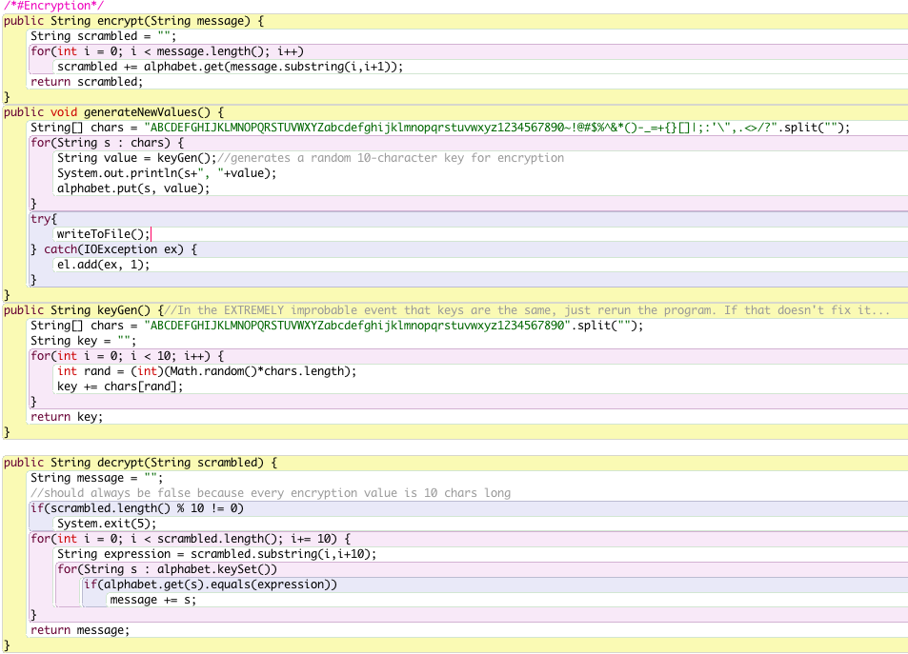

This code is responsible for encryption and decryption. Here each letter of the English alphabet, digit, and common symbol is assigned a random 10-character key (keygen () method). Capital and lowercase letters are assigned different keys. The decryption is based upon the structure of the encrypted String – we know that if it was copied and pasted in full, it has a length that’s divisible by 10 without a remainder. Therefore, the decryption algorithm employs that predictability. As seen in the demo, both encryption and decryption work perfectly.