Introduction 2

1. Balances 2
   1. Account Balances by Category 2
2. Macro Economics 2
3. Rate of Return 3
4. Accomplishments and Annual Performance 3
   1. Wealth Building 3
      1. Target Balances 3
      2. Growing Net Worth 3
      3. Financial Plan Progress 4
      4. Cash flow 4
      5. Long Term Savings 4
      6. Short Term Savings 4
      7. T. Ivany Funds 4
   2. Debt Free 4
   3. Live a Beautiful Life 4
      1. Vacations 4
      2. Simplified Budgeting and Tracking 4
   4. Learning 4
5. Notable Actions and Events of shaping the future 5
   1. Five Year Plan 5
6. Our Future & Goal Setting 5
   1. Anticipated Expenses 5
      1. Vacation 5
      2. Simplify Accounts 5
      3. Acquiring Additional Shared Knowledge 5
      4. Goal 2 5
7. Summary 6

# Introduction

We have a tradition of financial reports that help us communicate and make decisions. This report was intended to provide insight into our financial position, encourage conversation, and inspire us to achieve the means to live a beautiful life filled with music, movement, family and friends.

This report is organized to include the following information:

* Balance of accounts
* Macro Economics
* Rate of Return
* Accomplishments and Annual Performance
* Notable actions
* Our Future & Goal Setting

# Balances

## Account Balances by Category

We now have a list of liabilities, and few tangible assets that are hard to value.

Our only notable liability is our mortgage. We have Line of Credit (LoC) at CCCU, Simplii, and TD Visa, which we have been zeroing out each month.

Our most notable asset is the house and land, with token value in vehicles.

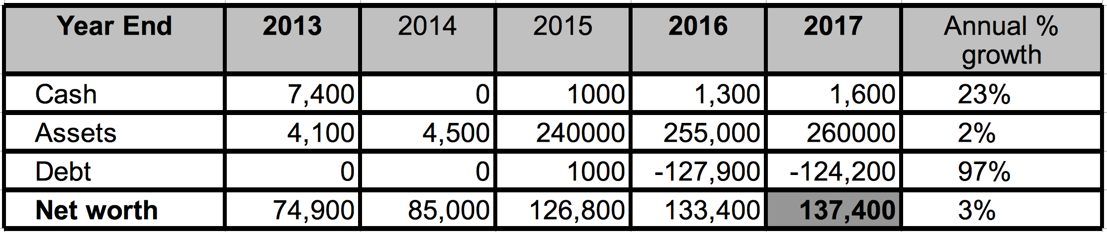

# Macro Economics

The finances of our family rest within the trends of Canadian and World economic trends. Our employability rests within the job market largely set by the unemployment rate. Our costs of borrowing and mortgage is closely tied to prime. Any returns we get on investments will likely co-correlate to the S&P.

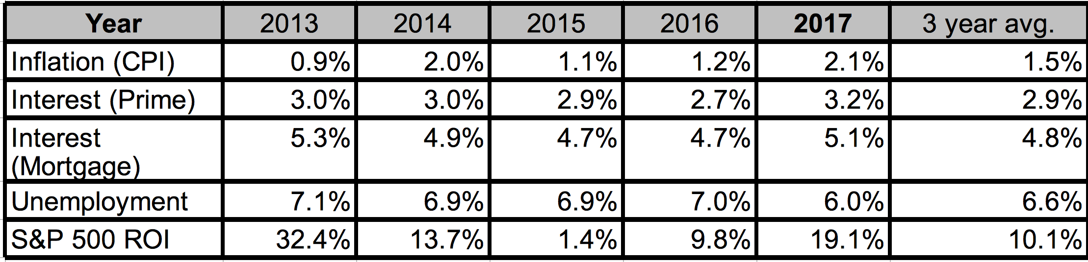

There is nothing exceptional to note about inflation, or interest rates of 2017.

The unemployment rate is hinting towards a hot job market.

This has been an exceptional year in the stock market, in which we did not participate.

**S&P 500 5 Year**

# Rate of Return

There will be no point in tracking Rate of Return for many years, until we have significant investments in markets liquid enough to evaluate. Meaning until we get >10k invested in public stock, ETFs, or other easily valued mechanism, I will not report ROI

Our net worth has grown a decent Compound Annual Growth Rate (CAGR) of 21%  
Bringing us from $20k in 2008 to $137k in 2017.

**Stock & Options**

We have a small amount of stock, and a much more notable amount of stock options in Jostle.

# Accomplishments and Annual Performance

Over this year we reestablished our monthly checkin.

We have often reviewed our accomplishments within the following categories:

* Wealth building
* Being debt free
* Living a beautiful life
* Learning

When practical we should compare these to quantifiable goals. However, we have changed strategy, so we will not live debt free for the foreseeable future. We have been considering a guidance to decrement debt. Though it is not obvious to me that this is desirable, now that we are committed to a leveraged debt.

Wealth building now will largely be assessed in our property.

## Wealth Building

### Target Balances

We should reestablish some tangible target within the next two years.

### Growing Net Worth

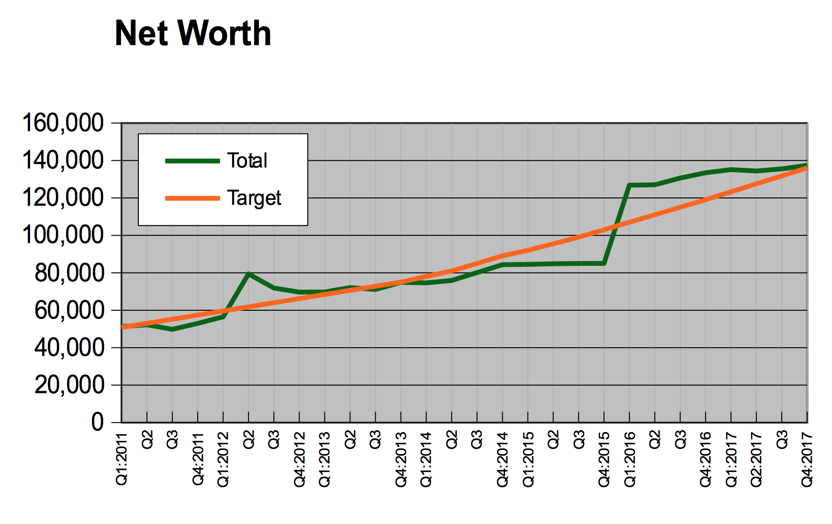  
A review of our Net Worth over the past several years.

### Financial Plan Progress

…

### Cash flow

This measurement provides significant insight into our short term management of our money, which feeds our long term plans. Any unusual patterns should be discussed, and understood. This shows a clear pattern of debt reduction.

**Visualization of Cash Flow**

### Long Term Savings

We essentially won’t have any until we decrement our liabilities, or change our strategy.

### Short Term Savings

We shall hold only a modest amount of savings as part of our monthly cash flow. We have abundant access to cash through LoC.

### T. Ivany Funds

The kids are essentially unfunded with essential float. Tully has elevated to reasonable expense petty cash.

## Debt Free

We have long aspired to reduce the stress of debt; however, home ownership has saddled us with a mortgage. This year we reduced our debt by about $4k.

## Live a Beautiful Life

Being mindful about our money helps us find the right balance between the present and the future so that we are able to live a beautiful life today, and invest in our future so that tomorrow can be better. What can you tell us about living a beautiful life this past year?

### Vacations

Mount Washington Ski in Ski out Mogul Manor...

### Simplified Budgeting and Tracking

We have compromised on a very loosely budgeted life, and are not imposing time restrictive tracking. This should be reconsidered.

## Learning

We reviewed the Mind Map in lengthy conversation.

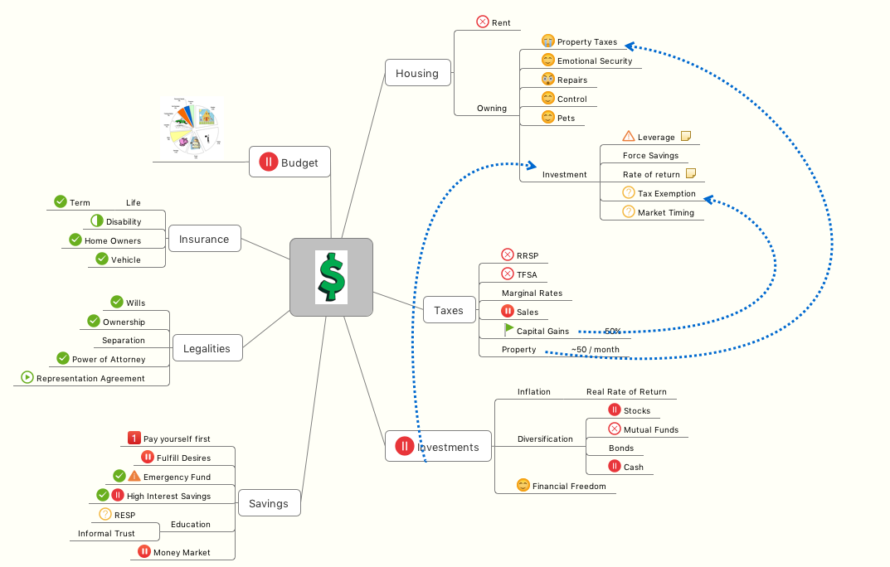

# Notable Actions and Events of shaping the future

The following has been raised over conversations throughout the year.

## Five Year Plan

Many years ago I projected two five year scenarios, and set a number of targeted financial goals such as income and net worth. It is amazing to see how we steered our life to make that true. We are really so much better off than we were when we started this (about 500% net worth).

## 

# Our Future & Goal Setting

## Anticipated Expenses

The Volvo is nearing a practical End Of Life for our family.

### Vacation

Let us consider our debt reduction desired with the balance of possible vacations.

### Simplify Accounts

We have been simplifying our accounts, though the process will take another 2 years. Primarily controlled by our mortgage.

### Acquiring Additional Shared Knowledge

It is time for me to create projections, intervals, milestones and targets for a couple of economic stories we likely might live.

### Goal 2

Our… journey… period.

# Summary

I do love you, and there is evidence that this is like a painful workout that I take on for evident family gains.