Introduction
- Balances
  - Account Balances by Category
- Macro Economics
- Rate of Return
- Accomplishments and Annual Performance
  - Wealth Building
    - Income
    - Cash flow
    - Long Term Savings
    - Short Term Savings
    - T. Ivany Funds
  - Debt Free
  - Live a Beautiful Life
    - Vacations
    - Simplified Budgeting and Tracking
- Notable Actions and Events of shaping the future
  - Multi Year Scenarios
- Our Future & Goal Setting
  - Anticipated Expenses
    - Vacation
    - Simplify Accounts
    - Acquiring Additional Shared Knowledge
- Summary

Introduction
We have a tradition of financial reports that help us communicate and make decisions. This report provides insight and history into our financial position, encourages conversations, and inspires us to achieve the means to live a beautiful life filled with music, movement, family and friends.
This report is organized to include the following information:
- Balance of accounts
- Macro Economics
- Rate of Return
- Accomplishments and Annual Performance
- Notable actions
- Our Future & Goal Setting
- Balances

Account Balances by Category
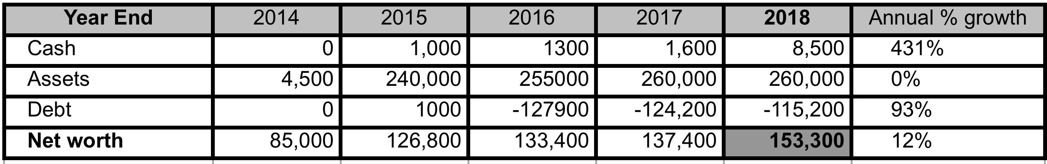
We now have a list of liabilities, and few tangible assets that are hard to value.
Our only notable liability is our mortgage.

We have Line of Credit (LoC) at CCCU, Simplii, and TD Visa, which we zeroing out each month.

Our notable asset is the house, with token value in vehicles, stock, cash, and house of crap 😉

- Macro Economics
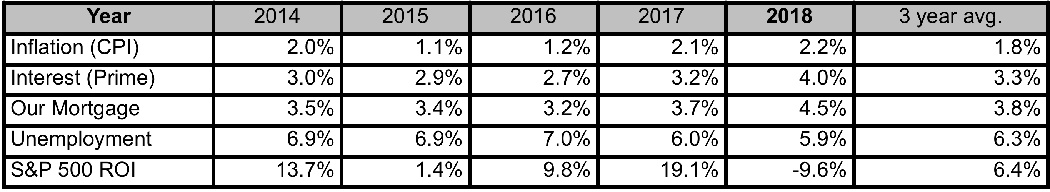
The finances of our family rest within the trends of Canadian and World economic trends. Our employability rests within the job market largely set by the unemployment rate. Our costs of borrowing and mortgage is closely tied to prime. Any returns we get on investments will likely co-correlate to the real estate market, which often correlates loosely to the stock markets.
There is nothing exceptional to note about inflation, or interest rates of 2018.
The unemployment rate is hinting towards a hot job market.
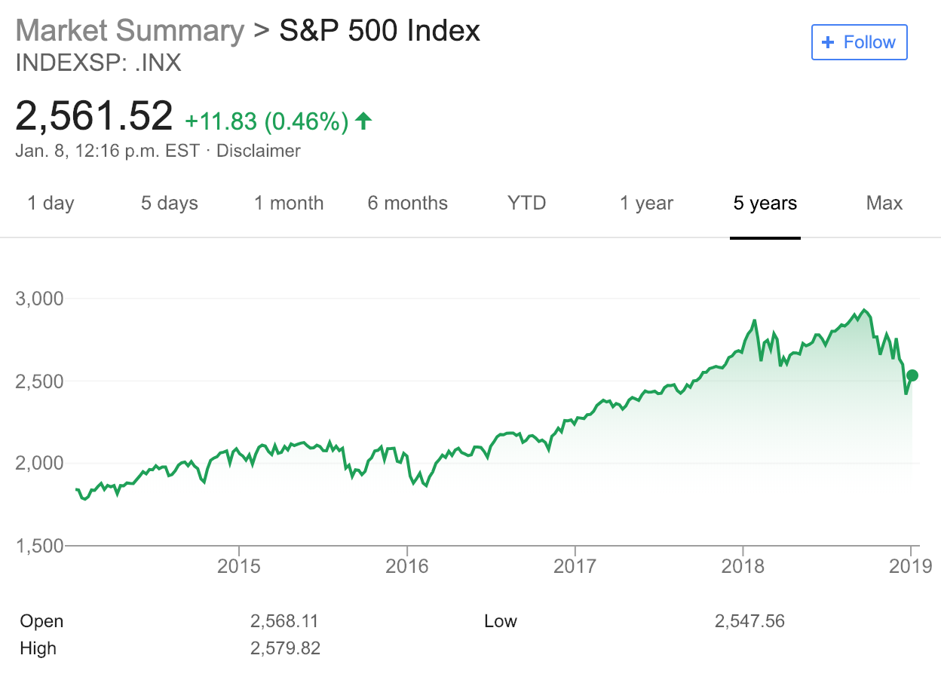
Last years exceptional year has been turned around by the worlds realization that Trump is a twit.

- Rate of Return

We shall track our Rate of Return based on our assessment. It is only a WAG (wild ass guess), but at least it is defined. Once we get >10k invested in public stock, ETFs, or other easily valued mechanism, I will again report ROI on those.
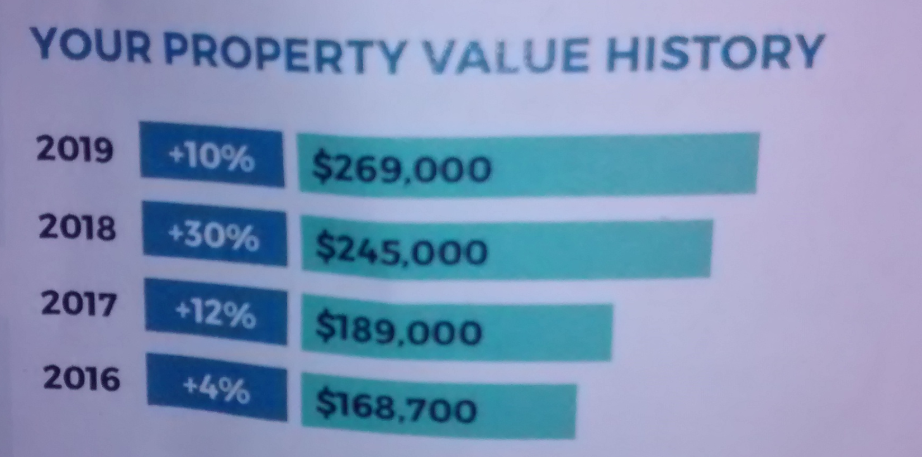
Our net worth has grown a decent Compound Annual Growth Rate (CAGR) of 12% for 2018 and 15% five year average. Bringing us from $75k in 2013 to $153 k in 2018.
Stock & Options
We have a small amount of stock, and a much more notable amount of stock options in Jostle.

- Accomplishments and Annual Performance
Over this year we continued frequent checkins.

We have often reviewed our accomplishments within the following categories:
- Wealth building
- Having a wealth not debt mindset (our only debt is mortgage 😄 )
- Living a beautiful life
- Learning
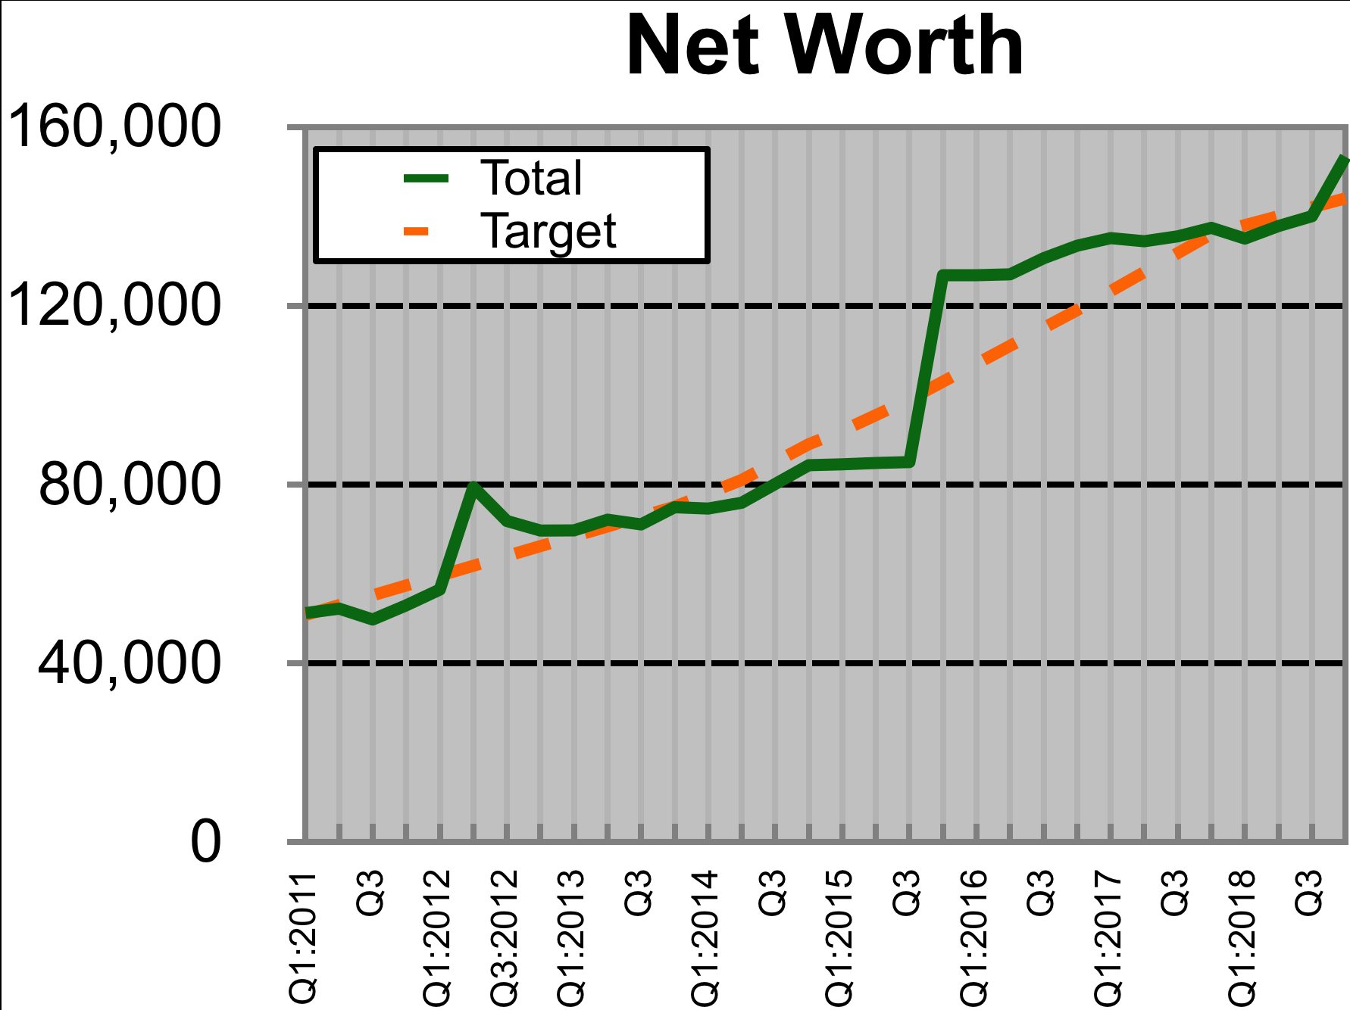
When practical we should compare these to quantifiable goals. However, we have changed strategy, so we will not live truly debt free for good reason. Wealth building now will largely be assessed in our property.

Wealth Building

Income

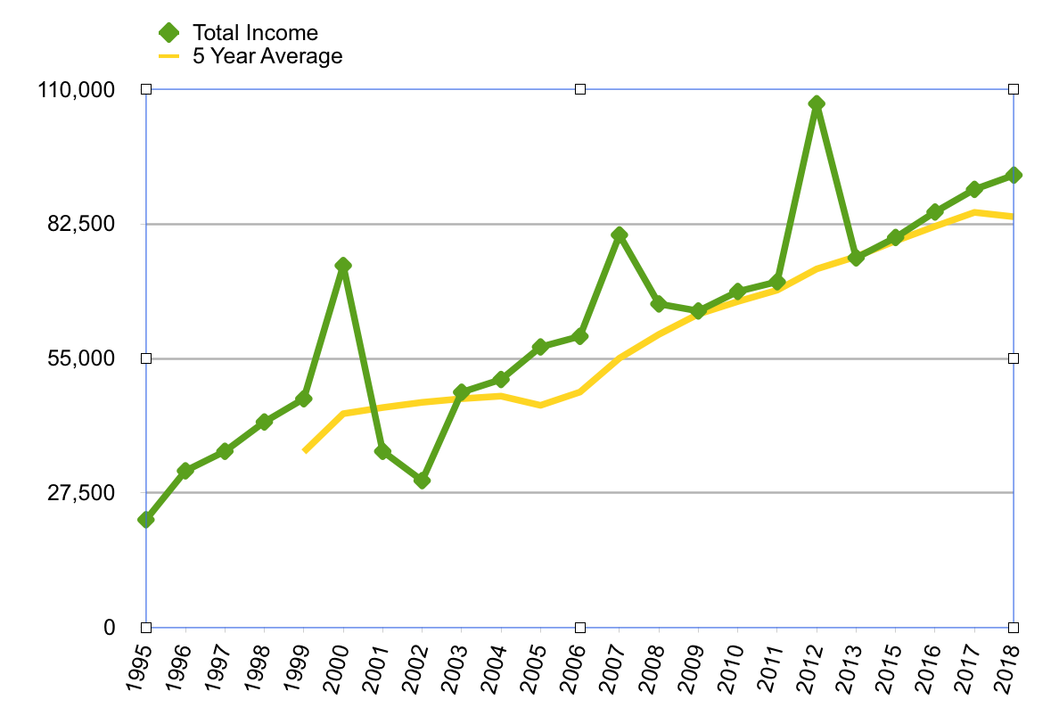
A review of my income over many years.

Cash flow
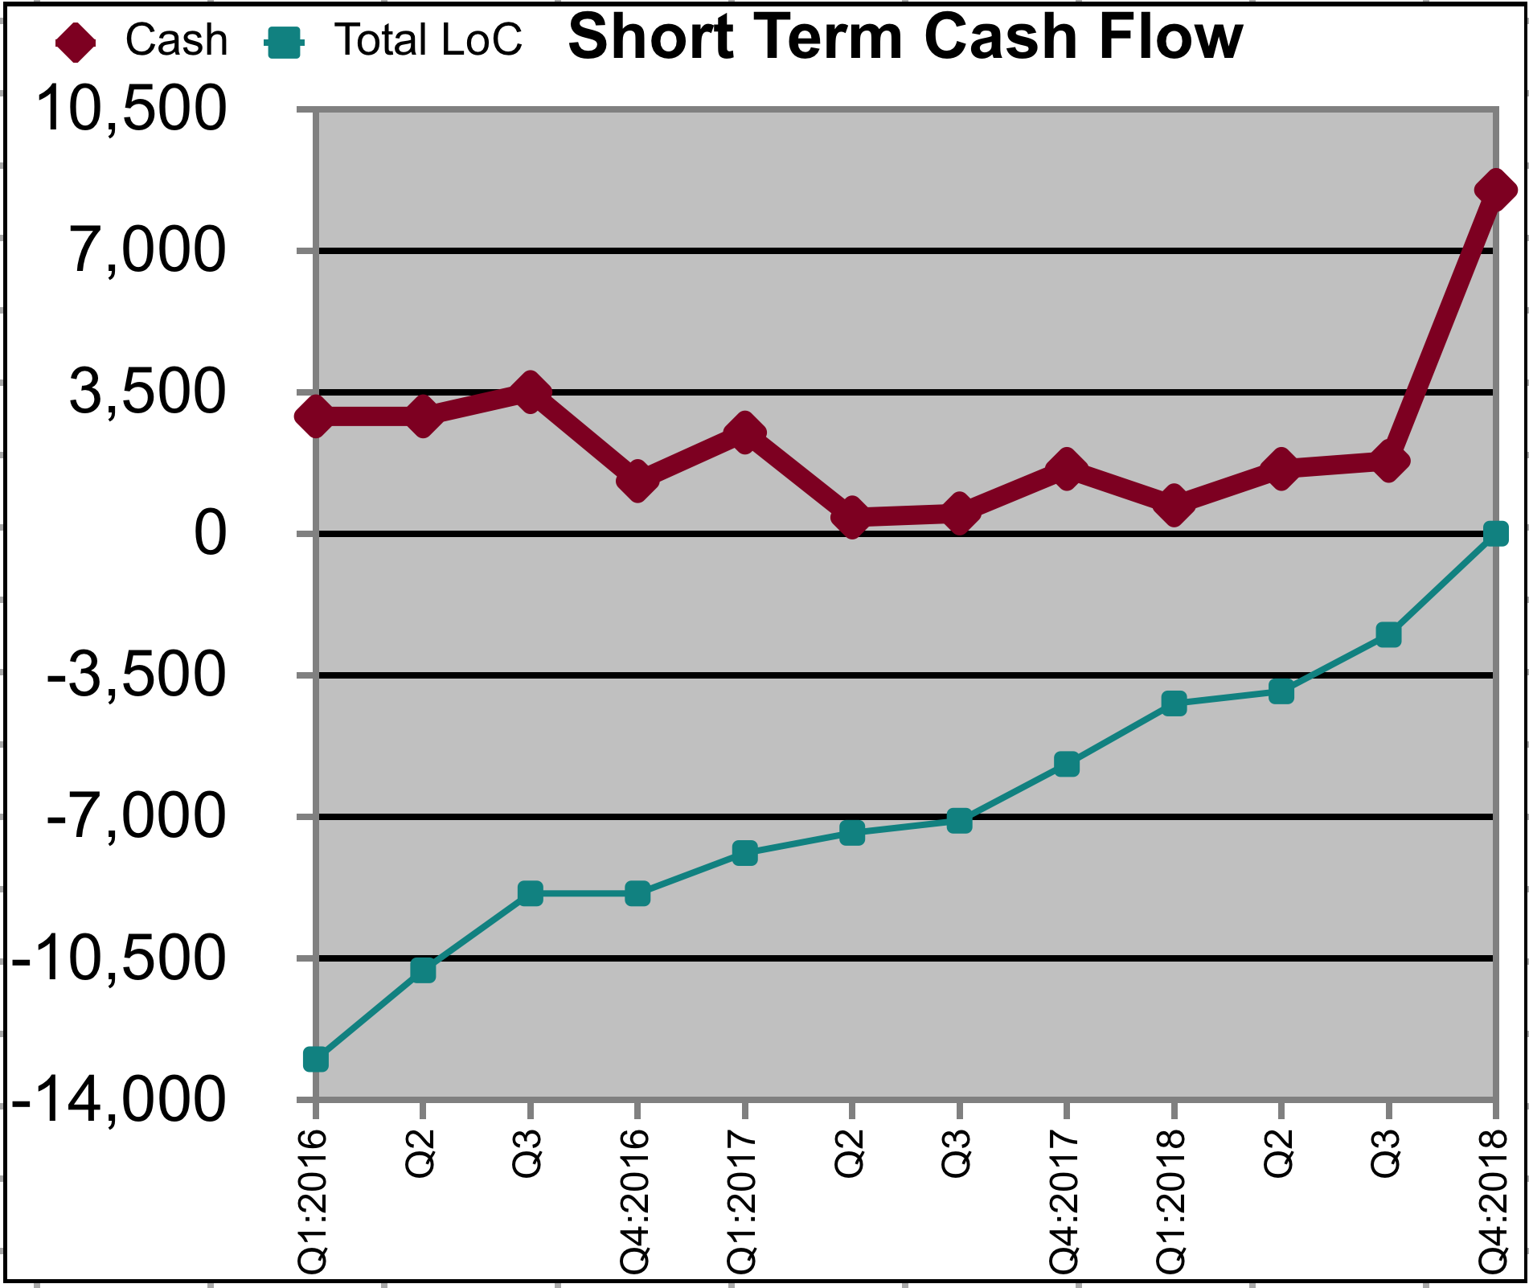
This measurement provides significant insight into our short term management of our money, which feeds our long term plans. Any unusual patterns should be discussed, and understood. This shows a clear pattern of debt reduction.

Long Term Savings
We essentially won’t have any until we decrement our liabilities, or change our strategy.

Short Term Savings
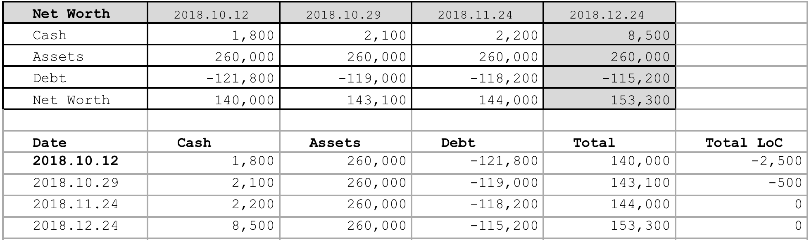
We shall hold only a modest amount of savings as part of our monthly cash flow. We have abundant access to cash through LoC. We are at a current exception of substantial short term savings at this time

T. Ivany Funds
The kids are essentially unfunded with essential float. Tully has elevated to reasonable expense petty cash.

Debt Free
We have long aspired to reduce the stress of debt; however, home ownership has saddled us with a mortgage. This year we reduced our debt by about $4k.

Live a Beautiful Life
Our home and freedom to explore our Provence is amazing. Our relationship is strong and our kids healthy.

Vacations
We had nice BC getaways, especially ELK Falls. The Ski in ski out Mt. Washington Mogul Manor was a lovely year end wrap up.

Simplified Budgeting and Tracking
We have compromised on a very loosely budgeted life, and are not imposing time restrictive tracking. This should be reconsidered.

Learning
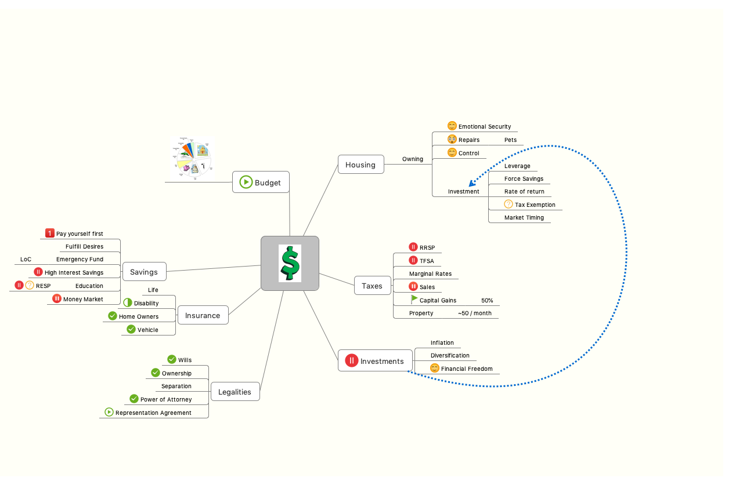
We reviewed the Mind Map in lengthy conversations over the year, let’s continue.

- Notable Actions and Events of shaping the future

Multi Year Scenarios
Plan A is to grow the differential between our earnings and expenses so that we can meet our ambitions of educated children, quality of life with transportation and recreation, and still achieve financial freedom, and alleviate the risk of economic failure.

Plan B would be a sweet buy-out/exit strategy that was best imagined by WorkDay. An opportunity where I could leverage an acquihire, and exit the majority of my sweat equity stock options, and continue in a profitable role of leadership, such as director, VP or other such role would be ideal.
Supplementing those plans should be growing earning potential by Jenny.

- Our Future & Goal Setting

Anticipated Expenses
The Volvo is nearing a practical End Of Life for our family, it is believable that there will be a notable able repair or replacement cost.

Vacation
Let us consider our debt reduction desire with the balance of possible vacations.

Simplify Accounts
We have been using a multi year simplification of accounts, as the process requires our mortgage renewal that is planned this year and executed next year.

Acquiring Additional Shared Knowledge
It is time for us to either figure out cost reduction through budgeting and accounts review, or find an alternate source to grow our income.

- Summary

This has been a good year for us. I love how you have been showing up as a life partner.

