Account Balances by Category 2
Wealth Building 4
CAGR (Compound Annual Growth Rate) of Net Worth 4
Target Balances 4
Growing Net Worth 4
Cash flow 5
Long Term Savings 5
Short Term Savings 5
T. Ivany Funds 5
Debt Free 5
Live a Beautiful Life 5
Vacations 5
Simplified Budgeting and Tracking 5
Learning 6
Five Year Plan 6
Anticipated Expenses 6
Vacation 6
Simplify Accounts 6
Acquiring Additional Shared Knowledge 6
Getting closer to self insuring 6
Become Mortgage Free 6

Introduction
We have a tradition of financial reports that help us communicate and make decisions. This report intends to provide insight into our financial position, encourage conversation, and inspire us to achieve the means to live a beautiful life filled with music, movement, family and friends.
This report is organized to include the following information:
- Balance of accounts
- Macro Economics
- Rate of Return
- Accomplishments and Annual Performance
- Notable actions
- Our Future & Goal Setting
- Balances

Account Balances by Category
We now have a growing list of assets and shrinking set of liabilities. Our only notable liability is our mortgage. We have Line of Credit (LoC) at CCCU, Simplii, TD and simplii Visas, which we have been zeroing out each month.
Our most notable asset is the house and land, with token value in vehicles.
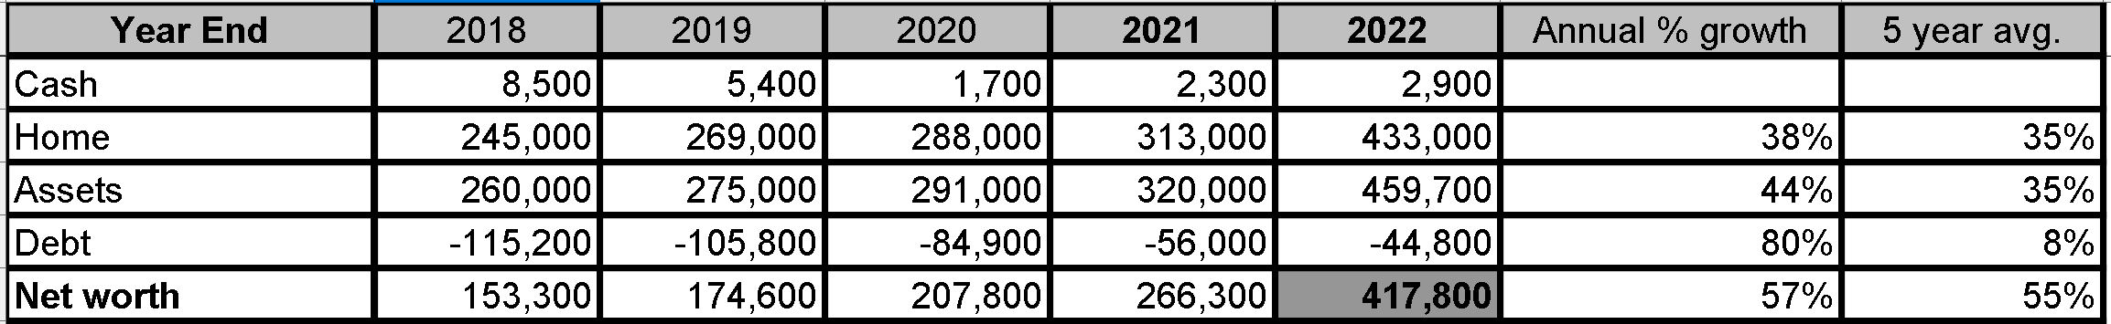
- Macro Economics & Rate of Return
The finances of our family rest within the trends of Canadian and World economic trends. Our employ-ability rests within the job market largely set by the unemployment rate. Our costs of borrowing and mortgage is closely tied to prime. Any returns we get on investments will likely co-correlate to the S&P.
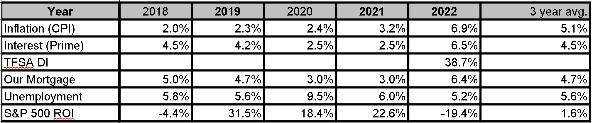
Inflation and interest rates have climbed unlike anything we have seen in decades. I believe the unemployment rate is hinting towards the end of a hot job market. It is the intention of the national banks to slow inflation thus cooling the job and investment markets.
Though we are only getting started in the stock market once again, we did exceptionallywell (38.7%) for that modest investment, especially compared to the market. Once this is > 10k and we have multiple full years, I will consider calculating and tracking CAGR (Compound Annual Growth Rate).

Five years ago I also indicated that it was not worth tracking ROI (Return on Investment) until we reach >10k invested in public stock, ETFs, or other easily valued mechanism.

Our net worth has grown a decent Compound Annual Growth Rate (CAGR) of 21%
Bringing us from $20k in 2008 to $137k in 2017.

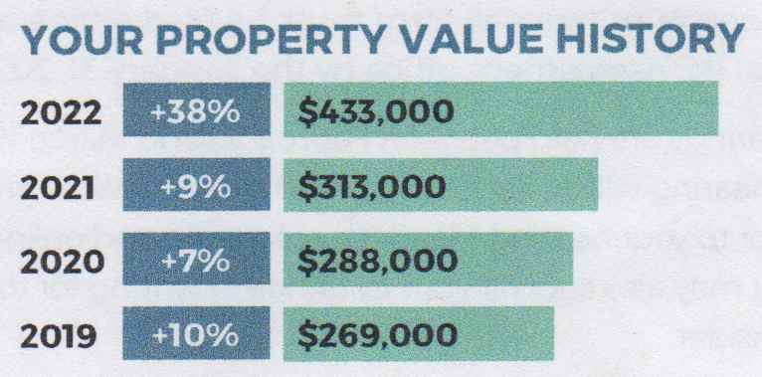

Stock & Options
We have purchased what has been evaluated for > than 10k for 5k of Jostle stock. I also have additional stock options that are barely valued at 1k just to keep it in the records. The below image is today's Property screen in Mint, which is a place that I have a record of these assets.
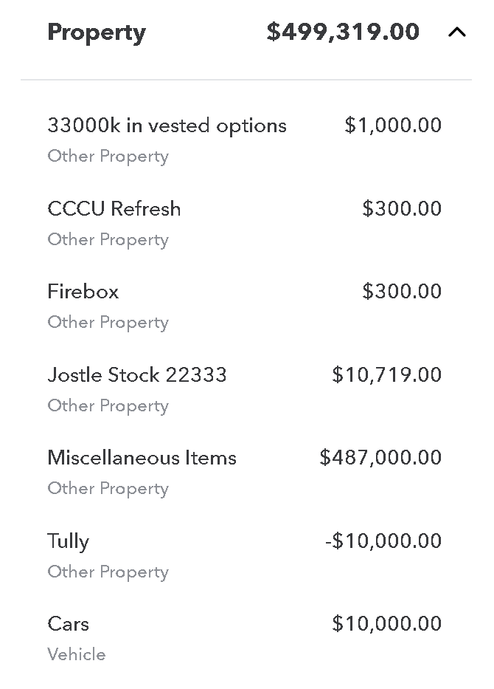
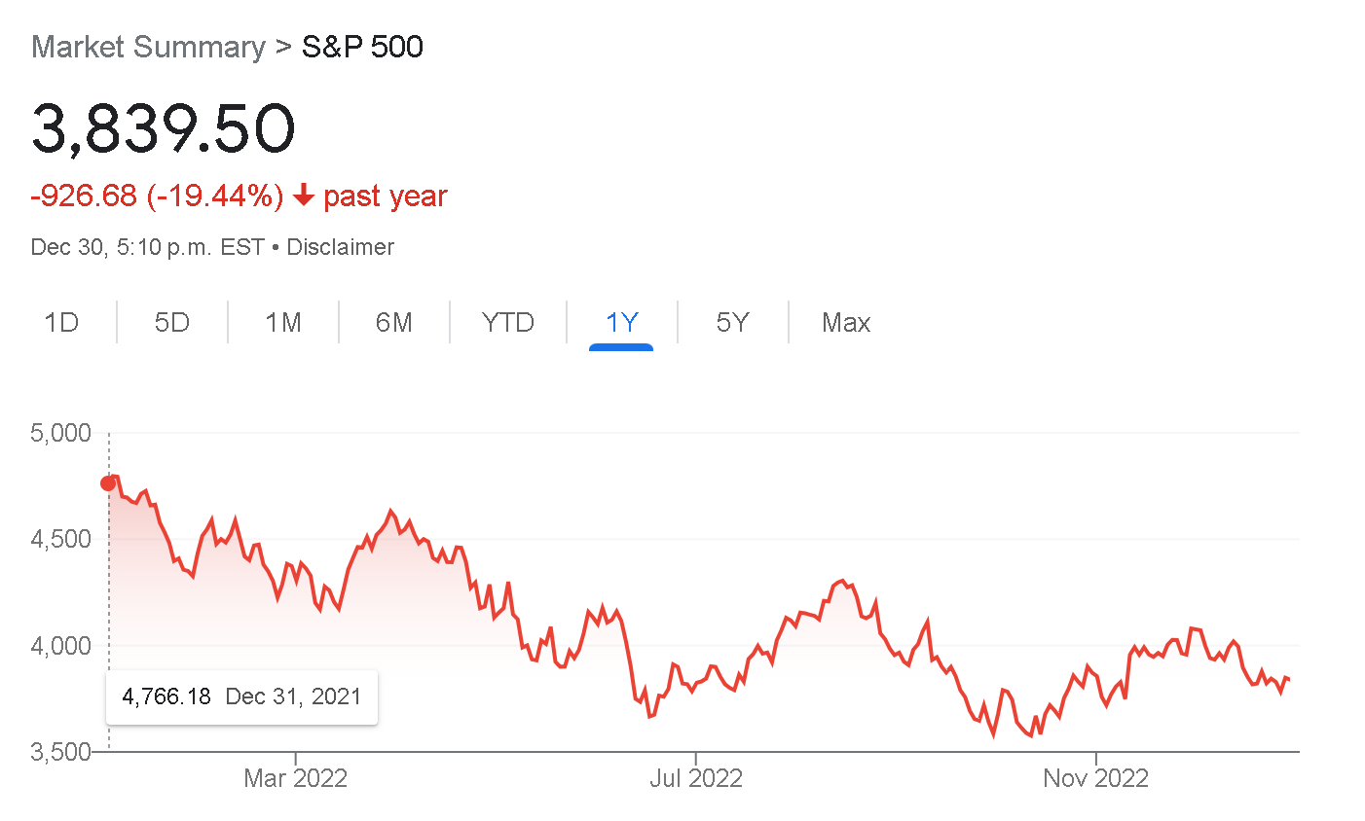

- Accomplishments and Annual Performance
Over this year we continued our periodic reviews. I will continue to lean more towards images and conversations, than long form type. We have often reviewed our accomplishments within the following categories:
- Wealth building
- Being debt free
- Living a beautiful life
includes improved dental coverage, literally a crowning achievement.
- Learning
When practical we should compare these to quantifiable goals. However, we have changed strategy, so we will not live debt free for the foreseeable future. We have been considering a guidance to decrement debt. Though it is not obvious to me that this is desirable, now that we are committed to a leveraged debt.
Wealth building now will largely be assessed in our property.
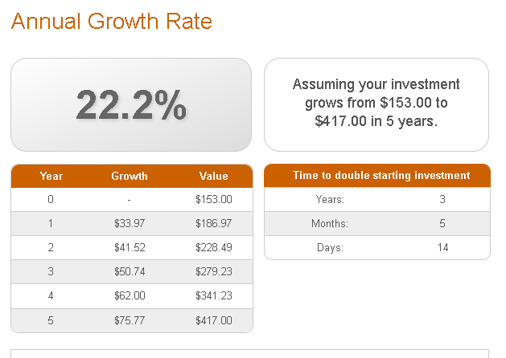

Wealth BuildingCAGR (Compound Annual Growth Rate) of Net Worth
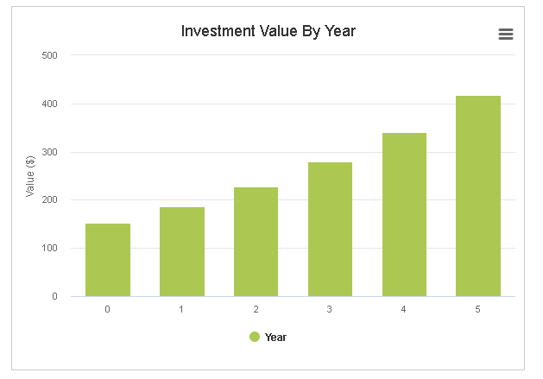

Target Balances

In a substantial and meaningful way greatly increase of targets.

Growing Net Worth
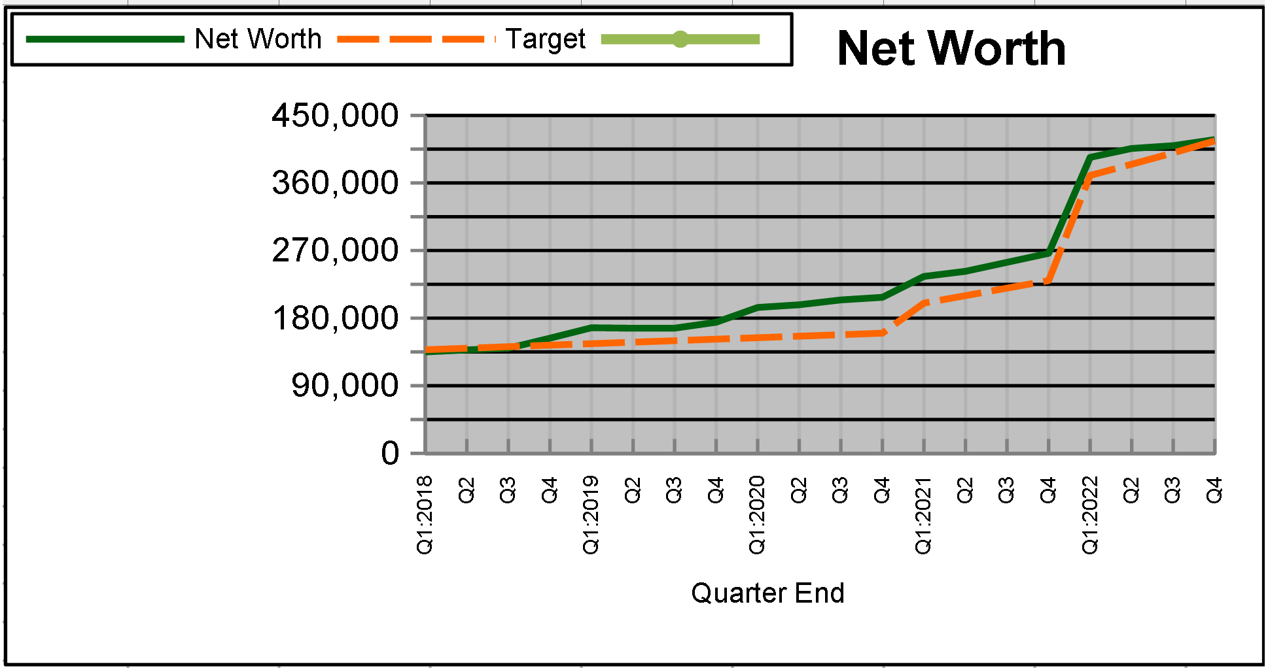
A review of our Net Worth over the past several years.

Cash flow
This measurement provides significant insight into our short term management of our money, which feeds our long term plans. Any unusual patterns should be discussed, and understood. This shows a clear pattern of debt reduction. The 2021 line of credit is the sensible Tully Fund, where he invests in our mortgage.
We can improve cash flow in food, insurance and numerous other places .
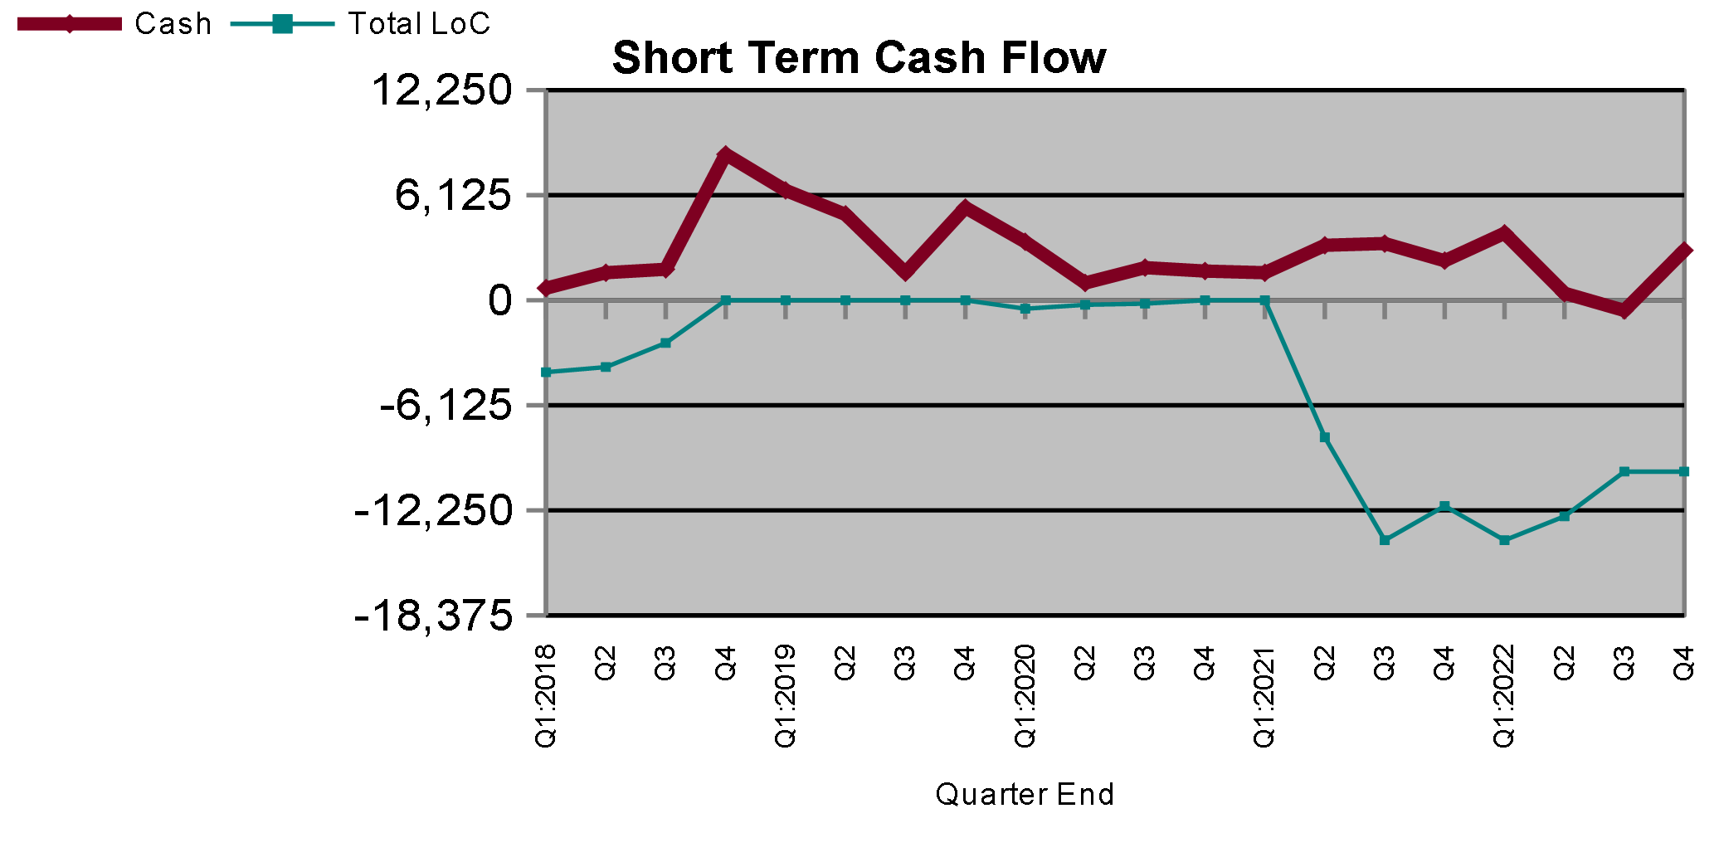

Long Term Savings
We essentially don't have any until we decrement our liabilities, or change our strategy. We will want to figure this out as we transition from the flex line mortgage, ina cou[le years.

Short Term Savings
We shall hold only a modest amount of savings as part of our monthly cash flow. We have abundant access to cash through LoC. This includes emergency cash in the box.

T. Ivany Funds
The kids are essentially unfunded with essential float. Tully is in a practicing phase of Ivany Inc 😉. The Buddies soon need to elevate to reasonable expense petty cash.

Debt Free
We are considering being mortgage free in a couple years. This year we reduced our debt by over $11k. This is during a year, in which we invest about 10k (private and public stock).

Live a Beautiful Life
Being mindful about our money helps us find the right balance between the present and the future so that we are able to live a beautiful life today, and invest in our future so that tomorrow can be better. What can you tell us about living a beautiful life this past year?

Vacations
BC only, but beautiful ones. We have also chosen to go basic luxury over being weathered out. Mini world cup, the lovely water view house for the power internet outage.

Simplified Budgeting and Tracking
We have compromised on a very loosely budgeted life, and are not imposing time restrictive tracking. This should always be reconsidered, and discussed.

Learning
- Investing
- Retirement planning
- Mortgage
- Insurance
- Notable Actions and Events of shaping the future
The following has been raised over conversations throughout the year.

Five Year Plan
Many years ago I projected two five year scenarios, and set a number of targeted financial goals such as income and net worth. It is amazing to see how we steered our life to make that true. We are really so much better off than we were when we started this (about 500% net worth).

- Our Future & Goal Setting

Anticipated Expenses
Vehicles are nearing the practical End Of Life for our family. Our roof, septic or wood rot will force a 10-25k commitment at some point, so family care to delay or avoid that is very valuable.
Other living arrangements.

Vacation
Remaining modest for viral and economic reasons.

Simplify Accounts
When we zero out the flexline, we should greatly simplify our accounts. Currently Mint is key to pulling together the transaction history. This process will take another 2 years, and is primarily controlled by our mortgage.

Acquiring Additional Shared Knowledge
It is time for me to create projections, intervals, milestones and targets for a couple of economic stories we likely might live.

Getting closer to self insuring
For each renewal let's consider saying not, or less please.

Become Mortgage Free
Become mortgage free in two years.

- Summary
I do love you, and there is evidence that this is like a painful workout that I take on for evident family gains.

