Account Balances by Category 2
Wealth Building 4
Target Balances 4
Growing Net Worth 4
Financial Plan Progress: Cash flow 5
Long Term Savings 5
Short Term Savings 5
T. Ivany Funds 5
Debt Free 5
Live a Beautiful Life 5
Vacation 5
Simplified Budgeting and Tracking 5
Learning 6
Ten Year Plan 6
Anticipated Expenses 6
Vacation 6
Simplify Accounts 6
Income History 7
Monthly 8

Introduction
We have a tradition of financial reports that help us communicate and make decisions. This report is intended to provide insight into our financial position, encourage conversation, and inspire us to achieve the means to live a beautiful life filled with music, movement, family and friends.
This report is organized to include the following information:
- Balance of accounts
- Macro Economics
- Rate of Return
- Accomplishments and Annual Performance
- Notable actions
- Our Future & Goal Setting
- Balances

Account Balances by Category
We now have a list of liabilities, and few tangible assets that are hard to value.
Our only notable liability is our mortgage. We have Line of Credit (LoC) at CCCU, Simplii, and TD Visa, which we have been zeroing out each month.
Our most notable asset is the house and land; with a modest amount in Jostle stock; TFSA, and a token value in vehicles.
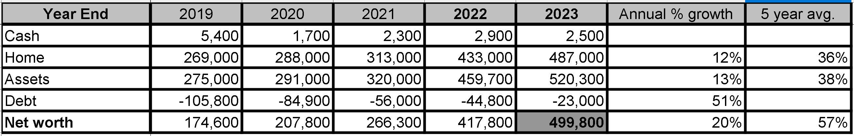
- Macro Economics
The finances of our family rest within the trends of Canadian and World economic trends. Our employ-ability rests within the job market largely set by the unemployment rate. Our costs of borrowing is closely tied to prime. Any returns we get on investments will likely co-correlate to the S&P and real estate for the region.
Inflation has become one of the most dominate topics of macro economics. What will the deliberate cooling of the economy mean for us?
The unemployment rate is hinting towards a normal job market.
This has been an exceptional year in the stock market, in which we modestly participated and exceeded the market..
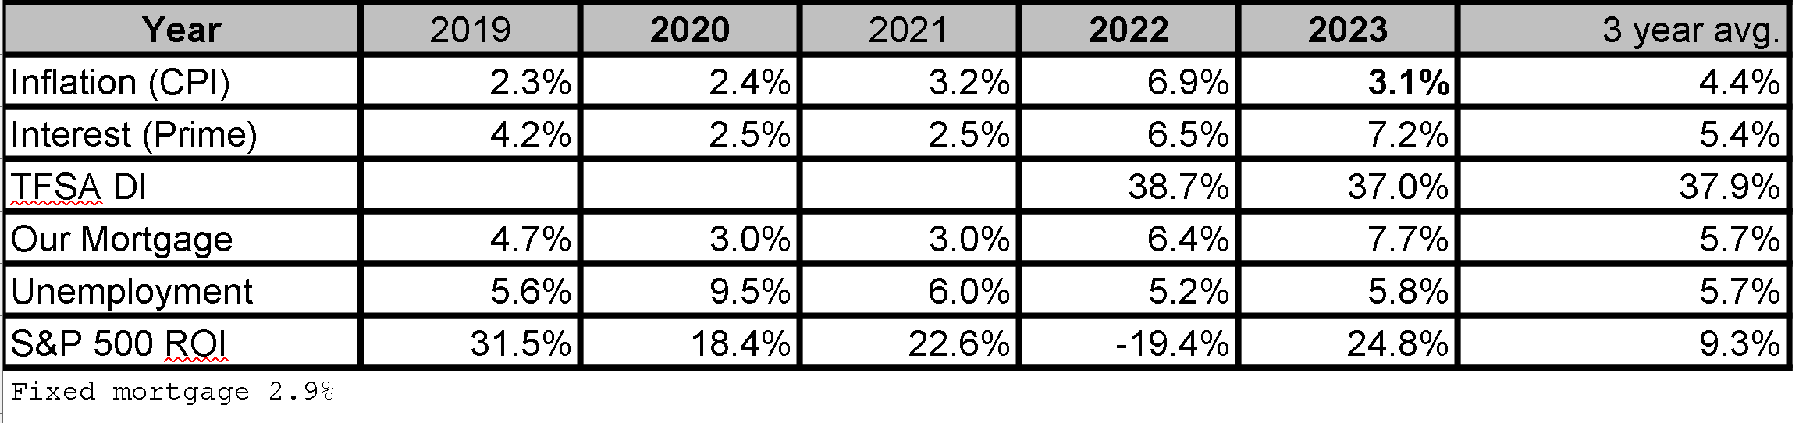

- Rate of Return

Our net worth has grown an impressive Compound Annual Growth Rate (CAGR) of 26.7%
Bringing us from $153k starting 2019 to $500k ending 2023.
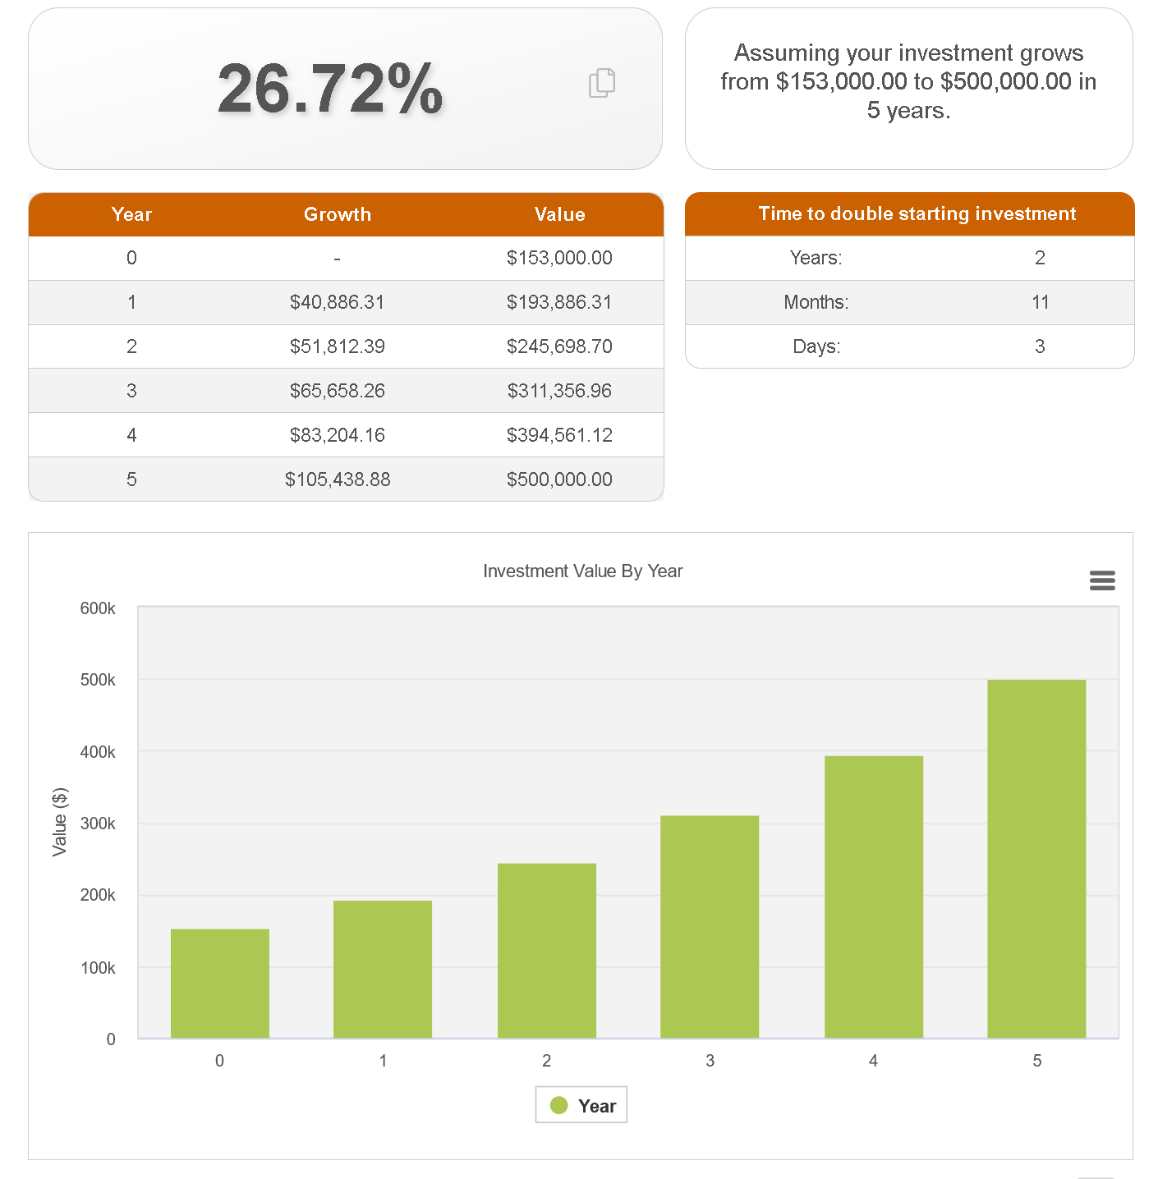
Stock & Options Primarily this is driven by real estate.
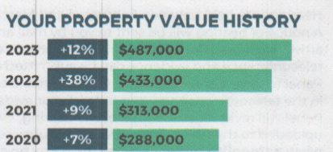
Our rate of return on my self directed TFSA was an impressive 36% in 2023. Going from $5000-6800. We are unlikely to do as well next year, as we have been so far a head of the market.
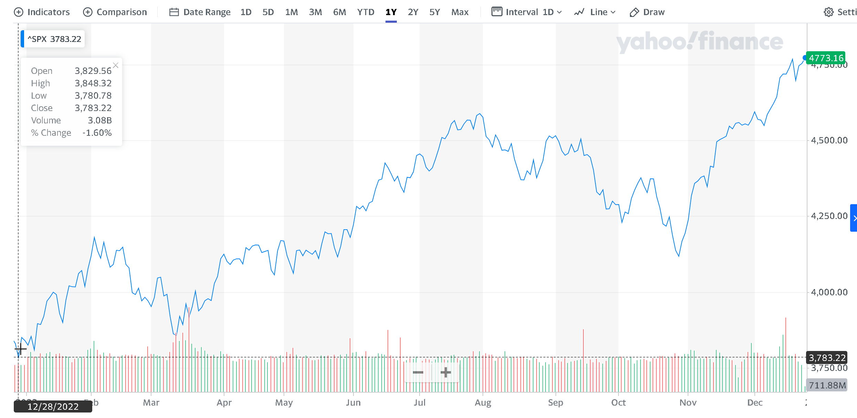
We have a modest amount of stock, and a much notable amount of stock options in Jostle.

- Accomplishments and Annual Performance
We have often reviewed our accomplishments within the following categories:
- Wealth building
- Being debt free
- Living a beautiful life
- Learning
When practical we should compare these to quantifiable goals. It is interesting that we can consider soon being truly debt free. We will need to consider debt vs leverage. Wealth building will soon be soon much more than our property.

Wealth Building

Target Balances
We have been close to our target balances. Because of the nature of annual property assessments, our targets are more linear and our evaluation more step wise.

Growing Net Worth
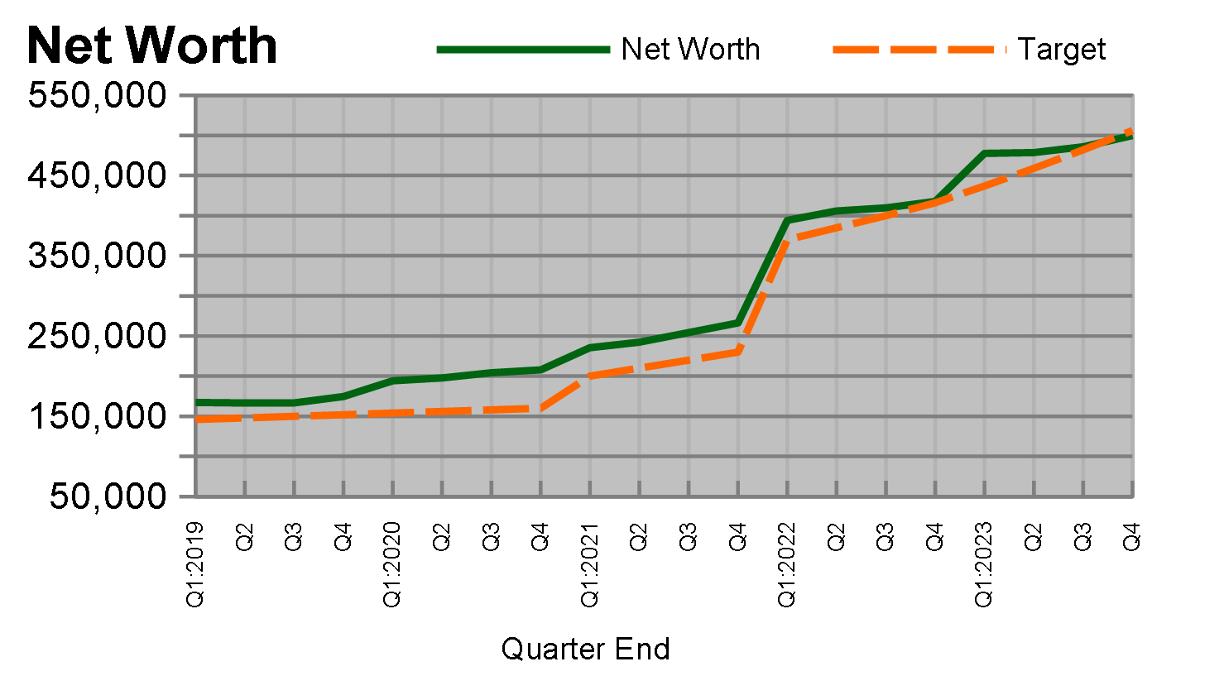
A review of our Net Worth over the past several years.

Financial Plan Progress: Cash flow
This measurement provides significant insight into our short term management of our money, which feeds our long term plans. Any unusual patterns should be discussed, and understood. This shows a clear pattern of debt reduction.
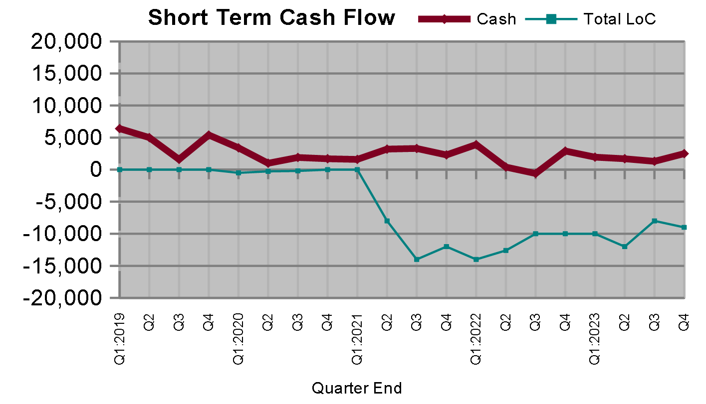

Long Term Savings
We essentially don’t have any until we decrement our liabilities, or change our strategy.

Short Term Savings
We shall hold only a modest amount of savings as part of our monthly cash flow. We have abundant access to cash through LoC.

T. Ivany Funds
The kids are essentially unfunded with essential float. Tuskar should elevate to reasonable expense petty cash, and debt card access. Tully is running a portion of our flexline.

Debt Free
We have long aspired to reduce the stress of debt; however, home ownership has saddled us with a mortgage. This year we reduced our debt by about $4k.

Live a Beautiful Life
Being mindful about our money helps us find the right balance between the present and the future so that we are able to live a beautiful life today, and invest in our future so that tomorrow can be better. What can you tell us about living a beautiful life this past year?

Vacation
Australia!

Simplified Budgeting and Tracking
We have compromised on a very loosely budgeted life, and are not imposing time restrictive tracking. This should be reconsidered.

Learning
Let’s review the Mind Map in a live conversation. We should also review additional graphs.
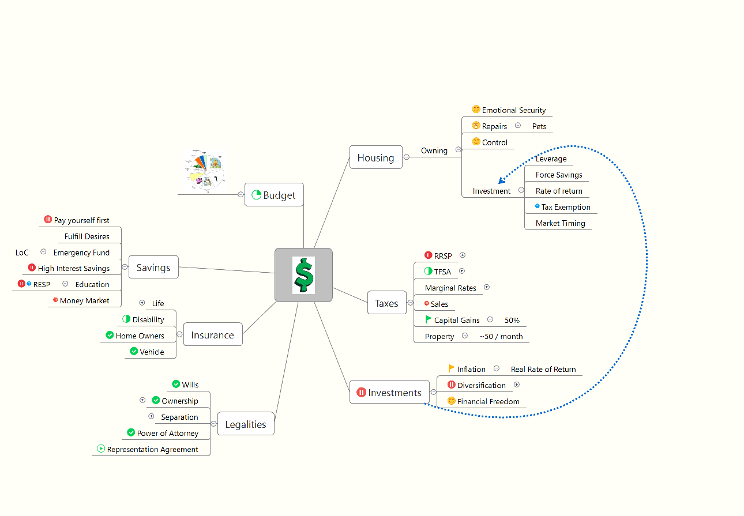

- Notable Actions and Events of shaping the future
The following has been raised over conversations throughout the year.

Ten Year Plan
We planned to own the home in 15 years. It is likely we will own it in 10. Our next plan should be focused on financial freedom (aka. Retirement.
- Our Future & Goal Setting

Anticipated Expenses
The roof, and vechicle.

Vacation
Let us consider our debt reduction desired with the balance of possible vacations.

Simplify Accounts
We have been simplifying our accounts, though the process will take another year. Primarily controlled by our mortgage, and clear title (aka discharge the mortgage).

- Summary
I do love you, and there is evidence that this is like a painful workout that I take on for evident family gains.
Additional Graphs

Income History

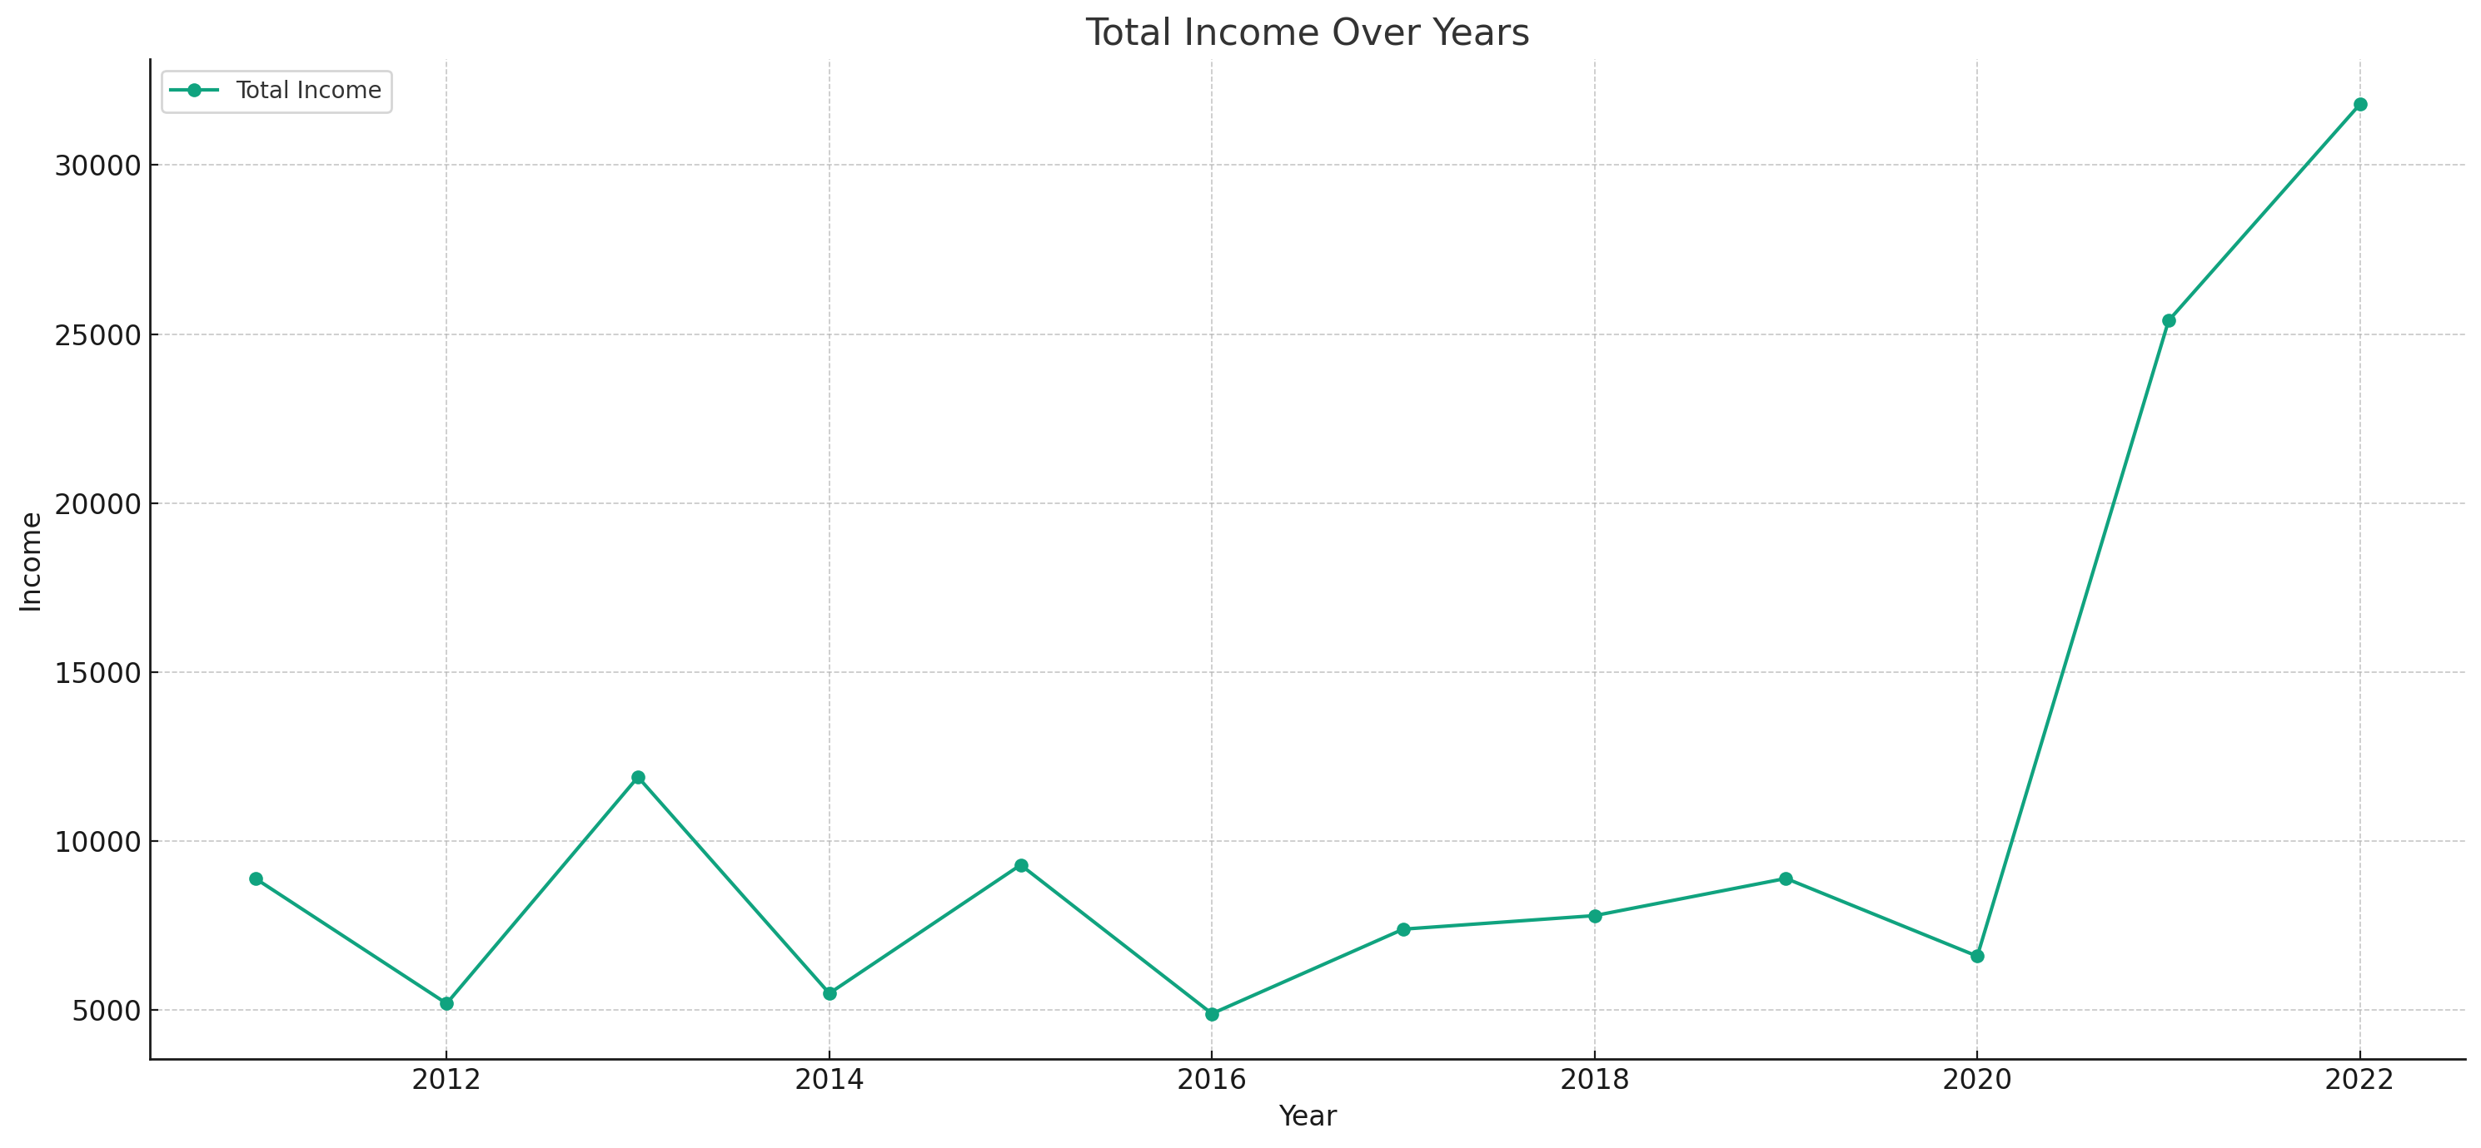

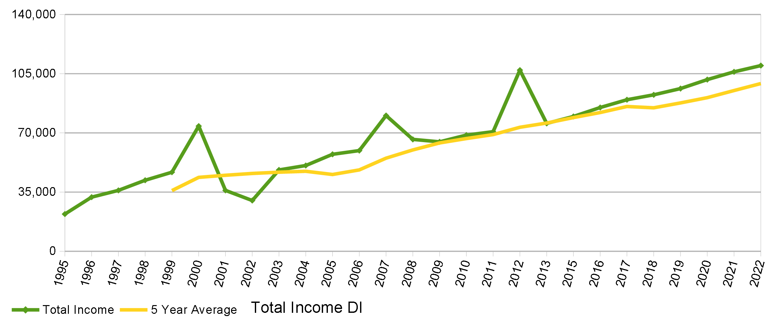

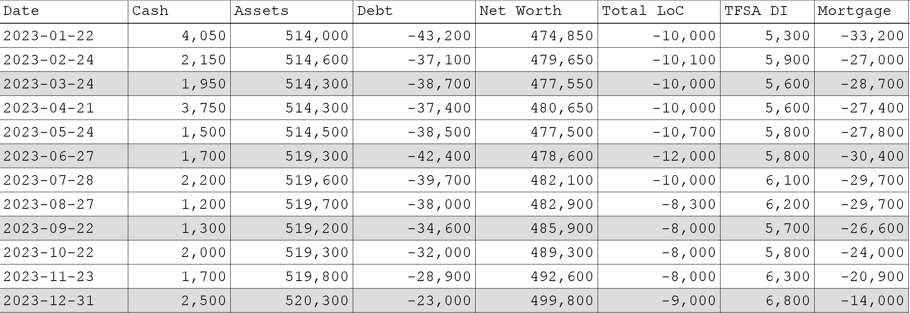
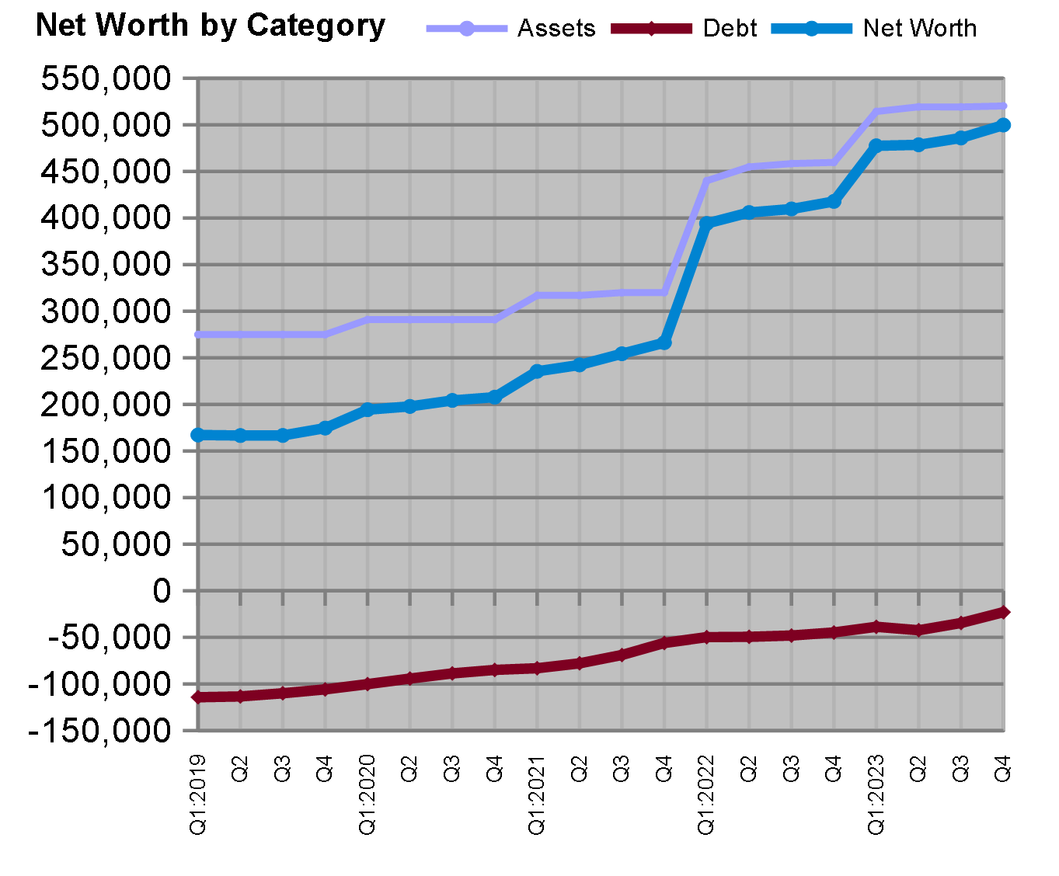

Monthly

