**Ganpat University**

**Faculty of Engineering & Technology**

**Computer Science & Engineering**

***Name:- Dwij Vatsal Desai***

***Sem:- 2***

***Sub: - BCS***

***Enrollment No.:- 23162121027***

***Prac:- 10***

**Practical – 10**

**Aim:** To perform Phase Shift Keying (PSK) Modulation and Demodulation

**Student Group Detail**

|  |  |  |
| --- | --- | --- |
| No | Enrollment No. | Student Name |
| 1 | 23162121027 | Dwij Desai |
| 2 | 23162121020 | Aagam shah |
| 3 | 23162121023 | Priyal soni |

**Block Diagram**

**1. Phase Shift Keying (PSK) Modulation**

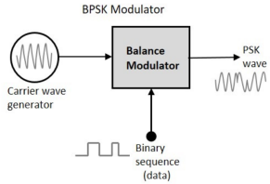

**2. Phase Shift Keying (PSK) Demodulation**

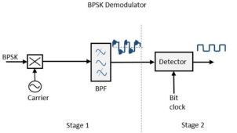

**Description:**

**Modulation**

The block diagram of Binary Phase Shift Keying consists of the balance modulator which has the carrier sine wave as one input and the binary sequence as the other input.

The modulation of BPSK is done using a balance modulator, which multiplies the two signals applied at the input. For a zero binary input, the phase will be 0° and for a high input, the phase reversal is of 180°.

The output sine wave of the modulator will be the direct input carrier or the inverted 180°phaseshifted input carrier, which is a function of the data signal.

**Demodulation**

The block diagram of BPSK demodulator consists of a mixer with local oscillator circuit, a bandpass filter, a two-input detector circuit.

By recovering the band-limited message signal, with the help of the mixer circuit and the band pass filter, the first stage of demodulation gets completed. The base band signal which is band limited is obtained and this signal is used to regenerate the binary message bit stream.

In the next stage of demodulation, the bit clock rate is needed at the detector circuit to produce the original binary message signal. If the bit rate is a sub multiple of the carrier frequency, then the bit clock regeneration is simplified. To make the circuit easily understandable, a decision-making circuit may also be inserted at the 2nd stage of detection.

**Expected Waveforms:**

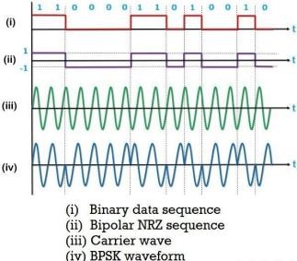**Observations:**

**Circuit Diagram**

**Case 1**

∙ Data: 11001100(Aagam shah)

∙ Waveforms

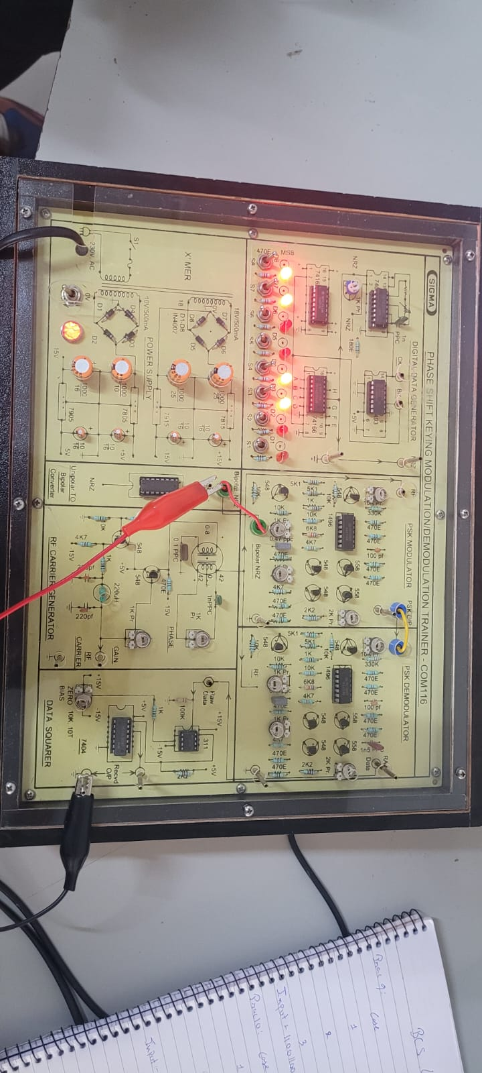

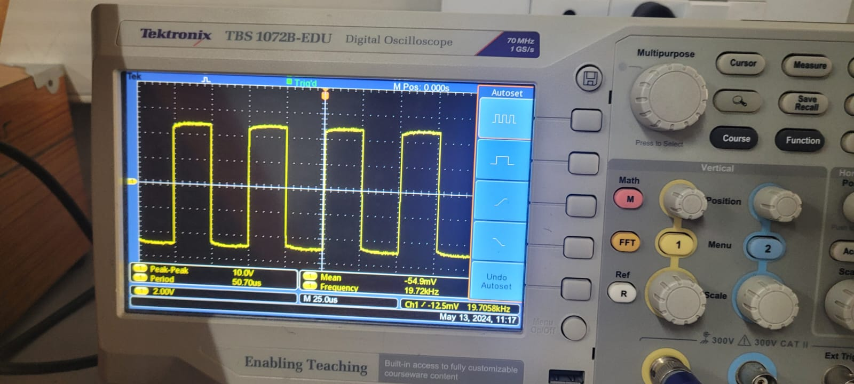

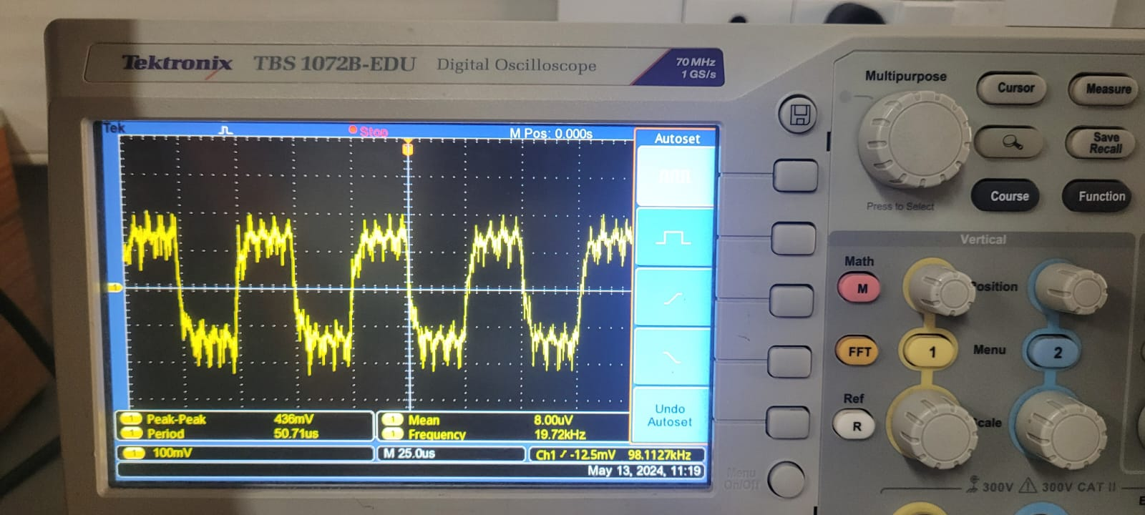

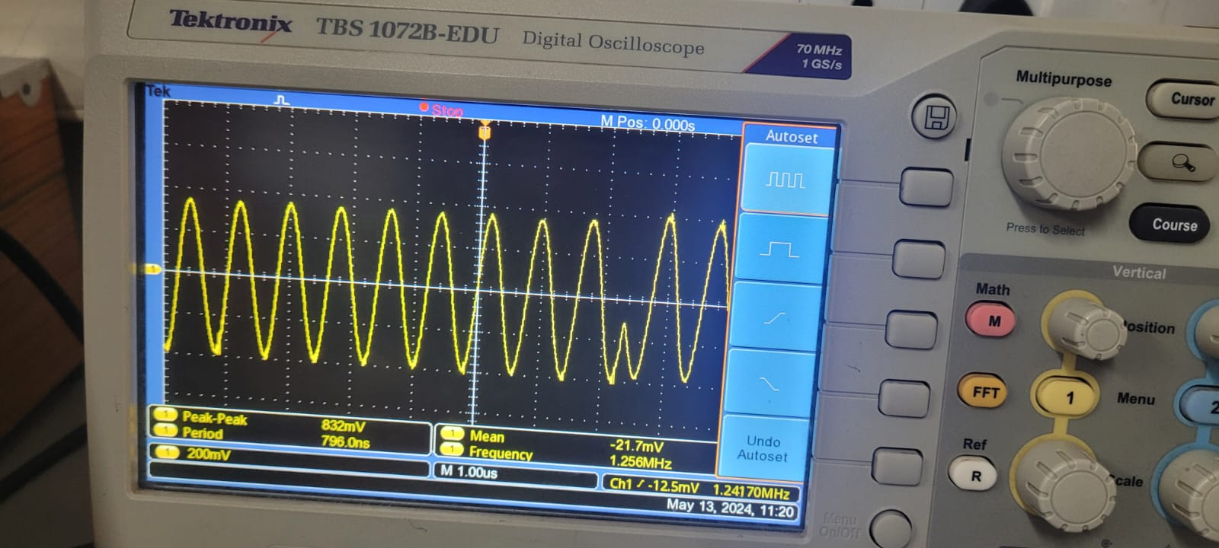

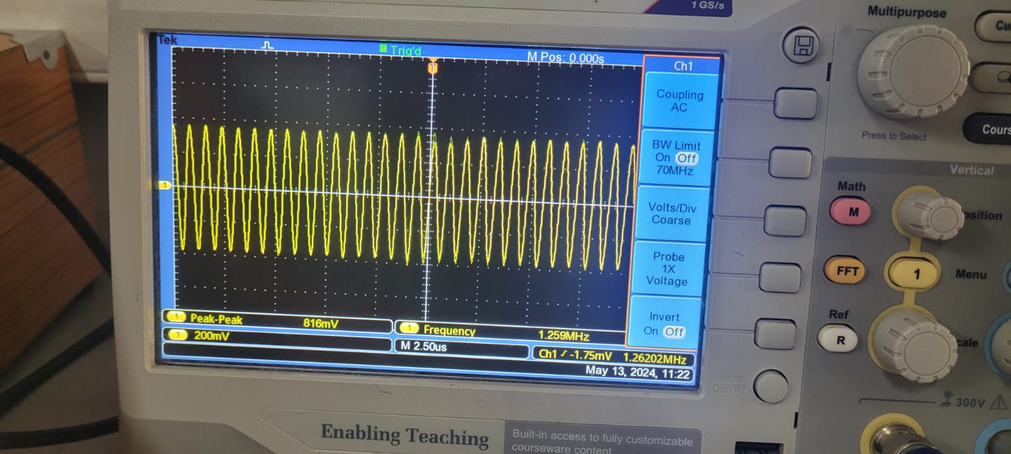

**Case 2**

∙ Data: 10101010(Dwij Desai)

∙ Waveforms

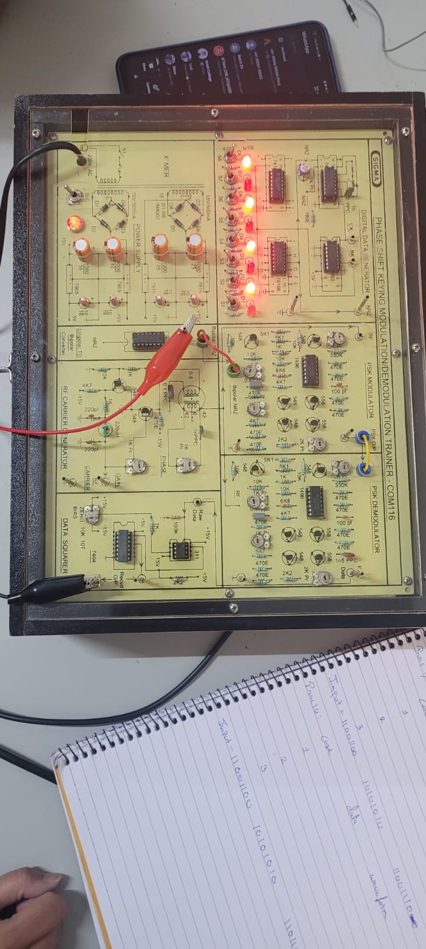

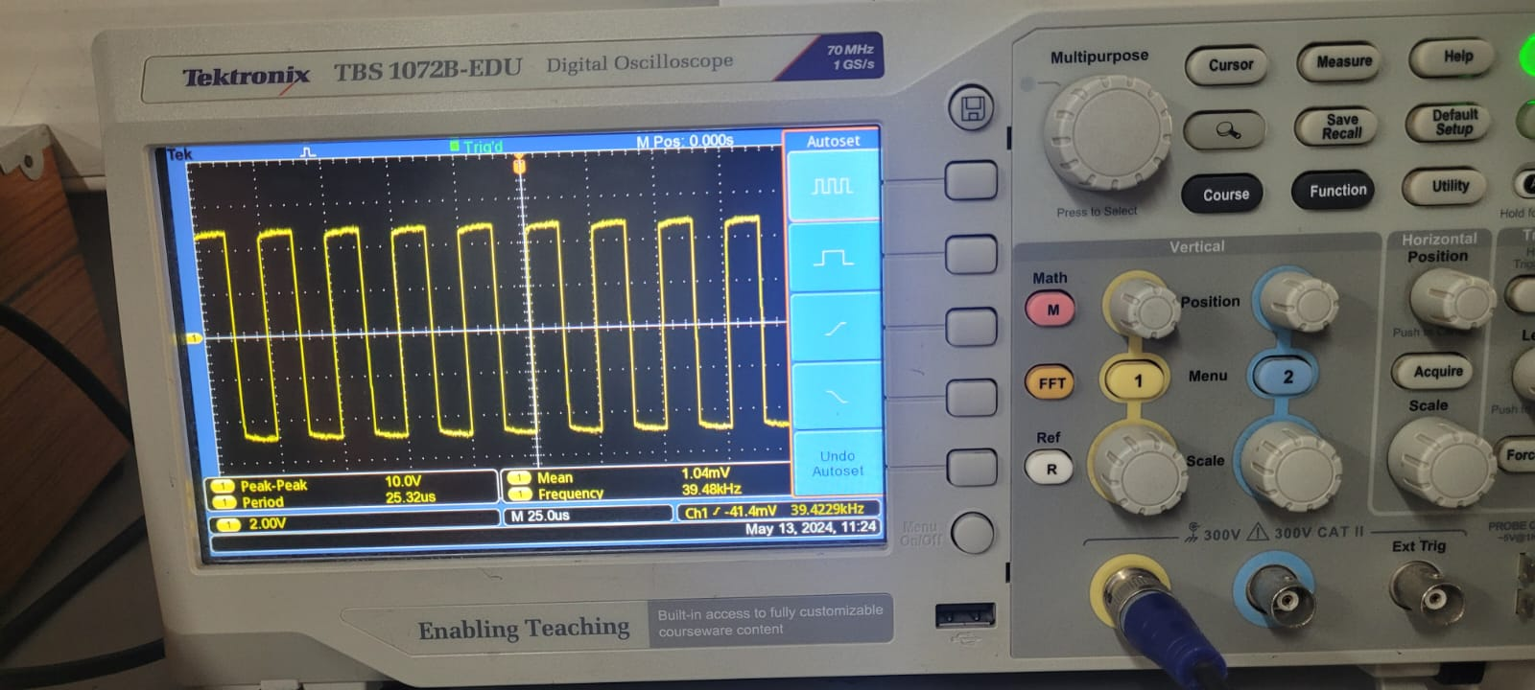

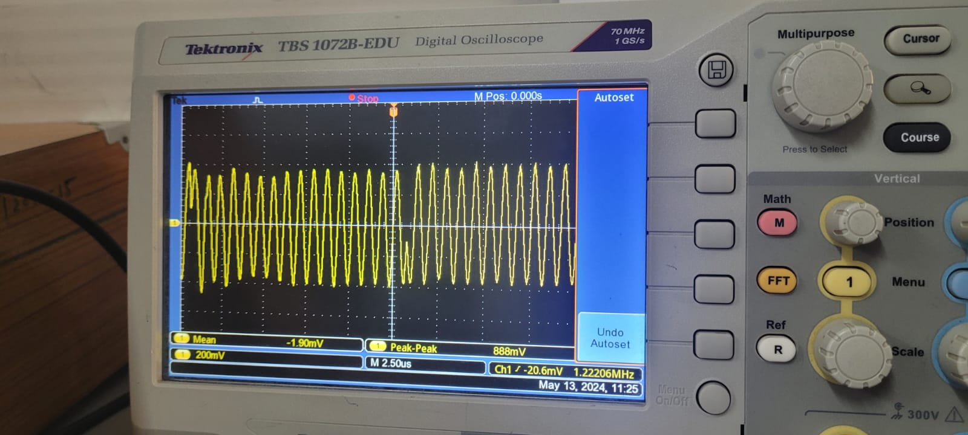

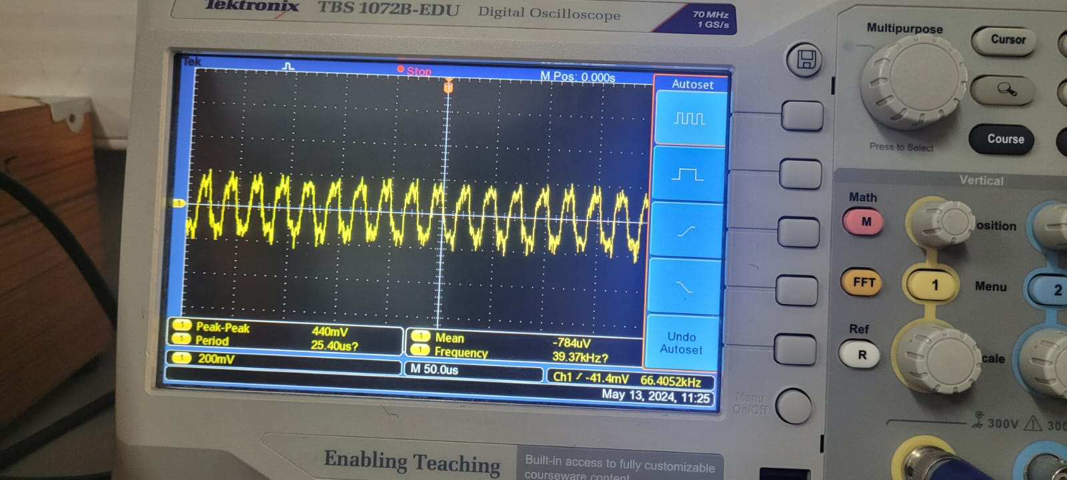

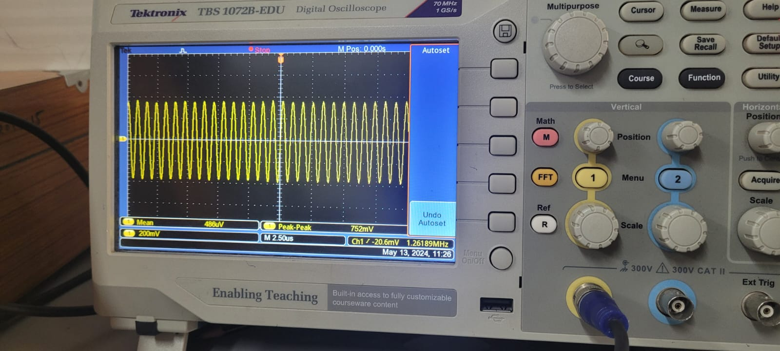

**Case 3**

∙ Data: 10110111(Priyal soni)

∙ Waveforms

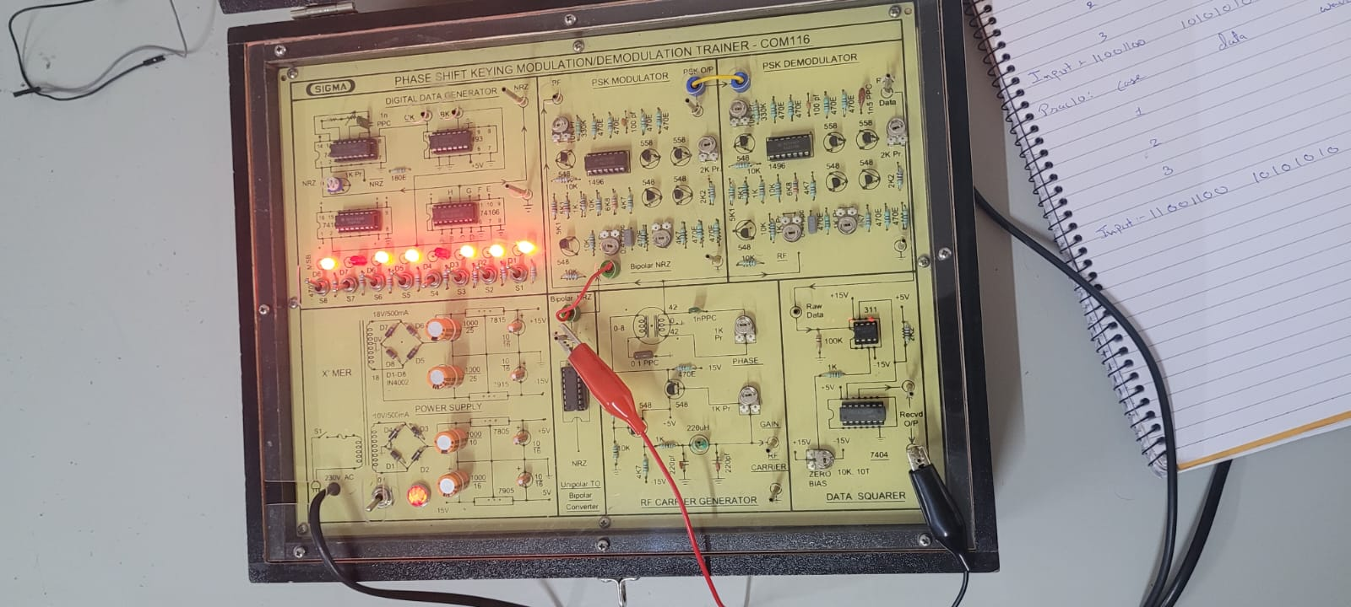

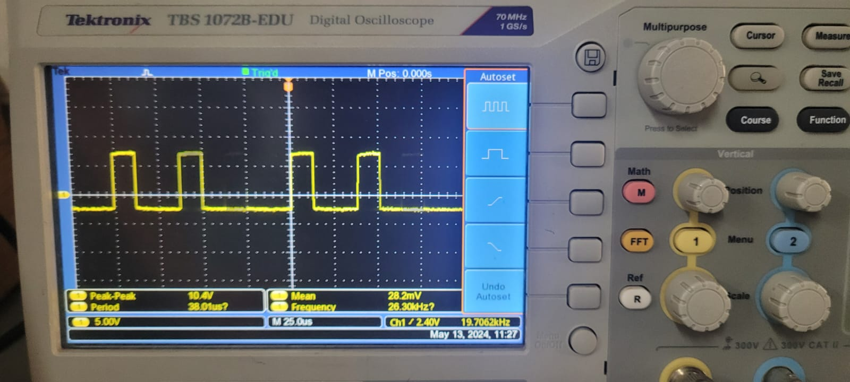

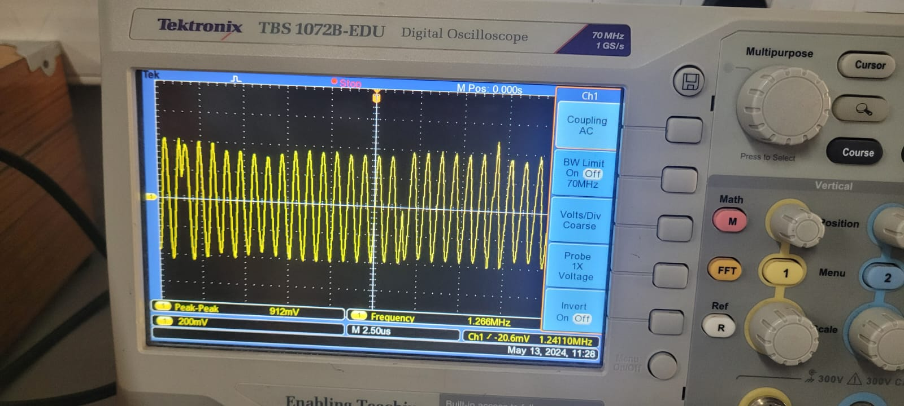

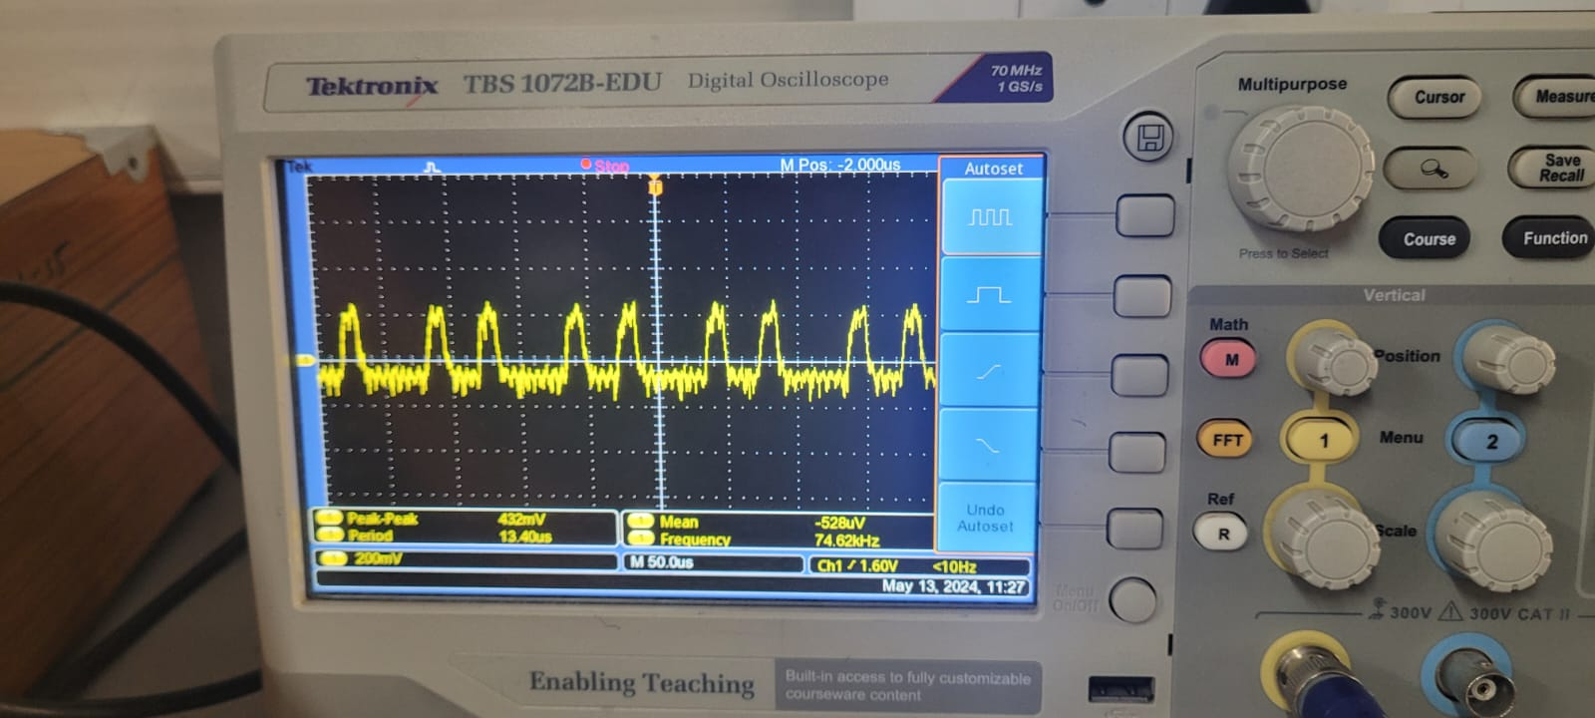

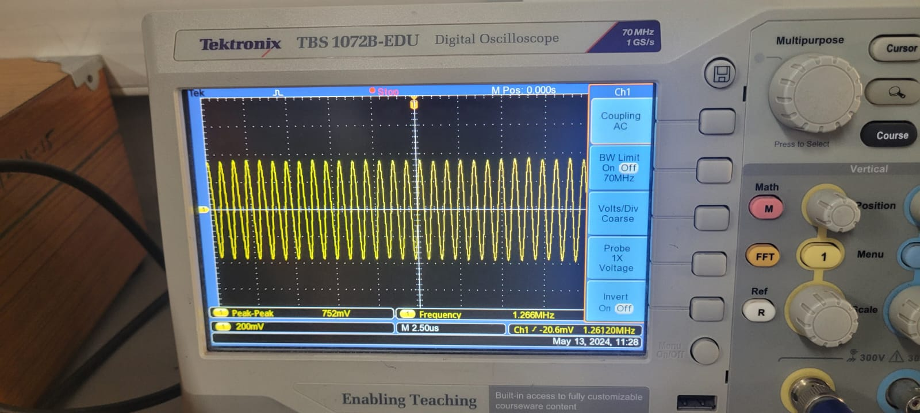

**Conclusion:**

**The experiment demonstrated successful Phase Shift Keying (PSK) modulation and demodulation, effectively encoding and retrieving binary data from carrier signals. Accurate clock regeneration and decision-making circuits were vital for streamlined demodulation and accurate data recovery.**