***nstitute of Computer And Technology***

***B.Tech – CSE(BDA)***

***Name:- Dwij Vatsal Desai***

***Sem:- 2***

***Sub: - BCS***

***Enrollment No.:- 23162121027***

***Prac:- 3***

***Date:- 16/2/2024***

**Aim:** Interconnection of various Local area networks using routers.

**Procedure:**

**Case 1:** Zenith Enterprise has three departments: Production, Sales and Admin.  Each department contains two hosts. You are appointed as Network Engineer in  Zenith Enterprise. Design the network to provide connectivity between these  three departments.

**Description :**

Zenith Enterprise has three departments: Production, Sales, and Admin, with two desktop computers (hosts) in each department. The network design includes a single switch connecting all hosts and a router for internet access. Each department is assigned a unique IP subnet for efficient routing. Basic security measures, like firewall rules and access control lists, are in place. DHCP and DNS servers handle IP assignment and name resolution. This setup offers a straightforward network infrastructure for Zenith Enterprise's needs.

**Design :**

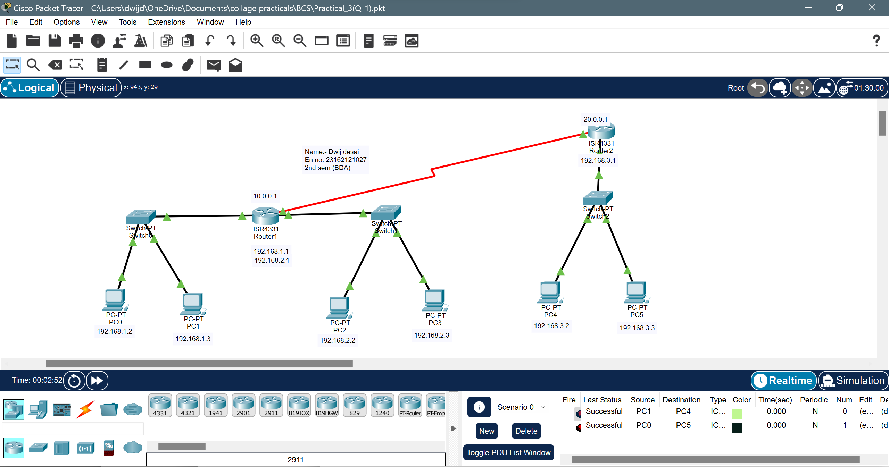

**Device Configuration:**

* For PC0

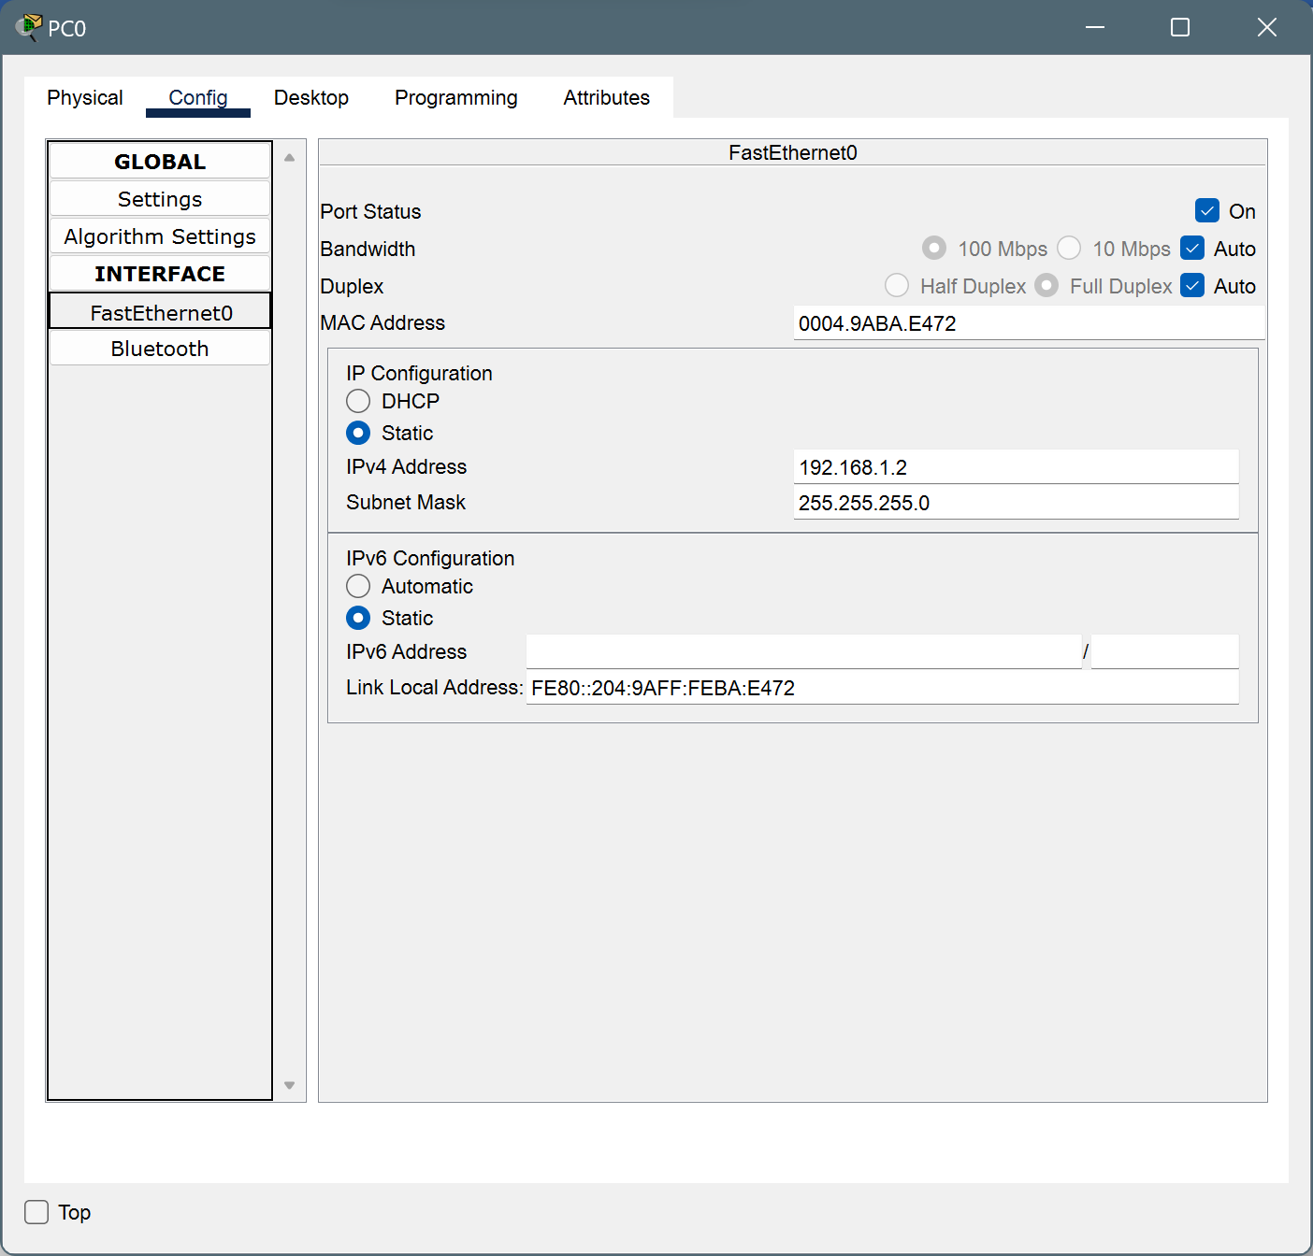

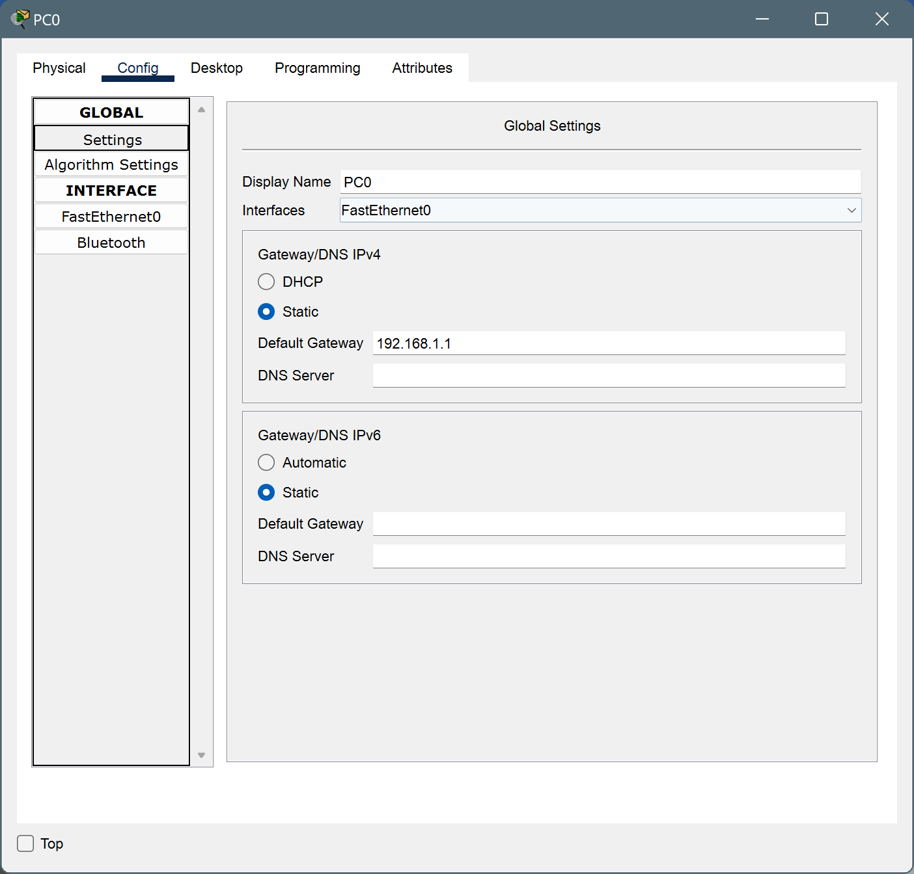

* For PC1

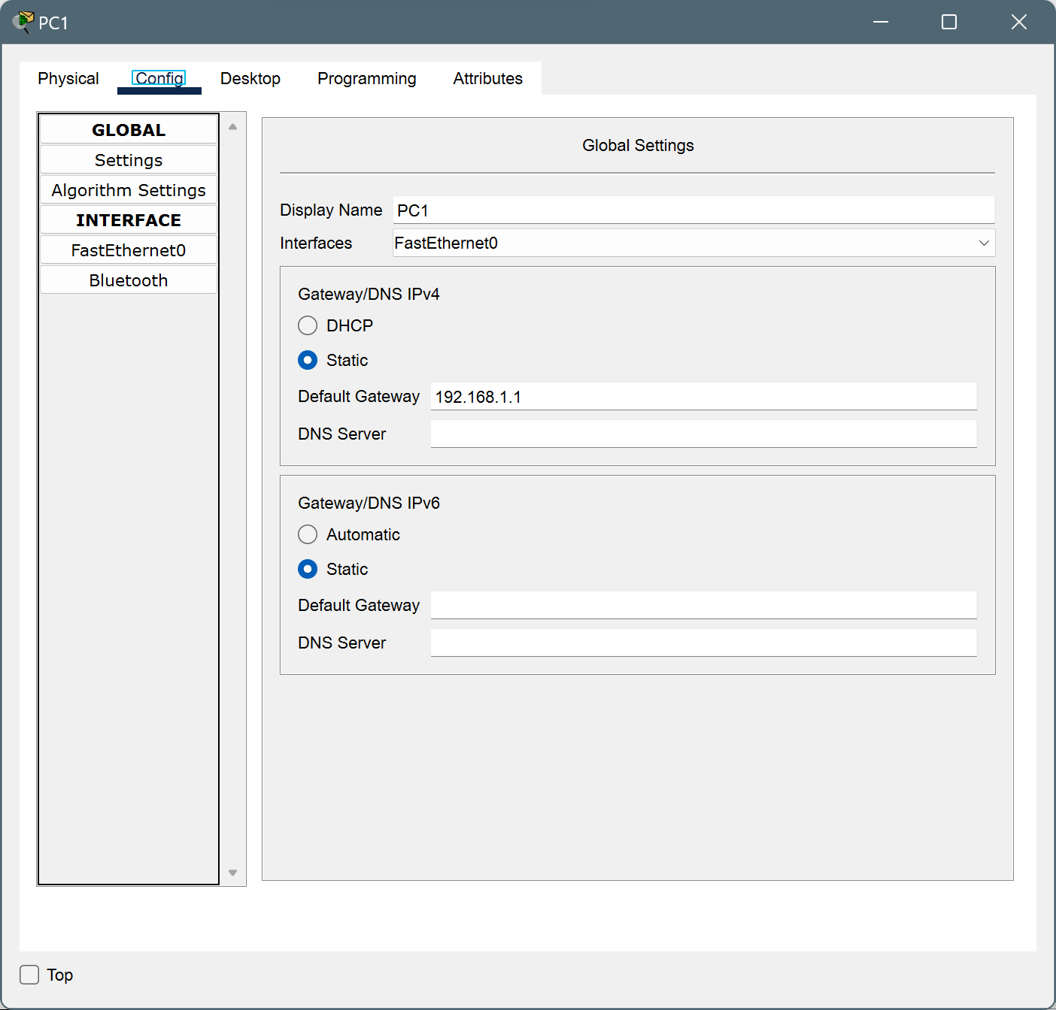

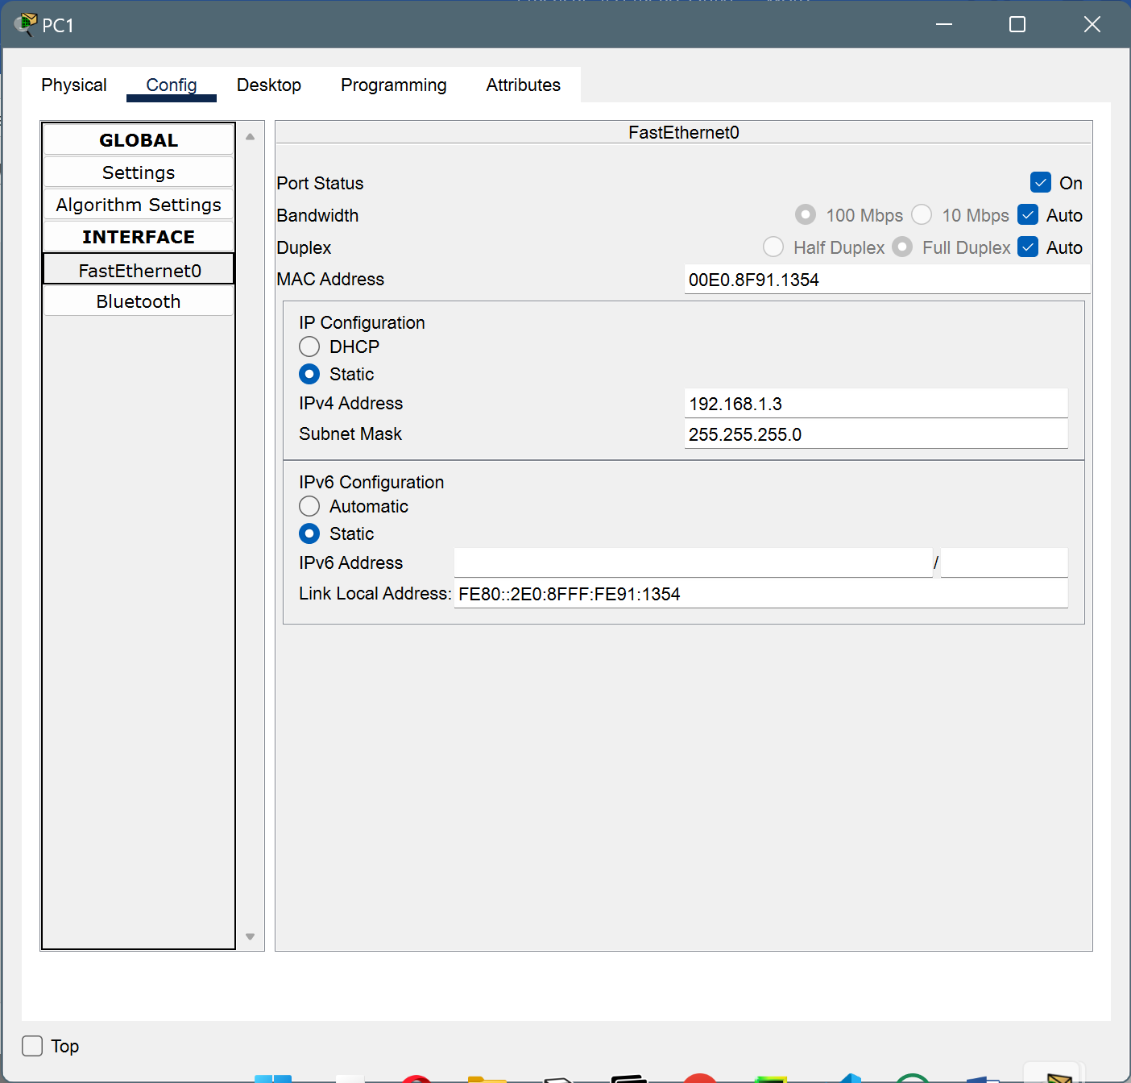

* For PC2

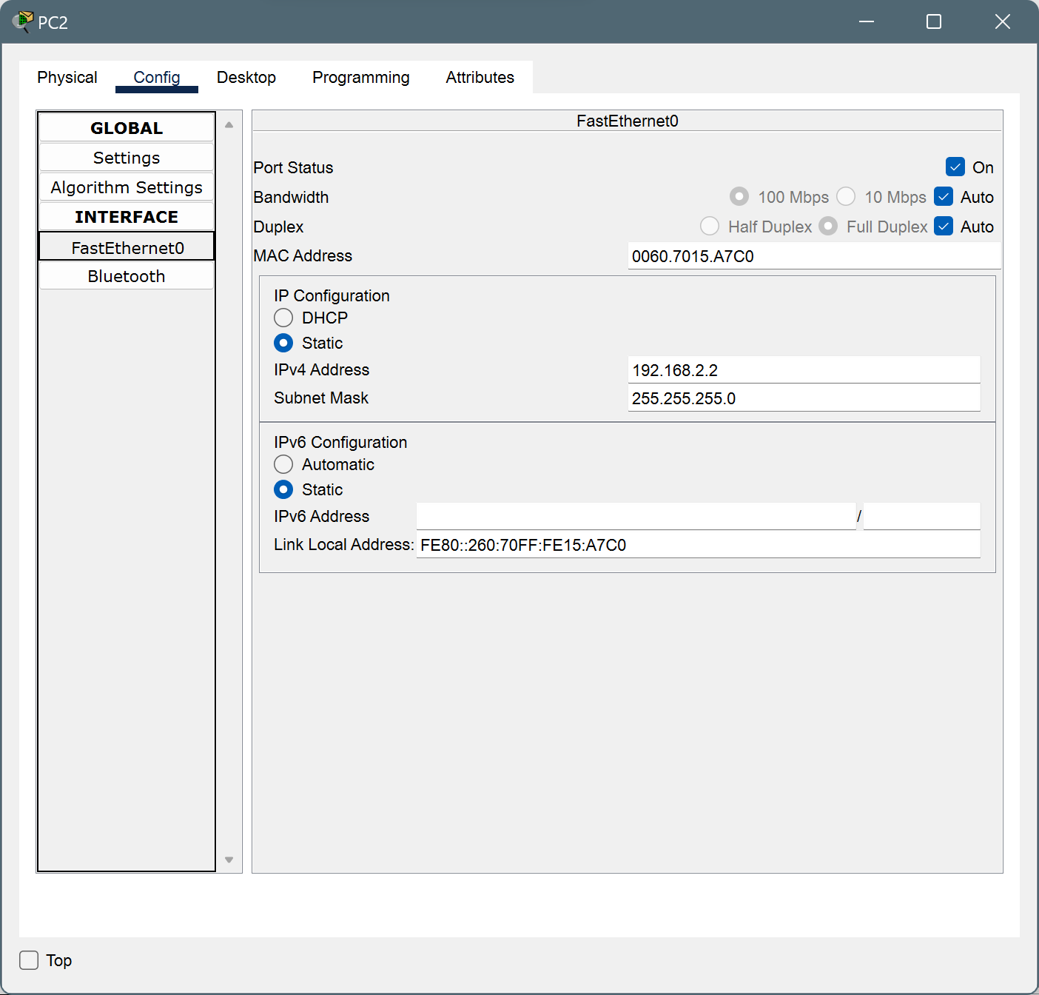

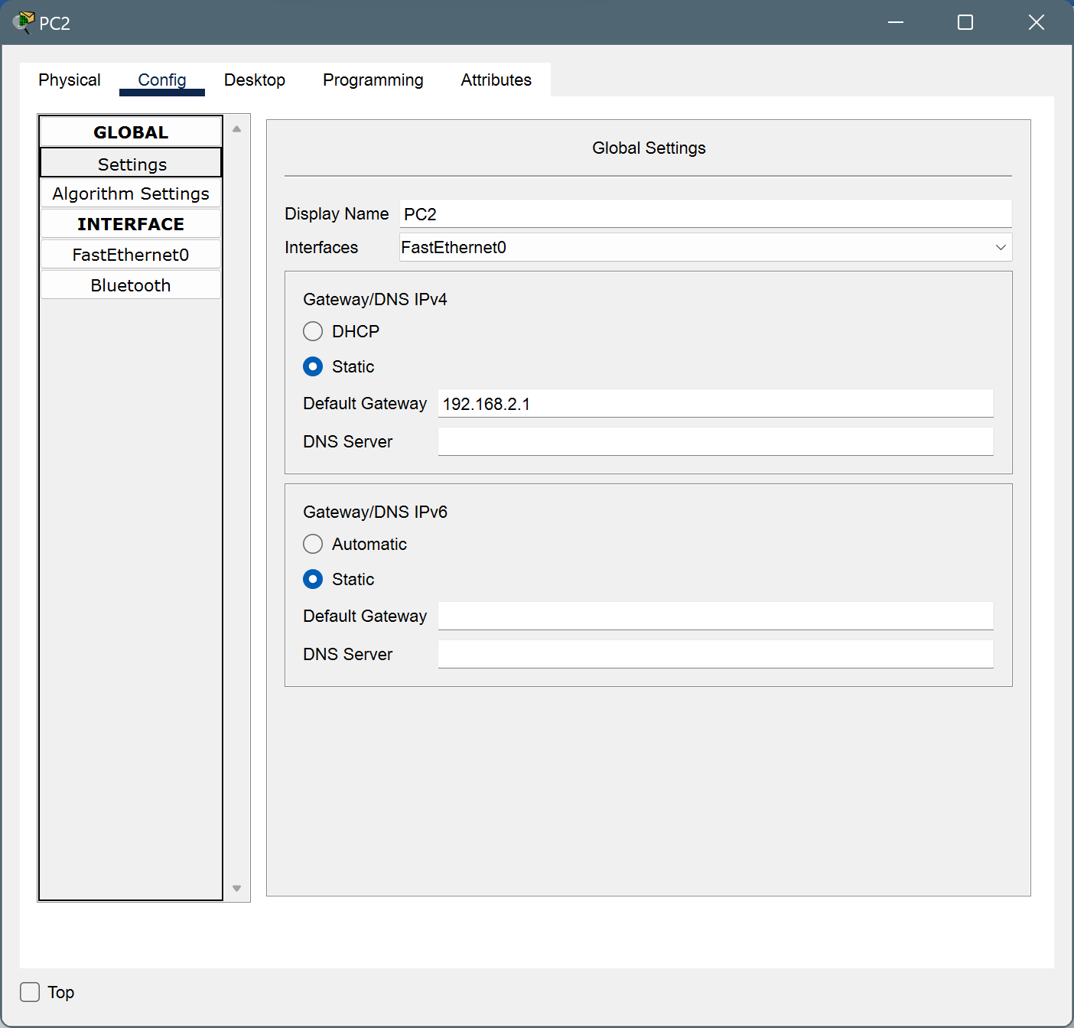

* For PC3

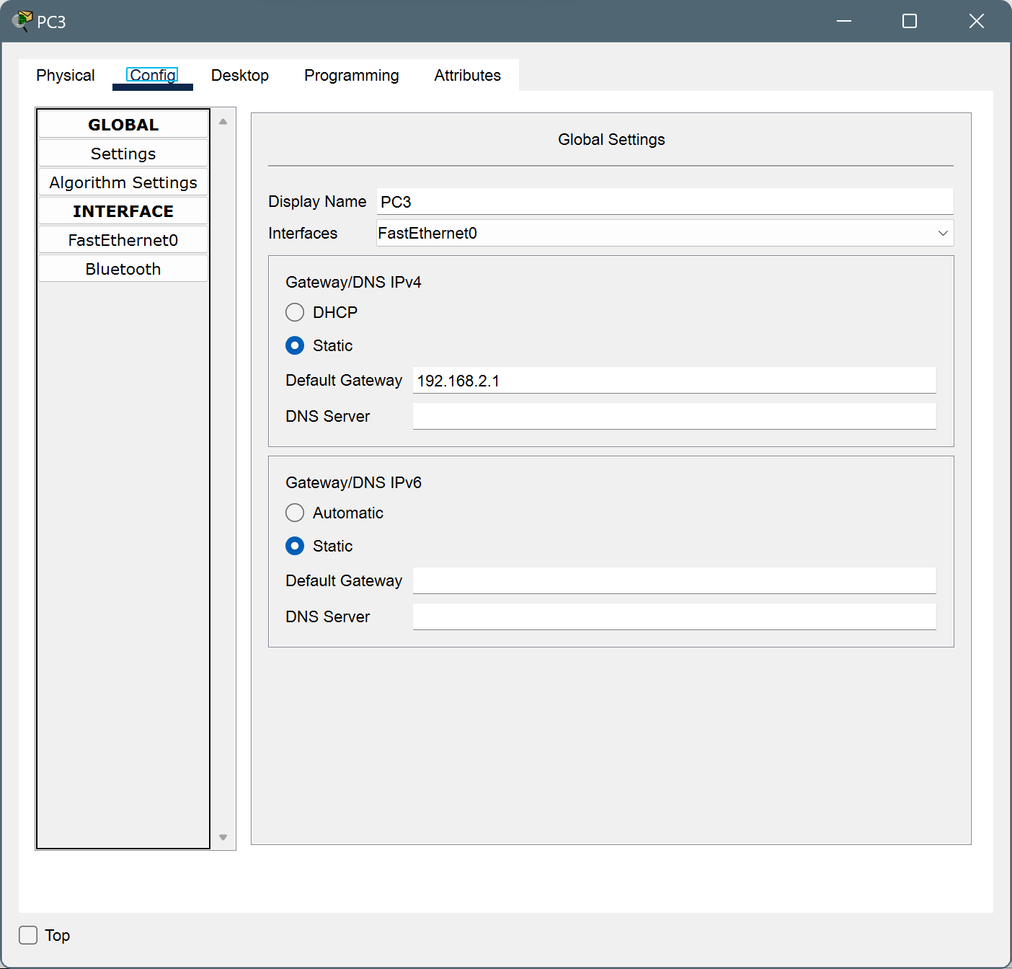

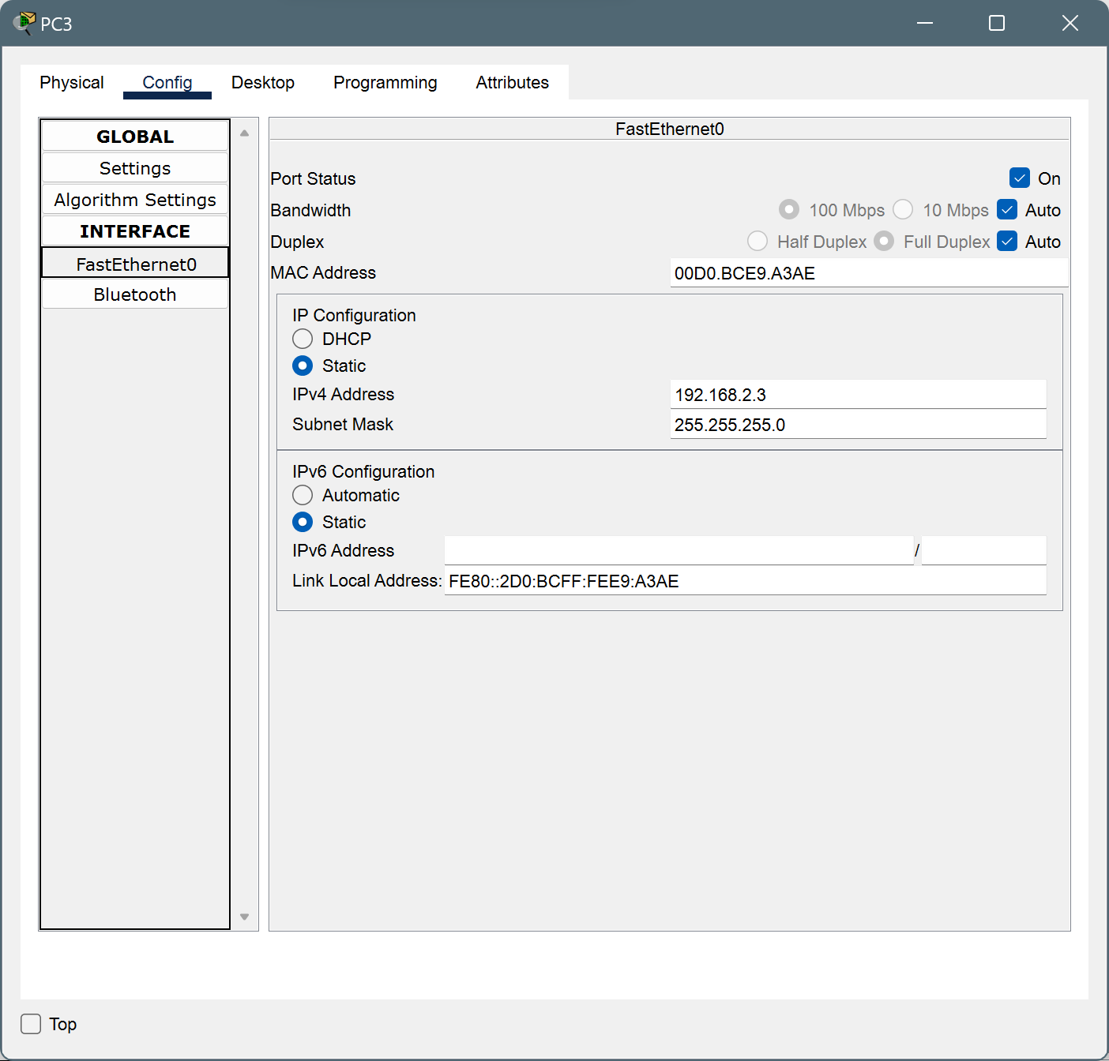

* Router1

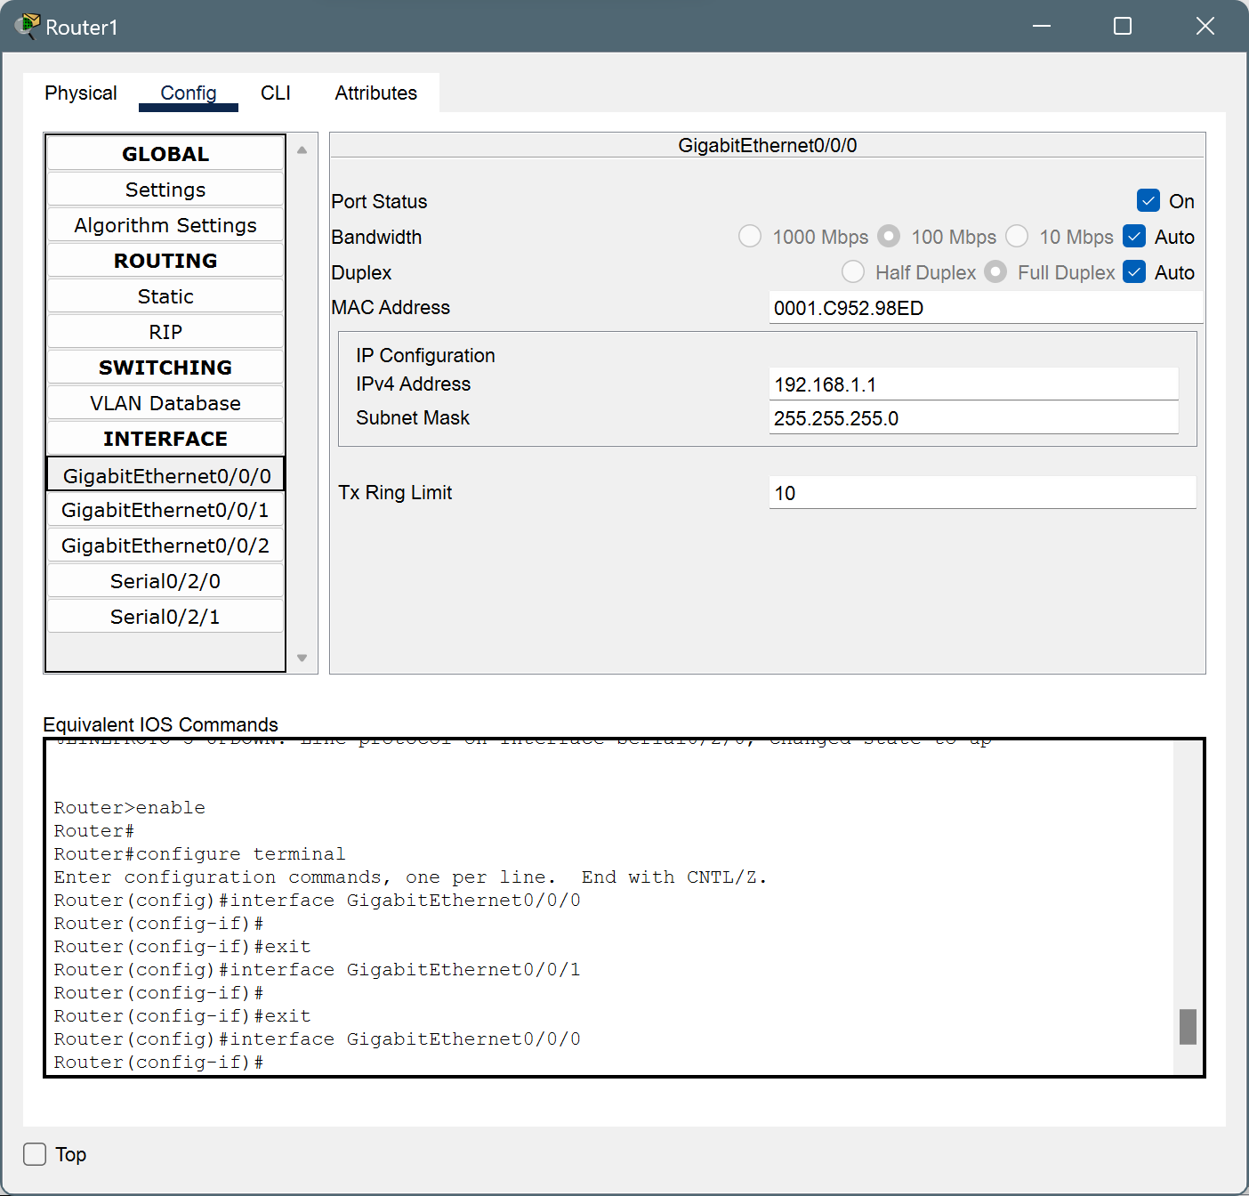

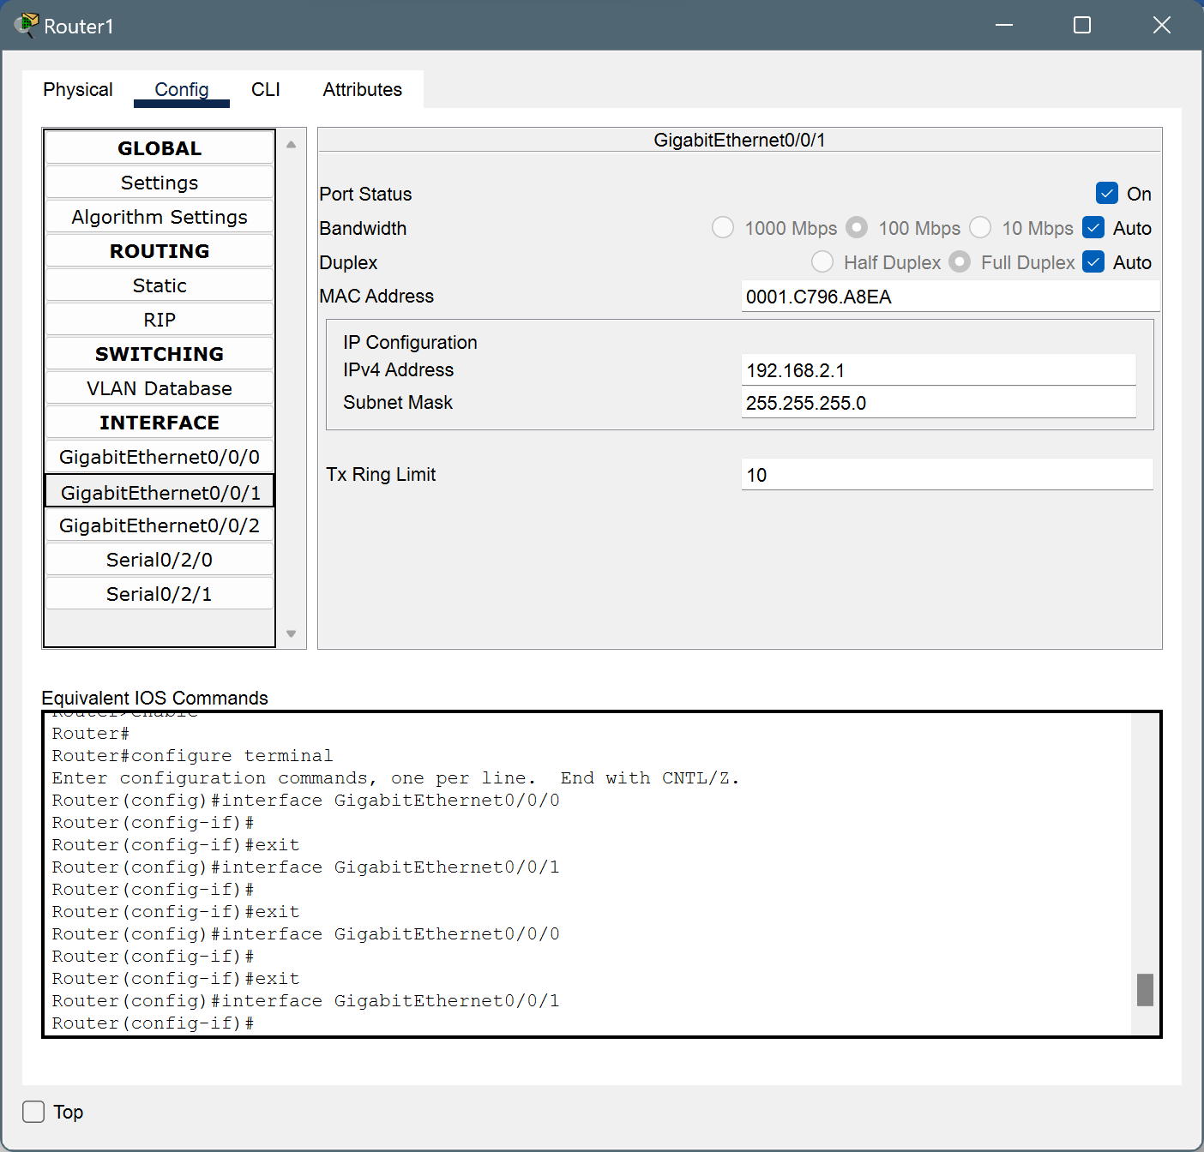

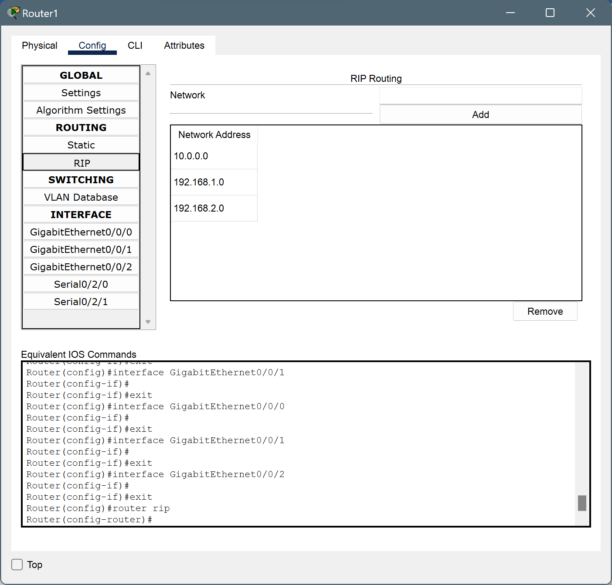

* For PC4

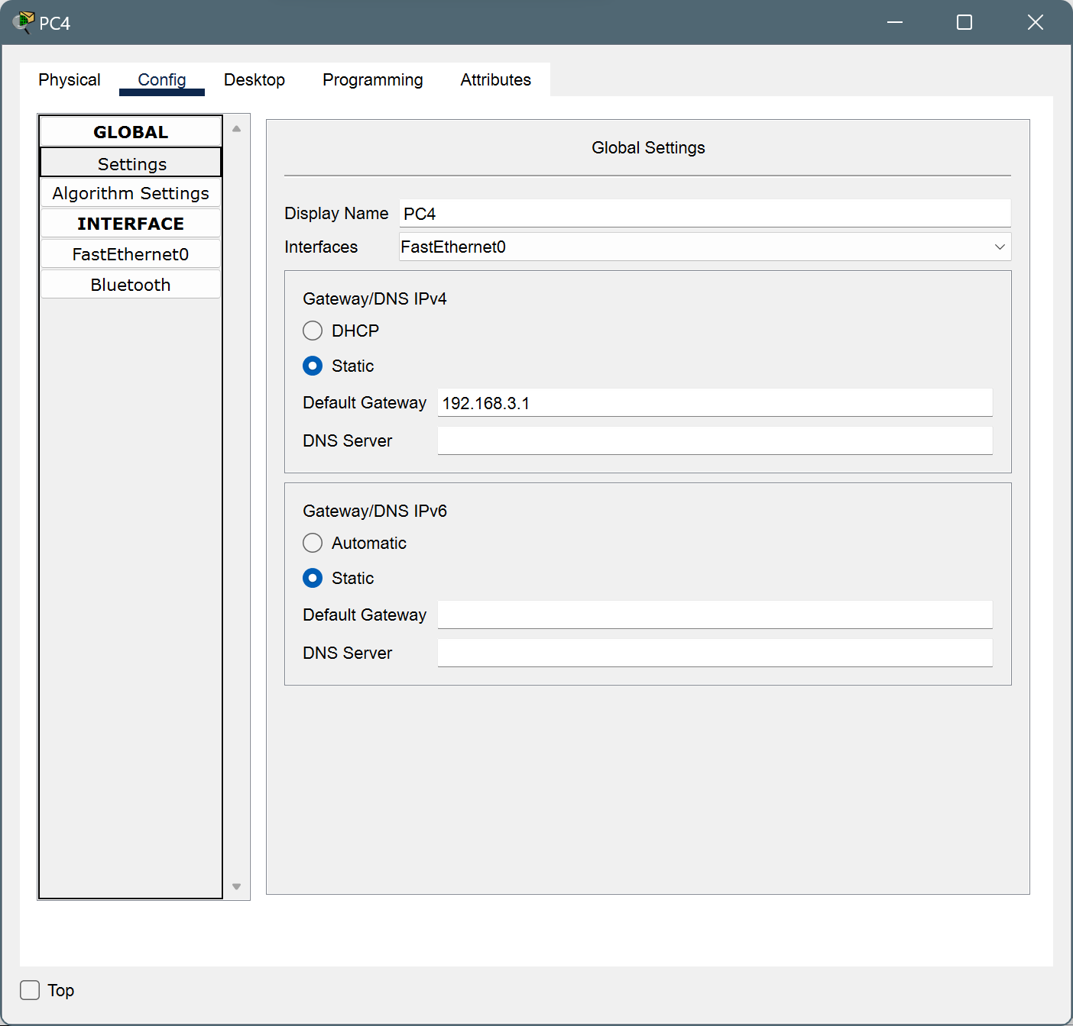 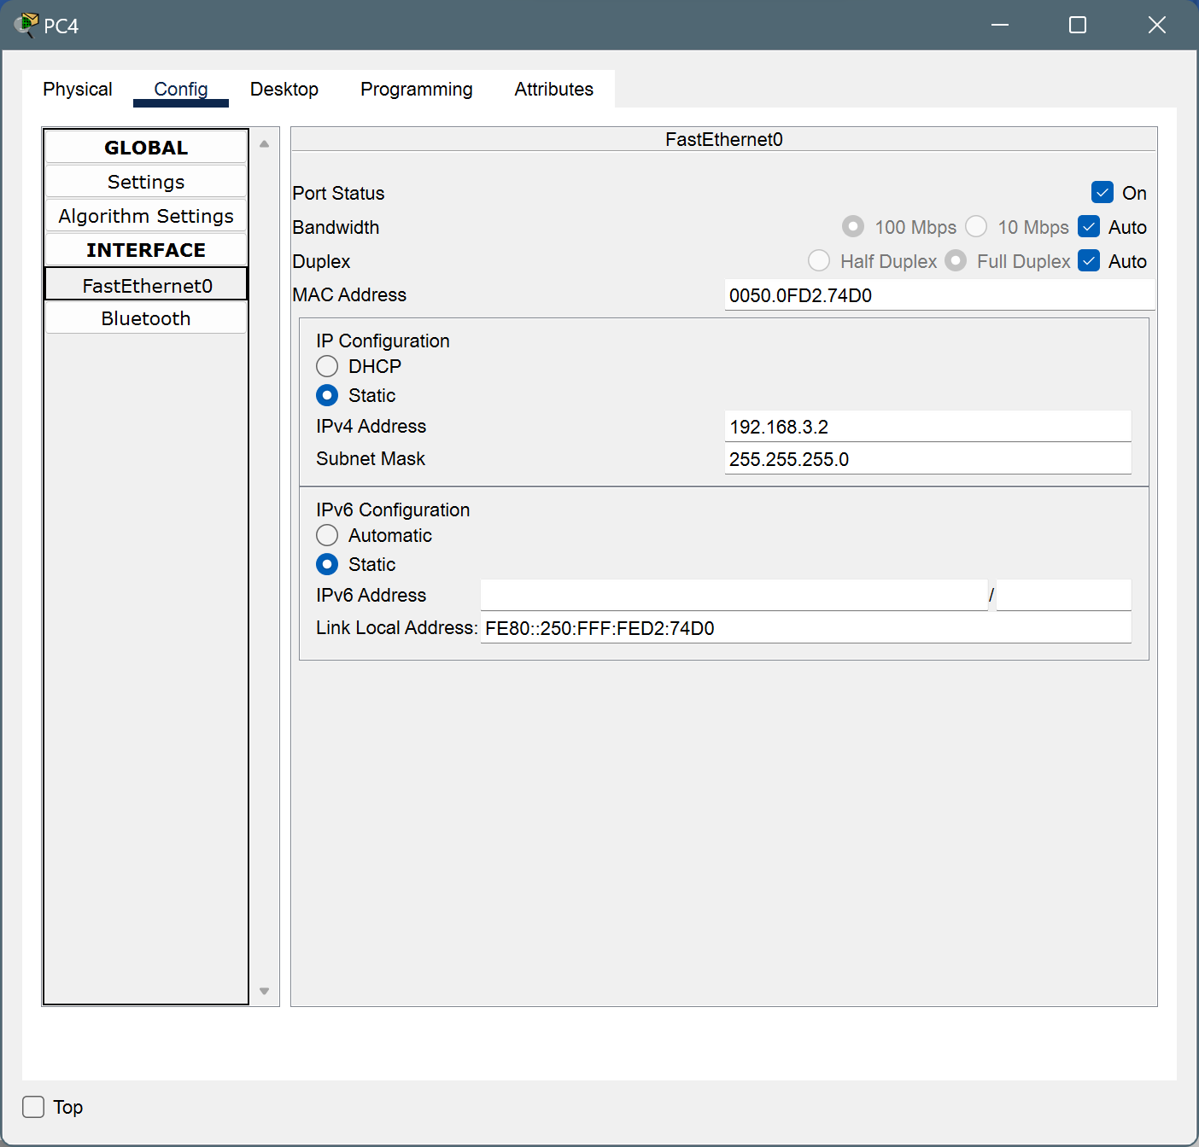

* For PC5

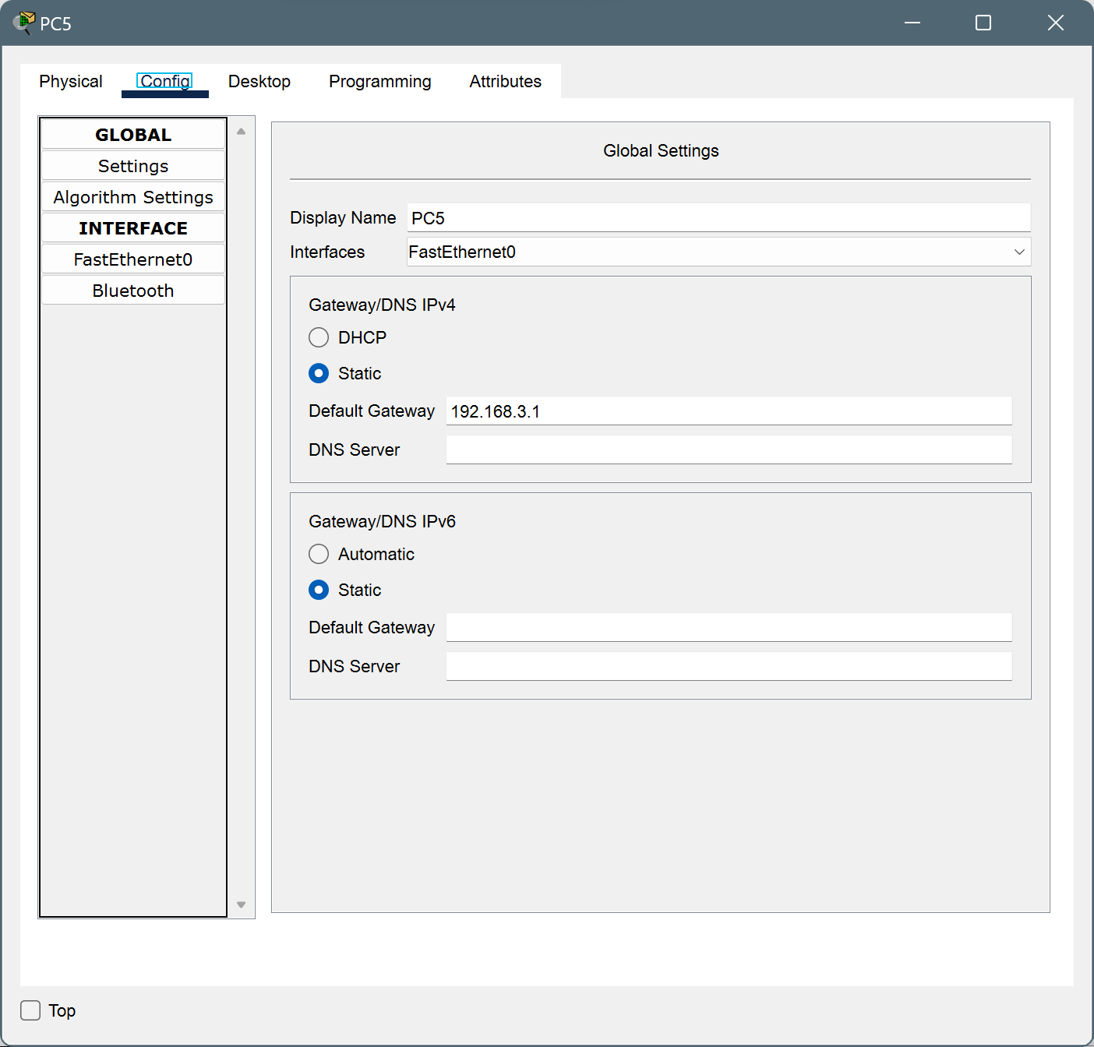

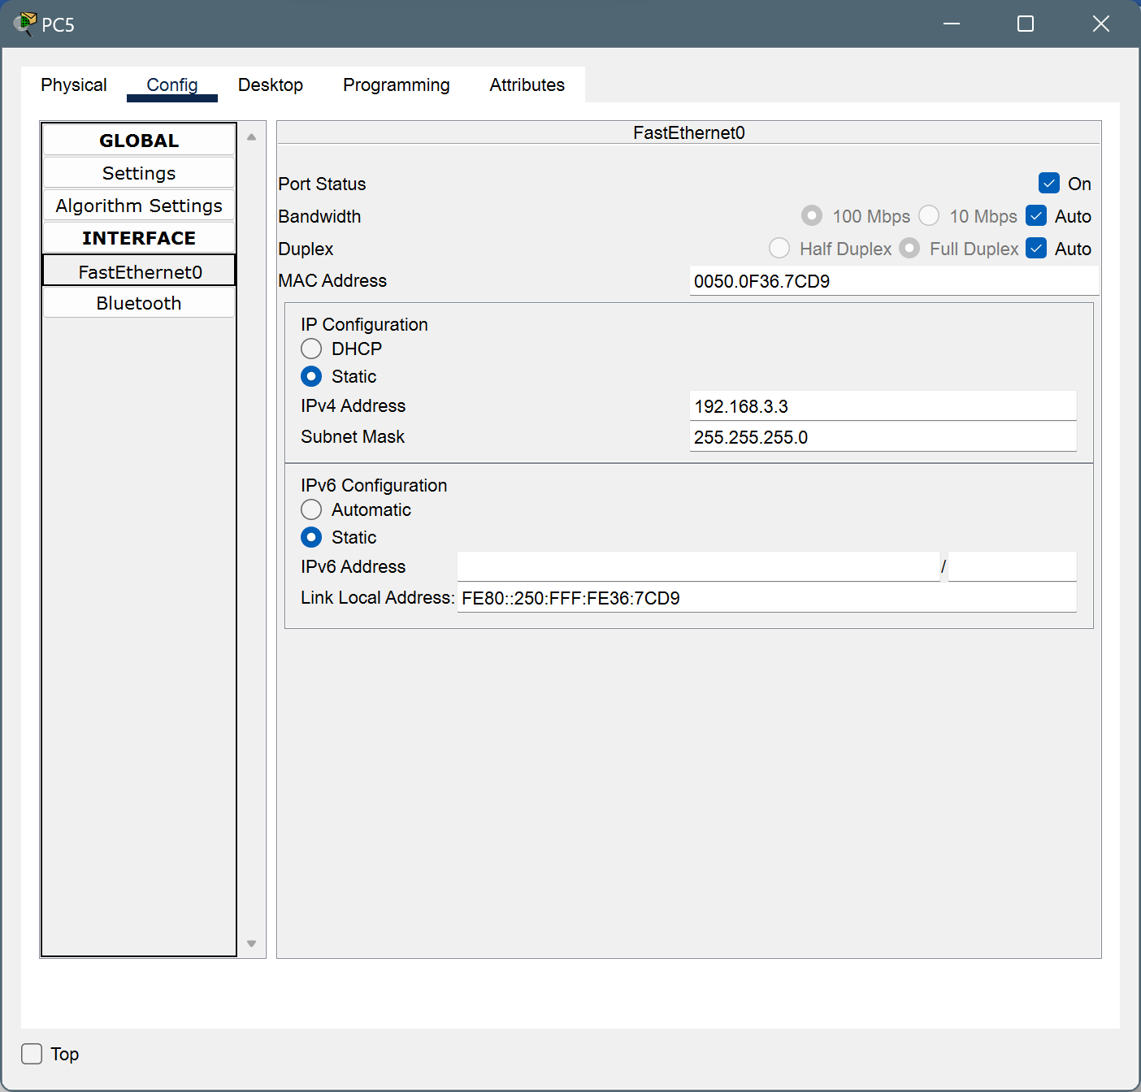

* Router2

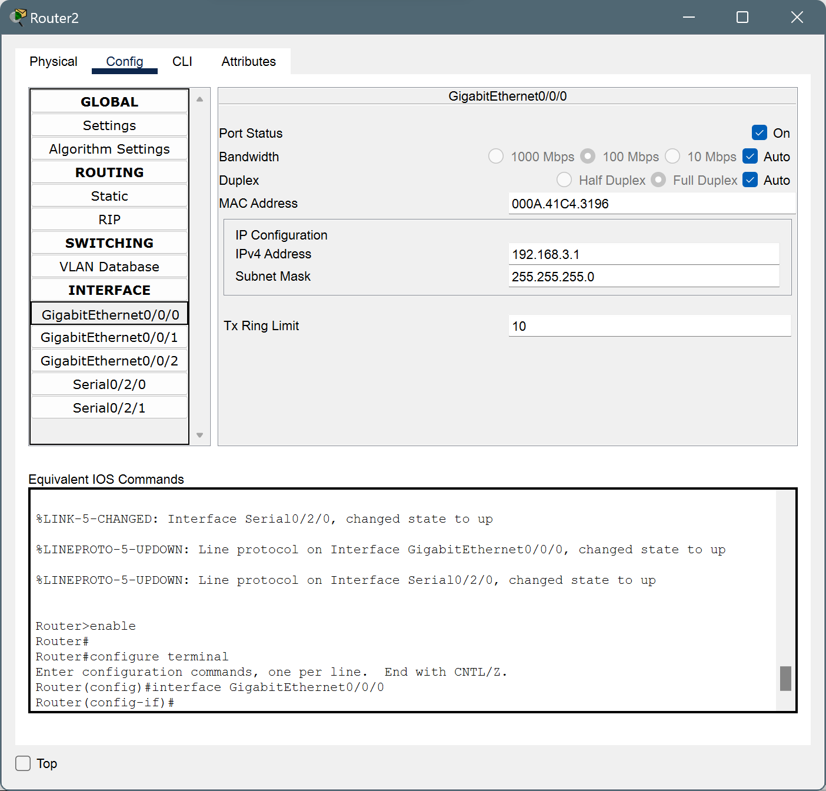

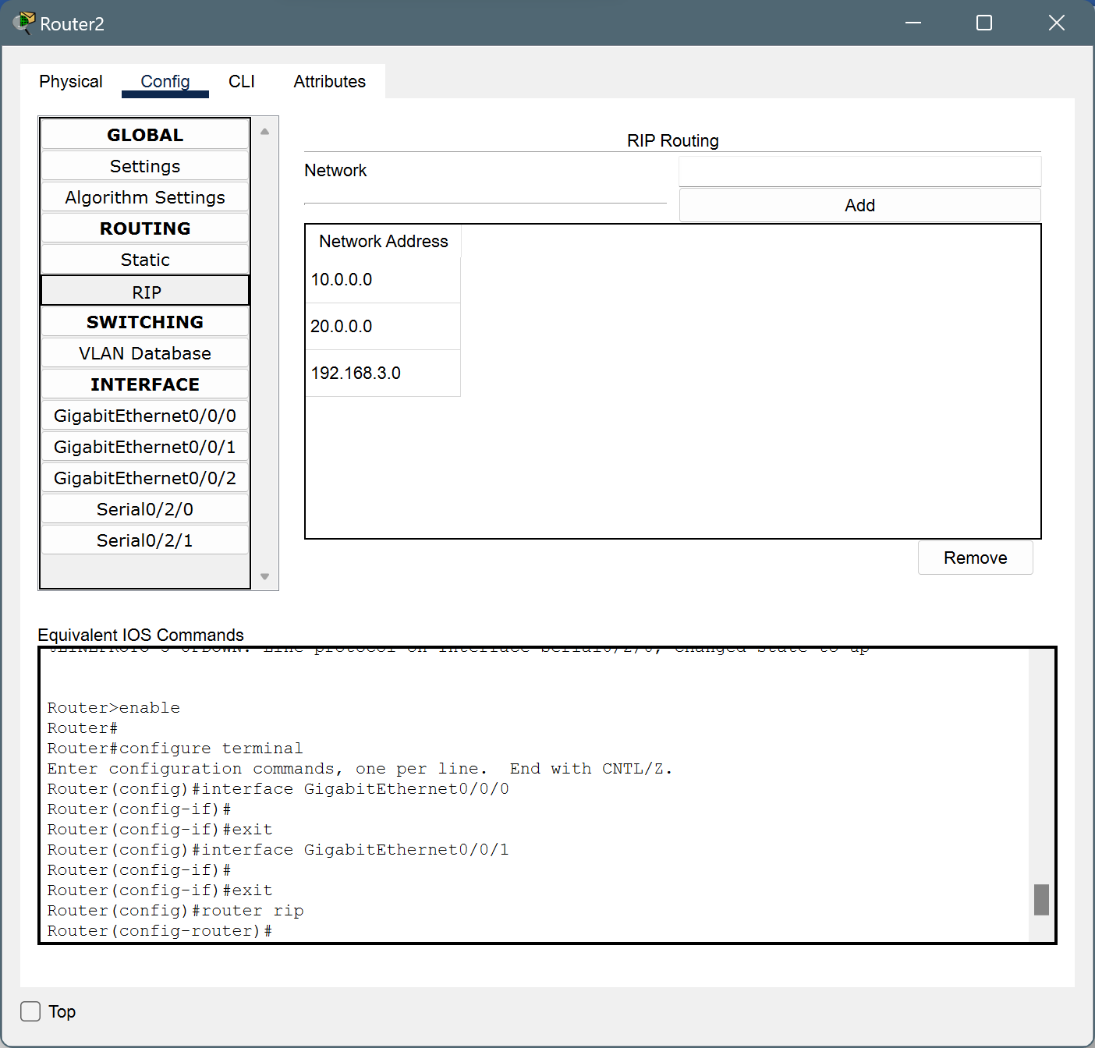

**Packet Transfer :**

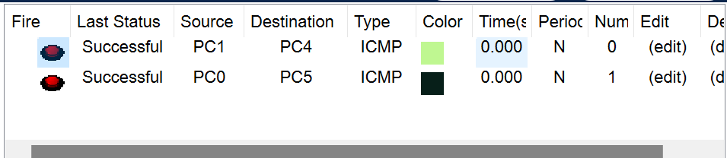

**Case 2:** Green Tech Pvt. Ltd. contains four departments: Production, Sales,  Admin and R&D. Each department has two hosts. You are appointed as Network  Engineer in Green Tech Pvt. Ltd. Design the network to provide connectivity  between these four departments.

**Description :**

Green Tech Pvt. Ltd. comprises four departments: Production, Sales, Admin, and R&D, each with two desktop computers (hosts). The network design features a central router connecting the departments, with each department having its own switch for host connections. Each department is assigned a unique IP subnet for efficient routing. Basic security measures, such as firewall rules and access control lists, are implemented. DHCP and DNS servers manage IP assignment and name resolution. This setup offers a straightforward network infrastructure for Green Tech Pvt. Ltd.'s operations.

**Design :**

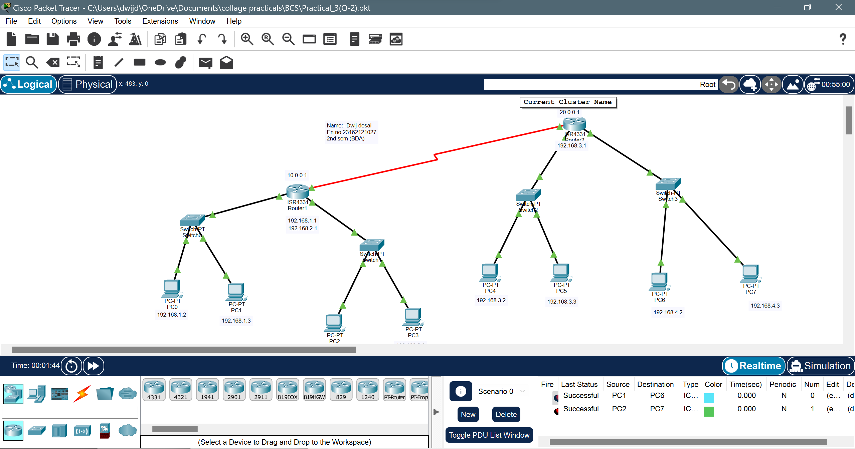

**Device Configuration:**

* For PC0





* For PC1





* For PC2





* For PC3





* Router1







* For PC4

 

* For PC5





* For PC6

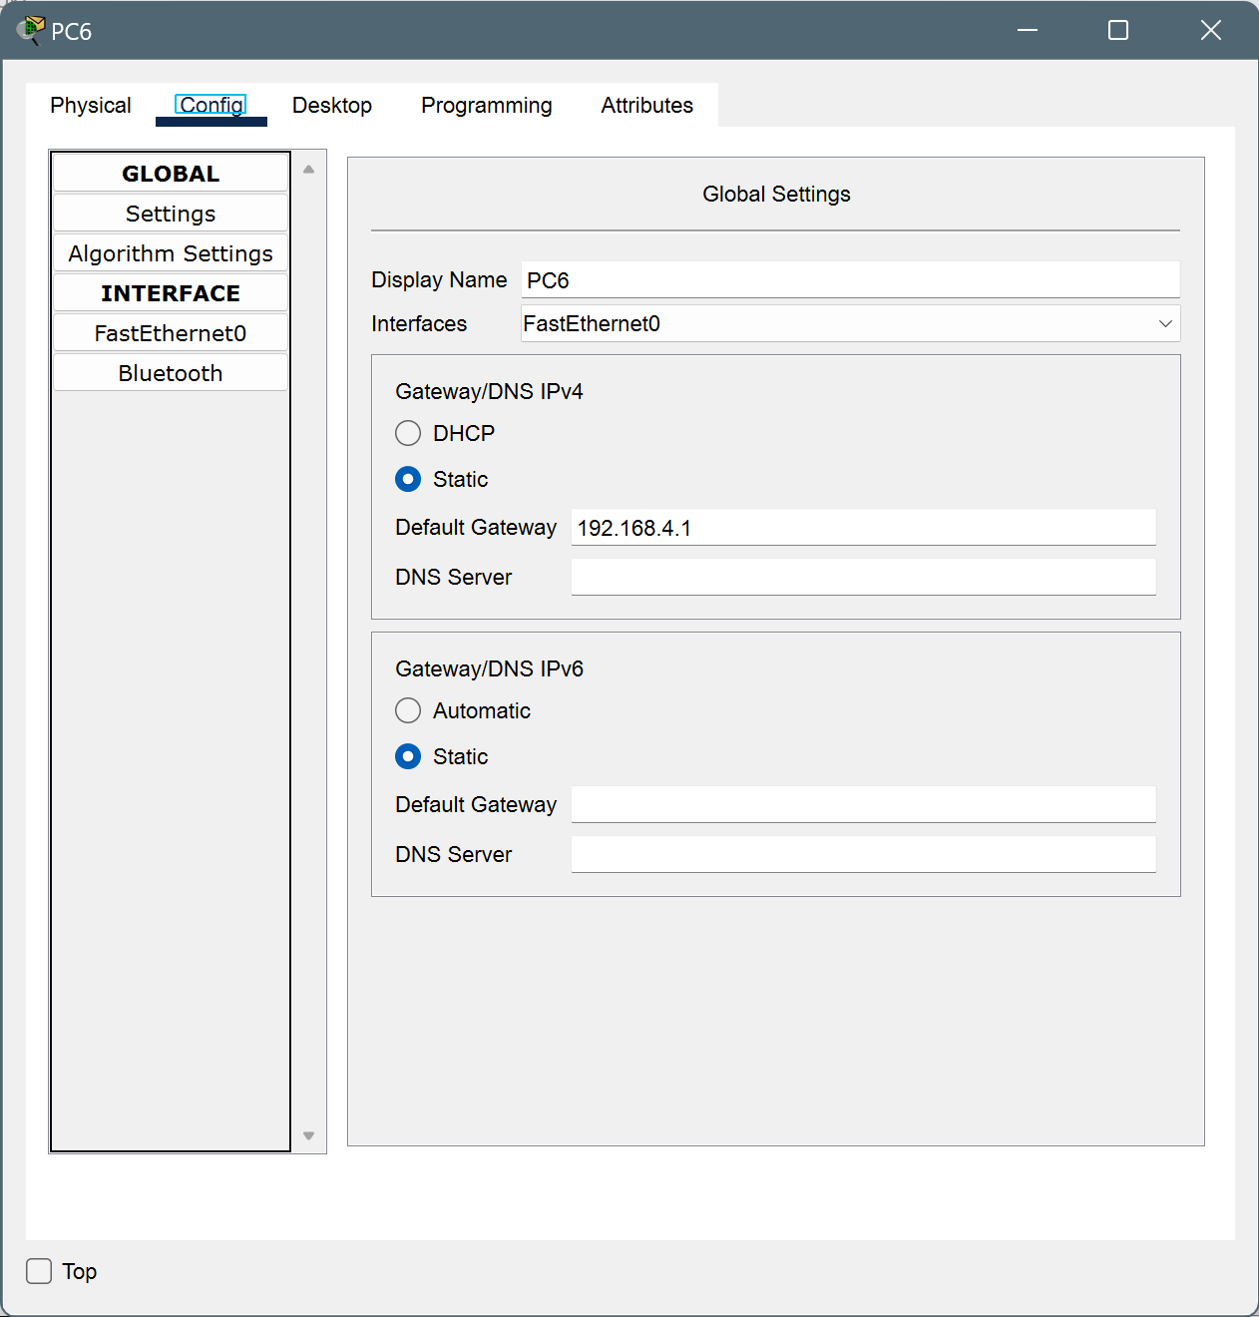

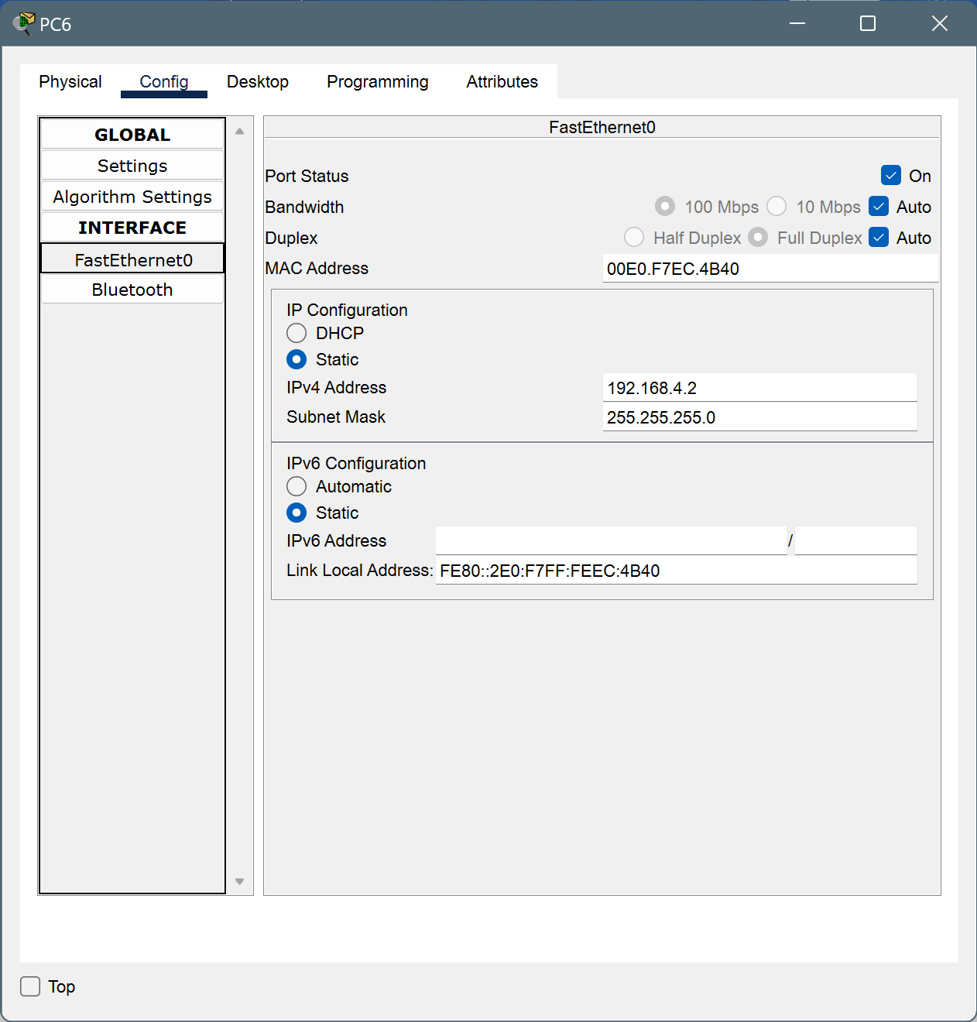

* For PC7

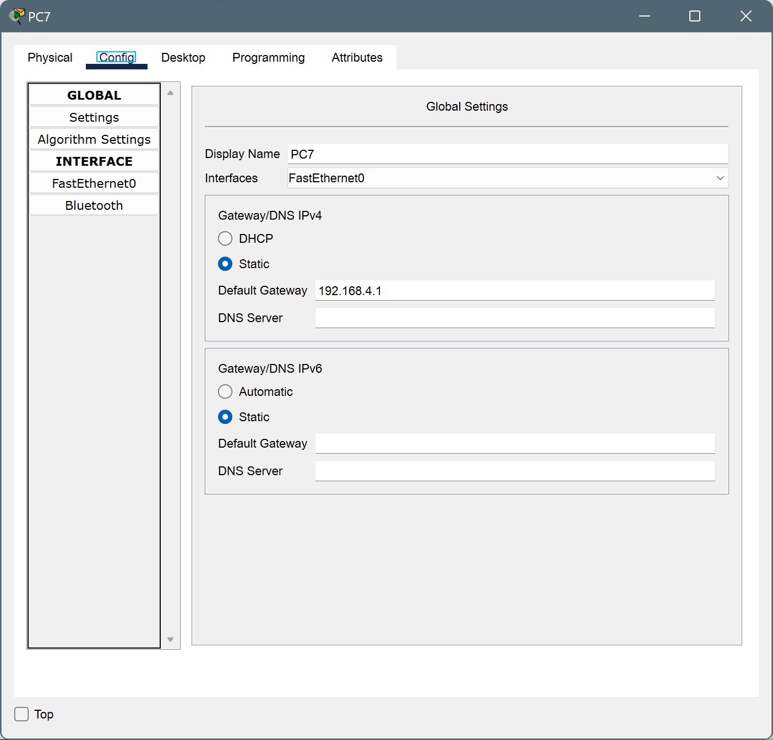

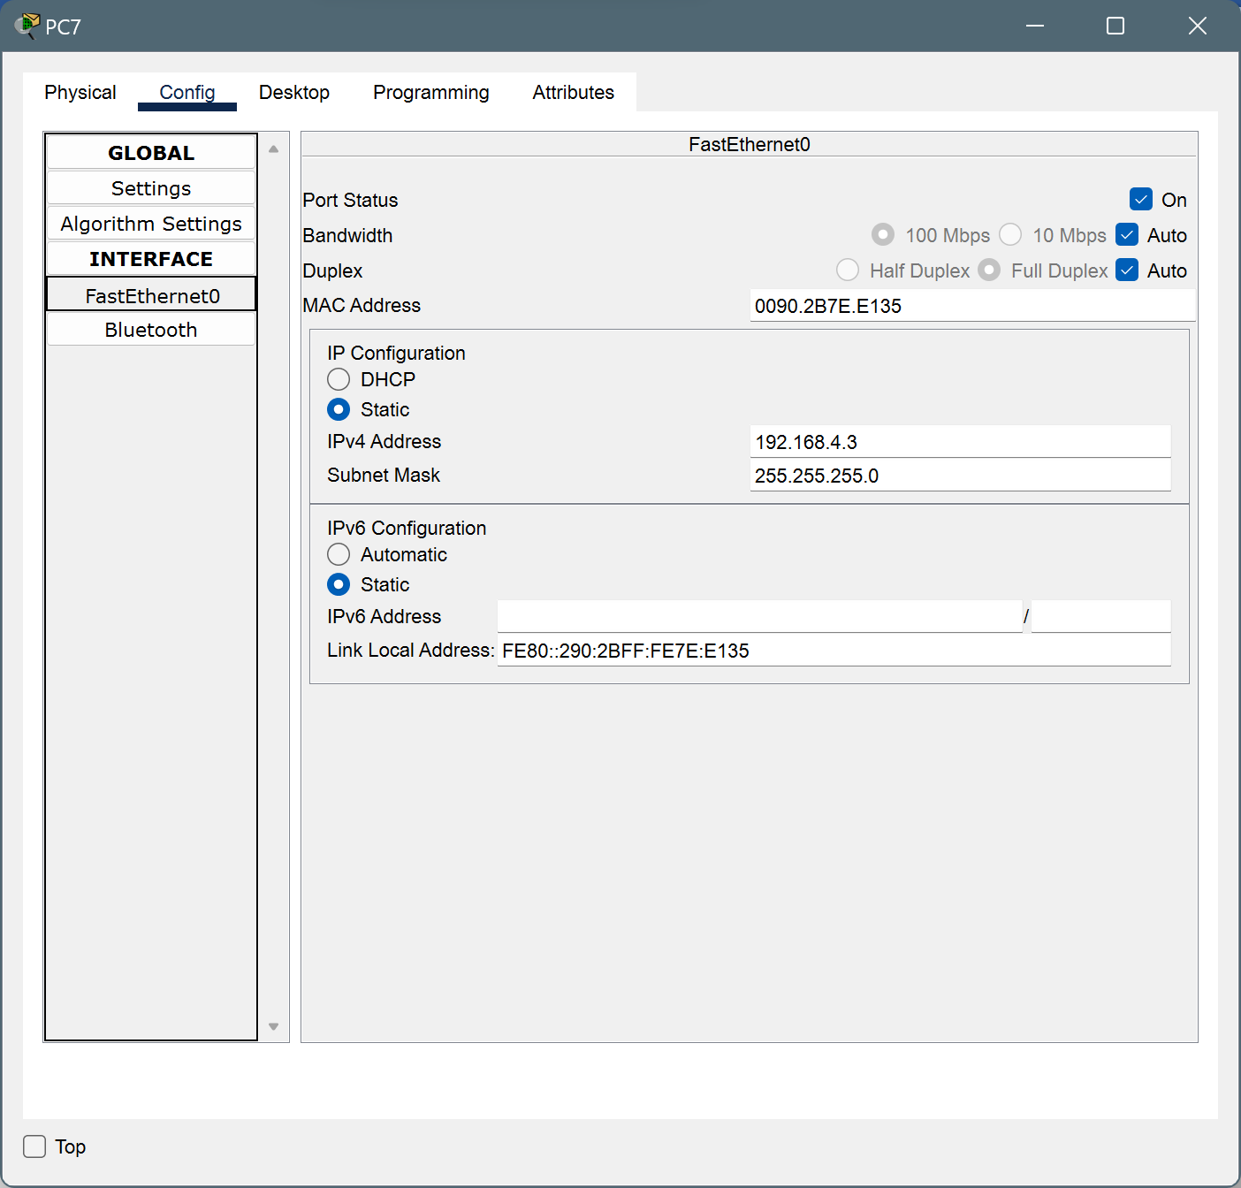

* Router2

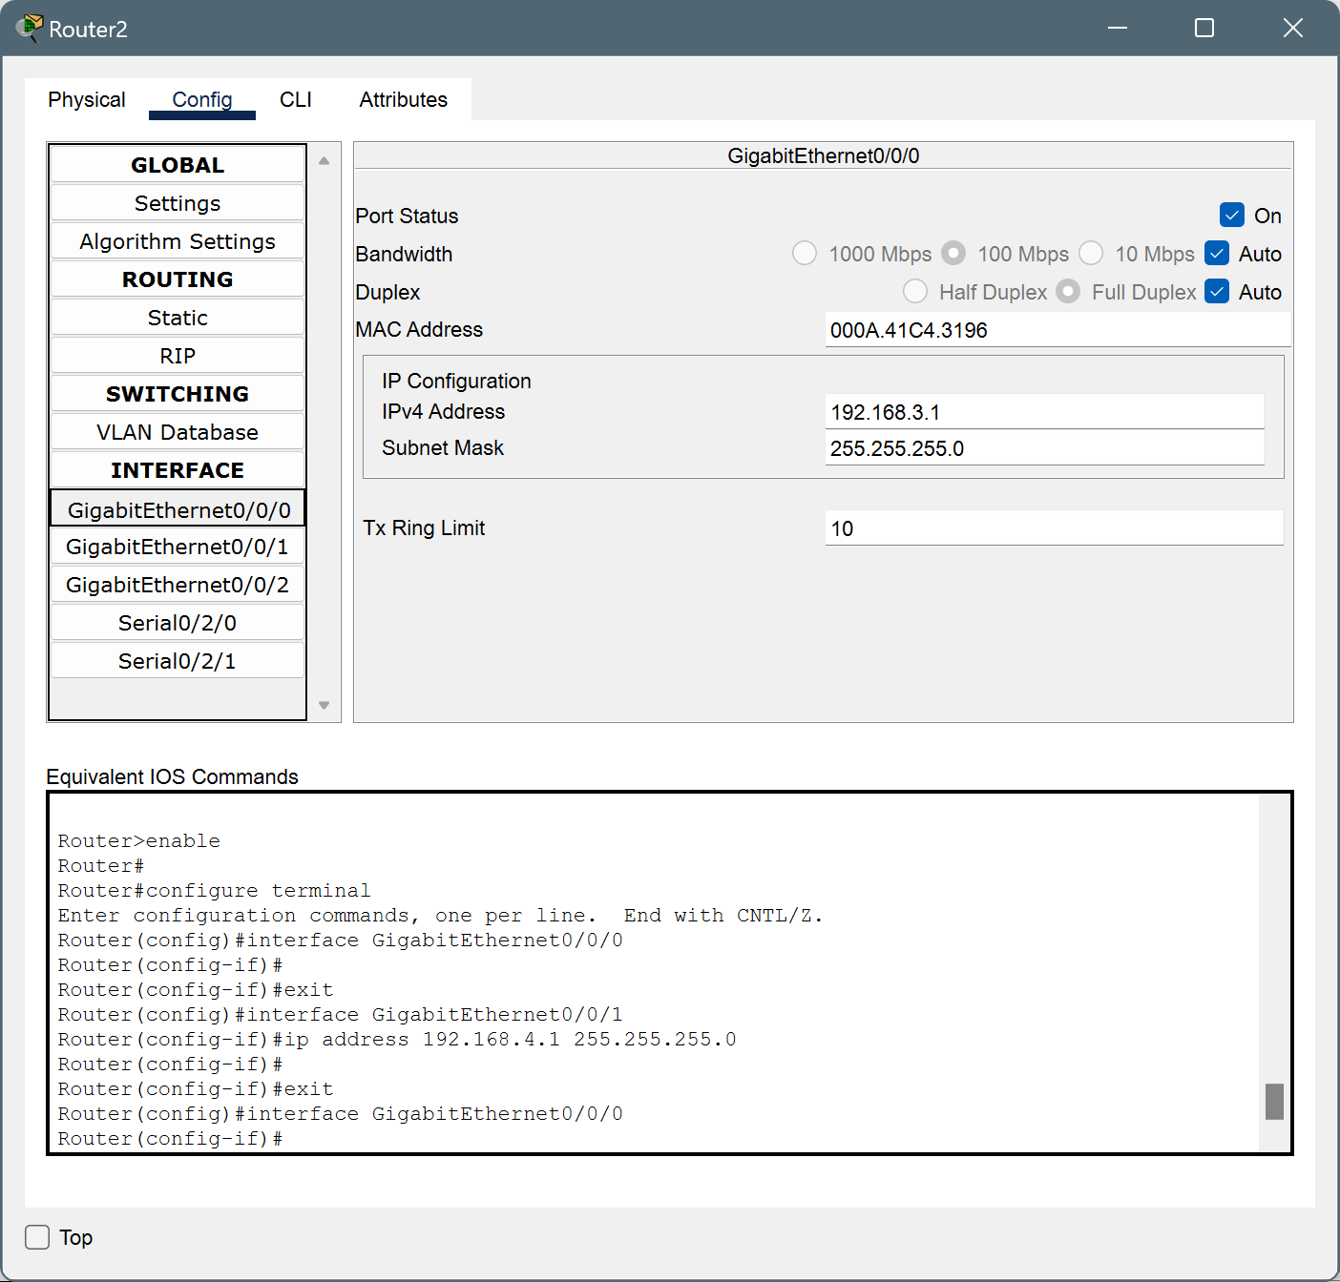

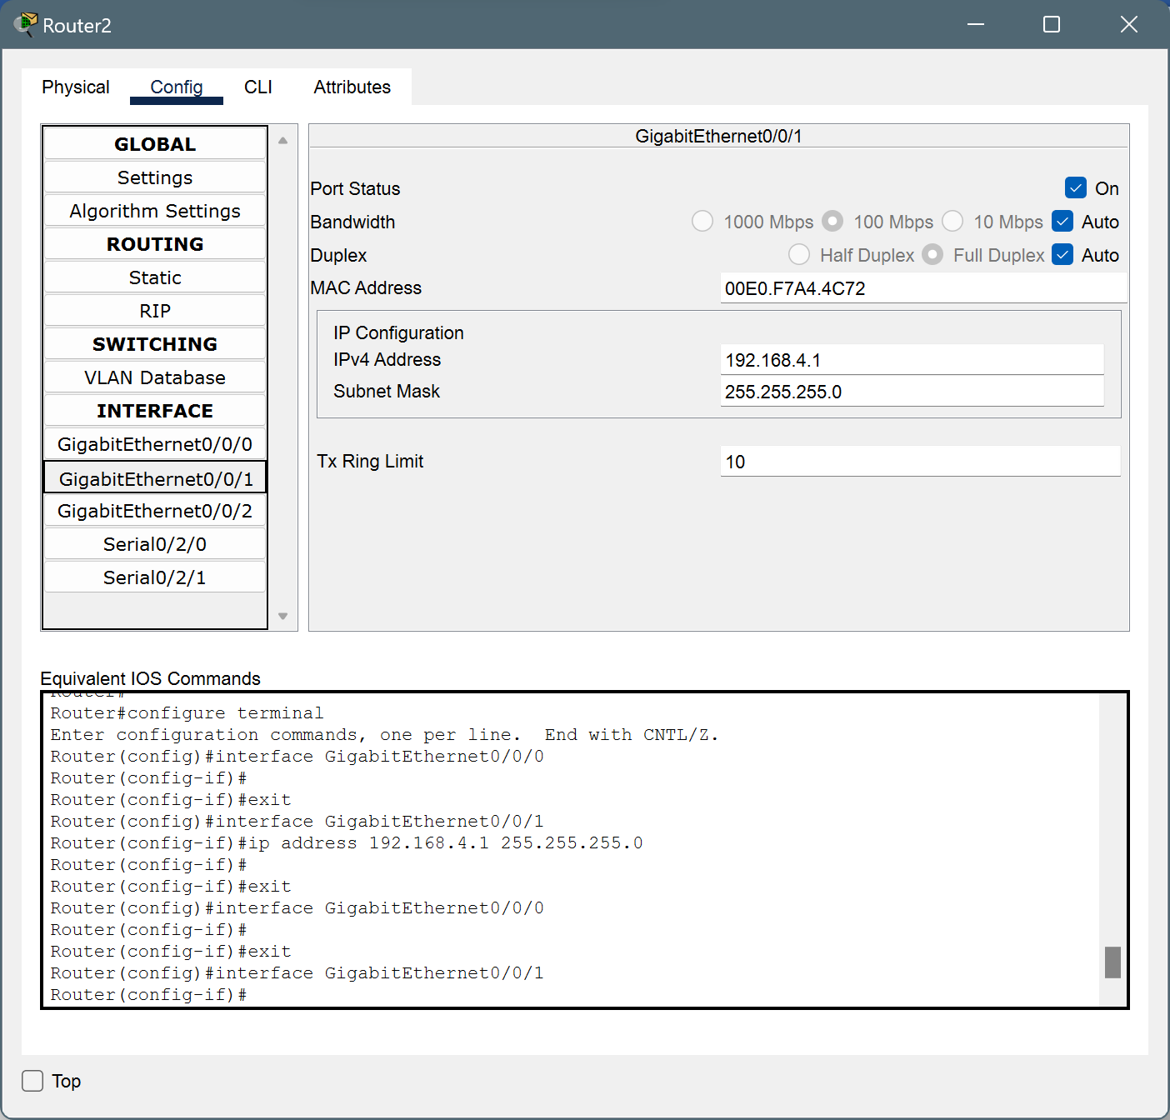

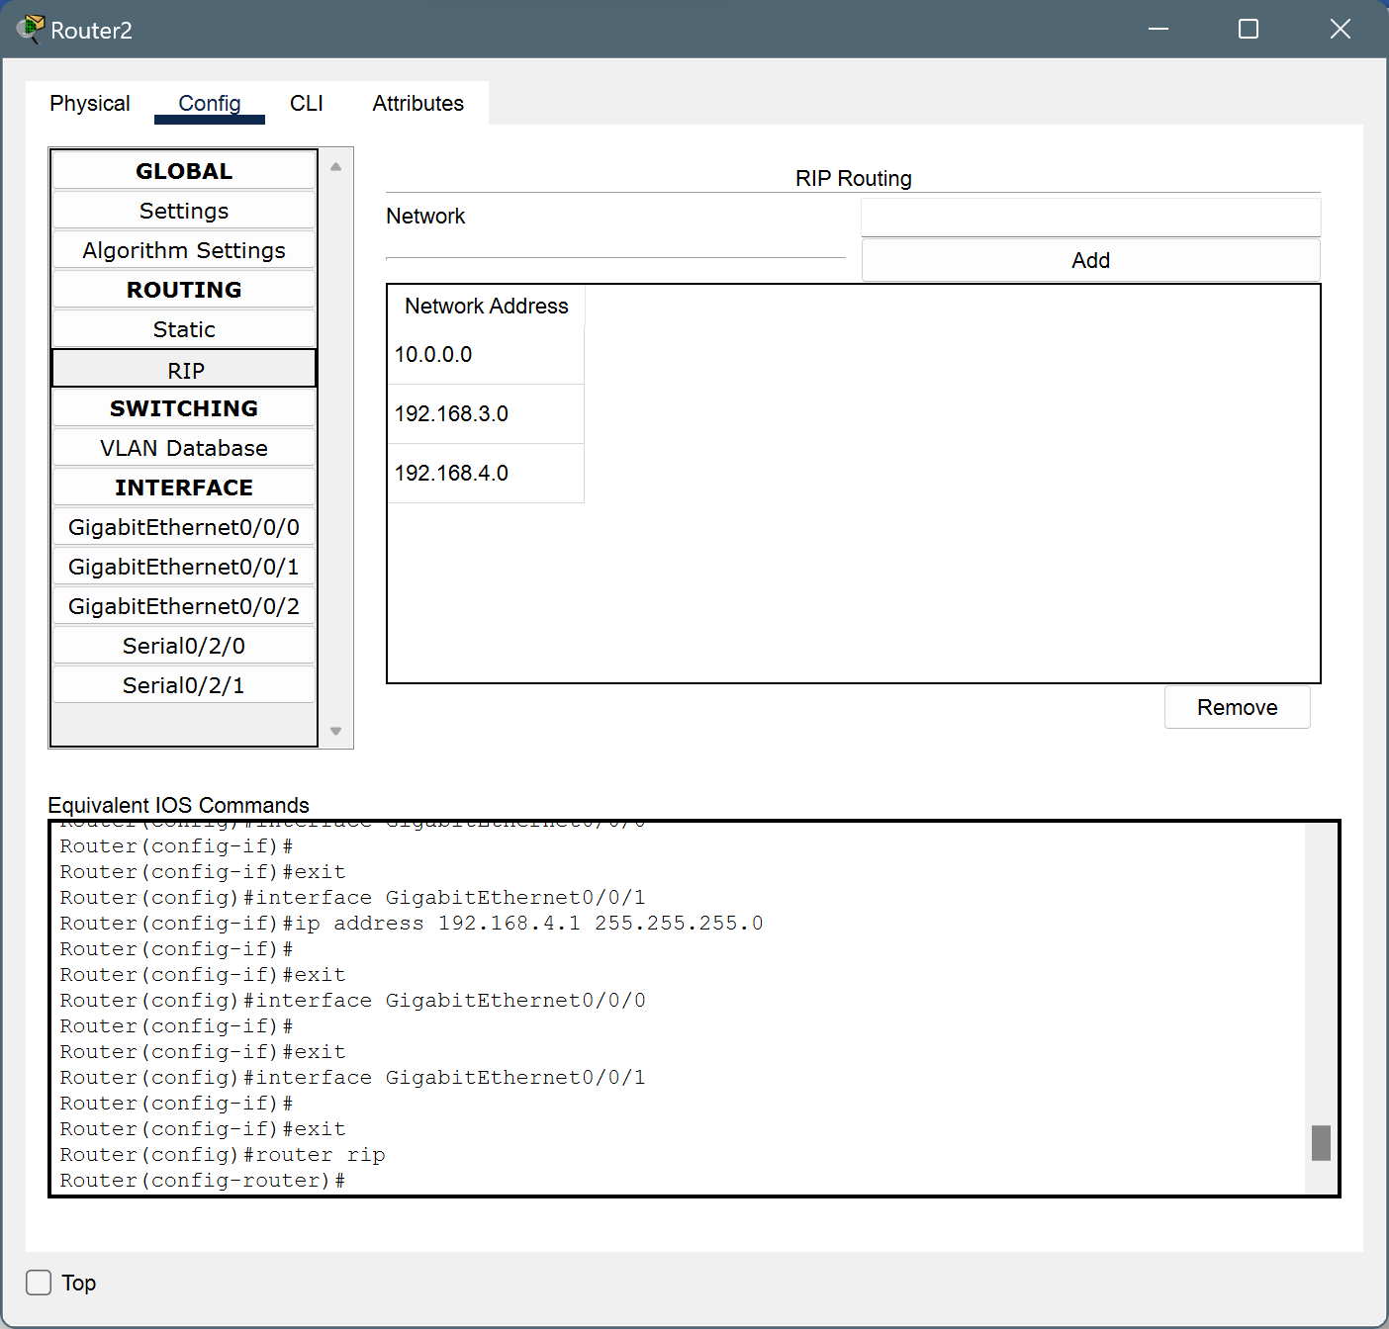

**Packet Transfer :**

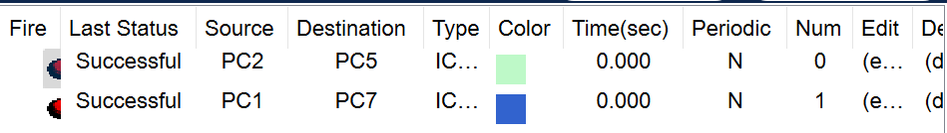

**Case 3:** Sigma Solution Pvt. Ltd. contains five departments: Production, Sales,  Admin, R&D and Marketing. Each department has two hosts. You are appointed  as Network Engineer in Sigma Solution Pvt. Ltd. Design the network to provide  connectivity between these five departments.

**Description :**

Sigma Solution Pvt. Ltd. consists of five departments: Production, Sales, Admin, R&D, and Marketing, each with two desktop computers (hosts). The network design includes a central router connecting the departments and a dedicated switch for each department. Each department is assigned a unique IP subnet for efficient routing. Basic security measures, like firewall rules and access control lists, are implemented. DHCP and DNS servers manage IP assignment and name resolution. This setup offers a simple and effective network infrastructure for Sigma Solution Pvt. Ltd.'s operations.

**Design :**

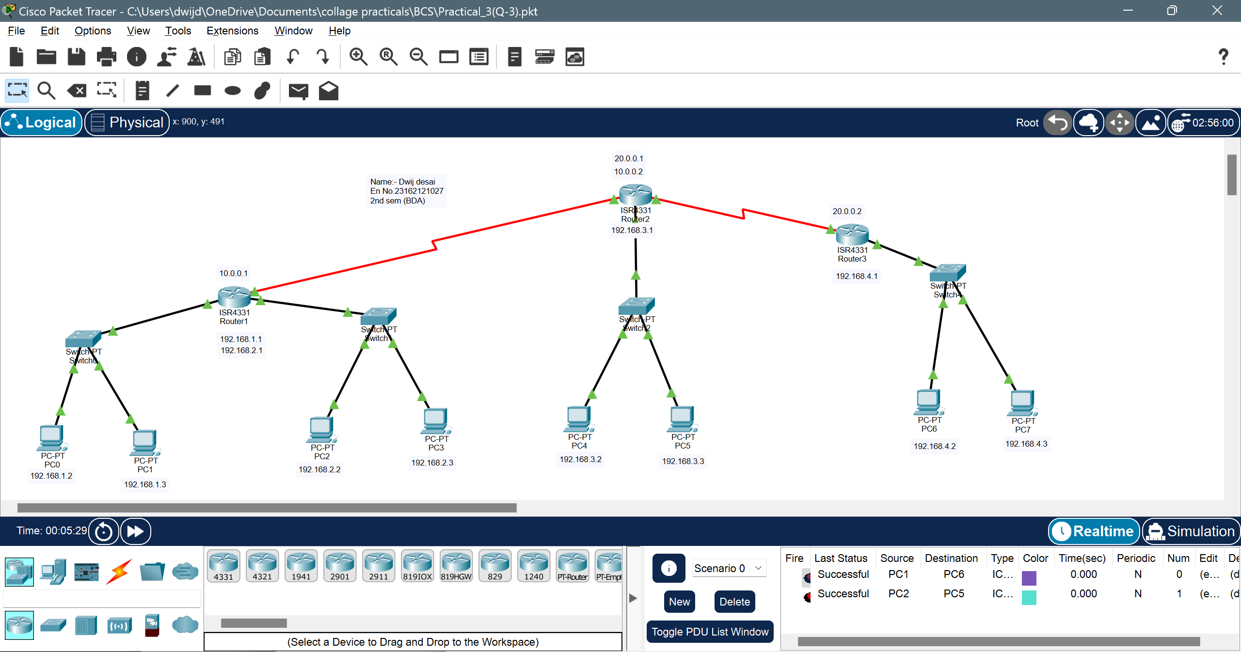

**Device Configuration:**

* For PC0





* For PC1





* For PC2





* For PC3





* Router1







* For PC4

 

* For PC5





* For PC6





* For PC7





* Router2







* Router3

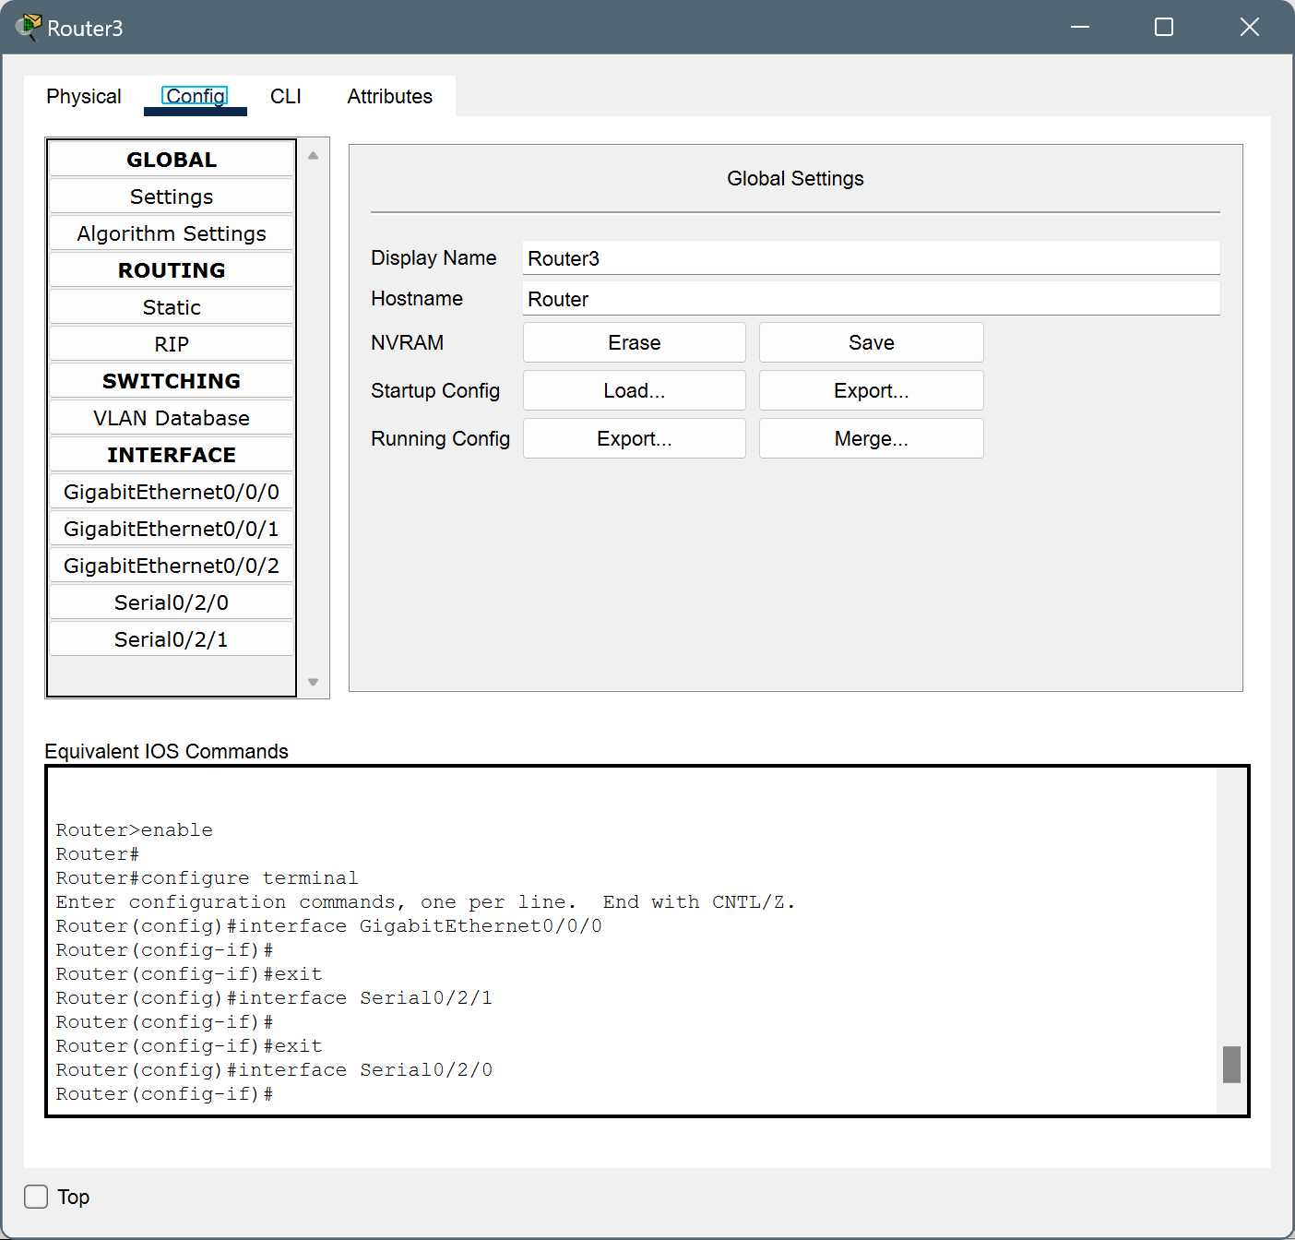

**Packet Transfer :**

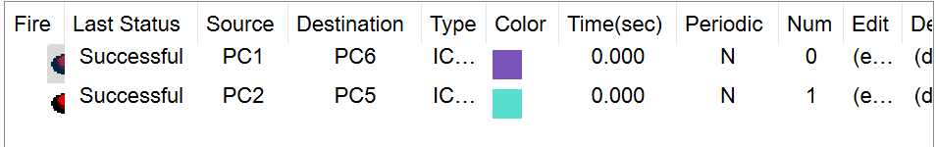

**Conclusion:**