**Practical – 4**

***Institute of Computer And Technology***

***B.Tech – CSE(BDA)***

***Name:- Dwij Vatsal Desai***

***Sem:- 2***

***Sub: - BCS***

***Enrollment No.:- 23162121027***

***Prac:- 4***

***Date:- 8/3/2024***

**Aim:** Design a network using the subnetting concept.

**Procedure:**

**Case 1:** Alpha Enterprise has three departments: Admin, Production and Service. Each department contains five users. Design the network to provide connectivity  between these three departments using subnetting concept.

**Description :**

To connect Alpha Enterprise's Admin, Production, and Service departments using subnetting, a Class C network (192.168.1.0/24) can be used. Each department will have its own subnet to manage IP addresses efficiently. Will be implemented to control and secure traffic between departments. Testing will be conducted to ensure proper connectivity, and monitoring tools will be used to manage network performance and security.

**Design:**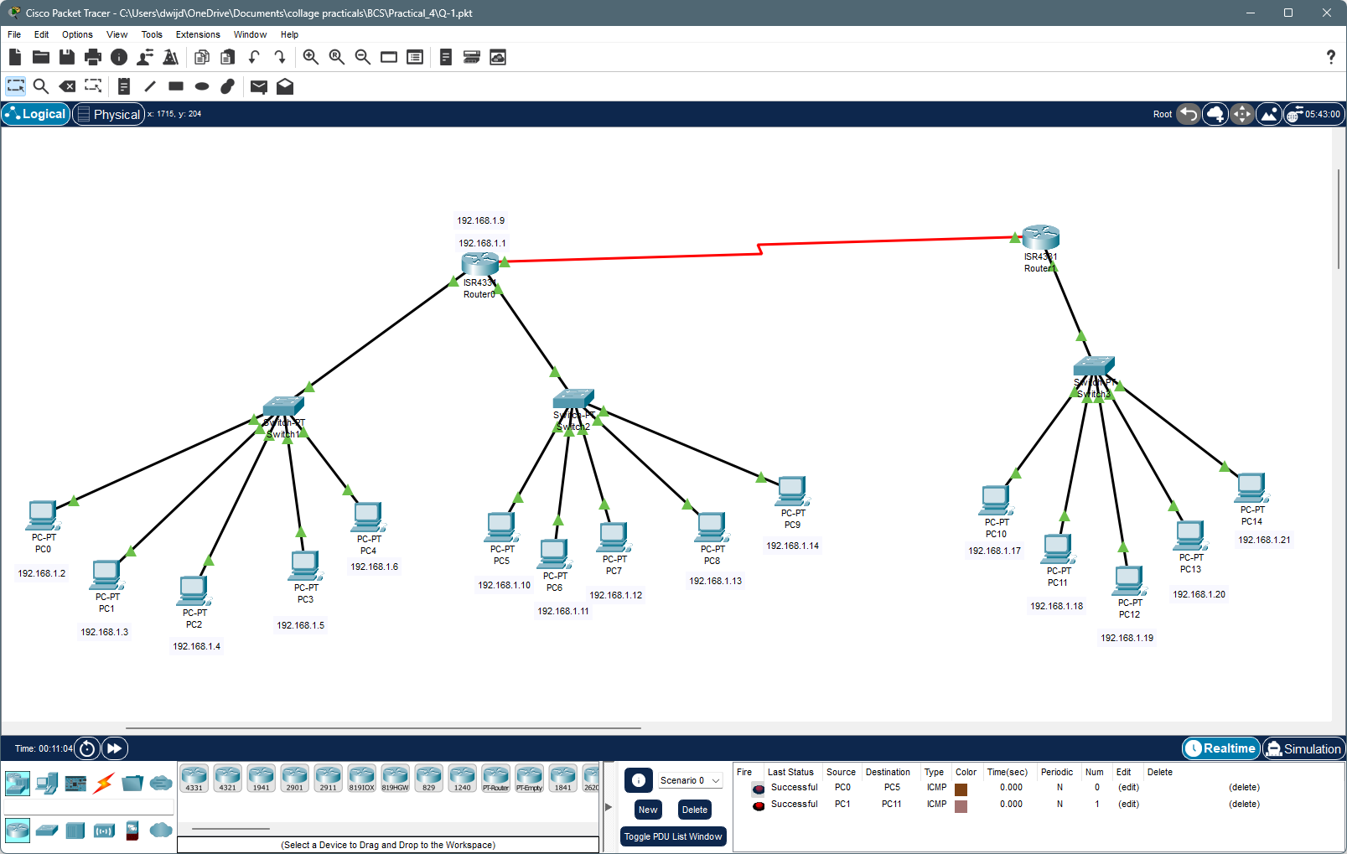

**Device Configuration:**

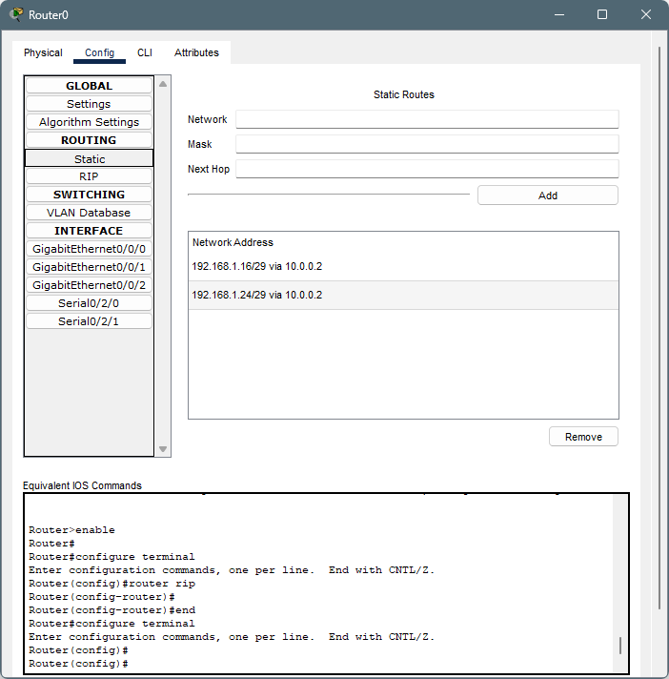

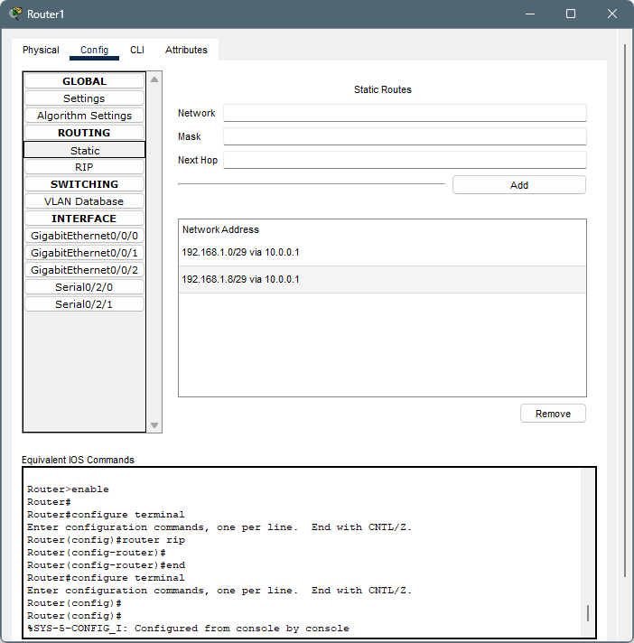

**Packet Transfer:**

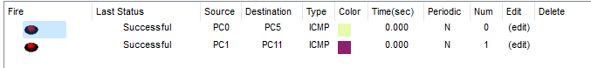

**2:** Gamma Tech Pvt. Ltd. contains four departments: Admin, Production,  Sales and R&D. Each department has five users. Design the network to provide  connectivity between these four departments using subnetting concept.

**Description :**

To connect Gamma Tech Pvt. Ltd.'s four departments (Admin, Production, Sales, and R&D), each with five users, using subnetting, a Class C network (192.168.1.0/24) can be utilized. Assigning a unique subnet to each department allows for efficient IP address management. For example, the Admin department can use 192.168.1.0/29, Production 192.168.1.8/29, Sales 192.168.1.16/29, and R&D 192.168.1.24/29. A router will be configured to connect these subnets, enabling inter-departmental communication. Security measures such as firewall rules should be implemented to control and secure traffic. Testing the connectivity and using monitoring tools will help manage network performance and security.

**Design :**

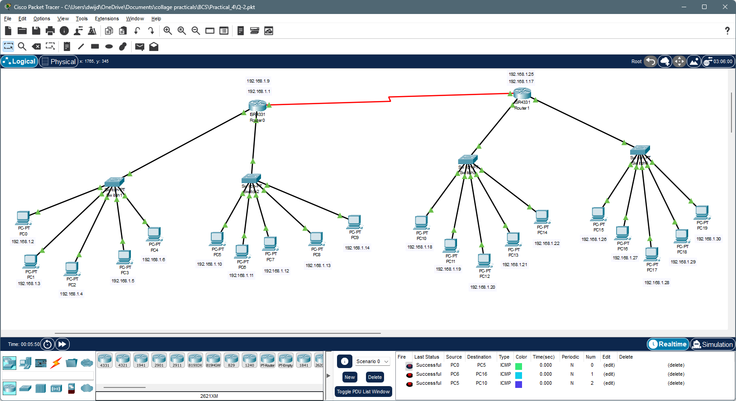

**Device Configuration:**

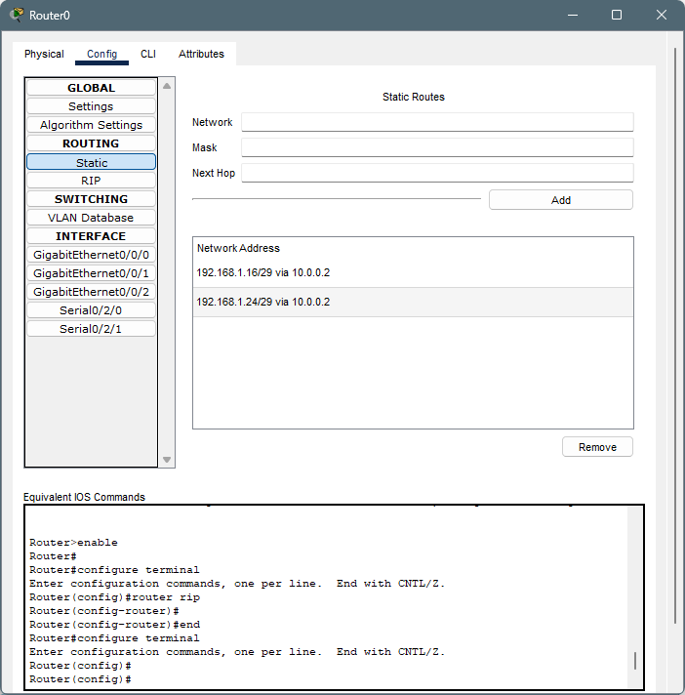

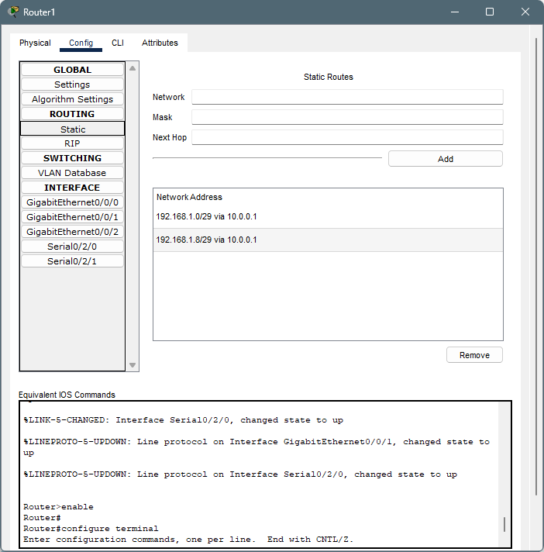

**Packet Transfer :**

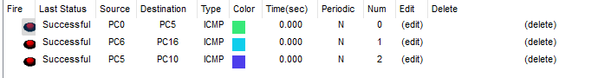

**Case 3:** Meta Solution Ltd. contains five departments: Production, Sales, Admin,  R&D and Marketing. Each department has five users. You are appointed as  Network Engineer in Sigma Solution Pvt. Ltd. Design the network to provide  connectivity between these five departments using subnetting concept.

**Description :**

To connect Meta Solution Ltd.'s five departments (Production, Sales, Admin, R&D, and Marketing), each with five users, using subnetting, a Class C network (192.168.1.0/24) can be used. Assigning each department its own subnet allows for efficient IP address management. For example, Production can use 192.168.1.0/29, Sales 192.168.1.8/29, Admin 192.168.1.16/29, R&D 192.168.1.24/29, and Marketing 192.168.1.32/29. Configuring a router to connect these subnets enables inter-departmental communication. Implementing security measures such as firewall rules helps control and secure traffic. Testing connectivity and using monitoring tools ensure effective network management.

**Design :**

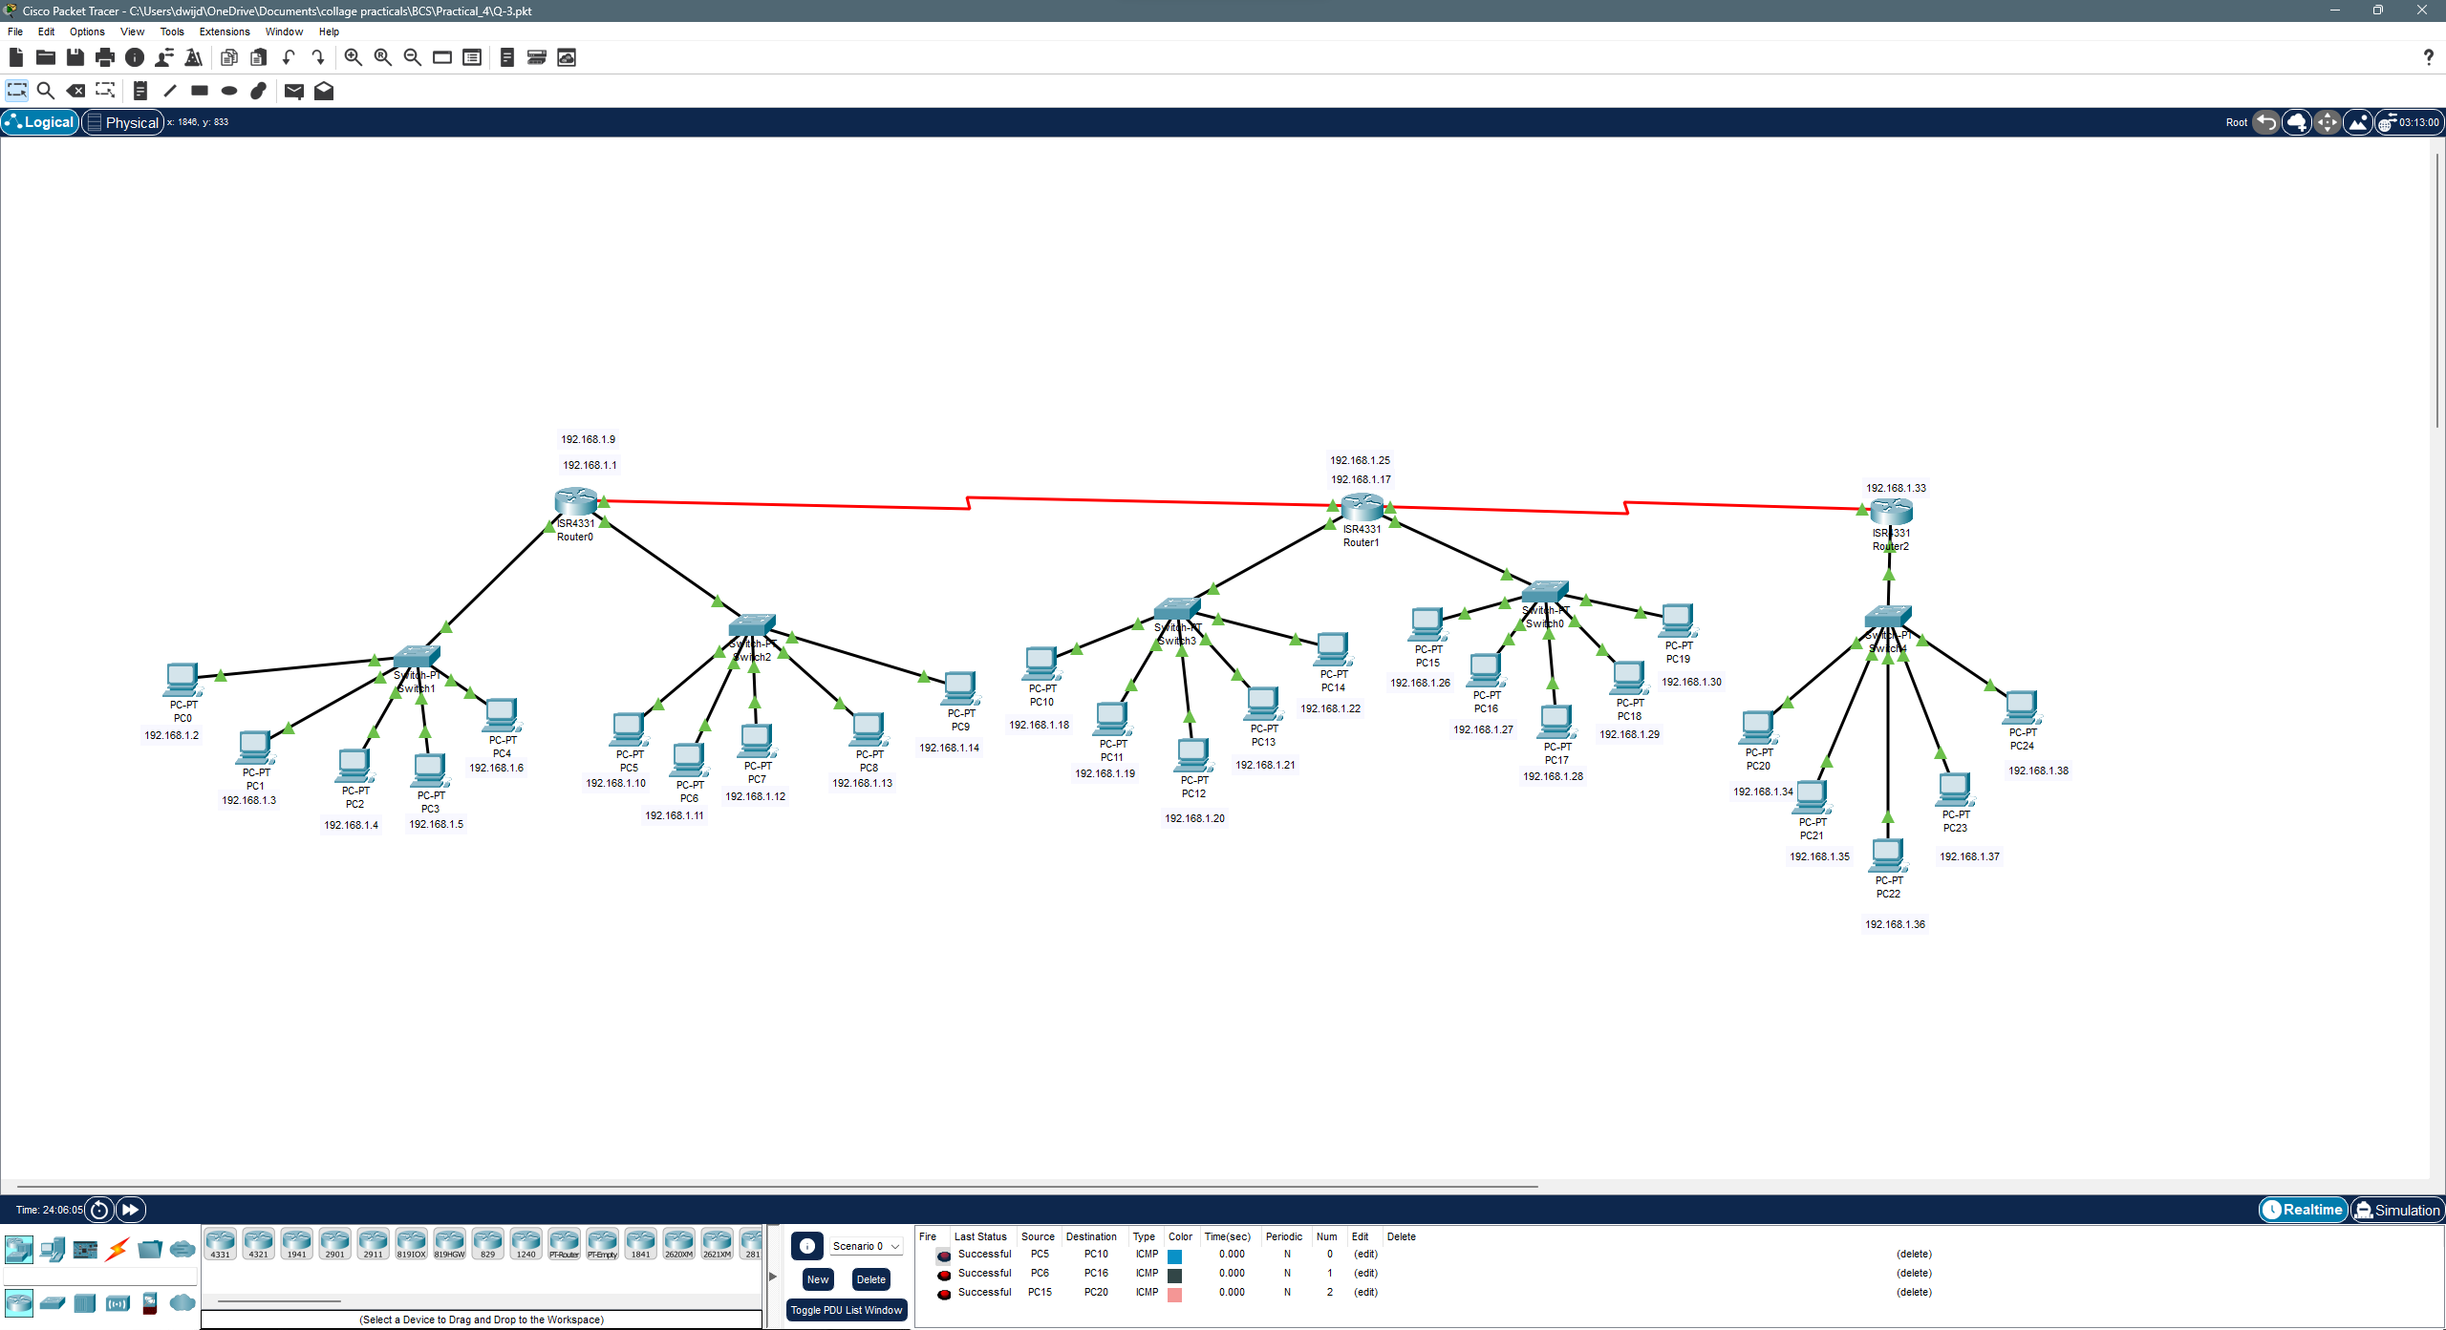

**Device Configuration:**

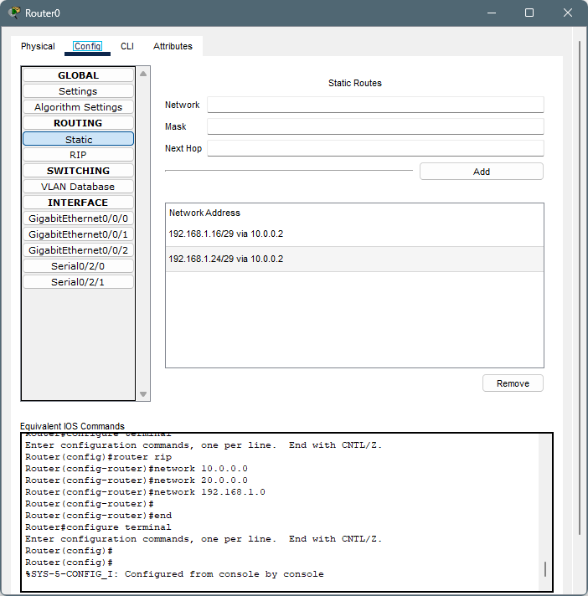

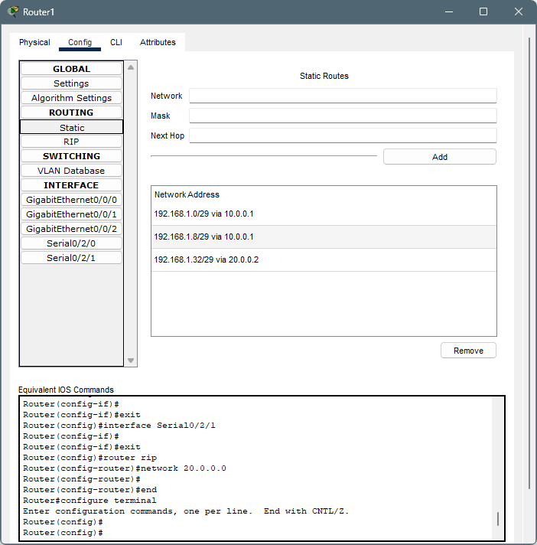

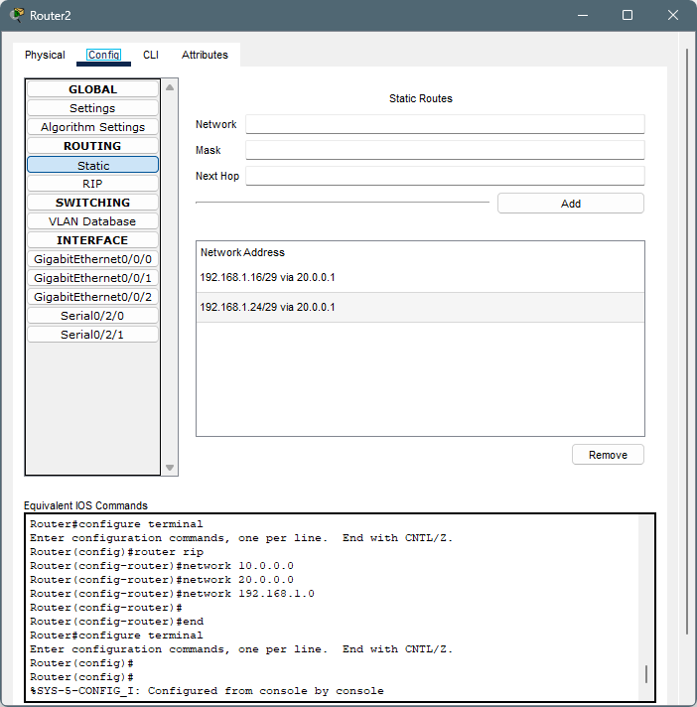

**Packet Transfer:**



**Conclusion:**

In conclusion, designing networks for companies like Alpha Enterprise, Gamma Tech Pvt. Ltd., and Meta Solution Ltd. involves subnetting to efficiently allocate IP addresses and provide connectivity between departments. By assigning each department its own subnet and configuring routers for inter-departmental communication, network engineers can ensure efficient IP address management and secure traffic flow. Testing connectivity and implementing security measures are crucial for effective network management.