**Ganpat University**

**Faculty of Engineering & Technology**

**Computer Science & Engineering**

***Name:- Dwij Vatsal Desai***

***Sem:- 2***

***Sub: - BCS***

***Enrollment No.:- 23162121027***

***Prac:- 6***

***Date:- 13/4/2024***

**Practical 6**

## Aim: To study the function of Amplitude Modulation and to calculated the modulation index.

**Student Group Detail :-** Dwij Desai , Kishna Patel and Trivedi Sanjari.

## Apparatus:

1. C.R.O (20MHz)
2. Function generator (1MHz).
3. Connecting cords & probes.

## Description:

Amplitude modulation can be produced by a circuit where the output is product of two input signals. Multiplication produces sum and difference frequencies and thus the side frequencies of the AM wave. Two general methods exist for achieving this multiplication, one involves a linear relation between voltage and current in a device and the second uses a linear device. A linear form of

**Ganpat University**

**Faculty of Engineering & Technology**

**Computer Science & Engineering**

***Name:- Dwij Vatsal Desai***

***Sem:- 2***

***Sub: - BCS***

***Enrollment No.:- 23162121027***

***Prac:- 5***

Aim: Create Logical and Physical designs of Star Topology.

Case 1: Logical Design of Star Topology using Cisco Packet Tracer

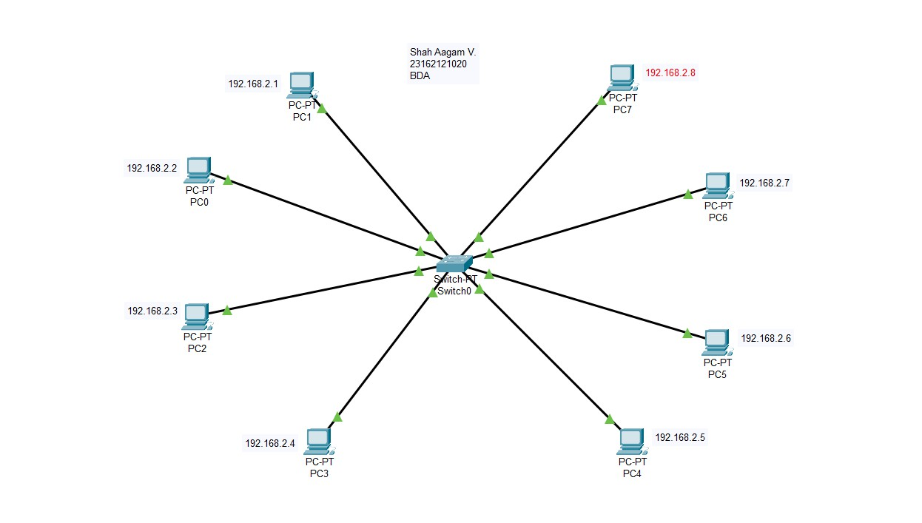Description : Design :

Aagam

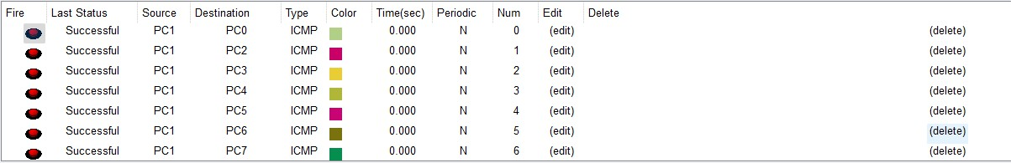Device Configuration: Packet Transfer :

Case 2: Physical Design of Star Topology using a switch

Description : Design :

Shah

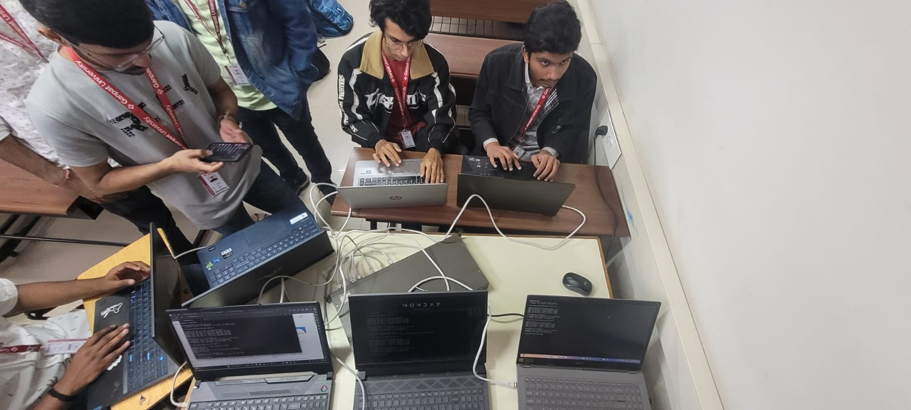

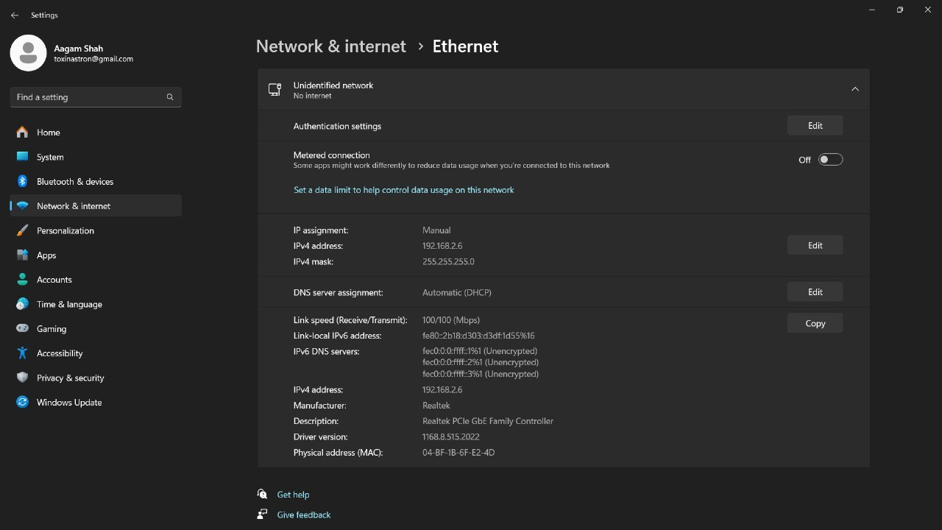Device Configuration:

Aagam

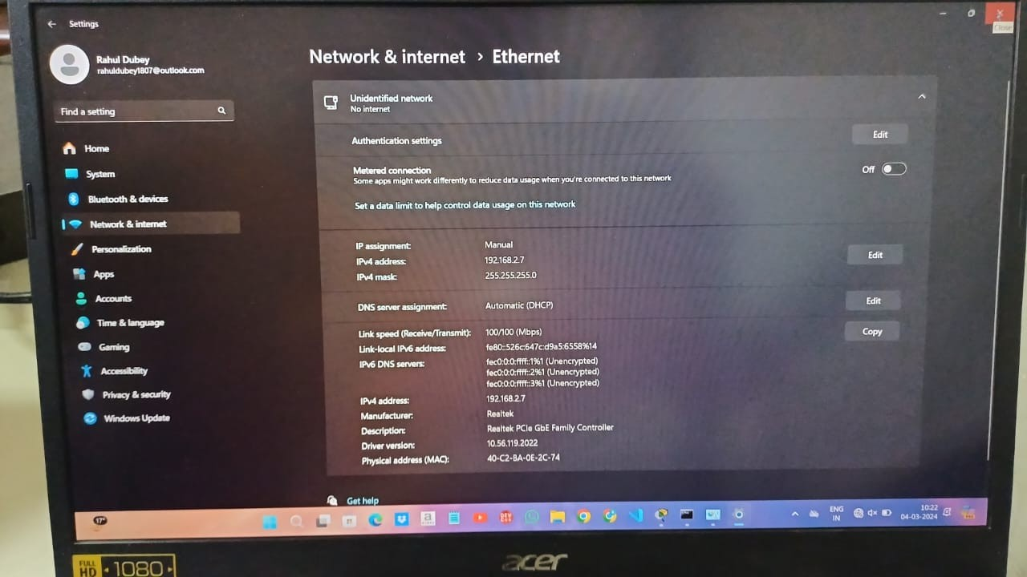

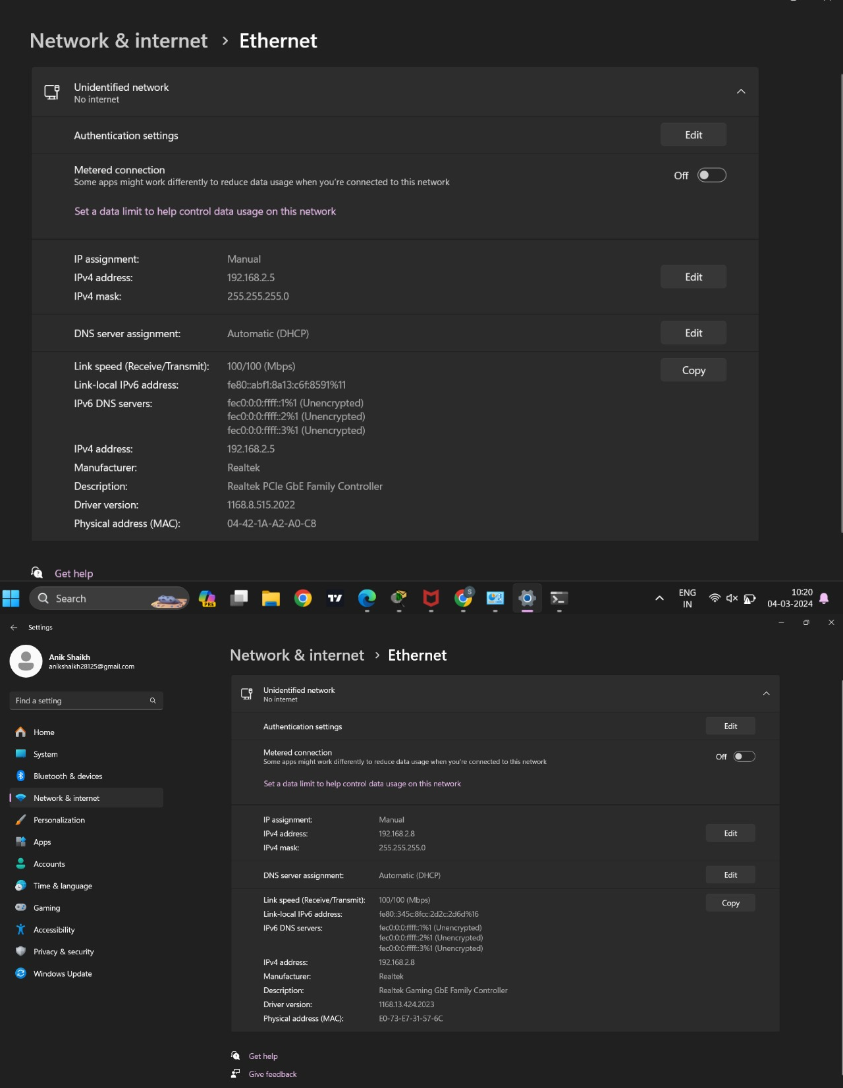

Aagam Shah

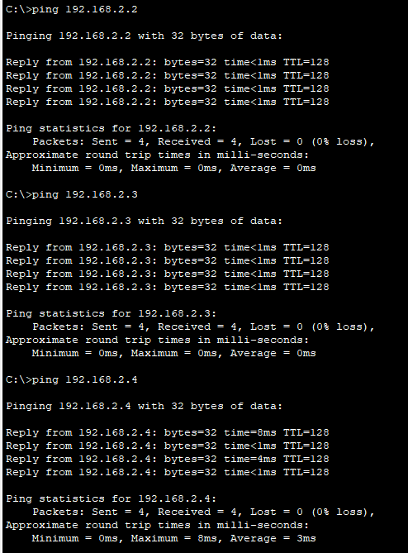Packet Transfer :

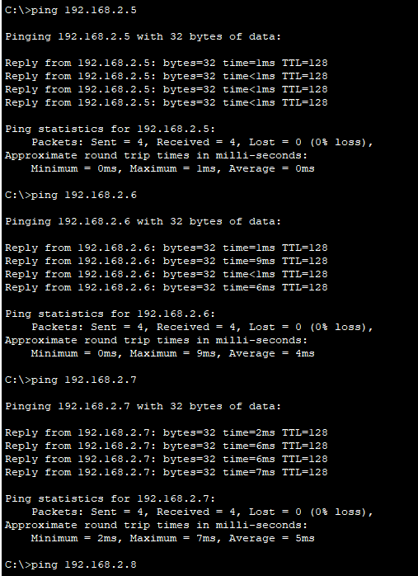

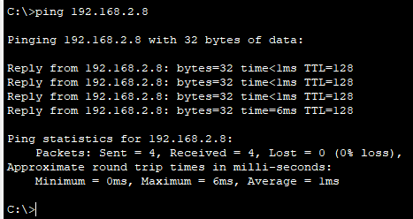

Conclusion:

In this Practical , We Got To know About Switches in Real Life.