**Ganpat University**

**Faculty of Engineering & Technology**

**Computer Science & Engineering**

***Name:- Dwij Vatsal Desai***

***Sem:- 2***

***Sub: - BCS***

***Enrollment No.:- 23162121027***

***Prac:- 8***

***Date:- 22/4/2024***

**Practical – 8**

**Aim:** To perform Pulse Amplitude Modulation (PAM)/ Sampling theorem and Demodulation.

**Student Group Detail**

|  |  |  |
| --- | --- | --- |
| No | Enrollment No. | Student Name |
| 1 | 23162121027 | Dwij Vatsal Desai |
| 2 | 23162121025 | Kishna Patel |
| 3 | 23162171025 | Virendra rabari |

**Apparatus:**

1. C.R.O (20MHz)

2. Function generator (1MHz).

3. Connecting cords & probes.

**Block Diagram**

**1. Pulse Amplitude Modulation (PAM)**

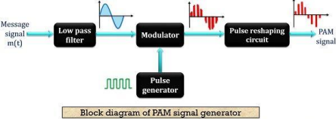

**2. Pulse Amplitude Demodulation**

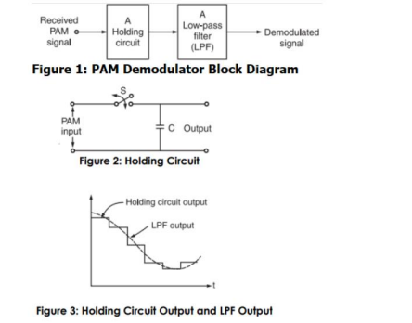**x**

**Description:**

Sampling is a process performed by a sampler. It is present in almost every type of digital communication system that helps in converting an analog signal to the digital signal. An analog signal is a continuous time-varying signal, while digital signal is a signal in the discrete form. The function of a sampler is to measure the samples of the instantaneous value of the continuous signal and convert it into the discrete values.

The combination of quantizer and sampler in digital communications works as an A/D (Analog to Digital) converter. It converts an incoming analog signal to the digital signal. The sampler converts the analog signal to the discrete values and the quantizer represent each level to the fixed discrete finite set of values. Thus, we can define the analog to digital conversion as a two step process. The first step is performed by the sampler and the second step is performed by the quantizer.

**Nyquist Rate of Sampling**

The theoretical minimum sampling rate at which a signal can be sampled and still can be reconstructed from its samples without any distortion is called the Nyquist rate of sampling.

Mathematically,

Nyquist Rate fN = 2 ∗ fm

Where fm is the maximum frequency component present in the signal.

∙ If the signal is sampled at the rate greater than the Nyquist rate, then the signal is called **over sampled.**

∙ If the signal is sampled at the rate less than its Nyquist rate, then it is said to be **under sampled.**

**Expected Waveforms:**

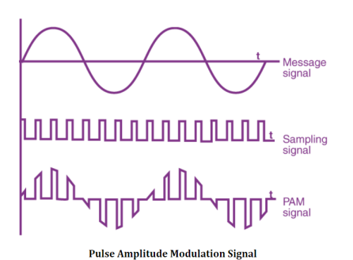

**Procedure:**

∙ Generate audio signal/ Information signal having maximum frequency fm.

∙ Generate Sampling signal (Pulse train) having frequency more than the nyquist criteria.

∙ Feed generated signal to PulseAmplitude Modulator (PAM) circuit and observe the output.

∙ Provide this signal to PAM demodulator circuit and observed the output.

**Observation Table:**

|  |  |  |  |  |
| --- | --- | --- | --- | --- |
| Case | fm | Nyquist Rate  fN | fs | Samples in a cycle |
| Case 1 | 6 | 6.38 | 1.063 | 24.76 |
| Case 2 | 8 | 10.73 | 1.34 | 37.46 |
| Case 3 | 7 | 18.07 | 2.58 | 50.14 |

**Circuit Diagram**

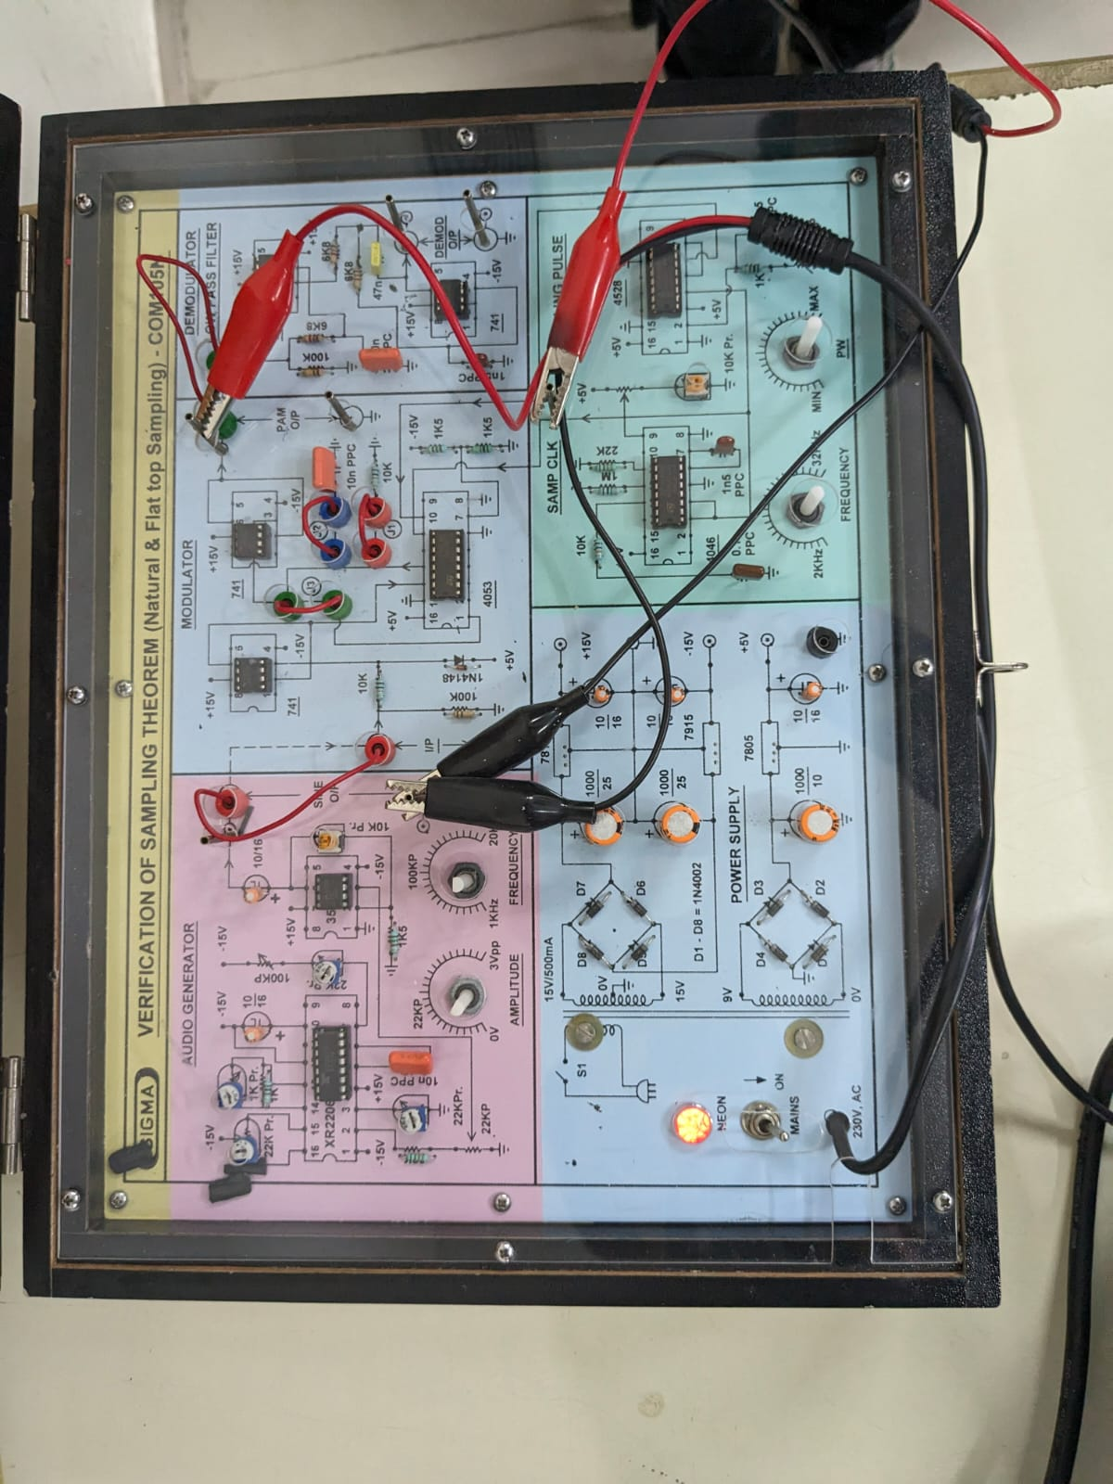

**Waveform:**

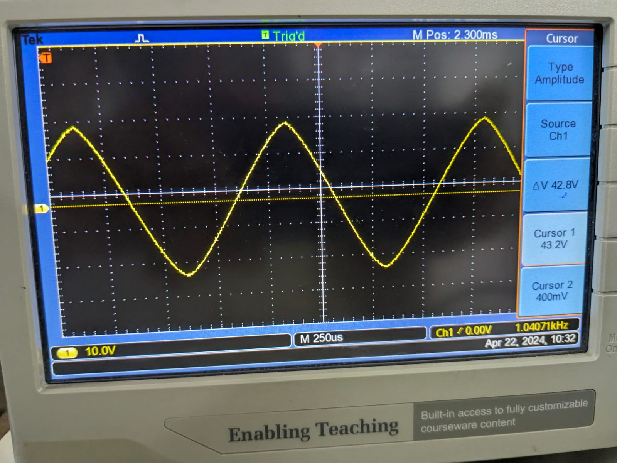

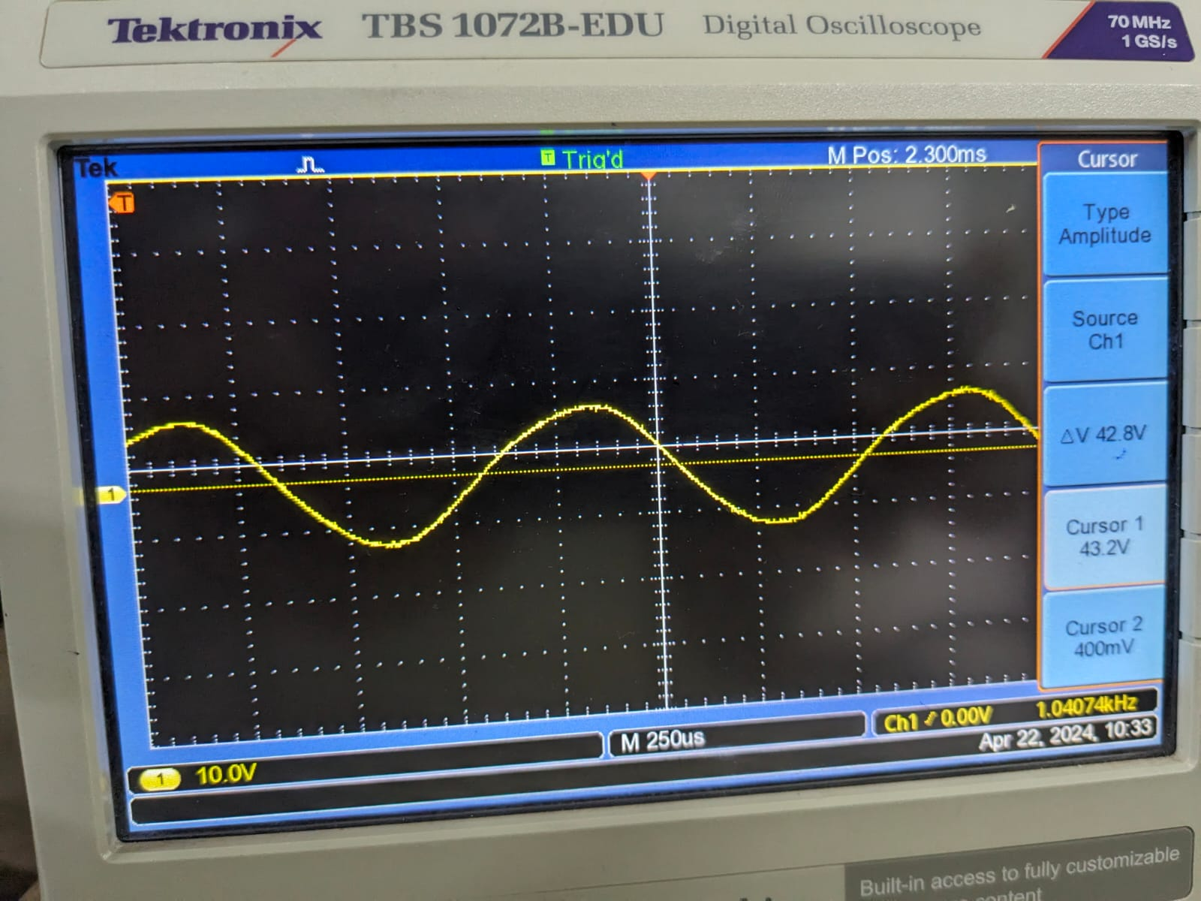

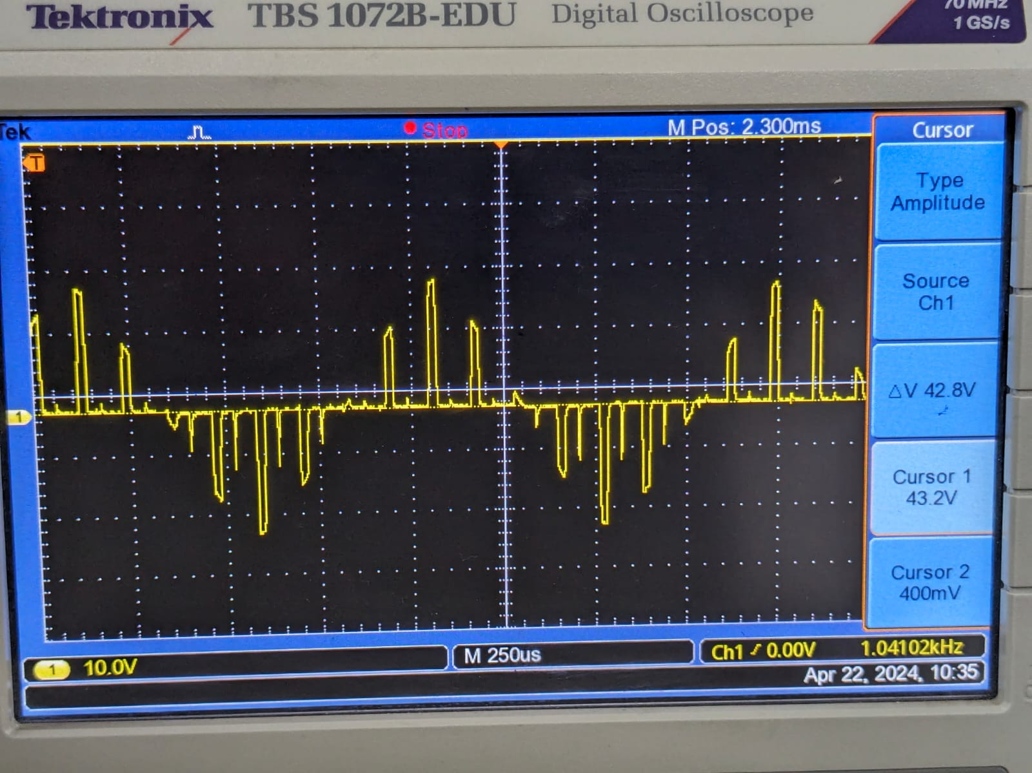

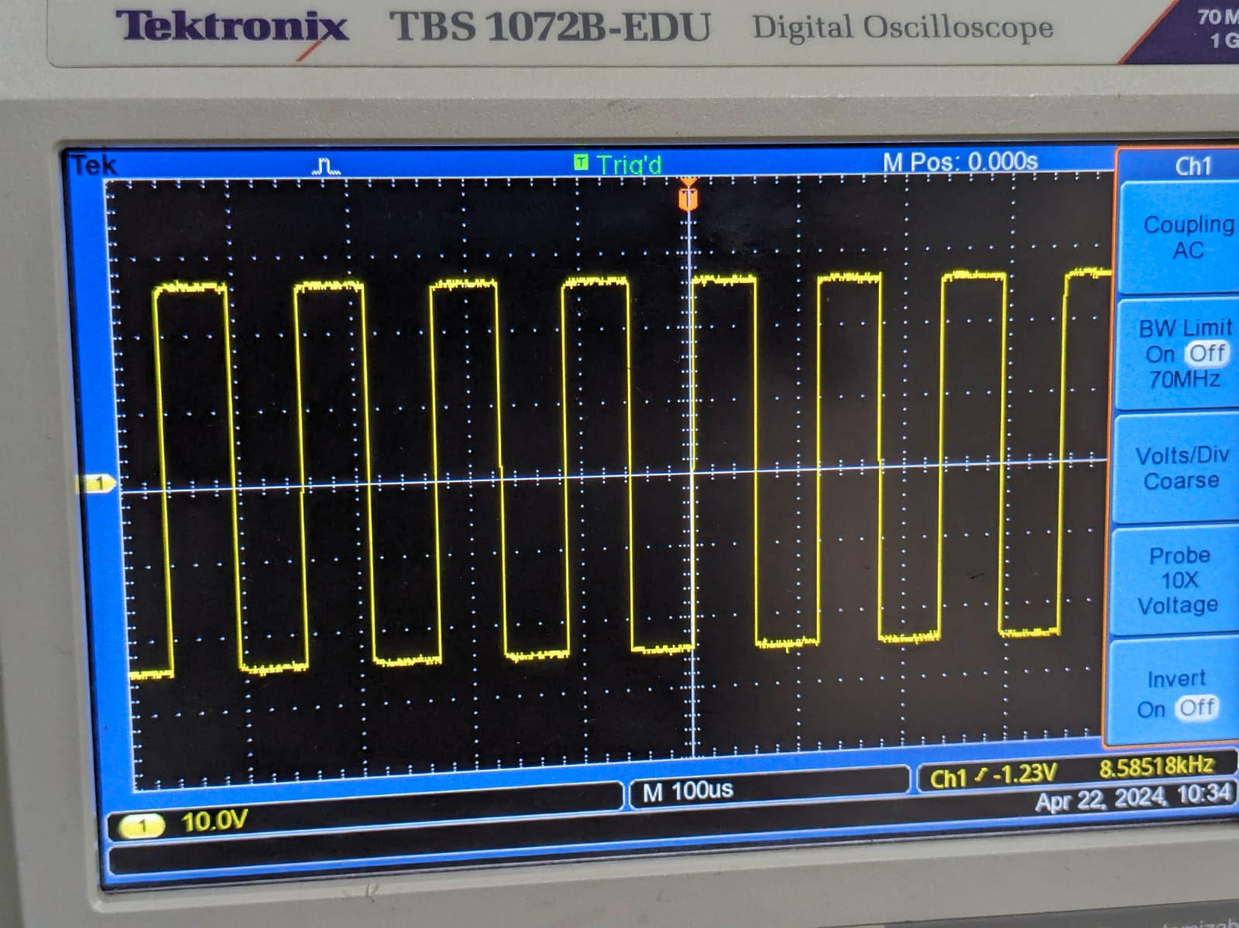

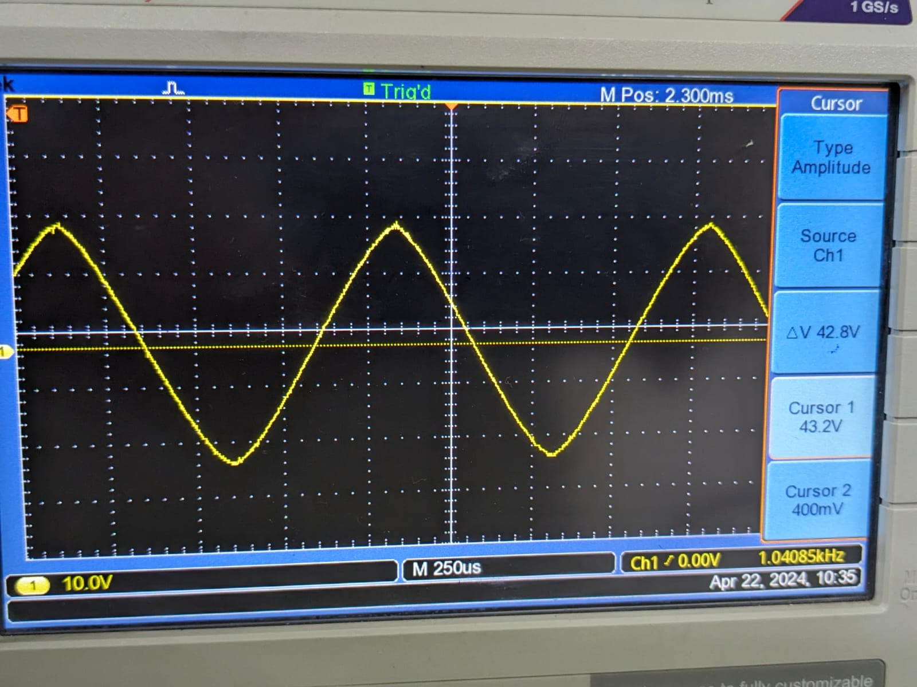

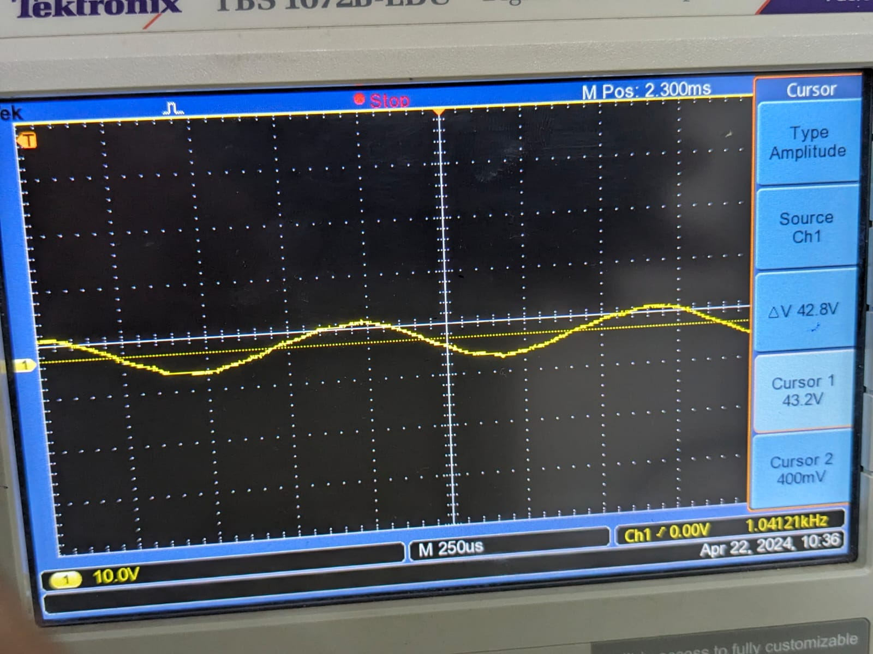

**Conclusion:**

**In this practical session, Pulse Amplitude Modulation (PAM) and the Sampling Theorem were studied in depth. Sampling, a crucial process in digital communication, involves converting continuous analog signals into discrete digital form by measuring samples of the signal's instantaneous value. The practical application of this concept was demonstrated through the generation of audio signals, sampling signals (pulse trains), and observation of PAM modulation and demodulation. Additionally, the Nyquist Rate of Sampling was discussed, highlighting its importance in ensuring distortion-free signal reconstruction. Through this practical, students gained hands-on experience and a deeper understanding of these fundamental concepts in digital communication systems.**