***Institute of Computer And Technology***

***B.Tech – CSE(BDA)***

***Name:- Dwij Vatsal Desai***

***Sem:- 2***

***Sub: - BCS***

***Enrollment No.:- 23162121027***

***Prac:- 1***

***Date:- 7/2/2024***

**Aim:** Introduction to CISCO Packet Tracer.

**Procedure:**

**Case – 1:** Communication between two computers in a Local Area Network (LAN) using a switch.

Steps:

1. Take 2 pc from end devices and place it side by side.
2. Take 1 switch from [network devices->switches->**PT-switch**].
3. Enter the IP address in both PCs in the following order: **1) 192.168.1.1, 2) 192.168.1.2.**
4. And connect both of 2 pc with switch by using copper straight from connection.

Screen shots:

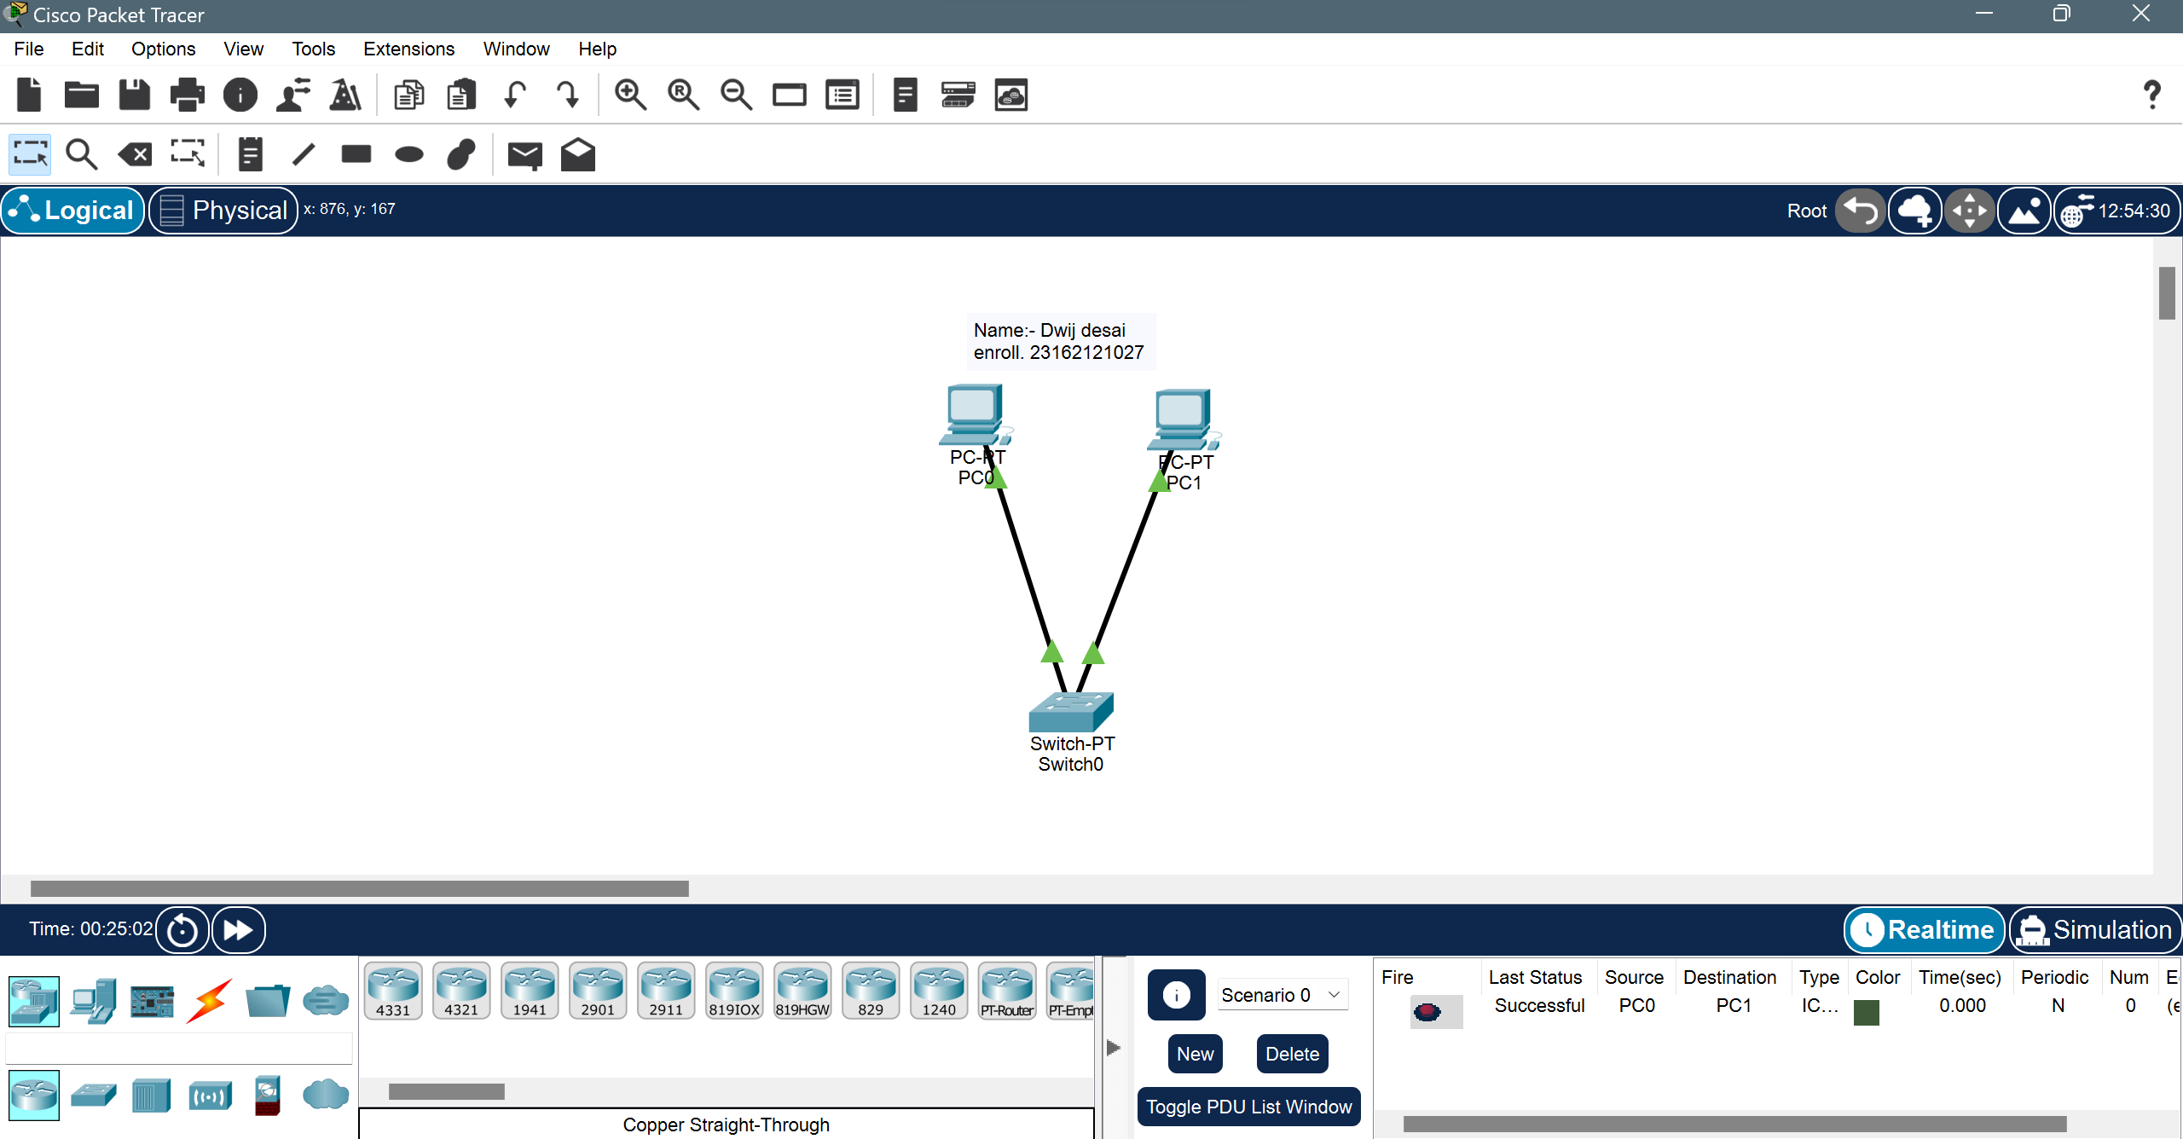

**Case – 2:** Star Topology in a LAN

Steps:

1. Take 5 pc from end devices and place it side by side.
2. Take 1 Hub from [network devices->Hub->**PT-Hub**].
3. Enter the IP address in both PCs in the following order: **1) 192.168.1.1, 2) 192.168.1.2, 3) 192.168.1.3, 4) 192.168.1.4, 5) 192.168.1.5.**
4. And connect both of 5 pc with Hub by using copper straight from connection.

Screen shots:

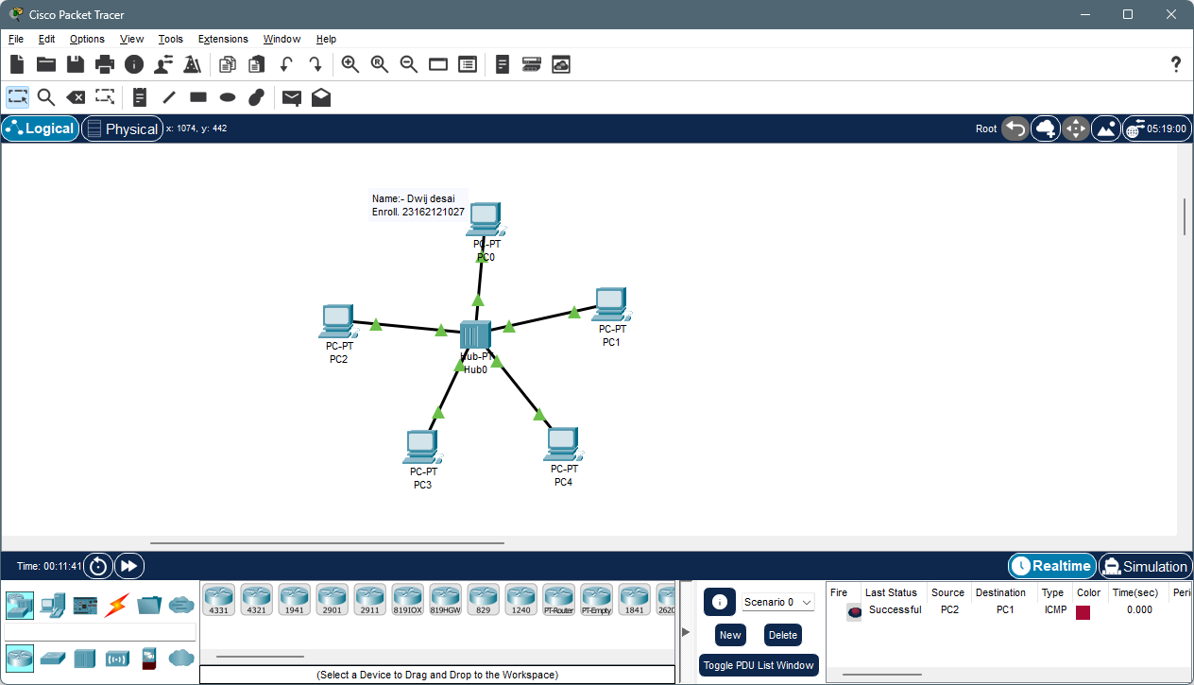

**Case – 3:** Communication between computers in a LAN using a Hub

Steps:

1. Take 3 pc from end devices and place it side by side.
2. Take 1 Hub from [network devices->Hub->**PT-Hub**].
3. Enter the IP address in both PCs in the following order: **1) 192.168.1.1, 2) 192.168.1.2, 3) 192.168.1.3**
4. And connect both of 3 pc with Hub by using copper straight from connection.

Screen shots:

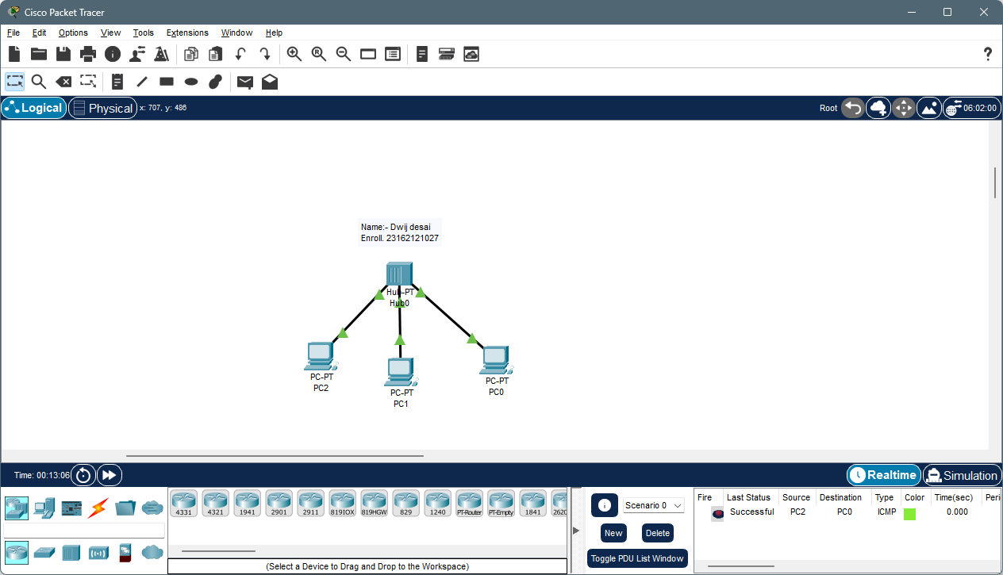

**Case – 4**: Hybrid Topology using Switch and Hub in a LAN

Steps:

1. Take 6 pc from end devices and place it side by side.
2. Take 1 Hub from [network devices->Hub->**PT-Hub**] and Take 1 switch from [network devices->switches->**PT-switch**].
3. Enter the IP address in both PCs in the following order: **1) 192.168.1.1, 2) 192.168.1.2, 3) 192.168.1.3, 4) 192.168.1.4, 5) 192.168.1.5,6) 192.168.1.5.**
4. And connect both of 6 pc with Hub by using copper straight from connection.
5. Connect hybrid of switch and hub with **copper cross-over**.

Screen shots: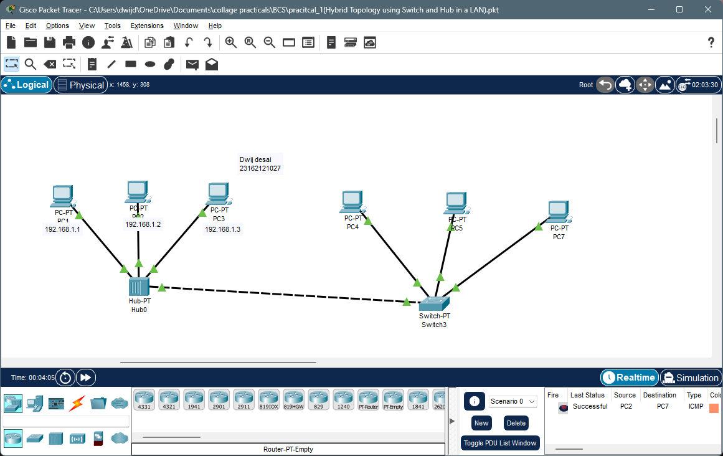

**Conclusion:**

**Questions**

**Q.1** Differentiate the working operation of switch and Hub.

**Ans.**

**HUB:-**

1. Network hubs broadcast the data to all connected devices.
2. It have only 1 basic use and it is ,connecting multiple Ethernet ports into one place.
3. Hubs are a useful for small LAN environments.

**Switch:-**

1. Switches identify MAC address to transmit the data only to the device that requested it.
2. switches have varying degrees of functionality based on the needs of the network.
3. Switch will work better with bigger LAN environments.

**Q.2** What will be the IP addresses of PC1 and PC2 in below given figure? Why?

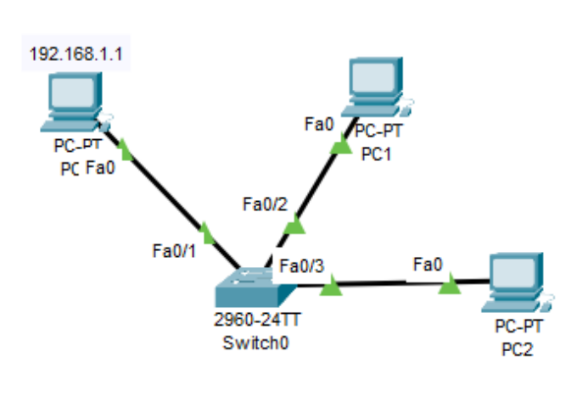

**Ans.**

* The IP addresses of PC1 and PC2 will be **1) 192.168.1.2, 2) 192.168.1.3.**
* Because switch or hub needs to recognize and differentiate between PCs/devise.
* If different PC have same IP addresses server can’t send info correctly.