***Institute of Computer And Technology***

***B.Tech – CSE(BDA)***

***Name:- Dwij Vatsal Desai***

***Sem:- 2***

***Sub: - BCS***

***Enrollment No.:- 23162121027***

***Prac:- 2***

***Date:- 16/2/2024***

**Aim: Utilization of Computer Network Commands.**

**Procedure:**

Case 1: Consider a scenario when you want to cross check whether your request

is being sent properly or not. Whether anybody is accessing your data or not.

**Command:** PING

**Description :**

PING is a tool that checks if another computer is reachable on a network. It sends a message to the other computer and waits for a reply. If it gets a reply, it means the other computer is reachable.PING is often used to test and troubleshoot network connections.

**Screen shot :**

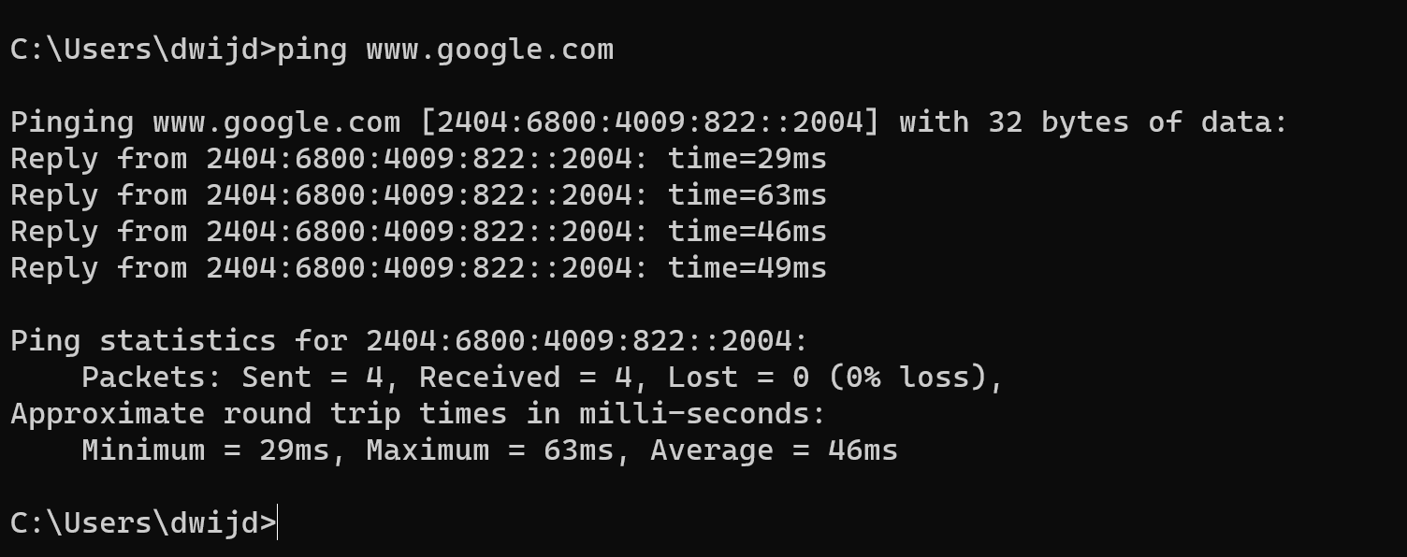

Case 2: If you don’t know the host name of your computer, then how do you get

aware with that?

**Command:** HOSTNAME

**Description :**

A hostname is a label assigned to a device connected to a computer network. It is used to identify the device in a network and is typically a human-readable string, such as "example.com". Hostnames are used in various network protocols to route data to the correct destination.

**Screen shot :**



Case 3: Consider the situation in which you want to display the computer's

currently assigned IP Address, subnet mask and default gateway addresses.

**Command:** IPCONFIG

**Description :**

IPCONFIG is a command-line tool in Windows used to display the current configuration of the TCP/IP network stack on a computer. It can show information such as the computer's IP address, subnet mask, and default gateway. IPCONFIG is often used for troubleshooting network connectivity issues.

**Screen shot :**

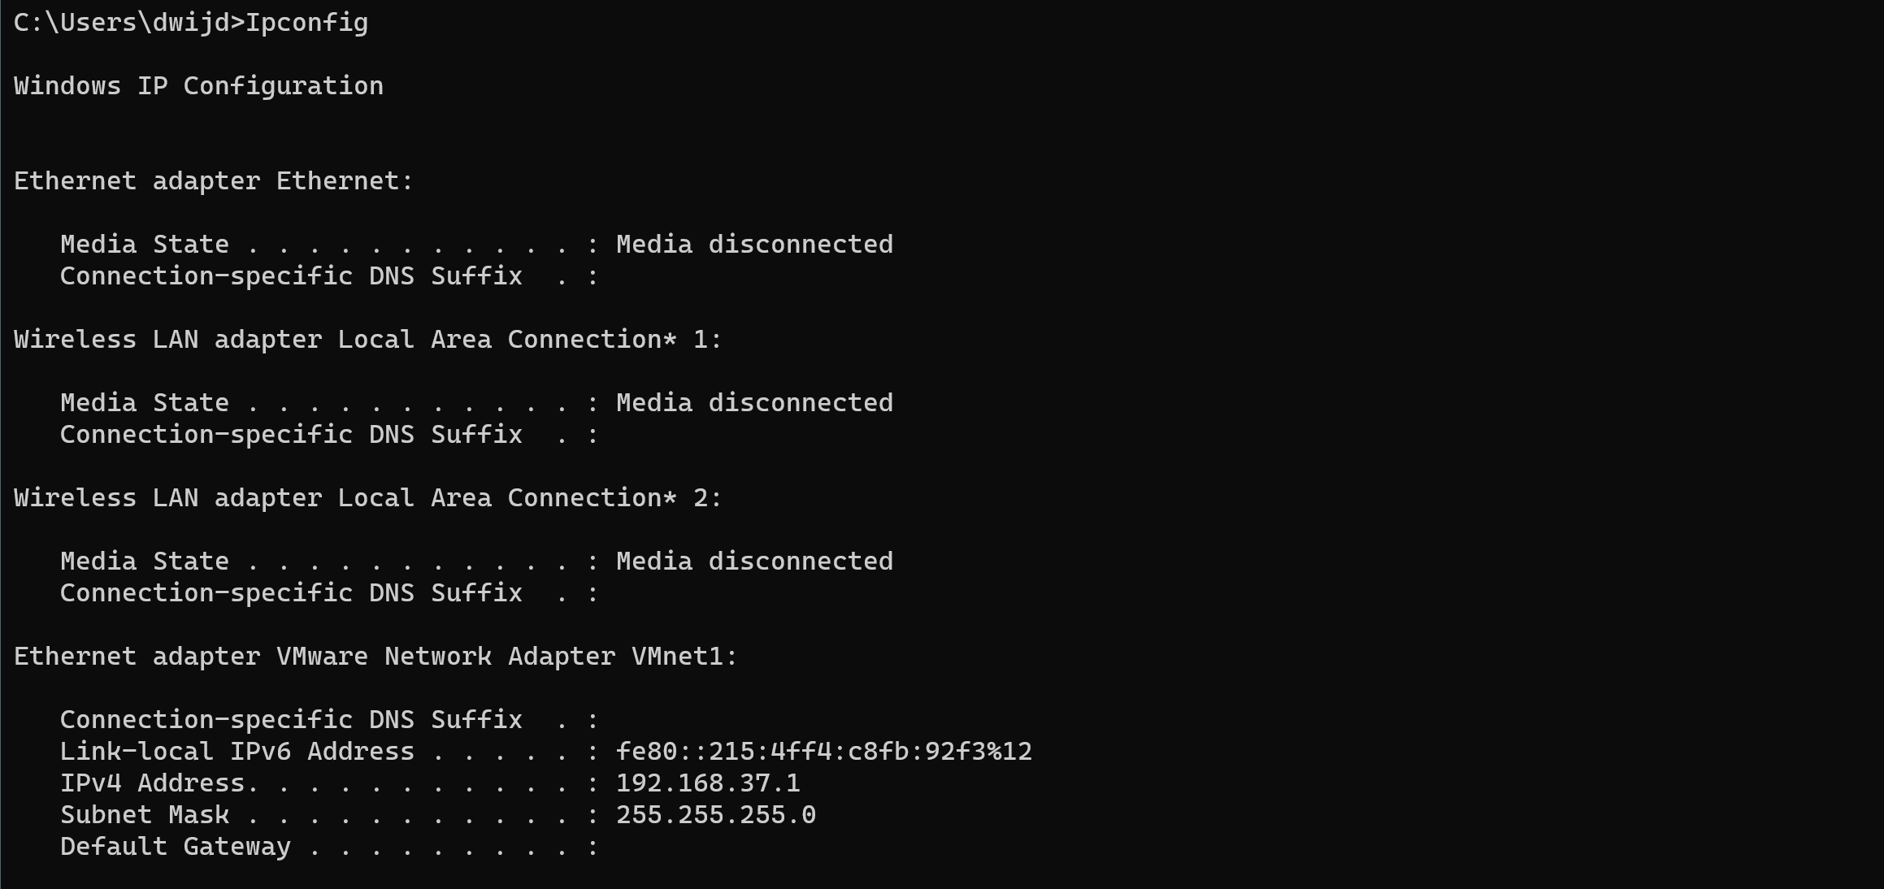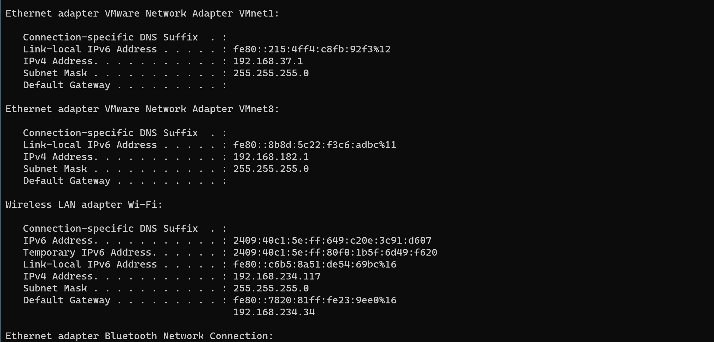 

Case 4: Consider a scenario when you want to know the time it takes for a packet

of information to travel between a local computer and a destination IP address or

domain.

**Command:** TRACERT

**Description :**

TRACERT is a command-line tool used to trace the route that packets take from one networked device to another. It shows the IP addresses of the routers that the packets pass through on their way to the destination. TRACERT is often used to diagnose network connectivity issues and to determine the path that data takes across a network.

**Screen shot :**

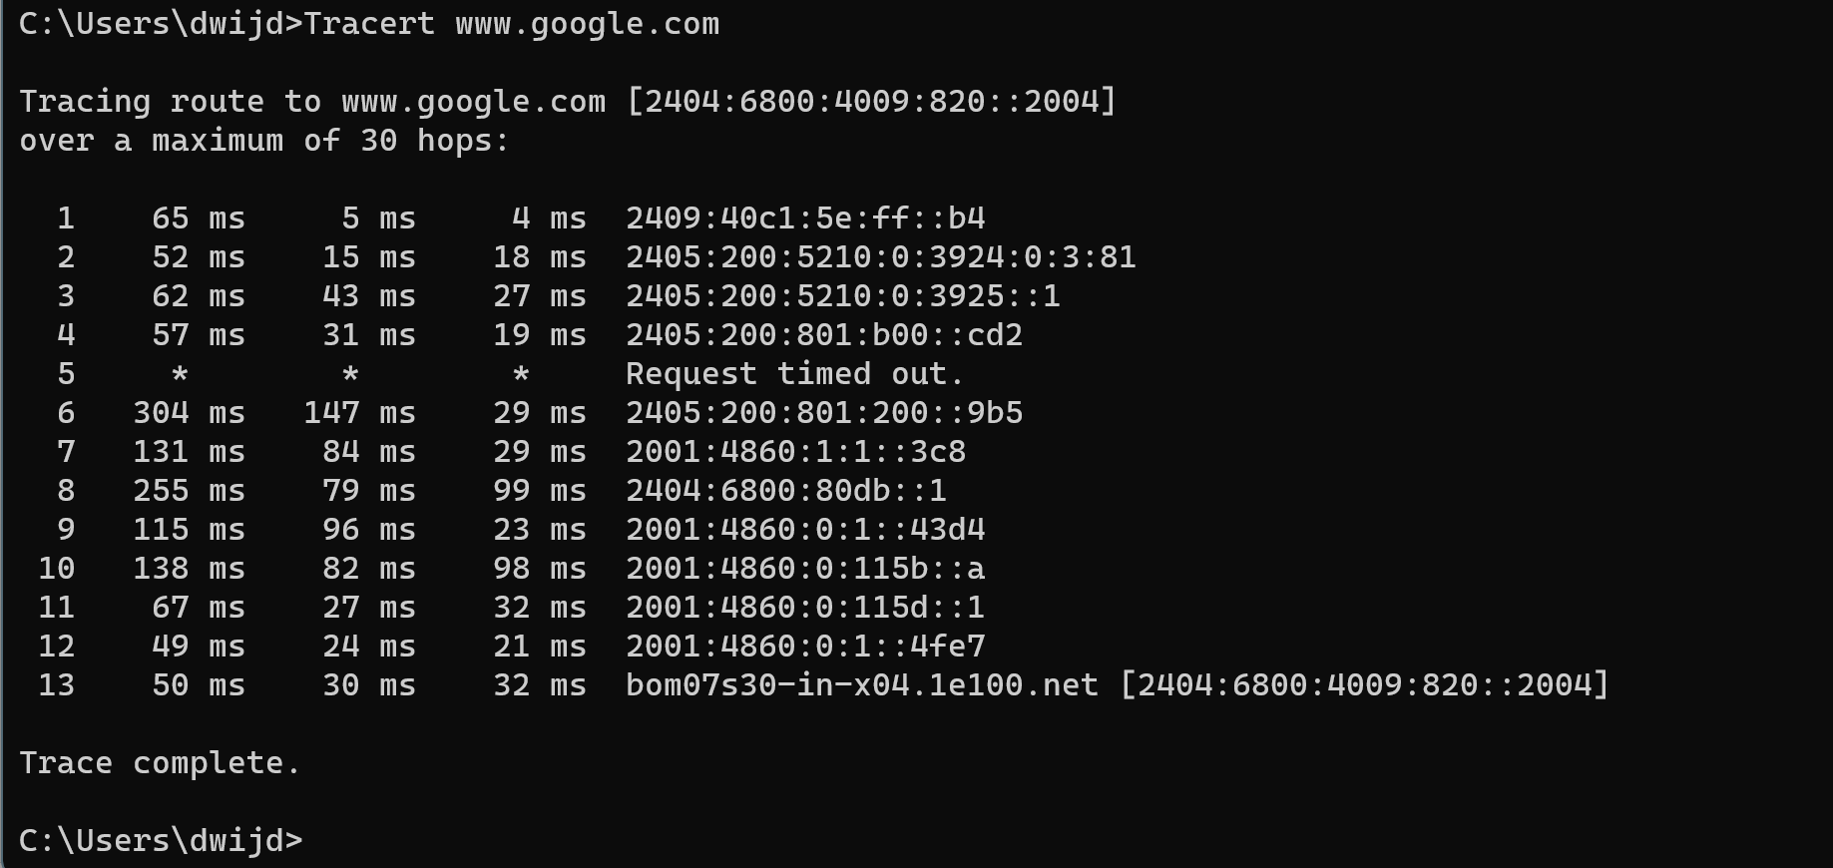

Case 5: Consider the case in which you want to know the network status and

protocol statistics.

**Command:** NETSTAT

**Description :**

NETSTAT is a command-line tool used to display network statistics and information about network connections on a computer. It can show the current connections, listening ports, routing tables, and other network-related information. NETSTAT is often used for diagnosing network issues and monitoring network activity.

**Screen shot :**

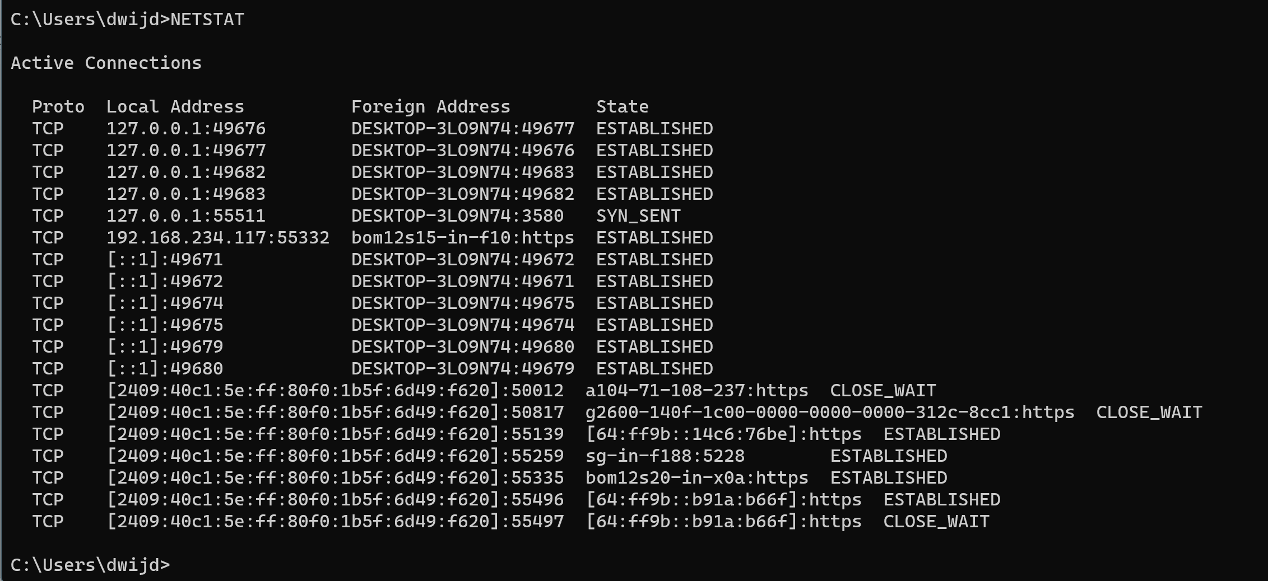

Case 6: Consider the case in which you want to display the Media Access Control

(MAC) addresses for each network adapter in the computer.

**Command:** GETMAC

**Description :**

GETMAC is a command-line tool in Windows used to display the media access control (MAC) address and list of network protocols associated with each address for all network cards in a computer. MAC addresses are unique identifiers assigned to network interfaces, such as Ethernet cards or Wi-Fi adapters. GETMAC is often used for network troubleshooting and identification of devices on a network.

**Screen shot :**

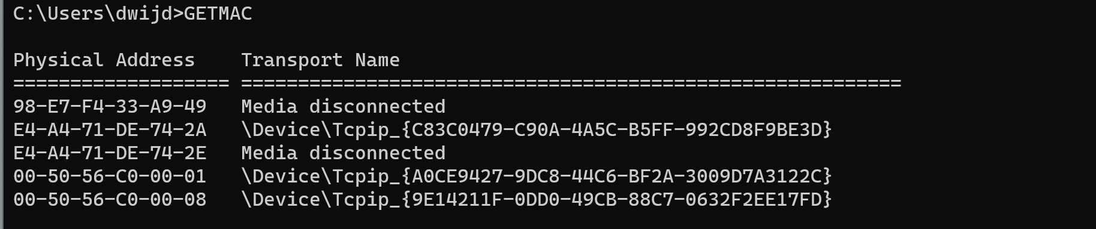

Case 7: Consider that you have already a domain name of website and you want

to find out the IP address and DNS server detail.

**Command:** NSLOOKUP

**Description :**

NSLOOKUP is a command-line tool used to query the Domain Name System (DNS) to obtain domain name or IP address mapping, or other DNS records. It can be used to troubleshoot DNS-related issues, such as checking DNS records, testing DNS configuration, and diagnosing DNS resolution problems.

**Screen shot :**

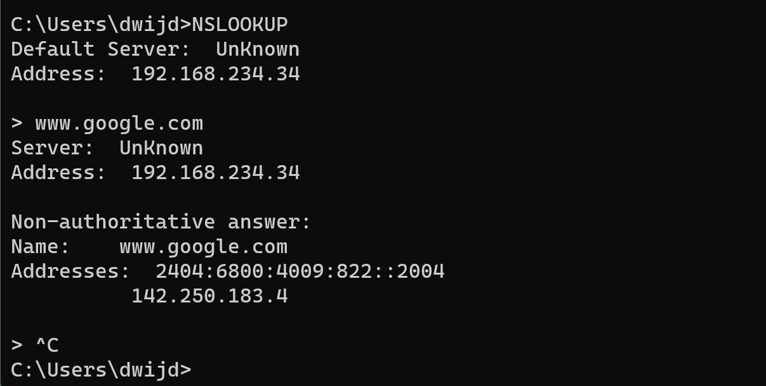

Case 8: Consider that you have to do the mapping between an Internet Protocol

(IP) address and a Media Access Control (MAC) address.

**Command:** arp –a

**Description :**

The "arp -a" command is used to display the current ARP (Address Resolution Protocol) cache on a computer. The ARP cache contains mappings of IP addresses to MAC addresses for devices on the local network. The command shows a list of IP addresses and their corresponding MAC addresses, along with the type of the entry (static or dynamic) and the interface through which the mapping was learned. ARP is used to translate IP addresses to MAC addresses for communication on a local network.

**Screen shot :**

