**Software instalation(package instalation)**

1. **There are two types ways to instale** 
   1. **Rpm**
   2. **Yum(we are going to use this one to instail software)**
2. **RPM Software Packages Objectives**
   1. 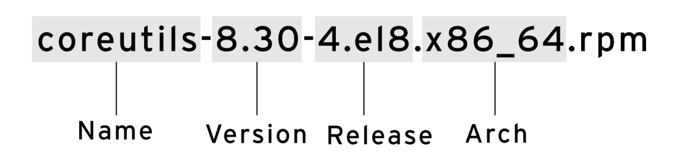
   2. The general form of a query is:
      1. **rpm -q [select-options] [query-options]**
         1. 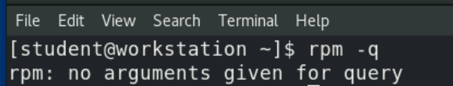
      2. **rpm -qa**: List all installed packages
         1. 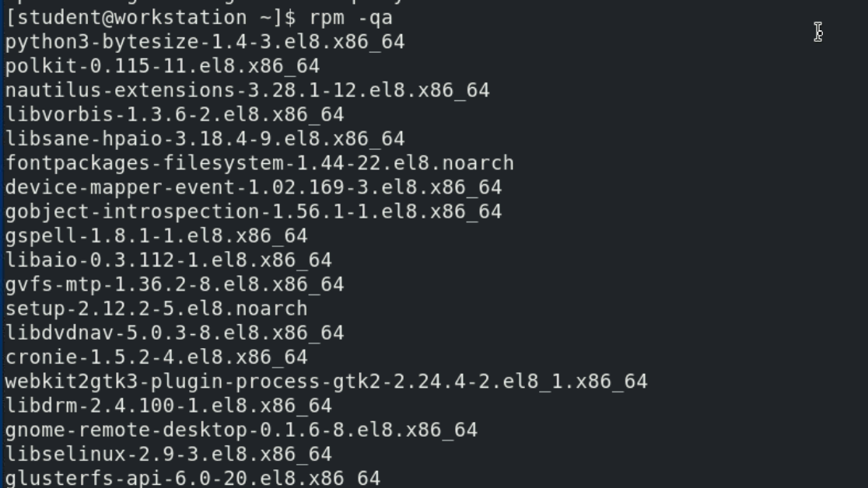
      3. **rpm -qf *FILENAME***: Find out what package provides FILENAME
         1. 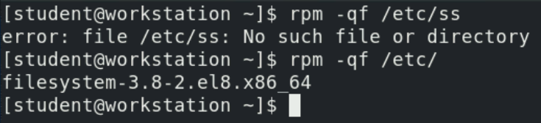
      4. **rpm -q**: List what version of the package is currently installed
         1. 
      5. **rpm -qi**: Get detailed information about the package
         1. 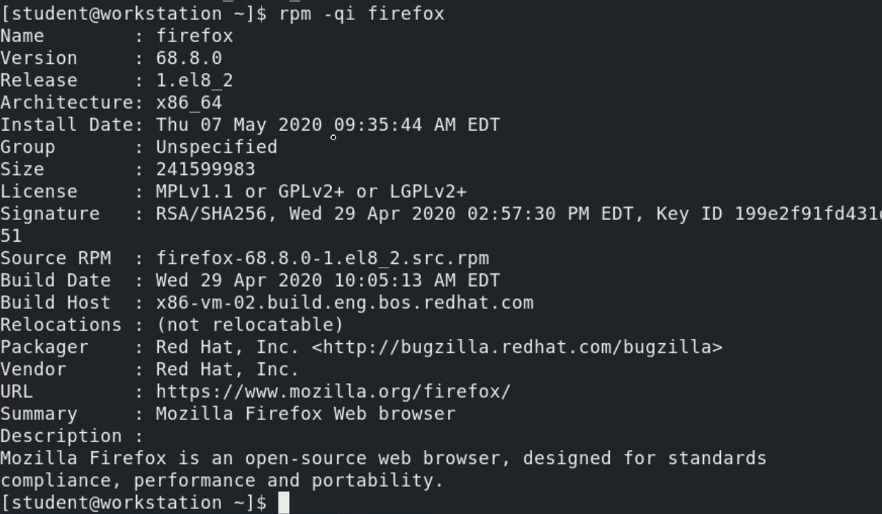
      6. **rpm -ql**: List the files installed by the package
         1. 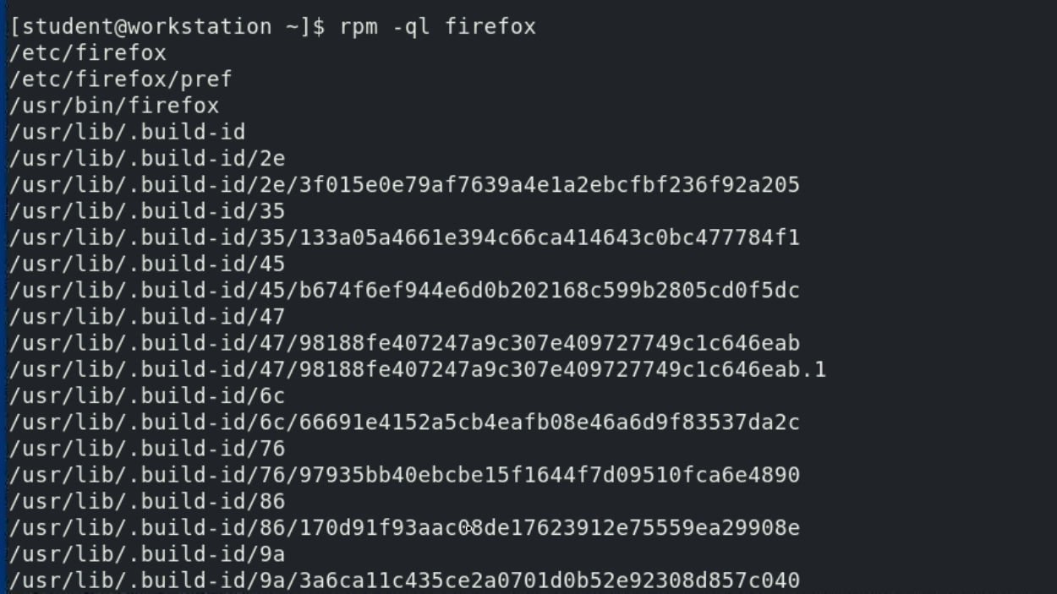
      7. **rpm -qc**: List just the configuration files installed by the package
         1. 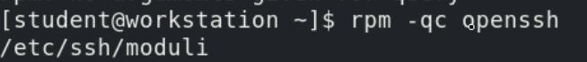
      8. **rpm -qd**: List just the documentation files installed by the package
         1. 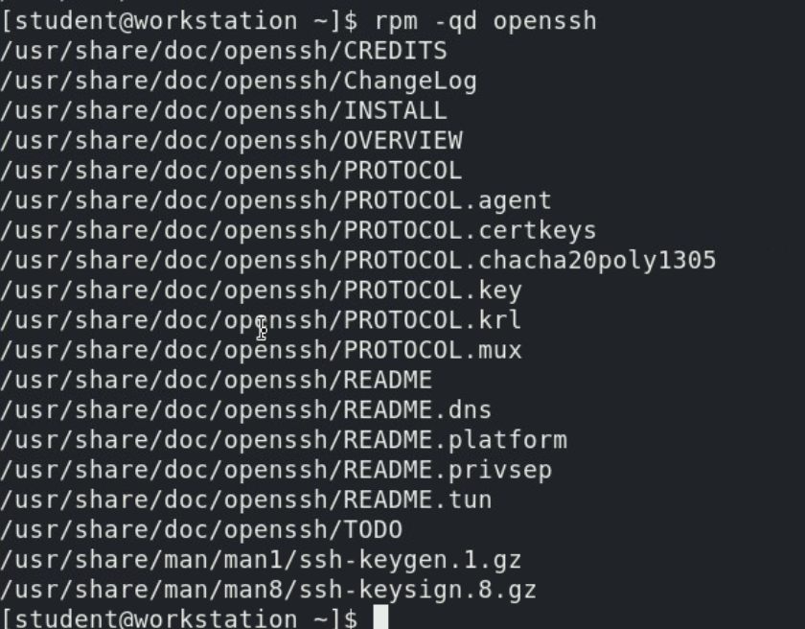
3. **Managing Software Packages with Yum** 
   1. **yum help** displays usage information.
      1. 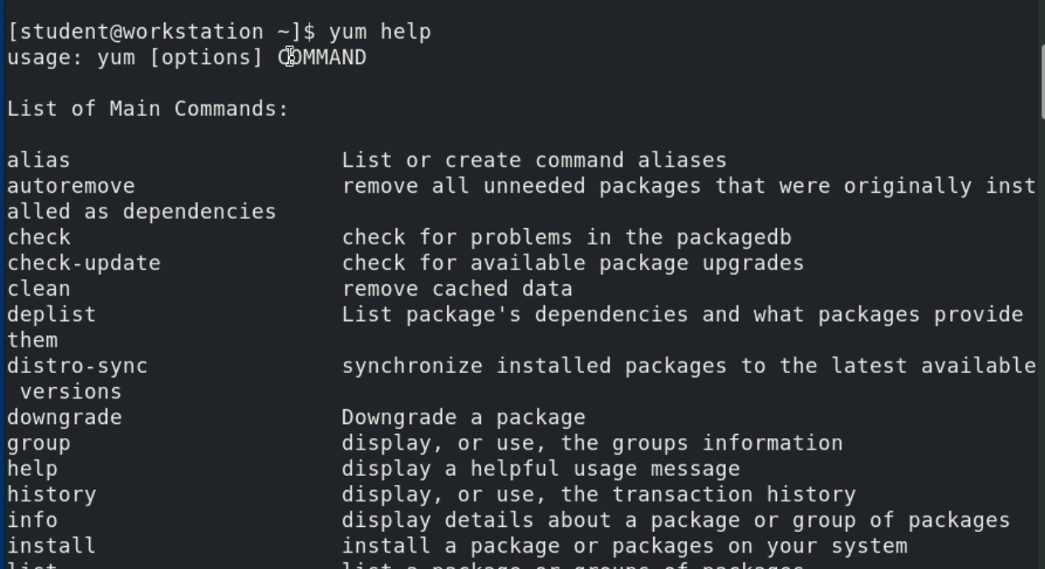
   2. **yum info = rpm -qi**
   3. **Installing and removing software with yum**
      1. 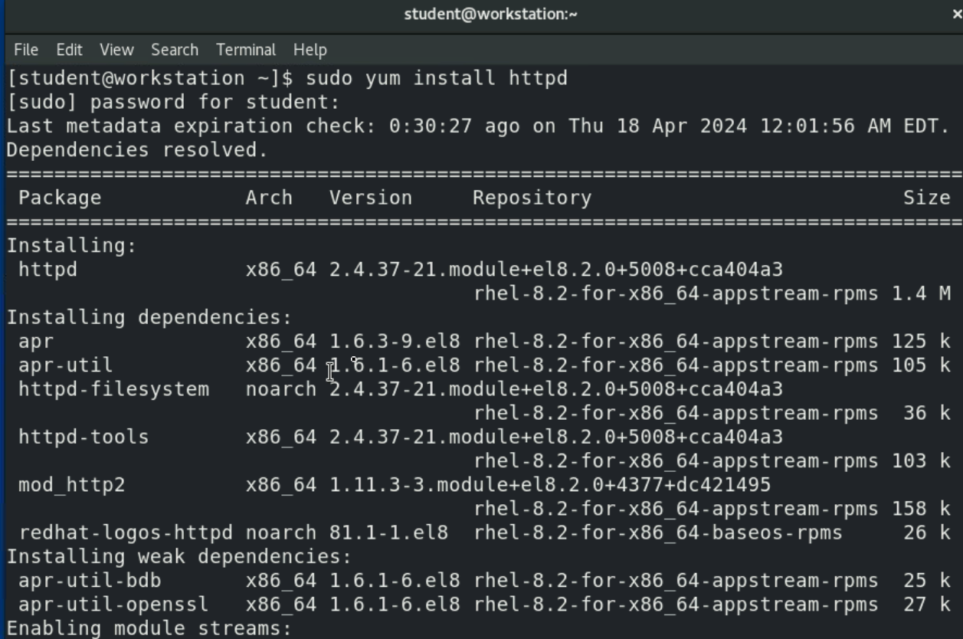
   4. 
      1. 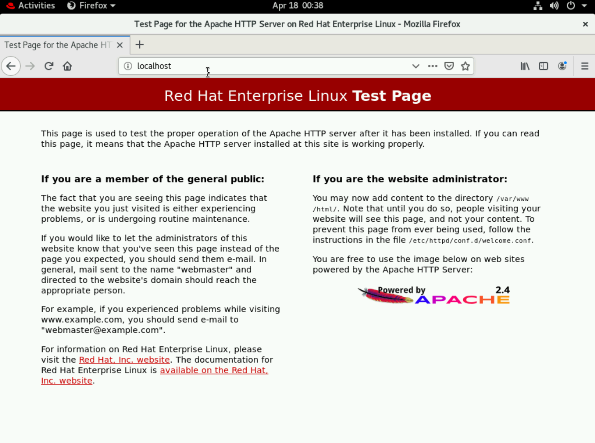
   5. 
      1. 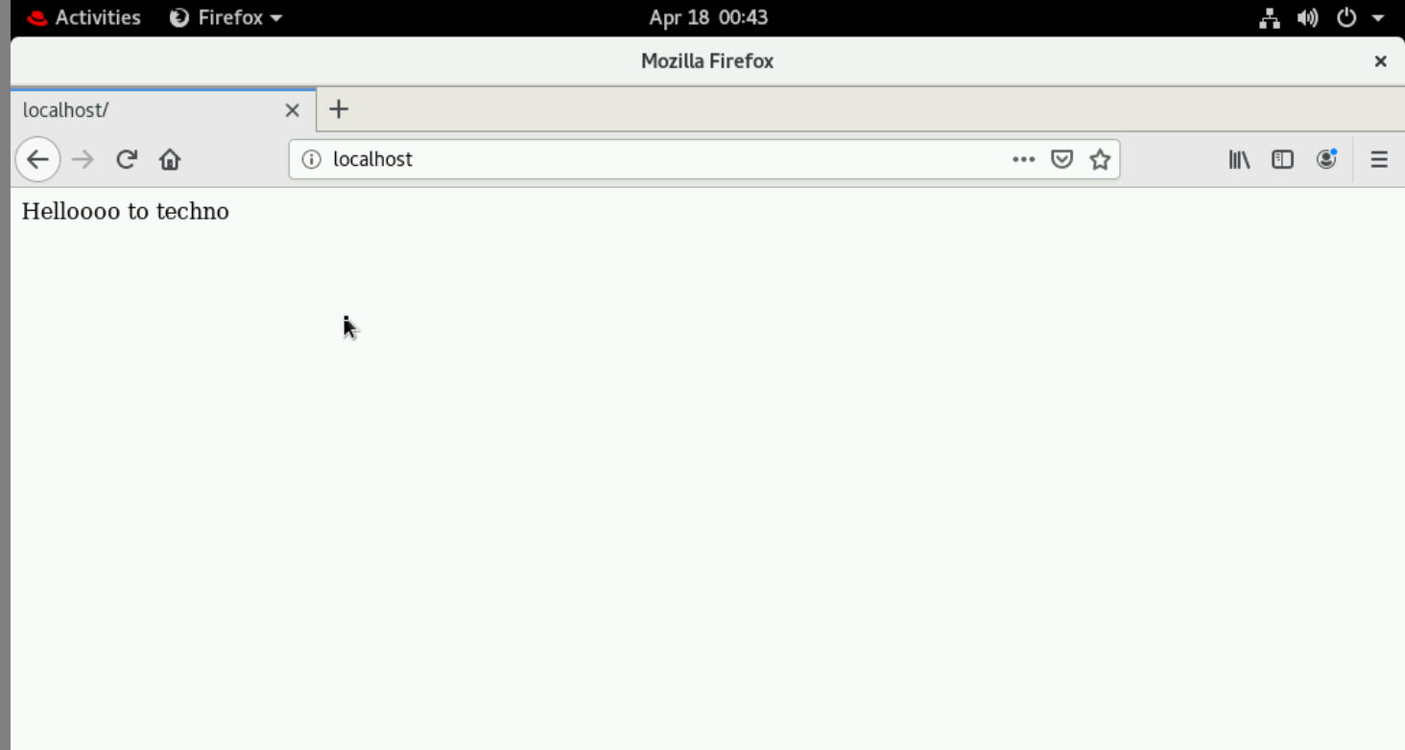
   6. 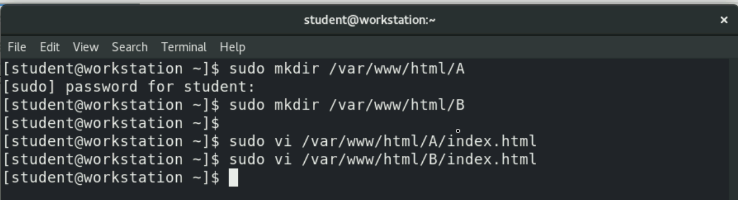
      1. For A
         1. 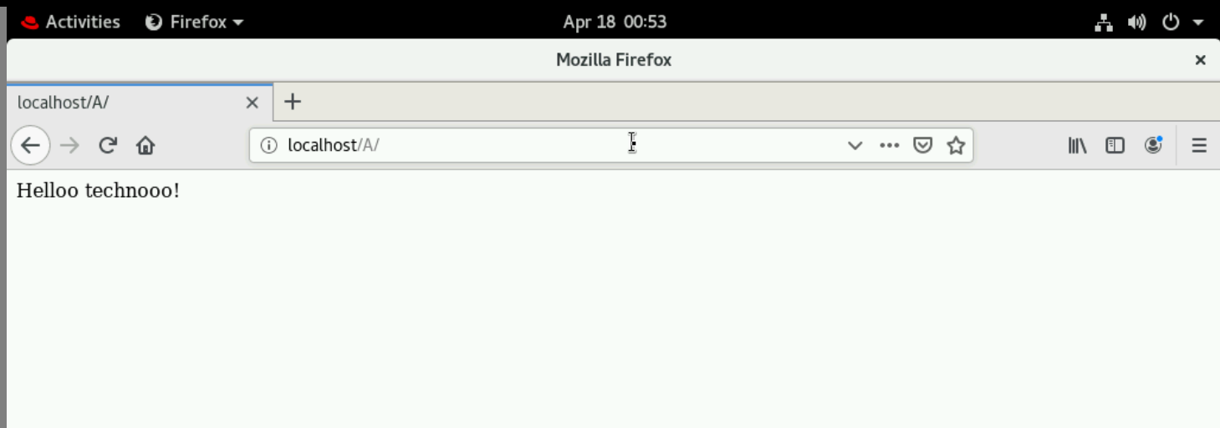
      2. For B
         1. 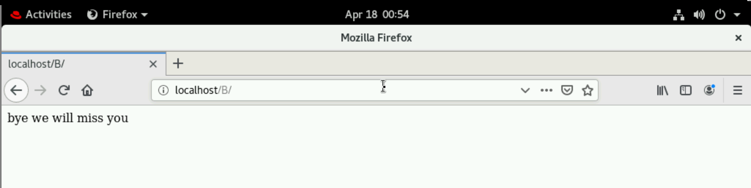
      3. 
         1. 