* ***Main-topic:-***

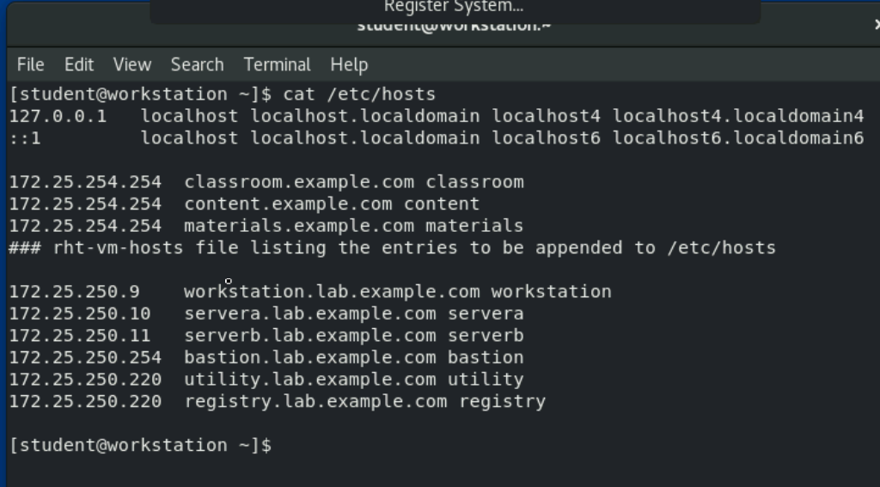

* + This servers are maped with ip
  + Ip address are maped with a name
  + 1 ip address can not have 2 name
* ***Fact-topic:-***

DHCP 🡪 (search at home)

* + Its work is to alocate dynamic ip(normaly used a company)
  + Home normaly have static ip
* ***Sub-topic:-***

(in windows)Ipconfig 🡪 to know the ip address of the user

* + 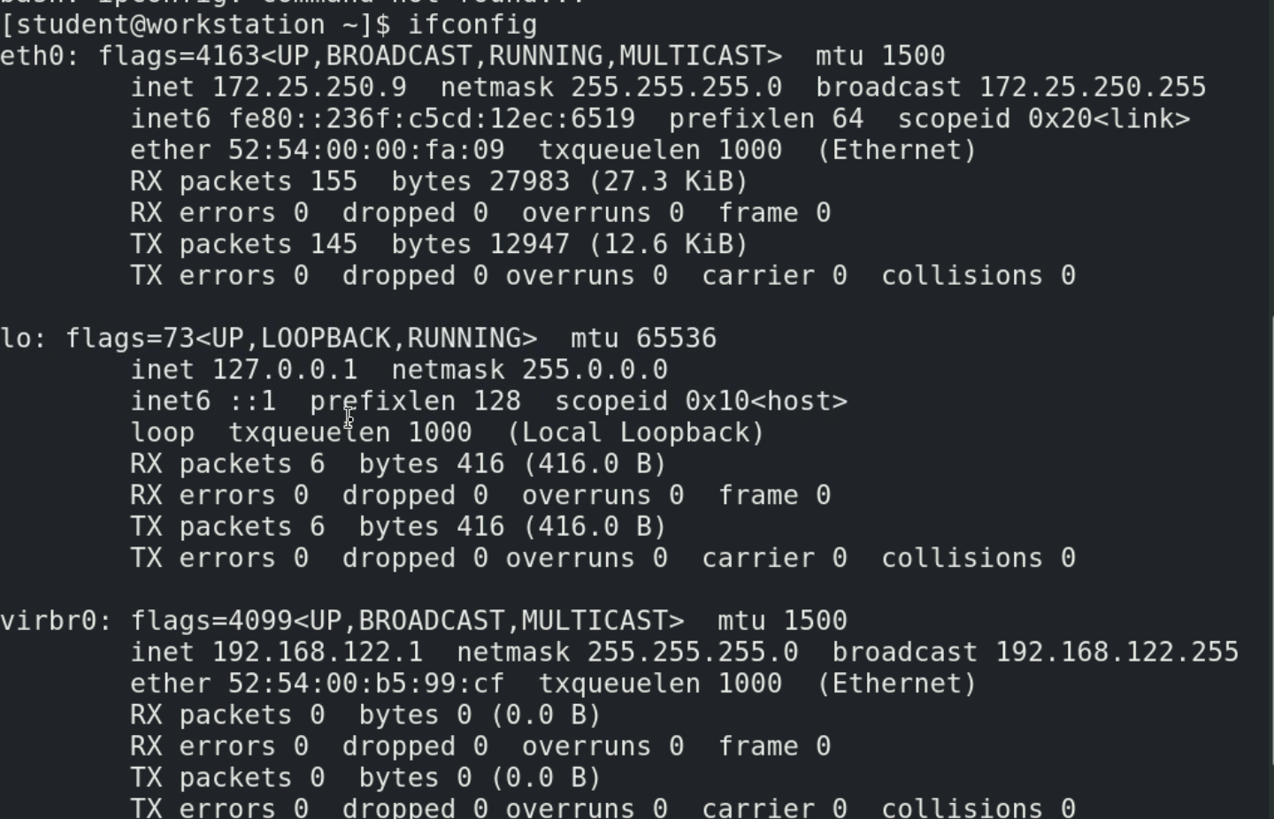
    - We use ifconfig in linux
    - Server a 🡪 172.25.250.10
    - Server b 🡪 172.25.250.11
    - workstation🡪 172.25.250.9
  + ipv4 can have 2^32 devises
  + so that is why we need ipv6 (2^128)
* ***fact-topic:-***

Gate-way

* + If a data want to go out/come in side of network form certain devises

X-----X-------X-----X----X----X---------X----End of concept-----X----X----X---------X----X----X----X------

* ***Main-topic:-***

12.5:-

* + #ifconig
  + 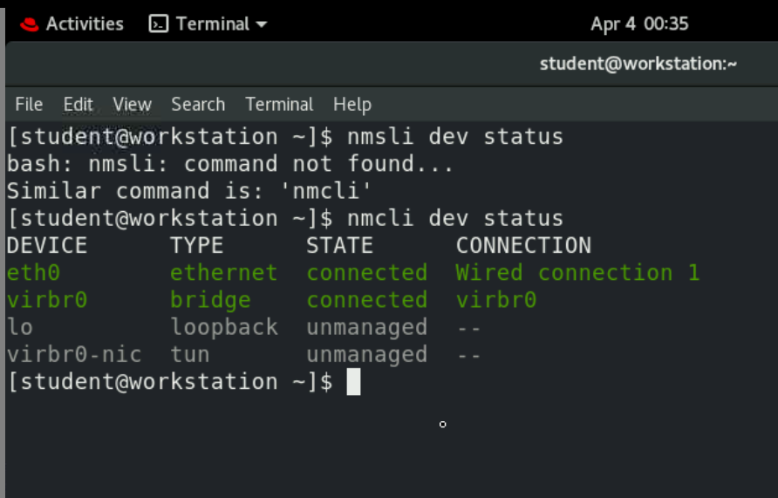
    - Shows Devices connected 🡪 nmcli dev status
  + 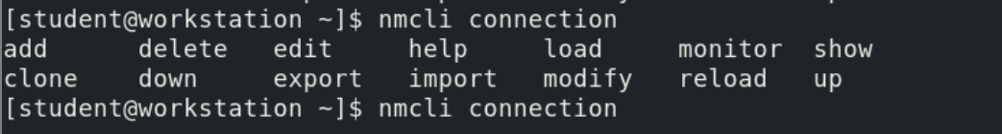
  + 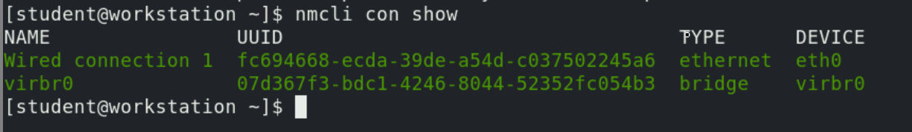
  + Add connect after adding a connection / just add a connection

Host name:-

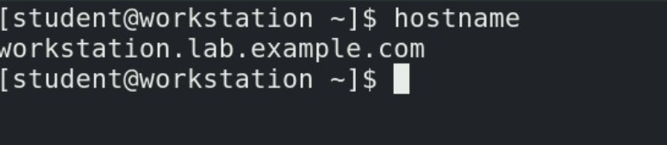

Change host name:-

* + 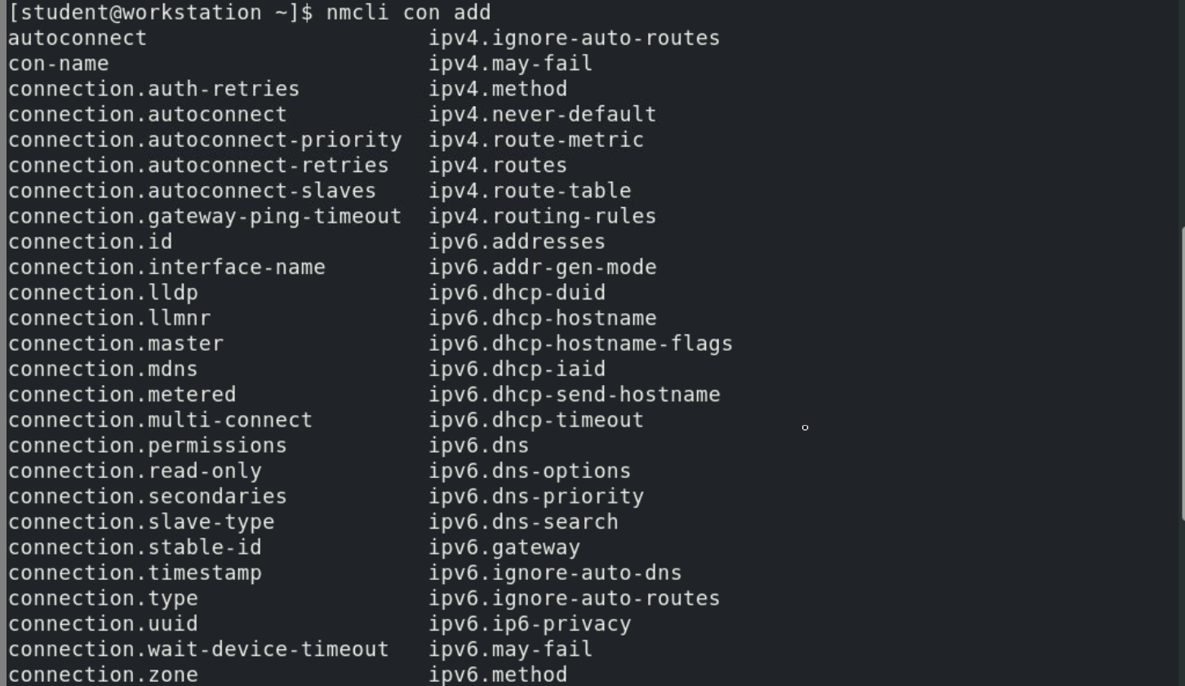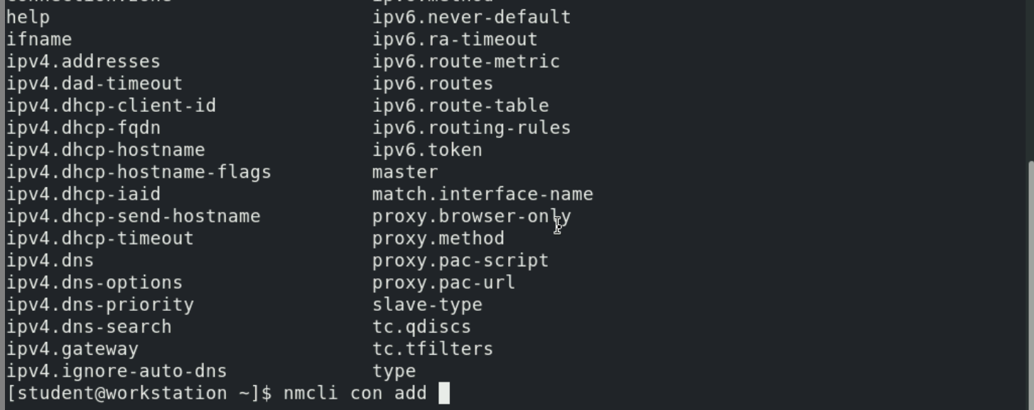
  + 
    - Here we added a test connection
  + 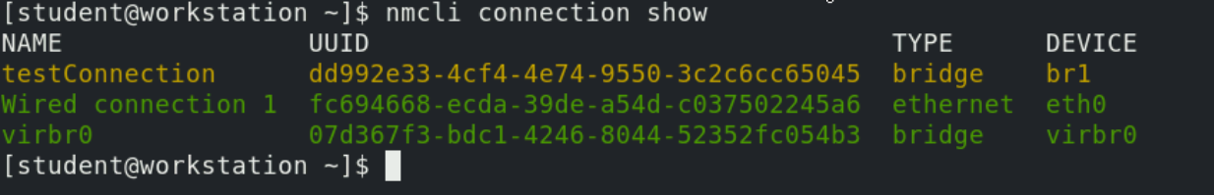
  + 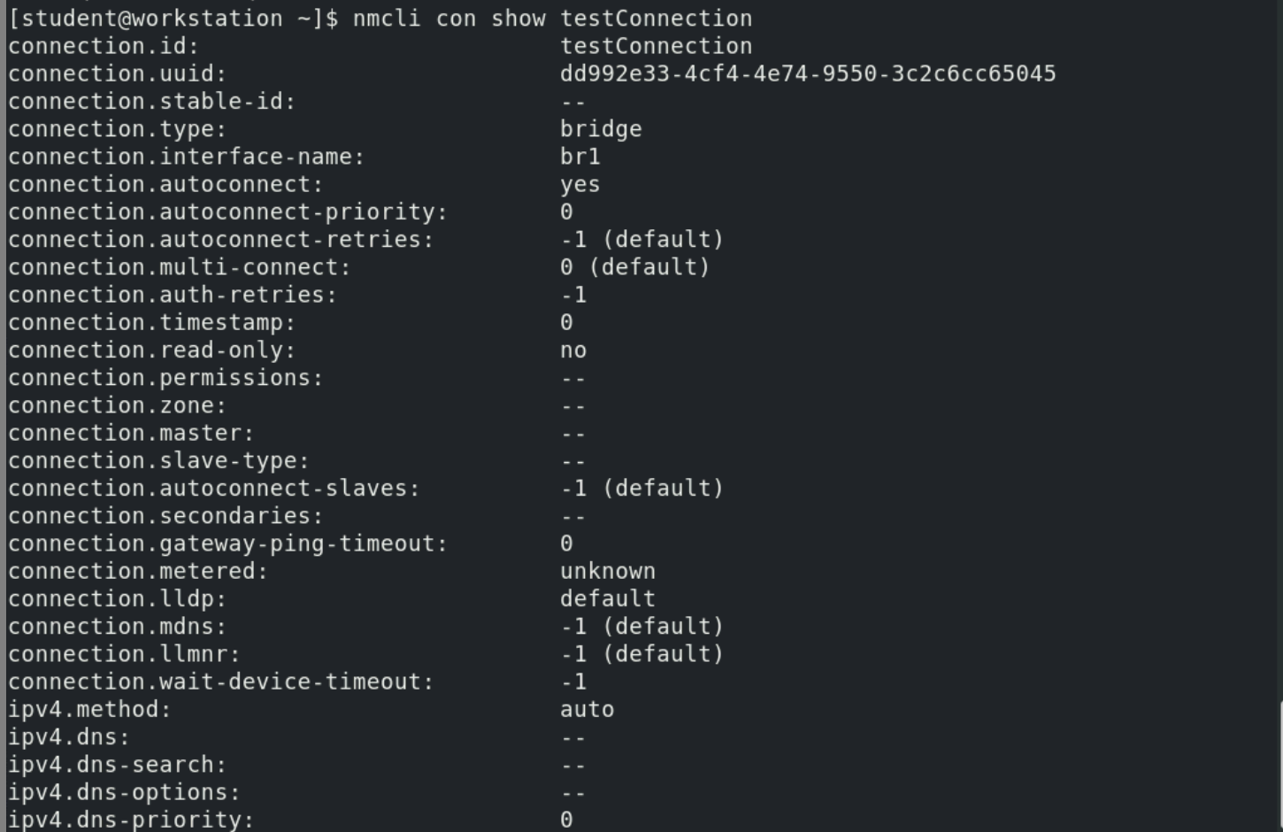
  + Now add ip address and gateway
    - 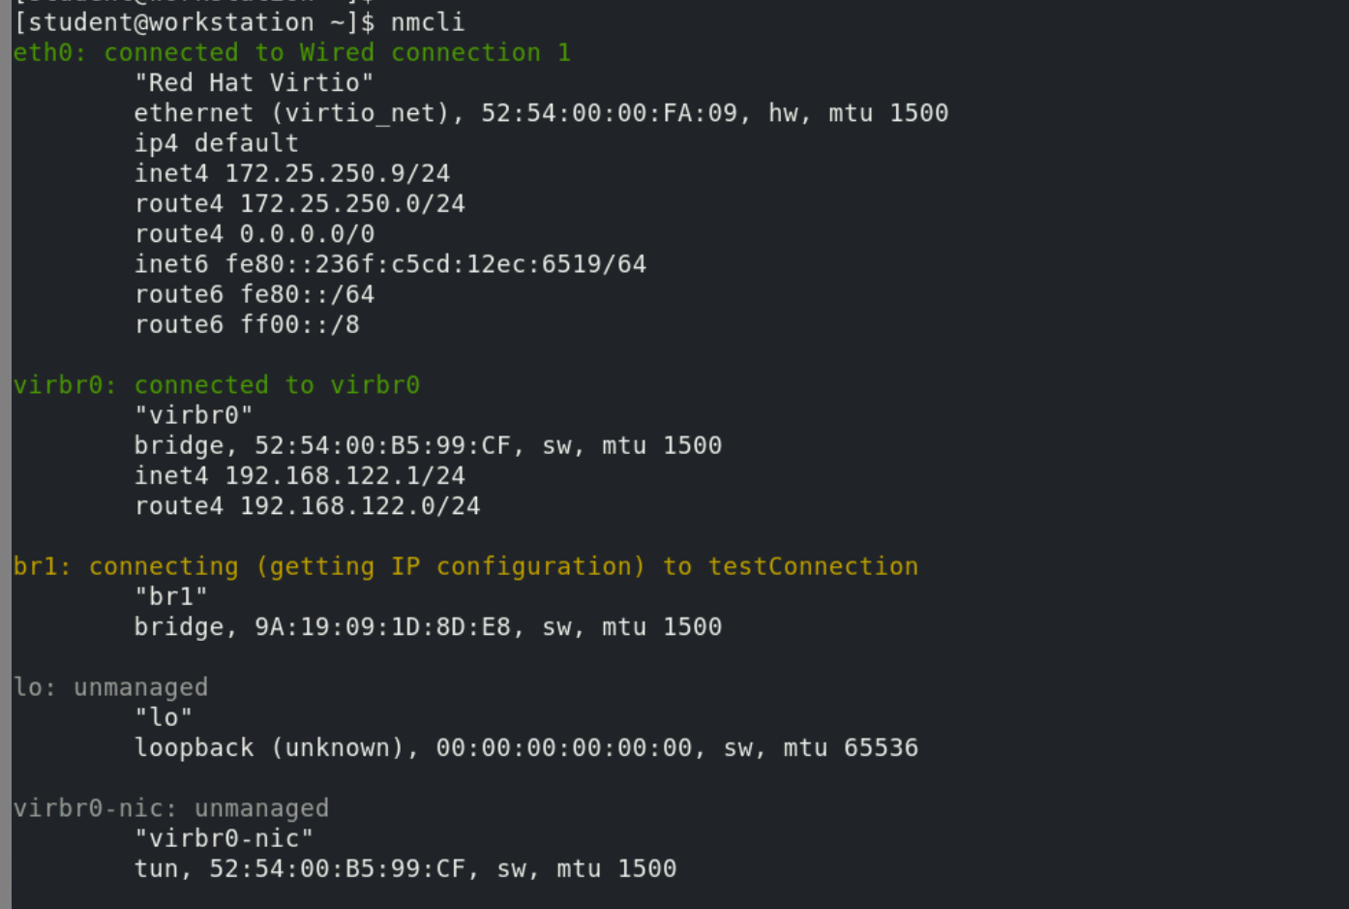
      * Connection type
    - 
     