Chapter 13. Archiving and Transferring Files

Archiving:-

## Converting multiple files in 1 file (But there is profit in size)

Aim 2 🡪 making it compered

* In linux type of files(size may vary form type of file define)
  + .gzip
  + .bzip
  + .xz

1. 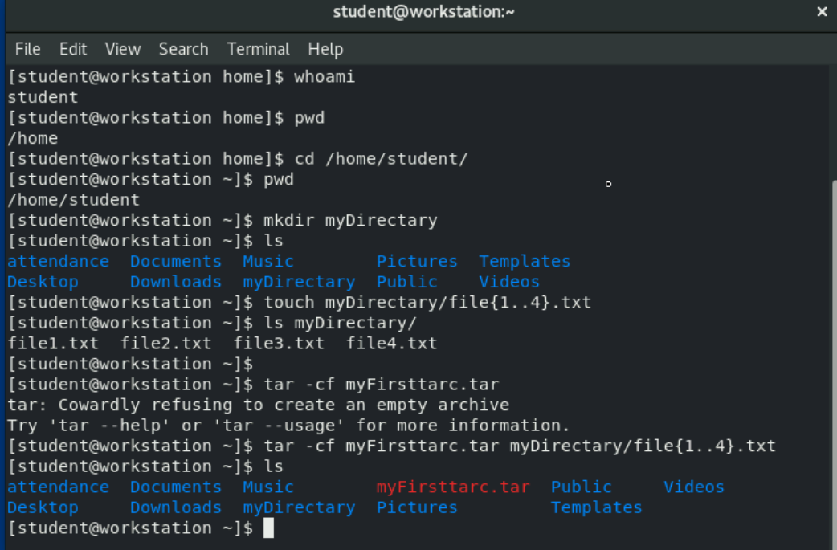
   1. First arhive
2. 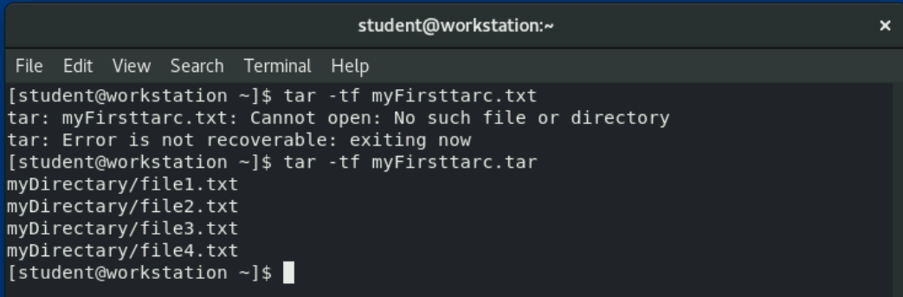
3. Now comprating file:-
   1. 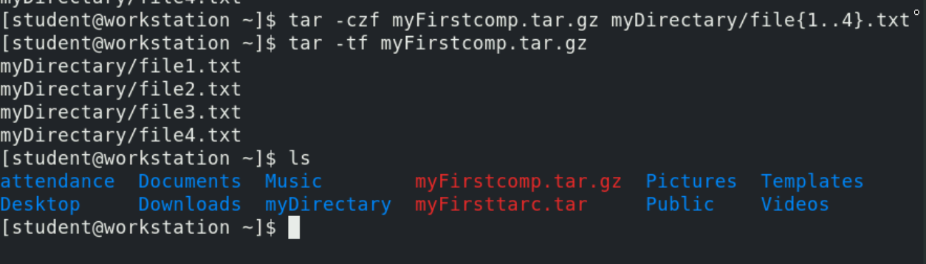
   2. 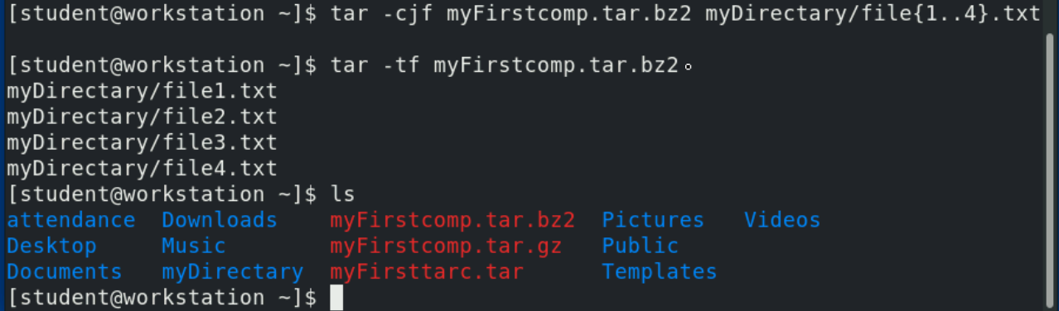
4. **Extracting Files from an Archive:-**
   1. We want to extract to diff directory
      1. 