Ch-6.1  
  
To know about user

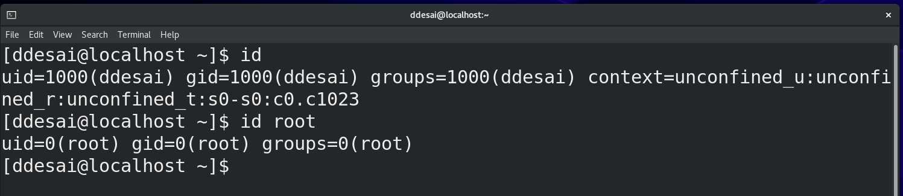

* if uid is 1000 then you are student user
* gid = 1000 then it is user id is 1000 of student
* groups = 1000 mean student is in 1000 group
* 10(wheel)🡪mean you have 10 saplimentary group
* Root is in only one group and it group = 0(root)

🡪vi /etc/passwd

It gives you the all the user of the system

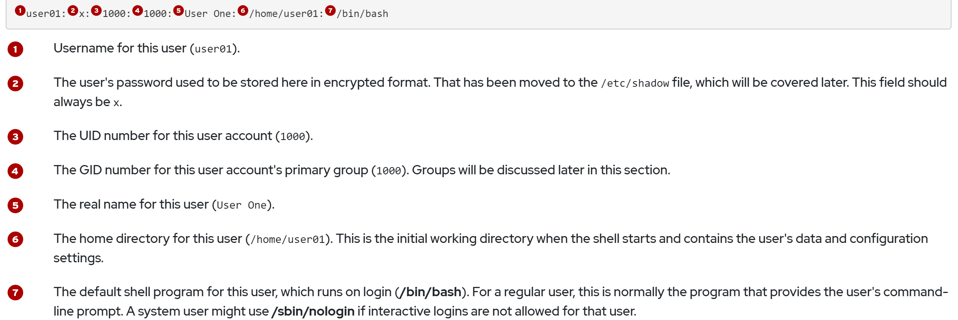

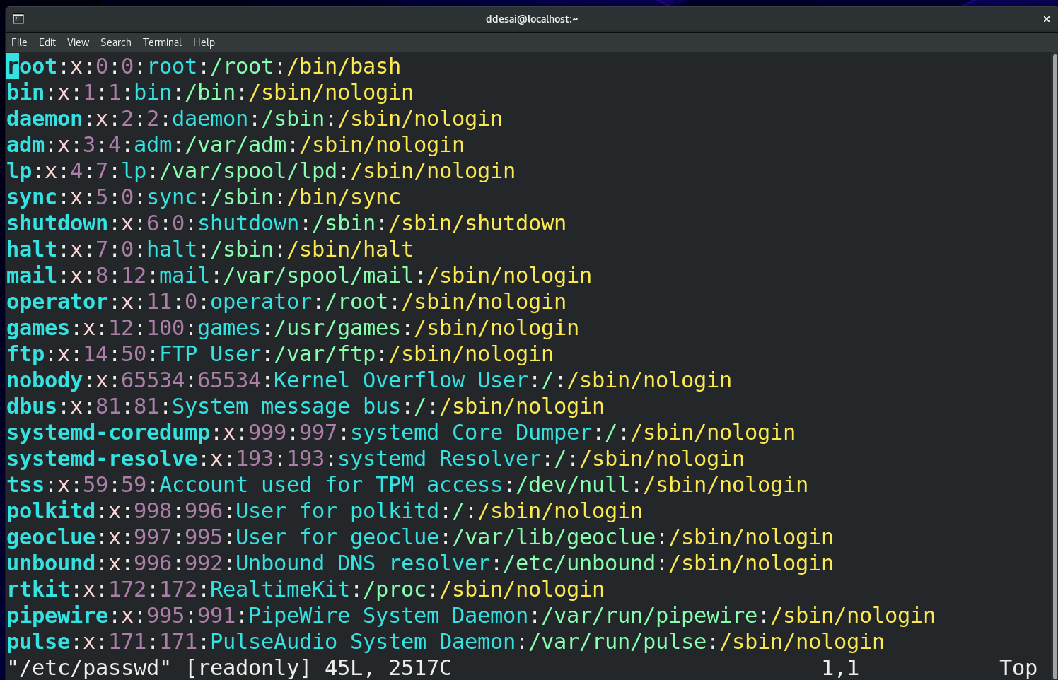

🡪vi /etc/group  
 it have all the group of the system

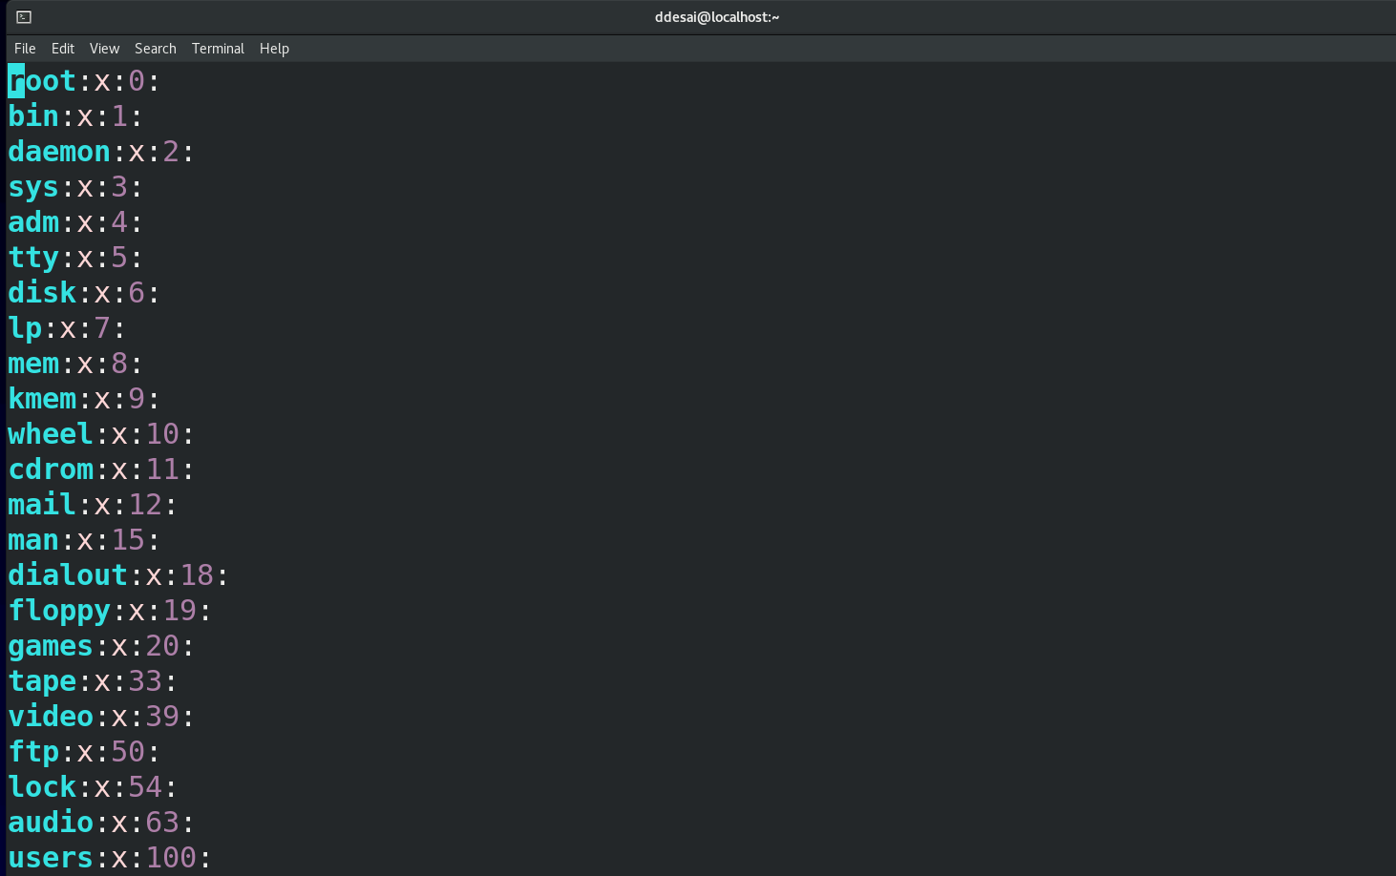

Adding user to the system

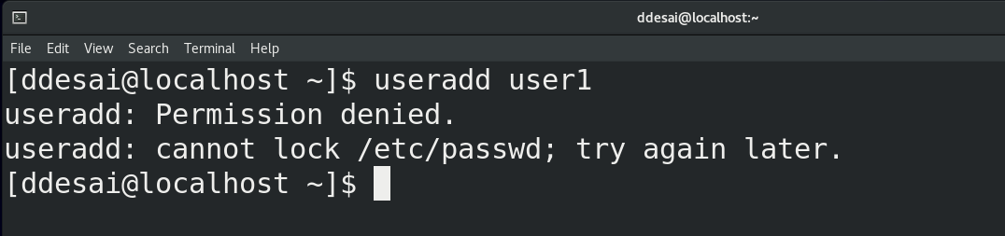

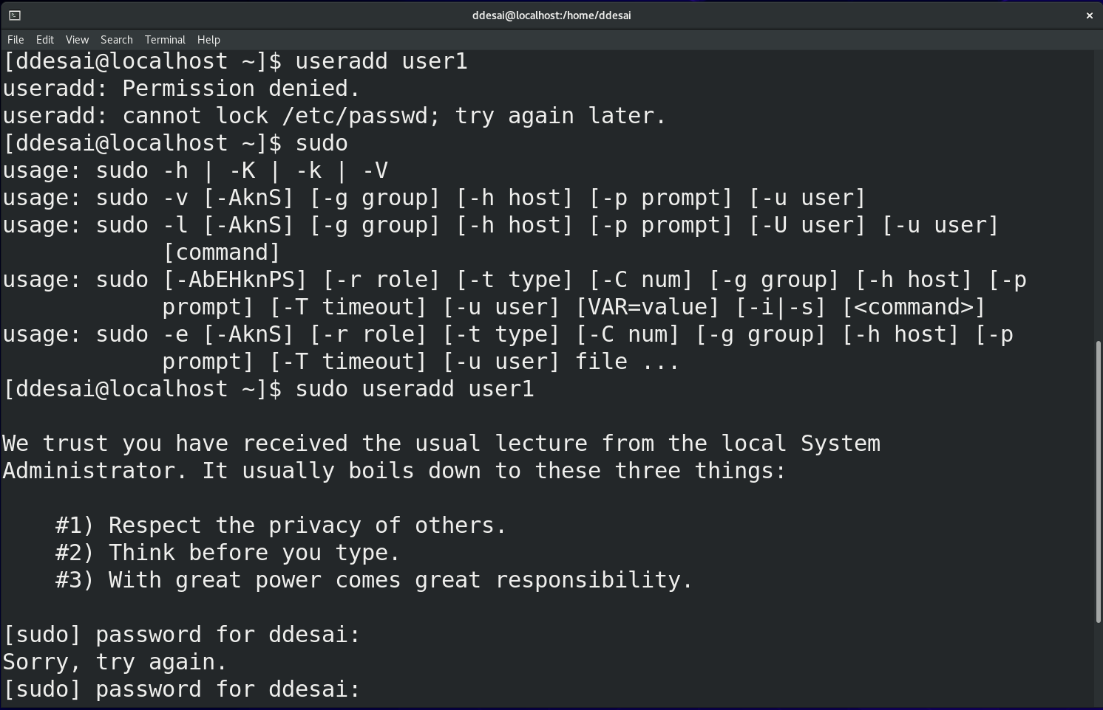

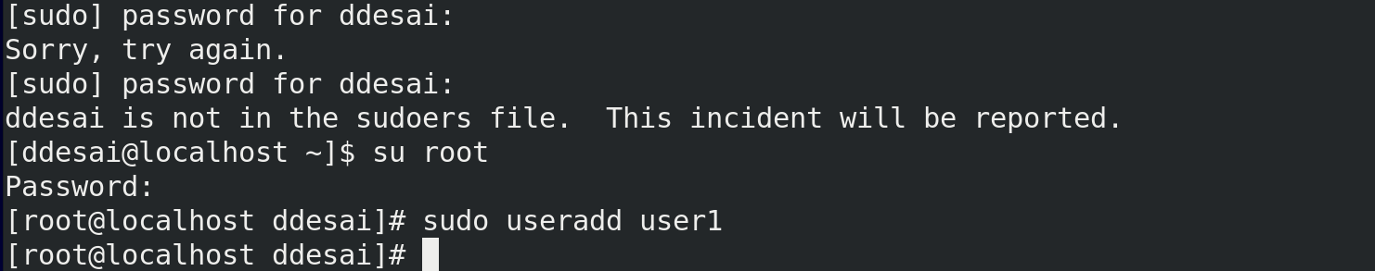

You need to use root in ‘centos’

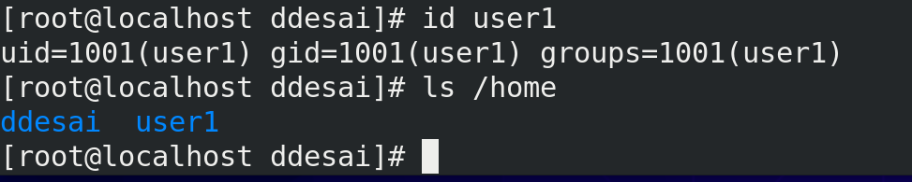

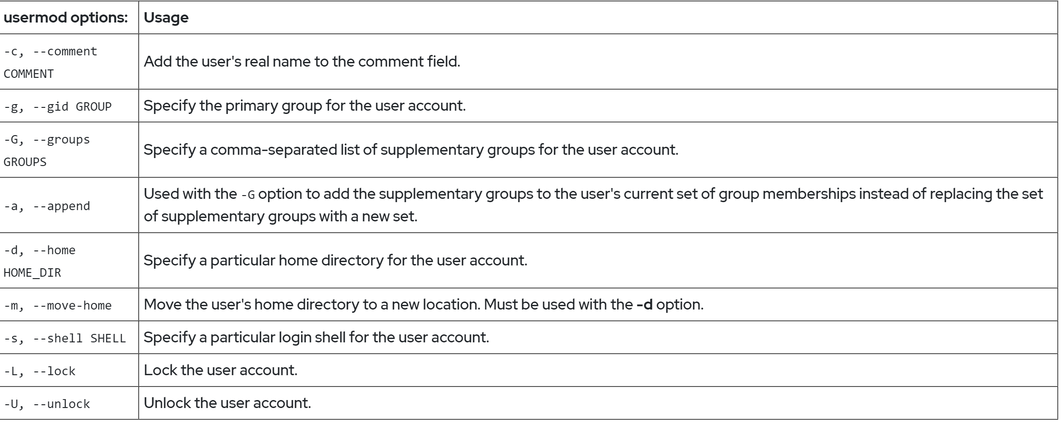

To make user name

And make group

And put in groups under multiple group art the same time

To make group 🡪 groupadd name_of_group

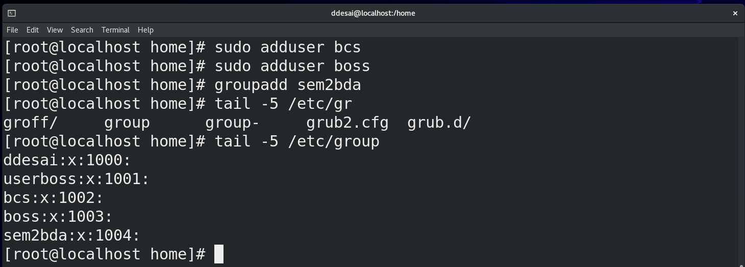

Create a group with other group id

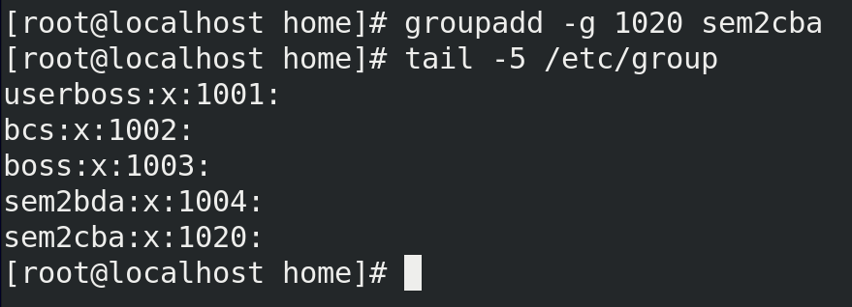

Add cba user in group of bda(we are making a suplimentary group)  
[🡪if I make user ‘bda’ then it will be group ‘bda’]

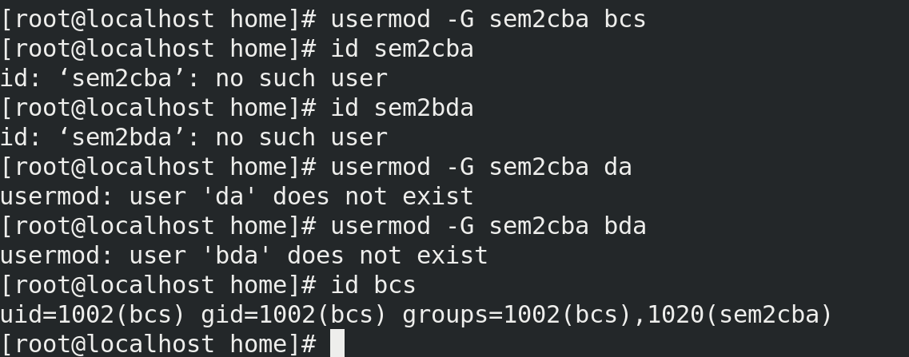

Now add in another suplimentary group

This will add and remove previous user🡪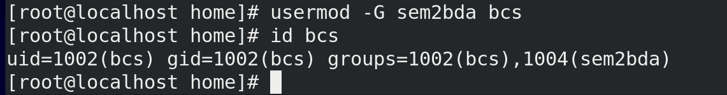

This will add with previous user🡪

This will change group name

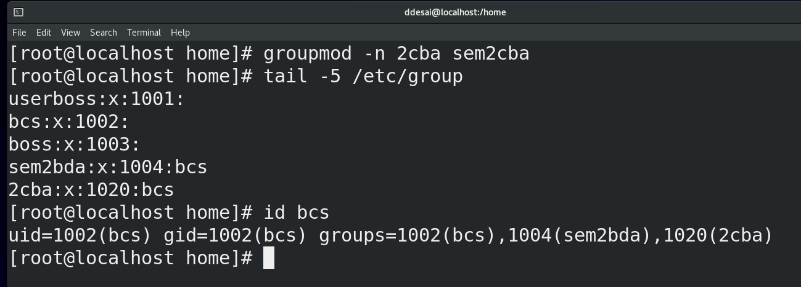

To make new user with same group id

*add hrush image from whatsapp*

**Topic :-**

Things about password

🡪

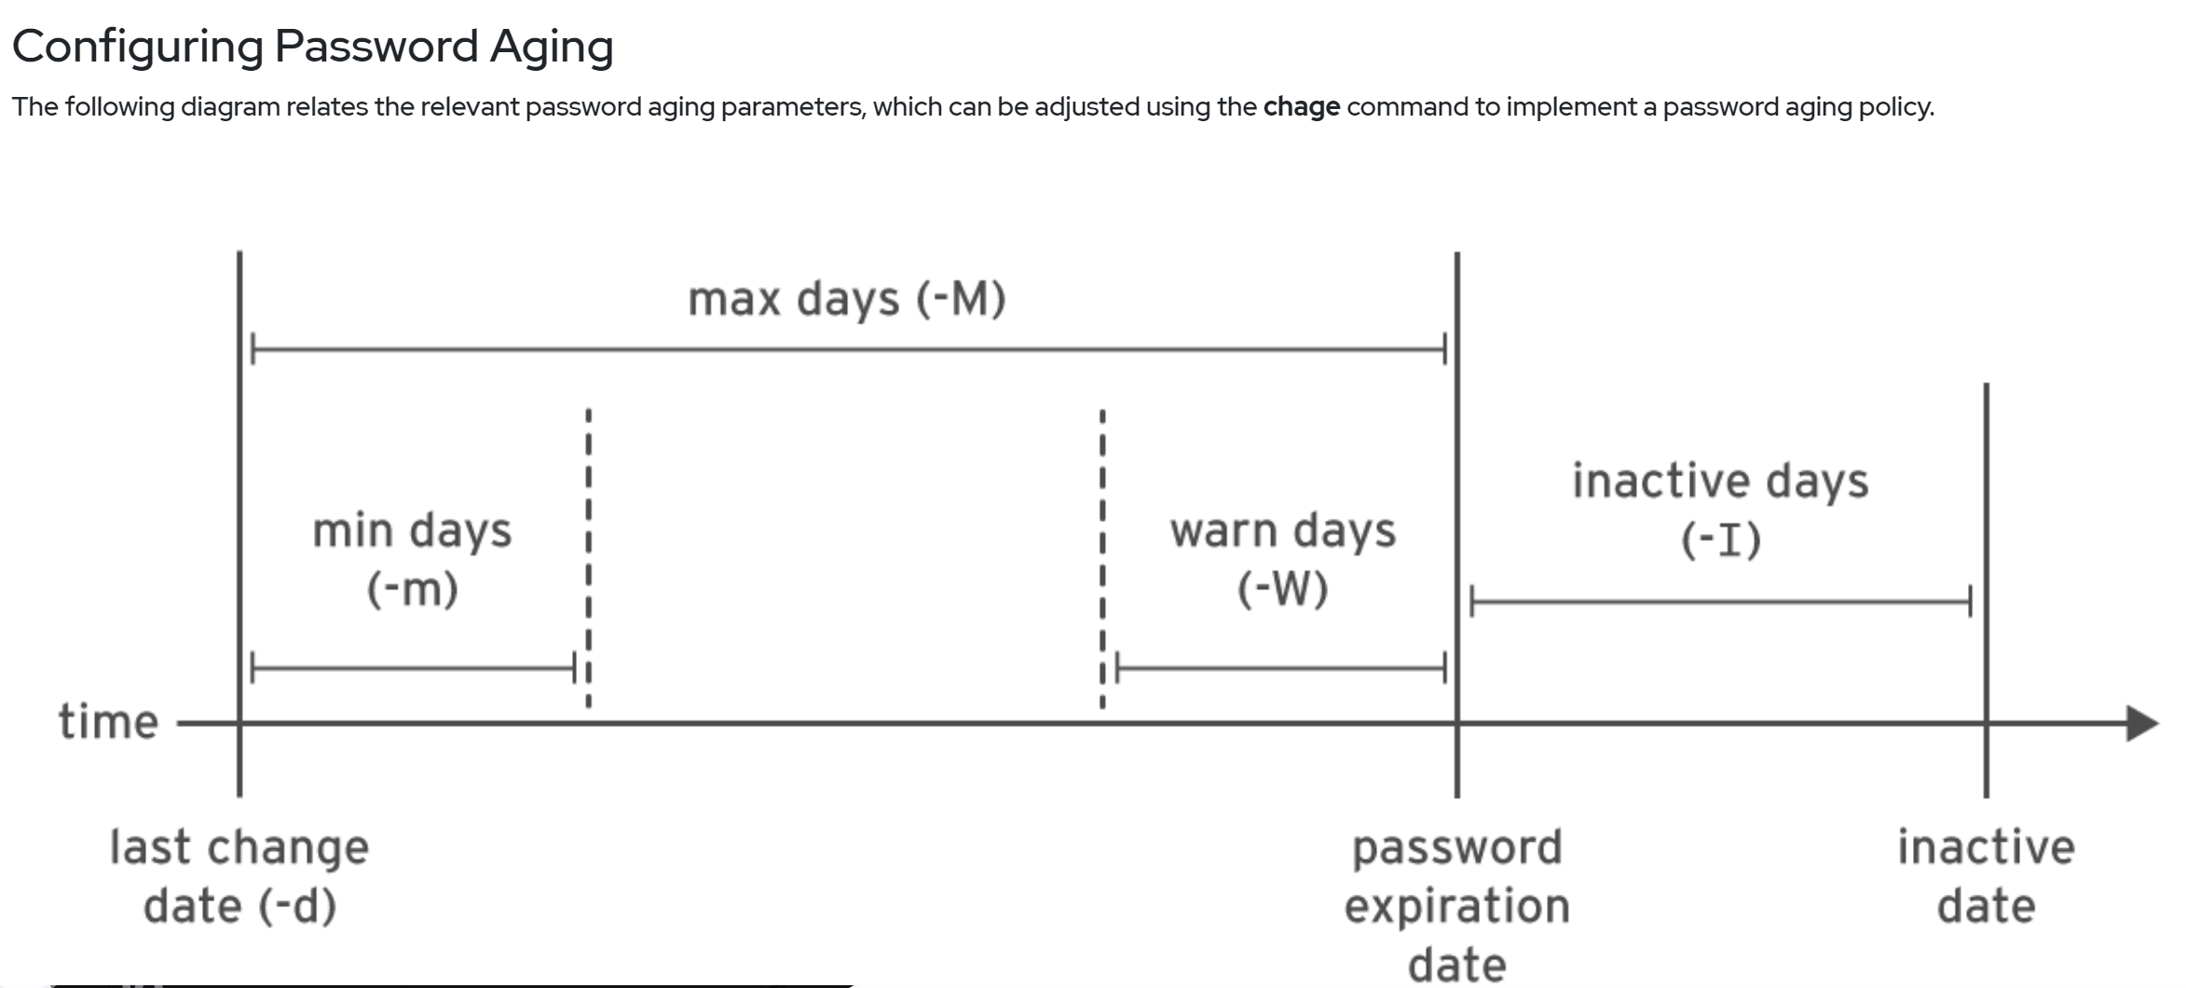

Vi /etc/shadow🡪It have

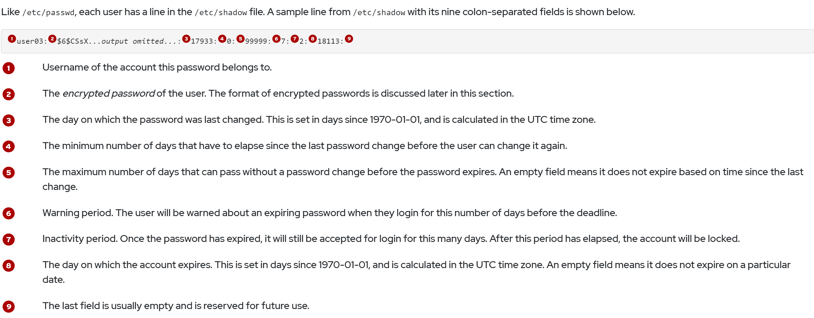

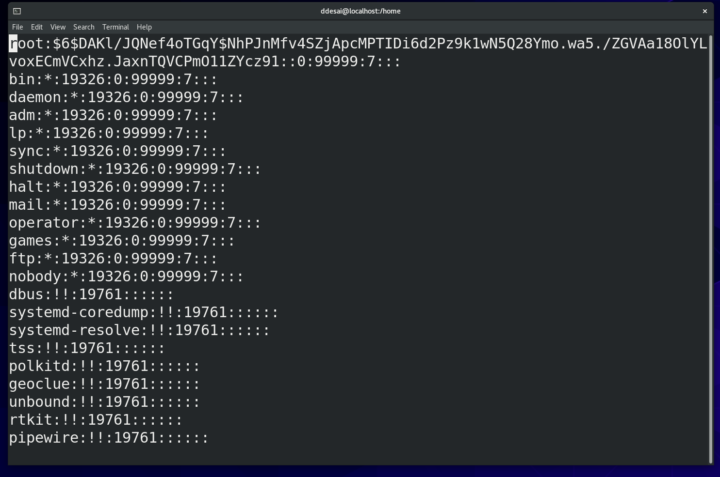

* -E is the date I want it to expire

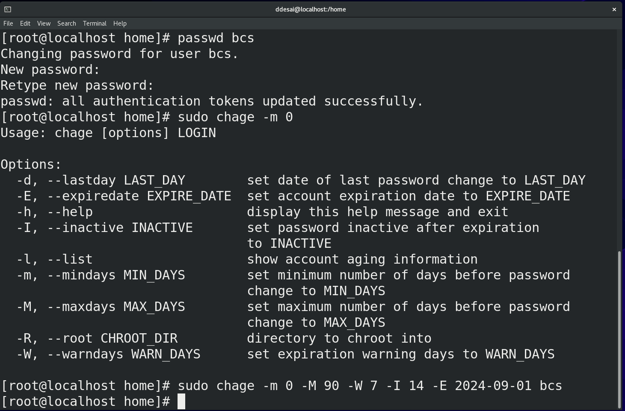

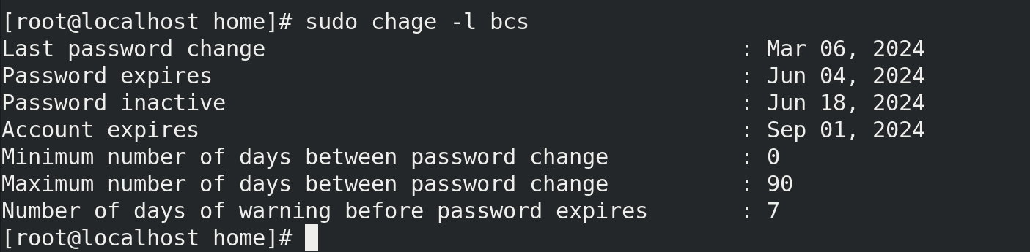

* This in vi /etc/shadow/



Lock the user account



we removed interactive terminal:-

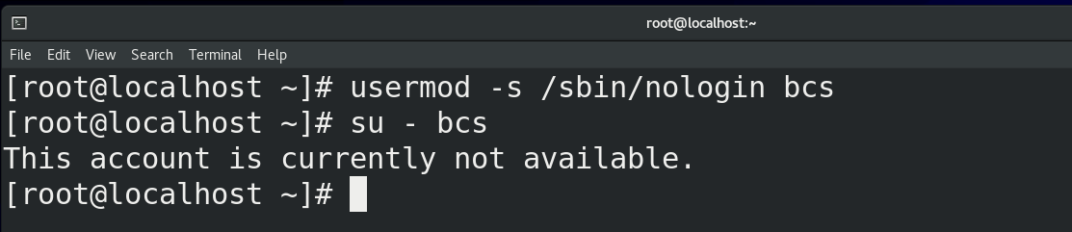

Now making it avaleble:-

