* There are two type of users   
  + U🡪User
  + G🡪group
  + O🡪other user
* There are two type of owner user horner, group honor
  + Group honer permition is 🡪r-read, w-write, x-exacute,
  + If give permiton to one group then it will give permition to all the user in the group.
  + If some one joins group later so he will also permition.
  + If some one exit then the permition is taken
* File1

A(owner) abc(group) d(other-user)

A(group mamber)

B(group mamber)

C(group member)

* 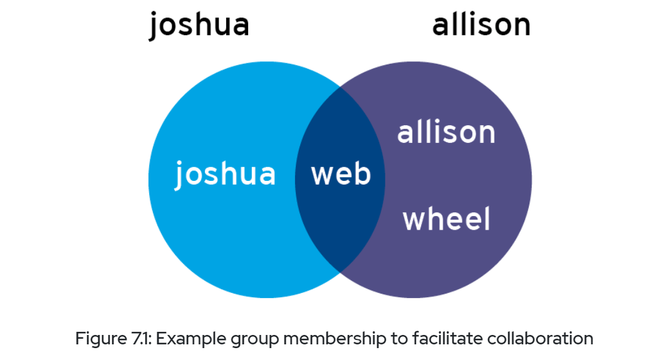
* Allison member of 🡪3 groups(allison,wheel,web)
* Joshua member of 🡪2 groups(Joshua,web)
* 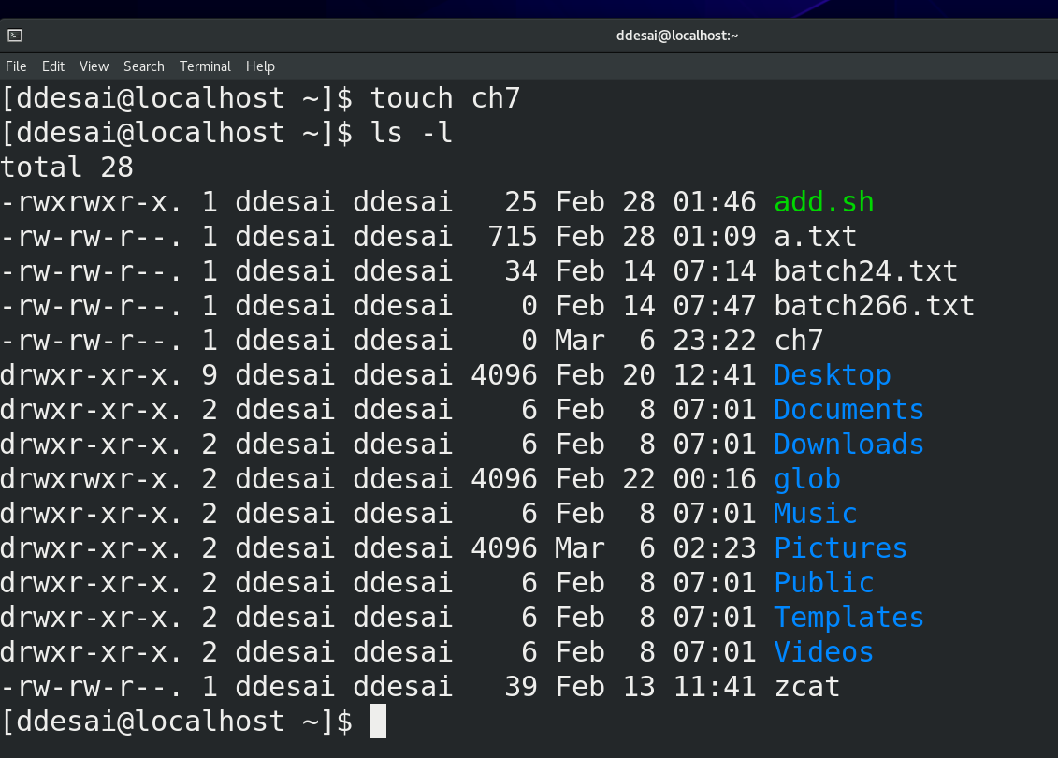
  + We are going to use 1st 2nd and 3rd colume
  + 1st 🡪
    - If start with ‘-’ then it is file
    - If start with ‘d’ then it is directary
    - If start with ‘l’ then it is softlink
    - The first 3 character(2nd,3rd,4th) it shows permition of user honor[read and write]
    - The next 3 character(5th,6th,7th) it shows permition of user honor[read and write]
    - Other user have just read fuction
    - 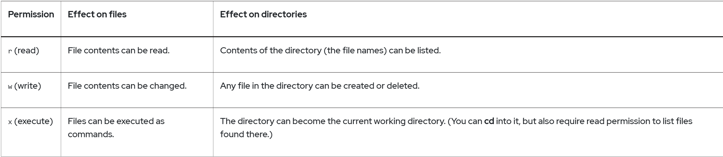
    - Write permition in directory then the user can add or remove files
    - We can go when in certen diectary(cd) with user getting permition[-xr]
  + 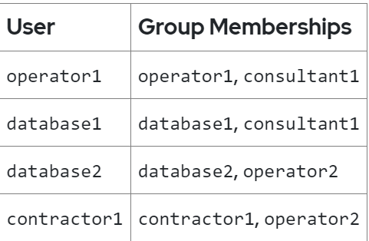
    - Here we have 4 user
    - 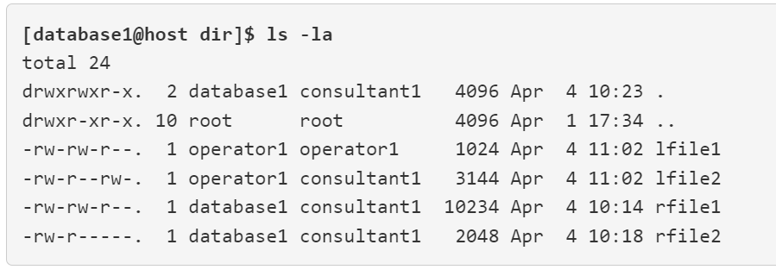
      * And here we have given files
      * For ‘lfile1’ ‘operator1’ have read and write || but ‘database1’ have read only permition.
    - 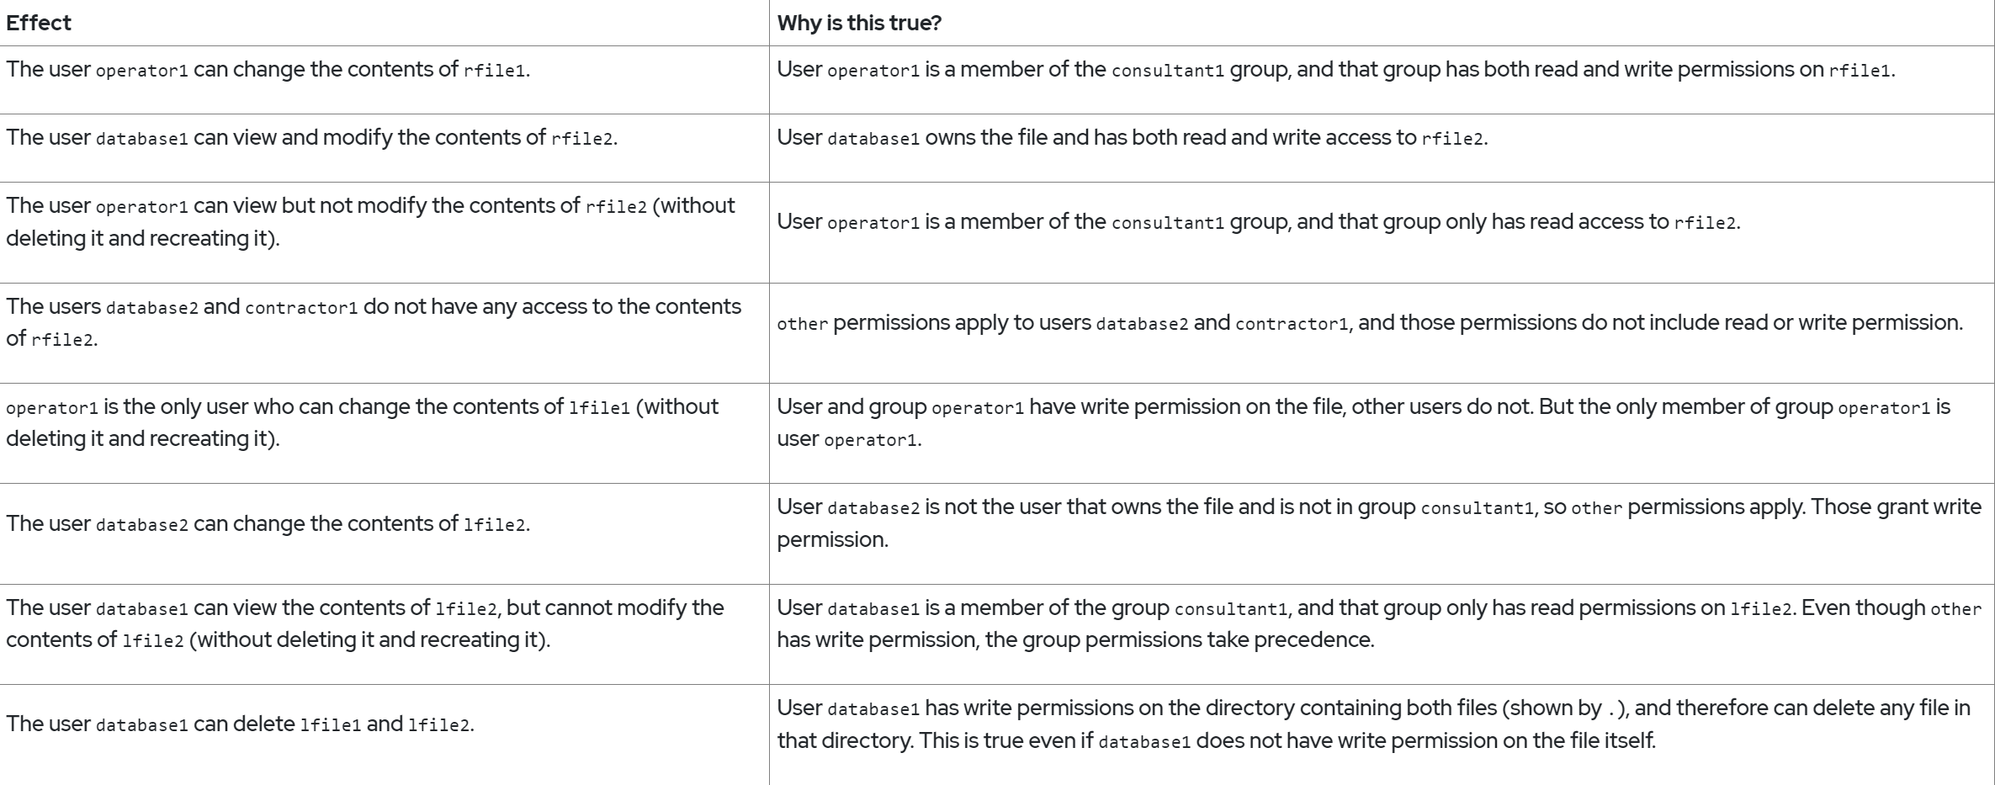
  + 2nd 🡪
  + 3rd 🡪group honor

**Topic:-**

**Add new permition**

* ‘+’ to add permition
  + Command:- Chmode o+w ch-7 (giving write permition to groupowner)
* ‘-’ to remove permition
  + Command:- Chmode g-w ch-7 (remove read permition to groupowner)
* Remove Read and Write
  + Command:- Chmode o-wr ch-7 (remove read and write permition to groupowner)
* Give Write permition in group and remove write permition from other users
  + Command:- chmode g+w,o-w ch-7
* Write permition without using ‘+,-‘
  + Command:- chmode 664 cg-7
    - Here r-4 w-2 x-1
      * 6🡪4 ,6🡪9 ,4🡪0
* You can use ‘-r’ for recersive
* We can use ‘=’ for specific permition (u=rx [gving permition to userowner to read and exacute])
* 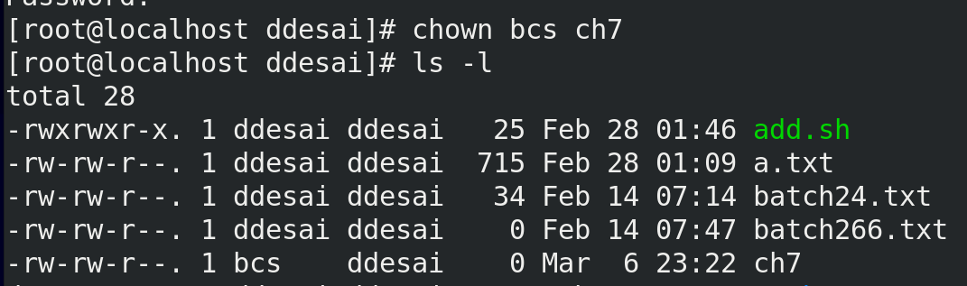
  + change userowner
* 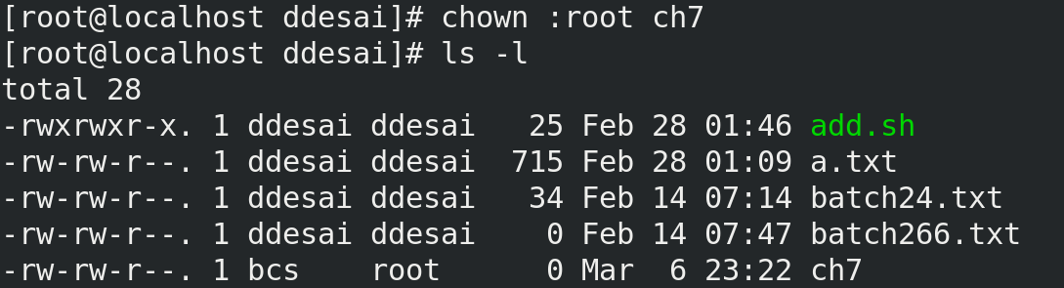
  + Change groupowner
* 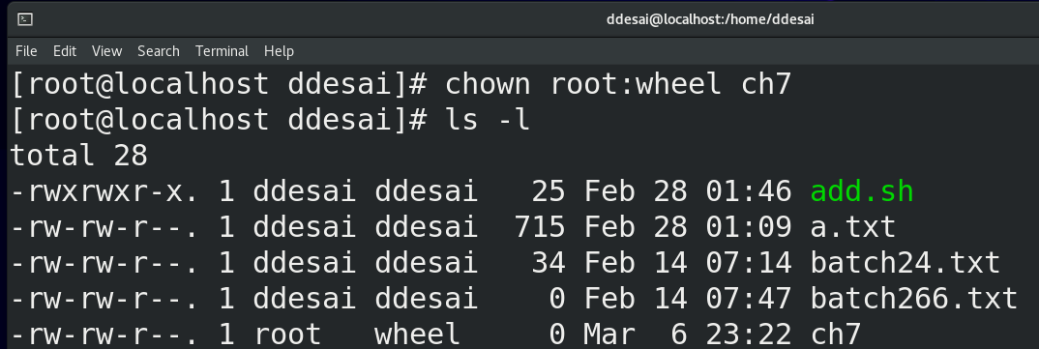
  + Change userowner and groupowner at the same time
* 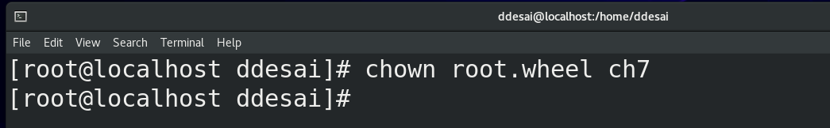
  + You can use . in place of ‘:’ but some username have ‘.’ So it is racomanded to use ‘:’
* There are 3 spesial permition
  + (comands are exacutable files)
  + /usr/bin/passwd
    - 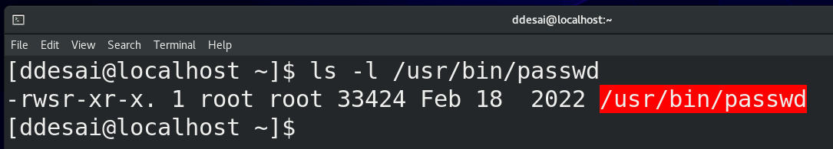
* Here special permition is given using ‘suid’ (the system will think that honor is running the program)
  + Chmod u+s filename(system will think this is run my root)
  + Chmode 4777 filename [this is 4 digit user ‘4’ spacifys ‘suid’(special permition) permition]
  + Chmod g+s filename(here group have special permition)
  + 777 (any one can do any thing to directory or file)
  + 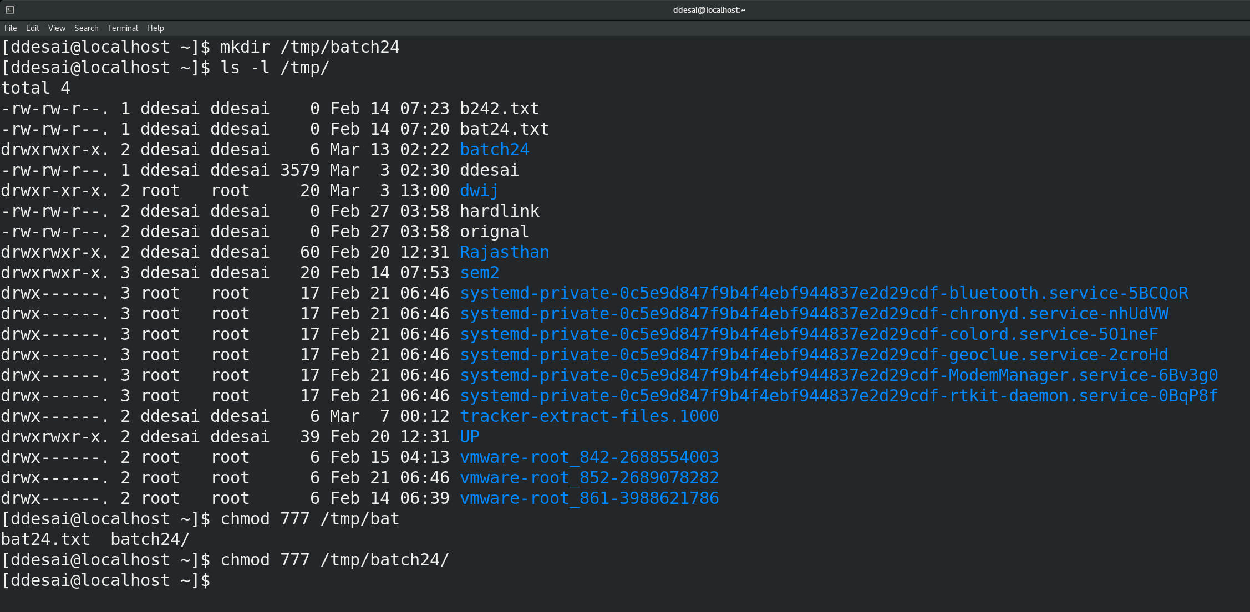
  + 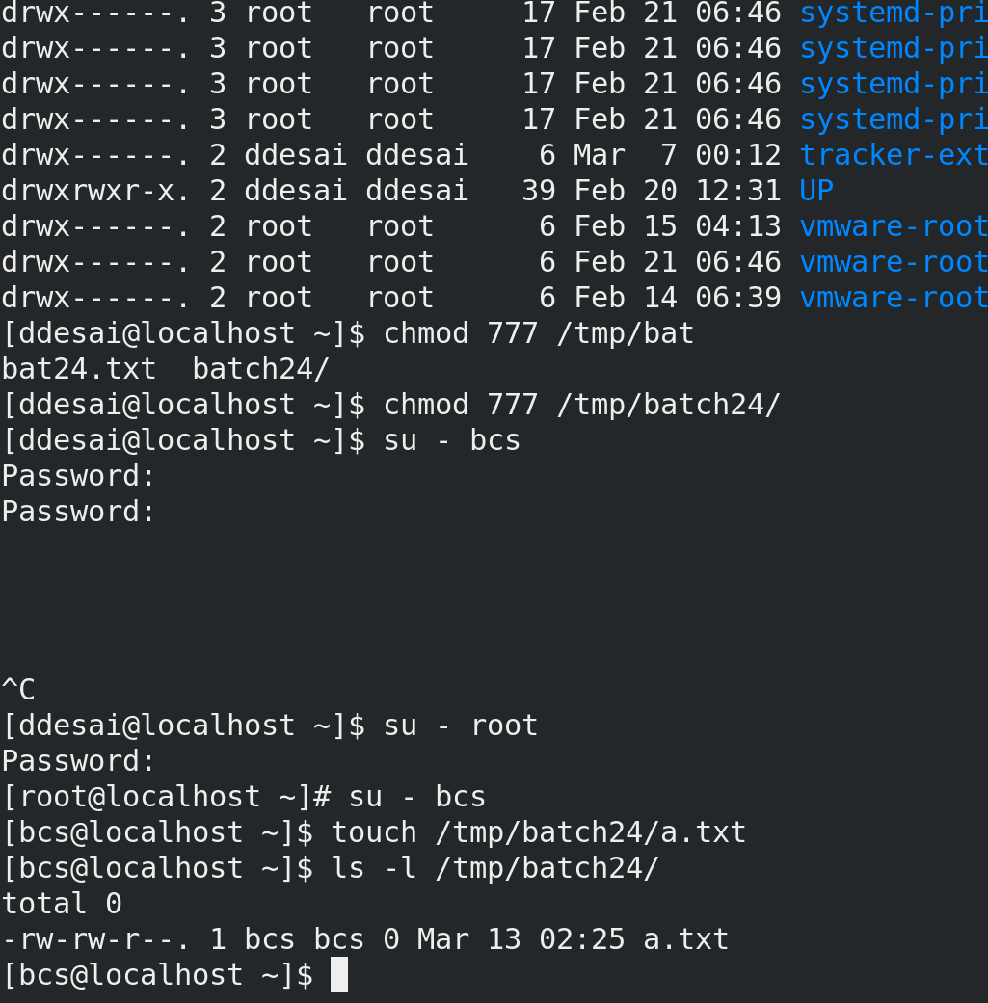
  + 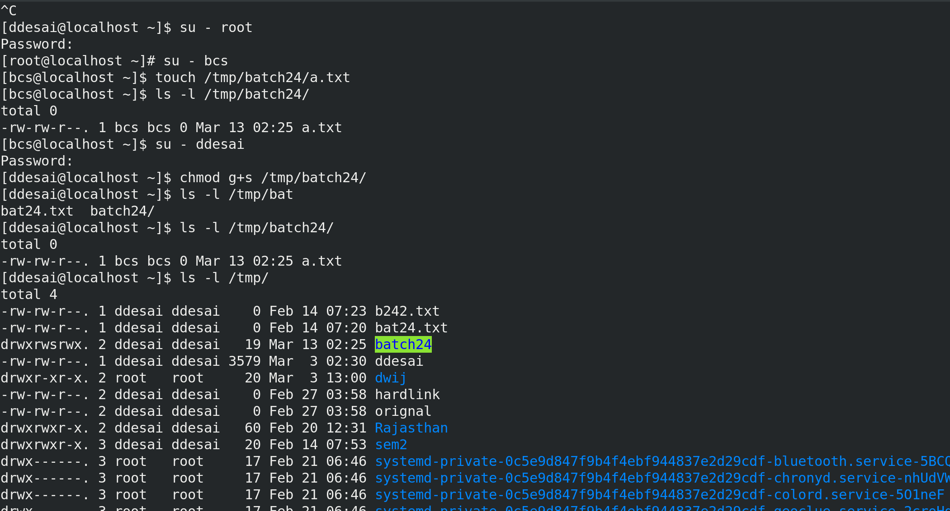
  + 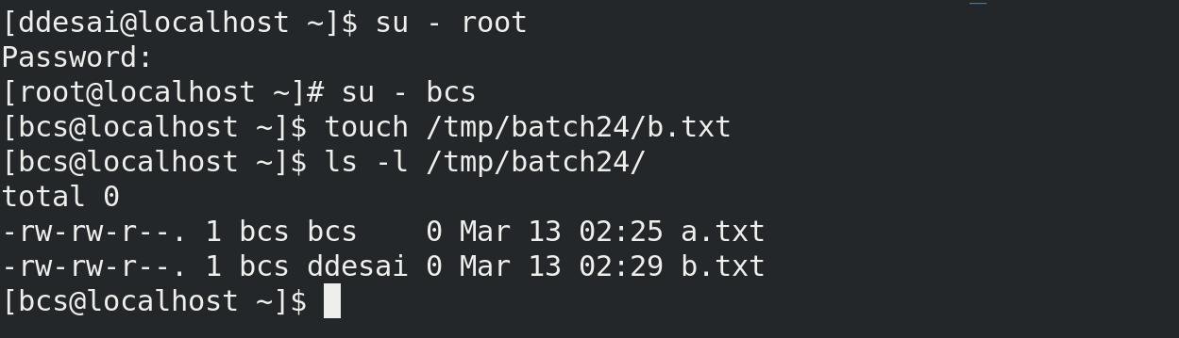
    - Here group honor is same as the group honor of directory
* Last permition(permition on other user)
  + (Any one can add but only I can delete my file)
  + Chmod 1777 /tmp/sticky
  + If t is at the end end only user can delet the file