***Ch-8***

*The protocol is called ‘ssh’*

*And the tool is called ‘openssh’*

* *The task of system addmistrater* 
  + *To install all the program and software in all the system at once(it is remote accsece to system)*
  + *If main user is in ‘workstation’ 🡪 so he can change setting in ‘server a’*
* *In serverb*
  + *Ifconfig*
  + 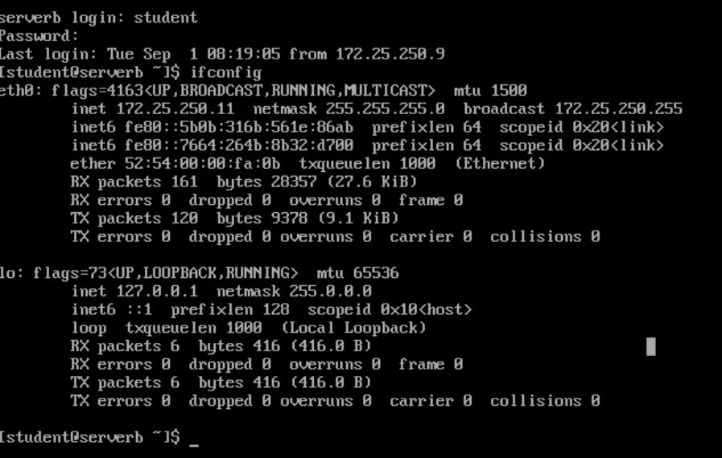
  + 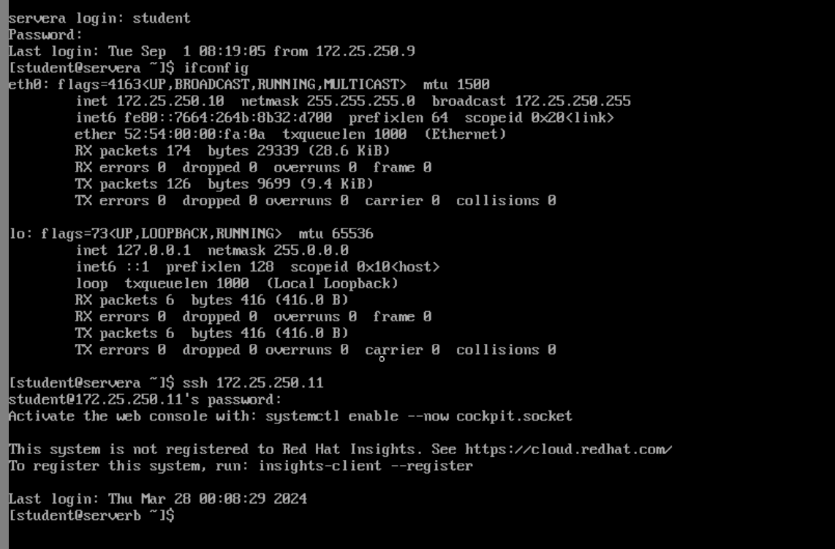

*This is in server in A*

* 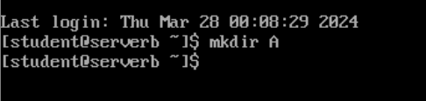
  + *This is in server*
    - 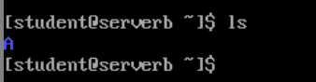
* 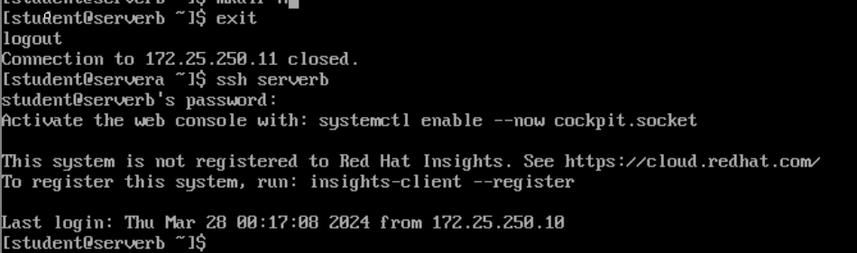
* *I want ot login from servera(student)🡪serverb(root)*
  + 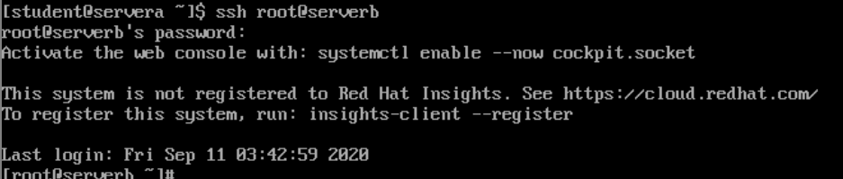
  + *This is the root user of serverb not root user of servera( and ssh root@172.25.250.11)*
    - *Is you are not saying what user then,you will get same user as in servera*
* 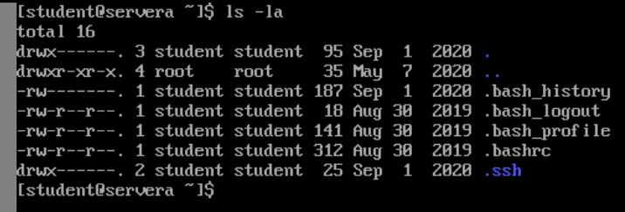
  + *Here .ssh is hiden directory*
  + 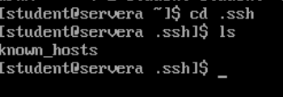
  + **
    - *It’s the key given by serverb[in known host]*
  + 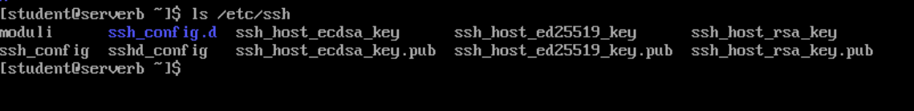
    - *Now in serverb*
    - *We can see ssh_host_ecdsa_key.pub*
    - 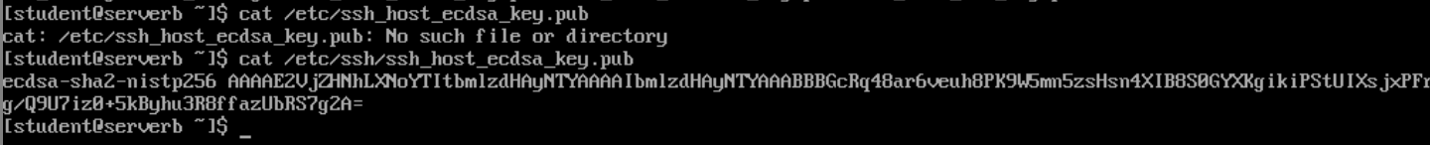
    - *You will find*
    - 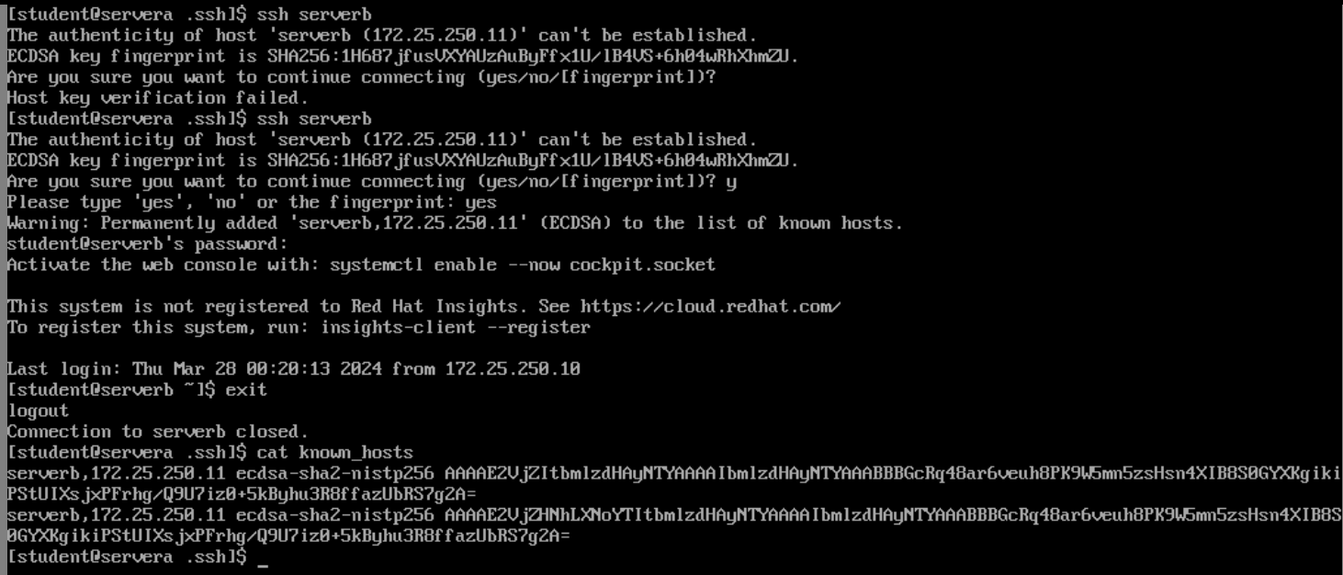
    - 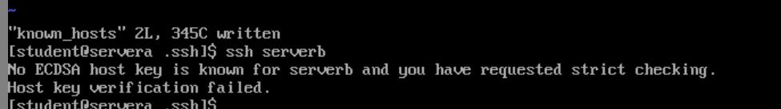
* *Aim :- To sign in without using password (only to student user of server B)*
* *To make privet key for server a*
  + 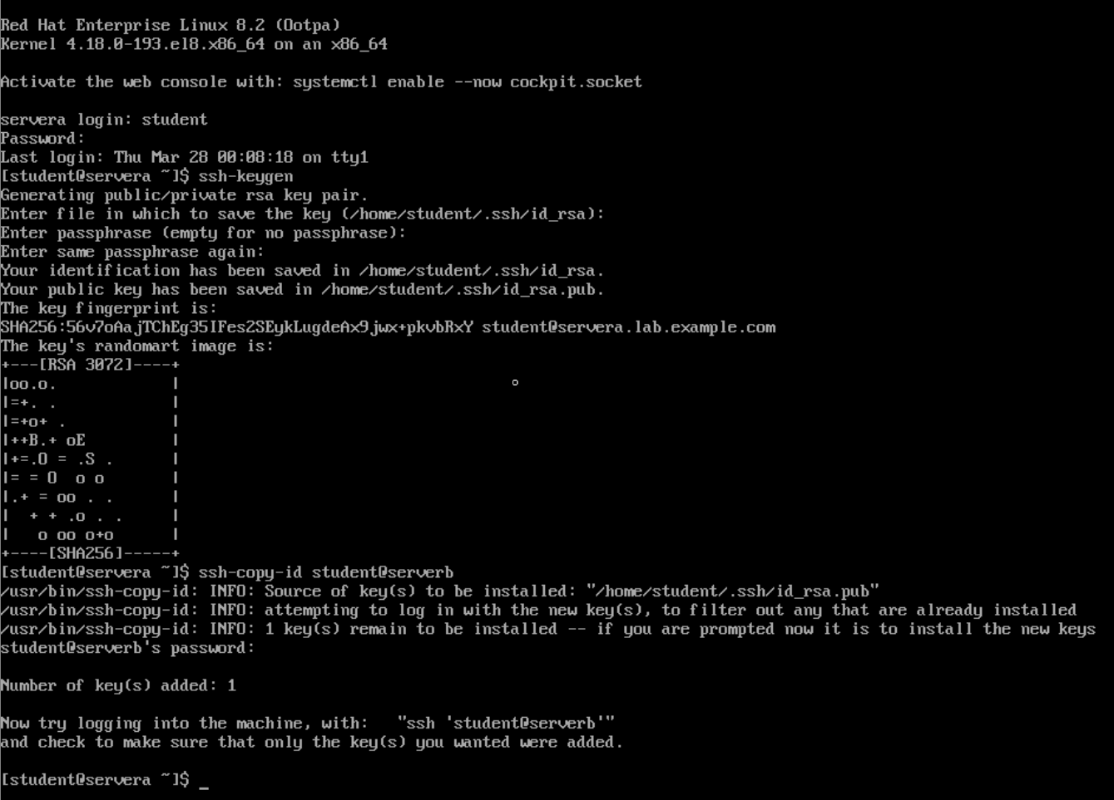
  + 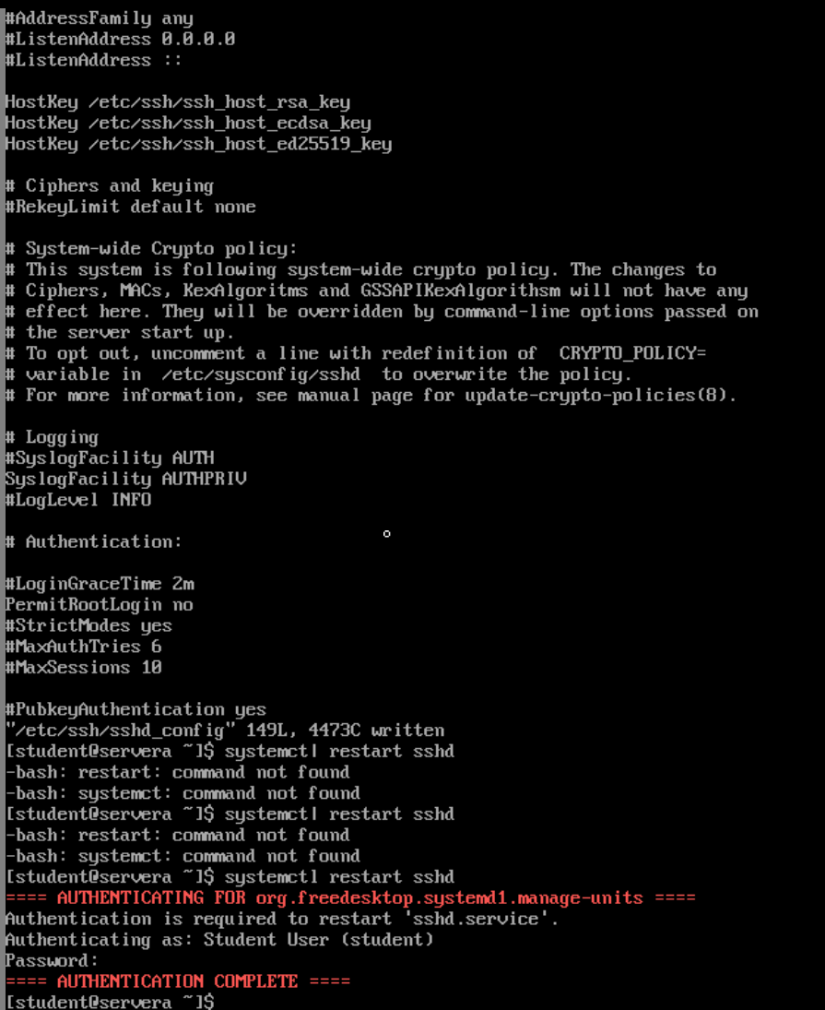
  + *Now in serverb*
  + 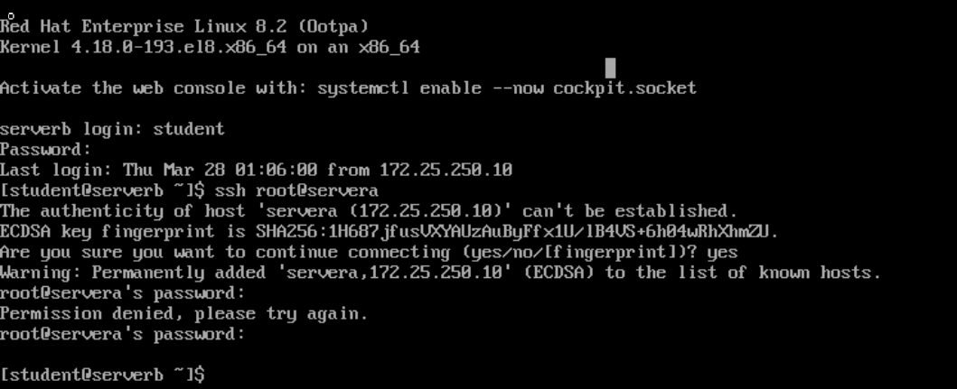
  + *(now any user in world can not login in servera root)*