**Ganpat University**

**Faculty of Engineering & Technology**

**Computer Science & Engineering**

**2CSE205: Computer Organization**

***Name:- Dwij Vatsal Desai***

***Sem:- 2***

***Sub: - CO***

***Enrollment No.:- 23162121027***

***Prac:- 5***

***Date:- 10/4/2024***

|  |
| --- |
| **PRACTICAL - 5** |

**AIM:** To study and design Wallace Tree Adder.

**THEORY:**

There are many cases where it is desired to add more than two numbers together. The  straightforward way of adding together m numbers (all n bits wide) is to add the first two, then add that sum to the next using cascading full adders.

The Wallace tree has three steps:

1. Multiply (that is – AND) each bit of one of the arguments, by each bit of the other, yielding n2results. Depending on position of the multiplied bits, the wires carry different weights, for example wire of bit carrying result of a2b3 is 32.

2. Reduce the number of partial products to two by layers of full and half adders.

3. Group the wires in two numbers, and add them with a conventional adder.

The second phase works as follows. As long as there are three or more wires with the  same weight add a following layer:

∙ Take any three wires with the same weights and input them into a full adder. The  result will be an output wire of the same weight and an output wire with a higher  weight for each three input wires.

∙ If there are two wires of the same weight left, input them into a half adder.

∙ If there is just one wire left, connect it to the next layer.

This requires a total of m − 1 additions, for a total gate delay of O(m lg n) (assuming look  ahead carry adders). Instead, a tree of adders can be formed, taking only O(lg m · lg n) gate delays.

A Wallace tree adder adds together n bits to produce a sum of log2n bits.

**Case 1:** Wallace tree adder to add seven bits (W7) is illustrated below: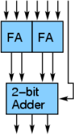

2CSE205: Computer Organization

**Case 2:** Wallace tree adder to add  three 4-bit numbers is illustrated  below:

**Case 3:** Wallace tree adder to add five 4-bit numbers  is illustrated below: 

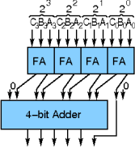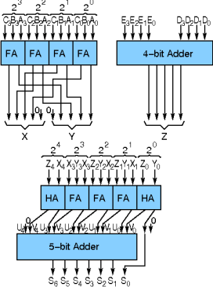**Components:**

1. Half Adder

2. Full Adder

3. 4-bit adder

**Result:** show steps for each case.

**LABWORK:** add extra pages

1. Addition of seven bits

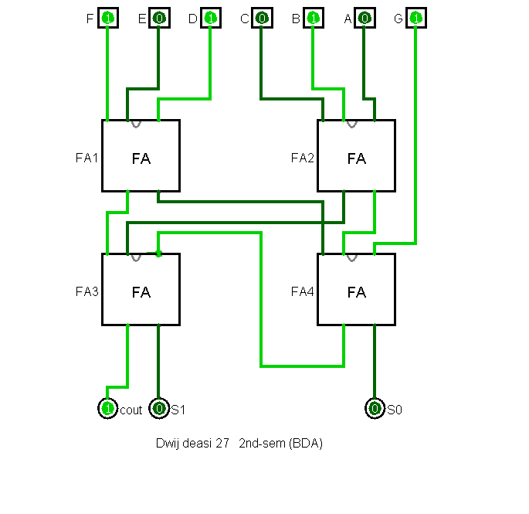

1. Addition of three 4-bit numbers

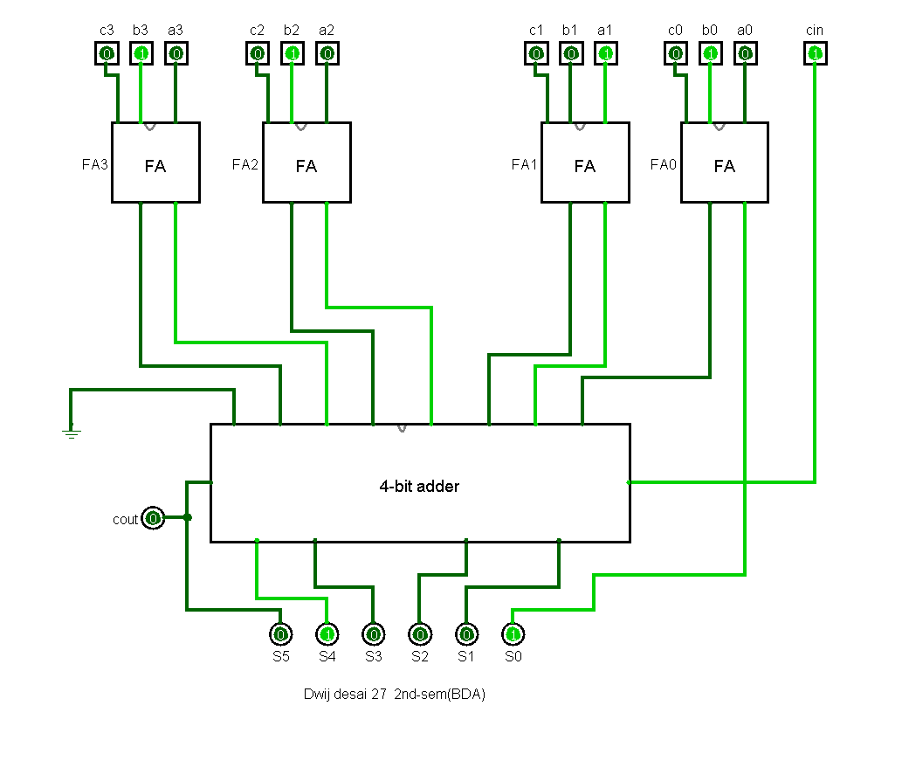

1. Addition of five 4-bit numbers

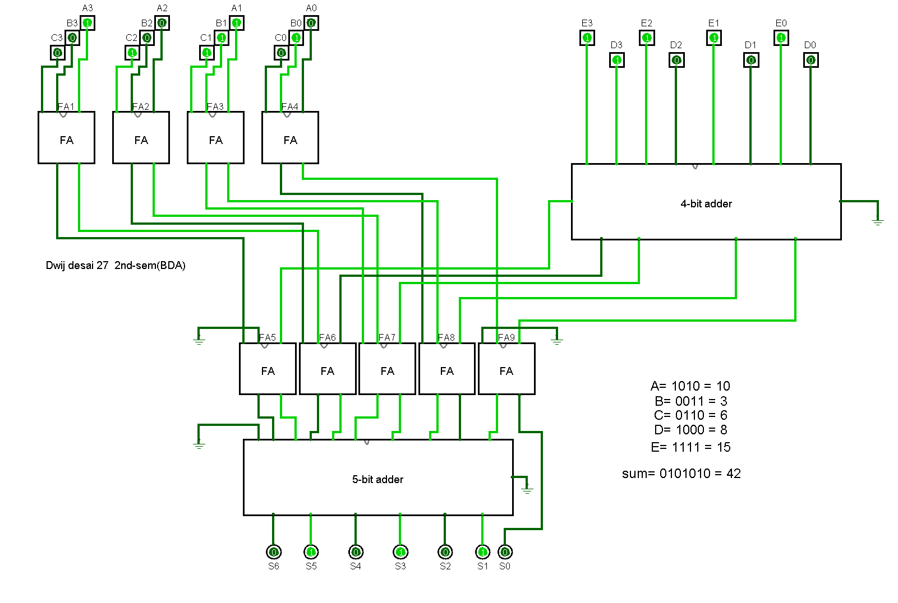

**CONCLUSION:**

In conclusion, Wallace tree adders are a strong contender for digital circuits where speed is paramount. Their parallel processing and efficient reduction techniques make them ideal for high-performance applications like signal processing and modern CPUs. However, for simpler tasks or situations where space and power are limited, simpler adder designs might be more suitable. Consider a scenario where a small, battery-powered device needs basic arithmetic capabilities. In this case, a Wallace tree adder's complexity and footprint might be overkill. A simpler adder, while slower, could provide adequate performance while conserving valuable space and power resources.