PRACTICAL - 2
Institute of Computer And Technology
B.Tech – CSE(BDA)
Name:- Dwij Vatsal Desai
Sem:- 2 Sub: - CO
Enrollment No.:- 23162121027
Prac:- 2 Date:- 20/2/2024

AIM: To design Ripple Carry Adder, incrementer and decrementer.
THEORY:
A binary adder is a combinational circuit that performs the arithmetic operations of addition and subtraction with binary numbers. We will develop this circuit by means of a hierarchical design. The half adder design is carried out first, from which we develop the full adder. Connecting n full adders in cascade produces a binary adder for two n-bit numbers.
Full adder reduces circuit complexity. It can be used to construct a ripple carry counter to add an n-bit number. Thus it is used in the ALU also. It is used in Processor chip like Snapdragon, Exynous or Intel pentium for CPU part. Which consists of ALU (Arithmetic Block unit). This Block is used to make operations like Add, subtract, Multiply etc. A full adder adds binary numbers and accounts for values carried in as well as out. A one-bit full adder adds three one-bit numbers, often written as A, B, and Cin; A and B are the operands, and Cin is a bit carried in from the previous less significant stage. The full adder is usually a component in a cascade of adders, which add 8, 16, 32, etc. bit binary numbers.
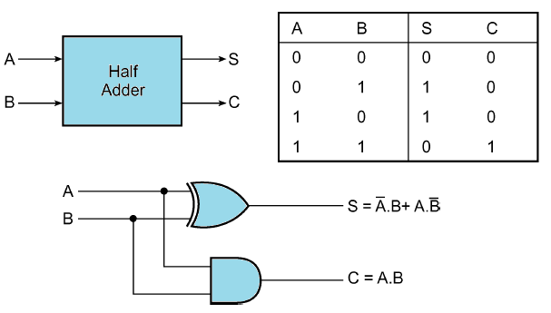
Half Adder: Half adder is a combinational logic circuit with two inputs and two outputs. The half adder circuit is designed to add two single bit binary number A and B. It is the basic building block for addition of two single bit numbers. This circuit has two outputs carry and sum.
Full Adder: Full adder is developed to overcome the drawback of Half Adder circuit. It can add two one-bit numbers A and B, and carry Cin. The full adder is a three input and two output combinational circuit.
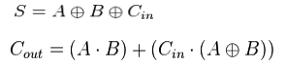
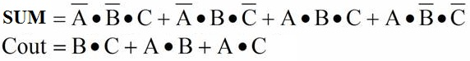

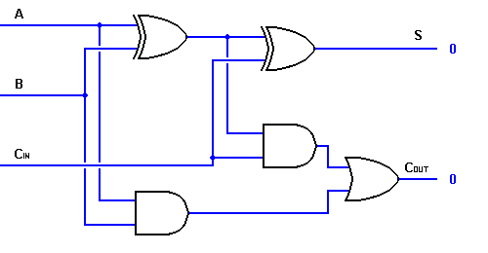
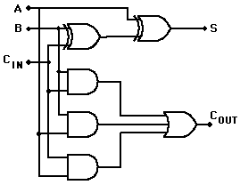

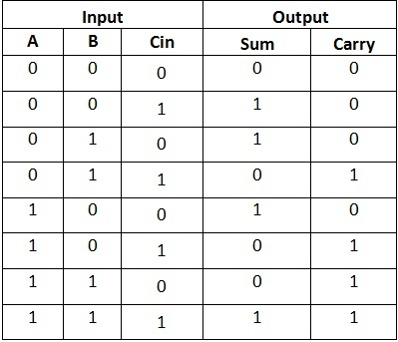

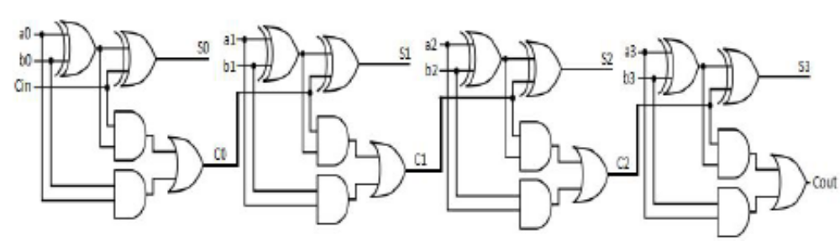
Ripple carry adder: A ripple carry adder is a logic circuit in which the carry-out of each full adder is the carry in of the succeeding next most significant full adder. It is called a ripple carry adder because each carry bit gets rippled into the next stage.
Binary Incrementer: The binary incrementer increases the value stored in a register by ‘1’. For this, it simply adds ‘1’ to the existing value stored in a register. It is made by cascading ‘n’ half adders/full adders for ‘n’ number of bits i.e. the storage capacity of the register to be incremented. Hence, a 4-bit binary incrementer requires 4 cascaded half adder/full adder circuits.
Binary decrementer: The binary decrementer decreases the value stored in a register by ‘1’. For this, we can simply add ‘1’ to the each bit of the existing value stored in a register. This is basically the concept of two's complement used for subtraction of '1' from given data. It is made by cascading ‘n’ full adders for ‘n’ number of bits i.e. the storage capacity of the register to be decremented. Hence, a 4-bit binary decrementer requires 4 cascaded full adder circuits. As stated above we add '1111' to 4 bit data in order to subtract '1' from it.
LABWORK: add extra pages
- 1 bit full adder (both architecture)
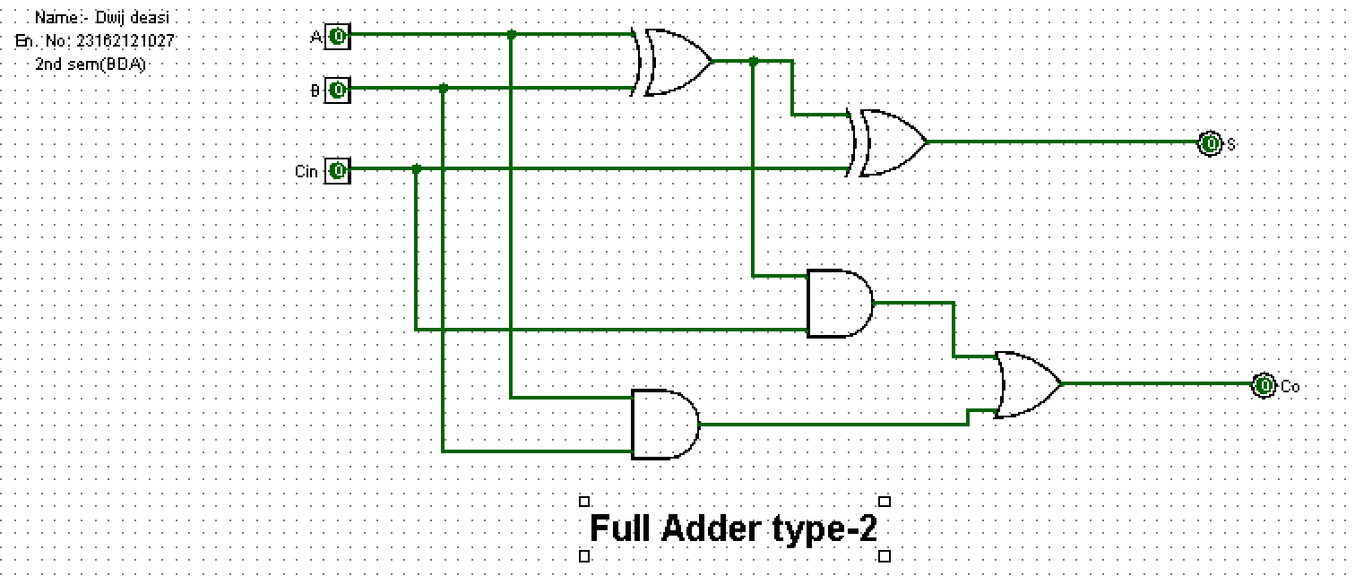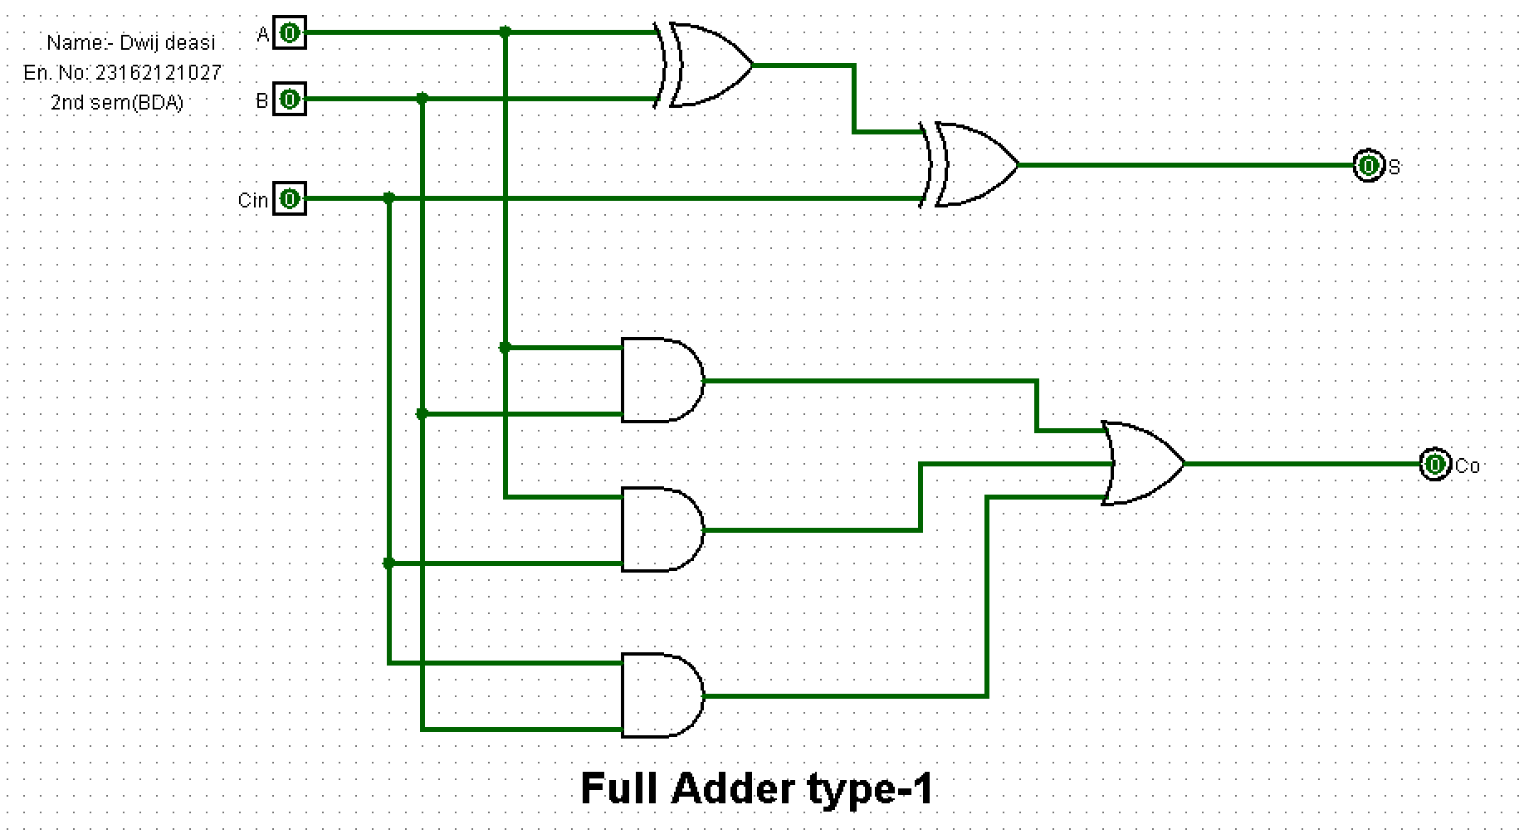

- Ripple carry full adder

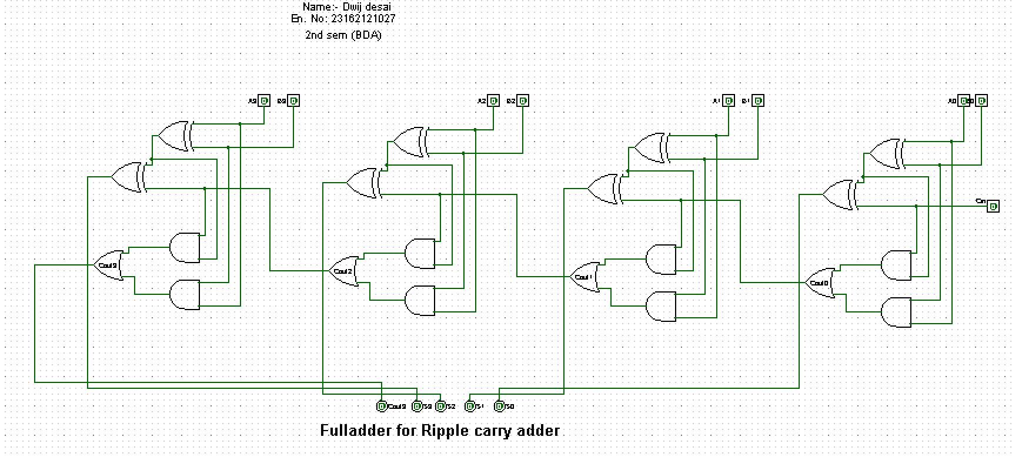
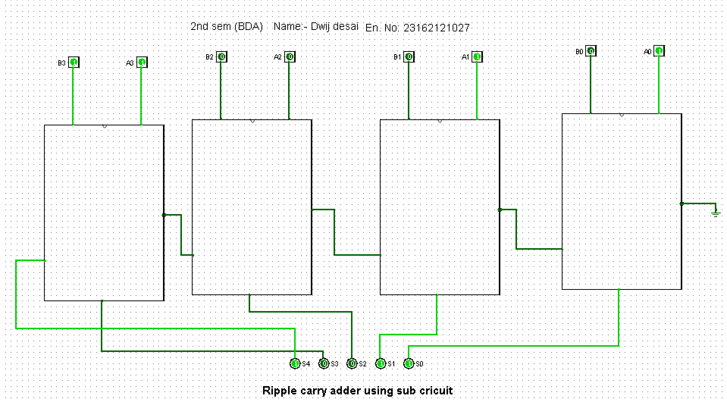

- Incrementer

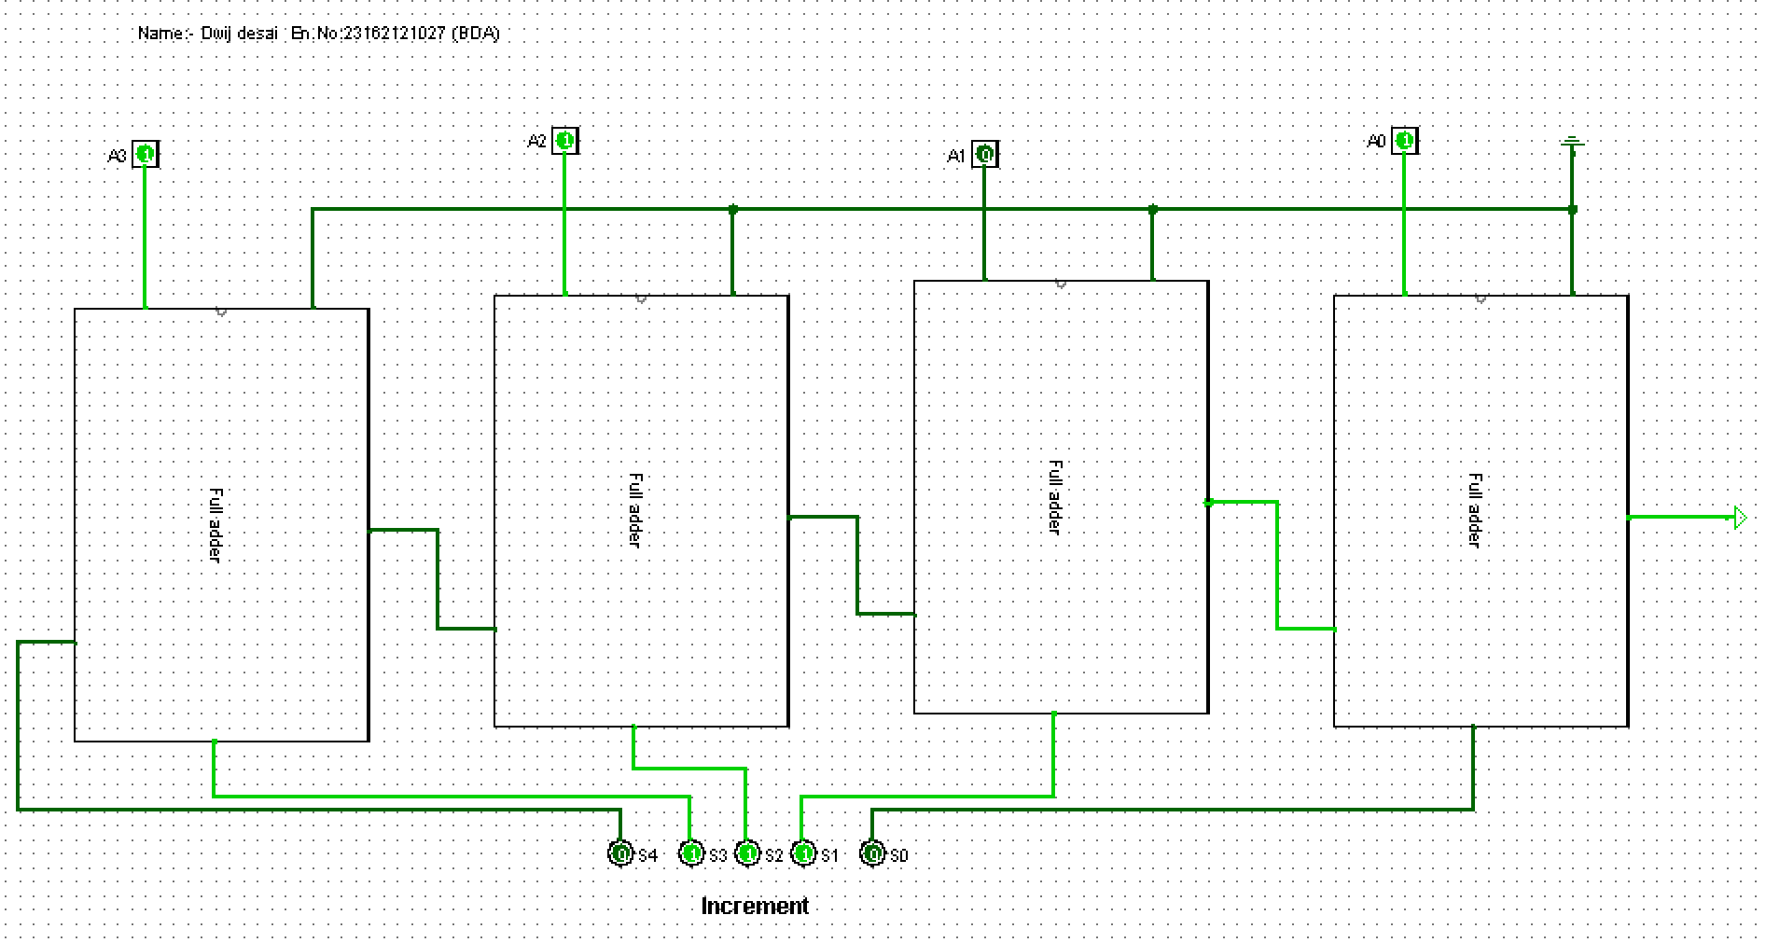

- Decrementer

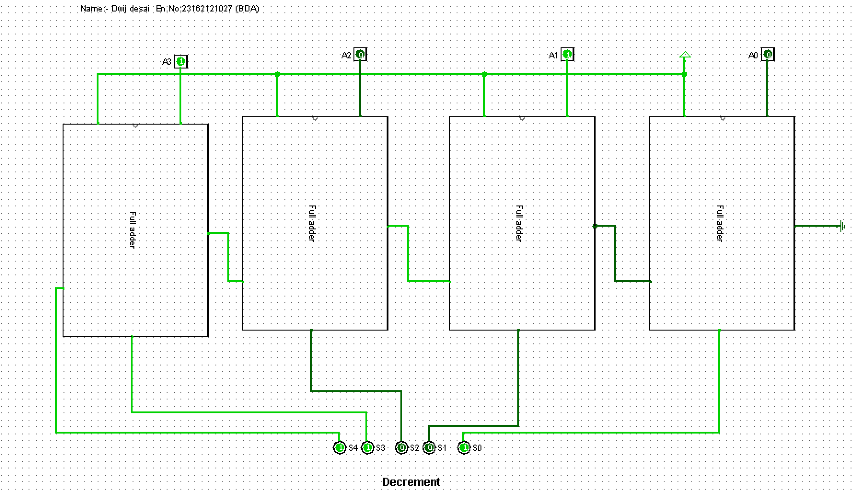

CONCLUSION:
- full adders are essential components in digital arithmetic operations, enabling the addition, incrementation, and decrementation of binary numbers in various applications.
- Their versatility and simplicity make them a cornerstone in digital circuit design.

