PRACTICAL - 4
Institute of Computer And Technology
B.Tech – CSE(BDA)

Name:- Dwij Vatsal Desai
Sem:- 2
Sub: - CO
Enrollment No.:- 23162121027
Prac:- 4
Date:- 5/3/2024

AIM: To design Carry look-ahead adder.
THEORY:
The ripple-carry adder, its limiting factor is the time it takes to propagate the carry. The carry look-ahead adder solves this problem by calculating the carry signals in advance, based on the input signals. The result is a reduced carry propagation time.
To be able to understand how the carry look-ahead adder works, we have to manipulate the Boolean expression dealing with the full adder. The Propagate P and generate G in a full-adder, is given as:
P_{i}= a_{i}⊕b_{i} Carry propagate
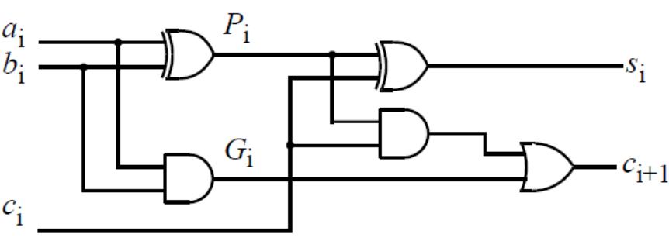
G_{i}= a_{i} b_{i} Carry generate

The new expressions for the output sum and the carryout are given by:
S_{i}= P_{i}⊕C_{i-1}
C_{i+1}= G_{i}+ P_{i}C_{i}
These equations show that a carry signal will be generated in two cases:
1) if both bits a_{i} and b_{i} are 1
2) if either a_{i} or b_{i} is 1 and the carry-in C_{i} is 1.
Notice that both propagate and generate signals depend only on the input bits and thus will be valid after two and one gate delay respectively.
If one uses the above expression to calculate the carry signals, one does not need to wait for the carry to ripple through all the previous stages to find its proper value. Let’s apply this to a 4-bit adder to make it clear.
Putting i= 0, 1, 2, 3;
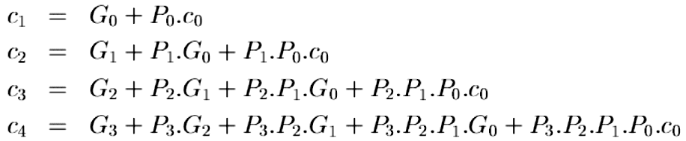

These expressions show that C₂, C₃ and C₄ do not depend on its previous carry-in. Therefore C₄ does not need to wait for C₃ to propagate. As soon as C₀ is computed, C₄ can reach steady state. The same is also true for C₂ and C₃.
The disadvantage of CLA is that the carry logic block gets very complicated for more than 4-bits. For that reason, CLAs are usually implemented as 4-bit modules and are used in a hierarchical structure to realize adders that have multiples of 4-bits.
_
-bits.
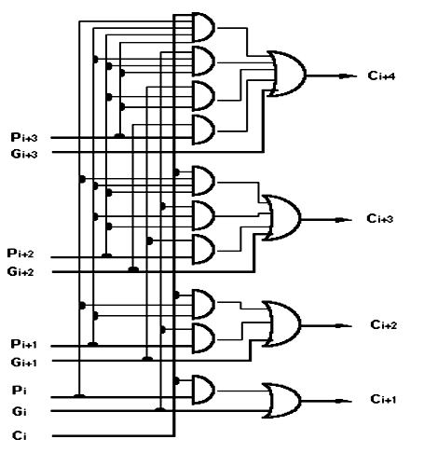
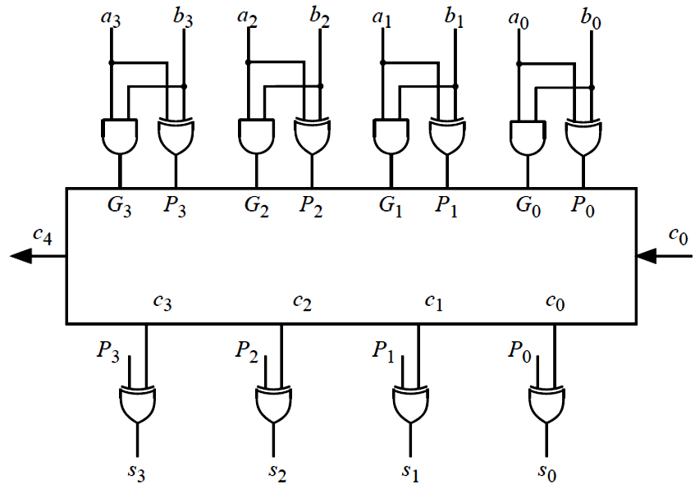
Look ahead carry generator
Carry Look Ahead adder

LABWORK: add extra pages
- Look ahead carry generator

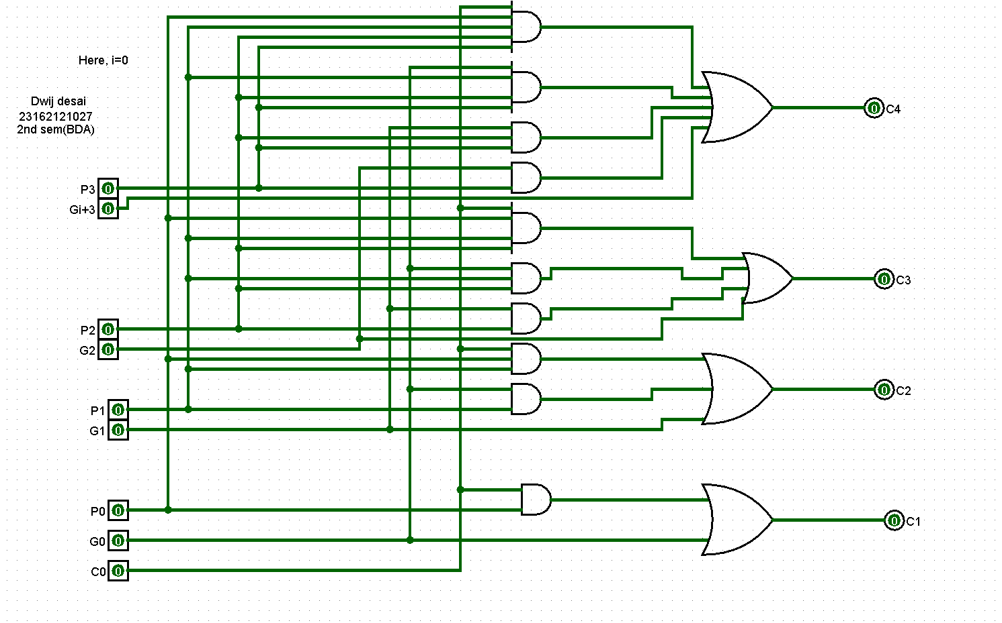

- Carry Look Ahead adder

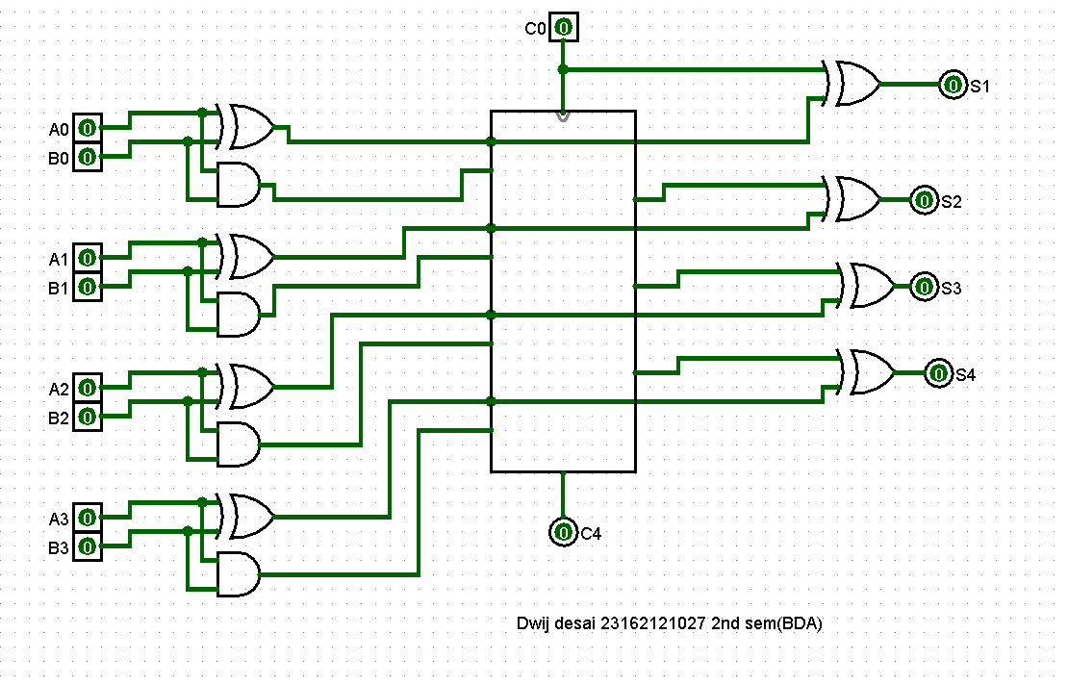
CONCLUSION:
The carry look-ahead adder improves addition performance by precomputing carry signals, reducing propagation delay. However, its complexity grows significantly for larger bit widths, often implemented in 4-bit modules for efficiency.

