**Ganpat University**

**Faculty of Engineering & Technology**

**Computer Science & Engineering**

***Name:- Dwij Vatsal Desai***

***Sem:- 2***

***Sub: - ESFP-II***

***Enrollment No.:- 23162121027***

***Prac:- 10***

***Date:- 16/4/2024***

**Practical 10**

***Definition:***

1. For the solving purpose of given topic practical, you need to create minimum one

classes, rest as per your requirement.

2. Declare minimum three function with same name and different signature as per the

relevant practical topic gathered information. If you want more function, you can take

it as per your requirement.

3. Declare minimum four operator (unary or binary) overloading function in program

and implement it as per your numeric value calculation.

4. Minimum 1 constructor method should be available in the program, rest as per your

requirement.

5. You must use access specifier for data member and member function declaration in

program.

6. Wherever is required to use character data member in class, instead of that use

compulsorily string data member.

7. Read 5 random name from user, using class object1, and object2, and then you

have to find and display which name is greater in the comparison of both the objects

field. Perform this task by the use of operator overloading concept.

8. Read minimum 4 information from user as two integer value and two string value by

object3, and object4 of given class, and then find and display addition of two object

integer value and concatenation of two object string value.

9. Take minimum 5 data from the user and display according to the choice of user

category wise. (Minimum six different options should be there for displaying

information, and if you want more as per program requirement you can add more

choices).

10.Use all possibility filter method from stored record information:

11.After all functionality execution, you need to call the destructor function.

***Code:-***

#include <iostream>

#include <string>

#include <cstring>

using **namespace** std;

**class** overload

{

**private:**

    string name1[5];

**public:**

    overload()

    {}

**void** getname(overload **&**sender1)

    {

        for (**int** i = 0 ; i<5 ; i++)

        {

            cout << i+1 << ". " ;

            cin>>sender1.name1[i];

        }

    }

**void** DisplayName(overload **&**sender1)

    {

        for (**int** i = 0 ; i<5 ; i++)

        {

            cout << i+1 << ". " ;

            cout<<sender1.name1[i]<<endl;

        }

    }

};

**class** prac10_tasks

{

**public:**

**int** a, b = 0;

    string x, c[5], d[5];

**bool** y[5],z[5];

    prac10_tasks()

    {}

**void** operator + (prac10_tasks **&**obj2)

    {

        cout << "Enter 2 numbers: ";

        cin >> a >> obj2.a;

        task(a, obj2.a);

    }

**void** operator - (prac10_tasks **&**obj2)

    {

        cout << "Enter 2 strings: ";

        cin >> x >> obj2.x;

        task(x, obj2.x);

    }

**void** operator > (prac10_tasks **&**obj)

    {

        for (**int** i = 0; i < 5; i++)

        {

            y[i] = c[i] > obj.c[i];

        }

    }

**void** operator < (prac10_tasks **&**obj)

    {

        for (**int** i = 0; i < 5; i++)

        {

            z[i] = c[i] < obj.c[i];

        }

    }

**void** task (**int** **&**a, **int** **&**b)

    {

        cout << endl << "Sum of 2 number = " << (a+b);

    }

**void** task (string **&**a, string **&**b)

    {

        cout << endl << "Concatenation of 2 strings = " << a << " " << b;

    }

**void** task (prac10_tasks **&**obj3, prac10_tasks **&**obj4)

    {

        obj3 > obj4;

        obj3 < obj4;

        for (**int** i = 0; i < 5 ; i++)

        {

            if (y[i])

            {

                cout << endl << obj3.c[i] << " is greater than " << obj4.c[i];

            }

            else if (z[i])

            {

                cout << endl << obj4.c[i] << " is greater than " << obj3.c[i];

            }

            else

            {

                cout << endl << obj3.c[i] << " and " << obj4.c[i] << ", both are equal";

            }

        }

    }

**void** getStrings(prac10_tasks **&**obj)

    {

        cout << "Enter 5 Strings:-";

        for (**int** i = 0; i < 5; i++)

        {

            cout << endl << i+1 << ") ";

            cin >> obj.c[i];

            obj.d[i] = obj.c[i];

        }

    }

**void** display(prac10_tasks **&**obj)

    {

        for (**int** i = 0; i < 5; i++)

        {

            cout << endl << i+1 << ") " << obj.c[i];

        }

    }

**void** revDisplay(prac10_tasks **&**obj)

    {

        for (**int** i = 0; i < 5; i++)

        {

            cout << endl << i+1 << ") " << obj.c[4-i];

        }

    }

**void** sortAscending(prac10_tasks **&**obj)

    {

        string dummy;

        for (**int** i = 0; i < 5; i++)

        {

            for (**int** j = 0; j < 4; j++)

            {

                if (obj.c[j] > obj.c[j + 1])

                {

                    dummy = obj.c[j + 1];

                    obj.c[j + 1] = obj.c[j];

                    obj.c[j] = dummy;

                }

            }

        }

    }

**void** search(prac10_tasks **&**obj)

    {

        string str;

        cout << endl << "Enter the string you want to find: ";

        cin >> str;

        for (**int** i = 0; i < 5; i++)

        {

            if (str == obj.d[i])

            {

                cout << endl << "M A T C H F O U N D";

                cout << endl << "The searched word " << str << " is present in the search array";

                return;

            }

        }

        cout << endl << "M A T C H N O T F O U N D";

        cout << endl << "The searched word " << str << " is present in the search array";

    }

};

**int** main()

{

    overload obj[2]; *//making object array(2 objects)*

    prac10_tasks obj1, obj2, obj3, obj4; *//3 and 4 is for string mangment*

**int** choice, exit = 1;

    while (exit != 0)

    {

        cout<<endl<<endl<<"<<< User INTERFACE >>>"<<endl<<endl;

        cout<<"[1] Input for 5 names in 2 groups"<<endl;

        cout<<"[2] Display the 5 names for the 2 groups"<<endl;

        cout<<"[3] Add 2 Numbers"<<endl;

        cout<<"[4] Add 2 Strings"<<endl;

        cout<<"[5] Compare 5 pairs of strings"<<endl;

        cout<<"[6] Display both Strings Arrays"<<endl;

        cout<<"[7] Search in String Array of object 3"<<endl;

        cout<<"[8] Search in String Array of object 4"<<endl;

        cout<<"[9] Display both Strings Arrays in Ascending Order"<<endl;

        cout<<"[10] Display both Strings Arrays in Descending Order"<<endl;

        cout<<"[0] Exit the program"<<endl<<endl;

        cout<<"Enter number here:  ";

        cin>>choice;

        cin.ignore();

        switch (choice)

        {

            case 1:

                cout<<endl<<"Enter any 5 values (Of object 1)"<<endl;

                obj[0].getname(obj[0]);

                cout<<endl<<"Enter any 5 values (Of object 2)"<<endl;

                obj[1].getname(obj[1]);

            break;

            case 2:

                cout<<"Enter the object wanted \n\t[1] for object 1 \n\t[2] for object 2 "<<endl;

                cin>>choice;

                cin.ignore();

                switch (choice)

                {

                    case 1:

                        cout<<endl<<"Displaying 5 values from object 1:"<<endl;

                        obj[0].DisplayName(obj[0]);

                    break;

                    case 2:

                        cout<<endl<<"Displaying 5 values from object 2:"<<endl;

                        obj[1].DisplayName(obj[1]);

                    break;

                    default:

                        cout<<"ERROR { Wrong value entered }";

                    break;

                }

            break;

            case 3:

                obj1 + obj2;

            break;

            case 4:

                obj1 - obj2;

            break;

            case 5:

                obj3.task(obj3, obj4);

            break;

            case 6:

                cout << endl << "String Array of object 3:";

                obj3.display(obj3);

                cout << endl;

                cout << endl << "String Array of object 4:";

                obj4.display(obj4);

            break;

            case 7:

                cout << "Search a string in String Array of Object 3 :-";

                obj3.search(obj3);

            break;

            case 8:

                cout << "Search a string in String Array of Object 4 :-";

                obj4.search(obj4);

            break;

            case 9:

                cout << endl << "String Array of object 3:";

                obj3.sortAscending(obj3);

                obj3.display(obj3);

                cout << endl;

                cout << endl << "String Array of object 4:";

                obj4.sortAscending(obj4);

                obj4.display(obj4);

            break;

            case 10:

                cout << endl << "String Array of object 3:";

                obj3.sortAscending(obj3);

                obj3.revDisplay(obj3);

                cout << endl;

                cout << endl << "String Array of object 4:";

                obj4.sortAscending(obj4);

                obj4.revDisplay(obj4);

            break;

            case 0:

                cout<<endl<<"Exiting Program...";

                exit = 0;

            break;

            default:

                cout<<"\tPlace enter right Numaric value";

            break;

        }

    }

    return 0;

}

***Output:-***

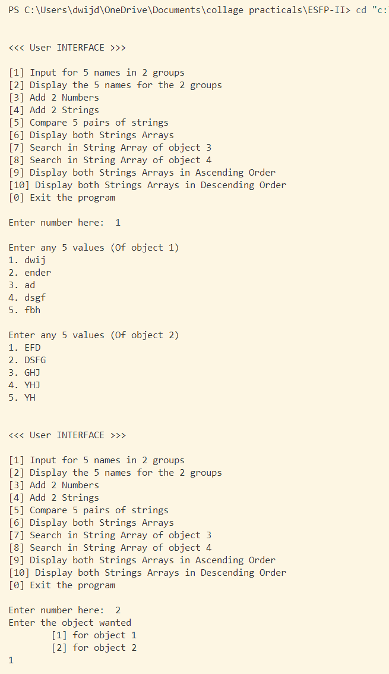

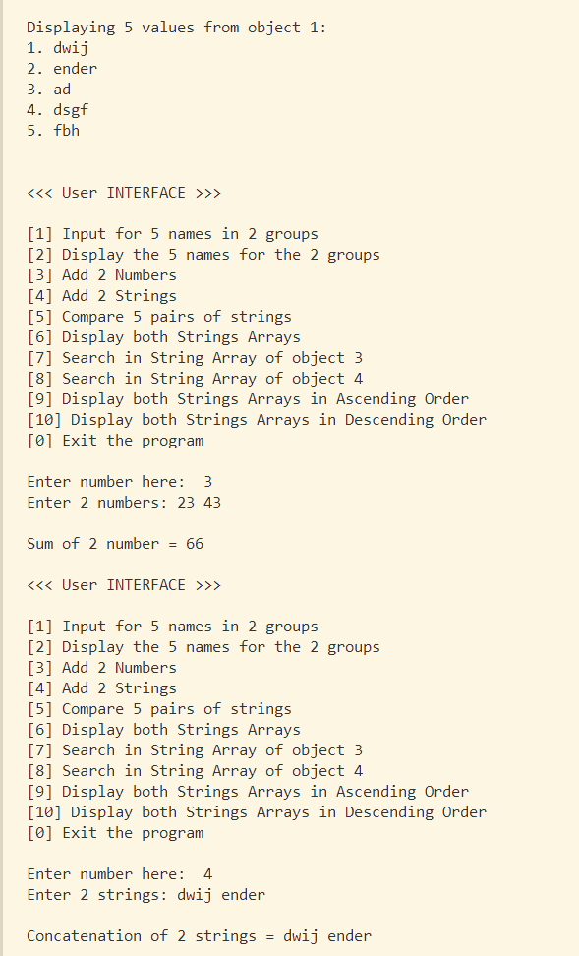

***Photo:-*** 