***Institute of Computer And Technology***

***B.Tech – CSE(BDA)***

***Name:- Dwij Vatsal Desai***

***Sem:- 2***

***Sub: - ESFP-II***

***Enrollment No.:- 23162121027***

***Prac:- 5***

***Date:- 12/2/2024***

**Q.1.** Calculate the fare for the passengers traveling in a bus. When a Passenger enters in the bus,

the conductor asks “What distance will you travel?” On knowing distance from the passenger (as

an approximate integer), the conductor mentions the fare to the passenger according to following

criteria.

Distance ( in KMS) Fare (Per KM)

0-20 Rs.1

21-40 Rs.2

41-60 Rs.3

61-80 Rs.4

81-100 Rs.5

101 and above Rs.6

[ Note: Perform this program using namespace].

**Code:-**

*#include* <iostream>

using namespace std;

namespace Bus_fare

{

    int distance = 0;

    int fare = 0;

    int data_input()

    {

        cout << "What distance will you travel?\n";

        cin >> distance;

*if* (distance >=0 && distance <= 20)

        {

            fare = distance * 1;

            cout << "\n" << "Your total fare is:" << "\t"<< fare;

        }

*else* *if* (distance >=21 && distance <= 40)

        {

            fare = distance * 2;

            cout << "\n" << "Your total fare is:" << "\t"<< fare;

        }

*else* *if* (distance >=41 && distance <= 60)

        {

            fare = distance * 3;

            cout << "\n" << "Your total fare is:" << "\t"<< fare;

        }

*else* *if* (distance >=61 && distance <= 80)

        {

            fare = distance * 4;

            cout << "\n" << "Your total fare is:" << "\t"<< fare;

        }

*else* *if* (distance >=81 && distance <= 100)

        {

            fare = distance * 5;

            cout << "\n" << "Your total fare is:" << "\t"<< fare;

        }

*else* *if* (distance >=101)

        {

            fare = distance * 6;

            cout << "\n" <<"Your total fare is:" << "\t"<< fare;

        }

    }

}; *// namespace Bus_fare;*

int main()

{

    Bus_fare :: data_input();

}

***Output-***

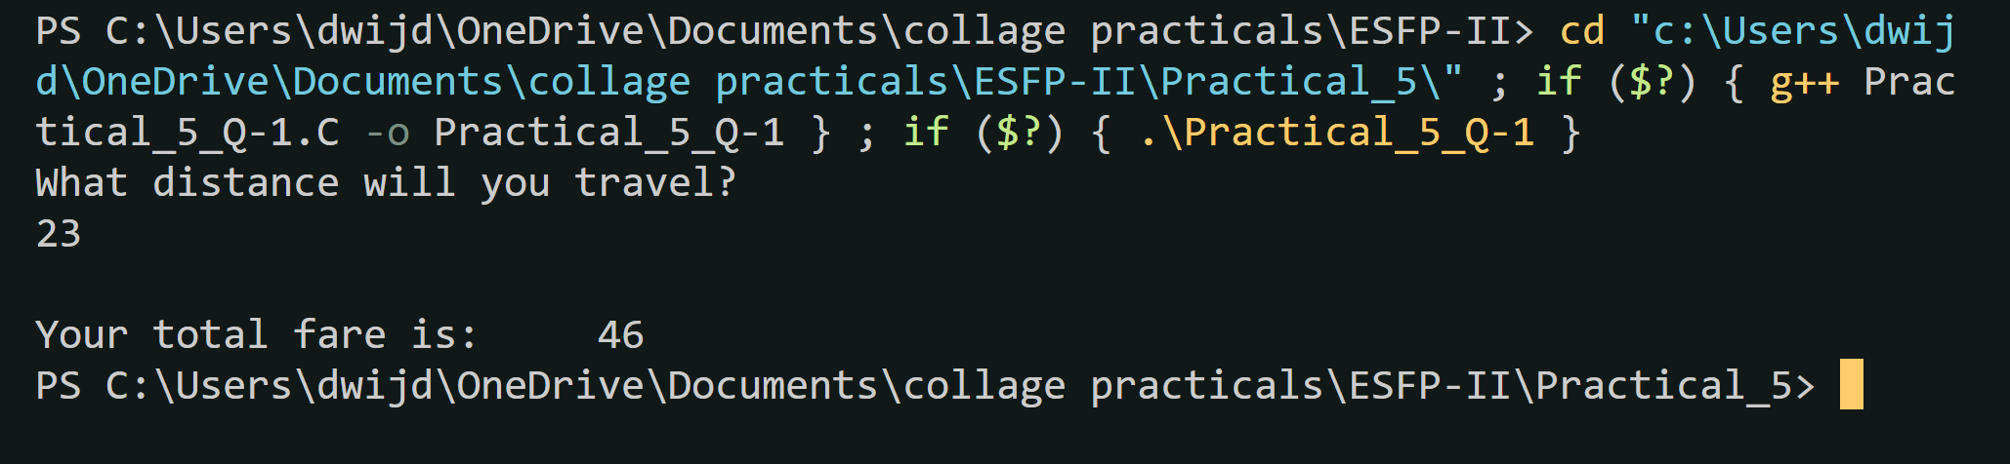

**Q.2.** Preform the following program using namespace.

1. Get a number from the user (upto 5 digit).

2. Check whether the number is palindrome or not.

3. Check whether the number is Armstrong number or not.

4. Display output for each operation performed with appropriate text.

**Code:-**

*#include* <iostream>

using namespace std;

namespace number

{

    int user_input = 0;

    int fare = 0;

    int n,digit,rev = 0;

    int originalNum, remainder, result = 0;

    int data_input()

    {

        cout << "Enter any 5 digit integer\n";

        cin >> user_input;

    }

    int palindrome()

    {

        data_input();

            n=user_input;

*do*

        {

            digit = user_input % 10;

            rev = (rev * 10)+ digit;

            user_input = user_input / 10;

        } *while*(user_input != 0);

        cout << "The reverse of the number is: " << rev << endl;

*if* (n == rev)

            cout << "The number is a palindrome.\n\n";

*else*

        {

            cout << "The number is not a palindrome.\n\n";

        }

    }

    int Armstrong()

    {

        data_input();

        originalNum = user_input;

*while* (originalNum != 0)

        {

*// remainder contains the last digit*

        remainder = originalNum % 10;

        result += remainder * remainder * remainder;

*// removing last digit from the orignal number*

        originalNum /= 10;

        }

*if* (result == user_input)

        {

            cout << user_input << " is an Armstrong number.\n\n";

        }

*else*

        {

            cout << user_input << " is not an Armstrong number.\n\n";

        }

    }

};

int main()

{

    using std::cout;

    using std::cin;

    int opition;

*for*(;;)

    {

        cout<<"Enter <1> for Palindrome\nEnter <2> for Armstrong\nEnter <3> to exit\n";

        cin>>opition;

*switch* (opition)

        {

*case* 1:

                number :: palindrome();

*break*;

*case* 2:

                number :: Armstrong();

*break*;

*case* 3:

*return* 1;

*break*;

*default*:

                cout<<"Enter right number\n";

*break*;

        }

    }

*return* 0;

}

***Output-***

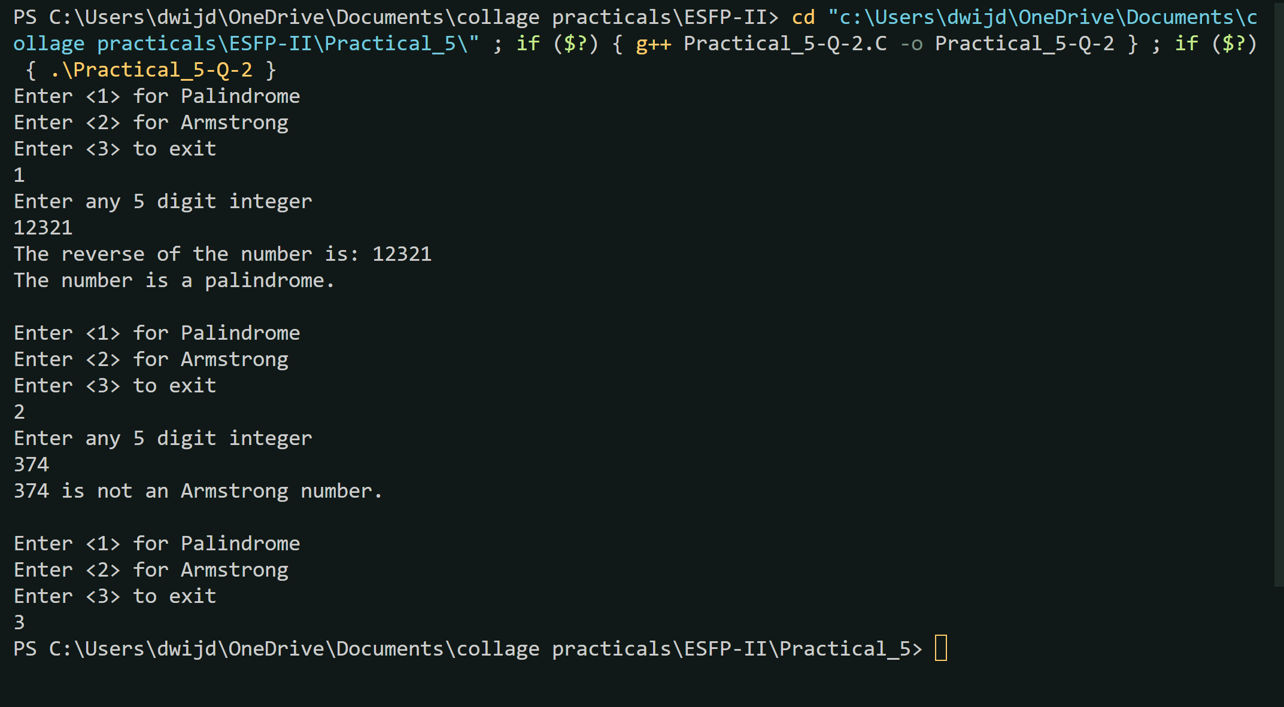

**Q.3**. Find out the error of the following program, correct it, and then write output of the

program with justification.

**1.)**

#include<iostream>

using namespace std;

namespace A {

int a,b,c;

void sum() {

cout<<"Enter two number:";

cin>>a>>b;

c=a+b;

cout<<"Sum of two number:"<<c;

}

}

int main() {

A.sum();

return 0;

**Code:-**

*#include*<iostream>

using namespace std;

namespace A

{

    int a,b,c;

    void sum()

    {

        cout<<"Enter two number:";

        cin>>a>>b;

        c=a+b;

        cout<<"Sum of two number:"<<c;

    }

}

int main()

{

*// wrong:- A.sum();*

    A :: sum();

*return* 0;

}

***Output-***

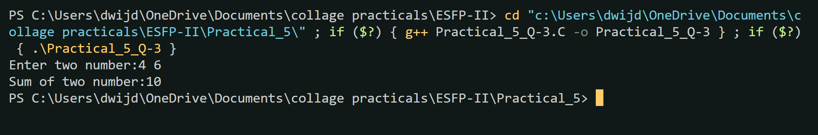

**2.)**

#include<iostream>

int main() {

using std::int;

using std::string;

using std::cout;

using std::endl;

string uname="Ganpat University";

string caddress="City Office: Ahmedabad";

cout<<collegeId<<endl;

cout<<uname<<endl;

cout<<caddress<<endl;

return 0;

}

**Code:-**

*#include*<iostream>

int main()

{

*//wrong:- using std::int;*

    using std::string;

    using std::cout;

    using std::endl;

    string uname="Ganpat University";

    string caddress="City Office: Ahmedabad";

*//wrong:- cout<<collegeId<<endl;*

    cout<<uname<<endl;

    cout<<caddress<<endl;

*return* 0;

}

***Output-***

