**Ganpat University**

**Faculty of Engineering & Technology**

**Computer Science & Engineering**

**(2CSE204) Basics of Operating System and Shell Scripting**

***Name:- Dwij Vatsal Desai***

***Sem:- 2***

***Sub: - ESFP-II***

***Enrollment No.:- 23162121027***

***Prac:- 7***

***Date:- 1/4/2024***

**Practical 7**

***Definition:***

Complete the code for the object assigned to you to satisfy following

specifications.

1. Minimum 2 constructor should be in a program like (Default constructor, two

Parameterized constructor and copy constructor).

2. You must use access specifiers like (public/private/protected) for data member and

member function declaration in program as per the requirements.

3. You are supposed to define normal function as per the requirement for displaying the

information.

4. You must declare a variable as string type. If required, you can use the string function

also.

5. You need to add a minimum one function with an object as a parameter for the

practical. As per your practical functionality requirement, if necessary, you can add more

functions.

6. Add one separate module in your given topic, where you must implement the concept

of operator overloading.

7. Take minimum 5 data from the user and display according to the choice of user

category wise. (Minimum three different options should be there for displaying

information, and if you want more as per program requirement you can add more

choices). Use string comparison to check and display a specific record based on string

inputs from user.

8. After all functionality execution, you need to call the destructor function.

[Note: You must implement object-oriented concept for the practical]

***Code:-***

#include <iostream>

#include <fstream>

#include <string>

#include <limits>

using **namespace** std;

**class** elearning *//only for b.tech*

{

**private:**

**int** expression;

    string selectedCourse;

    string courseLevel;

    string preferredWayOfLearning;

    string durationForEachDay;

**public:**

*// Default constructor*

    elearning()

    {

*// General initialization*

        expression = 0; *// Default value*

    }

*// Parameterized constructor*

    elearning(**int** exp)

    {

*// Initialization based on user input*

        expression = exp;

        switch (expression)

        {

        case 1:

            cout << endl << "You chose Business" << endl << endl;

            selectedCourse = "Business";

            selectComputerCourse();

            break;

        case 2:

            cout << endl << "You chose Computer course" << endl << endl;

            selectedCourse = "Computer course";

            selectComputerCourse();

            break;

        case 3:

            cout << endl << "You chose Data science" << endl << endl;

            selectedCourse = "Data science";

            selectComputerCourse();

            break;

        case 4:

            cout << endl << "You chose ICT" << endl << endl;

            selectedCourse = "ICT";

            selectComputerCourse();

            break;

        default:

            break;

        }

    }

**void** selectCourse()

    {

        cout << ">>>Course Selection<<<" << endl;

        cout << "<1> Business" << endl;

        cout << "<2> Computer course" << endl;

        cout << "<3> Data science" << endl;

        cout << "<4> ICT" << endl;

    }

**void** selectComputerCourse()

    {

**int** totalDuration = 0; *// Initialize total duration*

**int** innerExpression = 0;

        while (true)

        {

            cout << endl << ">>>Enter choice for Computer course:<<<" << endl;

            cout << "<1> Course Level" << endl;

            cout << "<2> Preferred Way of Learning" << endl;

            cout << "<3> Duration for Each Day" << endl;

            cout << "<4> Exit" << endl;

            cin >> innerExpression;

            switch (innerExpression)

            {

            case 1: *// Course Level*

            {

**int** level = 0;

                cout << "Course Level:" << endl;

                cout << "<1> 1-2 weeks (basic)" << endl;

                cout << "<2> 2-5 weeks (intermediate)" << endl;

                cout << "<3> 6-7 weeks (advance)" << endl;

                cin >> level;

                switch (level)

                {

                case 1:

                    cout << "1-2 weeks (basic)" << endl;

                    courseLevel = "1-2 weeks (basic)";

                    totalDuration += 2; *// Add 2 weeks to total duration*

                    break;

                case 2:

                    cout << "2-5 weeks (intermediate)" << endl;

                    courseLevel = "2-5 weeks (intermediate)";

                    totalDuration += 5; *// Add 5 weeks to total duration*

                    break;

                case 3:

                    cout << "6-7 weeks (advance)" << endl;

                    courseLevel = "6-7 weeks (advance)";

                    totalDuration += 7; *// Add 7 weeks to total duration*

                    break;

                default:

                    cout << "Invalid choice" << endl;

                    break;

                }

                break;

            }

            case 2: *// Preferred Way of Learning*

            {

**int** preferredWay = 0;

                cout << "Preferred Way of Learning:" << endl;

                cout << "<1> Guided project" << endl;

                cout << "<2> Personal practical" << endl;

                cout << "<3> Notes and concept learning" << endl;

                cin >> preferredWay;

                switch (preferredWay)

                {

                case 1:

                    cout << "Guided project" << endl;

                    preferredWayOfLearning = "Guided project";

                    break;

                case 2:

                    cout << "Personal practical" << endl;

                    preferredWayOfLearning = "Personal practical";

                    break;

                case 3:

                    cout << "Notes and concept learning" << endl;

                    preferredWayOfLearning = "Notes and concept learning";

                    break;

                default:

                    cout << "Invalid choice" << endl;

                    break;

                }

                break;

            }

            case 3: *// Duration for Each Day*

            {

**int** duration = 0;

                cout << "Duration for Each Day:" << endl;

                cout << "<1> 2 hours" << endl;

                cout << "<2> 4 hours" << endl;

                cout << "<3> 6 hours" << endl;

                cin >> duration;

                switch (duration)

                {

                case 1:

                    cout << "2 hours" << endl;

                    durationForEachDay = "2 hours";

                    break;

                case 2:

                    cout << "4 hours" << endl;

                    durationForEachDay = "4 hours";

                    break;

                case 3:

                    cout << "6 hours" << endl;

                    durationForEachDay = "6 hours";

                    break;

                default:

                    cout << "Invalid choice" << endl;

                    break;

                }

                break;

            }

            case 4: *// Exit*

                cout << "Exiting..." << endl;

                cout << "Total duration to complete the course: " << totalDuration << " weeks" << endl;

                storeDataToFile(); *// Store data to file*

                return; *// Exit the function and terminate the loop*

            default:

                cout << "Invalid choice" << endl;

                break;

            }

        }

    }

**void** storeDataToFile()

    {

        ofstream file("elearning_data.txt", ios_base::app);

        file.is_open();

        if (file.is_open())

        {

            file << "Selected Course: " << selectedCourse << endl;

            file << "Course Level: " << courseLevel << endl;

            file << "Preferred Way of Learning: " << preferredWayOfLearning << endl;

            file << "Duration for Each Day: " << durationForEachDay << endl;

            file << "---------------------------------------" << endl;

            file.close();

            cout << "Data saved to elearning_data.txt" << endl;

        }

        else

        {

            cout << "Unable to open file" << endl;

        }

    }

};

**int** main()

{

    elearning obj1; *// Calls default constructor*

    obj1.selectCourse();

**int** userChoice;

    cout << "Enter your choice: ";

    cin >> userChoice;

    cin.ignore(); *// remove buffer*

    elearning obj2(userChoice); *// sends data to 'exp'*

    return 0;

}

***Output:-***

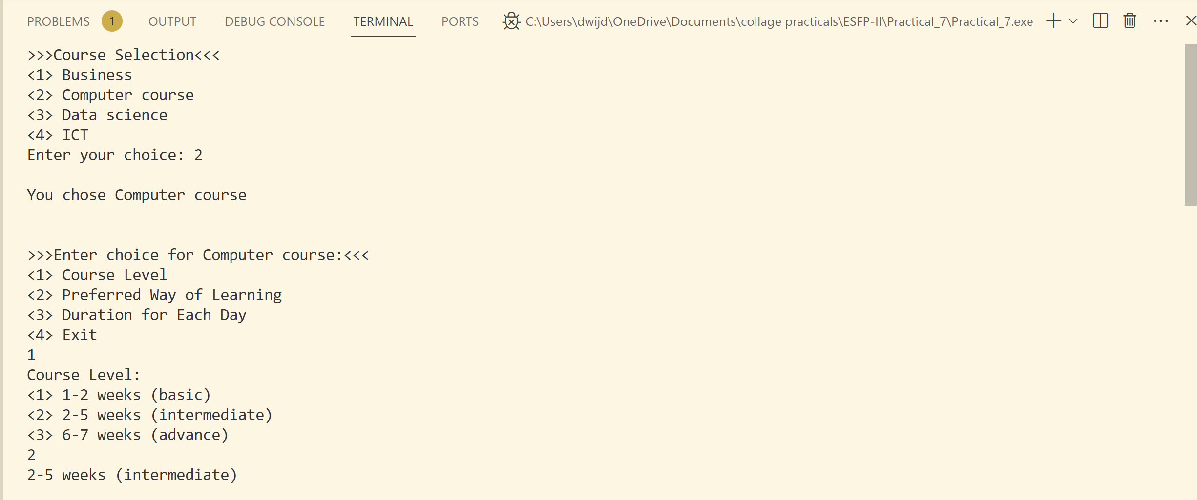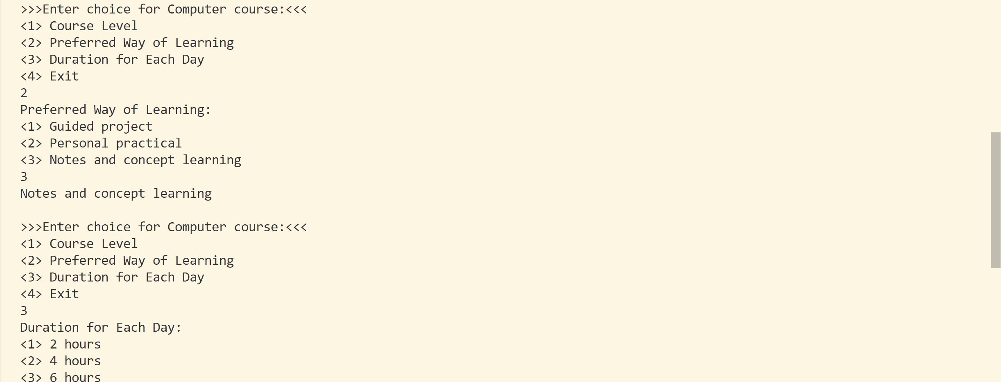 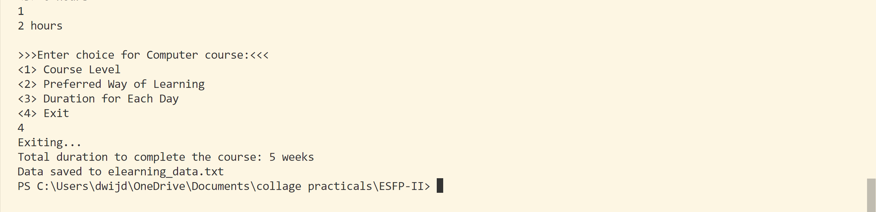

***Recorded data in text file:-***

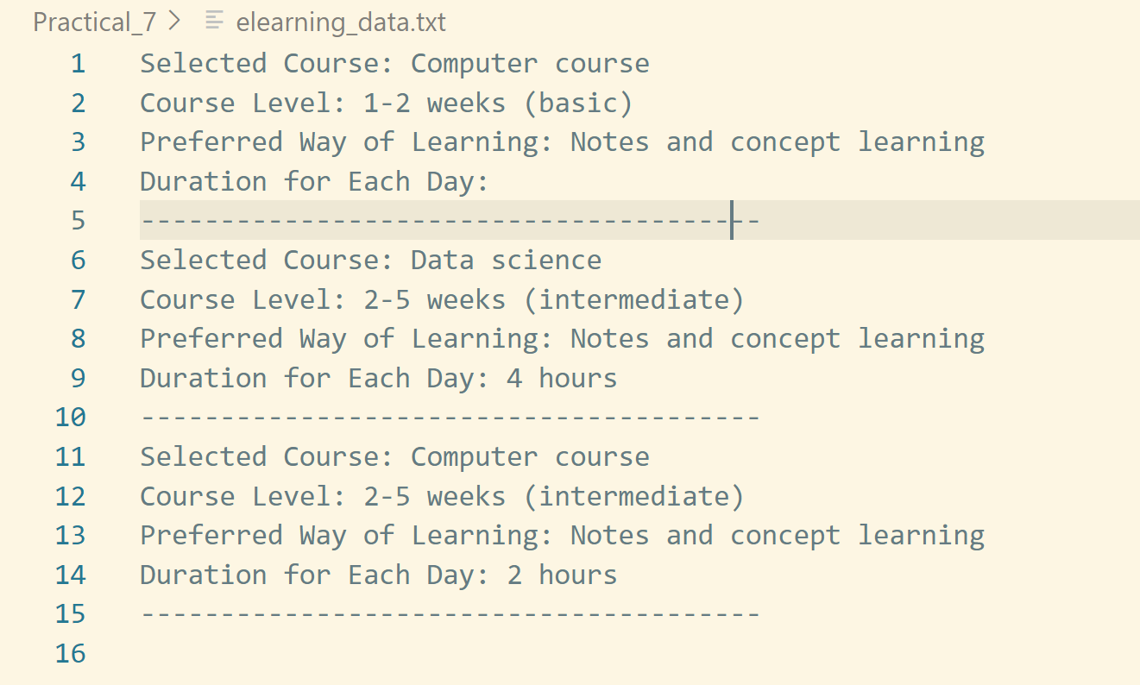

***Photo:-*** 