**Ganpat University**

**Faculty of Engineering & Technology**

**Computer Science & Engineering**

***Name:- Dwij Vatsal Desai***

***Sem:- 2***

***Sub: - ESFP-II***

***Enrollment No.:- 23162121027***

***Prac:- 8***

***Date:- 16/4/2024***

**Practical 8**

***Definition:***

Complete the code for the object already assigned to you during practical 7 to

satisfy following specifications.

This is the extended part of practical number-7, which is to be performed as per

the following instructions :

1. Append all string data to first string of your object and then display only string data of

all objects together (one record in one line).

2. Find the length of the string prepared in point 1, for all records and display on screen

with appropriate message.

3. Display last number of characters from given string field like customer name, product

name or brand, name, etc as per user choice.

4. Find first and last character of all the string fields found in point 1.

5. Extract substring from given string as per your string field available in the given

record.

6. Design a search method, which asks a data to be searched based on name and other

parameters of the object. Display record data if match found. Display appropriate

message if match not found.

7. Display all record information/data record in ascending and descending orders based

on their name field.

[Note: You must implement object-oriented concept for the practical]

***Code:-***

#include <iostream>

#include <fstream>

#include <string>

using **namespace** std;

**void** userinfo() {

    string age, name, address, email;

    cout << "Enter your info here (Age, Name, Address, Email): ";

    cin >> age >> name >> address >> email;

    cout << endl;

*// Append all strings into one*

    string tinfo = age + " " + name + " " + address + " " + email;

    cout << "Concatenated string: " << tinfo << endl;

*// Display length of the concatenated string*

    cout << "Length of concatenated string: " << tinfo.length() << endl;

*// Display last characters based on user choice*

**int** num_chars;

    cout << "Enter the number of characters to display from the end: ";

    cin >> num_chars;

    cout << "Last " << num_chars << " characters: " << tinfo.substr(tinfo.length() - num_chars) << endl;

*// Find and display first and last characters*

    cout << "First character: " << tinfo.front() << endl;

    cout << "Last character: " << tinfo.back() << endl;

*// Extract substring based on user input*

**int** start_index, length;

    cout << "Enter the starting index and length of the substring to extract: ";

    cin >> start_index >> length;

    cout << "Extracted substring: " << tinfo.substr(start_index, length) << endl;

*// Search method*

    string search_term;

    cout << "Enter the search term: ";

    cin >> search_term;

    if (tinfo.find(search_term) != string::npos) {

        cout << "Match found!" << endl;

    } else {

        cout << "No match found." << endl;

    }

}

**class** elearning {

**private:**

**int** expression;

    string selectedCourse;

    string courseLevel;

    string preferredWayOfLearning;

    string durationForEachDay;

**public:**

    elearning() {

        expression = 0;

    }

    elearning(**int** exp) {

        expression = exp;

        switch (expression) {

        case 1:

            cout << endl << "You chose Business" << endl << endl;

            selectedCourse = "Business";

            selectComputerCourse();

            break;

        case 2:

            cout << endl << "You chose Computer course" << endl << endl;

            selectedCourse = "Computer course";

            selectComputerCourse();

            break;

        case 3:

            cout << endl << "You chose Data science" << endl << endl;

            selectedCourse = "Data science";

            selectComputerCourse();

            break;

        case 4:

            cout << endl << "You chose ICT" << endl << endl;

            selectedCourse = "ICT";

            selectComputerCourse();

            break;

        default:

            break;

        }

    }

**void** selectCourse() {

        cout << ">>>Course Selection<<<" << endl;

        cout << "<1> Business" << endl;

        cout << "<2> Computer course" << endl;

        cout << "<3> Data science" << endl;

        cout << "<4> ICT" << endl;

    }

**void** selectComputerCourse() {

**int** totalDuration = 0;

**int** innerExpression = 0;

        while (true) {

            cout << endl << ">>>Enter choice for Computer course:<<<" << endl;

            cout << "<1> Course Level" << endl;

            cout << "<2> Preferred Way of Learning" << endl;

            cout << "<3> Duration for Each Day" << endl;

            cout << "<4> Exit" << endl;

            cin >> innerExpression;

            switch (innerExpression) {

            case 1: {

**int** level = 0;

                cout << "Course Level:" << endl;

                cout << "<1> 1-2 weeks (basic)" << endl;

                cout << "<2> 2-5 weeks (intermediate)" << endl;

                cout << "<3> 6-7 weeks (advance)" << endl;

                cin >> level;

                switch (level) {

                case 1:

                    cout << "1-2 weeks (basic)" << endl;

                    courseLevel = "1-2 weeks (basic)";

                    totalDuration += 2;

                    break;

                case 2:

                    cout << "2-5 weeks (intermediate)" << endl;

                    courseLevel = "2-5 weeks (intermediate)";

                    totalDuration += 5;

                    break;

                case 3:

                    cout << "6-7 weeks (advance)" << endl;

                    courseLevel = "6-7 weeks (advance)";

                    totalDuration += 7;

                    break;

                default:

                    cout << "Invalid choice" << endl;

                    break;

                }

                break;

            }

            case 2: {

**int** preferredWay = 0;

                cout << "Preferred Way of Learning:" << endl;

                cout << "<1> Guided project" << endl;

                cout << "<2> Personal practical" << endl;

                cout << "<3> Notes and concept learning" << endl;

                cin >> preferredWay;

                switch (preferredWay) {

                case 1:

                    cout << "Guided project" << endl;

                    preferredWayOfLearning = "Guided project";

                    break;

                case 2:

                    cout << "Personal practical" << endl;

                    preferredWayOfLearning = "Personal practical";

                    break;

                case 3:

                    cout << "Notes and concept learning" << endl;

                    preferredWayOfLearning = "Notes and concept learning";

                    break;

                default:

                    cout << "Invalid choice" << endl;

                    break;

                }

                break;

            }

            case 3: {

**int** duration = 0;

                cout << "Duration for Each Day:" << endl;

                cout << "<1> 2 hours" << endl;

                cout << "<2> 4 hours" << endl;

                cout << "<3> 6 hours" << endl;

                cin >> duration;

                switch (duration) {

                case 1:

                    cout << "2 hours" << endl;

                    durationForEachDay = "2 hours";

                    break;

                case 2:

                    cout << "4 hours" << endl;

                    durationForEachDay = "4 hours";

                    break;

                case 3:

                    cout << "6 hours" << endl;

                    durationForEachDay = "6 hours";

                    break;

                default:

                    cout << "Invalid choice" << endl;

                    break;

                }

                break;

            }

            case 4:

                cout << "Exiting..." << endl;

                cout << "Total duration to complete the course: " << totalDuration << " weeks" << endl;

                storeDataToFile();

                return;

            default:

                cout << "Invalid choice" << endl;

                break;

            }

        }

    }

**void** storeDataToFile() {

        ofstream file("elearning_data.txt", ios_base::app);

        if (file.is_open()) {

            file << "Selected Course: " << selectedCourse << endl;

            file << "Course Level: " << courseLevel << endl;

            file << "Preferred Way of Learning: " << preferredWayOfLearning << endl;

            file << "Duration for Each Day: " << durationForEachDay << endl;

            file << "---------------------------------------" << endl;

            file.close();

            cout << "Data saved to elearning_data.txt" << endl;

        } else {

            cout << "Unable to open file" << endl;

        }

    }

};

**int** main() {

    userinfo();

    elearning obj1;

    obj1.selectCourse();

**int** userChoice;

    cout << "Enter your choice: ";

    cin >> userChoice;

    cin.ignore();

    elearning obj2(userChoice);

    return 0;

}

***Output:-***

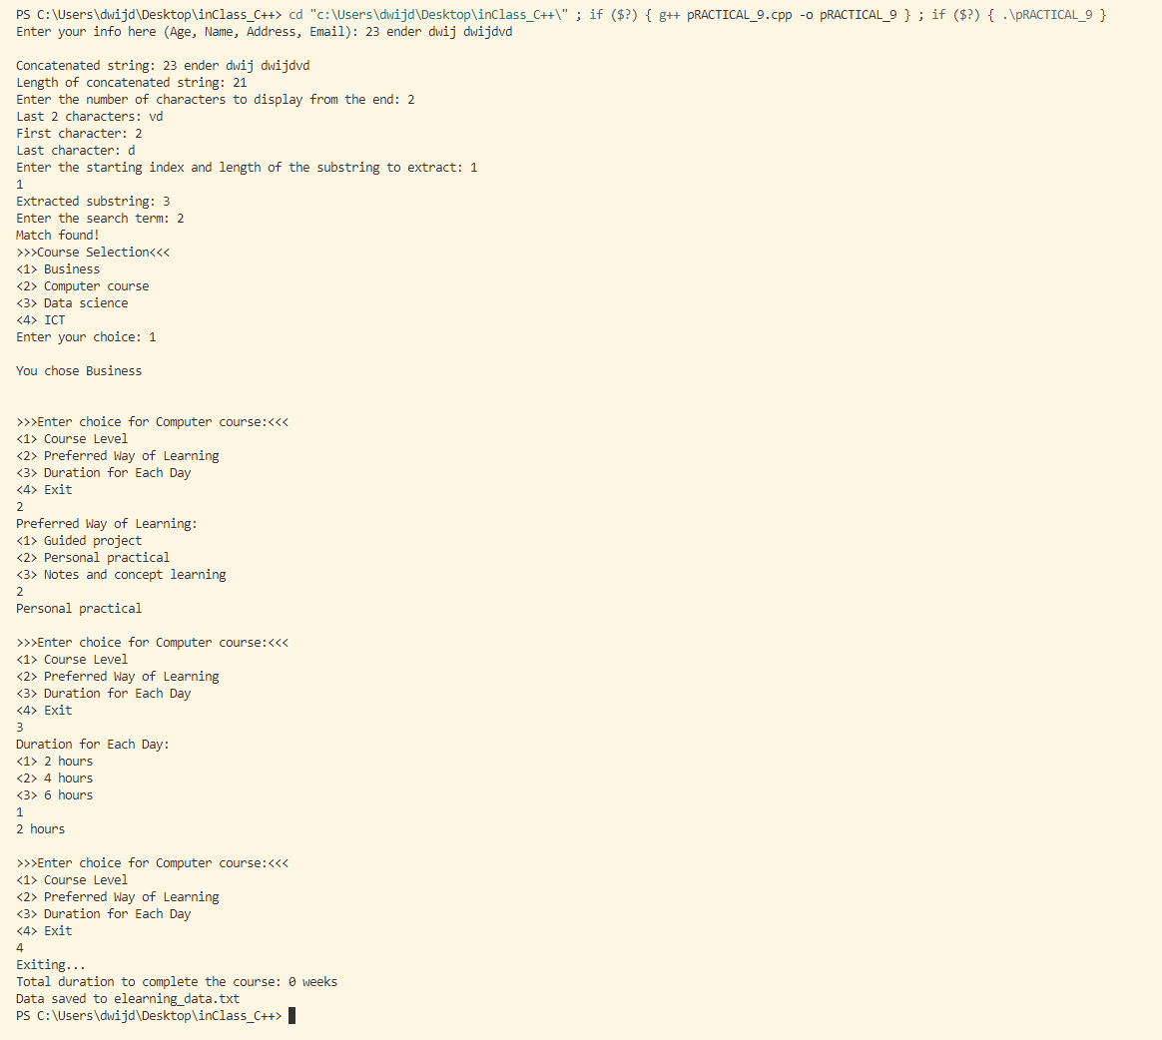

***Recorded data in text file:-***

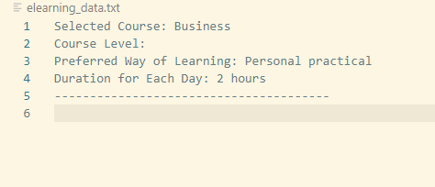

***Photo:-*** 