PID045. Real time Artificial Intelligence (AI) based Data Analysis for decision making

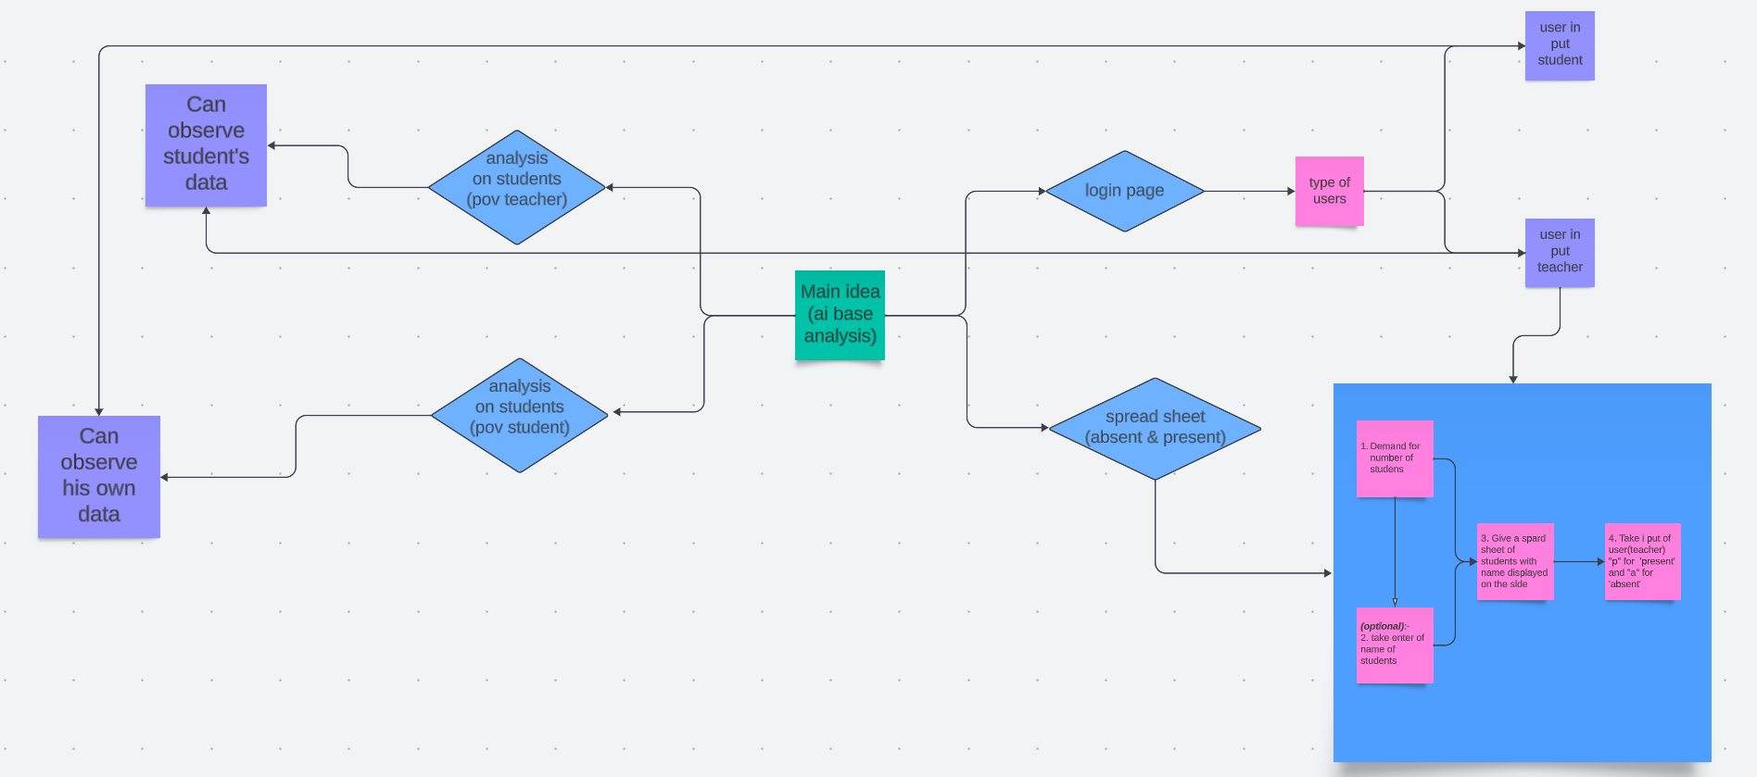

1. Registration and Login:

The program should have a registration process for both teachers and students. During registration, they would provide their basic information, including a username and password.

After registration, they can log in using their respective usernames and passwords.

2. Teacher's Dashboard:

When a teacher logs in, they are directed to their dashboard. In the dashboard, the teacher has several options:

View Attendance Spreadsheet: The teacher can access a spreadsheet showing the list of students, which could optionally include their names. The teacher can choose to input attendance for each student by typing 'p' for present or 'a' for absent next to each student's name. The spreadsheet is automatically updated as the teacher inputs attendance data.

View Student Percentage: The teacher can enter a student's name and view the percentage of classes that the selected student has attended. The program calculates this percentage based on the attendance data in the spreadsheet.

3. Student's Dashboard:

When a student logs in, they are directed to their dashboard. In the dashboard, the student has the following option:

View Personal Attendance Status: The student can see their own attendance record. They can see how many classes they attended and how many they missed.

4. Attendance Tracking:

For both teachers and students, the program records attendance as 'p' for present and 'a' for absent in the spreadsheet.

5. Data Storage:

The program should store all the attendance data securely and allow authorized access only for teachers and students.

6. Security:

It's crucial to ensure the program's security by implementing proper authentication and access control mechanisms to protect the data.

7. User-Friendly Interface:

The program should have a user-friendly interface, making it easy for teachers to input attendance and for students to check their records.

8. Reporting:

You may also consider implementing a reporting feature that allows teachers to generate attendance reports for specific time periods or for specific students.

By following these steps, your program can effectively track student attendance, making it easier for teachers to manage attendance records and students to monitor their own attendance status. Remember to focus on data security and user-friendly design to ensure a smooth user experience.