DengueWatch India
A Weather-Driven Dengue Early Warning System for Indian Districts
Minor Project — Python + Data Management & Engineering
Mahindra University
Submitted by: Dwijen Mehta (SE26MBDS001)
Faculty guide: [to be added]
Project documentation — living document, updated at every project step
Version 1.1 — 12 November 2026 (after Step 9)

Contents

Right-click the table above and choose "Update Field" in Word to refresh page numbers.

0. Project Roadmap & Progress Tracker
The project is developed step by step. After each step, this document is updated with what was done, the decisions taken, and the evidence behind them, so that it can be submitted as the final project documentation.
Step | Phase | Main outputs | Status
0 | Topic selection & feasibility check | Guidelines review, data availability, prior work | Done (11 Nov 2026)
1 | Problem definition | Problem statement, evidence, gap, objectives, target users & workflows | Done (11 Nov 2026)
2 | Requirements & system design | Functional/non-functional requirements, architecture diagram, ER diagram, API list, tech stack | Done (11 Nov 2026)
3 | Project setup | GitHub repo, folder structure, environment, requirements.txt, PostgreSQL install, README skeleton | Done (11 Nov 2026)
4 | Data acquisition & cleaning | Report downloader, PDF parser, cleaning, district name standardisation, validation | Done (12 Nov 2026)
5 | Database implementation | Schema scripts, data loading, indexes, analytical SQL queries/views | Done (12 Nov 2026)
6 | Weather data integration | NASA POWER history + Open-Meteo recent days and forecast, weekly weather aggregation | Done (12 Nov 2026)
7 | AI/ML early-warning model | Lagged-weather features, model training, time-based validation, evaluation | Done (12 Nov 2026)
8 | Flask REST API | Endpoints for outbreaks, districts, weather, risk scores; API tests | Done (12 Nov 2026)
9 | Dashboard (UI) | Risk map, district/year comparison, weather-to-outbreak timelines | Done (12 Nov 2026)
10 | Automation ("live" updates) | Scheduled weekly report ingestion and daily weather + risk refresh | Next
11 | AI agent (optional) | News-signal agent and/or natural-language-to-SQL, with guardrails | Pending
12 | Testing, evaluation & final documentation | End-to-end testing, results, limitations, final README | Pending
13 | Presentation & demo | Slides following the suggested structure, demo script, Q&A prep | Pending

1. Project Overview
Status: Complete (Step 1)
India publishes dengue outbreak information every week through the Integrated Disease Surveillance Programme (IDSP), but only as PDF reports. These reports cannot easily be searched, compared across districts and years, or linked to the weather conditions that came before an outbreak. In addition, the reports are published about two months after the week they describe.
DengueWatch India turns these reports into a queryable PostgreSQL database, links each district to its historical and forecast weather, and uses a machine-learning model to estimate which districts are at higher risk of a dengue outbreak in the coming weeks. The results are served through a Flask API and an interactive dashboard that updates itself automatically.
Domain (as per guidelines): Public health.

2. Guidelines Compliance Matrix
Each requirement from the Project Guidelines document and where it is addressed in this project.
Guideline requirement | How this project meets it | Where | Status
Novel scientific application (applied real-world problem) | Weather-driven dengue early warning for Indian districts; gap analysed against existing systems | Section 3 | Met
Problem selection backed by evidence (evaluation i) | National burden data, under-reporting studies, peer-reviewed climate–dengue lag studies | Section 3.2 | Met
Critical thinking in problem selection (evaluation ii) | Alternatives compared against explicit criteria | Section 3.8 | Met
Domain: Public health | Dengue outbreak surveillance (public health) | Section 1 | Met
Python as core language + UI package | Python pipeline and ML; Flask REST API (17 endpoints); Dash dashboard with 4 pages on the same Flask server | Sections 5, 6.5, 7.5 | Met
Relational database (SQL / PostgreSQL) | PostgreSQL 18: 11 tables with keys and constraints, 6 indexes, 3 views, 10 named analytical queries | Sections 5.3, 6.4 | Met (implemented)
AI/ML component (optional) | LightGBM outbreak-risk model with time-based validation and SHAP explanations | Sections 6.7, 7 | Met (implemented)
Model choice and validation (evaluation iv) | Five models compared on unseen years 2023–2026; leakage-safe features; alert thresholds set on a separate validation year | Sections 6.7, 7 | Met
Design clarity: user and architecture (evaluation iii) | Personas, architecture and ER diagrams, design decisions | Sections 4, 5 | Met
Deliverable 1: Process and Outcome | Development log updated at every step; data pipeline documented | Section 8 | In progress
Deliverable 2: Problem Statement | Problem, why it matters, gap in existing solutions | Section 3 | Met
Deliverable 3: Target User | Personas, key workflows and user stories | Section 4 | Met
Deliverable 4: System Design | Architecture diagram + ER diagram + data flows | Section 5 | Met
Deliverable 5: Technical Specification | Requirements, data sources, schema, APIs, stack, model design, assumptions | Section 6 | Specified; model details after Step 7
Deliverable 6: Use of Agent (optional) | News-signal / NL-to-SQL agent with guardrails | Section 9 | Step 11
Deliverable 7: GitHub Repository | README, requirements, schema scripts, sample data, commit history | Section 10 | Live on GitHub; grows each step

3. Problem Statement
Status: Complete (Step 1)
Problem statement: India's official dengue outbreak data is public but locked in weekly PDF reports that appear about two months late. As a result, health officials cannot search or compare outbreaks across districts and years, cannot see whether outbreaks followed specific weather conditions, and receive no advance warning of where outbreaks are likely next. Because weather is known to drive dengue weeks to months ahead, combining this surveillance data with weather data can turn a delayed, unsearchable record into a searchable history and a district-level early warning.

3.1 The problem
The Integrated Disease Surveillance Programme (IDSP) publishes a Weekly Outbreak Report listing outbreaks of dengue and other diseases by state and district, with case counts, deaths, start dates and actions taken. These reports are the only public, district-level record of dengue outbreaks in India going back to 2009. They have three practical weaknesses:
- Locked in documents. Each week is a separate PDF (896 reports from 2009 to 2026). Answering a simple question such as "how many dengue outbreaks has Pune reported in each of the last ten years?" means opening and reading hundreds of files.
- Delayed. On 11 November 2026 the latest available report was for Week 37 of 2026 (mid-September), a publication lag of roughly two months. By the time an outbreak appears in a public report, the response window has largely passed.
- Disconnected from its drivers. Dengue transmission depends strongly on rainfall and temperature in the preceding weeks (Section 3.2), but the reports carry no weather information, so the link cannot be seen or used.
The result is that dengue control at district level remains largely reactive: fogging, source reduction and hospital preparedness start after cases are already being reported.

3.2 Why it matters (evidence)
(a) Dengue is a large and persistent burden in India. Official national figures from the National Center for Vector Borne Diseases Control (NCVBDC):
Year | Reported cases | Reported deaths | Note
2021 | 1,93,245 | 346
2022 | 2,33,251 | 303
2023 | 2,89,235 | 485 | Highest in the period
2024 | 2,33,519 | 297 | Top: Karnataka, Tamil Nadu, Kerala
2025 | 1,21,824 | 131 | West Bengal not reported
Source: NCVBDC, Dengue cases and deaths 2021–2026 (till April). 2026 figures are provisional (13,336 cases to 30 April).
(b) Official figures greatly understate the true burden. A study in the American Journal of Tropical Medicine & Hygiene (Shepard et al., 2014) estimated nearly 6 million clinically diagnosed dengue cases a year in India in 2006–2012, about 282 times the officially reported number, at an economic cost of at least US$1.11 billion a year. For deaths, the Registrar General's medically certified cause-of-death data for 2023 records 3,254 dengue deaths against 485 in surveillance data. Every reported outbreak therefore represents a much larger hidden burden, which raises the value of early action.
(c) Weather drives dengue weeks to months in advance. Peer-reviewed Indian studies consistently find a lag between weather and dengue:
Study | Data | Key lag finding
Kakarla et al., 2019, Epidemiology & Infection | All-India weekly IDSP dengue cases, 2010–2017 | Highest risk 8–15 weeks after rainfall; peak risk at ~30 °C mean temperature with 0–3 week lag; risk rises above 24 °C
Singh & Chaturvedi, 2022, Scientific Reports | Delhi monthly dengue cases, 2015–2018 | Temperature two months earlier and cumulative rainfall are the best predictors
Pramanik et al., 2020, BMC Public Health | Delhi and Visakhapatnam | 2–3 month lag between rainfall and dengue cases
IITM Pune (Yacob & Koll), reported Jan 2025 | Pune | Risk rises above 27 °C with moderate rain (≤150 mm/week); model predicts outbreaks more than two months ahead

(d) The timing creates an opportunity. Weather leads dengue by roughly 2 to 15 weeks, while official outbreak reports trail by about 8 weeks. Weather data is available daily, with forecasts. A system that links the two can flag high-risk districts before outbreaks would appear in official reports. WHO's EWARS-csd tool shows this is achievable in principle, predicting dengue outbreaks about 12 weeks ahead in countries where it is deployed.
(e) The pattern is shifting. Reporting in 2026 indicates that dengue in India is no longer confined to the monsoon months, which makes fixed seasonal planning less reliable and data-driven warning more important.

3.3 Gap in existing solutions
Existing solution | What it does | Limitation for our users
IDSP Weekly Outbreak Reports (NCDC) | Official weekly list of outbreaks by district, since 2009 | PDF only, ~2-month lag, not searchable, no weather, no prediction
IHIP (Integrated Health Information Platform), 2021 | Near-real-time digital reporting for IDSP for government users | Not publicly accessible; NCDC announced a move to predictive surveillance in Nov 2025, but no timeline or public tool
EpiClim dataset (2025) | District-wise weekly epidemic–climate dataset built from IDSP reports | Static, covers 2009–2022 only, descriptive analysis; no updates, interface or prediction
Academic lag studies (Kakarla 2019, Singh 2022, Pramanik 2020) | Quantify how weather precedes dengue | National, city or state level; retrospective; not operational tools
IITM Pune dengue early warning (2025) | Climate-based dengue prediction model | Single city (Pune); not a public multi-district tool
WHO EWARS-csd | Generic early warning software for climate-sensitive diseases | Tested in India, but no public, continuously updated district-level dengue warning exists
aflip/IDSP (GitHub) | Notebook that extracts IDSP PDF tables | No database, dashboard, weather link or prediction

The gap: To our knowledge, there is no publicly accessible, continuously updated system that turns IDSP dengue outbreak reports into a queryable database, links them to weather, and gives district-level advance warning of outbreak risk.

3.4 Research questions
- How are rainfall, temperature and humidity in the preceding weeks associated with dengue outbreak reports in Indian districts, and at which lags?
- Can a model using lagged weather, season and past outbreak history predict whether a district will report a dengue outbreak in the next four weeks, when tested on years it was not trained on (2023–2026)?
- How much advance warning can a weather-based system give compared with the official reporting lag?

3.5 Objectives
- Build a pipeline that extracts dengue outbreak records from all IDSP weekly reports (2009–present) and cleans them.
- Design and implement a PostgreSQL database for outbreaks, districts, weeks, weather and predictions, with analytical SQL queries.
- Link every district to its historical and forecast weather.
- Train and validate a machine-learning model that estimates each district's outbreak risk for the coming four weeks.
- Expose the data and risk scores through a Flask REST API.
- Build an interactive dashboard for comparing districts and years and viewing current risk.
- Automate updates so new reports, weather and risk scores flow in without manual work.
- (Optional) Add an AI agent for news-based early signals or plain-English querying, with guardrails.

3.6 Scope
In scope | Out of scope
Dengue outbreaks in IDSP weekly reports, all Indian states/UTs, 2009–present | Individual patient or hospital-level data
District-level, weekly time resolution | Estimating true total dengue incidence (outbreak reports only)
Historical and forecast weather per district | Clinical diagnosis or treatment guidance
Outbreak risk for the next four weeks | Real-time case counts (not publicly available)
Web dashboard and REST API | Mobile app; deployment at government scale
Design that can later extend to other IDSP diseases (e.g. chikungunya, malaria) | Modelling other diseases in this project

3.7 Expected outcome
- A searchable database of all IDSP dengue outbreaks since 2009, linked to weather.
- A validated model with reported recall, precision and lead time on held-out years.
- A dashboard and API that update automatically and show current district risk.

3.8 Problem selection rationale (critical thinking)
Several directions were considered before choosing this problem. Each was judged on five criteria: relevance to India, availability of open data, feasibility within one semester, novelty compared with existing work, and fit with the guideline stack (Python, relational database, ML).
Option considered | Decision | Reason
Live dengue dashboard for India | Re-framed | No real-time public dengue data exists; reports are weekly with ~2-month lag. The "live" element was moved to weather and risk scores.
Dengue antiviral candidate explorer (ChEMBL / PubChem) | Not chosen | Strong science, but weakly India-specific and harder to justify to a public health audience.
Dengue serotype tracker (NCBI Virus) | Future extension | Relevant, but India sequence counts per region may be too thin for a full project.
Air quality and health risk | Not chosen | Live pollution data exists, but open Indian health-outcome data does not.
Drug adverse-event signals (openFDA) | Not chosen | Good API, but US data only; India's equivalent is not open.
Weather-driven dengue early warning (selected) | Selected | India-specific, 17 years of open district data, strong evidence base for weather lags, clear gap, and uses every part of the required stack.

4. Target Users
Status: Complete (Step 1)
No field interviews or surveys are conducted for this minor project. The personas below are illustrative and based on the published roles and responsibilities of IDSP surveillance units; user needs are stated as assumptions.

4.1 Primary user: District Surveillance Officer
Attribute | Description
Persona | "Dr. Meera" (illustrative), District Surveillance Officer, District Surveillance Unit under IDSP
Responsibilities | Monitors disease trends in the district, investigates outbreaks with the Rapid Response Team, and coordinates vector control and hospital preparedness
Technical skill | Comfortable with dashboards, spreadsheets and web portals; not a programmer
Main goal | Know early which areas need attention, so teams and resources can be sent before cases surge
Pain points | Public outbreak data is in PDFs and two months late; comparing with past years or neighbouring districts is manual; weather is not linked to outbreak history

Key workflows
- Weekly risk review: opens the dashboard each week, sees the outbreak risk for their district and neighbouring districts for the next four weeks, and why (recent rainfall and temperature).
- Historical comparison: compares this year's outbreaks with previous years and with nearby districts, by month or week.
- Weather check: views recent and forecast rainfall and temperature for the district alongside past outbreak timing.
- Briefing: exports a short summary or chart for the district health office or collector to justify vector-control and preparedness actions.

4.2 Secondary user: Public health researcher or student
Attribute | Description
Persona | "Arjun" (illustrative), postgraduate researcher in public health / biomedical data science
Technical skill | Uses Python, SQL and APIs
Main goal | Analyse dengue trends and climate links using clean, structured data
Pain points | Has to scrape and clean PDFs before any analysis; existing datasets stop in 2022

Key workflows
- Query: filters outbreaks by state, district, year or month through the dashboard or API.
- Export: downloads outbreak and weather data for their own analysis.
- Explore: examines weather–outbreak lag patterns and the model's performance and features.

4.3 User stories
ID | User story
US-1 | As a surveillance officer, I want to see which districts are at high risk of a dengue outbreak in the next four weeks, so that I can plan vector control early.
US-2 | As a surveillance officer, I want to compare dengue outbreaks in my district across years and months, so that I can tell whether this season is unusual.
US-3 | As a surveillance officer, I want to see rainfall and temperature before past outbreaks, so that I understand why my district is flagged.
US-4 | As a surveillance officer, I want the dashboard to update itself when new reports and weather arrive, so that I always see current information.
US-5 | As a surveillance officer, I want to export a summary, so that I can brief district administration.
US-6 | As a researcher, I want to query and download cleaned outbreak and weather data through an API, so that I can do my own analysis without parsing PDFs.
US-7 | As a researcher, I want to see how the model was validated, so that I can judge how far to trust its warnings.

These user stories will be turned into functional requirements in Step 2.

5. System Design
Status: Design complete (Step 2) — implemented in Steps 3–11

5.1 Architecture overview
DengueWatch India is a layered Python system built around a single PostgreSQL database. Data flows in one direction, from public sources into the database, through the ML layer, and out to users through one Flask web application. Figure 1 shows the components and how they interact.
Layer | Role
1. Data sources | IDSP weekly outbreak PDFs (NCDC), Open-Meteo weather API, and a district master list with centroid coordinates
2. Ingestion (Python) | Finds and downloads new reports, parses dengue rows from PDFs, cleans them and matches district names; fetches daily weather and aggregates it to weeks
3. Storage (PostgreSQL) | Single source of truth for outbreaks, reports, districts, weather, model versions and predictions
4. ML (Python) | Builds features from the database, trains the model offline, and scores every district's outbreak risk for the next four weeks
5. Application (Flask) | One Flask server hosts both the REST API (/api/v1) and the Dash dashboard (/dashboard)
6. Users | Surveillance officers use the dashboard; researchers use the dashboard and the API
Scheduler | Runs the weekly report ingestion and the daily weather refresh and re-scoring automatically
AI agent (optional) | Works only through the API with read-only access; never writes to official data tables

Figure 1 — System architecture
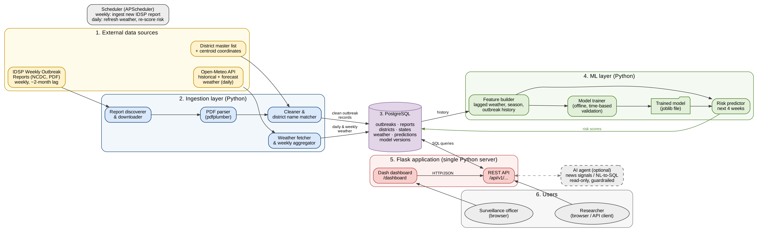
Figure 1. DengueWatch India architecture: data sources → ingestion → PostgreSQL → ML layer → Flask (API + dashboard) → users. The scheduler automates ingestion and re-scoring.

5.2 Data flows
A. Weekly report ingestion (automatic, once a week)
- Scheduler checks the NCDC Weekly Outbreaks page for report links not yet in the reports table.
- Each new PDF is downloaded, hashed and recorded in reports.
- The parser extracts outbreak rows; dengue rows are kept (the design allows other diseases later).
- District names are matched to the master list using exact match, then the alias table, then fuzzy matching; uncertain rows are flagged needs_review.
- Clean rows are inserted into outbreaks; duplicates (the same outbreak listed again in a later report) are detected and skipped.
- The run is logged in pipeline_runs.
B. Daily weather and risk refresh (automatic, once a day)
- Weather fetcher requests the latest observed and forecast weather for every district centroid from Open-Meteo.
- Daily rows are upserted into weather_daily; weekly totals and averages are computed from them in SQL.
- The feature builder assembles each district's latest features; the active model scores the risk of an outbreak in the next four weeks.
- Scores, risk levels and the main contributing factors are written to predictions.
C. User request
- The user opens the dashboard or calls the API.
- Dashboard callbacks call the REST API; the API runs parameterised SQL queries against PostgreSQL.
- Results are returned as JSON and drawn as maps, tables and charts.

5.3 Database design (ER diagram)
The database is normalised around districts and weeks. Figure 2 shows the entities and relationships; Section 6.4 lists the tables and their purpose.

Figure 2 — Entity–relationship diagram
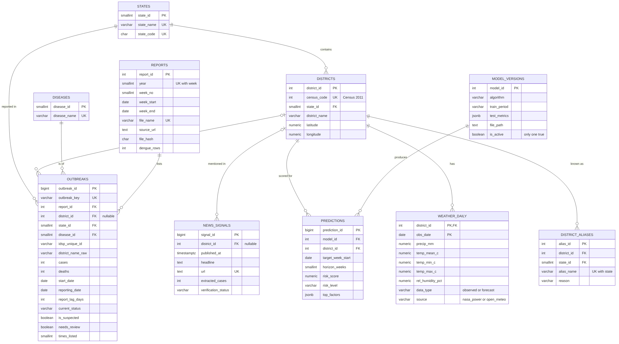
Figure 2. ER diagram as implemented in Step 5. PK = primary key, FK = foreign key, UK = unique. The standalone log table pipeline_runs is not shown.

Key relationships
- A state contains many districts; a district can have many alias spellings (used to match names in old reports).
- A report lists many outbreaks; each outbreak belongs to one district and one disease.
- Each district has one weather row per day (composite key: district_id + obs_date).
- Each model version produces many predictions; each prediction is for one district and one target week.
- News signals (optional agent) may or may not be linked to a district, and are stored separately from official outbreaks.

5.4 Design decisions
Decision | Alternatives considered | Reason
Dash for the dashboard | Streamlit | Dash runs on Flask, so the API and dashboard share one server, one codebase and one deployment. Streamlit would need a separate server and is less suited to multi-page apps with an API behind them.
PostgreSQL | SQLite, MySQL | Required by guidelines (SQL/PostgreSQL); strong date and window functions for weekly time series, JSONB for model metrics and factors, and handles ~5 million weather rows easily.
Census 2011 districts as the fixed geography | Current (~780) districts | About 140 districts were created or renamed between 2009 and 2026. Mapping every report to its 2011 parent district gives one stable unit for comparing years and training the model. (The ER diagram key lgd_code is implemented as census_code.)
Store weather daily, aggregate weekly in SQL | Store only weekly weather | Keeps the raw data, allows any lag window to be computed later, and shows SQL querying in action.
District master list + alias table | Use names as written in reports | Report spellings vary and districts were split or renamed since 2009; one canonical district ID is needed to compare across years.
Keep a needs_review flag on uncertain rows | Drop uncertain rows | Avoids silently losing data; uncertain rows can be checked manually and excluded from training if needed.
Predict "outbreak in next 4 weeks" (yes/no) | Predict case counts | The data records outbreak events, not all cases; a binary risk is more reliable and directly answers the officer's question.
Reporting-lag-aware features | Use all past outbreaks as features | At prediction time, outbreaks from the last ~8 weeks are not yet published. Using them in training would leak future information and overstate accuracy.
Time-based validation (train ≤2022, test 2023–2026) | Random train/test split | A random split mixes future and past weeks and gives unrealistically good results.
All SQL queries kept in database/queries.sql, run by name from Python | SQL strings inside Python code | One readable file that can be run directly in pgAdmin/psql and is reused unchanged by the API and dashboard; parameters are always bound safely.
NASA POWER for weather history, Open-Meteo for recent days and forecast | Open-Meteo for everything (as planned in Step 2) | Open-Meteo's free terms count every 2 weeks of data per location as one call (limit 10,000 a day), so 17 years × 640 districts (~280,000 calls) is not possible for free. NASA POWER returns the whole history for a point in one request (~640 requests in total). Open-Meteo is used only for the latest days and the 16-day forecast (~1,200 calls a day).
Weather source priority: NASA POWER > Open-Meteo observed > forecast | Keep whichever arrived last | Each day keeps its most reliable value; a forecast is automatically replaced by an observation once the day has passed.
Re-runnable loads (upsert on natural keys) | Delete and reload everything | New weekly reports can be added at any time without duplicates; the same rule as the Step 4 de-duplication (district + start date) is enforced by a UNIQUE key.
Model saved as a file + model_versions table | Retrain on every run | Training is done offline and versioned; daily scoring is fast and every prediction is traceable to a model version.
APScheduler inside the app | Windows Task Scheduler / cron | Pure Python, works the same on any OS, and keeps the automation inside the project code.
Agent has read-only access through the API | Direct database access | Prevents the agent from changing official data; keeps unverified news signals separate from IDSP records.

6. Technical Specification
Status: Specification complete (Step 2) — implemented in Steps 3–11

6.1 Functional requirements
Priority uses MoSCoW: Must (core), Should (important), Could (if time allows). Each requirement traces to a user story from Section 4.3.
ID | Requirement | User story | Priority
FR-1 | Automatically discover and download new IDSP weekly outbreak reports from the NCDC website. | US-4 | Must
FR-2 | Extract dengue outbreak records (state, district, cases, deaths, dates, status, action) from report PDFs, 2009 to present. | US-6 | Must
FR-3 | Match district names to a canonical district list and flag uncertain matches for review. | US-2, US-6 | Must
FR-4 | Store all data in PostgreSQL without duplicate outbreaks. | US-6 | Must
FR-5 | Fetch historical and forecast daily weather (rainfall, temperature, humidity) for every district. | US-3 | Must
FR-6 | Compute each district's risk of reporting a dengue outbreak in the next four weeks, with a risk level (low / medium / high). | US-1 | Must
FR-7 | Dashboard: map and ranked table of districts by current risk, filterable by state. | US-1 | Must
FR-8 | Dashboard: compare outbreaks by district, state, year, month or week. | US-2 | Must
FR-9 | Dashboard: district timeline showing weekly weather alongside outbreaks. | US-3 | Must
FR-10 | REST API for querying outbreaks, districts, weather, risk scores and model information. | US-6 | Must
FR-11 | Scheduled automatic updates: weekly ingestion and daily weather + risk refresh. | US-4 | Must
FR-12 | Show data freshness: latest report week and last weather update. | US-4 | Should
FR-13 | Model information page: validation method, metrics and main risk factors. | US-7 | Should
FR-14 | Explain each district's risk with its top contributing factors. | US-3 | Should
FR-15 | Export filtered outbreak data and a district summary as CSV. | US-5, US-6 | Should
FR-16 | AI agent: news-based unverified early signals and/or plain-English questions answered with read-only SQL. | — | Could

6.2 Non-functional requirements
ID | Quality | Requirement
NFR-1 | Performance | Typical dashboard views and API queries respond within about 3 seconds on a laptop with the full dataset.
NFR-2 | Reliability | Pipelines are safe to re-run (no duplicates), retry failed downloads, and log every run.
NFR-3 | Data quality | Parsed values are validated (e.g. cases ≥ 0, deaths ≤ cases, valid dates); raw source fields are kept for audit.
NFR-4 | Transparency | Every risk score is labelled as decision support, shows the model version, and links to validation results.
NFR-5 | Security | Public endpoints are read-only; admin actions need a token; all SQL is parameterised; credentials are kept in environment variables, not code.
NFR-6 | Privacy | Only aggregated, public, district-level data is stored; no personal or patient data.
NFR-7 | Usability | A non-programmer can find their district's risk and history within a few clicks.
NFR-8 | Maintainability | Modular code (ingestion, database, ML, API, dashboard), docstrings, PEP 8 style, automated tests for parser, API and features.
NFR-9 | Reproducibility | requirements.txt, schema scripts, sample data and fixed random seeds allow the project to be rebuilt from scratch.
NFR-10 | Portability | Runs locally on Windows, macOS or Linux with Python 3.11+ and PostgreSQL.
NFR-11 | Extensibility | Diseases are a lookup table, so other IDSP diseases can be added without schema changes.

6.3 Data sources
Source | Content | Update frequency | Access
IDSP Weekly Outbreak Reports (NCDC) | District-level outbreak events: state, district, disease, cases, deaths, start date, reporting date, status, action taken | Weekly (≈2-month lag) | Public PDFs (text-based)
NASA POWER daily API (NASA Langley) | Daily precipitation, mean/min/max temperature and relative humidity at each district centroid, 2009 to a few days ago | Daily (few-day lag) | Free REST API, no key
Open-Meteo forecast API | The same variables for the last 10 days and the next 16 days (forecast), many districts per request | Hourly model updates | Free REST API for non-commercial use, no key
District master list | 640 Census 2011 districts with census code, current state and centroid latitude/longitude, built from the DataMeet India district map (CC BY 2.5 India), plus 317 curated name aliases | Static | Open data (GitHub)
NCVBDC dengue statistics | State-wise dengue cases and deaths (annual / periodic); used only to sanity-check state trends | Periodic | Public PDFs

6.4 Database schema
Implemented in database/schema.sql (Step 5). Row counts are after loading the Step 4 data on 12 Nov 2026.
Table | Purpose | Rows now
states | States and union territories (current names, 2-letter code) | 36
districts | Census 2011 districts with census code and centroid | 640
district_aliases | Other names used in reports, mapped to a district | 317
diseases | Disease lookup (dengue now; extensible) | 1
reports | One row per weekly IDSP report: year, week, dates, URL, file hash | 891
outbreaks | One row per dengue outbreak, with quality flags | 2,224
weather_daily | Daily weather per district (observed and forecast) with its source | ≈4.2 million after the first full download (640 districts × ~6,500 days, ≈0.5 GB)
model_versions | Trained models and their test metrics | 0 (Step 7)
predictions | Risk score per district per target week | 0 (Step 7)
news_signals | Unverified news signals (optional agent) | 0 (Step 11)
pipeline_runs | Log of every automated job run | 1 per run

Data integrity rules enforced by the database
- Primary and foreign keys on every table; for example, an outbreak must point to an existing report, and to a district when one is known.
- UNIQUE keys stop duplicates: one report per year and week, one district per census code, one outbreak per district and start date (outbreak_key), and one weather row per district per day.
- CHECK rules: cases and deaths ≥ 0, week numbers 1–53, week_end = week_start + 6, humidity 0–100%, latitude and longitude inside India, risk_score between 0 and 1, risk_level in (low, medium, high).
- A partial unique index allows only one active model at a time.
Indexes and views
- Six indexes support the most common filters: outbreaks by district/state and date, weather by date, and predictions by week and risk level.
- v_outbreaks joins outbreaks with names and calendar fields; v_district_year summarises each district per year; v_weather_weekly turns daily weather into IDSP (ISO) weeks.
Analytical queries (database/queries.sql)
Query | What it answers / SQL features used
outbreaks_by_district_year | Yearly outbreaks and cases per district with change from the previous year (LAG window function)
district_year_matrix | District × year comparison table for 2019–2026 (conditional aggregation with FILTER)
monthly_seasonality | Month in which outbreaks start, nationally or for one state (window SUM for percentages)
repeat_hotspots | Districts with outbreaks in many different years (COUNT DISTINCT, HAVING)
state_ranking_by_year | Top states by cases each year (RANK window function, subquery)
reporting_lag_by_year | Median and 90th-percentile delay from outbreak start to report (PERCENTILE_CONT)
data_freshness | Latest report week, weather date and successful pipeline run (scalar subqueries)
data_quality_summary | How outbreaks were matched to districts and how many need review
rainfall_before_outbreaks | Rain and temperature in the 4, 8 and 12 weeks before each outbreak (date-range join with FILTER; used from Step 6)
current_risk | Latest risk score per district from the active model (used from Step 7)

Example result: when do outbreaks start? (monthly_seasonality, all India)
Month | Outbreaks | % of total | Month | Outbreaks | % of total
Jan | 64 | 2.9 | Jul | 222 | 10.1
Feb | 42 | 1.9 | Aug | 325 | 14.7
Mar | 91 | 4.1 | Sep | 365 | 16.6
Apr | 144 | 6.5 | Oct | 318 | 14.4
May | 212 | 9.6 | Nov | 144 | 6.5
Jun | 220 | 10.0 | Dec | 58 | 2.6

Example result: persistent hotspots (repeat_hotspots, outbreaks in ≥5 different years; top 5 of 88)
State | District | Years with outbreaks | Outbreaks | Avg cases
Maharashtra | Thane | 14 | 61 | 18
Kerala | Ernakulam | 13 | 79 | 30
Maharashtra | Kolhapur | 13 | 32 | 25
Tamil Nadu | Virudunagar | 13 | 21 | 21
Tamil Nadu | Dindigul | 13 | 15 | 26

6.5 API endpoints
Implemented in denguewatch/api/routes.py as a Flask blueprint under /api/v1 (Step 8). The full reference with example responses is in docs/API.md.
Method | Endpoint | Purpose / main parameters | Requirement
GET | / | Self-documenting list of all endpoints | —
GET | /health | Database status and data freshness (latest report week, latest weather date) | FR-12
GET | /states | States with district and outbreak counts | FR-8
GET | /districts | Districts with coordinates; filter ?state= | FR-8
GET | /districts/{code} | One district: outbreak summary and current risk | FR-8, FR-14
GET | /districts/{code}/timeline | Weekly outbreaks, cases and weather; ?from= ?to= | FR-9
GET | /outbreaks | Outbreak records; ?state ?district_code ?year ?from ?to, paging | FR-8, FR-10
GET | /outbreaks/summary | Totals by ?group_by=year|month|state|district | FR-8
GET | /weather/{code} | Daily or weekly weather, observed and forecast | FR-5, FR-9
GET | /risk/current | Latest 4-week risk for all districts; ?state ?level | FR-6, FR-7
GET | /risk/{code} | Risk history and top factors for one district | FR-14
GET | /model | Active model and its evaluation on unseen years | FR-13
GET | /reports | IDSP weekly reports loaded | FR-12
GET | /pipeline-runs | Recent automated jobs and their status | FR-11, FR-12
GET | /signals | Unverified news signals (optional agent, Step 11) | FR-16
GET | /export/outbreaks.csv | CSV download of filtered outbreaks | FR-15
POST | /admin/refresh | Start a background job (predict / weather); needs X-Admin-Token | FR-11

API conventions. Districts are identified by their Census 2011 code. Errors are always JSON with a status and message (400 bad parameter, 401 missing token, 404 not found). List endpoints support limit and offset (maximum 5,000). All parameters are validated before any query runs, and every query is parameterised. The planned /ask endpoint (plain-English questions) belongs to the optional agent in Step 11.

6.6 Tech stack
Layer | Technology | Why
Language | Python 3.11+ | Required core language; strong data and ML ecosystem
PDF extraction | pdfplumber (pdftotext as fallback) | Reads text and table positions from text-based PDFs
Data processing | pandas, RapidFuzz | Cleaning and transformation; fuzzy matching of district names
HTTP | requests | Downloading reports and calling the weather APIs
Weather data | NASA POWER (history) + Open-Meteo (recent days and forecast) | Free, no API key, district-centroid daily values
Database | PostgreSQL 16, SQLAlchemy 2, psycopg | Relational storage and querying; Python access layer
Machine learning | scikit-learn, LightGBM, joblib | Baselines and gradient-boosted model; model persistence
Explainability | Feature importance / SHAP values | Top contributing factors per district
API | Flask 3 | REST API (required by project plan)
Dashboard | Dash + Plotly (on the same Flask server) | Interactive maps and charts in Python
Scheduling | APScheduler | Weekly and daily automatic jobs
Testing | pytest | Parser, feature and API tests
Version control | Git + GitHub | Required deliverable; clear commit history
AI agent (optional) | LLM API with tool calling | News signals / NL-to-SQL; chosen in Step 11

6.7 Model details
Implemented in denguewatch/ml (features.py, train.py, predict.py) and run with scripts/train_model.py.
Aspect | Final design
Unit of prediction | One district (640 Census 2011 districts) at the end of one week; 553,600 labelled district-weeks from Jan 2010 to Jul 2026
Target | 1 if an outbreak starts in the district in the next 4 weeks (t+1 … t+4), else 0. Positive rate: 1.3% overall
Weather features (13) | Rainfall totals for weeks 1–4, 5–8, 9–12 and 13–16 back; mean temperature for weeks 1–4, 5–8 and 9–12; minimum and maximum temperature for weeks 1–4; humidity for weeks 1–4, 5–8 and 9–12; number of rainy weeks (≥10 mm) in the last 8
Season (3) and location (2) | Week of year (sine and cosine), month; district latitude and longitude
History (5), leakage-safe | District outbreaks in the past year, years with past outbreaks, past outbreaks at the same time of year, state outbreaks published in the last 8 weeks and in the past year. Only outbreaks that started at least 8 weeks before the prediction (and so were already published) are counted; an automated test checks this.
Algorithm | LightGBM gradient-boosted trees: 300 trees, learning rate 0.03, 31 leaves, at least 100 rows per leaf, 80% row and column sampling, class weight 10 for outbreaks
Hyper-parameter choice | Small grid (24 settings) compared on the 2022 validation year using precision–recall AUC; test years were not used to choose settings
Data split (by time) | Train 2010–2022 (2020 excluded: COVID-19 disrupted surveillance), validate on 2022 with a model trained on 2010–2021, test on 2023 – Jul 2026. The production model is retrained on all labelled weeks.
Risk levels | High = score at or above the top-5% level of the validation year (≥0.34); medium = top 15% (≥0.16); otherwise low
Explanation | SHAP contributions from LightGBM (pred_contrib): the three factors pushing each district’s score up are stored with every prediction
Baselines compared | Seasonal history rule, logistic regression (all features), LightGBM without weather, LightGBM with weather only
Metrics | Precision–recall AUC (main, suited to rare events), ROC AUC, Brier score; precision, recall and lift at each alert level; share of outbreaks warned 1–4 weeks ahead

6.8 Assumptions and limitations
See Section 11 (maintained as a running list).

7. Results & Evaluation
Status: Model results complete (Step 7); dashboard results follow in Step 12

7.1 Model performance on unseen years (2023 – Jul 2026)
All numbers below come from years the model never saw during training or tuning. In the test period, 1.7% of district-weeks were followed by an outbreak within 4 weeks, so a model that guesses at random would have a precision–recall AUC of about 0.017.
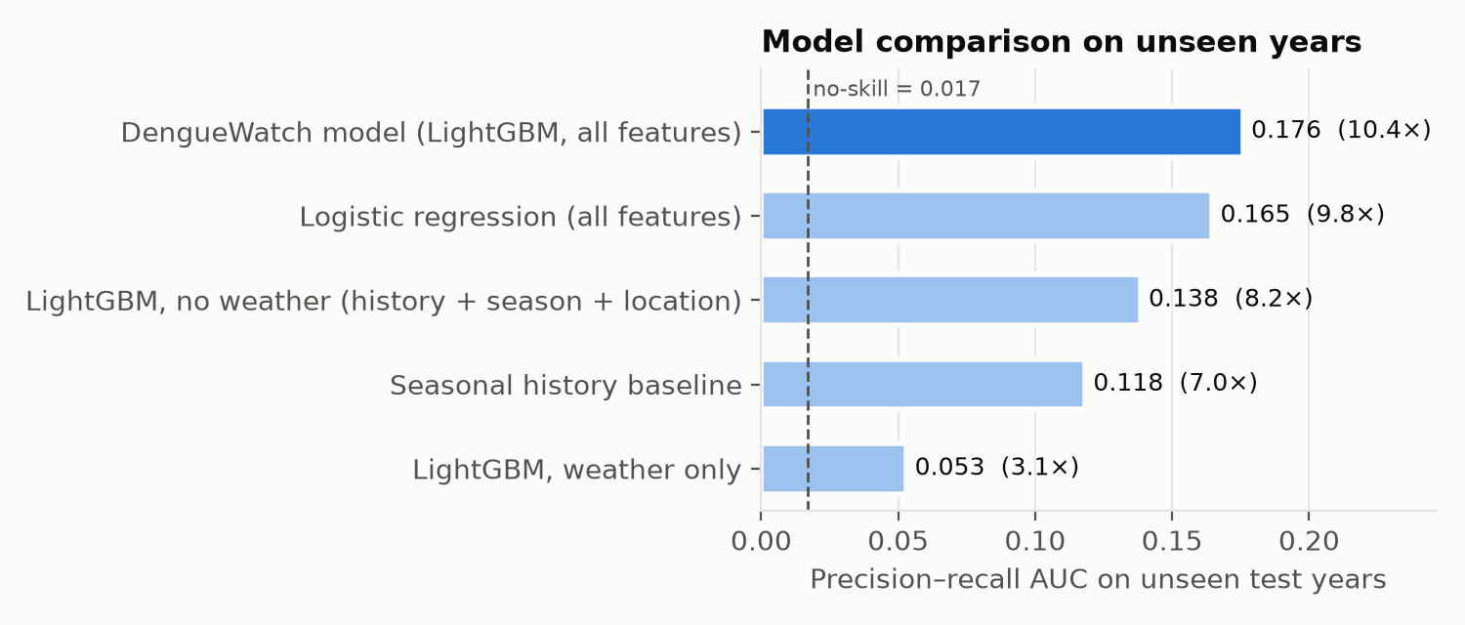
Figure 3. Precision–recall AUC on the test years for the DengueWatch model and four alternatives (all trained on the same 2010–2022 data). The multiplier shows how much better each is than chance.
Model | PR AUC | ROC AUC | vs chance
DengueWatch model (LightGBM, all features) | 0.176 | 0.869 | 10.4×
Logistic regression (all features) | 0.165 | 0.867 | 9.8×
LightGBM without weather (history + season + location) | 0.138 | 0.852 | 8.2×
Seasonal history baseline | 0.118 | 0.795 | 7.0×
LightGBM with weather only | 0.053 | 0.784 | 3.1×

Alerts in practice. Using the thresholds fixed on the 2022 validation year:
Alert level | District-weeks flagged | Precision | Recall | Lift over chance
High | 6.1% | 12.4% | 44.9% | 7.4×
Medium or high | 18.2% | 6.7% | 71.7% | 4.0×
Seasonal rule, same number of alerts as High | 6.1% | 11.4% | 41.1% | 6.7×

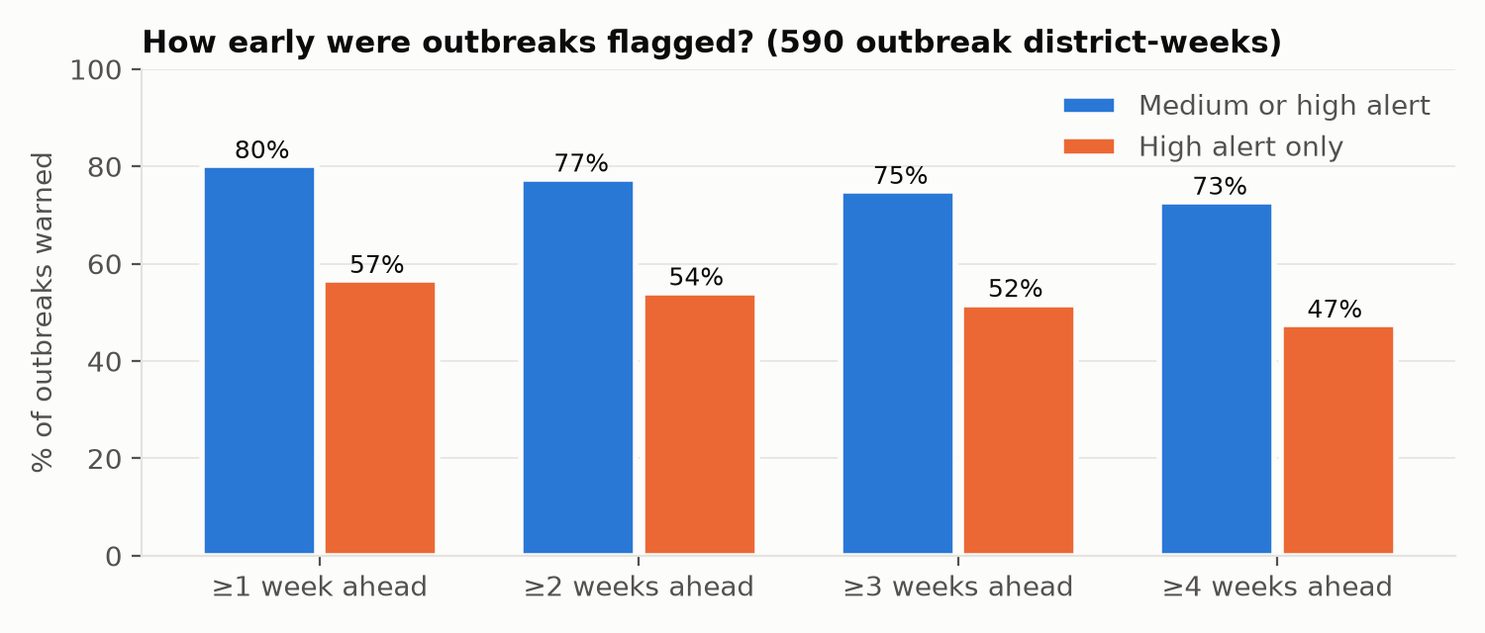
Figure 4. Share of the 590 district-weeks with a new outbreak in the test period that had already been flagged 1, 2, 3 or 4 weeks before the outbreak started.
- 80% of outbreaks were preceded by a medium or high alert, and 78% were flagged at least 2 weeks ahead. With high alerts only, 57% were flagged and 54% at least 2 weeks ahead.
- Performance holds in every test year (PR AUC 0.22 in 2023, 0.13 in 2024, 0.16 in 2025, 0.35 in 2026), always several times above chance.

7.2 What drives the predictions
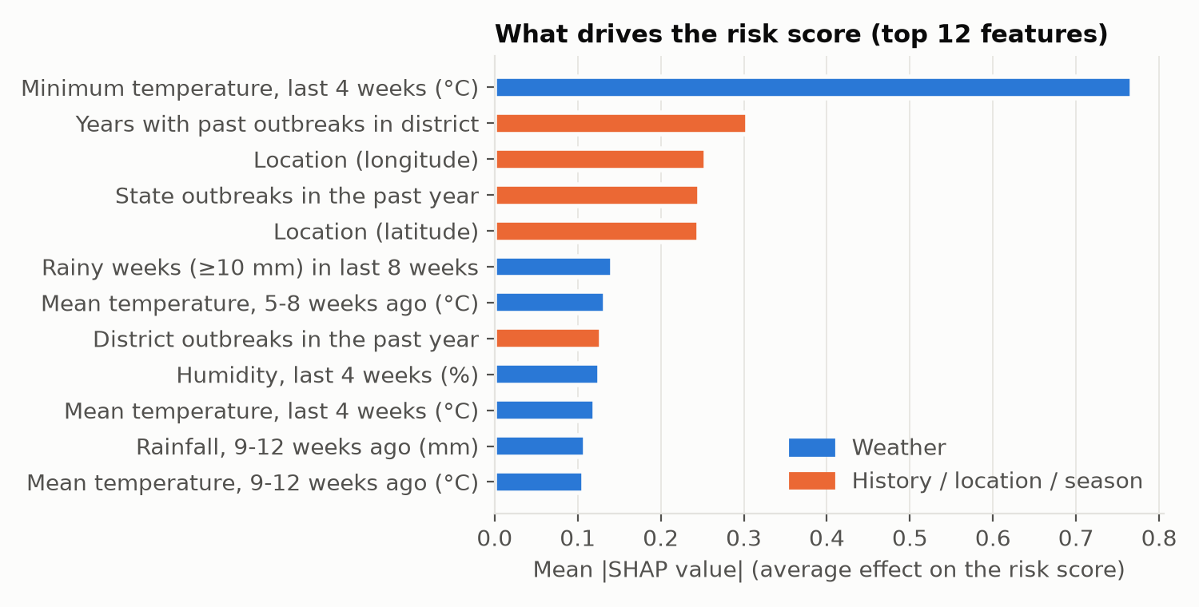
Figure 5. Average impact of each feature on the risk score (mean absolute SHAP value, test years). Blue = weather features.
- Weather features carry 56% of the total influence, history 25%, location 14% and season 5%.
- The strongest single signal is the minimum temperature over the last 4 weeks. This matches the Indian literature: Kakarla et al. (2019) found that risk more than doubles when the minimum temperature reaches about 26 °C. Recent rainy weeks, and rainfall and temperature 5–12 weeks earlier, follow.

7.3 Answers to the research questions (Section 3.4)
- RQ1, weather lags: Recent minimum temperature (last 4 weeks), the number of rainy weeks in the last 8, and rainfall and temperature 5–12 weeks earlier are the most informative weather signals. This is consistent with the 2–15 week lags reported for India.
- RQ2, predictability: Yes. On years it never saw, the model ranks district-weeks about 10 times better than chance (PR AUC 0.176, ROC AUC 0.87). Adding weather improves on history alone by 28% (PR AUC 0.176 against 0.138). Weather alone is weaker (0.053), so the two kinds of information work best together.
- RQ3, lead time: Most outbreaks (78%) were flagged at least 2 weeks before they started, and 73% at least 4 weeks before. The official PDF reports appear about 8 weeks after the outbreak, so the warning arrives roughly 10–12 weeks earlier than the public report.

7.4 Honest interpretation
- Precision is modest (12.4% for high alerts): most flagged district-weeks do not report an outbreak. Part of this is real and part reflects under-reporting, because an outbreak that happened but was never reported counts as a false alarm. For a surveillance officer the alert means "check here first", not "an outbreak is certain".
- Logistic regression performs almost as well as LightGBM (0.165 against 0.176). The gain from the more complex model is small; LightGBM was kept because it handles non-linear temperature effects and gives per-district explanations.
- The risk score is a ranking score, not a calibrated probability (the outbreak class is weighted 10× during training). The dashboard therefore shows risk levels rather than percentages.

7.5 The dashboard
The dashboard (Step 9) runs at http://localhost:8050/dashboard/ on the same Flask server as the API. It reads every number through the REST API, so users of the dashboard and of the API always see the same data. It has four pages, each answering a user story from Section 4.3. Screenshots are from the development copy; numbers on the laptop differ slightly (Section 8, Step 7).
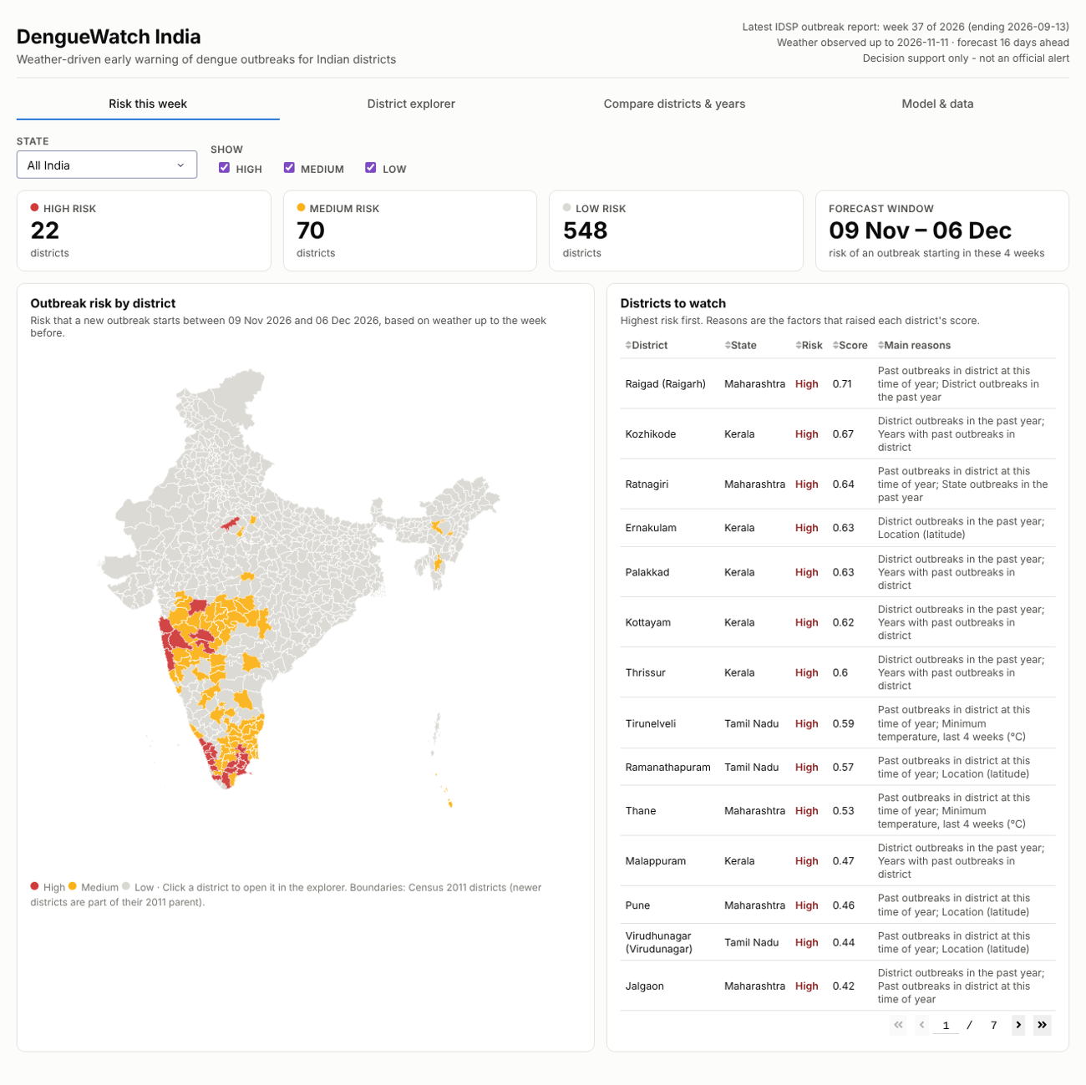
Figure 6. Risk this week (US-1): counts by risk level, a district map, and a ranked list of districts to watch with the main reasons. A state filter zooms the map; clicking a district opens it in the explorer.
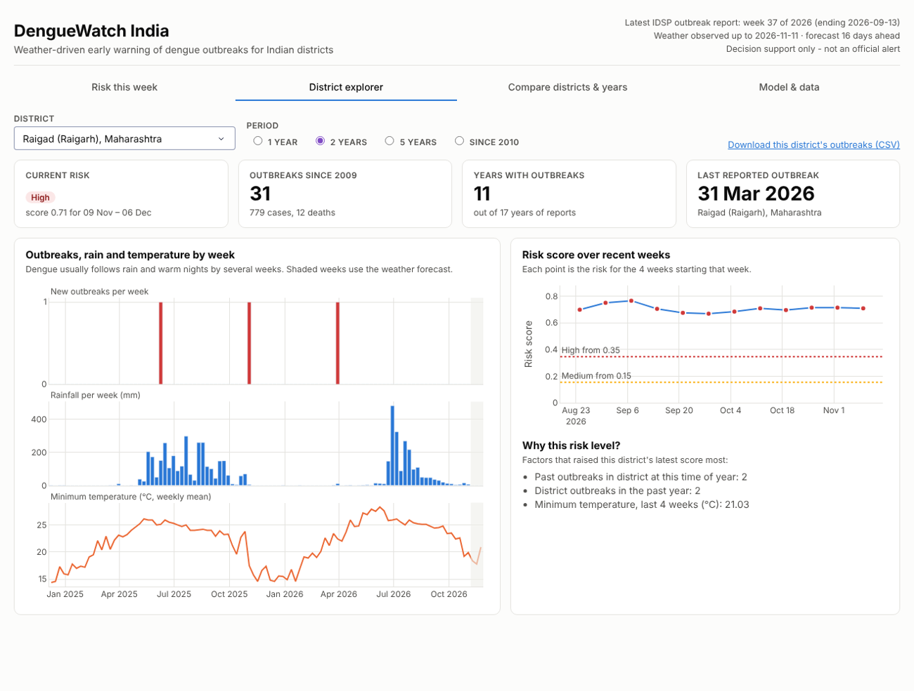
Figure 7. District explorer (US-2, US-3, US-5): current risk, outbreak history, weekly outbreaks shown against rainfall and minimum temperature (forecast weeks shaded), risk over recent weeks with the alert thresholds, the reasons for the score, and a CSV download.
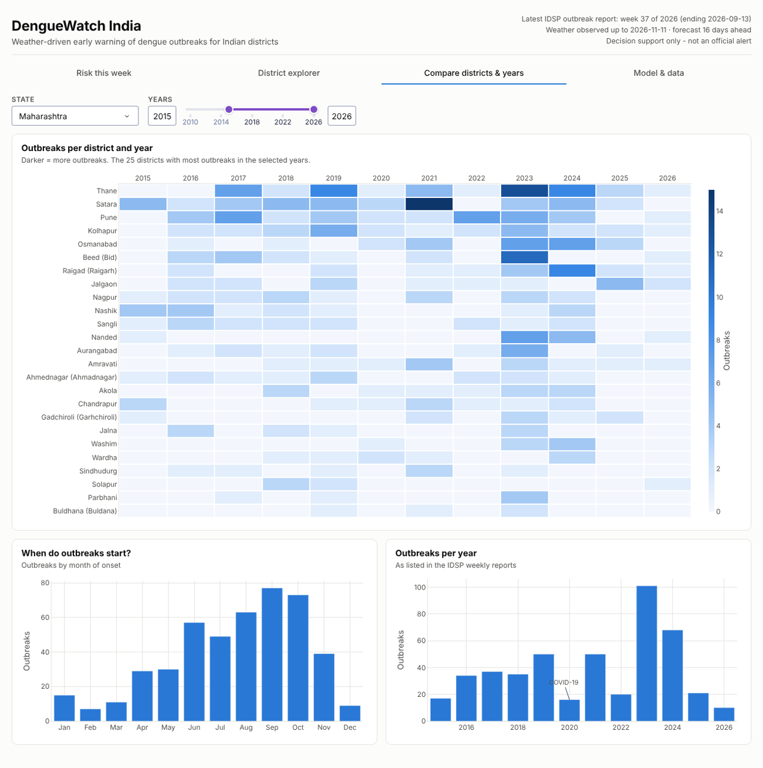
Figure 8. Compare districts & years (US-2): a district × year heatmap of outbreaks, the month in which outbreaks start, and outbreaks per year, for any state and period.
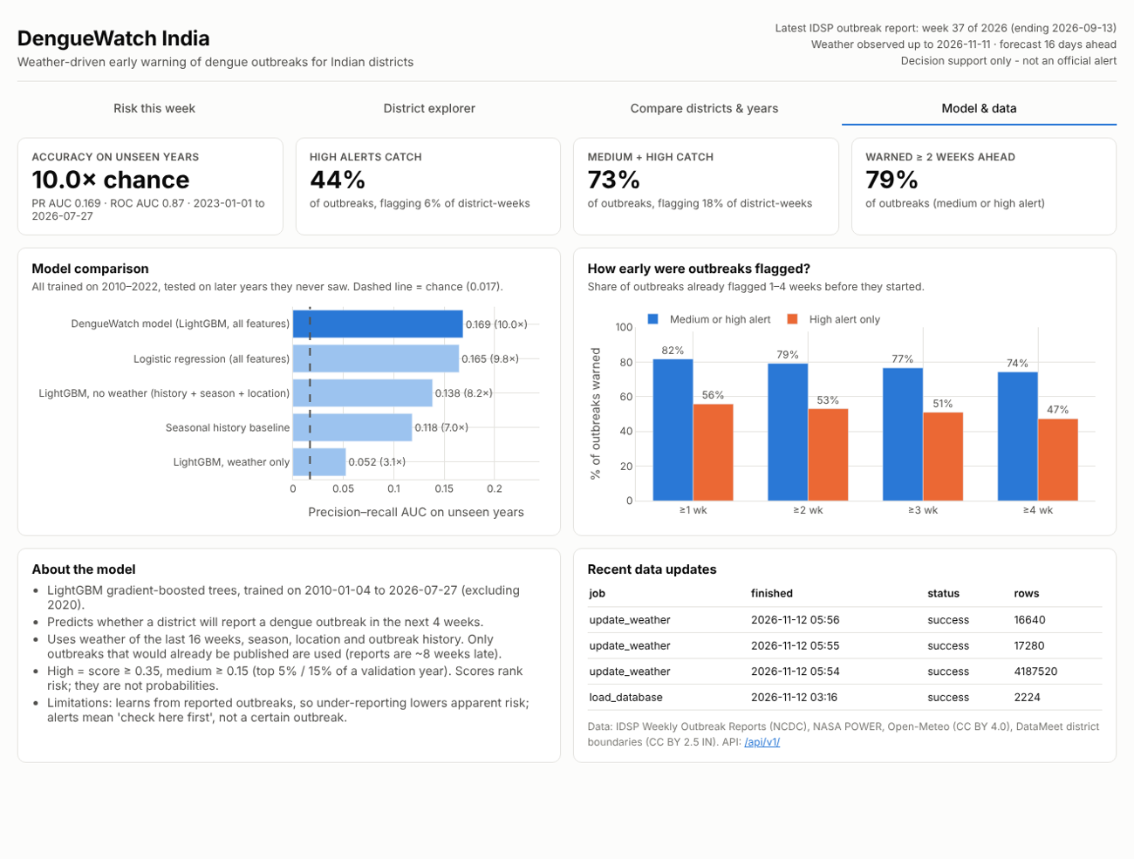
Figure 9. Model & data (US-4, US-7): accuracy on unseen years, model comparison, warning lead time, how the model works and its limits, and recent data updates.
Design choices. Risk levels use fixed status colours (red = high, amber = medium, grey = low) and are always shown with a text label, not colour alone. Charts that share a time axis are stacked (outbreaks, rain, temperature) rather than drawn on two y-axes. The map needs no online map tiles, so it also works offline during a presentation. Districts are drawn with Census 2011 boundaries, and today’s names are shown next to old Census spellings, e.g. “Raigad (Raigarh)”.

8. Development Process Log
A record of each step: what was done, how, and what was decided. This forms Deliverable 1 (Process and Outcome).

Step 0 — Topic selection & feasibility check (11 Nov 2026)
What was done
- Reviewed the Project Guidelines document in full: objective, required stack, evaluation criteria, seven deliverables and suggested presentation structure.
- Checked the initial problem idea (dengue outbreak information locked in weekly PDFs) against the guidelines: it fits the public health domain and the required Python + relational database stack.
- Reviewed prior work (EpiClim dataset, aflip/IDSP repository) to identify the gap.
- Evaluated a "live dashboard" idea. Finding: no real-time dengue data exists for India; IDSP reports are weekly with a lag of about two months. Weather data, however, is available daily with forecasts.
- Decision: re-framed the project as a weather-driven early warning system, so the "live" element comes from continuously updated weather and risk scores rather than case data.
Data feasibility check
- Located the complete IDSP weekly outbreak archive on the NCDC website: 896 weekly reports from 2009 to Week 37 of 2026 (about 52 per year).
- Downloaded 891 of them; all contain extractable text (no scanned images, so no OCR needed).
- A rough first-pass extraction found about 1,835 unique dengue outbreak events (≈1,07,000 cases) across about 320 districts. This is a lower bound: 2009–2011 use a different table layout that the quick parser missed.
Measure | Preliminary value
Dengue outbreak events (deduplicated) | ≈ 1,835
Outbreaks per year | ≈ 60–250 (highest: 2023, 251)
Districts with ≥ 1 outbreak | ≈ 320
Districts with ≥ 5 outbreaks | ≈ 70
Leading states | Maharashtra (421), Kerala (269), Karnataka (117), Tamil Nadu (100)

Implications for modelling
- Too few outbreaks per district for separate per-district models.
- A single pooled model across all districts is feasible: "Will district X report a dengue outbreak in the next 4 weeks?", using lagged weather, season, past outbreak history and state as features.
- Validation plan: train on 2009–2022 and test on 2023–2026 (time-based split).
Outcome: Topic confirmed — DengueWatch India, a weather-driven dengue early warning system with Python, Flask, PostgreSQL and an ML model.

Step 1 — Problem definition (11 Nov 2026)
What was done
- Collected evidence on dengue burden from official NCVBDC statistics (2021–2026) and published under-reporting studies.
- Reviewed peer-reviewed Indian studies on the lag between weather and dengue (Kakarla 2019; Singh & Chaturvedi 2022; Pramanik 2020) and the IITM Pune early warning work.
- Reviewed existing systems (IDSP reports, IHIP, EpiClim, WHO EWARS-csd, aflip/IDSP) to define the gap.
- Wrote the problem statement, research questions, objectives, scope and expected outcome (Section 3).
- Documented the reasoning behind choosing this problem over alternatives (Section 3.8).
- Defined the primary and secondary users, their workflows and seven user stories (Section 4).
Key decisions
- Prediction target: whether a district reports a dengue outbreak in the next four weeks (a yes/no risk), not exact case counts, because the data records outbreak events rather than all cases.
- Evaluation: time-based validation on 2023–2026, reporting recall, precision and lead time.
- Users: District Surveillance Officer (primary) and public health researcher or student (secondary), as illustrative personas.
Outcome: Deliverables 2 (Problem Statement) and 3 (Target User) are complete. Next: Step 2, requirements and system design.

Step 2 — Requirements & system design (11 Nov 2026)
What was done
- Turned the seven user stories into 16 functional requirements (with MoSCoW priority) and 11 non-functional requirements (Sections 6.1–6.2).
- Designed a six-layer architecture and drew the architecture diagram (Figure 1) and data flows for weekly ingestion, daily refresh and user requests (Section 5.2).
- Designed the PostgreSQL schema of 11 tables and drew the ER diagram (Figure 2); listed planned analytical queries.
- Specified 16 REST API endpoints traced to requirements (Section 6.5).
- Finalised the tech stack (Section 6.6) and the model design (Section 6.7).
- Recorded 11 design decisions with alternatives and reasons (Section 5.4).
Key decisions
- Dash chosen over Streamlit so that the Flask API and the dashboard run on one server.
- Weather stored daily and aggregated to weeks in SQL; districts identified by a canonical ID with an alias table.
- Model features respect the ~8-week reporting lag to avoid information leakage; evaluation uses a time-based split.
Outcome: Deliverable 4 (System Design) is complete and Deliverable 5 (Technical Specification) is specified. Diagram source files are saved in docs/diagrams. Next: Step 3, project setup.

Step 3 — Project setup (11 Nov 2026)
What was done
- Created the repository structure following the architecture: one Python package (denguewatch) with a sub-package per layer.
- Wrote README.md, requirements.txt, .gitignore and .env.example.
- Added a configuration module that reads settings from a .env file, so passwords are never stored in code.
- Built a minimal Flask application with a /api/v1/health endpoint and a placeholder Dash page at /dashboard, to prove the web stack works end to end.
- Wrote scripts/check_setup.py to check the environment and database connection, and three pytest smoke tests.
- Tested in a clean environment: all packages installed, 3/3 tests passed, and the health endpoint connected successfully to a PostgreSQL 16 test database.
- Added one-click Windows helpers: setup_windows.bat (finds conda/Python and PostgreSQL, creates the environment, installs packages, creates the database and .env), start_app.bat, and scripts/fix_database.bat.
Issues met and how they were solved
- conda was not available in a normal Command Prompt, and Anaconda was not in a standard folder: the setup script now locates it through the Anaconda Prompt shortcut and the registry, with a fallback to a plain Python virtual environment.
- PostgreSQL was not in C:\Program Files: a helper script now finds psql.exe through the PostgreSQL Windows service.
- The database password had been typed into .env.example (a file that is uploaded to GitHub) and contained an "@", which breaks database URLs. The password was moved to .env (never uploaded), and the database user was reset to a letters-and-numbers password.
Development environment (verified)
- Windows laptop; Python 3.11.18 (conda environment "denguewatch"); PostgreSQL 18.6; all 16 packages installed; setup check passed on 11 Nov 2026.
Outcome: Development environment ready and the project published to GitHub (github.com/Dwijen03/denguewatch-india, first commit "Step 3: project setup"). Next: Step 4, data acquisition and cleaning.

Step 4 — Data acquisition & cleaning (12 Nov 2026)
What was built
- reports.py: finds every weekly report linked from the NCDC Weekly Outbreaks page and downloads it politely (retries, pause between files, PDF check, SHA-256 fingerprint).
- pdf_parser.py: reads the outbreak tables in each PDF with pdfplumber and extracts dengue rows. It handles the three report layouts used since 2009, state/district cells merged across rows and pages, cases and deaths written as "17 / 0", and notes such as "310 (lab confirmed 12)".
- names.py and districts.py: recognise state names in messy text (e.g. "Maharashtr a", "Orissa") and match district names to 640 Census 2011 districts. Matching runs in order: exact name, then a curated alias list (317 renamed or newer districts, e.g. Belagavi → Belgaum, Palghar → Thane), then fuzzy match, then the IDSP unique ID.
- cleaning.py: parses dates in any format used, standardises status, flags suspected or mixed outbreaks, validates values, and removes outbreaks listed again in later weeks.
- pipeline.py and scripts/run_ingestion.py (or run_data_pipeline.bat) run everything and write five output files to data/processed/.
- 30 automated tests (pytest), including parsing two real IDSP reports kept as test fixtures.
Result
Measure | Value
Weekly reports processed | 891 of 896 listed (5 broken links); 2009 W25 – 2026 W37
Reports containing dengue outbreaks | 661
Dengue rows extracted | 2,460
Unique outbreaks (duplicates removed) | 2,224
Cases / deaths in those outbreaks | 1,20,705 / 552
Districts with ≥1 / ≥5 / ≥10 outbreaks | 353 / 134 / 56
Matched to a district | 98.6% (plus 9 state-wide outbreaks)
Flagged needs_review | 64 (2.9%)
Accuracy spot-check | 60 random outbreaks checked against their PDF page: 58 confirmed automatically; of the 2 checked by hand, 1 was correct and 1 had a wrong carried-over district, now fixed using the IDSP unique ID

First observations
- Strong seasonality: outbreaks starting in August–October make up 45% of the total, against 7% in December–February.
- Most outbreaks are reported from Maharashtra (613), Kerala (317), Tamil Nadu (260) and Karnataka (223). The busiest districts are Ernakulam, Thane, Satara and Beed.
- Median time from outbreak start to the end of the report week is 9 days. Public PDF release adds roughly 8 more weeks on top of this.
- 2020 had very few reports (41), consistent with surveillance disruption during COVID-19. The model will treat this year with care.
Problems solved
- Merged cells: state and district are printed once for a group of rows, so they are carried forward. Where the carry could be wrong (across page breaks), the IDSP unique ID (e.g. KN/CKR/2016/24/1401) is used to recover the state and district.
- Renamed and new districts: about 140 districts changed since 2011. These are mapped to their Census 2011 parent through a documented alias table.
- Duplicates: 154 outbreaks were listed more than once (follow-ups or late reports), producing 236 extra rows. Each outbreak is kept once, from its earliest report, and times_listed records how often it appeared.
Outcome: A clean, validated, district-level dengue outbreak dataset for 2009–2026 (data/sample/dengue_outbreaks.csv) ready to load into PostgreSQL. Next: Step 5, database implementation.

Step 5 — Database implementation (12 Nov 2026)
What was built
- database/schema.sql: 11 tables, keys, CHECK rules, 6 indexes and 3 views, following the Step 2 ER design. It is safe to run repeatedly.
- denguewatch/db/loader.py: creates the schema and loads states, districts, aliases, reports and outbreaks with upserts (INSERT … ON CONFLICT … DO UPDATE). Every load is logged in pipeline_runs.
- database/queries.sql + denguewatch/db/queries.py: 10 named analytical queries, run from Python by name with safely bound parameters. The API and dashboard will reuse them.
- scripts/setup_database.py (or setup_database.bat): builds and loads the database, prints row counts and example results. The --reset option rebuilds from scratch.
- tests/test_database.py: checks the data loaded, that no outbreak is orphaned, that every query runs and that the CHECK rules reject bad values. All changes made by the tests are rolled back.
Verification
- Loaded 891 reports and 2,224 outbreaks. Totals in the database match the Step 4 CSV exactly: 1,20,705 cases, 552 deaths, 2,192 outbreaks linked to a district, 64 flagged for review.
- Running the loader a second time left every count unchanged, so loads do not create duplicates.
- Rebuilding works both from the full processed data and from the sample data only, as a reviewer cloning the GitHub repository would do.
- All 44 automated tests pass: 30 from Step 4 and 14 for the database.
Design change from Step 2
- The districts key column lgd_code became census_code (Census 2011), because of the Census 2011 geography decision in Step 4. Outbreaks also gained quality columns: match_method, needs_review, review_reasons and times_listed. The ER diagram (Figure 2) was updated.
Outcome: A working, queryable PostgreSQL database with all dengue outbreak data and the analytical queries the app needs. Next: Step 6, weather data integration.

Step 6 — Weather data integration (12 Nov 2026)
What was built
- denguewatch/ingestion/weather.py: clients for NASA POWER (daily history from 2009) and the Open-Meteo forecast API (last 10 days and next 16 days, 50 districts per request). They include retries, polite pauses, handling of rate-limit replies and of history requested before it is published, and conversion to tidy daily rows.
- denguewatch/db/weather_store.py: bulk loading with PostgreSQL COPY into a temporary table, then a merge that keeps the most reliable value for each district and day (source priority). Downloads run in parallel. Only days still missing are downloaded, so the job can be stopped and restarted at any time.
- scripts/update_weather.py (or update_weather.bat). Options: --check tests that both services answer, --limit N does a trial run, and --no-history does the fast daily refresh. Every run is logged in pipeline_runs.
- Database: weather_daily gained a source column (nasa_power / open_meteo). Existing databases are upgraded automatically. The weekly view v_weather_weekly and the query rainfall_before_outbreaks now return results.
- tests/test_weather.py: tests the parsers with sample responses and checks that an observation replaces a forecast but never the reverse.
Verification
- This development environment cannot reach the weather services, so the complete pipeline was tested end to end against simulated NASA POWER and Open-Meteo responses with the real response formats. All 640 districts loaded with 4,170,880 daily rows (2009-01-01 to a few days ago) plus 16 forecast days, in under 2 minutes of database time. A second run correctly skipped all up-to-date districts.
- Queries on the full-size weather table are fast: rainfall before one district’s outbreaks takes 0.01 s and before all outbreaks about 1 s; a weekly weather lookup takes 0.01 s.
- All 48 automated tests pass.
- The real download runs on the development laptop with update_weather.bat (about 30–60 minutes for the first run, then about a minute per day).
Design change from Step 2
- Weather history now comes from NASA POWER instead of Open-Meteo, because of Open-Meteo’s free-use limits (see Section 5.4). Open-Meteo still provides the most recent days and the forecast that drive the early warning.
Outcome: Every district now has (or, after the laptop download, will have) daily weather from 2009 to 16 days ahead, linked to its outbreak history in SQL. Next: Step 7, the AI/ML early-warning model.

Step 7 — AI/ML early-warning model (12 Nov 2026)
What was built
- denguewatch/ml/features.py: builds the district-week table (598,400 rows) from outbreaks and weekly weather, with 23 features and the 4-week target. Reporting-lag rules make sure no feature uses information that was not yet published.
- denguewatch/ml/train.py: time-based evaluation, model comparison, alert thresholds, SHAP importance, and training of the final model. Models are saved as joblib files with their metrics as JSON and registered in model_versions (only one active).
- denguewatch/ml/predict.py: scores all 640 districts for the latest complete weather week (and the previous 11 weeks for history), stores risk score, level and top three factors in predictions, and can be re-run any time.
- scripts/train_model.py (or train_model.bat), scripts/plot_model_results.py for Figures 3–5, and scripts/export_weather_weekly.py to share weekly weather as a 7 MB file.
- tests/test_ml.py: checks the target windows and that an outbreak cannot influence any feature before it would have been published. All 53 tests pass.
How it was developed
- The real weather (exported from the project database) and the Step 4 outbreak data were used. 24 LightGBM settings were compared on the 2022 validation year; test years were used only once, for the final evaluation.
- The full script was first run against a database copy holding the same data, and then on the development laptop, where the registered model (version 1) was trained, evaluated and used to store predictions. Results in Section 7 are from the laptop run. The earlier run gave PR AUC 0.169 instead of 0.176, a small variation from parallel tree building, and all conclusions are the same.
First live risk map (scored for the 4 weeks from 9 Nov 2026)
- 22 districts at high risk and 68 at medium. The top ten are Raigad, Ratnagiri and Pune (Maharashtra); Kozhikode, Ernakulam, Palakkad, Thrissur and Kottayam (Kerala); and Tirunelveli and Ramanathapuram (Tamil Nadu). This is in line with the north-east monsoon season in the south.
Outcome: A validated, explainable early-warning model that updates from live weather. Next: Step 8, the Flask REST API.

Step 8 — Flask REST API (12 Nov 2026)
What was built
- denguewatch/api/routes.py: 17 endpoints in a Flask blueprint under /api/v1, covering outbreaks, summaries, district timelines, weather, current and past risk with explanations, model evaluation, data freshness, job history, CSV export and a token-protected refresh. The planned /ask endpoint moves to Step 11, with the agent.
- Input validation on every parameter (whole numbers, ranges, ISO dates, allowed values). Errors are consistent JSON and unknown /api paths return JSON 404s. Dates are formatted as YYYY-MM-DD.
- Security: read-only public endpoints; the admin refresh needs the secret ADMIN_TOKEN from .env and runs its job in the background; all SQL is parameterised.
- The analytical queries from Step 5 (database/queries.sql) are reused unchanged, for example current_risk and data_freshness.
- docs/API.md: a reference with real example responses. tests/test_api.py: 21 API tests covering bad inputs, a SQL-injection attempt, 404s, filters, paging, the CSV export and the admin token.
Verification
- All 74 automated tests pass.
- On the full dataset every endpoint answered in under 0.1 s, well inside the 3-second requirement (NFR-1). Returning all 640 district risks takes 0.02 s.
Outcome: Outbreaks, weather and risk can now be queried over HTTP by the dashboard and by researchers (FR-10, US-6). Next: Step 9, the dashboard.

Step 9 — Dashboard (12 Nov 2026)
What was built
- denguewatch/dashboard/app.py: a Dash app with four pages (Section 7.5), served at /dashboard/ on the same Flask server as the API. It gets all its data from the REST API through an internal, in-process client.
- Risk map: Census 2011 district boundaries (data/reference/districts_2011.geojson, simplified to 0.6 MB) drawn with a map style that needs no internet tiles.
- Interaction: state and risk-level filters, click-to-open from the map and the table, hover details on every chart, period selection, and per-district CSV export.
- Styling in denguewatch/dashboard/assets/style.css: one set of colours and spacing, status colours for risk levels, and a layout that adapts to phone screens.
Problems solved
- The first version froze: Dash prepares the page inside a request, and the page then called the API on the same app, which waited for itself. The fix was a small internal Flask app that holds only the API, used by the dashboard.
- The first map needed a world outline downloaded from the internet. It was replaced by a map type that needs no online resources.
Verification
- Tested in a real browser (Chromium) with screenshots of every page. Checked: the state filter (Kerala gives 7 high, 4 medium and 3 low), clicking the map opens the district explorer, period buttons, and a phone-sized screen. No browser errors.
- All 76 automated tests pass, including new dashboard tests.
- Requirements now met in the interface: FR-7 (risk map and table), FR-8 (comparisons), FR-9 (timeline with weather), FR-12 (data freshness in the header), FR-13 (model page), FR-14 (reasons per district) and FR-15 (CSV export).
Outcome: Surveillance officers and researchers can see current risk, explore any district and compare years without touching code. Next: Step 10, automation of weekly and daily updates.

9. Use of AI Agent (Optional)
Status: Pending — to be completed in Step 11
Options under consideration:
- News-signal agent: scans news daily for dengue reports, extracts district and case counts, and stores them as unverified early signals, kept separate from official data.
- Natural-language query agent: converts plain-English questions into read-only SQL queries over the database.
[Tools used, agent role and guardrails to be documented in Step 11]

10. GitHub Repository
Status: Live — first commit pushed in Step 3; updated at every step
Repository: github.com/Dwijen03/denguewatch-india (public)

10.1 Repository structure
Folder / file | Contents
denguewatch/ | Main Python package: config.py, app.py, and sub-packages ingestion, db, ml, api, dashboard, scheduler
database/ | SQL schema and analytical query scripts (Step 5)
data/raw, data/processed | Downloaded PDFs and intermediate files; not committed (re-created by the pipeline)
data/sample/ | Small sample dataset committed for reviewers
models/ | Trained model files; not committed
notebooks/ | Exploration and analysis notebooks
scripts/check_setup.py | Checks Python version, packages, .env and the PostgreSQL connection
tests/ | pytest tests (skeleton tests for configuration, API health and dashboard)
docs/diagrams/ | Architecture and ER diagrams with their source files
run.py | Starts the Flask server with the API and dashboard
requirements.txt | Python dependencies (minimum versions; pinned with pip freeze at the end)
.env.example | Template for local settings (database URL, admin token, source URLs)
.gitignore | Keeps secrets (.env), raw data, model files and caches out of Git
README.md | Overview, status, architecture, tech stack, structure, setup and usage instructions

10.2 Setup summary
- Install Python 3.11+ (Anaconda), PostgreSQL 16+ and Git.
- Create a conda environment and run pip install -r requirements.txt.
- Create a database user and database named denguewatch in PostgreSQL.
- Copy .env.example to .env and set the database password.
- Run python scripts/check_setup.py, then pytest, then python run.py and open http://localhost:8050.

10.3 Commit practice
Work is committed at the end of every project step (and more often during coding steps) with short, descriptive messages, so that the commit history shows how the project was built.

11. Assumptions & Limitations (running list)
- IDSP weekly reports list outbreak events reported by districts, not every dengue case. Outbreak counts are therefore an indicator, not total incidence.
- Not all states report every week (e.g. 21 States/UTs reported in Week 30, 2026), so "no outbreak reported" does not always mean "no outbreak".
- Official reports are published with a lag of about two months; the system cannot show real-time case data.
- Report tables are irregular across years; extracted values need cleaning and manual validation. Preliminary counts in Section 8 are approximate.
- District names vary in spelling, and some districts were split or renamed between 2009 and 2026.
- Weather is taken at a single representative point (district centre), not averaged over the whole district. NASA POWER values come from gridded reanalysis and satellite products (about 50 km resolution for temperature and humidity), so they describe the district’s general climate rather than a weather station reading.
- The most recent days come from Open-Meteo and older days from NASA POWER. Values from the two sources may differ slightly; Open-Meteo values are replaced automatically once NASA POWER data for those days is available.
- Districts created after 2011 are counted under their Census 2011 parent district (e.g. Palghar under Thane), so results are reported for 2011 boundaries.
- Text extraction from PDFs is not perfect: in a random check of 60 outbreaks one carried-over district was wrong (now corrected via the IDSP ID). 64 outbreaks (2.9%) are flagged needs_review and will be excluded from model training unless checked.
- Five weekly reports listed on the NCDC website could not be downloaded (broken links: 2009 W38, 2013 W9, 2016 W15, 2017 W4, 2019 W7).
- No field research or interviews are conducted for this minor project; user needs are stated as assumptions.
- Districts with no outbreak reported in a week are treated as "no outbreak" for training, while recognising that some may simply not have reported.
- Open-Meteo is used under its free non-commercial terms; the system is an academic prototype, not an operational government service.
- Risk scores are decision support only; they do not replace field surveillance or official alerts.
- The model learns from reported outbreaks, so districts or years with weak reporting look like low risk. 2020 was left out of training because COVID-19 disrupted surveillance.
- The latest 6 weeks of outbreak data cannot be used as training labels yet, because their reports are still being published.

12. Limitations & Future Extensions
Status: Pending — to be completed in Step 12
- Possible extension: dengue serotype tracking for India using NCBI Virus genome data.
- Possible extension: comparison with countries that have live dengue APIs (e.g. InfoDengue, Brazil).

13. References
NCDC — IDSP Weekly Outbreak Reports archive
IDSP Weekly Outbreak Report, Week 30, 2026
EpiClim: Weekly District-Wise all-India Multi-Epidemics Climate-Health Dataset (arXiv 2501.18602)
aflip/IDSP — extraction of IDSP data (GitHub)
NCVBDC — Dengue cases and deaths 2021–2026 (till April)
Al Jazeera — India's dengue no longer confined to the monsoons (June 2026)
NASA POWER Daily API documentation (NASA Langley Research Center)
Open-Meteo Forecast API documentation
Open-Meteo terms of use and API limits
Kakarla S.G. et al. (2019). Lag effect of climatic variables on dengue burden in India. Epidemiology and Infection, 147, e170.
Singh P.S. & Chaturvedi H.K. (2022). A retrospective study of environmental predictors of dengue in Delhi from 2015 to 2018 using the generalized linear model. Scientific Reports, 12, 8109.
Pramanik M. et al. (2020). El Niño Southern Oscillation as an early warning tool for dengue outbreak in India. BMC Public Health, 20, 1498.
Shepard D.S. et al. (2014). Economic and disease burden of dengue illness in India. Am. J. Trop. Med. Hyg. (summary: BrandeisNOW)
The South First (Dec 2025). Government death records show 571% more dengue deaths than Health Ministry data.
The Tribune / PTI (Jan 2025). Scientists link climate change to dengue outbreaks, develop early warning system (IITM Pune).
The Tribune (Nov 2025). India set to transition from detective to predictive disease surveillance.
WHO India (Apr 2021). Next-gen digital platform (IHIP) launched pan India to accelerate outbreak response.
WHO TDR. Early Warning and Response System for climate-sensitive diseases (EWARS-csd).

