### A MINOR-PROJECT REPORT

ON

## “FRISKY IMAGES”

### Submitted to

Kalinga Institute of Industrial Technology (KIIT), Deemed to be University

In Partial Fulfilment of the Requirement for the Award of BACHELOR’S DEGREE IN

COMPUTER SCIENCE

&

ENGINEERING BY

DWIJRAJ BHATTACHARYYA 1405214

DEBOTOSH SARKAR 1405212

HARSHIT KUMAR GUPTA 1405216

UNDER THE GUIDANCE OF

PROF. MANAS RANJAN LENKA



SCHOOL OF COMPUTER ENGINEERING

### KALINGA INSTITUTE OF INDUSTRIAL TECHNOLOGY

### DEEMED TO BE UNIVERSITY

BHUBANESWAR, ODISHA - 751024 2017-2018

### A MINOR-PROJECT REPORT

ON

## “FRISKY IMAGES”

### Submitted to

Kalinga Institute of Industrial Technology (KIIT), Deemed to be University

In Partial Fulfilment of the Requirement for the Award of BACHELOR’S DEGREE IN

COMPUTER SCIENCE

&

ENGINEERING BY

DWIJRAJ BHATTACHARYYA 1405214

DEBOTOSH SARKAR 1405212

HARSHIT KUMAR GUPTA 1405216

UNDER THE GUIDANCE OF

PROF. MANAS RANJAN LENKA



SCHOOL OF COMPUTER ENGINEERING

### KALINGA INSTITUTE OF INDUSTRIAL TECHNOLOGY

### DEEMED TO BE UNIVERSITY

BHUBANESWAR, ODISHA - 751024 2017-2018

## Kalinga Institute of Industrial Technology (KIIT), Deemed to be University

School of Computer Engineering Bhubaneswar, ODISHA 751024



# CERTIFICATE

This is certify that the project entitled

### “FRISKY IMAGES“

submitted by

DWIJRAJ BHATTACHARYYA 1405214

DEBOTOSH SARKAR 1405212

HARSHIT KUMAR GUPTA 1405216

is a record of bonafide work carried out by them, in the partial fulfilment of the requirement for the award of Degree of Bachelor of Engineering (Computer Science OR Information Technology) at Kalinga Institute of Industrial Technology (KIIT), Deemed to be University, Bhubaneswar. This work is done during year 2016-2017, under our guidance.

Date: 9/12 /2017

PROF. MANAS RANJAN LENKA PROF. PINAKI CHATTERJEE

(Prof. GUIDE NAME) (Prof. PROJECT COORD NAME)

Project Guide Project Coordinator

Acknowledgements

We are profoundly grateful to Prof. Manas Ranjan Lenka for his expert guidance and continuous encouragement throughout to see that this project rights its target since its commencement to its completion. .....................

DWIJRAJ BHATTACHARYYA

DEBOTOSH SARKAR

HARSHIT KUMAR GUPTA

## ABSTRACT

This is an open source project and is presenting Github. It’s an Android Library that Android Developers can use while developing Android Applications So that they are freed from the task of writing too many boiler plate codes for implementing a various animations. The library will have various functions that the developers would call to improvise their (User Interface)UI/(User Experience)UX .

The software will work on Android Studio , it is available for all Android Developers that develop android Applications for Jelly Bean(4.2.x, 4.3.x), KitKat(4.4),Lollipop (5.0), Marshmallow(6.0), Nougat(7.0),Nougat++(7.1).The project is licensed under apache license 2.0.

**Key Words :** Open Source, Library, UI/UX, Apache license

# Contents

1. Introduction 1

1.1 INTRODUCTION . . . . . . . . . . . . . . . . . . . . . . . . . . . 1

1.1.1 PROBLEM ………………………………………………… 1

1.1.2 PURPOSE. …………………………………………………. 1

1. Literature Survey 2

2.1 LITERATURE SURVEY . . . . . . . . . . . . . . . . . . . . . . . . . . 2

1. Software Requirements Specification 3

3.1 OVERALL DESCRIPTION . . . . . . . . . . . . . . . . . . . . . . . . . 3

1. Requirement Analysis 4

4.1 EXTERNAL INTERFACE REQUIREMENTS...................................... 4 4.2 FUNCTIONAL REQUIREMENTS…………………………………… 4

4.3 NON FUNCTIONAL …………………………………………………. 5

4.4 OTHER REQUIREMENTS…………………………………………… 5

1. System Design

5.1 USE CASE. . . . . . . . . . . . . . . . . . . . . . . . . . . 6

5.2 CLASS ………………………………………………………………………7

5.3 CLASS……………………………………………………………………….8

5.4 SEQUENCE………………………………………………………………….9

5.5 ACTIVITY…………………………………………………………….……10

1. System Testing 11

6.1 System Testing………………………………………………………………11

1. Project Planning 12

7.1 Project Planning…………………………………………………………….13

1. Implementation 14-16
2. Screenshots of Project 17
   1. Screenshot1………………………………………………………………..17
   2. Screenshot2………………………………………………………………..18
3. Conclusion and Future Scope 19
   1. Conclusion 19
   2. Future Scope……………………………………………………………..19

11. References 20

List of Figures

1.1 Use case UML Diagram ……………………………………………………………………………………… 6

1.2 Class Diagram…………………………………………………………………………………………………7-8.

1.3Sequential Diagram…………………………………………………………………………………………….9

1.4Activity Diagram……………………………………………………………………………………………….10

1.5 Images of working……………………………………………………………………………………………17

1.6 Images of working……………………………………………………………………………………………18

# Introduction

## **1.1 Problem**

Currently, Open source contribution is new trend and advancement in the field of information technology. Developers are at ease from android library functionalities but they are writing multiple lines of codes even to improvise basic UI/UX of their application. Although, open source contribution can be used for everyone’s ease.

## **1.2 Purpose**

The purpose of this project is contribution and encouragement for an open source android library to ease the life of the android developers for easy, swift and time saving android application development.

## **1.3 Document Conventions**

The proposed SRS( software Requirement Specification) document (Chapter-3) is based on IEEE SRS standards, covering all aspects required by developers and users to understand application interface and it’s capabilities.

*School of Computer Engineering, KIIT, BBSR* 1

Chapter 2

Literature Survey

1. The open source software (OSS) phenomenon has over the last decade had a significant impact, not only on the software industry, but also on software-intensive organisations in both the public and private sector. The collaborative development model often associated with OSS communities has introduced a new software development model. This model has inspired software companies into evolving their existing development processes and collaborating both internally and across company borders.
2. **Harnil Oza wrote in the article on 17 October 2017** that, **“** Today, all well-known mobile applications are coherently built by putting [UI/UX design](https://www.crowdreviews.com/blog/android-application-development-uiux-design-app-development/) into consideration.Mobile apps that are designed without putting UI/UX into consideration leads to a failure to attract users. Currently, with very attractive and cool looks, users prefer quick and easy to navigate applications that can solve their problems with fewer interactions and touch. Therefore, it is very important for mobile app development companies or [app developers in India](https://www.hyperlinkinfosystem.com/android-app-development-india.htm) to comprehend the importance of UI/UX in the development of mobile apps. ”

*School of Computer Engineering, KIIT, BBSR* 2

# Chapter 3

# SOFTWARE REQUIREMENTS SPECIFICATION:

## **3.1 Overall Description**

### **3.1.1 Product Perspective**

This product is an android library that android developers can use while developing android applications so that they are freed from the task of writing too many boiler plate codes for implementing various animations

### **3.1.2 Product Functions**

This library will have various functions that the developers would call which would help them improvise their UI/UX . The library functions contains boiler plate codes that one needs to write for performing various animations and the code is tested so that the developers need not worry about writing and testing them and developers could also customise.

### **3.1.3 User Classes and Characteristics**

The application is developed for all android developers who wish to improve their UI/UX without writing too many boiler plate codes.

*School of Computer Engineering, KIIT, BBSR* 3

# Chapter 4

# Requirements Analysis

## **4.1 External Interface Requirements**

### **4.1.1 User Interfaces**

Since this is an android library it doesn’t have it’s own UI .This is use to improve UI of android applications.

### **4.1.2 Software Interfaces**

The connections between this product and other specific software components are: Bintray database for uploading into gradle and maven repositories, android operating system, android studio.

### **4.1.3 Communications Interfaces**

This project will communicate with other android applications via various functions calls available in it.

## **4.2 FUNCTIONAL REQUIREMENTS**

### **Requirement 1:** Android version having API level 17 and above.

### **Requirement 2:** Android OS 4.4 and above.

### **Requirement 3:** Works on android tablets , phones.

*School of Computer Engineering, KIIT, BBSR 4*

## **4.3 NON FUNCTIONAL REQUIREMENTS**

### **4.3.1Performance Requirements**

This will work on IDE that can download libraries in JCentre and Maven.

### **4.3.2 Safety Requirements**

There are no safety requirement required

### **4.3.3 Security Requirements**

No security requirements developers can directly download the libraries from JCenter and Maven it is an open source project and anyone can contribute to it via pull requests on github.

# 4.4Other Requirements

The library is uploaded on bintray and can be used as JCenter and Maven repository.

*School of Computer Engineering, KIIT, BBSR 5*

# Chapter 5

# 5.System Design

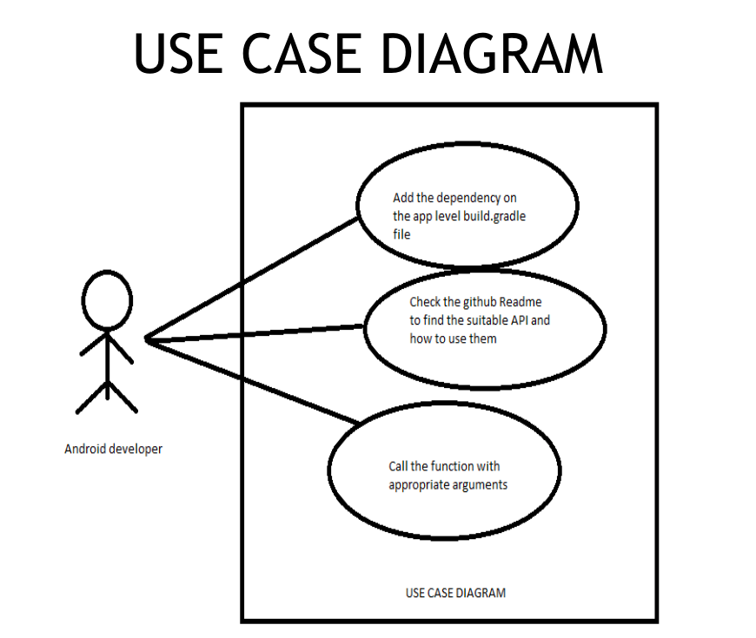

**Fig 1.1 Use Case Diagram for developing android application.**

*School of Computer Engineering, KIIT, BBSR 6*

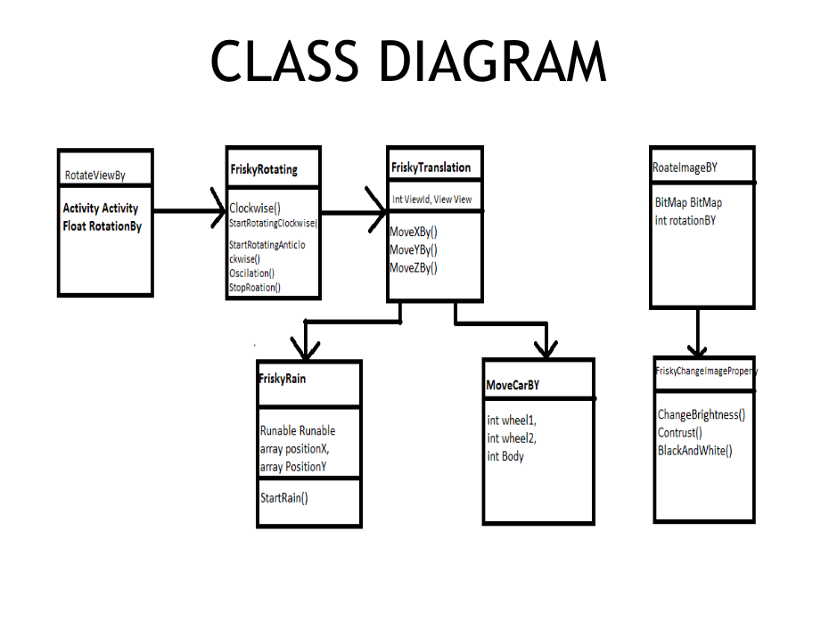

**Fig 1.2 Class Diagram**

*School of Computer Engineering, KIIT, BBSR* 7

Class Diagram

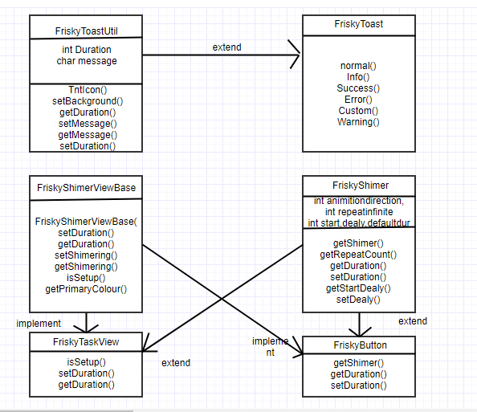

*School of Computer Engineering, KIIT, BBSR* 8

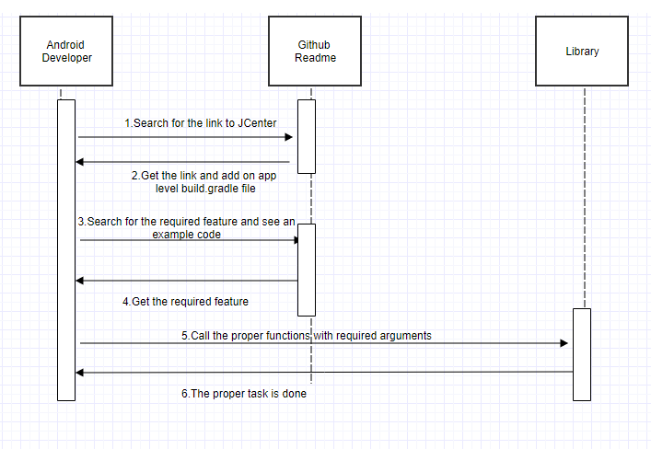

*School of Computer Engineering, KIIT, BBSR* 9

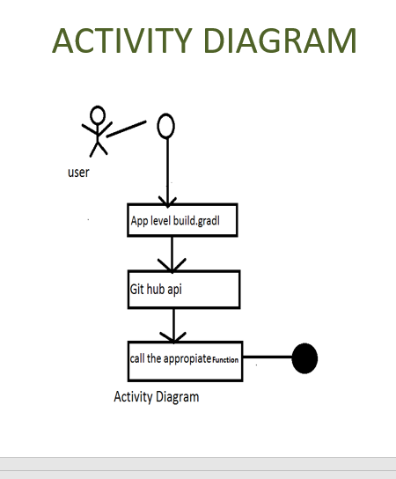

*School of Computer Engineering, KIIT, BBSR* 10

# Chapter 6 System Testing

## **6.1 Test Cases and Test Results**

|  |  |  |  |  |
| --- | --- | --- | --- | --- |
| Test  ID | Test Case Title | Test Condition | System Behavior | Expected Result |
| T01 | FriskyShimmer | Calling the function in a test  Android application | Shows shimmering effect as expected | Should show shimmering effect |
| T02 | FriskyBase64 | Calling the function in a test  Android application | Encodes the Image into Base64 without freezing the application | Should encode the image into base64 |
| T03 | FriskyAnim | Calling the function in a test  Android application | Shows Bounce ,Car movement, Rain animation | Should show the desired animation |
| T04 | ImagePropertyChange | Calling the function in a test  Android application | Changes the contrast ,Brightness and sharpness of the images  As expected | Changes the Bitmap into desired format |
| T05 | FriskyToast | Calling the function in a test  Android application | Shows toast message of the desired output | Should show toast of  with the parameters passed |

*School of Computer Engineering, KIIT, BBSR* 11

# Chapter 7 Project Planning

## **1.Requirement Gathering:**

## Firstly, we studied the current research in the field of the android development. Then the pre-requisites for making the android library were studied.

## **2.Analysis:**

## Since open source can be used to implement android library and can help developers to easily develop their applications easily by using single lines of code instead of multiple lines of codes.

*School of Computer Engineering, KIIT, BBSR* 12

|  |  |  |  |  |  |  |  |  |  |  |  |  |  |  |  |  |
| --- | --- | --- | --- | --- | --- | --- | --- | --- | --- | --- | --- | --- | --- | --- | --- | --- |
|  | 10th Oct 2017 - 4th Nov 2017 | | | | | | | 4th Nov 2017 - 25th Nov 2017 | | | | | | | 26 th Nov-1th Dec | |
| **Task Name** | Sun | Mon | Tue | Wed | Thu | Fri | Sat | Sun | Mon | Tue | Wed | Thu | Fri | Sat | Sun | Mon |
| *Documentation* |  |  |  |  |  |  |  |  |  |  |  |  |  |  |  |  |
| *Analysis* |  |  |  |  |  |  |  |  |  |  |  |  |  |  |  |  |
| *Requirement specification* |  |  |  |  |  |  |  |  |  |  |  |  |  |  |  |  |
| *Design and analysis* |  |  |  |  |  |  |  |  |  |  |  |  |  |  |  |  |
| *Coding* |  |  |  |  |  |  |  |  |  |  |  |  |  |  |  |  |
| *Testing* |  |  |  |  |  |  |  |  |  |  |  |  |  |  |  |  |
| *Deployment* |  |  |  |  |  |  |  |  |  |  |  |  |  |  |  |  |
| *Implementation* |  |  |  |  |  |  |  |  |  |  |  |  |  |  |  |  |

Gantt Chart

*School of Computer Engineering, KIIT, BBSR 13*

# Chapter 8 Implementation

1. Integrating the library into android application

Include this line on your app level build.gradle file under **dependencies** 

compile 'dwijrajbhattacharyya.FriskyImage:FriskyImage:2.0.0'

1. Animtions
   1. Moving car animation

Java Code

FriskyTanslationsWheel1=newFriskyTanslations(MainActivity.this,R.id.Image1);

FriskyTanslationsWheel2=newFriskyTanslations(MainActivity.this,R.id.Image2);

Wheel1.StartRotationClockWise();

Wheel2.StartRotationClockWise();

FriskyTanslations Car=new FriskyTanslations(MainActivity.this,R.id.car);

Car.MoveXBy(-140,3000);

Wheel1.MoveXBy(-140,3000,true);

Wheel2.MoveXBy(-140,3000,true);

*School of Computer Engineering, KIIT, BBSR* 14

2.2 Colliding Animation

FriskyBounce friskyBounce1=new FriskyBounce(MainActivity.this,R.id.RootId123,R.id.ID1234ID);

FriskyBounce friskyBounce1=new FriskyBounce(MainActivity.this,R.id.RootId123,R.id.ID1234ID);

FriskyBounce friskyBounce2=new FriskyBounce(MainActivity.this,R.id.RootId123,R.id.ID1235ID);

FriskyBounce friskyBounce3=new FriskyBounce(MainActivity.this,R.id.RootId123,R.id.ID1236ID);

friskyBounce1.StartCrazyBounce1(3000);

friskyBounce2.StartCrazyBounce2(3000);

friskyBounce3.StartBounce(5000,3000);

FriskyBounce friskyBounce=new FriskyBounce(MainActivity.this,R.id.RootId123,R.id.ID123ID);

friskyBounce.StartCrazyBounce3(3000);

FriskyBounce friskyBounce=new FriskyBounce(MainActivity.this,R.id.RootId123,R.id.ID123ID);

friskyBounce.StartCrazyBounce3(3000);

2.3 Rain animation

newFriskyRain().StartRain(R.drawable.rain_drop,R.id.Root1235,-10,MainActivity.this);

2.4 Fade animation

new FriskyFade().InfiniteRepeat

(bitmap1,MainActivity.this,R.id.FadeLayout,5000);

*School of Computer Engineering, KIIT, BBSR* 15

2.5 Frisky Toast

FriskyToast.warning(MainActivity.this,"WarningToast",Toast.LENGTH_SHORT).show();

FriskyToast.success(MainActivity.this,"Successs",Toast.LENGTH_SHORT).show();

FriskyToast.info(MainActivity.this,"Info",Toast.LENGTH_SHORT).show();

FriskyToast.error(MainActivity.this,"Error",Toast.LENGTH_SHORT).show();

FriskyToast.custom(MainActivity.this,"CustomToast",R.drawable.ic_launcher,Color.BLACK,3000,true,true).show();

2.6 Frisky Shimmer

XML Code

<dwijraj.FriskyView.FriskyFriskyShimmerTextView

android:layout_width="match_parent"

android:text="Hello world I am working"

android:textSize="23sp"

android:gravity="center"

android:id="@+id/FriskyShimmer"

android:textColor="@color/colorPrimaryDark"

android:layout_height="120dp" />

Java Code

shimmerTextView=(FriskyFriskyShimmerTextView) findViewById(R.id.FriskyShimmer);

FriskyShimmer shimmer=new FriskyShimmer();

shimmer.setDuration(5000);

shimmer.start(shimmerTextView);

*School of Computer Engineering, KIIT, BBSR* 16

# Chapter 9 Screenshots of Project

### 9.1 Screenshot of Frisky images

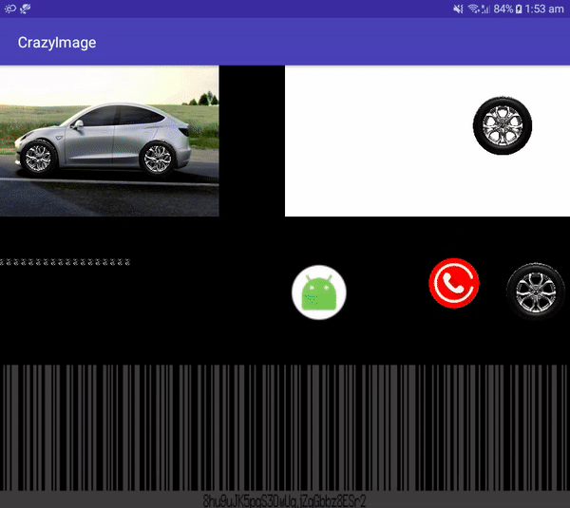

*School of mputer Engineering, KIIT, BBSR* 17

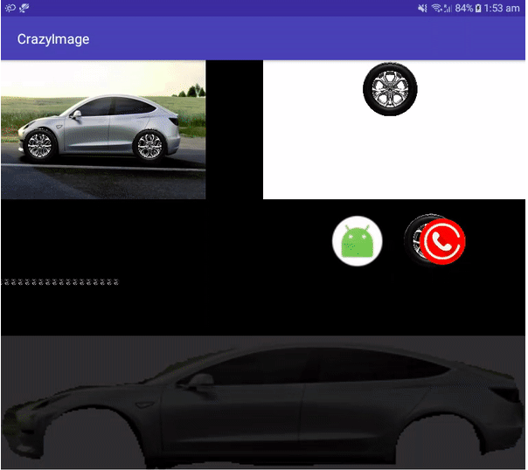

*School of mputer Engineering, KIIT, BBSR* 18

# Chapter 10

# Conclusion and Future Scope

## **Conclusion**

This project helped us to recognise and highlight the importance of open source and UI/UX. The sequential implementation of ‘Software Development Life Cycle’ waterfall model enhanced provided us exposure to real life project implementation scenario. This is an open source project and people can use, modify, contribute and enhance the project.

### **Future Scope**

Android is leading the market and directly or indirectly, it is has been able to successfully embed in our routine activities. Advancement and research work in the field of android development to make it more attractive, accessible and available to the people is taking place rapidly. In Future :

* + - Open source android libraries will make android development easy and swift.
    - Various research works across the globe can be used to implement and build better and attractive applications.

*School of Computer Engineering, KIIT, BBSR* 19

# References

[1] *NAME OF IEEE PAPER*; NAME OF AUTHORS

[2] <https://www.hyperlinkinfosystem.com/blog/importance-of-uiux-design-in-the-development-of-mobile-apps>

[3] <http://www.sciencedirect.com/science/article/pii/S0950584910000972>

[4] ] https://inthecheesefactory.com/blog/how-to-upload-library-to-jcenter-maven-central-as-dependency/en

*School of Computer Engineering, KIIT, BBSR* 20