The Effects of Long Term Predation on Courtship Behavior of Drosophila melanogaster and a Morphological Analysis of Natural Selection of Drosophila melanogaster by Salticus scenicus
David VanderZee
Introduction
Fitness is a measure of how well a given organism can perform the fundamental tasks it needs to survive. Within any species, there is a variance phenotypic expression and fitness. This observed variation likely has adaptive consequences. Darwin’s (1859) proposed theory states that environmental stresses spur adaptation. Because death effectively eliminates any chance of future reproduction, predation powerfully influences evolution through natural selection.
We are attempting to discover how predation affects mating activity and how morphological characteristics affect survivorship under predation. We would like to understand how predation affects mating habits, which may provide insight into the genesis of current mating behaviors. We also would like to view the evolutionary mechanism for wings in environments that emphasize selection on evasive and avoidance capabilities.
Predation is an important factor in the evolution of many morphological adaptations (Edmunds 1974; Endler 1980; Sih 1987). For example, guppies’ body mass and swimming abilities are significantly different in high and low predation environments (Ghalambor et al. 2004; Walker et al. 2005). Damselfly wing morphology was shown to be important in survival rates in encounters with predators (Svensson and Friberg 2007) during which evasive maneuvering would be critical to survival. Wing morphology plays an important role in predator avoidance and therefore is important in selection.
As with morphology, predation influences behavior heavily. For example, guppies’ schooling actions are thought to be a response to predation over time, because it lowers risk of capture (Seghers 1973). Damselfly larvae move significantly less after detecting the presence of a potential predator through sight and smell (Stoks et al. 2002) showing that organisms alter their behavior based on assessed predation risk. Because an organism will likely not successfully acquire a mate by hiding from predators for the duration of its life, it must make decisions about when to engage in reproductive activities. Reproductive methods often involve mating calls or displays that are noticeable by predators as well as potential mates. Therefore, reproductive behaviors would be altered by predation selection favoring reproductive mechanisms that involve the lowest risk. Thus, in the presence of predators, organisms must balance reproduction, a risky behavior, with predation risk.
We will measure the correlation between morphological traits and survivorship of Drosophila melanogaster under predation by Salticus scenicus. This will identify the extent of variation in our population, as well as identify the effects of morphology on survivorship. We expect to find that flies with the best survival rates will have characteristics closest to the population average; that the selection will be stabilizing
We also will compare the mating behaviors of D. melanogaster evolved under predation from Tenodera aridifolia sinensis with those of non-predated D. melanogaster. We predict that there will be no significant in the populations’ mating behavior.
Methodology
This study uses flies maintained by Dworkin Lab that were collected from Fenn Valley Winery in large numbers and maintained at large population size in order to represent the variation present in a large outbred natural population.
400 wildtype Fenn Valley Winery (FVW) flies, aged 0-3 days, grown in 32.5cmx32.5cmx32.5cm cages on cornmeal molasses media contained in bottles are introduced to three 32.5cmx32.5cmx32.5cm cages for one day with two 100mm diameter 15mm depth circular dishes of cornmeal molasses media. After 24 hours, five S. scenicus are introduced to the cages. Every 24 hours the eaten flies are removed. Two days after the introduction of S. scenicus the food is replaced. Four days after the introduction of S. scenicus the survivors are collected.
Flies from an ongoing experiment are used to examine the effects of predation on the behavior of D. melanogaster. There are eight 32.5cmx32.5cmx32.5cm; four predation (LTP R1-4) and four control (LTC R1-4). In January 2011, four hundred wildtype FVW flies were introduced to each cage. In all cages, five bottles containing cornmeal molasses media are present at all times; every four days a new bottle is added and the oldest bottle (20 days old at that time) is discarded. These cages are at 50% humidity and 23 degrees Celsuis, and on a natural day/night cycle. In the predation cages, T. aridifolia sinensis are constantly present. Two times a day, all cages are lightly sprayed with distilled water.
Bottles will be introduced every two days, beginning July 12, 2011 to experimental cages LTP R1, LTP R2, LTC R1, and LTC R2 for two hours to collect eggs. They will then be removed. Flies from these bottles will then be sexed using light carbon dioxide anesthesia while 0-12 h old and placed in polystyrene narrow drosophila vials containing cornmeal molasses media. The bottles and vials containing the flies are at 23 degrees Celsius and 50% humidity. Twenty males and twenty virgin females from the same cage, aged between three to five days, are placed in a 17.5cmx17.5cmx17.5cm cage at 23 degrees Celsius and 50% humidity. The number of copulating pairs of flies is recorded every five minutes for thirty-five minutes. Assays will be started and completed between 1 and 4 p.m.
Results
Figure 1 shows the results of the mating assays, averaged by cage. Figure 2 shows the relationship between survivorship and PC1, a calculated measure of overall body size. This includes both a spline and a model curve for selection, fit with confidence bands. Figure 3 shows the relationship between length of second leg tibia and survivorship, with a modeled relationship presented as a line including confidence bands.

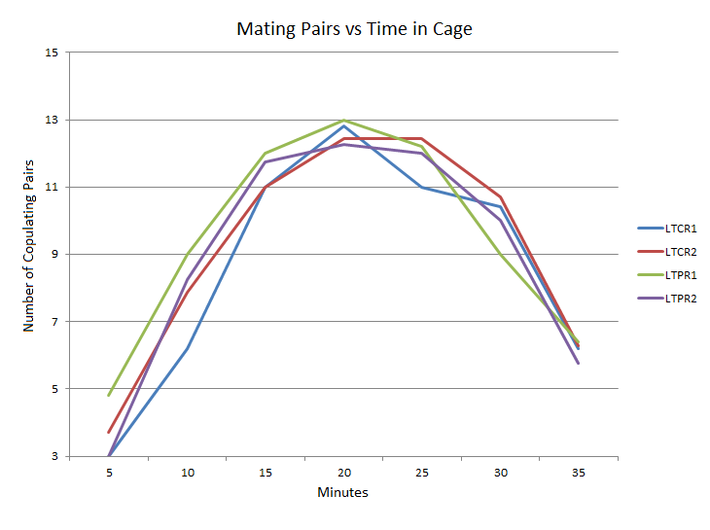
Figure 1
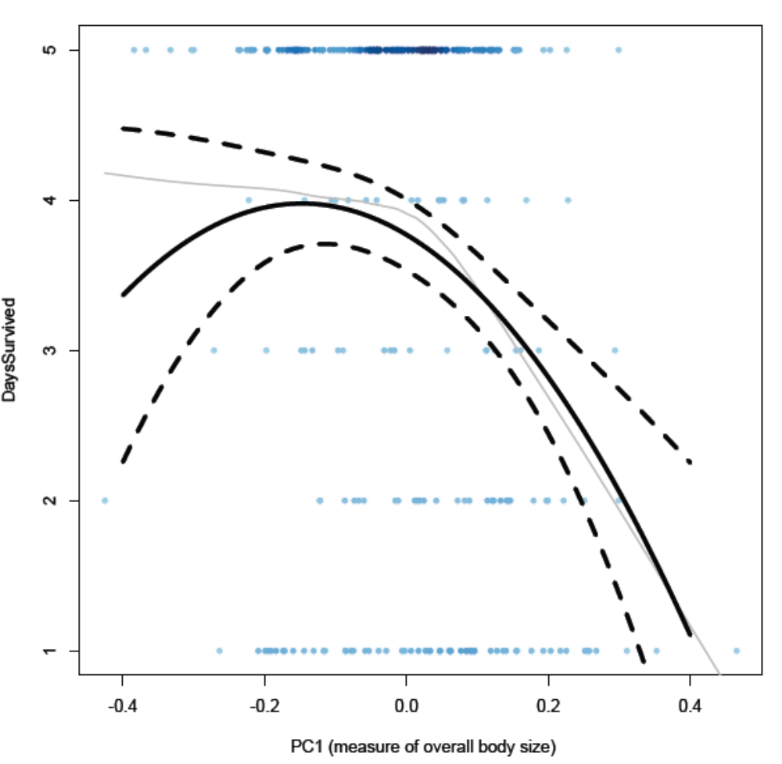
Figure 2
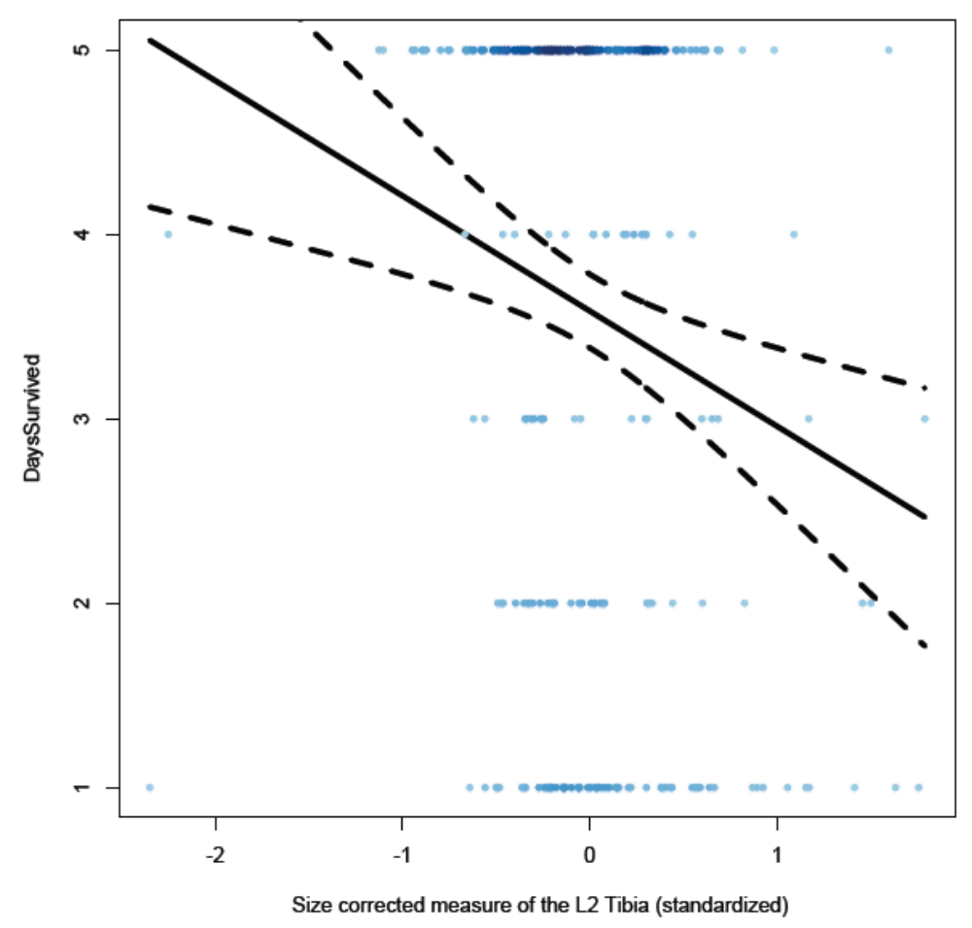
Figure 3
Discussion
The data from the assays, seen in Figure 1, shows no discernible difference in behaviors of any of the replicate populations used. Possible explanations for this include that the flies could be developing different mechanisms to cope with the predation stress for reproduction, or that there has not been enough time for significant behavioral evolution to take place.
Figure 2 shows significant selection occurring on PC1, used as an indicator of overall body size. The model shows negative stabilizing selection, while the spline shows a continued directional selection on size. Due to the small amount of data in that range, the confidence bands are very wide, so we do not know for certain if the selection is stabilizing or directional. We do see the general trend that as size increases, survivorship decreases. This could possibly be the case because larger flies are preferred by S. scenicus because larger prey means more energy intake, or because the larger flies cannot react as quickly to attacks by S. scenicus. In Figure 3, we see very clear and significant directional selection on length of second leg tibia.
Conclusion
No detectable change in adult mating behavior measurable by our assay method has been caused by the predation environment in the experimental population.
D. melanogaster survivorship under predation by S. scenicus is increased as second leg tibia length and overall body size decrease.
Acknowledgements
Many thanks to Ian Dworkin for his guidance and supervision of this project, analysis of the data, and his help in editing this paper. The funding for this project was provided by BEACON: The National Science Foundation center for the study of evolution in action.
References
BURK, T. 1982. Evolutionary significance of predation on sexually signaling males. Florida Entomology 65: 90-104.

Darwin, C. 1859. The origin of species. J. Murray, London.

Edmunds, M. 1974. Defence in animals. Longman Inc., New York

Endler, J. A. 1980. Natural selection on color patterns in Poecilia reticulata. Evolution, 34, 76-91.

Ghalambor, C. K., D. N. Reznick, and J. A. Walker. 2004. Constraints on adaptive evolution: the functional trade-off between reproduction and fast-start swimming performance in the Trinidadian guppy (Poecilia reticulata). American Naturalist 164:38–50.

Greenspan, R. J., Fervuer, Jean-Françios. 2000. Courtship In Drosophila. Annual Review of Genetics. 34:205-232.

Seghers, B. H. 1974. Schooling behavior in the guppy (Poecilia reticulata): an evolutionary response to predation. Evolution 28:486–489.

Sih, A. 1987 Predators and prey lifestyles: An evolutionary and ecological overview. In: W.C. Kerfoot and A. Sih, Editors, Predation and Indirect Impacts on Aquatic Communities, Univ. Press of New-England, Hanover pp. 203–224.

Stoks, R., McPeek, M. A., Mitchell, J. L. 2002. Evolution of Prey Behavior in Response to
Changes in Predation Regime: Damselflies in Fish and Dragonfly Lakes. Evolution, 57(3): 574–585

Svensson, E.I., Friberg M., 2007. Selective predation on wing morphology in sympatric damselflies. The American Naturalist 170: 101–112.

Walker, J. A., Ghalambor, C. K., Griset, O. L., McKennedy, D., Reznick, D. N. 2005. Do faster starts increase the probability of evading predators? Functional Ecology 19:808-815.

