Perception R Code

## How do different DGRP di-hybrid lines vary in their ability to perceive and avoid predator cues?

### Hypothesis:

DGRP dihybrids will show significant genetic variation in ability to percieve predator cues

### Prediction:

Each DGRP dihybrid lines will show within line consistancy, but display between line variability in the proportion within a spider vial, ranging from very low (~ 0%, avoiding spider cues) to a random assortment (~50%, randomly assortment, not recognizing spider cues).

### Sex Correlation:

## [1] -0.2526972

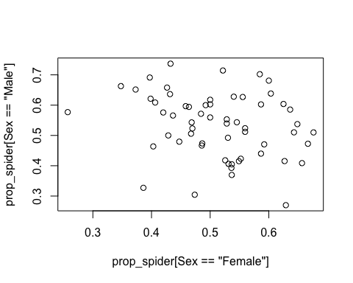

Sample sizes:

Females

## 26 28 38 41 42 45 57 59 85 88 91 129 158 177 195 208 217 228   
## 7 10 11 8 10 10 6 13 8 6 5 8 7 13 7 10 7 7   
## 229 235 239 301 307 315 332 354 357 367 371 373 375 379 385 391 392 395   
## 8 11 8 10 10 7 8 8 7 9 7 11 9 7 4 8 6 11   
## 399 427 437 439 443 491 492 502 508 509 517 596 703 757 765 774 799 808   
## 7 10 7 8 7 10 7 8 6 5 8 6 9 14 11 7 10 8   
## 843 894 900 907 911   
## 9 6 8 7 7

Males

## 26 28 38 41 42 45 57 59 85 88 91 129 158 177 195 208 217 228   
## 7 9 10 8 10 9 5 13 7 7 7 7 7 13 7 11 7 8   
## 229 235 239 301 307 315 332 354 357 367 371 373 375 379 385 391 392 395   
## 5 11 8 9 8 7 7 7 7 8 7 11 9 7 6 6 6 11   
## 399 427 437 439 443 491 492 502 508 509 517 596 703 757 765 774 799 808   
## 6 10 5 8 7 10 7 8 6 6 8 5 9 14 10 7 9 7   
## 843 894 900 907 911   
## 9 6 9 9 7

### Plots

All together

## Warning in `levels<-`(`*tmp*`, value = if (nl == nL) as.character(labels)  
## else paste0(labels, : duplicated levels in factors are deprecated  
  
## Warning in `levels<-`(`*tmp*`, value = if (nl == nL) as.character(labels)  
## else paste0(labels, : duplicated levels in factors are deprecated  
  
## Warning in `levels<-`(`*tmp*`, value = if (nl == nL) as.character(labels)  
## else paste0(labels, : duplicated levels in factors are deprecated  
  
## Warning in `levels<-`(`*tmp*`, value = if (nl == nL) as.character(labels)  
## else paste0(labels, : duplicated levels in factors are deprecated

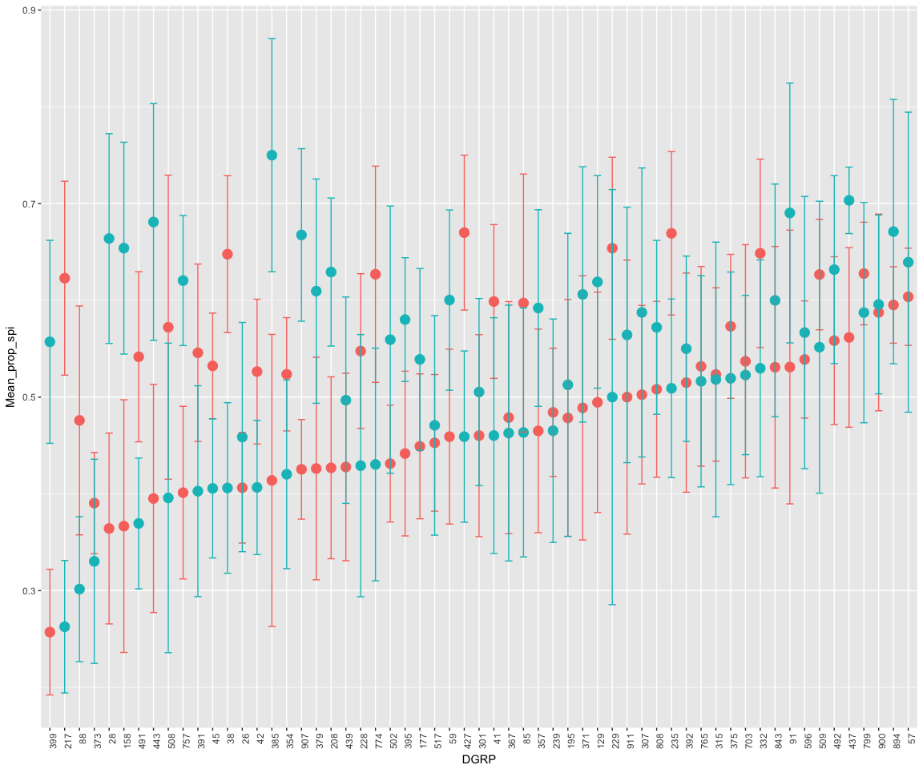

Males

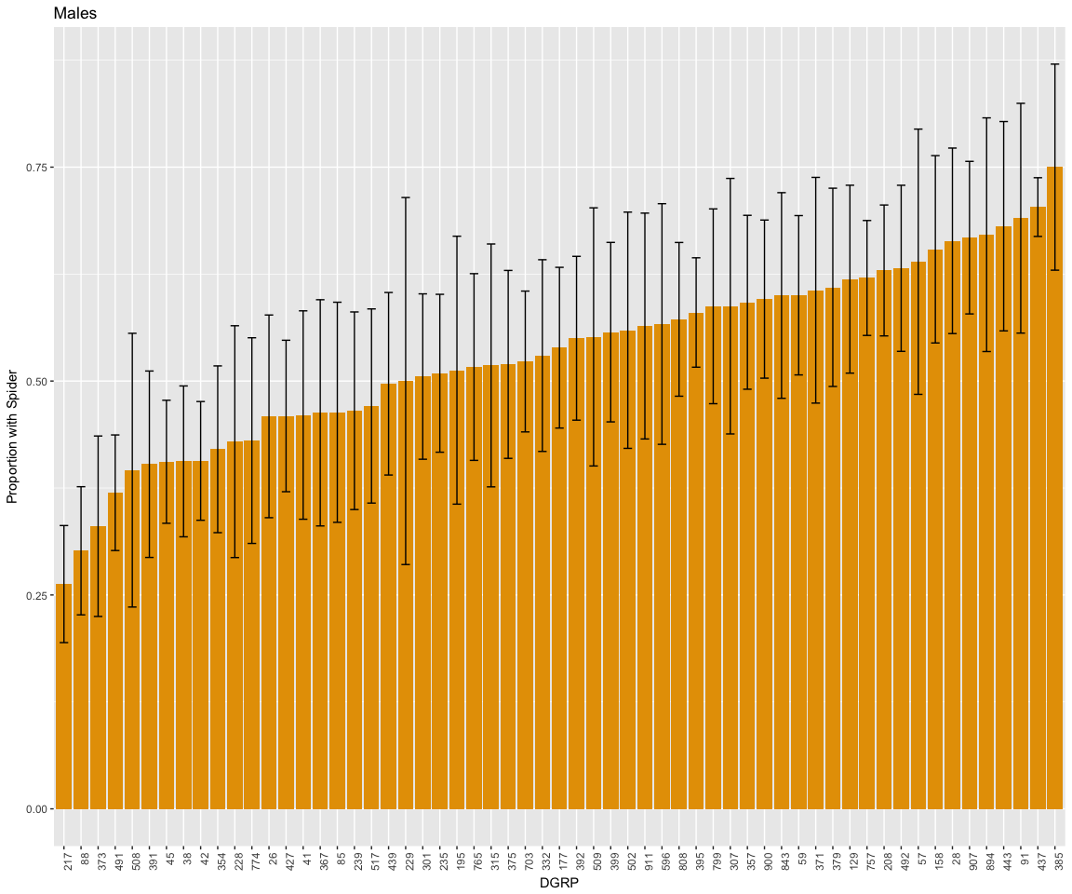

Females

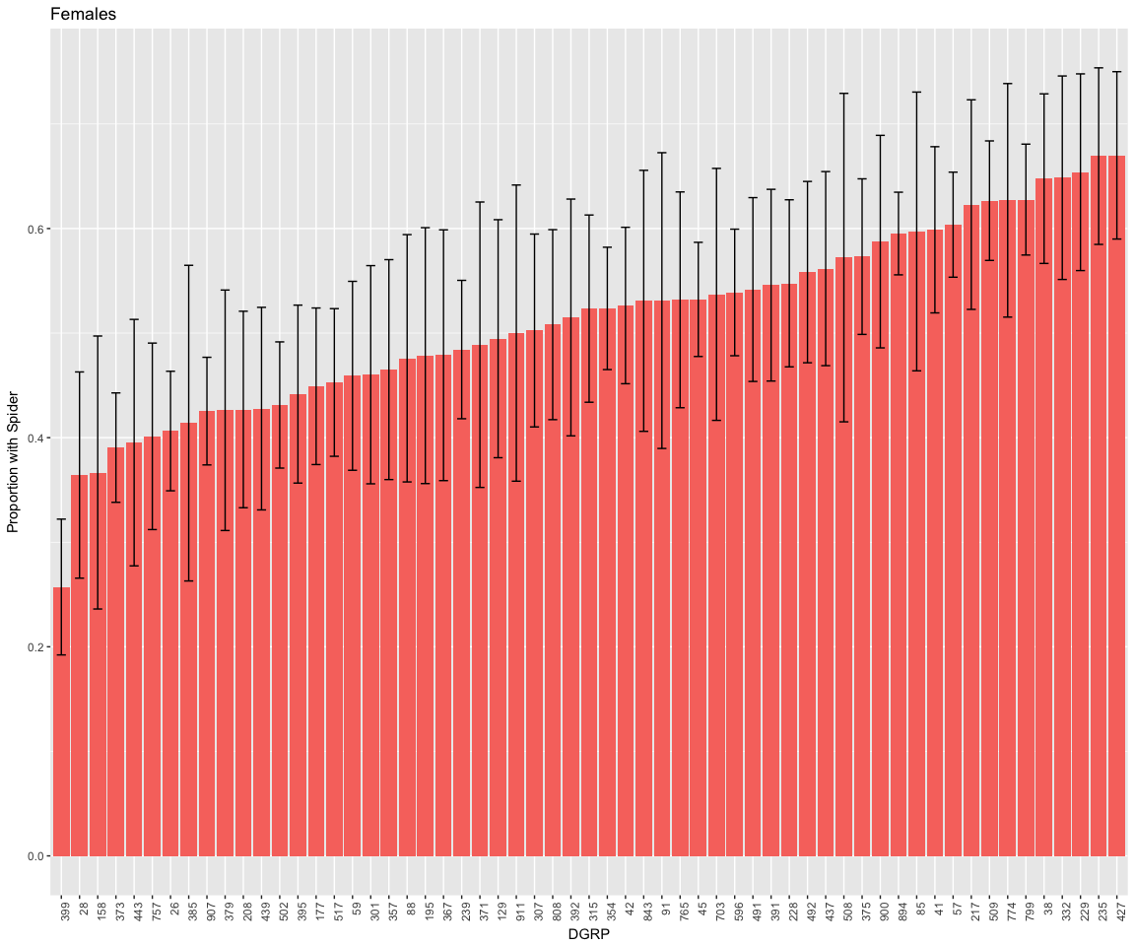

### Running models:

mod1 <- glmer(cbind(Not_spider, Spider) ~ 1 + Sex + Temp_Scaled + Humidity_Scaled + BP_Scaled + (1|Date)   
 + (0 + Sex|DGRP), data = DGRP_by_counts, family = "binomial")  
summary(mod1)

## Generalized linear mixed model fit by maximum likelihood (Laplace  
## Approximation) [glmerMod]  
## Family: binomial ( logit )  
## Formula:   
## cbind(Not_spider, Spider) ~ 1 + Sex + Temp_Scaled + Humidity_Scaled +   
## BP_Scaled + (1 | Date) + (0 + Sex | DGRP)  
## Data: DGRP_by_counts  
##   
## AIC BIC logLik deviance df.resid   
## 5529.6 5573.4 -2755.8 5511.6 952   
##   
## Scaled residuals:   
## Min 1Q Median 3Q Max   
## -3.7429 -1.3765 -0.0709 1.3610 3.9393   
##   
## Random effects:  
## Groups Name Variance Std.Dev. Corr   
## DGRP SexFemale 0.08134 0.2852   
## SexMale 0.12811 0.3579 -0.36  
## Date (Intercept) 0.01503 0.1226   
## Number of obs: 961, groups: DGRP, 59; Date, 10  
##   
## Fixed effects:  
## Estimate Std. Error z value Pr(>|z|)  
## (Intercept) -0.05143 0.06281 -0.819 0.413  
## SexMale -0.08390 0.08200 -1.023 0.306  
## Temp_Scaled 0.02346 0.05024 0.467 0.641  
## Humidity_Scaled -0.04285 0.04073 -1.052 0.293  
## BP_Scaled -0.02524 0.04675 -0.540 0.589  
##   
## Correlation of Fixed Effects:  
## (Intr) SexMal Tmp_Sc Hmdt_S  
## SexMale -0.571   
## Temp_Scaled 0.052 0.001   
## Humdty_Scld -0.104 0.003 -0.298   
## BP_Scaled -0.016 0.002 0.387 -0.113

mod2 <- lmer(proportion_spider ~ 1 + Sex + Temp_Scaled + Humidity_Scaled + BP_Scaled + (1|Date)   
 + (0 + Sex|DGRP), data = DGRP_by_counts)  
  
summary(mod2)

## Linear mixed model fit by REML ['lmerMod']  
## Formula: proportion_spider ~ 1 + Sex + Temp_Scaled + Humidity_Scaled +   
## BP_Scaled + (1 | Date) + (0 + Sex | DGRP)  
## Data: DGRP_by_counts  
##   
## REML criterion at convergence: 378.1  
##   
## Scaled residuals:   
## Min 1Q Median 3Q Max   
## -1.94967 -0.80687 0.02671 0.81983 1.81641   
##   
## Random effects:  
## Groups Name Variance Std.Dev. Corr   
## DGRP SexFemale 0.0006416 0.02533   
## SexMale 0.0013953 0.03735 -1.00  
## Date (Intercept) 0.0009796 0.03130   
## Residual 0.0827132 0.28760   
## Number of obs: 961, groups: DGRP, 59; Date, 10  
##   
## Fixed effects:  
## Estimate Std. Error t value  
## (Intercept) 0.510876 0.016951 30.138  
## SexMale 0.017644 0.020354 0.867  
## Temp_Scaled -0.004534 0.015169 -0.299  
## Humidity_Scaled 0.011099 0.012961 0.856  
## BP_Scaled 0.003919 0.014397 0.272  
##   
## Correlation of Fixed Effects:  
## (Intr) SexMal Tmp_Sc Hmdt_S  
## SexMale -0.574   
## Temp_Scaled 0.051 0.000   
## Humdty_Scld -0.084 0.004 -0.296   
## BP_Scaled -0.006 0.001 0.372 -0.153

mod3 <- lmer(proportion_spider ~ 1 + (1|Date)   
 + (1|DGRP), data = DGRP_by_counts)  
  
summary(mod3)

## Linear mixed model fit by REML ['lmerMod']  
## Formula: proportion_spider ~ 1 + (1 | Date) + (1 | DGRP)  
## Data: DGRP_by_counts  
##   
## REML criterion at convergence: 354.4  
##   
## Scaled residuals:   
## Min 1Q Median 3Q Max   
## -1.86789 -0.80425 -0.02344 0.89182 1.74799   
##   
## Random effects:  
## Groups Name Variance Std.Dev.  
## DGRP (Intercept) 0.0000000 0.00000   
## Date (Intercept) 0.0006217 0.02493   
## Residual 0.0836797 0.28927   
## Number of obs: 961, groups: DGRP, 59; Date, 10  
##   
## Fixed effects:  
## Estimate Std. Error t value  
## (Intercept) 0.52093 0.01239 42.03

mod4 <- lmer(Mean_prop_spi ~ 1 + Sex + Mean_temp_scaled + Mean_hum_scaled + Mean_BP_scaled +   
 (1|DGRP), data = DGRP_sub)  
summary(mod4)

## Linear mixed model fit by REML ['lmerMod']  
## Formula: Mean_prop_spi ~ 1 + Sex + Mean_temp_scaled + Mean_hum_scaled +   
## Mean_BP_scaled + (1 | DGRP)  
## Data: DGRP_sub  
##   
## REML criterion at convergence: -191.7  
##   
## Scaled residuals:   
## Min 1Q Median 3Q Max   
## -2.83046 -0.73402 0.06989 0.70417 2.18452   
##   
## Random effects:  
## Groups Name Variance Std.Dev.  
## DGRP (Intercept) 0.000000 0.00000   
## Residual 0.009471 0.09732   
## Number of obs: 118, groups: DGRP, 59  
##   
## Fixed effects:  
## Estimate Std. Error t value  
## (Intercept) 0.511204 0.013000 39.32  
## SexMale 0.019326 0.017927 1.08  
## Mean_temp_scaled -0.013413 0.054664 -0.25  
## Mean_hum_scaled 0.008155 0.028983 0.28  
## Mean_BP_scaled -0.027795 0.048613 -0.57  
##   
## Correlation of Fixed Effects:  
## (Intr) SexMal Mn_tm_ Mn_hm_  
## SexMale -0.686   
## Mn_tmp_scld 0.124 0.012   
## Men_hm_scld 0.037 0.020 -0.400   
## Men_BP_scld 0.186 0.000 0.758 -0.411