Tiles

Description
There is a huge 2 x N board, six types of tiles(砖瓦) are available, and each of them is infinitely(无限) many, you have to find the number of ways you can fill the board using the tiles.
Two board configurations are different if at least in one cell, their colors differ.
The tiles are given below:

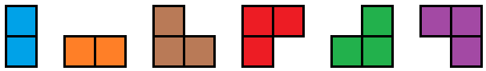

You cannot rotate or flip any tile.
And no cell in the board should be empty. The tiles shouldn't overlap.
For example, a 2 x 3 board can be colored by 5 ways, they are:
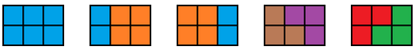

Input
Each case starts with a line containing an integer N (1 ≤ N ≤ 10⁹).

Output
For each case, print the number of ways the board can be colored. The number may be large, so, output the number modulo 10007.

Sample Input
3
10

Sample Output
5
1255

