Heros and Swords

Description
There are n swords of different weights W_{i} and n heros of different power P_{i}.
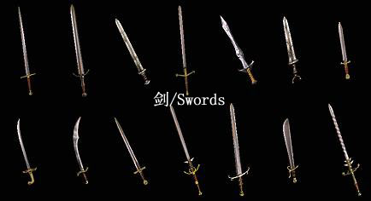
Your task is to find out how many ways the heros can carry the swords so that each hero carries exactly one sword.

Here are some rules:
(1)Every sword is carried by one hero and a hero cannot carry a sword whose weight is larger than his power.
(2)Two ways will be considered different if at least one hero carries a different sword.

Input
Each case starts with a line containing an integer n (1 ≤ n ≤ 10⁵) denoting the number of heros and swords.
The next line contains n space separated distinct(不同的) integers denoting the weight of swords.
The next line contains n space separated distinct integers denoting the power for the heros.
The weights and the powers lie in the range [1, 10⁹].

Output
For each case, print the number of ways those heros can carry the swords.
This number can be very big. So print the result modulo 1000 000 007.

Sample Input
5
1 2 3 4 5
1 2 3 4 5
2
1 3
2 2
3
2 3 4
6 3 5

Sample Output
1
0
4

