Website URL: <http://cs3360.cs.utep.edu/dnrodriguez/>

The website implements a login page that uses SESSIONS and COOKIES to declare elements in for later use in the store. After the user is given permissions to access the library by using the admin password, the user is presented with a navigation bar with the options of Library, Stores, Information, and Logout. The library will be initially empty, in order to buy songs, the user will have to go to the store page. On the store page, the user is presented with two stores, iRecords and Pear Music, from where the user can buy from a selection of songs (each has different selections of songs). Once the user in the store page, the user can add annotations to the song before purchase, which will be displayed back in the library.

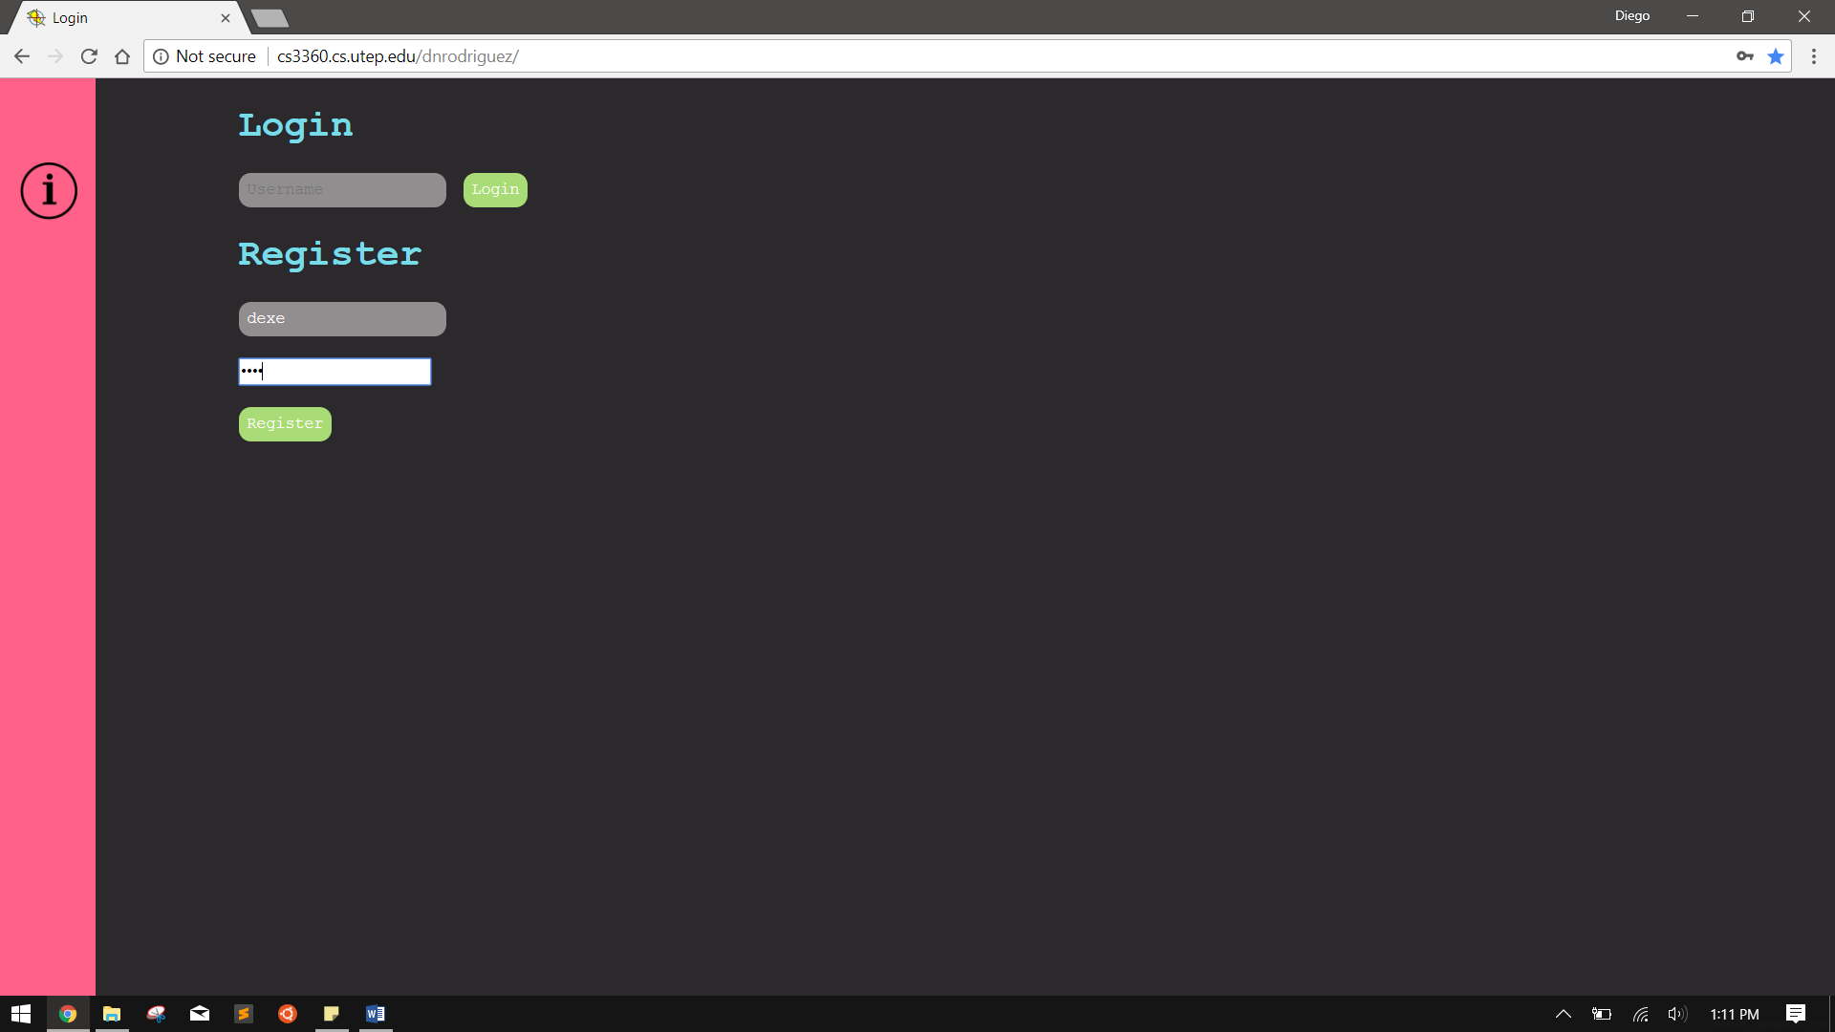

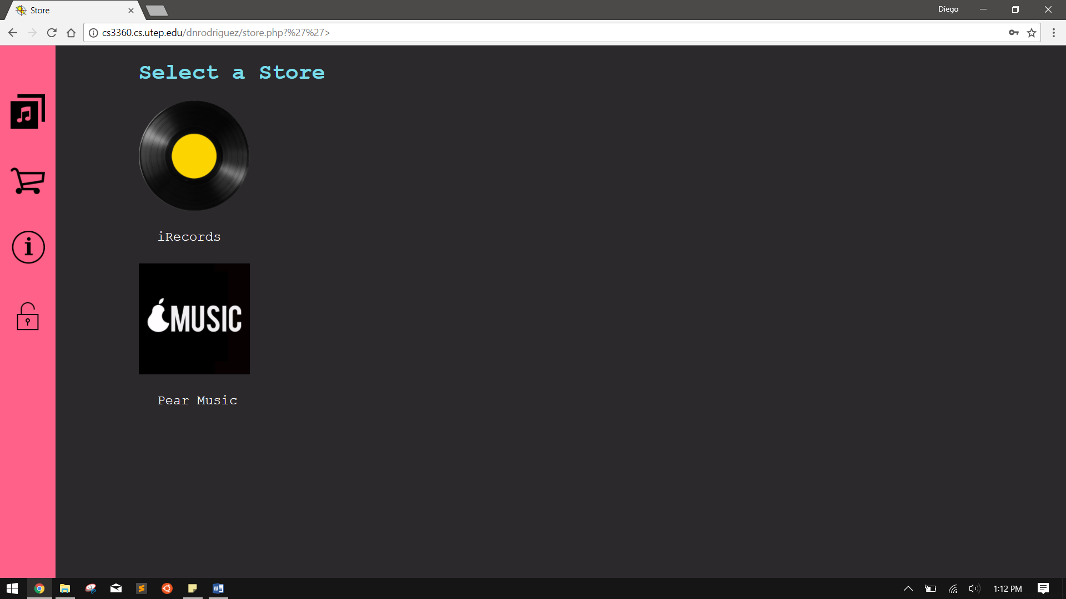

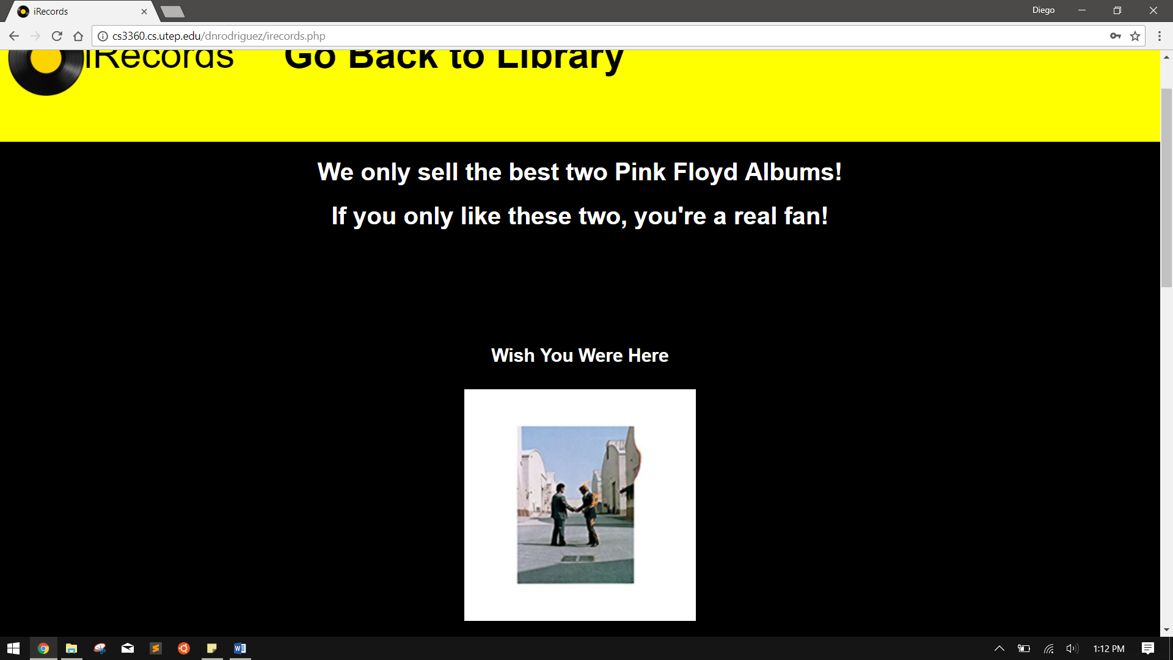



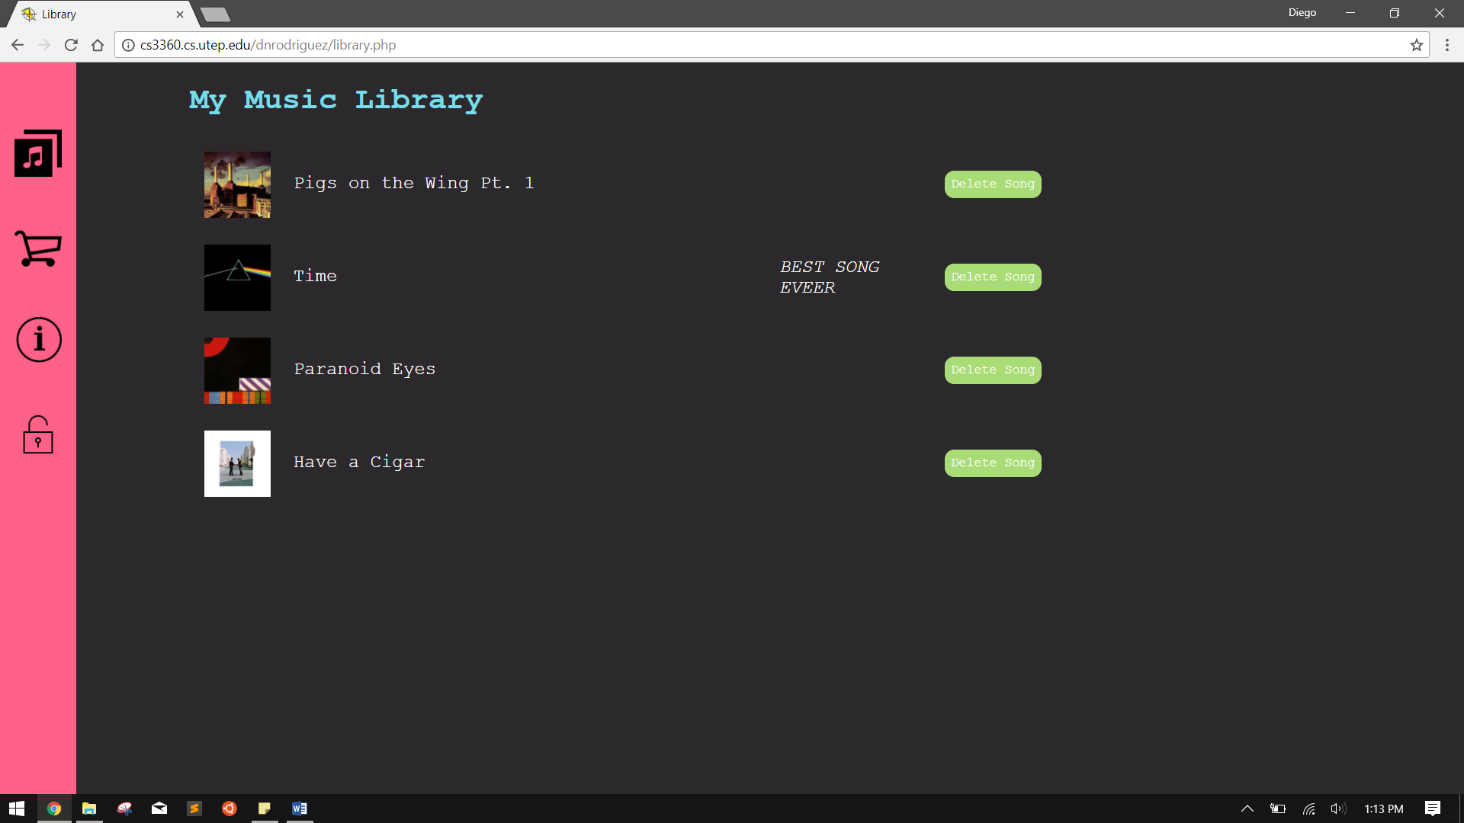

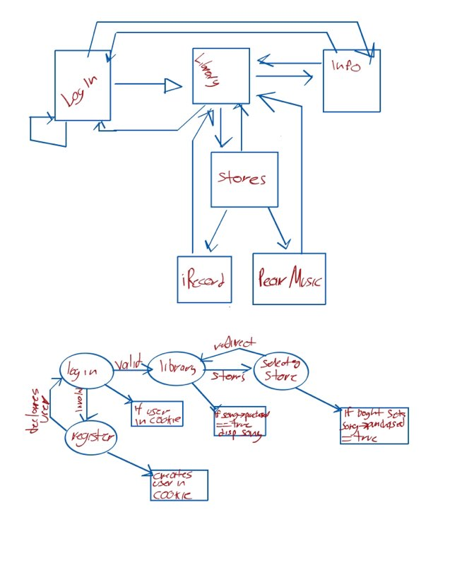

Objects

I realized that the writability of PHP is too simple for me and would rather it have more OO features. I initially tried to create an array of a class and store it into session, but realized that I would have to extract the variable so that I could modify or access the information of the array. I then tried to create a class of user to implement users, but I couldn’t declare an array of another class inside the super class. For the most part I tried to do things a s I would in java, but the familiarity of the language was a great factor in not going into more OO as I would like. The only class I implemented was Songs which contained a name string, a purchased Boolean, and a note string, which are used to determine if a song is bought and if it has a note added when purchased.

Troubleshoot

I implemented my dressing using COOKIE and SESSION, but I didn’t kwon that when refreshing a page, any var declaration would be redeclared, thus leading me to not being able to delete songs from my library (I displayed all the songs in the library for testing). After committing my self to hate PHP, I found that I could create PHP header files for use, I did that and then realized that placing my variables in the header file would redeclare them every time. So, I ended up declaring the variables in the index file and then moving them to cookies so that they wouldn’t redeclare, allowing for modification.