Test Script for Approval/Rejection of Loan Request

Name of User: Role/Job Position: Date of Testing:

# VI. Approval/Rejection of a Loan Request

Function : Approval/Rejection of a Loan Request

|  |  |  |  |  |  |  |
| --- | --- | --- | --- | --- | --- | --- |
| **Approval/Rejection of a Loan Request on LoanSmart Application** | | | | | | |
|  | **Test Scenario** | **Test case** | **Expected Result** | **Remarks (if any)** | **Assessment** | |
| Pass | Pending |
| 1 | Open the Loan Request. (Performed by the Sales Assistant) | 1. Click on the app drawer located in the top-left corner of the window.   Select LoanSmart application     1. Click on the Loans Menu in the top area of the Window.   Select Loan Request     1. Select the Loan Request to be submitted for approval. | 1. User will see the LoanSmart application overview. (See Screenshot 1 in Appendix A). 2. User will see the list of the Loan Requests that are assigned to the user. (See Screenshot 2 in Appendix A). 3. User will see the Loan Request window. (See Screenshot 3 in Appendix A). |  |  |  |

|  |  |  |  |  |  |  |
| --- | --- | --- | --- | --- | --- | --- |
| **Approval/Rejection of a Loan Request on LoanSmart Application** | | | | | | |
|  | **Test Scenario** | **Test case** | **Expected Result** | **Remarks (if any)** | **Assessment** | |
| Pass | Pending |
| 2 | Request for Approval (Performed by the Sales Assistant) | a. Click the “For Approval” button to request approval from the assigned approver. | a. The Loan Request status will update from “FOR CI” to “FOR APPROVAL”. (See Screenshot 3a in Appendix A)  Note: The sales assistant will see the “For Approval” button on the left side of the loan request form when the CI Report and Collateral Records, if any, are both tagged as “COMPLETED”. |  |  |  |
| 3 | Approval of Loan Request (Performed by the General Manager/Approving Officer) | 1. Click on the app drawer located in the top-left corner of the window.   Select LoanSmart application     1. Click on the Loans Menu in the top area of the Window.   Select “Loan Requests For Approval” | 1. User will see the LoanSmart application overview. (See Screenshot 1 in Appendix A). 2. User will see the list of the Loan Requests for approval. (See Screenshot 4 in Appendix A). |  |  |  |

|  |  |  |  |  |  |  |
| --- | --- | --- | --- | --- | --- | --- |
| **Approval/Rejection of a Loan Request on LoanSmart Application** | | | | | | |
|  | **Test Scenario** | **Test case** | **Expected Result** | **Remarks (if any)** | **Assessment** | |
| Pass | Pending |
|  |  | 1. Open the loan request to be approved and fill in the “Remarks for Approval by the Company” field before approving the Loan Request. 2. After adding the remarks for approval, click the “Approve” button.      1. Click the “Ok” button of the confirmation message.   Icon  Description automatically generated | 1. User will be directed to the form view of the loan request and able to input the remarks for approval.   (See Screenshot 5 in Appendix A)   1. User will see a confirmation message (See Screenshot 6a in Appendix A) for the printing of the Loan Proposal Summary. (See Screenshot 6b in Appendix A) 2. The Loan Request status will update from “FOR APPROVAL” to “APPROVED BY THE COMPANY”. (See Screenshot 6c in Appendix A) |  |  |  |

|  |  |  |  |  |  |  |
| --- | --- | --- | --- | --- | --- | --- |
| **Approval/Rejection of a Loan Request on LoanSmart Application** | | | | | | |
|  | **Test Scenario** | **Test case** | **Expected Result** | **Remarks (if any)** | **Assessment** | |
| Pass | Pending |
| 4 | Option to Reject/Cancel Loan Request (Performed by General Manager) | a. Reject and Cancel button will appear if the status is not in “Draft”.  b-1. If the user intends to reject the loan request, click the ‘Edit’ button and input remarks on the “Remarks for Rejection” field under the  “Remarks” tab. (See Screenshot 7 in Appendix A)  After inputting the remarks, click “Save” button to save the remarks and click “Reject” button to reject the loan request.  b-2. If the user intends to cancel the loan request, click the ‘Edit’ button and input remarks on the “Remarks for Cancellation” field under the  “Remarks” tab. (See Screenshot 8 in Appendix A)  After inputting the remarks, click “Save” button to save the remarks and click “Cancel” button to cancel the loan request.  Note: A pop-up message will appear (See Screenshot 9 and Screnshot 10 in Appendix A) if the Remarks for Rejection/Cancellation is not filled up before rejecting/cancelling the loan request. | a. The user will be able see the “Reject” and “Cancel” button.  b-1. The user will be able to reject the loan request.  The loan request status will be updated from “For Approval” to “Rejected”.  b-2. The user will be able to cancel the loan request.  The loan request status will be updated from “For Approval” to “Cancelled”.  The user will not be able to reject or cancel a loan request if there is no remarks for rejection/cancellation |  |  |  |

# Appendix A

Screenshot 1

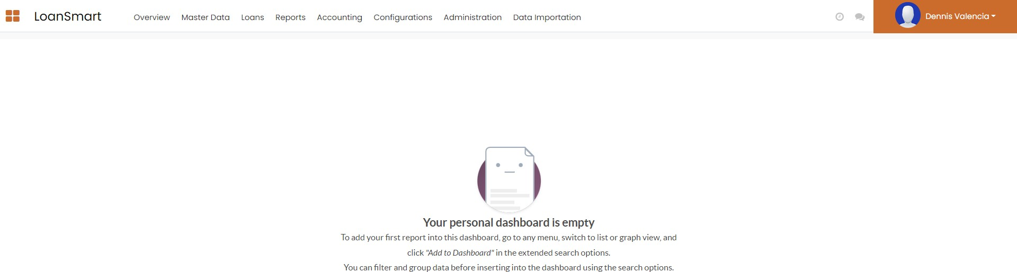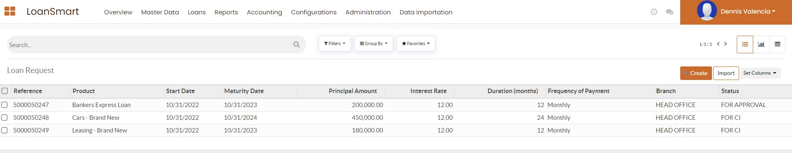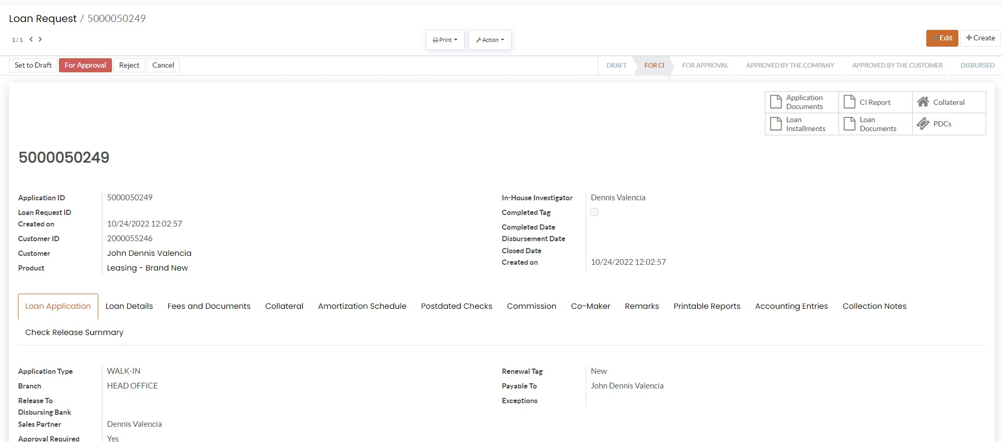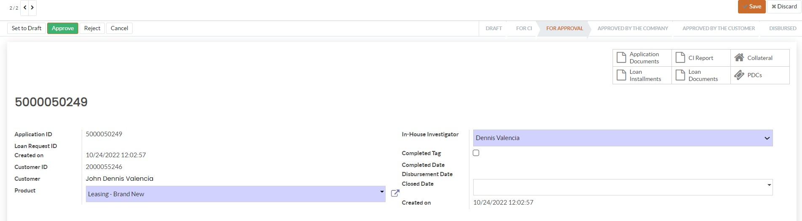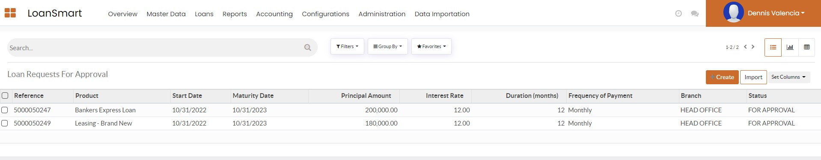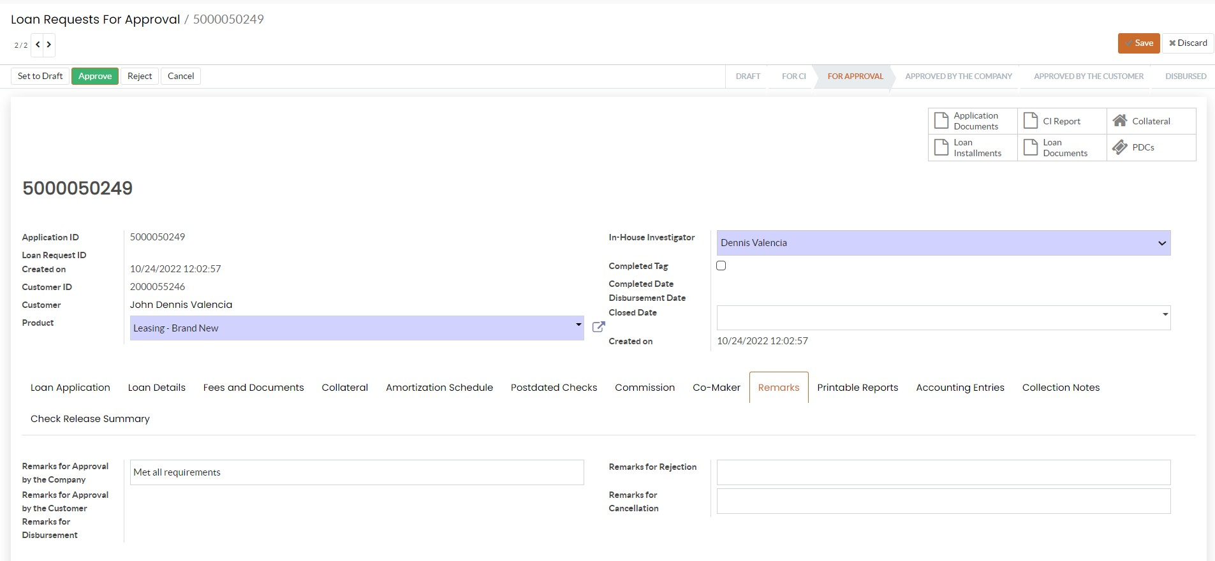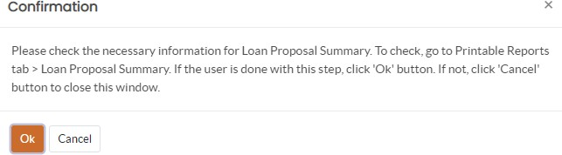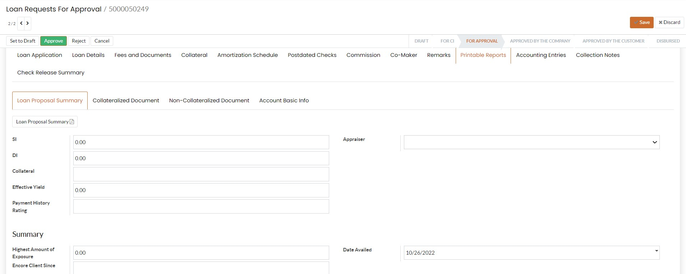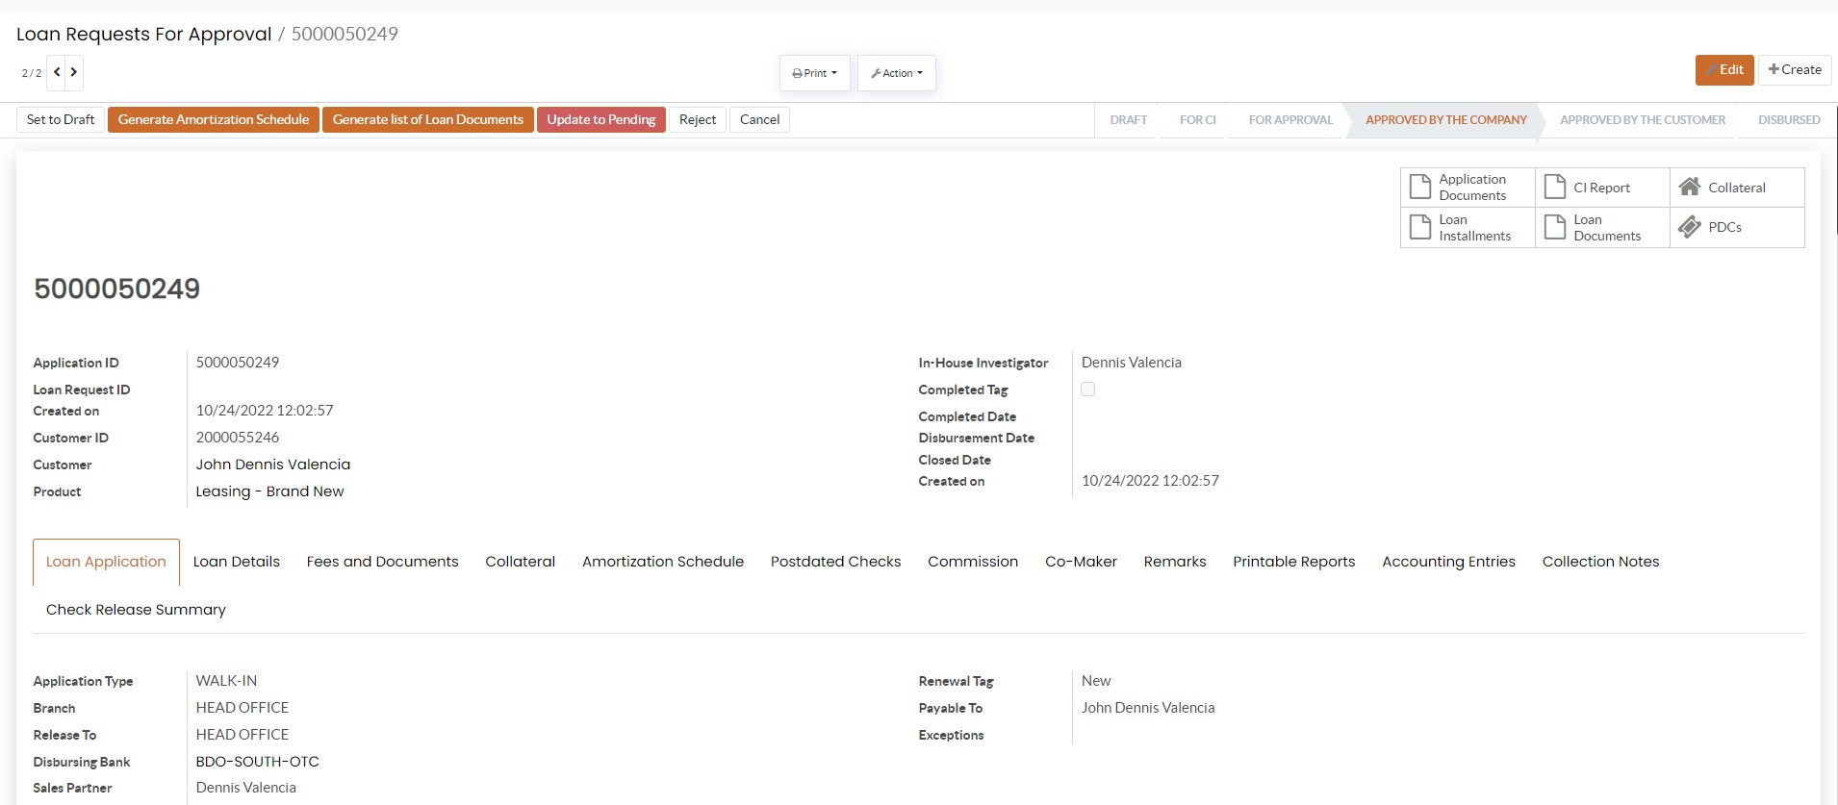

Screenshot 8

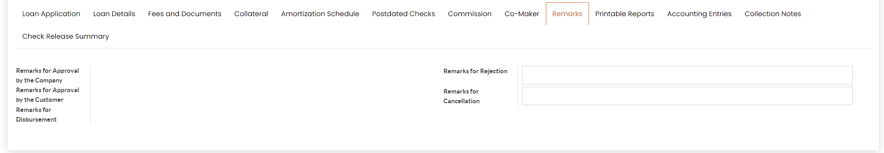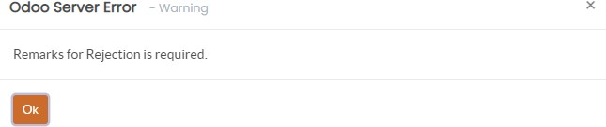

Screenshot 10

