SteelForce — Discount & Incentive Console
UI Workflow + User Stories + Acceptance Criteria + Development Requirements
Updated requirement: Epic 2 includes a Sales “Request for Discount” action; Epic 5 automatically shows eligible incentives on the product card after final filtering or product selection.

1. Source & Business Scope
This document is based on the provided “Console invoice cut.xlsx”. The workbook contains four business areas: Depot Discount Request, Depot Discount Master, Invoice COD, and Product Incentive/Rebate. The source includes customer/BP-specific discount information, COD/pickup rules by product category, and quantity-based incentive/rebate schemes.
- Depot Discount Request sheet: customer/BP request information, depot type, sales employee, requested discount fields, and remarks.
- Depot Discount sheet: customer/BP-specific on-invoice and settlement/payment discount columns.
- Invoice COD sheet: COD, PNP pickup, and branch pickup rules by product category.
- Sheet2: Camstar free-goods tiers, White Cement incentive/rebate rules, and Frame quantity-based incentive rules.
The source data should be treated as a business-rule specification. It should not be copied directly into application logic or hard-coded in the mobile app.

2. Product Goal
Build a central discount and incentive capability in SteelForce where the Backend is the source of truth. Sales users consume approved rules and can request special discounts when an existing rule is insufficient. Admin/HQ users review requests, manage rules, approve/reject requests, and maintain audit history.

3. End-to-End Workflow
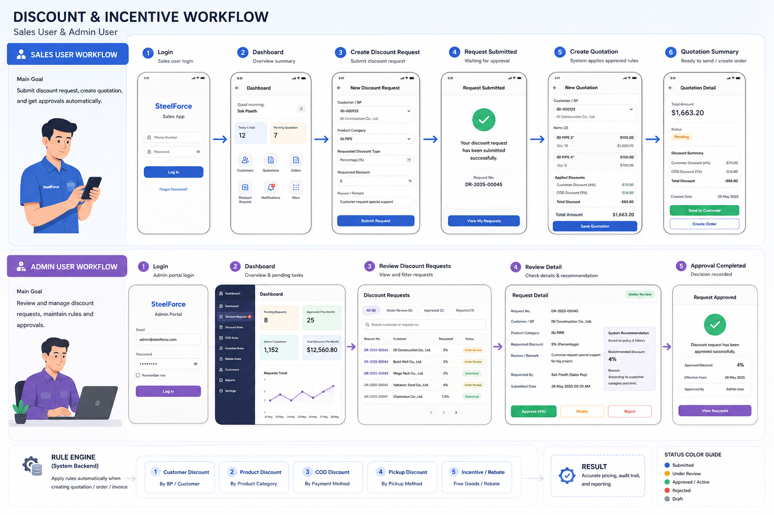
SALES USER
Login
↓
Dashboard
↓
Select Customer/BP
↓
Open Product Selection
↓
Final Filter / Select Product
↓
Product Card automatically shows applicable Incentive
↓
Need special discount?
├─ No → Continue quotation/order
└─ Yes → Request for Discount
↓
Submitted
↓
HQ Review
↓
Approved / Rejected / Modified
↓
Sales receives status
↓
Quotation
↓
Order
ADMIN / HQ
Login
↓
Dashboard
↓
Discount Requests
↓
Filter / Search
↓
Request Detail
↓
Review customer + product + requested discount
↓
Approve / Modify / Reject
↓
Create/activate approved rule
↓
Audit Log
↓
Backend Rule Engine
↓
Quotation / Order / Invoice

4. Sales User UI Workflow
Screen | UI | Purpose
S-01 | Sales Login | Authenticate Sales Rep and load assigned customers/products.
S-02 | Sales Dashboard | Show visits, quotations, orders, discount requests, and pending request count.
S-03 | Customer/BP Selection | Select a customer before creating a quotation or requesting a customer-specific discount.
S-04 | Product Search & Final Filter | Filter by category/product and complete the final selection.
S-05 | Product Card with Incentive | After final filter or product selection, automatically display an incentive badge/card when the selected product and quantity qualify.
S-06 | Request for Discount | Allow Sales to request a special discount from the product/customer context.
S-07 | Request Form | Capture requested discount type/value, reason, product/category, and supporting information.
S-08 | Request Submitted | Show request number and Pending/Under Review status.
S-09 | My Discount Requests | Show Draft, Submitted, Under Review, Approved, Rejected, and Expired requests.
S-10 | Quotation | Apply approved rules automatically and show discount/incentive summary.

5. Admin / HQ UI Workflow
Screen | UI | Purpose
A-01 | Admin Login | Secure access to discount console.
A-02 | Admin Dashboard | Show pending requests, approved requests, active customers/rules, and recent activity.
A-03 | Discount Requests | Search/filter by request number, BP, customer, Sales Rep, product/category, status, and date.
A-04 | Request Detail | Review requested discount, current rule, customer context, product/category, reason, and history.
A-05 | Approve / Modify / Reject | Record decision and approval remark.
A-06 | Discount Rule Master | View/create/edit/deactivate customer/product discount rules.
A-07 | COD & Pickup Rules | Maintain COD, PNP pickup, and branch pickup rules.
A-08 | Incentive Rules | Maintain free-goods and quantity-based incentive tiers.
A-09 | Rebate Rules | Maintain monthly target/rebate rules where applicable.
A-10 | Audit Log | Show old value, new value, user, time, action, and reason.

6. Epic 1 — Customer / Depot Discount Rules
Purpose: allow Admin/HQ to maintain approved customer/BP-specific discount rules without releasing a new mobile version.

US-01 — View customer discount
User Story: As a Admin/HQ user, I want to view the discount configuration for a customer/BP, so that I can understand which approved rules may apply to a quotation/order/invoice..
Acceptance Criteria
- Search by BP Code, Customer Name, Sales Employee, and Location.
- Show product/category and discount type/value.
- Show whether the rule is On Invoice, Settlement/Payment, Special, Case-by-Case, or No Discount.
- Show effective dates, status, last updated date, and configured/approved by.
- Show rule history.

US-02 — Create customer discount rule
User Story: As a Admin/HQ user, I want to create an approved discount rule for a BP, so that the rule can be automatically evaluated by the Backend..
Acceptance Criteria
- Required: BP, Customer Name, Location, Product Category, Discount Type, Discount Value, Effective From, Effective To, Status, Remark.
- Support Percentage, Fixed Amount, Percentage Range, Case By Case, and No Discount.
- Prevent overlapping active rules for the same scope unless an explicit priority is configured.
- Record created_by and approved_by.

US-03 — Deactivate/expire a rule
User Story: As a Admin/HQ user, I want to deactivate or end-date an existing rule, so that old discounts are not applied after they stop being valid..
Acceptance Criteria
- Allow manual deactivation with reason.
- Effective To must be respected by the rule engine.
- Historical invoices/orders must retain the applied value used at transaction time.

7. Epic 2 — Discount Request & Approval (UPDATED)
New UI requirement: Sales must have a clear “Request for Discount” button from the customer/product/quotation context.
Sales
↓
Customer/BP
↓
Product / Category
↓
[ Request for Discount ] ← NEW BUTTON
↓
Request Form
↓
Submit
↓
SUBMITTED
↓
UNDER REVIEW
↓
APPROVED → ACTIVE
or
REJECTED
↓
Sales Notification / My Requests

US-04 — Request for discount
User Story: As a Sales Rep, I want to request a special discount for a selected customer/BP and product/category, so that the request can be reviewed and approved by HQ..
Acceptance Criteria
- Show the “Request for Discount” button when Sales is viewing a customer/product or creating a quotation.
- Customer/BP should be pre-filled from the current context.
- Product/Product Category should be pre-filled when launched from a selected product.
- Allow Sales to choose discount type and enter requested value.
- Require a reason/remark.
- Show current applicable discount, if available, so Sales knows why a request is needed.
- Prevent duplicate active pending requests for the same BP/product/category unless the backend explicitly allows them.
- After submit, show a unique Request Number and status SUBMITTED.
Development Notes: The mobile app sends the request to the Backend. It must not directly change the active discount rule.

US-05 — Review discount request
User Story: As a Admin/HQ user, I want to review a submitted request, so that I can make an informed approval decision..
Acceptance Criteria
- List requests with status filters: All, Submitted, Under Review, Approved, Rejected, Expired.
- Search by request number, BP, customer, Sales Rep, and product/category.
- Detail page shows requested value, current rule, reason, submitted by/date, and history.
- Admin can Approve, Modify, or Reject.
- Modification must record the final approved value separately from the original request.

US-06 — Complete approval
User Story: As a Admin/HQ user, I want to approve or reject a request with a decision remark, so that the system records an auditable outcome and activates the approved rule when applicable..
Acceptance Criteria
- Approve creates/updates an active rule with effective dates.
- Reject requires a rejection reason.
- Modify requires the final approved value and reason.
- Sales receives an in-app notification/status update.
- Audit log records action, old value, new value, actor, timestamp, and reason.

8. Epic 3 — Automatic Discount in Quotation

US-07 — Calculate quotation discount
User Story: As a Sales Rep, I want to create a quotation with applicable approved discounts, so that I do not need to manually calculate customer-specific discounts..
Acceptance Criteria
- Backend evaluates customer-specific, customer-group/depot, product/category, and applicable promotion rules.
- Show line-level and total discount.
- Show the rule/source where practical (for example: Customer Discount 4%).
- Final business calculation is performed by Backend, not independently by Flutter.
- Quotation stores the applied rule/version/value for auditability.

9. Epic 4 — Invoice COD & Pickup Rules
Source workbook examples include 1.0% COD for many categories, 1.5% PNP pickup for many categories, 0.5% branch pickup for selected categories, and $5.00 PNP values for selected trading products.

US-08 — Apply COD/pickup rule
User Story: As a System, I want to determine the applicable COD or pickup rule based on product category and transaction method, so that the correct invoice calculation is applied consistently..
Acceptance Criteria
- Support Percentage and Fixed Amount rule types.
- Support payment method COD.
- Support pickup method PNP and Branches where configured.
- If a rule is N/A, do not apply it.
- If no rule exists, return a clear no-rule result rather than assuming zero.

10. Epic 5 — Product Incentive / Free Goods (UPDATED)
New UI requirement: the incentive must be visible directly on the product card after the user finishes filtering or selects a product. The Sales user should not need to open a separate promotion screen to discover the incentive.
PRODUCT LIST
↓
User applies filters
↓
FINAL FILTER RESULT
↓
Product Card loads
├─ No eligible incentive → normal product card
└─ Eligible / applicable incentive
↓
Show incentive badge
↓
“Buy 300 Bags → Free 15”
↓
User selects quantity
↓
Backend validates eligibility
↓
Quotation shows free-goods line / incentive summary

US-09 — Auto-show incentive on product card
User Story: As a Sales Rep, I want to see the applicable incentive directly on a product card after final filtering or product selection, so that I can immediately understand the promotion before adding the product..
Acceptance Criteria
- When the user completes the final product filter, the product card must request/receive applicable incentive information.
- When a product is selected/opened, the same incentive information must be visible.
- If an incentive is applicable, show a clear badge/banner such as “Promotion”, “Free Goods”, or “Rebate”.
- Show the qualifying quantity and benefit, for example: “Buy 300 Bags → Free 15”.
- If multiple tiers exist, show the nearest/next qualifying tier and/or the currently achieved tier according to product UX decision.
- If quantity is entered/changed, refresh the incentive result based on the final quantity.
- If no incentive applies, do not show an empty promotion section.
- The Backend remains the source of truth for eligibility.
Development Notes: The UI should avoid showing a promotion that is outside its effective date or unavailable for the selected customer/order context.

US-10 — Apply free goods
User Story: As a Sales Rep, I want to add an eligible incentive to a quotation/order, so that the promotional quantity is captured correctly..
Acceptance Criteria
- For Camstar, support quantity tiers such as 40 → Free 1, 100 → Free 4, 300 → Free 15, 500 → Free 35, 2,000 → Free 280.
- The Backend calculates the eligible tier.
- Free quantity must be represented explicitly in the quotation/order.
- The user must be able to see why the free quantity was granted.
- Changing/removing the qualifying quantity must recalculate eligibility.

11. Epic 6 — Monthly Rebate

US-11 — Calculate monthly rebate
User Story: As a Admin/HQ user, I want to configure and monitor monthly purchase targets and rebate values, so that eligible customers can be evaluated consistently..
Acceptance Criteria
- Support target-based monthly rules.
- Example from source: White Cement target 50 Tons → 3 USD/Ton (0.12 USD/Bag); 100 Tons → 5 USD/Ton (0.20 USD/Bag).
- Do not combine monthly rebate logic with invoice discount or free-goods logic.
- Rebate calculation must use the correct monthly period and approved rule.

12. Rule Engine & Priority
The Backend should evaluate rules centrally. Recommended priority, subject to Finance/ERP confirmation:
- Customer-specific approved rule.
- Customer group / depot rule.
- Product/category default rule.
- Promotion / incentive rule.
- No applicable rule.
COD/pickup and incentive/rebate rules should be separate rule families. The engine should not silently merge different business concepts into one discount percentage.

13. Data & Rule Modeling
discount_rules
id, bp_id, product_category_id, discount_type, discount_value, min_value, max_value, application_type, effective_from, effective_to, status, remark, created_by, approved_by, created_at, updated_at
discount_requests
id, bp_id, requested_by, product_category_id, requested_discount_type, requested_value, reason, status, submitted_at, reviewed_by, reviewed_at, approval_remark
incentive_rules
id, product_category_id, min_quantity, max_quantity, free_quantity, effective_from, effective_to, status
cod_rules
id, product_category_id, payment_method, pickup_method, rule_type, rule_value, effective_from, effective_to, status

14. Business Rule Data Normalization
The source workbook contains human-readable values such as percentages, ranges, N/A, and Case By Case. These should be normalized into typed fields rather than stored as a single free-text discount field.
Source value | Normalized type | Meaning
4% | percentage | 0.04
0.04 | percentage | 0.04
2%-4% | percentage_range | min=0.02, max=0.04
$5.00 | fixed_amount | 5.00
Case By Case | case_by_case | requires approval/manual decision
N/A | not_applicable | do not apply

15. Product Card UI Specification — Epic 5
State | UI | Behavior
Default | Product name / image / price / stock | No incentive section when no applicable rule.
Eligible incentive | Badge + short text | Example: “Buy 300 Bags → Free 15”.
Near next tier | Progress/helper text | Example: “Buy 20 more bags to get Free 15” — only if the business wants this behavior.
Multiple tiers | Tier summary | Show current eligible tier and next tier without overwhelming the card.
Expired/not applicable | Hide incentive | Do not show stale promotions.

16. Sales UI — Request for Discount Button
- Primary placement: Customer/Product/Quotation context, near the pricing or discount area.
- Button label: “Request for Discount”.
- Button should be visible when Sales has a customer/BP context and the user is allowed to request a discount.
- If a pending request already exists for the same scope, replace the primary action with “View Request” or show the pending request status.
- When tapped, open the request form with BP and product/category pre-filled where possible.
- After submission, show Request Number and status.
- Approved requests should become available to the quotation rule engine according to effective date.

17. Status Model
DRAFT
↓
SUBMITTED
↓
UNDER_REVIEW
├──→ APPROVED → ACTIVE
├──→ MODIFIED → ACTIVE (approved value)
└──→ REJECTED
ACTIVE
↓
EXPIRED / DEACTIVATED

18. Notifications
- Sales: request submitted successfully.
- Sales: request moved to Under Review.
- Sales: request approved.
- Sales: request modified/approved with final value.
- Sales: request rejected with reason.
- Admin: new discount request submitted.
- Admin: request remains pending beyond configured SLA, if an SLA is later defined.

19. API / Backend Responsibilities
Method | Endpoint | Purpose
GET | /discount-rules/applicable | Return applicable customer/product/COD/incentive rules for current context.
POST | /discount-requests | Create Sales discount request.
GET | /discount-requests/my | Sales user's requests.
GET | /discount-requests | Admin request list with filters.
GET | /discount-requests/{id} | Request detail and history.
POST | /discount-requests/{id}/approve | Approve request.
POST | /discount-requests/{id}/modify | Approve with modified value.
POST | /discount-requests/{id}/reject | Reject with reason.
GET | /incentives/applicable | Return eligible incentive for product/customer/quantity context.

20. Key Development Rules
- Do not hard-code customer or product discount values in Flutter.
- Do not calculate the final business discount independently in the mobile app.
- Do not treat Case By Case as 0%. It means approval/manual decision is required.
- Do not mix free goods, invoice discount, COD/pickup discount, and monthly rebate into one rule type.
- All financial rules need effective dates.
- Keep audit history for changes and approvals.
- Normalize Excel values into typed database fields.
- Prevent accidental duplicate active rules and duplicate pending requests.
- Transactions should preserve the exact applied rule/value used at the time of quotation/order/invoice.

21. MVP Delivery Plan
Phase | Scope
Phase 1 — Core | Customer/BP discount, product/category discount, percentage/fixed amount, effective dates, approval, audit log, Sales request button.
Phase 2 — Invoice | COD, PNP pickup, branch pickup, invoice discount, fixed amount rules.
Phase 3 — Incentive | Product-card incentive display, quantity tiers, free goods, monthly rebate.
Phase 4 — SAP | Synchronize customer, product, price, and approved master rules between SAP and SteelForce Backend.

22. QA / Acceptance Test Scenarios
- Sales selects a customer and product; applicable existing discount is shown in quotation.
- Sales taps Request for Discount; BP and product/category are pre-filled.
- Sales submits a 5% request; request appears in Admin as Submitted.
- Admin approves at 4%; Sales sees Approved and the 4% becomes active according to effective date.
- Admin rejects a request; rejection reason is visible to Sales.
- Sales filters to a Camstar product; the product card automatically shows the applicable incentive tier.
- Sales changes quantity from below 40 to 40 bags; Backend returns Free 1 and UI updates.
- Sales changes quantity from 300 to 500 bags; incentive updates from Free 15 to Free 35.
- A product with no applicable incentive does not show an empty promotion card.
- An expired incentive is not displayed.
- COD rule is applied only when the payment/pickup context matches the rule.
- A fixed $5 rule is not treated as 5%.
- Case By Case is presented as approval required.
- An old approved rule remains traceable on historical transactions after a newer rule is activated.

23. Open Business Decisions Before Development
- Confirm the exact priority when customer-specific discount and product/default discount both exist.
- Confirm whether multiple discount types can stack or whether only one discount rule may apply.
- Confirm whether COD/pickup discounts stack with customer discounts.
- Confirm whether Sales can request discounts only from product context or also from quotation line context.
- Confirm whether Admin can modify the requested value during approval or must reject and create a new rule.
- Confirm whether the product-card incentive should show only the current eligible tier or also the next tier.
- Confirm whether free goods are automatically added as a zero-price line or shown only as an incentive summary.
- Confirm whether monthly rebate is calculated in SteelForce or only synchronized from SAP/Finance.
- Confirm effective-date timezone and rule versioning requirements.

24. Final Recommendation
The strongest UX is to make discounts and incentives visible at the point where Sales makes a pricing decision. For Epic 2, the “Request for Discount” button should be available directly from the customer/product/quotation context. For Epic 5, the incentive should be automatically surfaced on the product card immediately after the final filter or product selection, with Backend validation when quantity or order context changes.
This keeps Sales focused on selling, gives HQ control over approvals and master rules, and keeps the Backend as the single source of truth for financial calculations.

